## SAVITRIBAI PHULE PUNE UNIVERSITY



**A MINI PROJECT REPORT ON**

“Decentralized File Storage Using Blockchain Technology.”

**Submitted by**

**Name: Anshuman Kalbhor Roll no: 04**

**Under the Guidance of**

Prof. Sonal Fatangare



# DEPARTMENT OF COMPUTER ENGINEERING

## RMD SINHGAD SCHOOL OF ENGINEERING

WARJE, PUNE 411058

**2024- 2025**



# DEPARTMENT OF COMPUTER ENGINEERING

## RMD SINHGAD SCHOOL OF ENGINEERING

WARJE, PUNE 411058

**CERTIFICATE**

This is to certify that the project report entitles

**“BOOK RECOMMENDER SYSTEM”**

*Submitted by*

Name: **Anshuman Kalbhor** PRN No : **72217735G**

It is a bonafide work carried out by them under the supervision of Prof. Pradnya Kasture. And it is submitted towards the partial fulfillment of the requirement of University of Pune for Third Year.

### (Prof. Sonal Fatangare ) (Prof. Vina M. Lomte)

Guide, Head,

Department of Computer Engineering Department of Computer Engineering

Place: Pune Date:

### (Dr. V. V. Dixit)

Principal,

RMD Sinhgad School of Engineering Pune – 58

**II**

**Certificate by Guide**

This is to certify that **Mr. Anshuman Kalbhor** has completed the Mini Project work under my guidance and supervision and that, I have verified the work for its originality in documentation, problem statement, implementation and results presented in the Project. Any reproduction of other necessary work is with the prior permission and has given due ownership and included in the references.

Place: Pune Date:

Signature of Guide

**(Prof. Sonal Fatangare)**

# III

# ACKNOWLEDGEMENT

It is our pleasure to acknowledge sense of gratitude to all those who helped us in making this seminar. We thank our Mini Project Guide **Prof. Sonal Fatangare** helping us and providing all necessary information regarding our project. We are also thankful to **Prof. Vina M. Lomte (Head**

**- Department of Computer Engineering)** for providing us the required facilities and helping us while carrying out this seminar work. Finally, we wish to thank all our teachers and friends for their constructive comments, suggestions and criticism and all those directly or indirectly helped us in completing this seminar.

## NAME OF THE STUDENT

**Anshuman Kalbhor**

**IV**

**ABSTRACT**

Recommendation systems are used in hundreds of different services - everywhere from online shopping to music to movies. For instance, the online retailer Amazon had a heavy hand in developing collaborative filtering algorithms that recommend items to users. Music services like Pandora identify up to 450 uniquely identifying characteristics of songs to find music similar to that of their users’ preferences. Other music streaming services, such as Spotify, heavily rely upon the music selections of similar users to make weekly song recommendations and personalized radio stations. Netflix, a popular television and movie streaming service, uses these systems to recommend movies that viewers may enjoy. We can see how recommendation systems have a surprisingly large impact on the materials consumers engage with over the course of their daily lives.

For our senior comprehensive project, we analyzed three systems that predict how users will rate specific books. Our system that we created makes these predictions based on data gathered from the Amazon Book Reviews dataset, BookCrossing dataset, GoogleBooks API, and GoodReads API. To accurately predict users’ reactions to books, we’ve integrated several strategies in the field of recommendation systems.

# INDEX

| **Sr. No** | **Table of Contents** | **Page Number** |
| --- | --- | --- |
| **1** | Introduction | 1 |
| **2** | Problem Statement | 2 |
| **3** | Objective | 2 |
| **4** | Motivation | 3 |
| **5** | Methodological Details | 4 |
| **6** | Implementation Code | 5 |
| **7** | Results | 6 |
| **8** | Future Scope | 7 |
| **9** | Conclusion | 8 |
| **10** | References | 9 |

**INTRODUCTION**

A book recommender system is designed to help readers discover books that align with their personal preferences, interests, and reading habits. In an era where vast amounts of literary content are readily available across various platforms, readers often face the challenge of selecting relevant books from an overwhelming array of choices. Traditional recommendation systems often rely on simple filtering techniques that fail to capture the complexity of individual tastes and preferences, leading to missed opportunities for discovering new and diverse books.

The need for an intelligent, personalized, and context-aware recommender system has become more critical to enhance the reading experience. By leveraging advanced technologies such as artificial intelligence (AI) and machine learning, book recommendation systems can provide tailored suggestions, promote lesser-known works, and ensure that users remain engaged. This system aims to bridge the gap between readers and books, offering a more refined, enjoyable, and interactive way to explore literature.

# PROBLEM STATEMENT

Readers struggle to discover books that match their preferences due to the overwhelming number of options and lack of personalized recommendations. Current systems often fail to provide accurate, diverse, and context-aware suggestions, leading to reduced engagement and satisfaction.

# OBJECTIVE

To Provide accurate book suggestions based on users' preferences, reading history and behavior and to ensure a wide variety of books, including lesser-known and underrepresented authors, are recommended.

**MOTIVATION AND RATIONALE OF STUDY**

The motivation for studying book recommender systems arises from the growing challenge readers face in navigating an overwhelming amount of available content. With millions of books published globally each year and digital platforms offering easy access to them, readers often struggle to find relevant, engaging, and personalized recommendations. The lack of accurate suggestions leads to frustration, reduced engagement, and missed opportunities to discover new or diverse literature.

The rationale for this study lies in the potential to significantly enhance user experiences by developing a smarter, more adaptive recommendation system. Advances in AI, machine learning, and natural language processing can improve personalization, diversity, and accuracy in book recommendations. By investigating how these technologies can be applied, this study aims to contribute to creating systems that understand user preferences, adapt to changing tastes, and foster a more enjoyable, efficient reading discovery process.

# METHODOLOGICAL DETAILS

**1. Data Collection**

The first step in developing a Book Recommender System is gathering a dataset containing user interactions with books. This dataset is used to train the recommendation model. Typical features include:

User IDs: Identifiers for each user.

Book IDs: Identifiers for each book.

Ratings: User ratings for each book (e.g., 1 to 5 stars).

Book Metadata: Information about books, such as title, author, genre, and description.

**2. Data Preprocessing**

Data Cleaning: Removing any duplicate or irrelevant entries from the dataset.

Normalization: Standardizing ratings (if necessary) to ensure consistency.

Feature Engineering: Creating additional features, such as:

Average Ratings: Calculating the average rating for each book.

Genres: One-hot encoding genres for categorical representation.

**3. Collaborative Filtering Model Development**

Algorithm Selection: Choose collaborative filtering techniques such as:

Item-Based Collaborative Filtering: Suggests books similar to those a user has liked.

Model Training: Train the model using the user-item interaction matrix to identify similarities among users or items.

**4. Flask Back-End**

The Flask web framework is used to handle user inputs, process recommendations through the collaborative filtering model, and return a list of recommended books.

**5. Front-End Development**

The interface is developed using HTML, CSS, and JavaScript, allowing users to input preferences (such as favorite books or genres) and view recommendations.

**6. Model Deployment**

The model is deployed on a web server, with Flask managing interactions between the user interface and the recommendation model, allowing users to access the system online and receive book suggestions in real-time.

**IMPLEMENTATION CODE**

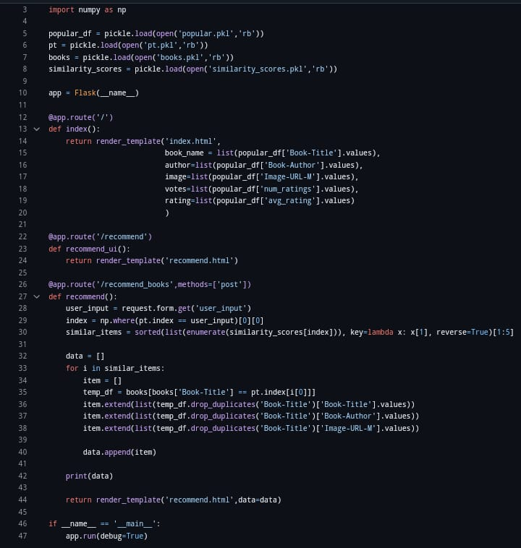

# RESULT

# 

**FUTURE SCOPE**

The future of book recommender systems is promising, driven by advancements in AI, machine learning, and user preferences. Key developments include:

1. Enhanced Personalization using deep learning and natural language processing for better recommendations based on user sentiment and behaviour.

2. Voice and Conversational Systems integrated with virtual assistants and chatbots to provide seamless, interactive book suggestions.

3. Social and Community-driven recommendations based on social networks and user-generated content.

4. Context-aware recommendations tailored to location, time, and user preferences.

5. Multilingual and Global systems that cater to diverse readers worldwide.

6. Ethical and Diverse suggestions to reduce bias and promote inclusivity.

**CONCLUSION**

All of the systems– purely content-based, purely collaborative-filtering, and hybrid– performed quite well. Looking back on the project, one thing that we might have chosen to do differently in retrospect would have been to spend more time searching for a dataset of ratings with a higher rating variance per user. Had we been able to find such a dataset, our implementations of algorithms would have been tested on data that would have been more representative of what a typical commercial recommendation system could access in creating its predictions. However, given the data that was available to us, as well as the results our various approaches produced, our systems were largely successful, providing insight into how the different systems we regularly use work and the varying algorithms that make that possible.

# REFERENCES

# [1] Jure Leskovec, Anand Rajaraman, and Jeffrey David Ullman. Mining of massive datasets. Cambridge University Press, 2014.

[2] Bing Liu and Lei Zhang. “A survey of opinion mining and sentiment analysis.” In: Mining text data. Springer, 2012, pp. 415–463.

[3] Pasquale Lops, Marco De Gemmis, and Giovanni Semeraro. “Content-based recommender systems: State of the art and trends.” In: Recommender systems handbook. Springer, 2011, pp. 73–105.

[4] Raymond J Mooney and Loriene Roy. “Content-based book recommending using learning for text categorization.” In: Proceedings of the fifth ACM conference on Digital libraries. ACM. 2000, pp. 195–204.

[5] Francesco Ricci, Lior Rokach, and Bracha Shapira. Introduction to recommender systems handbook. Springer, 2011.

[6] Badrul Sarwar et al. “Item-based collaborative filtering recommendation algorithms.” In: Proceedings of the 10th international conference on World Wide Web. ACM. 2001, pp. 285– 295.

[7] Ana Stanescu, Swapnil Nagar, and Doina Caragea. “A hybrid recommender system: user profiling from keywords and ratings.” In: Proceedings of the 2013 IEEE/WIC/ACM International Joint Conferences on Web Intelligence (WI) and Intelligent Agent Technologies (IAT)-Volume 01. IEEE Computer Society. 2013, pp. 73–80.

[8] Xiaoyuan Su and Taghi M Khoshgoftaar. “A survey of collaborative filtering techniques.” In: Advances in artificial intelligence 2009 (2009), p. 4.

[9] Peter D Turney and Patrick Pantel. “From frequency to meaning: Vector space models of semantics.” In: Journal of artificial intelligence research 37 (2010), pp. 141–188.