**Certificate (By Company)**

i

**Certificate (By Student)**

This is to certify that **……………,** student of **…………………………………………………….**, of branch **Information Technology** bearing Roll No. **210xxxxxxxxx** has successfully completed Industrial Training in **Java Windows Development** to my satisfaction and submitted the same during the academic year 2024-25 towards the partial fulfillment of final year of B.Tech under the Department of ……………………………………….

Signature : xxxxxxxxxxxxxxxxxxx

Industrial Training Incharge

**ACKNOWLEDGEMENT**

I would like to express my sincere gratitude and appreciation to all those who have contributed to the successful completion of my industrial training at xxxxxxx Technologies Private Limited. This experience has been invaluable in enhancing my skills and knowledge in the field of Java Windows Development.

I am thankful to the entire team at xxxxxxx Technologies for providing me with an environment that fostered learning and growth. The collaborative atmosphere and exposure to real-world projects have greatly contributed to my professional development. I appreciate the opportunities I had to work alongside skilled professionals who willingly shared their knowledge and expertise.

In conclusion, my industrial training experience at xxxxxxxxx Technologies Private Limited has been transformative, and I am thankful for the opportunities and knowledge I have gained. I look forward to applying the skills I've acquired in my future endeavors and contributing positively to the field of Java Windows Development.

Signature: Name : xxxxxxxxxxx Roll No : xxxxxxx

**Table of Content**

Certificate (by company) …………………………………………………………………

……

……

…...

…….

…..

…...

…...

Certificate …………………………………………………………………………………

ii iii

Acknowledgement iv

Chapter 1 Company Profile 1

* 1. Company Vision & Mission 1
  2. Core Values 1
  3. Product & Service Offering 2
  4. Organizational Structure 4
  5. Company Culture And Work Environment 5

1.6 Future Outlook …………………………………………………………….... 3

Chapter 2 Industry at a Glance 7

…5… 3

….4

…..4

……

2.1 Software Development………..……………………………………………... 7

* + 1. Custom Software Development …………………………………… 7
    2. Web Application Development 7
    3. Mobile Application Development 7
  1. IT Consulting And Advisory 7

.

…

..

…..

…

.…

…

…

…

.

….

…

..

..

* + 1. Technology Strategy And Planning 8
    2. Digital Transformation Consulting 8
    3. Cyber Security Consulting 8
  1. Cloud Solutions 8
     1. Cloud Strategy And Migration 8
     2. Cloud Management And Optimization …………………………… 8

2.4 Enterprise Solutions ………………………………………………………… 9

* + 1. Enterprise Resource Planning …………………………………….. 9
    2. Customer Relationship Manager ………………………………… 9
  1. Data Analytics And Business Intelligence ………………………………… 9

2.5.1 Data Analytics …………………………………………………… 9

2.5.2 Business Intelligence 9

* 1. Artificial Intelligence And Machine Learning 9
     1. AI And ML Solutions 9
     2. AI Powered Applications 10
  2. IOT Solutions 10
     1. IOT Device Integration 10
     2. IOT Analysis 10

…

.

….

…

.

….

.

…..

.

/..

.

….

…

…

...

.

.

….

…

…

...

..

.

…

..

.

…

...

* 1. UI/UX – Design 10
     1. User Interface Design 10
     2. User Experience Design 11
  2. Support And Maintenance 11
     1. Technical Support 11
     2. System Maintenance 11
  3. Training And Development 11
     1. Technical Training 11
     2. Workshops And Seminars 11
  4. Industry Specific Solutions 11
     1. Healthcare IT Solutions 12
     2. Finance And Banking Solutions 12
     3. Retail Solutions 12

Chapter 3 Tools & Technologies used in Industry 13

* 1. Software Development Tools 13
     1. Integrated Development Environment 13
     2. Programming Languages 13
     3. Version Control System 13
     4. Build CI/CD Tools 14
  2. Web And Mobile Development Technologies 14
     1. Web Development Framwork 14
     2. Mobile App Development Framework 14
  3. Cloud Solutions Technologies 14
     1. Cloud Services Providers 15
     2. Cloud Management And Monitoring Tools 15
  4. Data Analytics And Business Intelligence Tools 15
     1. Data Analytics Tools 15
     2. Business Intelligence Tools 15
  5. Artificial Intelligence And Machine Learning Tools 16
     1. Machine Learning Framework 16
     2. Natural Language Processing 16
     3. Computer Vision Tools 16
  6. IOT Technologies 16
     1. IOT platform 16

….

…

.

….

…

..

…

.

...

...

..

…

..

..

.

..

…

..

…

.

...

…..

……

...

…

…..

…

..

……

* + 1. IOT Protocols 16
  1. User Interface And User Experience Tools 17
     1. Design Tools 17
     2. Prototyping And Collaboration Tools 17
  2. Support And Maintenance Tools 17
     1. Help Desk System 17
     2. System Monitoring And Diagnostics 17

Chapter 4 Modules Description 18

* 1. Software Development Modules 18
     1. Authentication And Authorization Module 18
     2. Database Management Module 18
     3. User Interface Module 18
     4. Business Logic Module 19
     5. Integration Module 19
  2. Cloud Solutions Module 19
     1. Infrastructure As A Service 19
     2. Platform As A Service 19
     3. Software As A Service 20
  3. Data Analytics And Business Intelligence Module 20
     1. Data Extraction Module 20
     2. Data Transformation Module 20
     3. Data Visualization Module 20
     4. Reporting Module 21
  4. Artificial Intelligence And Machine Learning Module 21
     1. Data Preprocessing Module 21
     2. Data Training Module 21
     3. Data Deployement Module 22
     4. Natural Language Processing Module 22
  5. IOT Module 22
     1. Device Management Module 22
     2. Data Collection Module 22
     3. Data Processing Module 22
     4. Control And Automation Module 23
  6. UI/UX – Design Module 23

33

…

.

…

.

…

…

…..

..

……

……

…..

……

……

…...

…..

…….

……

…...

…….

…….

……

…..

…..

…..

…...

…..

…...

……

…….

…..

…….

….

…...

…...

* + 1. Prototyping Module 23
    2. User Research Module 23
    3. System Design Module 23
  1. Support And Maintenance Module 24
     1. Helpdesk Module 24
     2. System Montoring Module 24
     3. Maintenance Scheduling Module 24

Chapter 5 Modules of Industry 25

* 1. Java 25
     1. Key Features of Java 25
     2. Java Architecture 26
     3. Java Syntax & Language Elements 26
     4. Applications of Java 27
     5. Conclusion 27
  2. Java Swing 27
     1. History & Introduction to Java Swing 27
     2. Key Features of Java Swing 28
     3. Swing Architecture 28
     4. Common Swing Components 28
     5. Layout Managers in Swing 29
     6. Modern Applications of Java Swing 29
     7. Conclusion 30
  3. NetBeans 30
     1. Introduction to NetBeans 30
     2. Key Features of NetBeans 30
     3. NetBeans Architecture 31
     4. NetBeans Tools & Extensions 31
     5. NetBeans in Modern Software Development 32
     6. Conclusion 32
  4. Git & GitHub 32
     1. Introduction to Git & GitHub 32
     2. Key Concepts of Git 33
     3. Benefits of Git & GitHub 33
     4. Git Workflows 33

……

……

……

……..

……

…..

……

…….

……..

...

…...

…...

…..

…...

…….

…….

…….

…..

…….

…..

…...

…..

…...

* + 1. Applications of Git & GitHub 34
    2. Challenges and Future of Git & GitHub 34
    3. Conclusion 34
  1. Visual Studio Code 34

Chapter 6 Details about the Modules 36

* 1. Introduction 36
  2. Features 36
  3. Implementation 37
  4. GUI Layout 39

Chapter 7 Training Outcome 43

* 1. Introduction 43
  2. Overview of the Industrial Training 43
  3. Skills Acquired During Training 43
  4. Practical Applications of Skills 44
  5. Enhanced Understanding of Core Java 44
  6. Exposure to Industry Standards & Best Practices 44
  7. Improvement in Problem-Solving Abilities 44
  8. Effective Team Collaboration & Communication 45
  9. Introduction to Real-World Software Development 45
  10. Project Management & Time Management Skills 45

Chapter 8 Conclusion 46

References 48

**CHAPTER 1 COMPANY PROFILE**

Xxxxx Technology Pvt. Ltd., headquartered in Noida, India, is a leading technology solutions provider specializing in a diverse range of IT services and products. Established with the vision to deliver innovative and high-quality technology solutions, Xxxxx has established itself as a significant player in the technology sector, serving clients across various industries.

* 1. **Company Mission and Vision**

Mission: Xxxxx Technology Pvt. Ltd. is dedicated to providing cutting-edge technology solutions that empower businesses to achieve their strategic objectives. The company’s mission is to deliver tailored, high-performance solutions that drive operational efficiency, enhance user experiences, and foster business growth.

Vision: The vision of Xxxxx Technology Pvt. Ltd. is to be a global leader in technology innovation and services. By leveraging emerging technologies and maintaining a customer- centric approach, Xxxxx aims to be at the forefront of technological advancements and contribute to the success of businesses worldwide.

* 1. **Core Values**
     1. **Innovation:** Xxxxx prioritizes innovation, constantly exploring and integrating the latest technologies to offer state-of-the-art solutions.
     2. **Quality:** Commitment to high standards of quality ensures that all products and services meet rigorous performance and reliability benchmarks.
     3. **Customer Focus:** The company places a strong emphasis on understanding and meeting client needs, delivering solutions that are aligned with their business goals.
     4. **Integrity:** Ethical business practices and transparency are fundamental to Xxxxx’s operations, fostering trust and long-term relationships with clients.
     5. **Excellence:** Striving for excellence in every aspect of its operations, Xxxxx is dedicated to achieving outstanding results and exceeding client expectations.
  2. **Products and Services**

Xxxxx Technology Pvt. Ltd. offers a comprehensive suite of products and services designed to address the diverse needs of businesses. These include:

* + 1. **Software Development**
       - **Custom Software Development:** Tailor-made software solutions designed to meet specific client requirements, including enterprise applications, desktop software, and more.
       - **Web Application Development:** Development of robust, interactive web applications using modern technologies and frameworks.
       - **Mobile Application Development:** Creation of mobile apps for iOS and Android platforms, including native and cross-platform solutions.
       - **Software Testing and Quality Assurance:** Rigorous testing processes to ensure software products are reliable and meet quality standards.
    2. **IT Consulting and Advisory**
       - **Technology Strategy and Planning:** Assisting businesses in developing and implementing IT strategies that align with their goals.
       - **Digital Transformation Consulting:** Guiding organizations through the adoption of new technologies to enhance operational efficiency.
       - **Cybersecurity Consulting:** Offering expertise in securing IT systems and protecting against cyber threats through risk assessments and security audits.
    3. **Cloud Solutions**
       - **Cloud Strategy and Migration:** Helping businesses transition to cloud platforms like AWS, Azure, and Google Cloud, ensuring a smooth migration process.
       - **Cloud Management and Optimization:** Managing cloud resources to optimize performance, control costs, and ensure security.
    4. **Enterprise Solutions**
       - **ERP Solutions:** Implementing and customizing Enterprise Resource Planning systems to integrate and streamline various business processes.
       - **CRM Solutions:** Developing and deploying Customer Relationship Management systems to enhance customer interactions and data management.
    5. **Data Analytics and Business Intelligence (BI)**
       - **Data Analytics:** Analysing data to provide insights and support decision-making processes.
       - **Business Intelligence:** Creating BI solutions that offer visualizations and reports to track key performance indicators and metrics.
    6. **Artificial Intelligence (AI) and Machine Learning (ML)**
       - **AI and ML Solutions:** Developing intelligent solutions using AI and ML technologies for automation and predictive analytics.
       - **NLP and Computer Vision:** Implementing natural language processing and computer vision technologies to enhance user experiences and business processes.
    7. **Internet of Things (IoT)**
       - **IoT Device Integration:** Developing solutions for integrating and managing IoT devices, enabling real-time monitoring and control.
       - **IoT Analytics:** Analysing data from IoT devices to provide actionable insights and improve operations.
    8. **UI/UX Design**
       - **User Interface Design:** Creating visually appealing and functional interfaces for applications and websites.
       - **User Experience Design:** Enhancing user experiences by designing intuitive and engaging interactions.
    9. **Support and Maintenance**
       - **Technical Support:** Providing ongoing support and troubleshooting for software and IT systems.
       - **System Maintenance:** Performing regular updates, patches, and optimizations to ensure system performance and security.
    10. **Training and Development**
        - **Technical Training:** Offering training programs on various technologies and tools to enhance skills and knowledge.
        - **Workshops and Seminars:** Organizing events to educate clients and employees on industry trends and best practices.
    11. **Industry-Specific Solutions**
        - **Healthcare IT Solutions:** Developing solutions like electronic health records (EHR) systems and telemedicine applications for the healthcare sector.
        - **Finance and Banking Solutions:** Creating systems for core banking, fraud detection, and financial analytics for the finance sector.
        - **Retail Solutions:** Implementing solutions such as point-of-sale (POS) systems and inventory management tools for the retail industry.
  1. **Organizational Structure**

Xxxxx Technology Pvt. Ltd. operates through various departments, each focusing on specific aspects of the company’s services:

* + 1. **Software Development Department:** Responsible for creating and maintaining software applications, including custom software, web, and mobile applications.
    2. **IT Consulting and Advisory Department:** Provides strategic advice on technology adoption, digital transformation, and cybersecurity.
    3. **Cloud Solutions Department:** Focuses on cloud strategy, migration, and management services.
    4. **Enterprise Solutions Department:** Specializes in ERP and CRM solutions for large organizations.
    5. **Data Analytics and BI Department:** Offers data analytics and business intelligence services to help clients make informed decisions.
    6. **AI and ML Department:** Develops AI and ML solutions for automation, predictive analytics, and advanced technologies.
    7. **IoT Department:** Integrates and manages IoT devices and solutions, providing analytics and insights.
    8. **UI/UX Design Department:** Designs user-friendly and aesthetically pleasing interfaces and experiences.
    9. **Support and Maintenance Department:** Provides technical support and system maintenance services.
    10. **Training and Development Department:** Offers training programs and organizes workshops to enhance skills and knowledge.
    11. **Industry-Specific Solutions Department:** Develops tailored solutions for healthcare, finance, and retail sectors.
  1. **Company Culture and Work Environment**

Xxxxx Technology Pvt. Ltd. fosters a collaborative and innovative work environment. The company values continuous learning and professional development, encouraging employees to stay updated with the latest technologies and industry trends. The culture emphasizes teamwork, creativity, and a strong commitment to delivering exceptional results for clients.

* + 1. **Employee Benefits:**
       - **Professional Development:** Opportunities for training, certifications, and career advancement.
       - **Work-Life Balance:** Flexible work arrangements and supportive policies to maintain a healthy work-life balance.
       - **Innovative Environment:** A culture that encourages creativity, experimentation, and innovation.
    2. **Clientele and Market Presence**

Xxxxx Technology Pvt. Ltd. serves a diverse clientele across various industries, including healthcare, finance, retail, and more. The company’s strong focus on delivering customized solutions and its ability to adapt to different industry needs have contributed to its success and growth. Xxxxx’s reputation for excellence and its commitment to client satisfaction have earned it a strong market presence and a loyal customer base.

* 1. **Future Outlook**

Looking ahead, Xxxxx Technology Pvt. Ltd. aims to continue its growth trajectory by embracing emerging technologies and expanding its service offerings. The company plans to invest in research and development, explore new market opportunities, and strengthen its position as a leader in the technology sector. By staying ahead of technological trends and maintaining a client-centric approach, Xxxxx is poised for continued success in the ever- evolving technology landscape.

In summary, Xxxxx Technology Pvt. Ltd. is a forward-thinking technology company committed to delivering innovative solutions and services. With a diverse range of offerings and a strong focus on quality and customer satisfaction, Xxxxx is well-positioned to make a significant impact in the technology industry.

**CHAPTER 2 INDUSTRY AT A GLANCE**

The technology industry is one of the most dynamic and rapidly evolving sectors globally. Spanning a broad spectrum of disciplines—from software development and cloud computing to cybersecurity and artificial intelligence (AI)—this industry plays a pivotal role in driving innovation and economic growth. As businesses and organizations increasingly rely on technology to optimize operations, engage customers, and gain competitive advantages, the demand for cutting-edge solutions and skilled professionals continues to surge.

* 1. **Software Development**
     1. **Custom Software Development:**

Xxxxx Technologies specializes in creating tailored software solutions to meet the unique requirements of businesses. Their custom software development services encompass everything from initial consultation and requirements gathering to design, development, and deployment. The company's team of skilled developers utilizes various programming languages and frameworks to build scalable, reliable, and efficient software solutions.

* + 1. **Web Application Development:**

In the realm of web application development, Xxxxx Technologies excels in creating robust and interactive web applications. Their expertise includes the development of both front-end and back-end components, ensuring that web applications are not only visually appealing but also functionally sound. The use of modern technologies such as React, Angular, and Node.js allows Xxxxx to deliver high-performance web applications tailored to client needs.

* + 1. **Mobile Application Development:**

With the increasing reliance on mobile devices, Xxxxx Technologies offers comprehensive mobile app development services for both iOS and Android platforms. Their approach includes native app development as well as cross-platform solutions using frameworks like Flutter and Xamarin. This versatility ensures that clients receive mobile applications that deliver a seamless user experience across different devices and operating systems.

* 1. **IT Consulting and Advisory**
     1. **Technology Strategy and Planning:**

Xxxxx Technologies provides strategic IT consulting services to help businesses align their technology investments with their overall goals and objectives. This involves assessing current technology infrastructure, identifying gaps, and recommending improvements. Their consultants work closely with clients to develop technology roadmaps and implementation plans that drive business growth and efficiency.

* + 1. **Digital Transformation Consulting:**

In today’s rapidly evolving digital landscape, businesses need to continuously adapt to stay competitive. Xxxxx Technologies offers digital transformation consulting to help organizations leverage new technologies to enhance their operations. This includes evaluating existing processes, identifying opportunities for automation and digital innovation, and guiding the implementation of cutting-edge solutions.

* + 1. **Cybersecurity Consulting:**

Protecting sensitive data and maintaining secure IT environments are critical concerns for businesses. Xxxxx Technologies provides cybersecurity consulting services to assess and strengthen an organization’s security posture. Their services include risk assessments, vulnerability testing, and the development of security policies and procedures to safeguard against cyber threats.

* 1. **Cloud Solutions**
     1. **Cloud Strategy and Migration:**

Xxxxx Technologies assists businesses in developing and executing cloud strategies to optimize their IT infrastructure. Their cloud migration services include planning and executing the transition of on-premises systems to cloud environments, such as AWS, Azure, or Google Cloud. This ensures a smooth migration with minimal disruption to business operations.

* + 1. **Cloud Management and Optimization:**

Post-migration, Xxxxx Technologies offers cloud management services to monitor and manage cloud resources efficiently. They focus on optimizing cloud performance, controlling costs, and ensuring high availability and scalability of cloud applications. Their cloud experts provide ongoing support to help businesses leverage cloud technology effectively.

* 1. **Enterprise Solutions**
     1. **Enterprise Resource Planning (ERP):**

Xxxxx Technologies provides ERP solutions to help organizations streamline their operations and improve efficiency. Their ERP services include the implementation and customization of ERP systems such as SAP, Oracle, and Microsoft Dynamics. These systems integrate various business functions, including finance, HR, supply chain, and manufacturing, into a unified platform.

* + 1. **Customer Relationship Management (CRM):**

Effective management of customer interactions is crucial for business success. Xxxxx Technologies offers CRM solutions to help businesses manage customer relationships, track sales, and improve customer service. Their CRM services include the implementation of popular CRM systems like Salesforce and Zoho CRM, as well as custom CRM development tailored to specific business needs.

* 1. **Data Analytics and Business Intelligence**
     1. **Data Analytics:**

Xxxxx Technologies provides data analytics services to help businesses extract valuable insights from their data. This includes data collection, cleaning, and analysis to identify trends, patterns, and opportunities. Their analytics solutions support data-driven decision-making and help organizations make informed strategic choices.

* + 1. **Business Intelligence (BI):**

Their BI services involve the development and implementation of BI solutions to visualize and interpret data. Using tools like Power BI, Tableau, and QlikView, Xxxxx Technologies enables businesses to create interactive dashboards and reports that provide a clear view of key performance indicators and business metrics.

* 1. **Artificial Intelligence and Machine Learning**
     1. **AI and ML Solutions:**

Xxxxx Technologies is at the forefront of integrating artificial intelligence (AI) and machine learning (ML) into business processes. They offer services that include the development of AI models, machine learning algorithms, and natural language processing (NLP) solutions. These technologies help businesses automate tasks, predict outcomes, and gain deeper insights from data.

* + 1. **AI-Powered Applications:**

Their expertise extends to creating AI-powered applications that enhance user experiences and drive innovation. This includes developing intelligent chatbots, recommendation systems, and predictive analytics tools that leverage AI to provide personalized and efficient solutions.

* 1. **IoT Solutions**
     1. **IoT Device Integration:**

Xxxxx Technologies provides solutions for integrating Internet of Things (IoT) devices into business operations. Their services include the development of IoT applications and platforms that enable real-time monitoring and control of connected devices. This is particularly valuable for industries such as manufacturing, logistics, and smart cities.

* + 1. **IoT Analytics:**

In addition to device integration, Xxxxx Technologies offers IoT analytics services to process and analyze data generated by IoT devices. Their analytics solutions help businesses gain actionable insights from IoT data, improving operational efficiency and decision-making.

* 1. **UI/UX Design**
     1. **User Interface (UI) Design:**

Xxxxx Technologies places a strong emphasis on creating intuitive and engaging user interfaces. Their UI design services focus on delivering visually appealing and functional designs that enhance user interactions with software applications and websites.

* + 1. **User Experience (UX) Design:**

Alongside UI design, Xxxxx Technologies offers UX design services to ensure that applications provide a seamless and satisfying user experience. This involves user research,

wireframing, prototyping, and usability testing to create products that meet user needs and preferences.

* 1. **Support and Maintenance**
     1. **Technical Support:**

Xxxxx Technologies provides ongoing technical support to ensure that clients’ IT systems and applications run smoothly. Their support services include troubleshooting, issue resolution, and regular maintenance to address any technical problems that may arise.

* + 1. **System Maintenance:**

Regular maintenance is essential for keeping IT systems up-to-date and secure. Xxxxx Technologies offers system maintenance services to apply updates, patches, and upgrades to software and hardware, ensuring optimal performance and security.

* 1. **Training and Development**
     1. **Technical Training:**

To empower clients with the skills needed to effectively use and manage their technology solutions, Xxxxx Technologies offers technical training programs. These programs cover various technologies and tools, providing hands-on experience and knowledge to clients' IT teams.

* + 1. **Workshops and Seminars:**

Xxxxx Technologies also organizes workshops and seminars on emerging technologies and industry best practices. These events offer valuable insights and practical knowledge to help businesses stay ahead in the rapidly changing tech landscape.

* 1. **Industry-Specific Solutions**
     1. **Healthcare IT Solutions:**

Xxxxx Technologies offers specialized IT solutions for the healthcare industry, including electronic health records (EHR) systems, telemedicine solutions, and healthcare analytics. These solutions aim to improve patient care, streamline healthcare processes, and enhance data management.

* + 1. **Finance and Banking Solutions:**

In the finance and banking sector, Xxxxx Technologies provides solutions such as core banking systems, fraud detection systems, and financial analytics tools. These solutions help financial institutions manage their operations, ensure compliance, and mitigate risks.

* + 1. **Retail Solutions:**

For the retail industry, Xxxxx Technologies offers point-of-sale (POS) systems, inventory management solutions, and customer engagement tools. Their solutions are designed to enhance the retail experience, optimize operations, and drive sales.

**CHAPTER 3**

**TOOLS AND TECHNOLOGY USED IN INDUSTRY**

Xxxxx Technology Pvt. Ltd., a leading technology solutions provider based in Noida, India, utilizes a wide array of tools and technologies to deliver its diverse range of services. These tools and technologies enable the company to develop robust software solutions, implement cutting-edge technologies, and maintain high standards of quality and efficiency. Below is a detailed description of the tools and technologies used across various departments at Xxxxx Technology Pvt. Ltd.

* 1. **Software Development Tools**
     1. **Integrated Development Environments (IDEs):**
        + **Visual Studio:** A comprehensive IDE from Microsoft used for developing .NET applications, including web, desktop, and mobile apps.
        + **IntelliJ IDEA:** A powerful IDE for Java development and other JVM-based languages, offering advanced code assistance and tools for building robust applications.
        + **Eclipse:** An open-source IDE commonly used for Java development, but also supports other languages through plugins.
     2. **Programming Languages:**
        + **Java:** Widely used for building enterprise-level applications, web applications, and Android mobile apps.
        + **Python:** Known for its simplicity and readability, Python is used for web development, data analysis, machine learning, and scripting.
        + **JavaScript:** Essential for web development, JavaScript is used for creating interactive and dynamic web pages. Frameworks like React and Angular enhance its capabilities.
        + **C#:** Used primarily in the .NET ecosystem for developing Windows applications, web services, and enterprise solutions.
     3. **Version Control Systems:**
        + **Git:** A distributed version control system used to manage code changes, track revisions, and collaborate with other developers. Git repositories are often hosted on platforms like GitHub or GitLab.
        + **SVN (Subversion):** A centralized version control system used for managing changes to code and other digital assets.
     4. **Build and CI/CD Tools:**
        + **Jenkins:** An open-source automation server used to build, test, and deploy applications continuously. Jenkins integrates with various tools and plugins to support DevOps practices.
        + **Maven:** A build automation tool primarily used for Java projects, managing project dependencies and building project artifacts.
        + **Docker:** A containerization platform that allows developers to package applications and their dependencies into containers for consistent deployment across environments.
  2. **Web and Mobile Development Technologies**
     1. **Web Development Frameworks:**
        + **React:** A JavaScript library for building user interfaces, particularly single-page applications (SPAs), developed and maintained by Facebook.
        + **Angular:** A TypeScript-based framework developed by Google for building dynamic and scalable web applications.
        + **Vue.js:** A progressive JavaScript framework used for building user interfaces and single-page applications with a focus on ease of integration and flexibility.
     2. **Mobile App Development Platforms:**
        + **Android Studio:** The official IDE for Android development, providing tools for building, testing, and debugging Android applications.
        + **Xcode:** The IDE used for developing iOS applications, offering a suite of tools for coding, debugging, and designing user interfaces for Apple platforms.
        + **Flutter:** A UI toolkit from Google for building natively compiled applications for mobile, web, and desktop from a single codebase using the Dart language.
  3. **Cloud Solutions Technologies**
     1. **Cloud Service Providers:**
        + **Amazon Web Services (AWS):** A comprehensive cloud computing platform offering services such as computing power, storage, and databases. Key services include EC2 (virtual servers), S3 (object storage), and RDS (managed databases).
        + **Microsoft Azure:** A cloud platform from Microsoft providing a range of services including virtual machines, app services, and SQL databases. Azure also offers tools for AI, machine learning, and analytics.
        + **Google Cloud Platform (GCP):** Google’s cloud computing services include Compute Engine (virtual machines), Cloud Storage, and BigQuery (data analytics).
     2. **Cloud Management and Monitoring Tools:**
        + **Kubernetes:** An open-source platform for managing containerized applications across clusters of machines, providing automation for deployment, scaling, and operations.
        + **Terraform:** An infrastructure-as-code tool that allows users to define and provision cloud infrastructure using a declarative configuration language.
  4. **Data Analytics and Business Intelligence Tools**
     1. **Data Analytics Tools:**
        + **Apache Spark:** An open-source data processing engine for big data analytics, known for its speed and ease of use. Spark supports various data processing tasks such as batch processing and streaming.
        + **Hadoop:** A framework for distributed storage and processing of large data sets using a cluster of computers. It includes components like HDFS (Hadoop Distributed File System) and MapReduce.
     2. **Business Intelligence (BI) Tools:**
        + **Power BI:** A Microsoft tool for creating interactive visualizations and business intelligence reports, offering integration with various data sources.
        + **Tableau:** A data visualization tool that helps users create interactive and shareable dashboards, providing insights through intuitive and dynamic graphics.
        + **QlikView:** A BI tool that enables users to explore and analyze data through interactive dashboards and reports.
  5. **Artificial Intelligence (AI) and Machine Learning (ML) Tools**
     1. **Machine Learning Frameworks:**
        + **TensorFlow:** An open-source library developed by Google for machine learning and deep learning applications, providing tools for building and training models.
        + **PyTorch:** An open-source machine learning library developed by Facebook, known for its flexibility and ease of use in developing deep learning models.
     2. **Natural Language Processing (NLP) Tools:**
        + **NLTK (Natural Language Toolkit):** A Python library for working with human language data, providing tools for text processing and linguistic analysis.
        + **spaCy:** An open-source NLP library in Python designed for advanced text processing tasks such as named entity recognition, part-of-speech tagging, and dependency parsing.
     3. **Computer Vision Tools:**
        + **OpenCV:** An open-source computer vision library that provides tools for image and video analysis, including object detection and recognition.
        + **Microsoft Azure Computer Vision:** A cloud-based service offering image analysis, text extraction, and object detection capabilities.
  6. **Internet of Things (IoT) Technologies**
     1. **IoT Platforms:**
        + **AWS IoT Core:** A managed cloud service that allows secure connection and interaction with IoT devices, providing features for device management and data processing.
        + **Google Cloud IoT:** A suite of services for connecting, managing, and analyzing data from IoT devices, including IoT Core and IoT Edge.
     2. **IoT Protocols:**
        + **MQTT (Message Queuing Telemetry Transport):** A lightweight messaging protocol for small sensors and mobile devices, widely used in IoT applications for its efficiency and low bandwidth requirements.
        + **CoAP (Constrained Application Protocol):** A protocol designed for constrained devices and networks, providing efficient communication in IoT environments.
  7. **User Interface (UI) and User Experience (UX) Design Tools**
     1. **Design Tools:**
        + **Adobe XD:** A design and prototyping tool for creating user experiences and interfaces, offering features for wireframing, visual design, and interactive prototypes.
        + **Sketch:** A digital design tool for creating user interfaces and prototypes, particularly popular among UX/UI designers for its vector-based approach.
     2. **Prototyping and Collaboration Tools:**
        + **Figma:** A collaborative design tool that enables real-time collaboration on design projects, offering features for designing, prototyping, and feedback.
        + **InVision:** A prototyping and collaboration platform for creating interactive prototypes and gathering feedback from stakeholders.
  8. **Support and Maintenance Tools**
     1. **Ticketing and Help Desk Systems:**
        + **Jira Service Management:** A service management tool for handling support requests, incidents, and changes, offering features for ticketing, tracking, and reporting.
        + **Zendesk:** A customer service platform that provides tools for managing support tickets, live chat, and customer interactions.
     2. **System Monitoring and Diagnostics:**
        + **Nagios:** An open-source monitoring system used to monitor network and system performance, providing alerts and notifications for issues.
        + **Datadog:** A cloud-based monitoring and analytics platform that provides visibility into application performance, infrastructure, and logs.

**CHAPTER 4 MODULES DESCRIPTION**

In the technology industry, modules are distinct components or functional units within larger systems or solutions, each designed to handle specific tasks or processes. These modules enable organizations to build scalable, modular systems that can be easily maintained and updated.

Below is a detailed description of various modules commonly found in technology solutions across different industry sectors:

* 1. **Software Development Modules**
     1. **Authentication and Authorization Module**
        + **Functionality:** Manages user login, authentication, and permissions. It ensures secure access to applications by verifying user credentials and controlling user access based on roles and permissions.

##### Components:

1. **Login Interface:** User input fields for username and password.
2. **Authentication Logic:** Validates credentials against a database or authentication.
3. **Authorization Management:** Determines access levels based on user roles.
   * 1. **Database Management Module**
        + **Functionality:** Handles data storage, retrieval, and management. It interacts with databases to perform operations like creating, reading, updating, and deleting records.

##### Components:

1. **Database Connection:** Interfaces with the database server.
2. **Query Engine:** Executes SQL or NoSQL queries.
3. **Data Access Layer:** Provides methods to access and manipulate data.
   * 1. **User Interface (UI) Module**
        + **Functionality:** Provides the graphical interface through which users interact with the application. It includes elements like forms, buttons, and navigation menus.

##### Components:

1. **UI Components:** Buttons, text fields, drop-down menus, and other interactive elements.
2. **Layout Management:** Organizes UI elements on the screen.
3. **Event Handling:** Manages user interactions and responses.
   * 1. **Business Logic Module**
        + **Functionality:** Contains the core functionality and rules of the application. It processes user inputs, performs calculations, and enforces business rules.

##### Components:

1. **Business Rules Engine:** Applies logic and rules to data.
2. **Processing Functions:** Implements core application processes and algorithms.
   * 1. **Integration Module**
        + **Functionality:** Facilitates communication between different systems and services. It handles data exchange, API calls, and integration with third-party services.

##### Components:

1. **API Gateway:** Manages API requests and responses.
2. **Service Connectors:** Interfaces with external services and databases.
   1. **Cloud Solutions Modules**
      1. **Infrastructure as a Service (IaaS) Module**
         * **Functionality:** Provides virtualized computing resources over the cloud. It includes services like virtual machines, storage, and networking.

##### Components:

1. **Virtual Machines:** Scalable computing instances.
2. **Storage Services:** Cloud storage solutions for data backup and retrieval.
3. **Networking:** Virtual networks, load balancers, and security groups.
   * 1. **Platform as a Service (PaaS) Module**
        + **Functionality:** Offers a platform for developing, running, and managing applications without dealing with underlying infrastructure.

##### Components:

1. **Application Hosting:** Environments for deploying and running applications.
2. **Development Tools:** Integrated development environments and deployment tools.
3. **Middleware Services:** Databases, messaging systems, and other supporting services.
   * 1. **Software as a Service (SaaS) Module**
        + **Functionality:** Provides software applications over the internet, allowing users to access and use applications via web browsers.

##### Components:

1. **Application Interface:** Web-based interface for users to interact with the application.
2. **Subscription Management:** Handles user subscriptions, billing, and licensing.
   1. **Data Analytics and Business Intelligence (BI) Modules**
      1. **Data Extraction Module**
         * **Functionality:** Extracts data from various sources, including databases, APIs, and flat files. It prepares data for analysis and reporting.

##### Components:

1. **ETL Tools (Extract, Transform, Load):** Extracts data, transforms it into the desired format, and loads it into a data warehouse.
2. **Data Connectors:** Interfaces with different data sources.
   * 1. **Data Transformation Module**
        + **Functionality:** Transforms raw data into a usable format by cleaning, normalizing, and aggregating it.

##### Components:

1. **Data Cleaning Tools:** Remove inconsistencies and errors from data.
2. **Data Aggregation:** Combines data from multiple sources.
   * 1. **Data Visualization Module**
        + **Functionality:** Creates graphical representations of data to help users understand and interpret information.

##### Components:

1. **Dashboards:** Interactive panels displaying key metrics and visualizations.
2. **Charts and Graphs:** Various types of visualizations, such as bar charts, pie charts.
   * 1. **Reporting Module**
        + **Functionality:** Generates and delivers reports based on analyzed data, providing insights and summaries.

##### Components:

1. **Report Designer:** Tool for creating custom reports.
2. **Report Scheduler:** Automates the generation and distribution of reports.
   1. **Artificial Intelligence (AI) and Machine Learning (ML) Modules**
      1. **Data Preprocessing Module**
         * **Functionality:** Prepares data for training machine learning models by cleaning, normalizing, and splitting datasets.

##### Components:

1. **Data Cleaning:** Handles missing values, outliers, and data inconsistencies.
2. **Feature Engineering:** Creates and selects relevant features for model training.
   * 1. **Model Training Module**
        + **Functionality:** Trains machine learning models using historical data and selected algorithms.

##### Components:

1. **Algorithm Selection:** Chooses appropriate ML algorithms based on the problem and data.
2. **Model Evaluation:** Assesses model performance using metrics like accuracy, precision, and recall.
   * 1. **Model Deployment Module**
        + **Functionality:** Deploys trained models into production environments where they can make predictions and decisions.

##### Components:

1. **Model Serving:** Provides APIs or services for real-time predictions.
2. **Monitoring:** Tracks model performance and retrains as necessary.
   * 1. **Natural Language Processing (NLP) Module**
        + **Functionality:** Processes and analyzes human language data for tasks such as sentiment analysis, text classification, and entity recognition.

##### Components:

1. **Tokenization:** Breaks text into individual words or tokens.
2. **Named Entity Recognition (NER):** Identifies entities like names, dates, and locations in text.
   1. **Internet of Things (IoT) Modules**
      1. **Device Management Module**
         * **Functionality:** Manages IoT devices, including registration, configuration, and monitoring.

##### Components:

1. **Device Registration:** Enrolls devices into the IoT network.
2. **Device Configuration:** Sets parameters and configurations for devices.
   * 1. **Data Collection Module**
        + **Functionality:** Collects data from IoT devices and sensors, transmitting it to centralized systems for analysis.

##### Components:

1. **Data Aggregators:** Collect and aggregate data from multiple devices.
2. **Data Transmission:** Handles data transfer protocols like MQTT or CoAP.
   * 1. **Data Processing Module**
        + **Functionality:** Processes and analyzes data collected from IoT devices to extract meaningful insights.

##### Components:

1. **Stream Processing:** Analyzes real-time data streams from devices.
2. **Edge Computing:** Performs data processing at the edge of the network to reduce latency.
   * 1. **Control and Automation Module**
        + **Functionality:** Automates actions and responses based on data collected from IoT devices.

##### Components:

1. **Rule Engines:** Applies predefined rules to trigger actions or alerts.
2. **Actuators:** Devices that perform physical actions based on control signals.
   1. **UI/UX Design Modules**

## Prototyping Module

* + - * **Functionality:** Allows designers to create interactive prototypes of applications and user interfaces.

##### Components:

1. **Wireframes:** Basic layouts and structures of the UI.
2. **Interactive Prototypes:** Clickable models that simulate user interactions.

## User Research Module

* + - * **Functionality:** Gathers and analyses user feedback and behaviour to inform design decisions.

##### Components:

1. **Surveys and Questionnaires:** Tools for collecting user opinions and preferences.
2. **User Testing:** Observes users interacting with prototypes to identify usability issues.
   * 1. **Design System Module**
        + **Functionality:** Provides a standardized set of design patterns and components to ensure consistency across applications.

##### Components:

1. **Design Patterns:** Reusable design solutions for common UI problems.
2. **Component Library:** Pre-designed UI components like buttons, forms, and navigation elements.
   1. **Support and Maintenance Modules**

## Help Desk Module

* + - * **Functionality:** Manages and tracks customer support requests, incidents, and service tickets.

##### Components:

1. **Ticketing System:** Logs and tracks support requests.
2. **Knowledge Base:** Provides self-service resources and FAQs for common issues.
   * 1. **System Monitoring Module**
        + **Functionality:** Monitors system performance, availability, and health to ensure smooth operations.

##### Components:

1. **Performance Metrics:** Tracks key metrics such as CPU usage, memory utilization, and network traffic.
2. **Alerts and Notifications:** Sends alerts for system issues or performance anomalies.

## Maintenance Scheduling Module

* + - * **Functionality:** Plans and schedules routine maintenance tasks such as updates, patches, and backups.

##### Components:

1. **Maintenance Calendar:** Schedules and tracks upcoming maintenance activities.
2. **Automated Backups:** Regularly backs up system data to prevent data loss.

**CHAPTER 5 MODULES OF TRAINING**

# Java

Java, created by James Gosling and his team at Sun Microsystems (now owned by Oracle Corporation), is a widely used and versatile programming language. First introduced in 1995, Java has evolved into a platform that powers everything from desktop applications to enterprise- level systems, mobile apps, and even embedded devices. This comprehensive overview will delve into the key features, architecture, syntax, and applications of Java.

## Key Features of Java

Java's popularity is attributed to its numerous features that make it suitable for a variety of programming needs:

* + - * **Platform Independence:** One of Java's most significant features is its platform independence, achieved through the "Write Once, Run Anywhere" (WORA) principle. Java programs are compiled into bytecode, which can be executed on any platform with a compatible Java Virtual Machine (JVM).
      * **Object-Oriented:** Java is a fully object-oriented language, promoting the use of classes, objects, and inheritance. This approach fosters code reusability, modularity, and easier maintenance.
      * **Strongly Typed:** Java enforces strict typing, ensuring type compatibility during both compilation and runtime. This minimizes errors and enhances code stability.
      * **Garbage Collection:** Java's automatic memory management, handled by the JVM, includes garbage collection. This feature releases memory occupied by objects that are no longer in use, preventing memory leaks.
      * **Multithreading:** Java offers built-in support for multithreading, allowing developers to create concurrent and parallel programs easily. This is vital for developing applications that utilize modern hardware efficiently.
      * **Exception Handling:** Java's robust exception handling mechanism enables programmers to manage and recover from runtime errors gracefully.
      * **Rich Standard Library:** Java provides a vast standard library, offering pre-built classes and APIs for various tasks, from data manipulation to networking and graphical user interfaces.

## Java Architecture

Java's architecture revolves around the concept of the Java Virtual Machine (JVM), a crucial component that enables the platform's platform independence. Here's an overview of the architecture:

* + - * **Source Code:** Developers write Java code using a human-readable format. This code is saved in .java files.
      * **Compiler:** The Java Compiler (javac) compiles the source code into bytecode (.class files), which is a platform-independent format.
      * **Classloader:** The Classloader is responsible for loading bytecode files into memory. It ensures that classes are loaded as needed, enhancing efficiency.
      * **Bytecode:** Bytecode is a low-level representation of the source code that can be executed by the JVM. It is a set of instructions that the JVM interprets or compiles further, depending on the JVM implementation.
      * **Java Virtual Machine (JVM):** The JVM is the cornerstone of Java's platform independence. It interprets or compiles bytecode and manages memory, garbage collection, and execution of Java applications.

## Java Syntax & Language Elements

Java's syntax is largely influenced by C and C++ while incorporating object-oriented concepts. Some essential language elements include:

* + - * **Classes and Objects:** Java's core building blocks are classes and objects. A class defines the blueprint for an object, while objects are instances of classes.
      * **Variables and Data Types:** Java supports various data types, including primitive types (e.g., int, boolean, char) and reference types (e.g., objects). Variables store values of these types.
      * **Methods:** Methods are functions defined within classes to encapsulate behavior. They can take parameters and return values.
      * **Control Structures:** Java supports control structures like if, else, for, while, and switch for decision-making and looping.
      * **Inheritance:** Inheritance allows classes to inherit properties and behaviors from other classes, enabling code reuse and hierarchy.
      * **Interfaces and Abstract Classes:** Interfaces define contracts that classes must adhere to, while abstract classes provide partial implementations for other classes to extend.
      * **Exception Handling:** Java's exception handling mechanism involves try, catch, finally, and throw statements to manage and handle runtime errors.

## Applications of Java

Java's versatility has led to its application in various domains:

* + - * **Web Development:** Java's server-side technologies, such as Java Servlets, JavaServer Pages (JSP), and JavaServer Faces (JSF), are used to build dynamic web applications.
      * **Desktop Applications:** Java's graphical user interface (GUI) libraries, like Swing and JavaFX, enable the development of cross-platform desktop applications.
      * **Mobile Applications:** The Android operating system uses Java as the primary programming language for building mobile apps.
      * **Enterprise Solutions:** Java's robustness and scalability make it a preferred choice for developing large-scale enterprise applications, including Customer Relationship Management (CRM) systems, Enterprise Resource Planning (ERP) systems, and more.
      * **Embedded Systems:** Java's lightweight version, Java ME (Micro Edition), is used for developing applications on embedded devices, such as mobile phones and Internet of Things (IoT) devices.
      * **Scientific Computing:** Java's numerical libraries and mathematical capabilities find applications in scientific research and data analysis.

## Conclusion

Java's enduring popularity can be attributed to its robust architecture, platform independence, rich standard library, and versatile applications. From web development to mobile apps and enterprise systems, Java continues to be a driving force in the world of programming. Its ability to adapt to changing technology trends while maintaining its core principles has secured its place as a language of choice for developers across various domains. As technology evolves, Java remains a language worth mastering for both newcomers and experienced programmers.

# Java Swing

Graphical User Interfaces (GUIs) play a pivotal role in enhancing user experience and interaction with software applications. Java Swing, a part of the Java Foundation Classes (JFC), offers a rich set of components and tools for creating cross-platform, interactive, and visually appealing GUIs. In this exploration of Java Swing, we will delve into its history, key features, architecture, components, layout managers, and its role in modern application development.

## History & Introduction to Java Swing

Java Swing was introduced as a part of the Java Foundation Classes (JFC) in Java 1.2, providing a more modern and flexible alternative to the original Abstract Window Toolkit (AWT). Unlike AWT, which relies heavily on native components and varies in appearance across different

platforms, Swing is built entirely in Java, offering a consistent look and feel across different operating systems.

## Key Features of Java Swing

Java Swing is renowned for its remarkable features, contributing to its popularity among developers:

* + - * **Platform Independence:** Swing components are implemented purely in Java, making them independent of the underlying operating system. This ensures that Swing-based applications look and behave consistently across different platforms.
      * **Customizability:** Swing components are highly customizable, allowing developers to alter their appearance, behavior, and functionality to suit specific application requirements.
      * **Rich Set of Components:** Swing provides an extensive range of components, from basic ones like buttons and labels to advanced ones like tables, trees, and scroll panes, enabling developers to build complex and feature-rich user interfaces.
      * **MVC Architecture:** Swing encourages the Model-View-Controller (MVC) architecture, which promotes the separation of concerns by separating data, user interface, and control logic.
      * **Pluggable Look and Feel:** Swing supports different look and feel options, allowing developers to choose between various predefined styles or create their own custom styles.
      * **Event Handling:** Swing offers a comprehensive event-handling mechanism, enabling developers to respond to user interactions and create dynamic user interfaces.

## Swing Architecture

Swing's architecture is designed to provide maximum flexibility and modularity :

* + - * **Containers:** Swing components are organized within containers like panels, frames, and dialogs. Containers hold and arrange components on the user interface.
      * **Components:** Swing components are lightweight, self-contained entities that provide various user interface elements. These include buttons, labels, text fields, and more.
      * **Layout Managers:** Layout managers determine how components are arranged within containers, adapting to different screen sizes and orientations.

## Common Swing Components

Swing offers an extensive palette of components for creating interactive interfaces:

* + - * **JFrame:** The primary top-level container for building windows with title bars, minimize/maximize buttons, and close buttons.
      * **JPanel:** A lightweight container used to group and organize other components.
      * **JButton:** A button that triggers actions when clicked by the user.
      * **JLabel:** A component used to display text or images.
      * **JTextField:** A single-line text entry field for user input.
      * **JTextArea:** A multi-line text area that can display and receive large amounts of text.
      * **JComboBox:** A drop-down list that allows users to select from a predefined set of options.
      * **JCheckBox:** A checkbox that can be toggled on or off by the user.
      * **JRadioButton:** A radio button that allows users to choose one option from a group of mutually exclusive options.
      * **JScrollPane:** A component used to provide scrolling functionality to components.

## Layout Managers in Swing

Layout managers are essential for arranging components within containers, ensuring proper sizing and alignment across different screen sizes and resolutions. Swing offers several built-in layout managers, including:

* **FlowLayout:** Components are arranged in a row or column, flowing to the next row or column when the container's size is exceeded.
* **BorderLayout:** Components are organized in five regions: north, south, east, west, and center. Each region can contain only one component.
* **GridLayout:** Components are arranged in a grid with a fixed number of rows and columns.
* **BoxLayout:** Components are placed in a single row or column, allowing for more flexible arrangement.
* **CardLayout:** Components are stacked on top of each other, with only one component visible at a time. This is often used for creating wizard-like interfaces.

## Modern Applications of Java Swing

Despite the rise of web-based and mobile applications, Swing continues to have a significant role in various domains:

* + - * **Desktop Applications:** Swing is widely used for developing cross-platform desktop applications that require rich and interactive user interfaces.
      * **Tools and IDEs:** Many integrated development environments (IDEs), like Eclipse and IntelliJ IDEA, use Swing to provide their user interfaces.
      * **Scientific Applications:** Swing's flexibility and customizability make it a preferred choice for creating scientific data visualization tools.
      * **Enterprise Applications:** Swing-based applications are used in enterprise settings, such as accounting software, inventory management systems, and customer relationship management (CRM) tools.

## Conclusion

Java Swing remains a powerful and versatile toolkit for building graphical user interfaces in Java applications. Its platform independence, rich set of components, customizability, and support for modern design patterns make it an enduring choice for developers looking to create cross- platform desktop applications. While new technologies and frameworks have emerged, Swing's legacy continues to be relevant, and its capabilities continue to evolve through contributions from the open-source community. Whether it's for scientific visualization, enterprise solutions, or desktop applications, Java Swing remains an essential tool in the programmer's toolkit.

# NetBeans

In the world of software development, Integrated Development Environments (IDEs) play a crucial role in enhancing productivity, streamlining workflows, and providing developers with tools to create high-quality applications efficiently. Among these IDEs, NetBeans stands out as a versatile, open-source platform that has been empowering Java developers for years. In this exploration of NetBeans, we'll dive into its history, key features, architecture, tools, and its role in modern software development.

## Introduction to NetBeans

NetBeans, initially developed by Sun Microsystems in 1996, has evolved into a powerful IDE supporting multiple programming languages, with a primary focus on Java. It offers a range of tools for coding, debugging, and testing, all within a unified and user-friendly interface. The open-source nature of NetBeans allows developers to contribute, customize, and extend the IDE to suit their specific needs.

## Key Features of NetBeans

NetBeans boasts an array of features that cater to developers' needs and significantly impact their productivity:

* + - * **Rich Set of Tools:** NetBeans provides a comprehensive suite of tools for coding, debugging, profiling, testing, and deploying applications, reducing the need to switch between multiple applications.
      * **Code Templates and Generation:** NetBeans offers code templates and auto-generation features that simplify and speed up the coding process. This includes generating getters, setters, constructors, and overriding methods.
      * **Integrated Debugger:** The integrated debugger in NetBeans helps identify and rectify issues in the code, offering step-by-step execution, breakpoints, variable inspection, and more.
      * **Visual Design Tools:** NetBeans includes GUI builders for Swing and JavaFX, allowing developers to create graphical user interfaces visually, reducing the need for manual coding.
      * **Version Control Integration:** NetBeans seamlessly integrates with version control systems like Git, enabling efficient collaboration and code management.
      * **Maven and Ant Support:** NetBeans supports both Apache Maven and Apache Ant, popular build tools for managing project dependencies and automating build processes.
      * **Easy Plugin Development:** NetBeans' modular architecture makes it easy to develop and integrate plugins, enhancing the IDE's functionality to suit specific project requirements.

## NetBeans Architecture

NetBeans' architecture is designed to facilitate modularity and extensibility, ensuring a customizable environment for developers:

* + - * **NetBeans Platform:** The NetBeans Platform is the underlying framework on which NetBeans IDE is built. It provides a set of reusable modules that form the foundation of the IDE.
      * **Module System:** NetBeans employs a module system that allows developers to extend the functionality of the IDE by creating and integrating modules. This modularity enhances customization and reduces the risk of code conflicts.
      * **Editor Infrastructure:** NetBeans' editor infrastructure supports syntax highlighting, code completion, and code navigation, tailored to various programming languages.
      * **Window System:** The window system manages the arrangement of windows, toolbars, and panels within the IDE, allowing developers to organize their workspace according to their preferences.

## NetBeans Tools & Extensions

NetBeans offers a plethora of tools and extensions that cater to various development needs:

* + - * **Java Development Tools:** NetBeans provides tools for coding, testing, and debugging Java applications, along with support for popular Java frameworks.
      * **Web Development Tools:** NetBeans supports web development with tools for HTML, CSS, JavaScript, and integration with web frameworks like JavaServer Faces (JSF) and Spring.
      * **Mobile Application Development:** NetBeans supports mobile application development, including Android development using the Android Studio plugin.
      * **Database Tools:** NetBeans integrates with databases, offering tools for creating, querying, and managing databases within the IDE.
      * **Version Control and Collaboration:** NetBeans seamlessly integrates with version control systems like Git, facilitating team collaboration and code management.

## NetBeans in Modern Software Development

NetBeans continues to have a significant impact on modern software development practices:

* + - * **Java Development:** NetBeans remains a popular choice for Java development, providing a range of tools and a familiar interface for Java programmers.
      * **Web Development:** With its HTML, CSS, and JavaScript support, NetBeans is utilized for creating modern web applications and websites.
      * **Enterprise Development:** NetBeans' integration with Java EE (Enterprise Edition) technologies makes it suitable for building robust and scalable enterprise applications.
      * **Education:** NetBeans is commonly used in educational settings to teach programming and software development due to its user-friendly interface and comprehensive toolset.

## Conclusion

NetBeans has solidified its position as a powerful and versatile IDE, catering to the needs of Java developers and beyond. Its rich set of features, modular architecture, extensive toolset, and open- source nature make it a valuable asset for programmers looking to streamline their workflows and create high-quality applications efficiently. While new IDEs and technologies continue to emerge, NetBeans' legacy and continued relevance in the development community make it a tool worth exploring and mastering for both beginners and experienced developers alike.

# Git & GitHub

In the realm of software development, version control and collaboration are paramount. Git, a distributed version control system, and GitHub, a web-based platform built around Git, have revolutionized the way developers manage code, collaborate on projects, and streamline software development workflows. This exploration delves into the history, key concepts, benefits, workflows, and applications of Git and GitHub.

## Introduction to Git & GitHub

Git, created by Linus Torvalds in 2005, addresses the challenges of version control by providing a distributed system that enables developers to track changes, manage versions, and collaborate effectively. GitHub, launched in 2008, enhances Git by offering a web-based platform for hosting

repositories, collaborating on code, and enabling social coding. Together, Git and GitHub have transformed software development practices across the globe.

## Key Concepts of Git

Git operates based on a set of fundamental concepts that shape its version control capabilities:

* + - * **Repository (Repo):** A repository is a collection of files, folders, and their history. It holds all versions of a project's code and metadata.
      * **Commit:** A commit represents a snapshot of the project's state at a specific point in time. Commits track changes made to files and provide a history of the project's evolution.
      * **Branches:** Git allows developers to create separate branches to work on different features or fixes. Branches enable parallel development without interfering with the main codebase.
      * **Merge and Pull Requests:** Merging combines changes from one branch into another. Pull requests are a way to propose and discuss changes before they are merged into the main codebase.
      * **Clone:** Cloning creates a local copy of a remote repository, enabling developers to work on their machines while staying synchronized with the remote repository.
      * **Push and Pull:** Pushing sends local commits to a remote repository, while pulling retrieves changes from a remote repository to a local copy.

## Benefits of Git & GitHub

Git and GitHub offer numerous advantages to developers and teams:

* + - * **Version Control:** Developers can track changes, revert to previous states, and collaborate seamlessly without the risk of overwriting each other's work.
      * **Collaboration:** GitHub facilitates collaboration by providing a platform for teams to work together, contribute code, and review changes efficiently.
      * **Code Review:** Pull requests on GitHub enable thorough code reviews, leading to higher code quality and improved collaboration.
      * **History and Accountability:** Git's commit history provides a detailed record of changes made to the codebase, enhancing accountability and troubleshooting.
      * **Branching Strategies:** Git's branching model allows for the implementation of various development workflows, such as feature branching and Gitflow.

## Git Workflows

Several Git workflows guide how developers collaborate on code:

* + - * **Centralized Workflow:** A single repository serves as the central source of truth, and developers collaborate through branches and pull requests.
      * **Feature Branch Workflow:** Developers work on feature branches that are later merged into the main branch via pull requests.
      * **Gitflow Workflow:** A branching model that defines a structured approach to feature development, release preparation, and bug fixing.
      * **Forking Workflow:** Developers fork a repository to their own account, make changes in their fork, and propose changes back to the original repository via pull requests.
    1. **Applications of Git & GitHub**

Git and GitHub have a broad range of applications:

* + - * **Software Development:** Git and GitHub are fundamental to modern software development, enabling version control, collaboration, and code sharing.
      * **Open Source:** GitHub has become the de facto platform for hosting open source projects, fostering global collaboration and community contribution.
      * **Documentation:** Git and GitHub are used to manage documentation, enabling versioning and collaboration on documentation projects.
      * **Continuous Integration/Continuous Deployment (CI/CD):** CI/CD pipelines are often integrated with Git and GitHub to automate testing and deployment processes.
    1. **Challenges and Future of Git & GitHub**

While Git and GitHub have brought remarkable advancements, challenges such as repository size, scalability, and code security persist. Additionally, alternatives like GitLab and Bitbucket provide similar functionalities and cater to different use cases. The future may involve advancements in code analysis, automation, and security within Git-based workflows.

* + 1. **Conclusion**

Git and GitHub have fundamentally reshaped the landscape of software development, offering version control, collaboration, and code sharing capabilities that enhance productivity and code quality. By providing a platform for developers to work together seamlessly, they have fostered innovation and open source contributions on a global scale. As software development continues to evolve, Git and GitHub remain at the forefront, driving collaboration and pushing the boundaries of what can be achieved through effective version control and collaborative coding practices.

* 1. **Visual Studio Code**

Visual Studio Code, often referred to as VS Code, is a free and open-source code editor developed by Microsoft. It supports a wide range of programming languages and offers an extensive set of features through extensions.

Key features of VS Code include:

* **Intelligent Code Editing:** VS Code provides features like syntax highlighting, code completion, and code navigation to enhance productivity.
* **Integrated Terminal:** The editor includes an integrated terminal for running commands without leaving the IDE.
* **Extensions:** VS Code's extension marketplace offers a plethora of extensions for language support, debugging, version control, and more.
* **Git Integration:** VS Code has built-in Git integration for version control tasks, making it easier to manage code changes.
* **Debugging:** The debugger supports various programming languages and allows developers to set breakpoints, inspect variables, and step through code.
* **Customizability:** VS Code's user interface can be customized using themes and settings to match individual preferences.
* **Extensions Marketplace:** VS Code boasts a vibrant extensions marketplace with thousands of extensions covering a wide array of programming languages, frameworks, tools, and functionalities. These extensions enhance the editor's capabilities and allow developers to tailor their workflow.

In conclusion, Java is a versatile programming language known for its platform independence. Java Swing is a GUI toolkit for creating desktop applications. NetBeans is an IDE for Java development with features like code generation and a GUI builder. Git is a distributed version control system, while GitHub provides a platform for code hosting and management. Visual Studio Code is a powerful code editor with extensive language support and customization options. Each of these technologies plays a crucial role in modern software development, enabling developers to create efficient, user-friendly, and collaborative applications.

**CHAPTER 6**

**DETAILS ABOUT THE MODULES**

* 1. **Introduction**

In today's fast-paced world, the banking sector plays a crucial role in the economic development of a nation. The need for an efficient and secure banking system is paramount to managing the vast amount of financial data and transactions that occur daily. The "Banking Management System" project aims to develop a comprehensive software solution using Core Java that facilitates the management of banking operations in an effective and user-friendly manner.

This system is designed to handle essential banking functions such as account management, transaction processing, balance inquiries, and fund transfers. By leveraging the robust features of Core Java, the system ensures a high level of security, reliability, and performance. The project is focused on providing a seamless experience to both bank employees and customers by automating routine tasks and minimizing the potential for human error.

The Banking Management System is intended to be a scalable solution, capable of adapting to the evolving needs of the banking industry. It incorporates a modular design, allowing for easy integration of additional features and functionalities in the future. This report will detail the development process, system architecture, and the key features of the Banking Management System, along with the benefits it offers to the banking sector.

* 1. **Features**
     + **User Authentication:** Secure login and registration process for customers and bank employees. Password encryption and user role management (admin, customer).
     + **Account Management:** Ability to open new savings or checking accounts. Display account balance, account type, and account number. Modify personal details like address, phone number, and email.
     + **Transaction Management:** Allows customers to deposit money into their accounts. Enables customers to withdraw money while ensuring sufficient balance. Facilitates transfer of funds between different accounts within the bank. Provides a detailed view of past transactions, including deposits, withdrawals, and transfers.
     + **Balance Inquiry:** Real-time balance checking for customers to view their available funds.
  2. **Implementation**

The implementation of the Banking Management System is carried out using Core Java, focusing on object-oriented principles, modular design, and efficient use of Java’s standard libraries. The system is divided into several modules, each responsible for a specific aspect of the banking operations.

##### System Architecture

The system is designed using a three-tier architecture comprising:

* + **Presentation Layer:** Handles the user interface, which can be a console-based UI or a basic GUI using Java Swing. This layer interacts with the user and captures inputs like account details, transaction types, etc.
  + **Business Logic Layer:** Implements the core functionalities such as account management, transaction processing, and interest calculations. This layer contains the main business logic classes and methods.
  + **Data Access Layer:** Manages the storage and retrieval of data using file handling or a simple relational database (using JDBC). This layer ensures data persistence across sessions.

##### Key Classes

The system is designed using the following classes:

**Login Class:** The Login class is responsible for managing the authentication process of users, whether they are customers or administrators. It validates user credentials against stored data to ensure secure access to the system.

**SignUp Class:** The SignUp class facilitates the registration process for new customers. It collects personal details and account preferences to create a new user profile.

**BalanceEnquiry Class:** The BalanceEnquiry class allows users to check their current account balance. It retrieves the account balance from the database and displays it to the user.

**Deposit Class:** The Deposit class handles the process of depositing money into the user's account. It updates the account balance and records the transaction.

**Withrwal Class:** The Withdrawal class manages the withdrawal of funds from the user's account. It checks for sufficient balance before allowing the transaction and updates the account balance

accordingly.

**Transaction Class:** The Transaction class records all financial operations performed by the user, such as deposits, withdrawals, and transfers. It maintains a detailed transaction history that can be accessed by the user or admin.

**FastCash Class:** The FastCash class provides a quick withdrawal option for predefined amounts, allowing users to withdraw a set amount with a single click.

**MiniStatement Class:** The MiniStatement class provides a summary of the most recent transactions in the user's account. It is a quick way for users to review their recent account activities.

**PinChange Class:** The PinChange class allows users to update their account's PIN (Personal Identification Number). It includes security checks and ensures the new PIN meets security criteria.

##### Database Interaction

For data persistence, the system uses simple file handling or JDBC for interaction with a relational database like MySQL. The Data Manager class abstracts the database operations such as connecting to the database, executing SQL queries, and managing transactions. This approach ensures that all data, including customer details, account information, and transaction history, are stored securely and retrieved efficiently.

##### Implementation of Key Functionalities

**Account Management:** The BankAccount class provides methods to create new accounts, view and update account information, and perform deposit, withdrawal, and fund transfer operations. Account information is stored and retrieved using the DataManager class.

**Transaction Processing:** The Transaction class records each financial operation, ensuring that each transaction is logged with a unique transaction ID and timestamp. The transaction history can be accessed by the customer through the UI.

**Security and Authentication:** User authentication is handled by a combination of password encryption and session management. The User class, which Customer and Admin extend, includes methods for login, logout, and session handling, ensuring that unauthorized access is prevented.

**Error Handling and Validation:** Robust error handling is implemented using Java's exception handling mechanisms. Input validation is performed at the presentation layer to ensure that all user inputs are within the expected format and range, reducing the likelihood of runtime errors.

* 1. **GUI**

The project has following Pages:

* + 1. **Login Page**

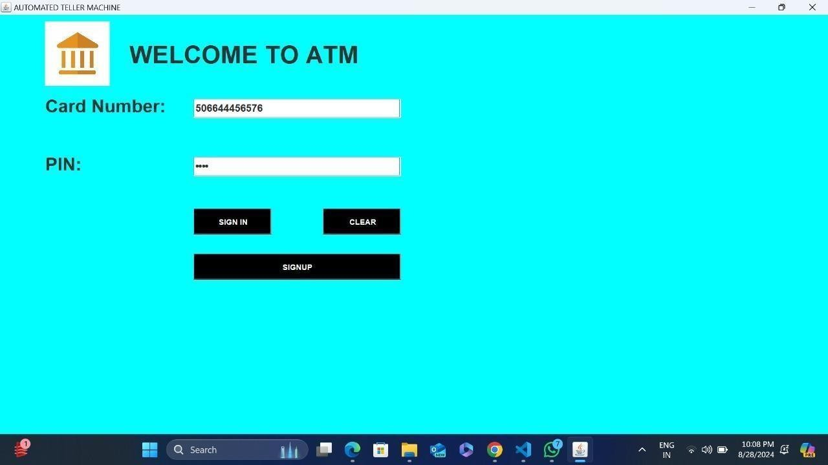

* + 1. **Transactions Page**

Fig 1. Login Page

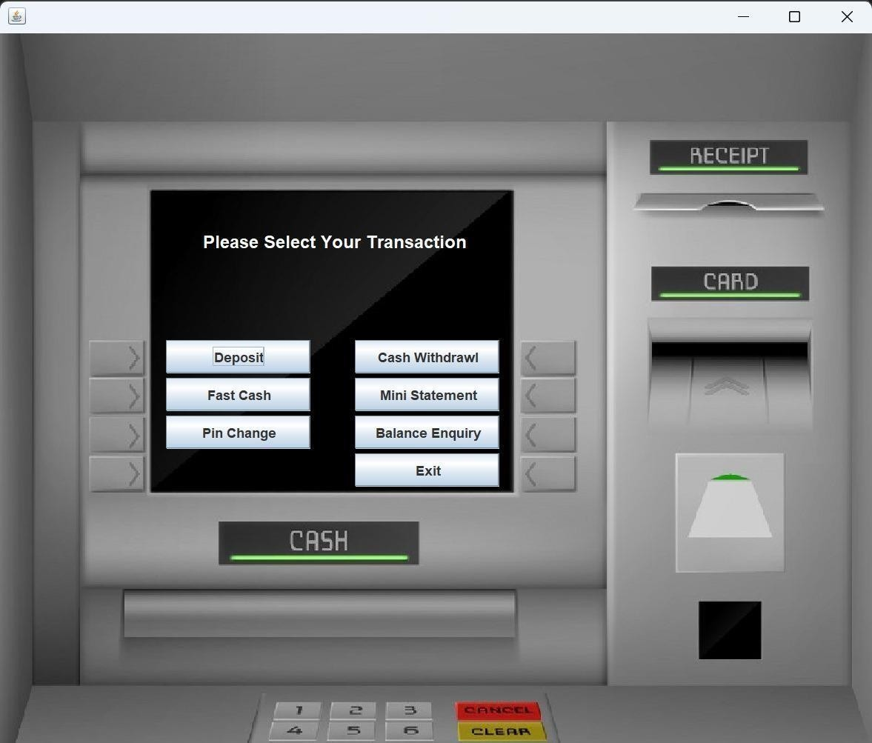Fig. 2 Deposit Amount Page

* + 1. **Deposit Page**

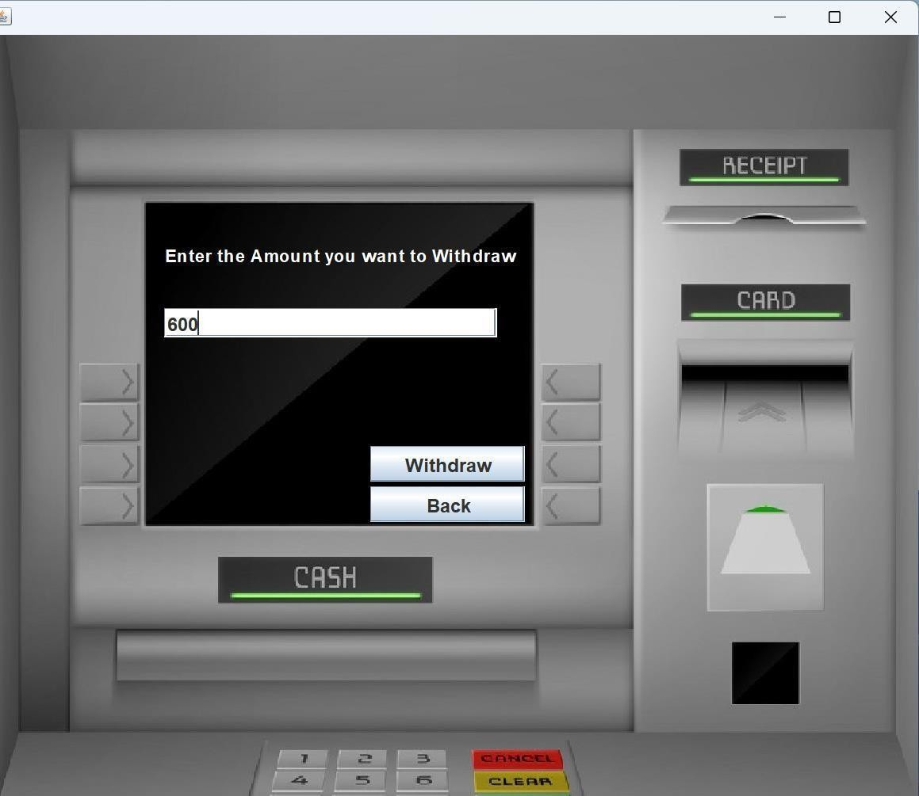

Fig. 3 Withdrawal Page

* + 1. **Balance Enquiry Page**

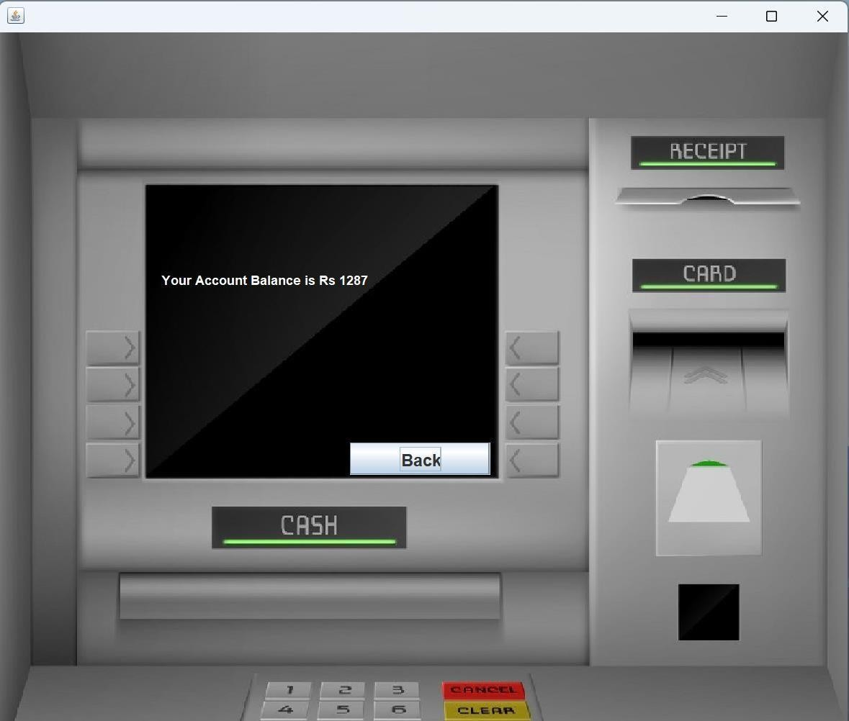

Fig. 4 Balance Enquiry Page

* + 1. **Change Pin Page**

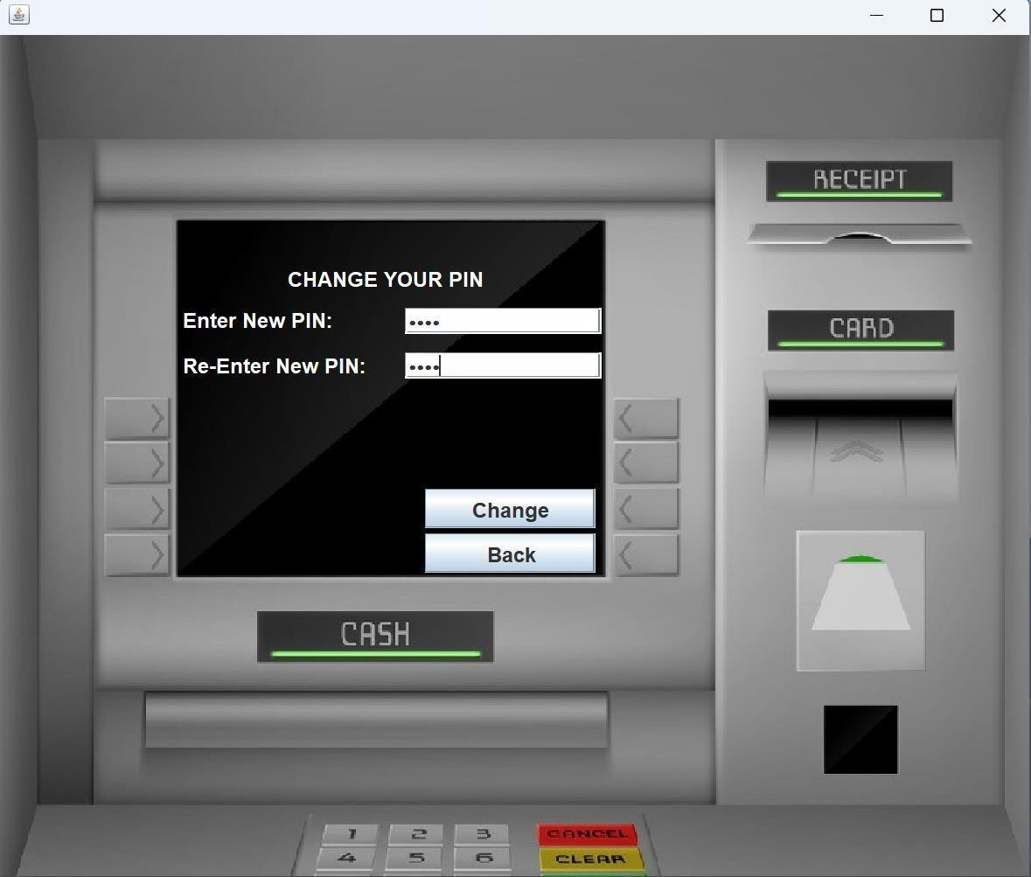

Fig. 5 Change Pin Page

* + 1. **Withdrawal Amount Page**

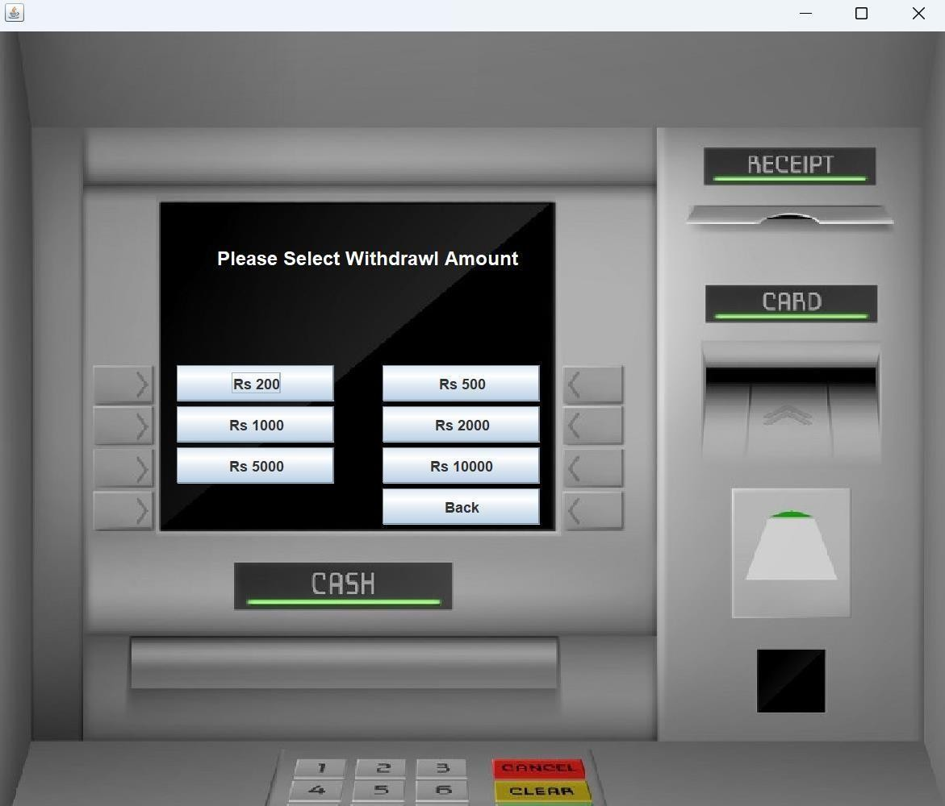

Fig. 6 Choose Withdrawal Amount Page

* + 1. **Mini statement Page**

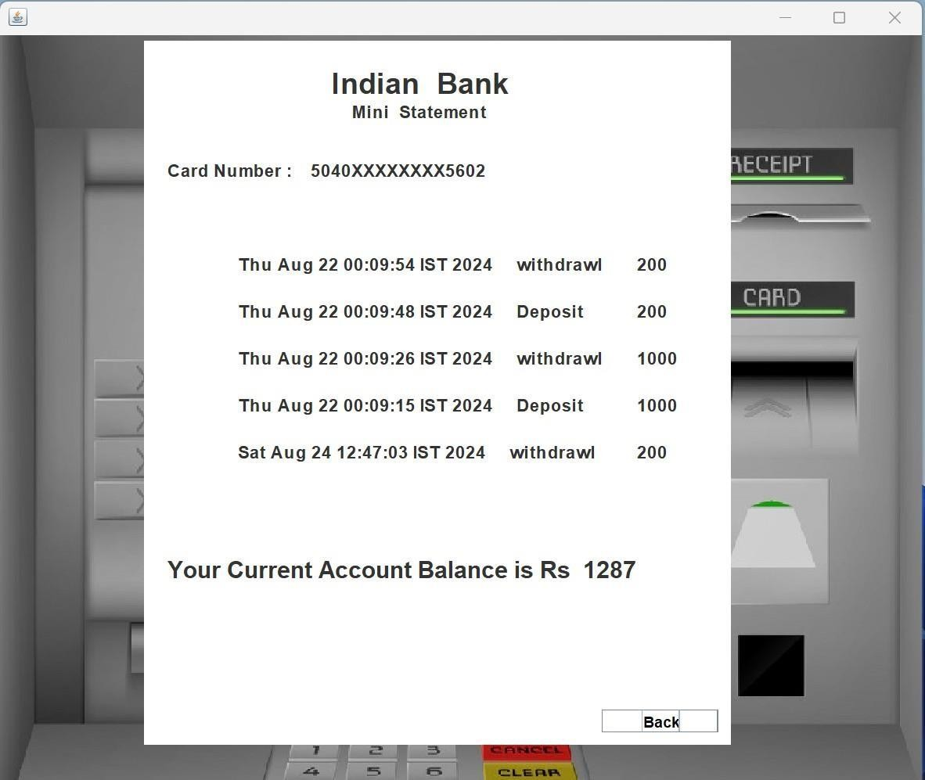

### Fig. 7 Mini Statement Page

* 1. **Introduction**

**Chapter 7 Training Outcome**

This chapter delves into a detailed exploration of the training outcome attained during the enriching industrial training period at Azure Skynet Solutions Private Limited. The training's primary objective was to cultivate an enhanced mastery of Core Java, fostering the practical application of this versatile programming language within real-world contexts. Beyond the technical competencies acquired, the training experience also acted as a catalyst for substantial personal and professional development.

* 1. **Overview of the Industrial Training**

The industrial training at Azure Skynet Solutions Private Limited was meticulously tailored to center around Core Java, a bedrock programming language pivotal to the software development landscape. This comprehensive training curriculum encompassed an array of modules, encompassing an in-depth exploration of Java fundamentals, immersive GUI (Graphical User Interface) development using Java Swing, adept utilization of development tools such as NetBeans, and a foundational introduction to the world of version control facilitated by Git and GitHub. This holistic approach to training ensured a well-rounded exposure to Java and its multifaceted applications.

* 1. **Skills Acquired during Training**

Throughout the training period, several valuable skills were acquired:

* + - **Java Programming:** A thorough understanding of Java's syntax, data structures, and object-oriented concepts was developed.
    - **Graphical User Interface (GUI) Development:** Proficiency in creating interactive GUI applications using Java Swing was achieved.
    - **Version Control:** Practical experience in using Git and GitHub for collaborative software development and version management.
    - **IDE Usage:** Familiarity with using NetBeans and Visual Studio Code for efficient coding, debugging, and project management.
    - **Problem-Solving:** Enhanced problem-solving skills through hands-on programming exercises and projects.
    - **Team Collaboration:** Exposure to collaborative coding through Git and GitHub, emphasizing teamwork and version control.
  1. **Practical Application of Skills**

The proficiencies gained during the training phase metamorphosed into practical prowess, ingeniously harnessed across a spectrum of projects and real-world scenarios. Armed with hands- on experience, the capacity to forge functional, user-centric applications using Java Swing was harnessed to great effect. From user interaction paradigms to intricate data manipulation operations, practical assignments and projects evolved as the conduits for the application of acquired skills, ultimately solidifying the theoretical bedrock of the training.

* 1. **Enhanced Understanding of Core Java**

The training voyage significantly elevated the level of comprehension pertaining to Core Java's intricate landscape. From fundamental programming constructs to the holistic embrace of object- oriented programming paradigms, and the deft manipulation of data structures, the training provided a panoramic understanding of the language's foundations. Furthermore, the curated exposure to a diverse spectrum of Java libraries and APIs broadened the horizon of Java's versatile capabilities.

* 1. **Exposure to Industry Standards & Best Practices**

A pivotal facet of the training at Azure Skynet Solutions was the resolute adherence to industry standards and best practices within the realm of coding and application development. This institutionalization of best practices catalyzed the development of a coding ethos characterized by cleanliness, modularity, and maintainability. The mastery of structuring code congruent with industry standards emerged as a pivotal cornerstone, immeasurably augmenting the caliber of programming skills on offer.

* 1. **Improvement in Problem-Solving Abilities**

Central to the training trajectory were myriad programming conundrums and exercises necessitating an amalgamation of analytical finesse and imaginative problem-solving dexterity. These intellectual crucibles functioned as crucibles for honing the art of dissecting intricate challenges, demystifying them into more manageable components, and architecting efficacious solutions that bore testament to the burgeoning problem-solving acumen.

* 1. **Effective Team Collaboration & Communication**

The orchestration of collaborative brilliance found its expression through the realm of version control systems, prominently exemplified by Git and GitHub. This symphony of collaborative coding fostered an intuitive understanding of code repository management, the dynamics of harmonious teamwork, and the art of harmonizing potentially discordant merge conflicts. An unequivocal takeaway was the profound realization of the centrality of effective communication and teamwork within the tapestry of software development projects.

* 1. **Introduction to Real-World Software Development**

The synthesis of hands-on projects and assignments unfurled an introductory vista into the intricate tapestry of the software development life cycle. From the meticulous analysis of requirements to the meticulous design of user interfaces, the embodiment of functionality, the rigors of testing, and the finesse of debugging, the training journey provided an invaluable backstage pass to the art of translating abstract concepts into tangible, functional applications.

* 1. **Project Management & Time Management Skills**

Juggling the concurrent stewardship of multiple assignments and projects within the confines of finite temporal parameters emerged as a crucible for the development of robust project management and time allocation skills. The training's crucible underscored the pivotal import of strategic planning, the delineation of milestones, and the punctual negotiation of deadlines as indispensable pillars underpinning the triumphant fruition of any project endeavor.

**CHAPTER 8 CONCLUSION**

In summary, my internship at Xxxxx Technologies Pvt Ltd has been an invaluable experience, particularly in the context of working with the Java Windows Development. The hands-on exposure to these technologies has significantly enhanced my understanding of full- stack development and provided practical insights into how modern dynamic web applications are designed, developed, and deployed.

Throughout the internship, I had the opportunity to contribute to various projects, applying java core principles to solve real-world problems. This practical experience allowed me to refine my skills in building scalable and efficient dynamic web applications, from setting up server-side logic with Node.js and Express.js to creating dynamic, user-friendly interfaces with Java.

Working at Xxxxx Technologies Pvt Ltd also provided me with a deeper understanding of industry best practices, including version control with Git, agile development methodologies, and the importance of code quality and maintainability. The collaborative environment fostered by the team enabled me to learn from experienced professionals and actively participate in meaningful discussions about project architecture and implementation strategies.

Overall, the internship has not only solidified my technical skills but also enhanced my problem-solving abilities and project management capabilities. I am confident that the knowledge and experience gained during this period will serve as a strong foundation for my future career in software development. I am grateful for the support and mentorship provided by the team at Xxxxx Technologies and look forward to applying these insights in my future endeavours.

In conclusion, my internship at Xxxxx Technologies Pvt Ltd has been a defining period in my journey as a software developer. The hands-on experience with the Java Windows Development, combined with exposure to industry practices and collaborative teamwork, has significantly contributed to my professional development.

The projects I worked on and the challenges I encountered have equipped me with practical skills and a deeper understanding of web development. The insights gained into agile methodologies, coding standards, and project management will undoubtedly benefit me in my future endeavors.

I am grateful for the opportunity to work with a talented and supportive team at Xxxxx

Technologies. This internship has not only strengthened my technical abilities but also fostered a passion for continuous learning and innovation in the ever-evolving field of technology. As I move forward in my career, the knowledge and experiences gained during this period will serve as a solid foundation for future growth and success in the realm of software development.

**References**

* [**https://xxxxx.com/**](https://rannlab.com/)
* [**https://xxxxx.com/services/**](https://rannlab.com/services/)
* [**https://xxxxx.com/about-us/**](https://rannlab.com/about-us/)