INFOSYS SPRINGBOARD VIRTUAL INTERNSHIP 6.0

FOOD TRENDS
UNDERSTANDING CUSTOMER PREFERENCES

Group-1, Batch - 11, TEAM – A
Mentor: Ms. Nityasree

TEAM MEMBERS:
Jai Akash L J
Abhinit Kumar
Lekhana S.R
Harshini Ganesan

1. Project Title
Food Trends – Understanding Customer Preferences

2. Project Objective
The main objective of this project is to analyze customer food ordering behavior and preferences using data visualization techniques.
This project aims to understand how customer demographics, food choices, ordering platforms, service quality, and external factors influence food ordering decisions. By using interactive Power BI dashboards, the project helps derive meaningful insights that can support restaurants and food delivery platforms in improving customer satisfaction and business performance.

3. Project Description
3.1 Overview
The Food Trends – Understanding Customer Preferences project focuses on analyzing food ordering data collected through a structured dataset. The dataset contains customer details, restaurant information, order behavior, service experience, and external influencing factors.
Using Power BI, multiple dashboards were created to visually represent patterns and trends in customer behavior. These dashboards help in understanding what customers prefer, when they order food, which platforms they use, and what factors influence their decisions.

3.2 Project Approach
The project followed a systematic and milestone-based approach:
- Understanding the dataset structure and attributes
- Cleaning and preprocessing raw data
- Categorizing data into logical domains
- Creating DAX measures for KPIs
- Designing interactive dashboards in Power BI
- Analyzing insights from each dashboard
This structured approach ensured accuracy, clarity, and meaningful business insights.

3.3 Technology Used
- Power BI Desktop – Data modeling, visualization, dashboard creation
- Power Query – Data cleaning and transformation
- DAX (Data Analysis Expressions) – Calculated measures and KPIs
- Excel / CSV – Dataset storage and handling

3.4 Insights from the Dashboard
Key insights derived from the dashboards include:
- Young customers and students form the largest customer segment
- Taste, food quality, and freshness strongly influence customer satisfaction
- Vegetarian food is preferred by a majority of customers
- Direct call ordering is still widely used along with online platforms
- Ratings, discounts, and accurate location details influence customer decisions
- Lunch and snack times are peak ordering periods
These insights help businesses improve menu planning, service quality, and promotional strategies.

3.5 Real-World Impact for Media and Public Communication
This project demonstrates how data visualization can be used to communicate complex customer behavior in a simple and effective way.
Media and businesses can use such dashboards to:
- Understand changing food trends
- Communicate customer preferences visually
- Support data-driven storytelling
- Improve transparency and decision-making

4. Timeline Overview
The project was completed in multiple weeks, progressing from data understanding and preprocessing to final dashboard analysis and reporting. Each week aligned with internship milestones to ensure timely completion and quality outcomes.
Week | Activity
Week 1 | Dataset collection, data understanding, and initial exploration
Week 2 | Data cleaning, preprocessing, handling missing values, and data type validation
Week 3 | Customer profile analysis and demographic-based dashboard development
Week 4 | Food preference analysis and ordering pattern dashboards
Week 5 | Analysis of ordering platforms, wait times, and peak ordering hours
Week 6 | Service quality analysis including delivery tracking, food freshness, and payment ease
Week 7 | Restaurant performance, promotions analysis, and external impact evaluation
Week 8 | Final dashboard validation, documentation, reporting, and project review

5a. Key Milestones
Milestone | Activity Achieved | Date
Milestone 1 | Data understanding and preprocessing | 9 January 2026
Milestone 2 | Development of first three dashboards (Customer Profile, Food Preference, Ordering Patterns) | 23 January 2026
Milestone 3 | Development of dashboards focused on service quality and customer decision factors | 30 January 2026
Milestone 4 | Final dashboards on restaurant performance, promotions analysis, final review and reporting | 6 February 2026

5b. Project Execution Details
- Dataset cleaning and transformation using Power Query
- KPI creation using DAX
- Dashboard design with consistent layout and theme
- Validation of insights across dashboards
- Cross-verification of data consistency between visuals and underlying dataset
- Version control and repository management using GitHub and GitLab for organized team collaboration
- Documentation and reporting

6. Snapshots / Screenshots
6.1 Page 1: Customer Profile Intelligence
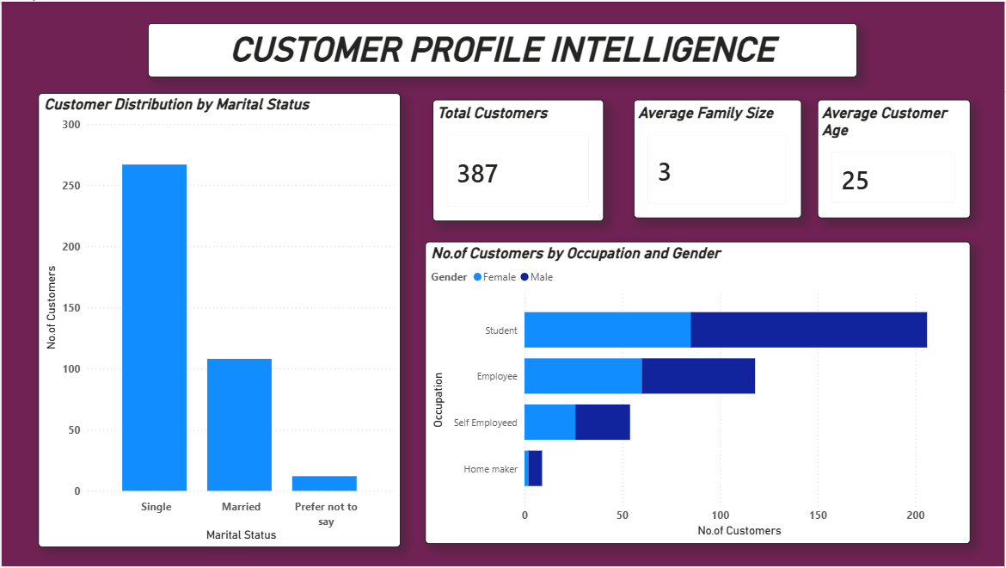
Screenshot showing customer demographics, age, family size, and occupation.
6.2 Page 2: Order & Food Preference Analysis
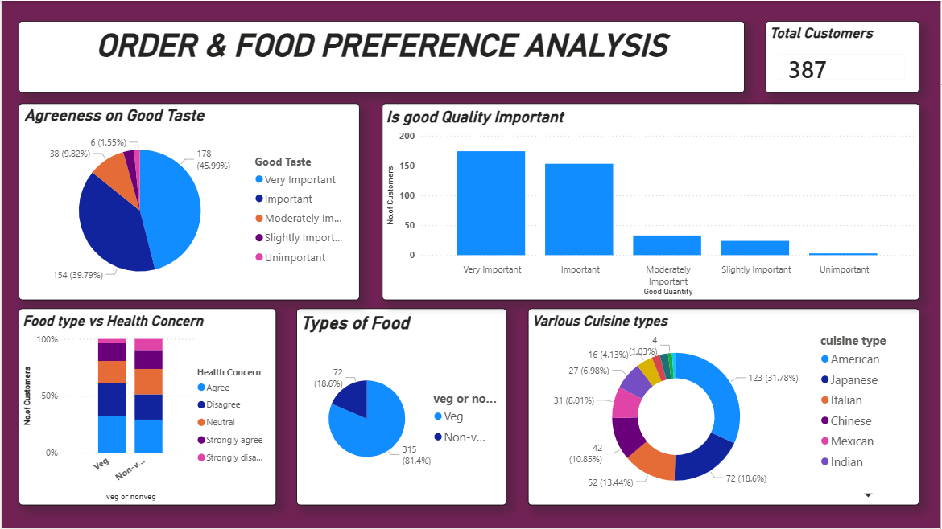Screenshot showing food type, cuisine preference, taste, and quality analysis.
6.3 Page 3: Ordering Patterns & Platform Behaviour
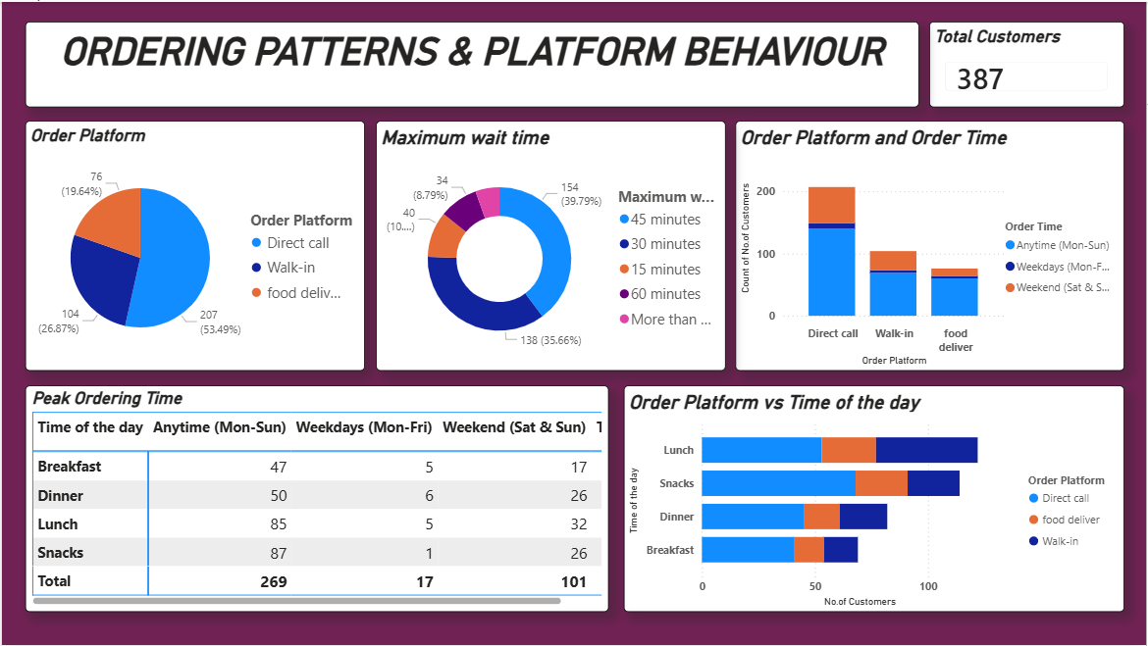
Screenshot showing order platforms, waiting time, and peak ordering periods.

6.4 Page 4: Delivery Experience & Service Quality
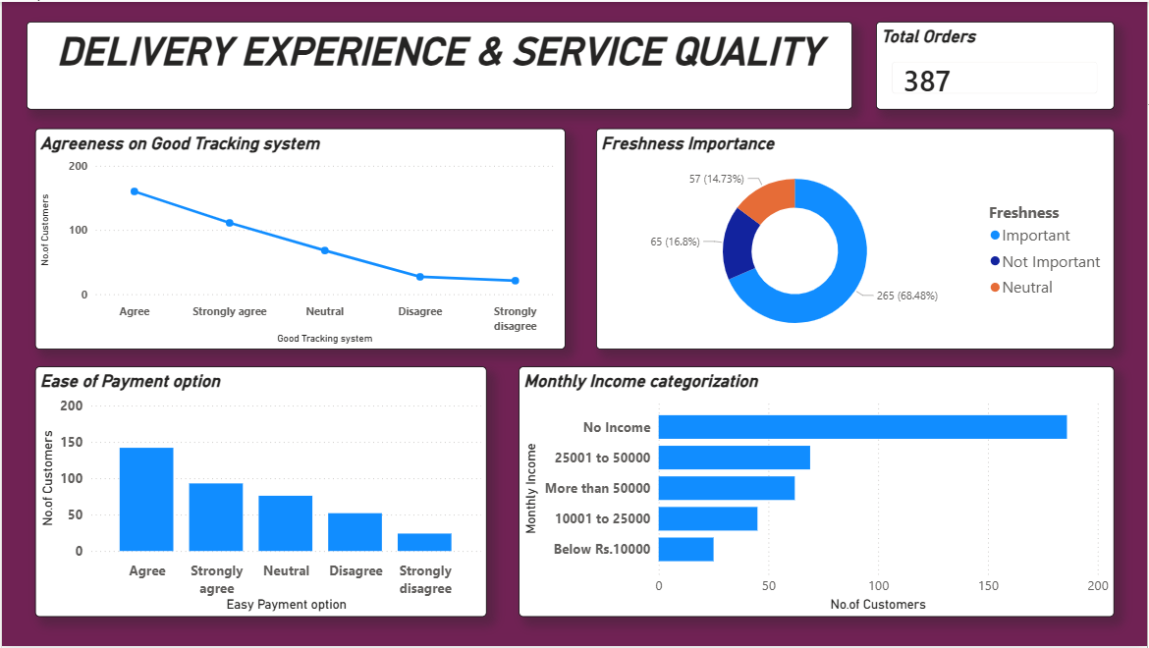
Screenshot showing tracking system, freshness, payment ease, and income categories.
6.5 Page 5: Customer Decision & Influence Factors
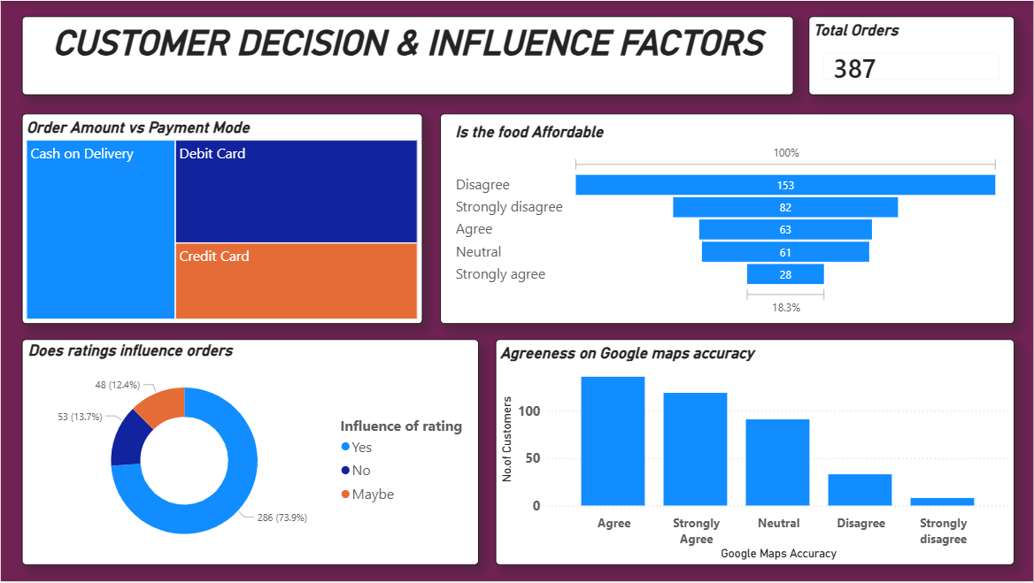
Screenshot showing affordability, ratings influence, payment mode, and Google Maps accuracy.
6.6 Page 6: Restaurant & Cuisine Performance Insights
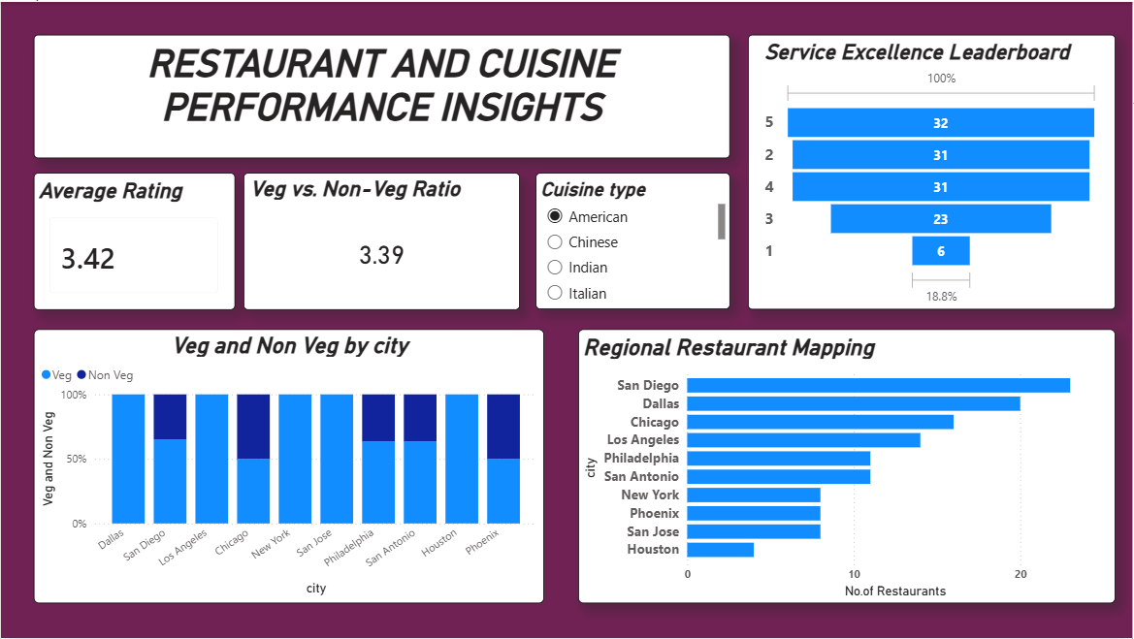
Screenshot showing ratings, veg/non-veg ratio, city-wise analysis, and leaderboard.
6.7 Page 7: Promotion, Time & External Impact Analysis
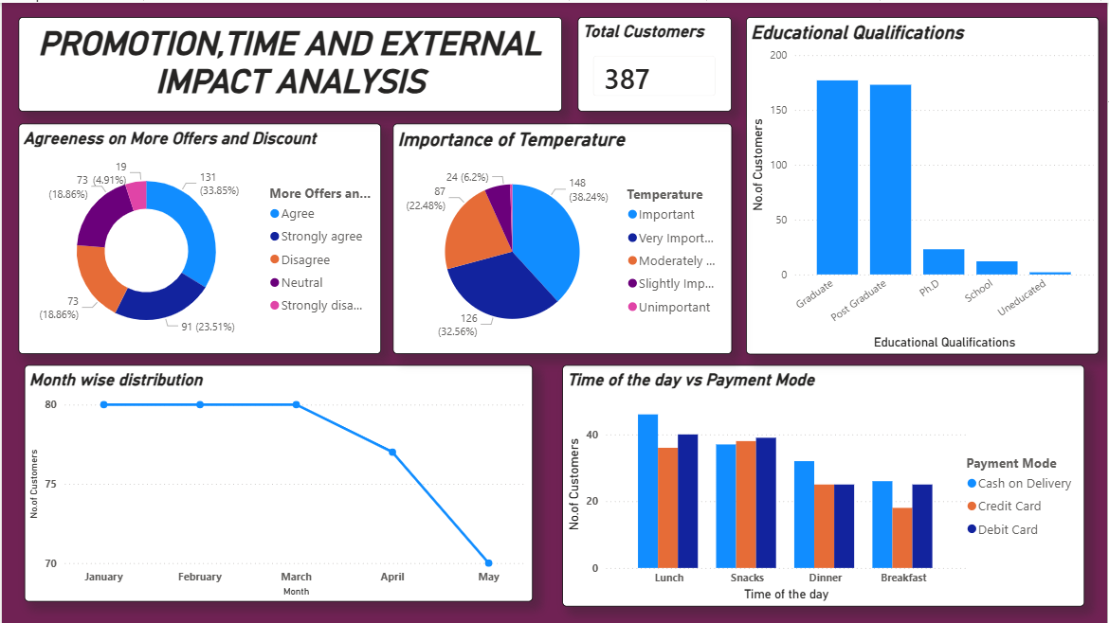
Screenshot showing offers, temperature impact, education level, and payment timing.

7. Challenges Faced
7.1 Data Cleaning Challenges
- Inconsistent category labels (Veg/Non-Veg, rating levels)
- Power BI Service does not support true parallel dashboard editing, making team collaboration difficult
- Each update required publishing and pulling the latest version from the cloud
- Missing or unclear survey responses
Resolution:
- Adopted a sequential editing workflow for Power BI dashboards.
- Assigned clear responsibility for report updates to avoid conflicts.
- Standardized values using Power Query and handled missing data carefully.

7.2 Visualization Challenges
- Managing multiple dashboards with consistent KPIs
- Avoiding overcrowded visuals
Resolution:
Used slicers, clean layouts, and milestone-wise dashboard creation.

8. Learnings & Skills Acquired
8.1 Technical Skills
- Data cleaning and preprocessing
- Power BI data modeling
- DAX calculations
- Dashboard design

8.2 Analytical and Problem-Solving Skills
- Identifying trends and patterns
- Converting raw data into insights
- Business-oriented data interpretation

8.3 Soft Skills and Team Collaboration
- Team coordination and communication
- Time management
- Presentation and documentation skills

8.4 Domain Knowledge and Application
- Understanding food industry trends
- Customer behavior analysis
- Service quality and decision factors
- Understanding F&B marketing using the 4 Ps framework
  - Product: Veg and Non-Veg food preferences
  - Price: Affordability and spending behavior
  - Place: Online food ordering platforms
  - Promotion: Impact of ratings and reviews

9. Testimonials from Team
Jai Akash L J
- Collected the dataset and performed data preprocessing.
- Worked on Page 1 and Page 4 of the dashboard.
- Conducted overall dashboard validation and ensured data consistency.
- Took leadership in managing the team by effectively separating tasks and assigning roles.
- Reviewed and checked the overall integrity and accuracy of each dashboard.
- Handled both GitHub and GitLab repositories for the team, managing the upload and organization of the Power BI dashboard files, individual PPTs, and overall group documentation.

Harshini Ganesan
- Contributed to data preprocessing activities.
- Worked on Page 2 and Page 7 of the dashboard.
- Assisted in validating cleaned data before dashboard development.
- Helped in ensuring consistency between visuals and underlying data.

Lekhana S.R
- Worked on Page 3 and Page 5 of the dashboard.
- Contributed to the preparation of the team PPT.
- Performed multiple design iterations and trial-and-error approaches to identify the most suitable and effective dashboard layout.
- Assisted in formatting and structuring presentation slides for clarity.

Abhinit Kumar
- Worked on Page 6 of the dashboard.
- Handled team documentation for each milestone.
- Provided suggestions for dashboard development and contributed ideas for improving the overall dashboard layout and structure.
- Contributed to verifying alignment between documentation and dashboard outputs.

10. Conclusion
This project successfully analyzed customer ordering behaviour and food preferences in the Food & Beverage (F&B) domain using Power BI dashboards. Through systematic data preprocessing, validation, and visualization, raw data was transformed into meaningful and actionable insights. Key patterns related to peak ordering hours, customer preferences, affordability, delivery experience, and service quality were clearly identified. The dashboards provided a structured and data-driven understanding of customer decision-making factors and restaurant performance.
The project was completed through coordinated team efforts and structured task management. Responsibilities were clearly assigned, and a sequential editing workflow was followed to manage dashboard updates effectively in Power BI Service. Challenges such as data preprocessing errors were resolved collaboratively through validation and recovery steps. This experience not only strengthened technical skills in analytics and visualization but also improved team coordination, responsibility sharing, problem-solving, and project management practices in a real-world setting.

11. Acknowledgements
We would like to express our heartfelt gratitude to:
- Infosys Springboard Team – for organizing this valuable internship opportunity and providing a structured learning platform.
- Our Mentor (Ms. Nityasree) – for continuous guidance, support, constructive feedback, and encouragement throughout the project.
- My Teammates – for their collaboration, teamwork, shared responsibility, and valuable insights that strengthened the overall outcome of the project.
We also extend our appreciation to:
- The creators and maintainers of Microsoft Power BI Documentation and community resources, which supported our technical learning and implementation.
- Kaggle, for providing access to publicly available datasets that enabled practical, real-world data analysis experience.
- The learning resources and structured modules provided through the internship, which enhanced our understanding of data analytics concepts and visualization techniques.
This internship has been a significant step in our professional growth and technical journey. It has strengthened our analytical thinking, technical proficiency, teamwork, and problem-solving abilities while providing valuable exposure to real-world data-driven decision-making.

