Lab 01 — The price of one request

1. Token Ratio: Predictions vs. Measured Values
Token count evaluation for the complaint text (COMPLAINT) and system prompt based on byte predictions and measured values:
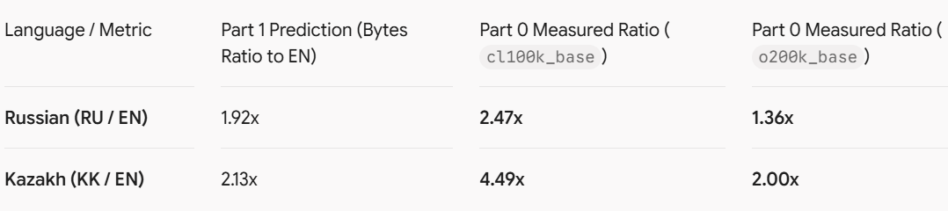
Conclusion: Byte ratios (approx. 2.0x for Cyrillic) undercount token usage on legacy tokenizers (cl100k_base), where Kazakh requires 4.49x more tokens than English. Modern tokenizers (o200k_base) compress Kazakh much more efficiently (down to 2.00x relative to EN).

2. Annual Cost Table (Volume: 5,000 requests/day)
Annual cost estimate for running a first-line support queue (in USD per year at 5,000 requests/day):
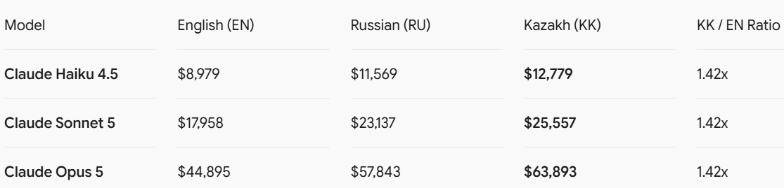
Volume Justification:
A daily volume of 5,000 requests reflects a realistic daily ticket load for a medium-sized bank or telecom support line in Kazakhstan during peak operational hours.

3. Production Model Recommendation for Kazakh Support Queue
Recommended Model: Claude Haiku 4.5
- Cost Argument: Deploying Haiku 4.5 for Kazakh costs $12,779/year compared to $63,893/year on Opus 5 (over 80% cost reduction), making automated customer support economically viable.
- Quality Argument: For standard customer support workflows (answering FAQs from documentation), Haiku 4.5 provides high instruction-following precision and low latency, making the modest price increment between EN and KK ($12,779 vs $8,979) easily manageable.

4. Cost Lever Not Used in This Lab
Unused Cost Optimization Lever:
Applying Prompt Caching, which reduces the cost of repeated incoming tokens (such as the system prompt) by up to 90% for all subsequent requests in the queue.

