1. a) What are the main phases in the database design? What is done on each development phase?

Initial phase -- characterize fully the data needs of the prospective database users.

▪Second phase -- choosing a data model •Applying the concepts of the chosen data model •Translating these requirements into a conceptual schema of the database. •A fully developed conceptual schema indicates the functional requirements of the enterprise. ▪Describe the kinds of operations (or transactions) that will be performed on the data. Final Phase -- Moving from an abstract data model to the implementation of the database

•Logical Design –Deciding on the database schema. ▪Database design requires that we find a “good” collection of relation schemas.

▪Business decision –What attributes should we record in the database?

▪Computer Science decision –What relation schemas should we have and how should the attributes be distributed among the various relation schemas?

•Physical Design –Deciding on the physical layout of the database

b) What is the entity-relationship (ER) data model?

Entity Relationship Model (covered in this chapter) •Models an enterprise as a collection of entities and relationships

▪Entity: a “thing” or “object” in the enterprise that is distinguishable from other objects

•Described by a set of attributes▪Relationship: an association among several entities

•Represented diagrammatically by an entity-relationship diagram:

•Formalize what designs are bad, and test for them

**2.**

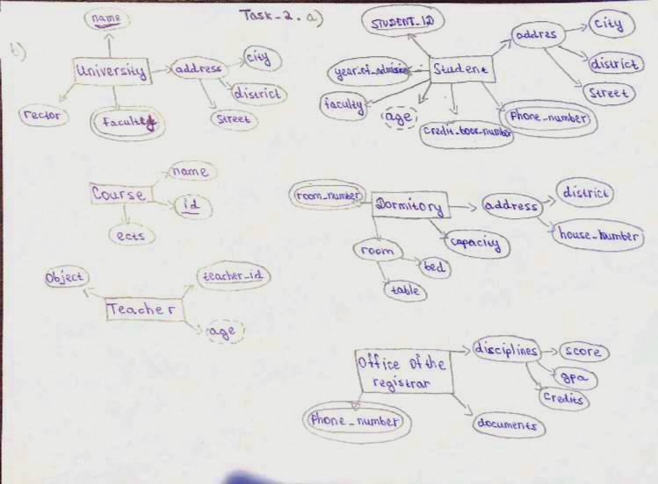

**3.**

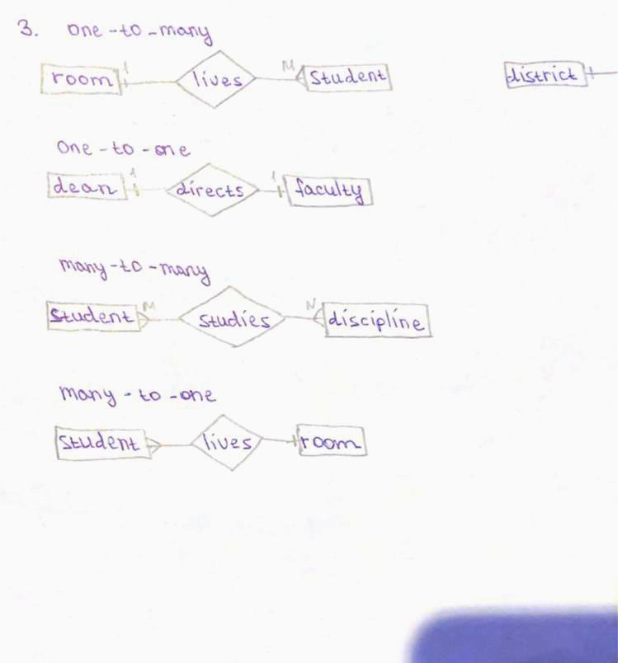

**4.**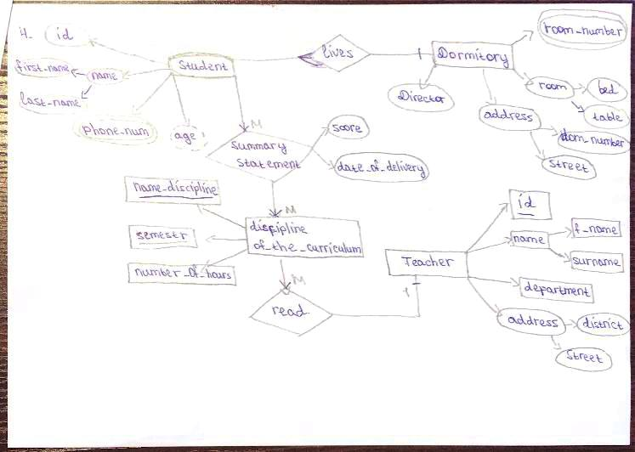

**5.**