MyLibrary

User Manual

|  |  |  |
| --- | --- | --- |
| **Rev. No.** | **Date** | **Description** |
| 00 | 8/9/2022 | First version. Corresponds to MyLibrary v1.3.0. |

Table of Contents

1 Introduction 4

1.1 Database 4

1.2 Fields 4

2 Installation and Requirements 6

3 User Interface 6

3.1 Main window 6

3.2 Menus 7

3.2.1 File 7

3.2.2 View 7

3.2.3 Help 8

3.3 Toolbar 9

3.4 Filter 9

3.5 Selected Item Details 9

4 Tag Management 10

4.1.1 Creating a new tag 10

4.1.2 Deleting a tag 11

4.2 Managing tags for a specific item 11

5 Adding a new book 12

5.1 Manually adding a new book 12

5.2 Searching online by ISBN 13

6 Adding a new media item 13

7 Wishlist 14

7.1.1 Adding a new item 15

7.1.2 Updating an item 16

7.1.3 Deleting an item 16

7.1.4 Adding a wishlist item to library 16

8 Item copy management 17

8.1.1 Adding a new copy 17

8.1.2 Updating a copy 18

8.1.3 Deleting a copy 18

9 CSV imports 18

10 Excel imports and exports 20

10.1 Exporting worksheets 21

10.2 Importing worksheets 22

10.2.1 Media items 22

10.2.2 Books 23

11 Known issues 23

11.1 Storing large images in database 23

11.1.1 Issue 23

11.1.2 Workaround 23

12 Changelog 23

12.1 v1.4.0 – unreleased 24

12.1.1 Fixed 24

12.1.2 Added 24

12.1.3 Changed 24

12.2 v1.3.0 – 8-9-2022 24

12.2.1 Fixed 24

12.2.2 Added 24

12.2.3 Changed 24

12.3 v1.2.1 – 30-6-2022 24

12.3.1 Fixed 24

12.4 v1.2.0 – 2-4-2022 24

12.4.1 Remarks 24

12.4.2 Fixed 24

12.4.3 Added 25

12.4.4 Changed 25

12.5 v1.1.1 – 1-3-2022 25

12.5.1 Fixed 25

12.5.2 Added 25

12.6 v1.1.0 – 24-2-2022 25

12.6.1 Added 25

12.7 v1.0.1 – 30-1-2022 25

12.7.1 Fixed 25

12.7.2 Changed 25

12.7.3 Removed 25

12.8 v1.0.0 – 23-1-2022 25

12.8.1 Added 25

12.8.2 Fixed 25

12.9 v0.9.0 – 8-1-2022 25

12.9.1 Fixed 25

12.9.2 Changed 25

12.10 v0.8.0 – 31-12-2021 26

12.10.1 Added 26

# Introduction

MyLibrary is an application to keep track of books and media items (“library items”). It is a database-driven Windows desktop application.

It provides a means of keeping a list of books and media items and categorising them with tags, searching and filtering, updating, and deleting. It supports adding images for each item. Multiple copies can be stored per item. A “wishlist” feature is provided. Data can be exported, updated, and imported in CSV and Microsoft Excel format.

The following item types are supported:

* Book
* CD
* DVD
* BluRay
* Flash Drive
* Floppy Disk
* Other

## Database

Data is stored in an Sqlite database file. Schema changes may result in incompatibility between databases from different application versions.

v1.3.0 introduces support for Flash drive and Floppy disk media item types. This is not backwards compatible with previous versions. Data from previous versions may be imported using the CSV and Excel import features (images are not supported, future versions may support importing images).

It is recommended to make regular backup copies of the database file.

## Fields

Each entry in the database consists of specific fields. Some fields are mandatory. Some fields are updatable. A summary is provided below. Note that all records also have an “Id” field, which is omitted in these tables.

Authors

Table : Authors data dictionary

|  |  |  |  |
| --- | --- | --- | --- |
| **Field** | **Comments** | **Mandatory** | **Example** |
| First Name | Text. First and last name combination must be unique. | Yes | John |
| Last Name | Text. First and last name combination must be unique. | Yes | Smith |

Publishers

Table : Publishers data dictionary

|  |  |  |  |
| --- | --- | --- | --- |
| **Field** | **Comments** | **Mandatory** | **Example** |
| Name | Text. Must be unique. | Yes | AC Publishing |

Tags

Table : Tags data dictionary

|  |  |  |  |
| --- | --- | --- | --- |
| **Field** | **Comments** | **Mandatory** | **Example** |
| Name | Text. Must be unique. | Yes | History |

Media items

Table : Media items data dictionary

|  |  |  |  |
| --- | --- | --- | --- |
| **Field** | **Comments** | **Mandatory** | **Example** |
| Title | Text. Must be unique. | Yes | Funny movie |
| Type | Cd, Dvd, BluRay, Vhs, Vinyl, Flash Drive, Floppy Disk, Other | Yes | Dvd |
| Number | Integer. Usually a barcode found on the item. | No | 0123456789 |
| Image | Image | No | N/A |
| Running Time | Integer. Expressed in minutes. | Yes | 80 |
| Release Year | Integer | No | 2022 |
| Notes | Text. | No |  |

Books

Table : Books data dictionary

|  |  |  |  |
| --- | --- | --- | --- |
| **Field** | **Comments** | **Mandatory** | **Example** |
| Title | Text. Must be unique. | Yes | Fun with coding |
| Long Title | Text. | No | Fun with coding: coding is fun |
| ISBN | Text. Must consist of 10 digits or X’s. Must be unique if not empty. | No | 012345678X |
| ISBN13 | Text. Must consist of 13 digits or X’s. Must be unique if not empty. | No | 0123456789012 |
| Dewey Decimal | Decimal. | No | 200.5 |
| Publisher |  | Yes | AC Publishing |
| Format | Text. | No | Hardcover |
| Language | Text. | Yes | English |
| Date Published | Text. | No | 2022 |
| Place of Publication | Text. | No | AU |
| Edition | Text. | No | 1st Edition |
| Pages | Integer. | Yes | 100 |
| Dimensions | Text. | No |  |
| Overview | Text. | No |  |
| Image | Image | No | N/A |
| MSRP | Text. | No | $30 |
| Excerpt | Text. | No |  |
| Synopsys | Text. | No |  |
| Notes | Text. | No |  |

Wishlist

Table : Wishlist data dictionary

| **Field** | **Comments** | **Mandatory** | **Example** |
| --- | --- | --- | --- |
| Title | Text. | Yes | Fun with coding |
| Type | Book, Cd, Dvd, BluRay, Vhs, Vinyl, Flash Drive, Floppy Disk, Other | Yes | Book |
| Notes | Text. | No |  |

# Installation and Requirements

MyLibrary is a portable application, so no installation is required. It is available as a Git repository. To run the application, the source code must be compiled using Microsoft Visual Studio IDE.

1. Clone the repository: git clone https://github.com/Alc2110/MyLibrary.git
2. Compile using Microsoft Visual Studio IDE.
3. Set the dbPath parameter in app.config to the path of the database file database.db.
4. To run the application, execute MyLibrary.exe.

A Windows operating system is required, with .NET Framework 4.7.2 or higher.

For compiling and development purposes, Microsoft Visual Studio IDE is required.

# User Interface

The application’s user interface is simple and intuitive, consisting of a main window displaying a list of items, and subwindows and dialogs designed to perform certain tasks. For a screenshot of the main window, see Figure 2.

On start up, by default, a tip of the day dialog is shown, displaying various tips about using the software:

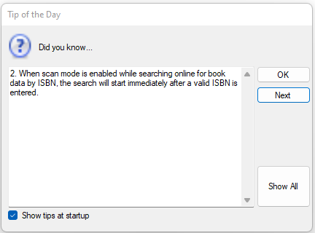

Figure : Tip of the day dialog

## Main window

The main window displays a list of items based on type, with optional further filtering based on certain criteria.

The details of the currently selected item are displayed on the lower left part of the window. Tags, image, and notes for the item can be modified in this section.

Filtering of items of the selected type is allowed, by title and tag.

The status bar at the bottom of the main window shows the status of the application, the number of items selected, the number of items displayed, and the number of items in the selected category.

Figure : Main window

## Menus

### File

* New Book – opens “Add New Book” window. Refer to section 5.
* New Media Item – opens “Add New Media Item” window. If the selected category in the main window is “Book” or “Media Items (all types)”, the selected type in the dialog will be “Cd” by default. In other cases, the selected type in the dialog will match the selected category. Refer to section 6.
* Import -> CSV -> Tags – opens “Import tags” dialog. Refer to section 9.
* Import -> CSV -> Authors – opens “Import authors” dialog. Refer to section 9.
* Import -> CSV -> Publishers – opens “Import publishers” dialog. Refer to section 9.
* Import -> XLSX – opens “Import Excel” dialog. Refer to section 10.2.
* Export -> Tags – opens “Export Tags” dialog. Refer to section 10.1.
* Export -> Publishers – opens “Export Publishers” dialog. Refer to section 10.1
* Export -> Authors – opens “Export Authors” dialog. Refer to section 10.1
* Export -> Books – opens “Export Books” dialog. Refer to section 10.1
* Export -> Media items – opens “Export Media items” dialog.
* Export -> Wishlist – opens “Export Wishlist items” dialog. Refer to section 7.
* Exit – closes the application.

### View

* Database statistics – opens a dialog showing a summary of the number of books, publishers, authors, media items, and tags records in the database:

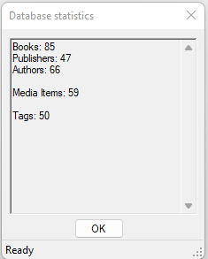

Figure : Database statistics dialog

* Books – selects the “Book” category in the main window.
* Media Items (All categories) – selects all media item types in the main window.
* Cds – selects Cd types in the main window.
* Dvds – selects Dvd types in the main window.
* BluRays – selects BluRay types in the main window.
* Vhss – selects Vhs types in the main window.
* Vinyls – selects Vinyl types in the main window.
* Flash drives – selects Flash drive types in the main window.
* Floppy disks – selects Floppy disk types in the main window.
* Other – selects other media item types in the main window.

### Help

* About – opens a dialog which shows various information about the software:

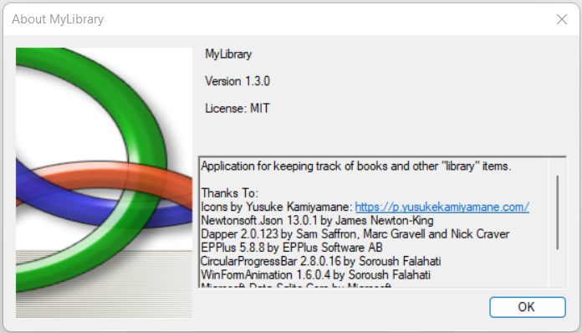

Figure : About box

* Manual – opens the user manual in the default PDF viewer application.

## Toolbar



Figure : Toolbar

1. Add New Item button – opens “Add New Book” or “Add New Media Item” window, depending on the category selection (see item 6).
2. Search Books Online by ISBN button – opens dialog for searching for books online by ISBN.
3. Delete Selected Item button – deletes currently-selected item in the list in the main window (confirmation dialog is shown).
4. Tags button – opens the “Manage Tags” dialog.
5. Wishlist button – opens the “Wishlist” window.
6. Category selector – allows selecting the type of item displayed in the list. The following selections are available:
7. Book
8. Media Items (all types)
9. Cd
10. Dvd
11. BluRay
12. Vhs
13. Vinyl
14. Flash Drive
15. Floppy Disk
16. Other

## Filter

This section allows filtering the items in the list by title and tags.

There is a time delay of 2 s until the filtering is performed, unless the “Apply” button is clicked, in which case the filtering is performed immediately.

To apply the filter immediately, click the “Apply” button.

To clear the filter, click the “Clear” button.

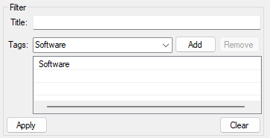

Figure : Main window filter

## Selected Item Details

This section shows the details (properties) of the currently selected item in the list, and allows updating the notes and image for the item.

Clicking on the item’s image will display a dialog allowing a more detailed view of the image, and the option to save the image to disk.

The “Manage Tags” button opens the “Manage Tags for Item” dialog.

The “Manage Copies” button opens the “Manage Copies for Item” window.

The “Save Changes” button updates the database with any changes to the notes or image for the selected item.

# Tag Management

Each item in the database can be associated with zero or more tags. A tag can be associated with any number of items.

The tags that an item is tagged with are displayed in the “Tags” column of the list in the main window.

The “Manage Tags” dialog allows you to create and delete tags. It displays a list of all tags in the database. To open the “Manage Tags” dialog, click the tag icon in the toolbar.

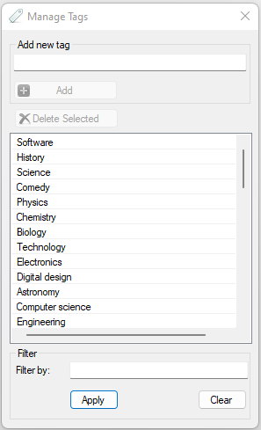

Figure : Manage Tags dialog

Tags can be filtered by name, in the “Filter” section. There is a time delay of 2 s until the filtering is performed, unless the “Apply” button is clicked, in which case the filter will be applied immediately. To clear the filter, click the “Clear” button.

### Creating a new tag

To add a new tag, type a name for the tag in the input field in the “Add new tag” section. NOTE: tags cannot contain commas.

Click the “Add” button to save the new tag. Once saved, the new tag will appear in the list.

### Deleting a tag

To delete a tag, select it in the list.

Click the “Delete Selected” button. Once the selected tag has been deleted, the list will be updated.

## Managing tags for a specific item

To attach or remove tags for a specific item, select it in the list on the main window, and click the “Manage Tags” button. This opens the “Manage Tags For Item” dialog.

NOTE: Removing a tag for a specific item does not delete the tag entirely, it only disassociates the tag from that item.

Tags can be filtered by name, in the “Filter” section. There is a time delay of 2 s until the filtering is performed, unless the “Apply” button is clicked, in which case the filter will be applied immediately. To clear the filter, click the “Clear” button.

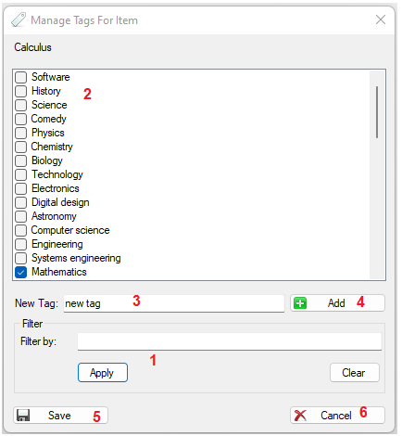

Figure : Manage Tags For Item dialog

1. Optionally, tags displayed in the list can be filtered by name.
2. The list contains tag names alongside checkboxes. Tags associated with the current item are checked, and the rest are unchecked. To associate or remove a tag from the current item, simply check or uncheck the appropriate checkbox.
3. Optionally, new tags can be added for this item. Type the name of the new tag in the input field. NOTE: tag names cannot contain commas.
4. If a new tag is to be added, click the “Add” button. The new tag will be added to the list and is checked by default. NOTE: the new tag will not be saved in the database unless the “Save” button is clicked.
5. Click the “Save” button to apply the changes.
6. To close the dialog, click the “Cancel” button.

# Adding a new book

## Manually adding a new book

A new book record can be added using the “Add New Book” window. To access this window, select the “Book” category in the main window then click the “+” button in the toolbar, or click the File -> New Book menu item.

Figure : Add New Book dialog

The following are mandatory fields for books:

* Title
* Pages
* Language
* Publisher

To add a new book:

1. Complete at least the mandatory fields. Authors, tags, and publishers are filterable fields. The filters will be applied after a 2 s delay, unless the “Apply” button is clicked, in which case the corresponding filter will be applied immediately. To clear a filter, click the corresponding “Clear” button.
2. Click the “Save” button to save the new book.
3. To close the dialog, click the “Cancel” button.

## Searching online by ISBN

Using this feature, book data can be found online by ISBN, and used to pre-fill the “Add New Book” form. To open the “Search By ISBN” dialog, click the “Search Books Online by ISBN” button (open book icon) in the toolbar.

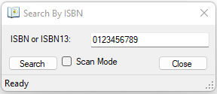

Figure : Search By ISBN dialog

To search for a book by ISBN, enter an ISBN10 or ISBN13 in the input field. Click the “Search” button to search. If “Scan Mode” is enabled, the search will start automatically as soon as a valid ISBN10 or ISBN13 is entered in the input field. “Scan Mode” is enabled by default.

If a book with the given ISBN is found, a “Add New Book” form is opened, and the data is pre-filled. If a book with the given ISBN is not found, a message box appears explaining this.

# Adding a new media item

A new media item record can be added using the “Add New Media Item” window. To access this window, select any of the media item types in the category selector on the main window and then click the “+” button in the toolbar, or click the File -> New Media Item menu item.

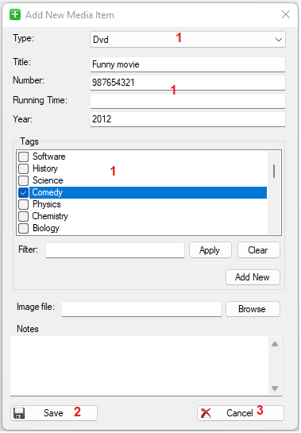

Figure : Add New Media Item window

The following are mandatory fields for media items:

* Type
* Title
* Number
* Year

To add a new media item:

1. Complete at least the mandatory fields. Tags are filterable fields. The filter will be applied after a 2 s delay, unless the “Apply” button is clicked, in which case the filter will be applied immediately. To clear the filter, click the corresponding “Clear” button.
2. Click the “Save” button to save the new media item.
3. To close the dialog, click the “Cancel” button.

# Wishlist

The application has a “whishlist” feature. To open the “Wishlist” dialog, click the “Wishlist” button (clipboard icon) on the toolbar.

Figure : Wishlist window

The wishlist consists of a simplified list of items. A single record contains the title, type, and notes. Wishlist items are selectable. The wishlist is separate from the main lists of items.

Wishlist items do not support tags.

Wishlist items do not support images.

### Adding a new item

Figure : New Item section of Wishlist dialog

1. Enter the item title in the “Title” input field.
2. Select an item category.
3. Optionally, enter some text in the “Notes” input field.
4. Click the “Save Changes” button. Once the wishlist item is saved, the wishlist will be updated.

### Updating an item

Figure : Updating wishlist item

1. The “Notes” field of the selected item can be updated.
2. If you want to reverse the changes made, click the “Discard Changes” button.
3. Click the “Save Changes” button. Once the wishlist item is saved, the wishlist will be updated.

### Deleting an item

Figure : Deleting wishlist item

1. The selected item can be deleted by clicking the “Delete” button. Once the item is deleted, the wishlist will be updated.

### Adding a wishlist item to library

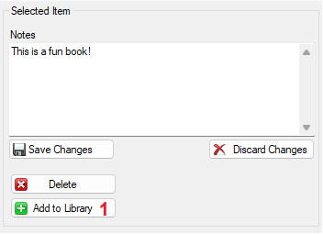

Figure : Add wishlist item to main list

Wishlist items can be added to the main list.

1. Simply click the “Add to Library” button after selecting the wishlist item. An “Add New Book” or “Add New Media Item” dialog will be shown, depending on the type of the selected item. The title and notes fields will be pre-filled. See sections 5 and 6.

# Item copy management

Multiple copies are supported for each item. This is optional, and an item record need not have copies associated with it.

To open the “Manage Copies For Item” window, click the “Manage Copies” button in the selected item details section in the main window.

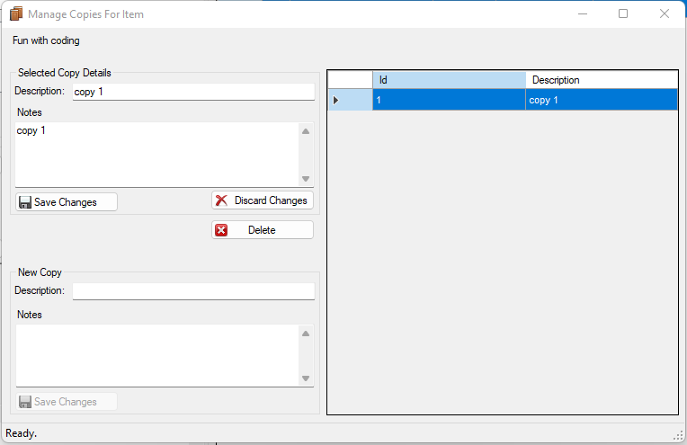

Figure : Manage Copies For Item window

### Adding a new copy

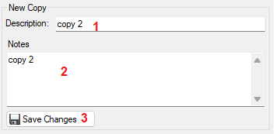

Figure : Creating a new item copy

1. Enter a description in the “Description” input field.
2. Optionally, enter some text in the “Notes” field.
3. Click the “Save Changes” button. Once the copy is saved, the copy list will be updated.

### Updating a copy

Figure : Updating item copy

1. Update the description field.
2. Update the notes field.
3. To clear the changes, click the “Discard Changes” button.
4. To save the changes, click the “Save Changes” button. Once updated, the copy list will be updated.

### Deleting a copy

Figure : Deleting item copy

1. To delete a copy, click the “Delete” button. After the copy has been deleted, the copy list will be updated. NOTE: deleting all copies for an item does not remove the item record itself.

# CSV imports

The application supports importing records of certain types from appropriately formatted CSV files. Importing tags, authors, and publishers is supported.

The relevant dialog for importing records of one of the above types can be accessed via the File -> Import -> CSV menu.

The CSV files used for imports must have a specific format for each type. In each of the following examples, the first row is the header (which must be exactly as shown). The remaining rows are data rows:

Figure : Tag CSV import

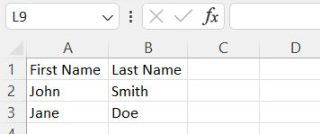

Figure : Author CSV import

Author names such as the following are supported:  
John,Smith

John H.,Smith

John,Smith-Jones

John H.,Smith-Jones

John,de Coder

John,d’Coder

Figure : Publisher CSV import

To import a CSV file containing records of one of the supported types (authors example shown in figure):

Figure : Import CSV dialog

1. Open the appropriate CSV import dialog. Click the “Open File” button and browse for the file to import. Once a file is selected, the import process will start. Pre-existing records will be skipped. Errors and warnings will be listed in the list box in the middle of the dialog, and a summary will be shown at the top of the dialog. NOTE: an error dialog will be shown if the selected CSV file has an invalid format.
2. Click the “Cancel” button to close the dialog.

# Excel imports and exports

The application supports importing and exporting data in Excel format.

The following data can be exported:

* Tags
* Publishers
* Authors
* Books
* Media items
* Wishlist

The following data can be imported:

* Books
* Media items

The worksheets used by the import and export features have a specific format. There is a metadata section indicating the application name, application version, type of export, and a timestamp. Each field of a record id displayed in a corresponding column in that row. The following is an example for authors records:

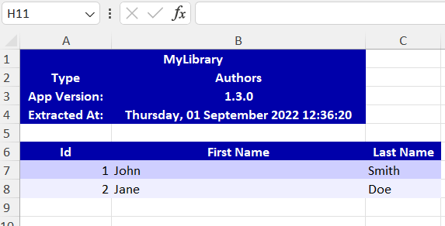

Figure : Worksheet export example - Authors

The book and media item worksheets exported can be used to import and update records in the database. For these types, certain fields are updatable, and new records can be added. The non-updatable fields are protected in the worksheet.

## Exporting worksheets

1. To open the export dialog, click the appropriate menu item under File -> Export. The following is an example of the dialog for exporting tags:

Figure : Export Tags dialog

1. Click the “Browse” button to select a folder to export the file. By default, the filename will be {type}_export.xlsx. Alternatively, enter the full file path in the path input box.
2. Click the “Start” button. The export process will begin. Once complete, a summary will be provided at the top of the dialog.
3. To close the dialog, click the “Cancel” button.

## Importing worksheets

To access the dialog used to import worksheets, click the File -> Import -> XLSX menu item. This opens the “Import Excel” dialog. This dialog has two radio buttons for selecting the type of import – books or media items.

Worksheets exported from MyLibrary can be used to import and update data. Data in certain fields can be updated, and new rows can be added. Non-updatable fields are protected in the worksheet.

MyLibrary will look for a worksheet with the correct name and validate that it has the appropriate structure.

Each row in the worksheet will be read one by one. If there is invalid data in a particular row, an error will be raised, and that row will be skipped.

Once the worksheet has been read, the database will be updated.

### Media items

The following fields are updatable for media items:

* Number
* Running Time
* Tags
* Notes

Tags must be separated by commas.

Figure : Import Excel dialog

1. Select the “Media Items” radio button.
2. Click the “Browse” button to select a file to import. Alternatively, enter the directory in the path input box.
3. Click the “Start” button to start the import/update process. A summary will be displayed at the top of the dialog. Any errors will be registered in the list below the radio buttons.
4. To close the dialog, click the “Cancel” button. The list in the main window will be refreshed.

### Books

The following fields are updatable for books:

* Tags
* Dewey Decimal
* MSRP
* Format
* Date Published
* Place of Publication
* Edition
* Dimensions
* Overview
* Synopsys
* Excerpt
* Notes
* Long Title

Tags must be separated by commas.

Entries in the authors field must adhere to a specific format, otherwise an error will occur. The format is: Firstname Lastname; Firstname Lastname; … Firstname Lastname. Examples:

John Smith

John Smith; Jane Doe

John H. Smith; John de Coder

1. Select the “Books” radio button.
2. Click the “Browse” button to select a file to import. Alternatively, enter the directory in the path input box.
3. Click the “Start” button to start the import/update process. A summary will be displayed at the top of the dialog. Any errors will be registered in the list below the radio buttons.
4. To close the dialog, click the “Cancel” button. The list in the main window will be refreshed.

# Known issues

## Storing large images in database

### Issue

Storing images with large file sizes can cause performance issues (slow loading when the item is selected).

### Workaround

It is recommended to keep item images under about 25 MB in size.

# Changelog

All notable changes to this application will be documented in this section.

NOTE: all dates are in dd-mm-yyyy format.

## v1.4.0 – unreleased

### Fixed

* Unique constraint on book long titles
* bug with last row in book export Excels unprotected

### Added

* Dialog to view item images
* Tip of the day dialog
* Support for updating book long titles via workbooks

### Changed

* “Add New Book”, “Add New Media Item”, “Wishlist”, and “Manage Copies” dialogs to modeless windows.
* improved filtering by tags in main window

## v1.3.0 – 8-9-2022

### Fixed

* bug with filtering in manage tags for item dialog
* bug with delete selected tag button remaining enabled if filtering returns no results in manage tags dialog

### Added

* Support for Flash Drives and Floppy Disks
* Support for importing/updating book and media item worksheets
* Various icons for dialogs and toolstrip
* Application icon
* Support for author names with composite and apostrophied last names

### Changed

* Replaced buttons below menustrip with toolstrip
* Place main window category selection drop-down near toolbar
* Enhancements to wishlist window

## v1.2.1 – 30-6-2022

### Fixed

* Cancel button in add new book form disabled when adding another book in scan mode
* Information from previously added book appears in pre-populated forms
* Ok button enable logic in add new publisher or tag dialogs for add new item forms
* ISBN fields now disabled in search dialog during API requests

## v1.2.0 – 2-4-2022

### Remarks

First stable version. Previous versions were development versions.

### Fixed

* Various performance fixes and improvements
* Various user interface enhancements
* Several memory leaks
* Bug with new wishlist item title and notes not being cleared after saving
* Bug with handling authors and publishers when scanning books
* Bug with processing ISBNs with dashes from API
* Bugs with populating authors, tags, and publishers when pre-filling add new item forms

### Added

* import CSV functionality
* export as Excel functionality
* spinner when loading item data
* filtering for authors and publishers in add new book dialog

### Changed

* Restructured database to store images in a separate table
* Better error handling when searching for books using API

## v1.1.1 – 1-3-2022

### Fixed

* Bug with checking if ISBN already exists when adding new book

### Added

* Filtering for tags when adding new item

## v1.1.0 – 24-2-2022

### Added

* Wishlist feature

## v1.0.1 – 30-1-2022

### Fixed

* “insufficient parameters supplied to the command” error when attempting to remove tag from media item
* Minor bugs in manage copies dialog

### Changed

* Increased size of tags list box in main window filters
* Increased sizes of tags, authors, and publishers list boxes in add new item dialogs

### Removed

* Sample data from database

## v1.0.0 – 23-1-2022

### Added

* Manage copies feature

### Fixed

* Bug with processing author names in comma format while adding new book

## v0.9.0 – 8-1-2022

### Fixed

* Main window layout problem

### Changed

* Minor colour changes to main window

## v0.8.0 – 31-12-2021

### Added

* Initial release