Robotik WS17/18

Assignment 7

Name | MatrNr | Mail
Sven Heinrichsen | 4780388 | s.heinrichsen@fu-berlin.de
Alexander Hinze-Huettl | 4578322 | Hinze.alex@gmail.com

Repo: https://github.com/al-eax/robotik_ws1718

1. Fish-eye camera calibration

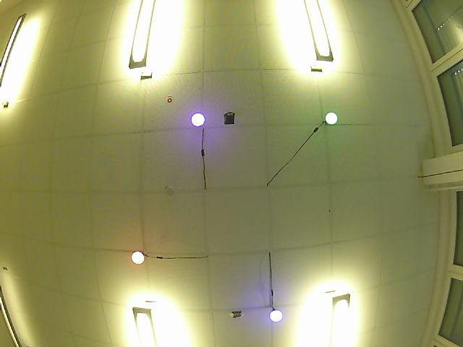
The distorted image:

The rectified image:
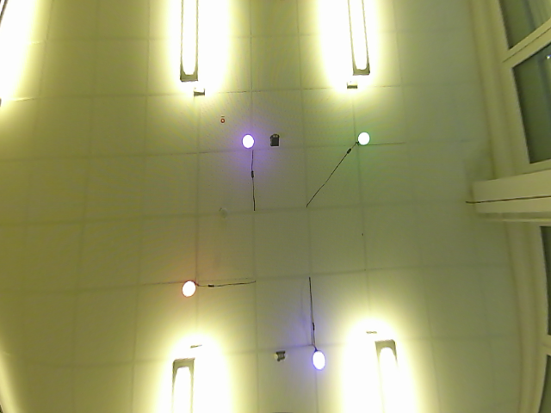

2. Find the color range for each balloon

We filtered the image using a YUV color space mask and used the HSV color space afterwards to identify the lamps from an array of cv2 contours.
Here are the hue-values we used to identify the lamps:

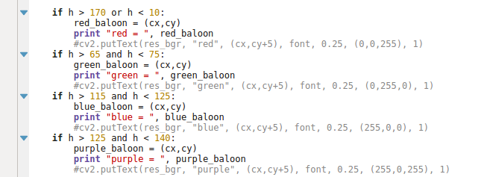

3. Visual GPS

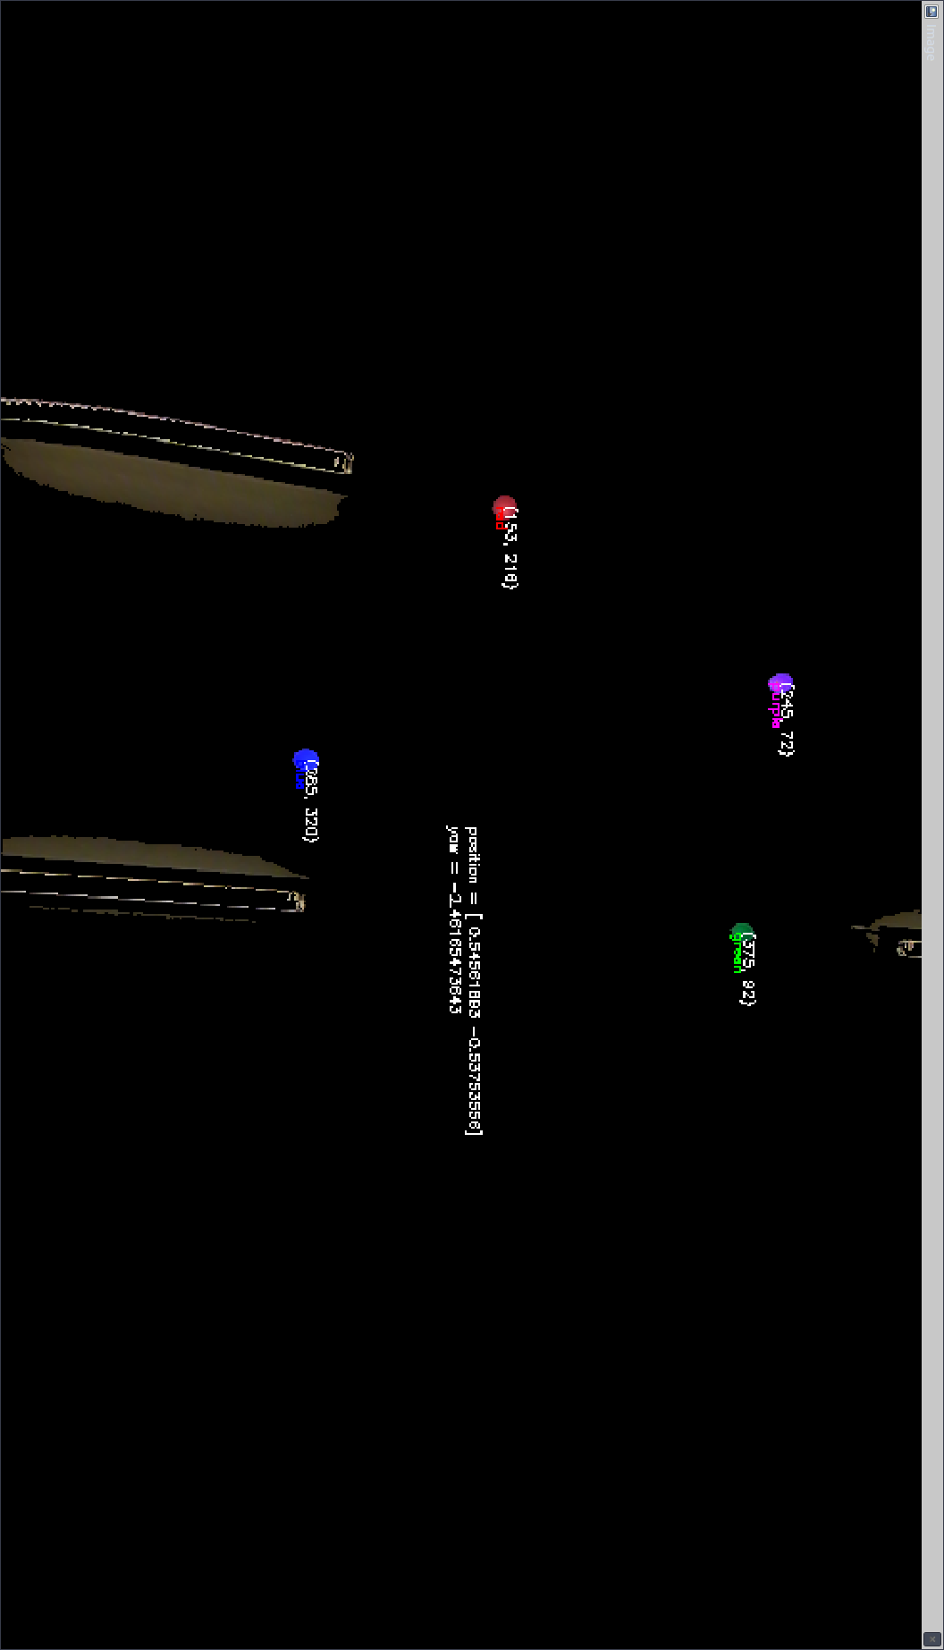
The following is an image of the 4 lamps with their HSV values, and centered in the middle is the current position and yaw in radians.
We used the 2nd method for this task. Here we let the car move in a circle and plotted the odometry data using rviz. Our results look good (the red ones) but the standard /odom topic (yellow) did not quite work as expected:

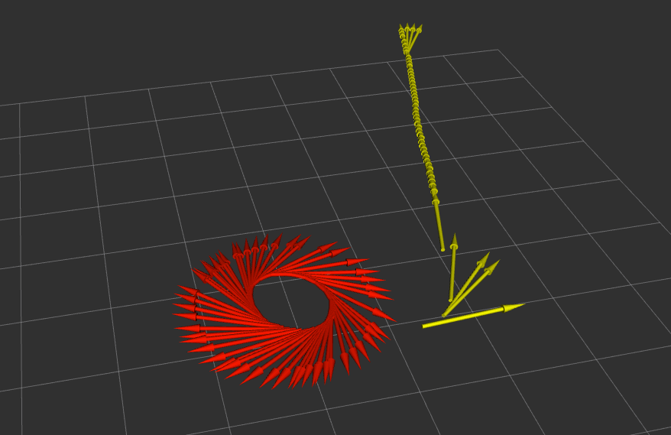
Even after restarting the /odom topic it would not do what it should:
