Project # 2 report

Task 1
In the task an application to Qt was done. A calculator with several additional functions was created.
File mainwindow.cpp contains the following code, where all buttons and labels are executed:
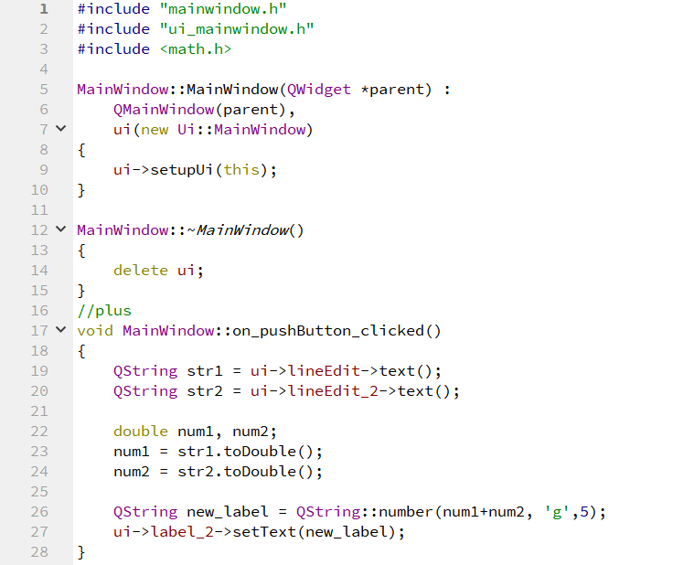
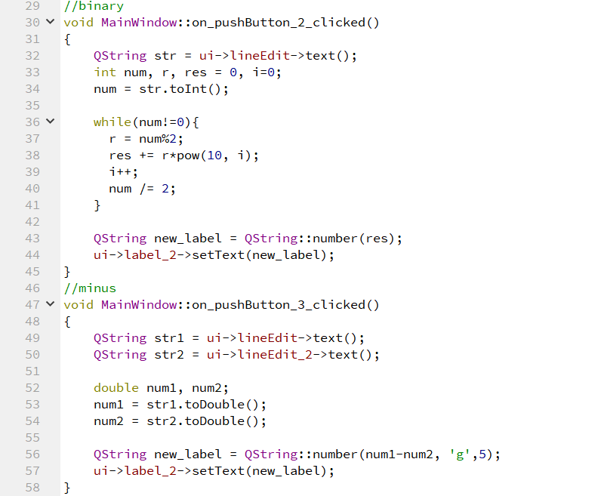
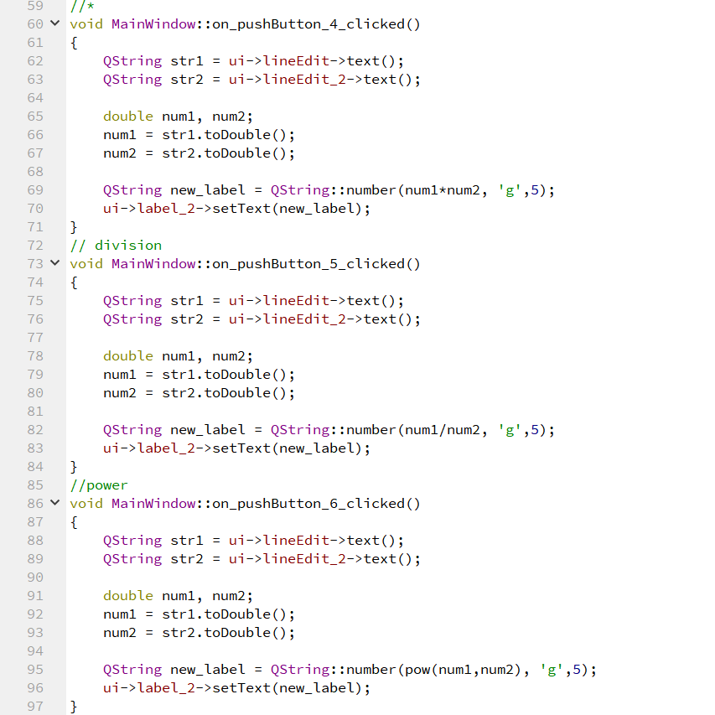
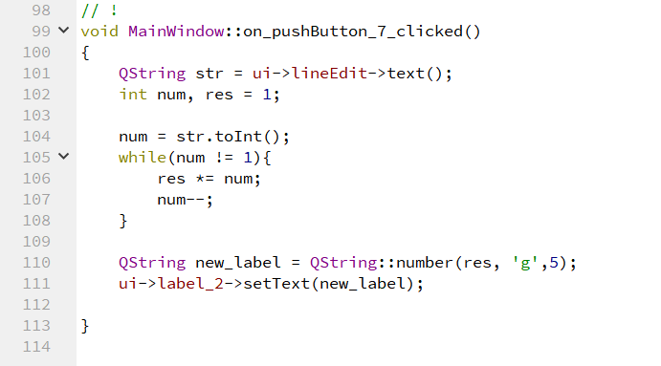
Each time any of buttons is pushed the part of code responsible for the button is executed.The interface appears to be the following:
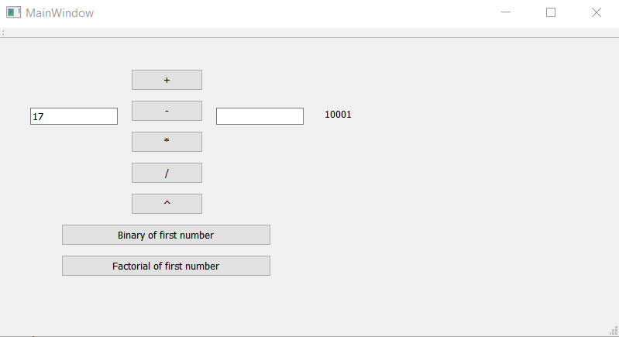
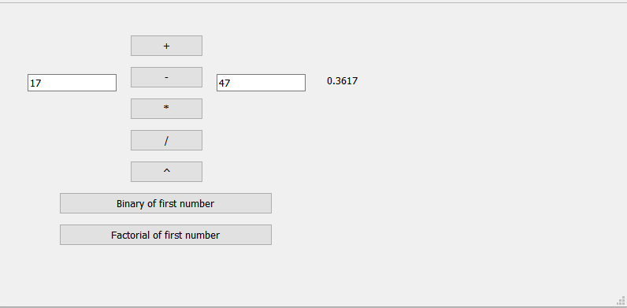

Task 2
Project2 folder contains file from previous project ggMD.cpp and new part of the project was added to make connection with PC.
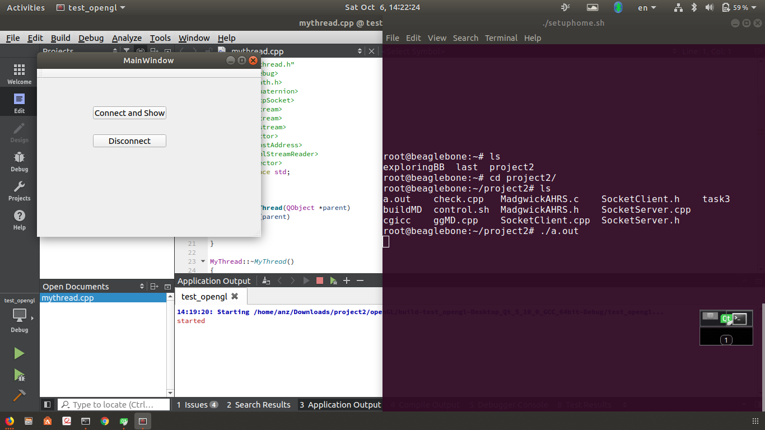
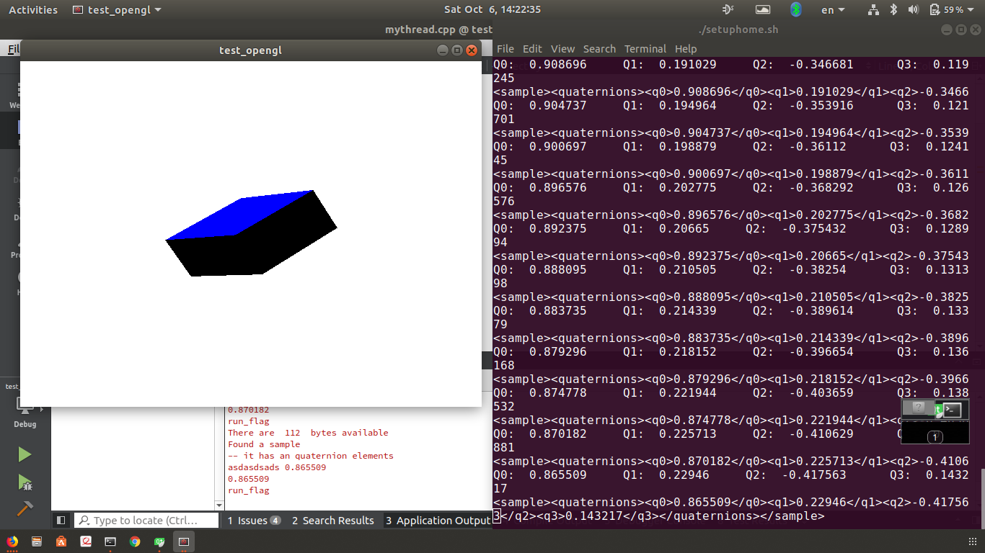

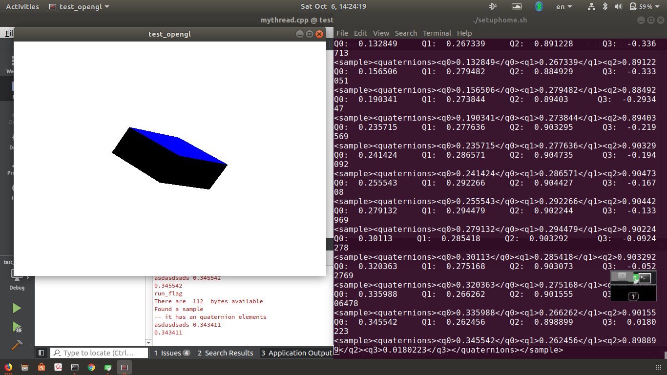
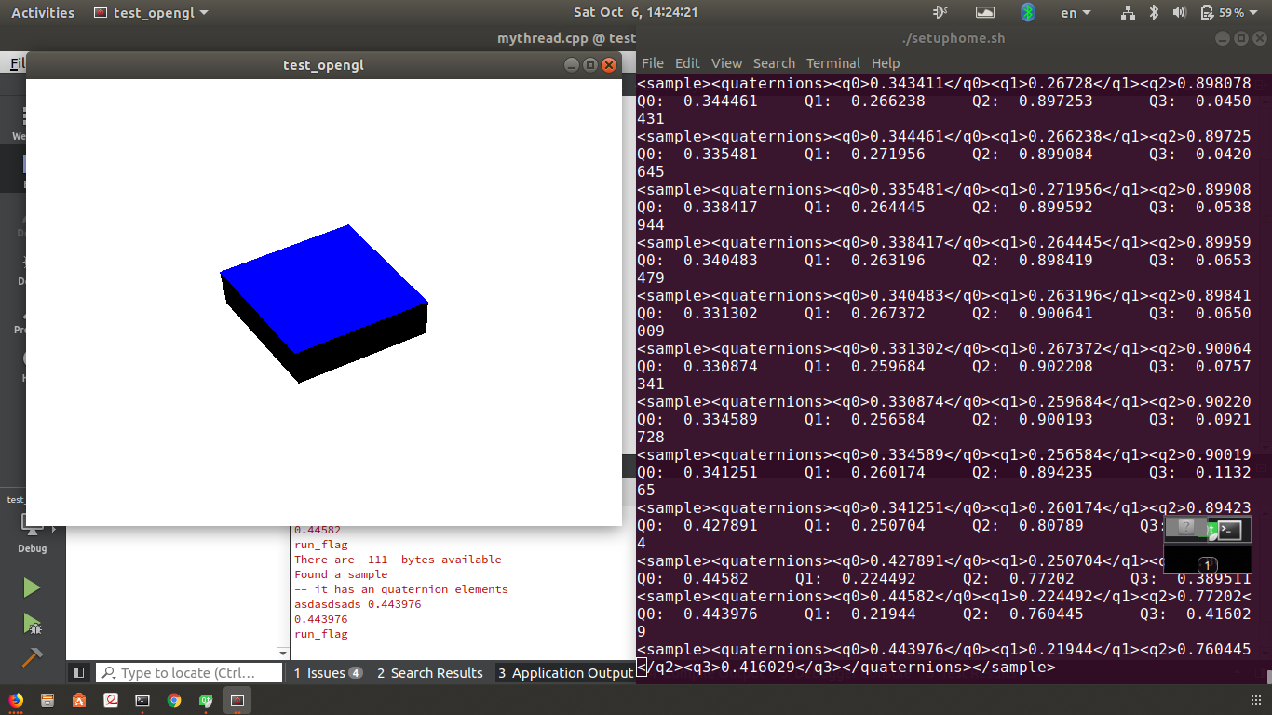
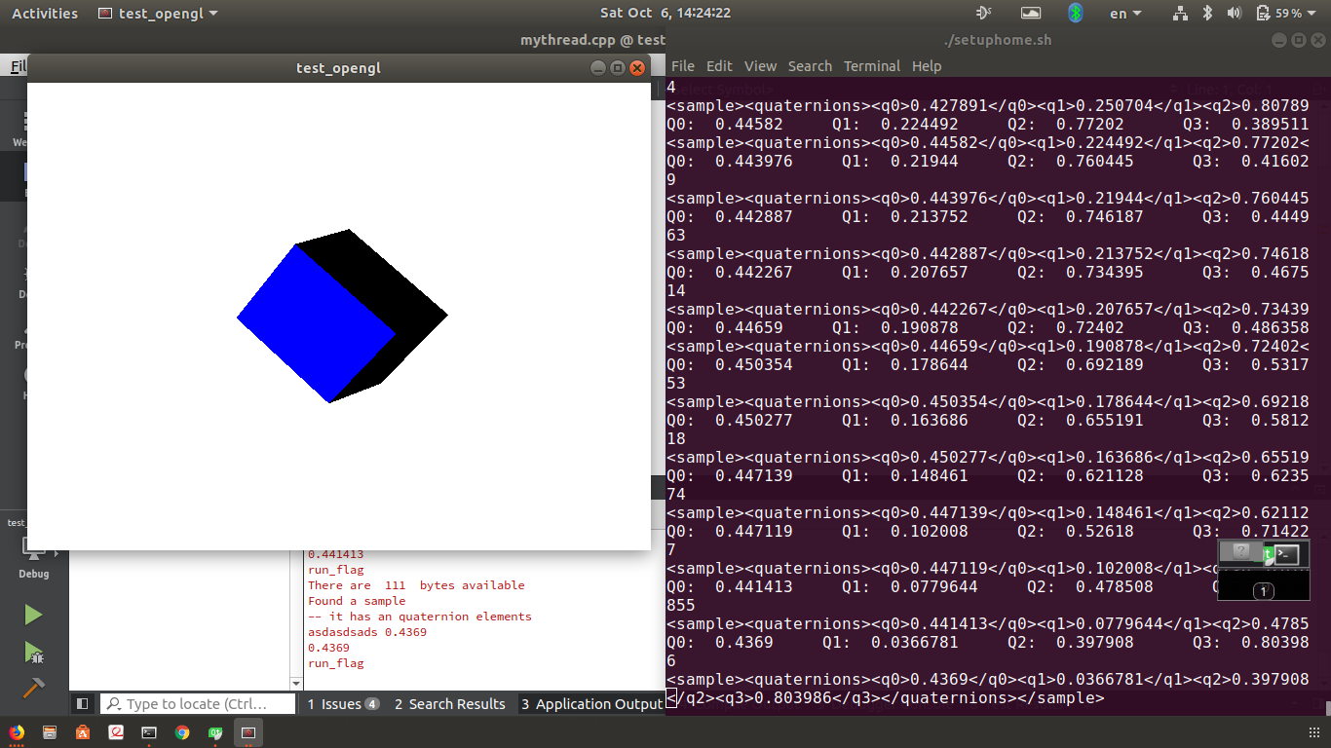

Task 3

The folder with the code will be attached.

