ECE 295 Course Development Notes

# Good resources

* <https://atmega32-avr.com/atmega8-ft232r-usb-esr-meter-circuit/>
  + Explain how to set up the usb programming interface
  + 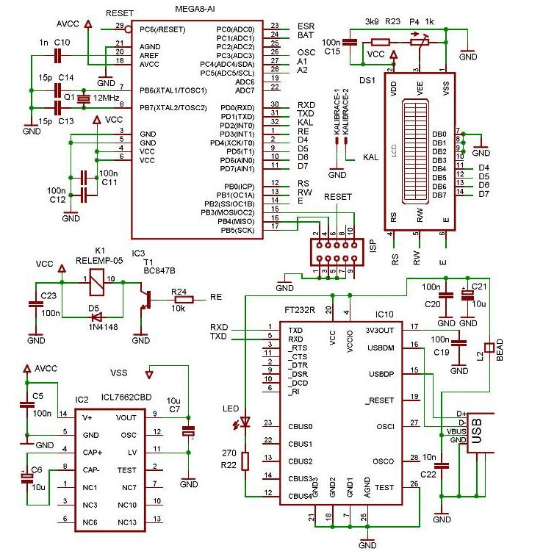
  + 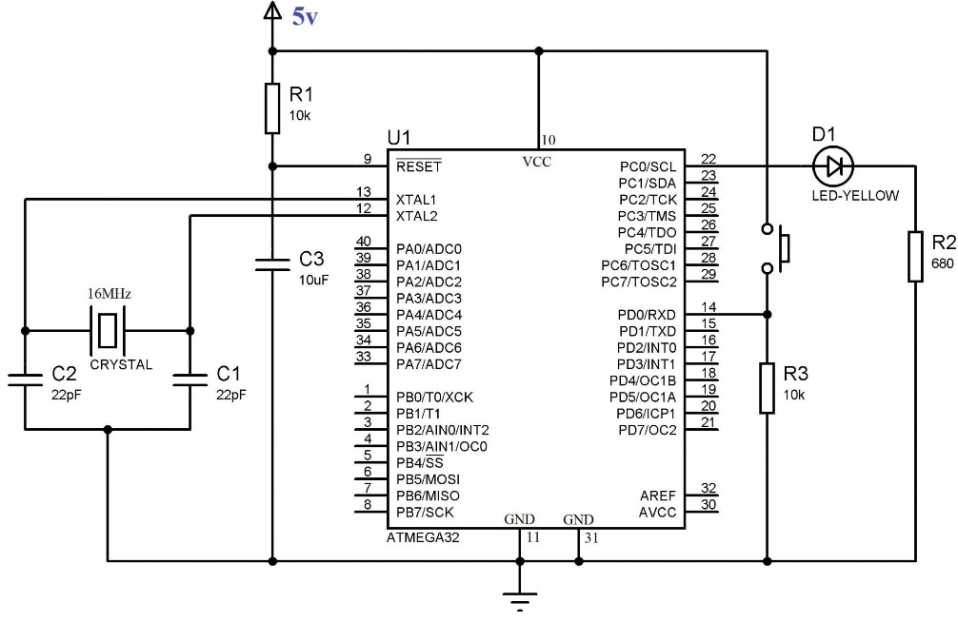
* You can use an on board clock (default) if you want. I’m not sure of the advantages of a discrete oscillator besides faster boot times
* 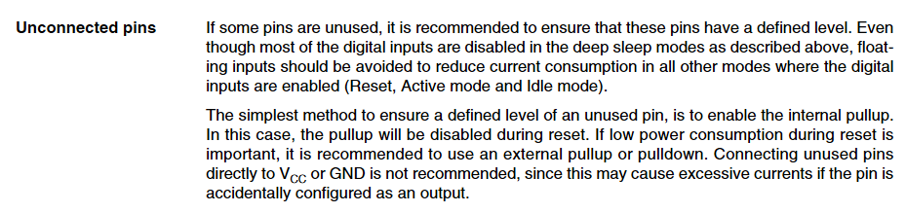
* <https://www.analog.com/en/parametricsearch/11183#/p6694=|Yes&p4781=|Dual%20PLL|Fractional-N%20PLL&ps2=2.41|19>

# Preliminary Block Diagram for Subsystem D

