ECEN5283 Project 2 Edge Detection
(Due on Feb. 28, 2018)

- Given four color retinal images, blood vessels are major anatomical structures which are very important for disease diagnosis. You are required to implement the three edge detection algorithms you learned from the class to extract the blood vessels.
  - The images are RGB true color (24 bits per pixel). You can implement edge detection on the green channel only (I=imread(‘retina1.bmp’); J(:,:)=I(:,:,2);).
  - Implement blood vessel extraction by using both Laplacian of Gaussian (LoG) and the Canny detector. You are encouraged to try several different parameters in both LoG and Canny detector as well. For Canny detection, all edge pixels should be color-coded (four colors) to indicate the orientations.
  - Implement the Matched filtering-based blood vessel extraction. Try to optimize the parameters in matched filtering.
- Some useful Matlab functions for post-processing the edge detection results
  - [X, Num]=BWLABEL(I): Label connected components in binary image. You can use it to remove small edge branches (length filtering). The detailed length filter procedure is followed.
    - Use BWLABEL to label binary image pixels as different connected components and to obtain the number of connected components.
    - For each connected component, count the number of pixels which share the same label (Y=FIND(I==i));
    - Remove the connected components with small numbers of pixels.
  - BWMORPH(I, ‘thin’): Do the thinning of edges to find the centerline.

PPT Report Requirements.
- Briefly discuss and compare three edge detection techniques.
- The source codes for three methods should be attached.
- Demonstrate and discuss your experimental results for all four retinal images. Try to optimize the parameters to produce good edge detection results. Some examples are shown below.
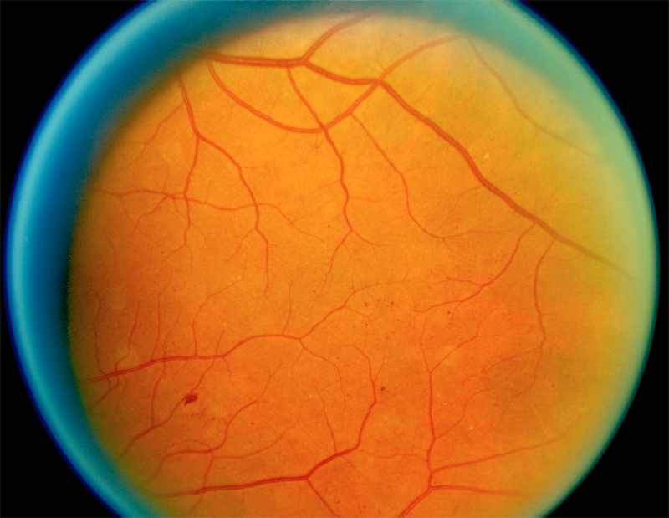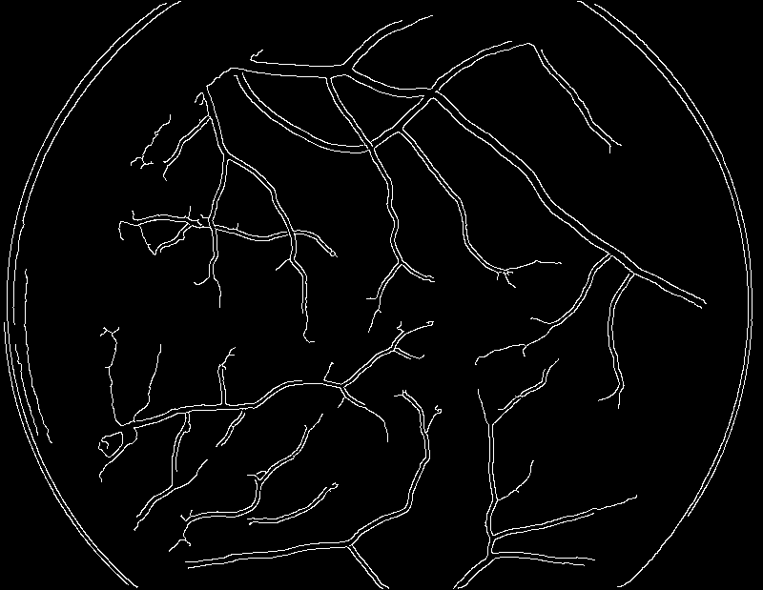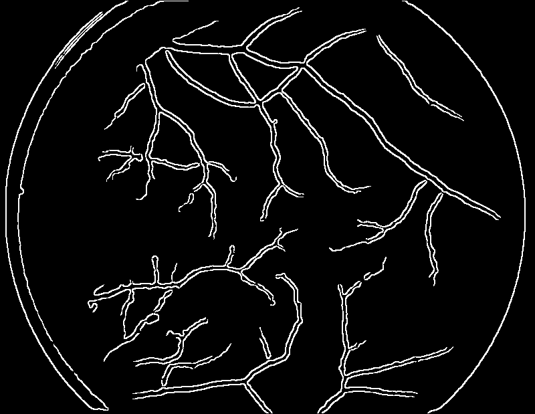
A retinal image Canny detection LoG detection
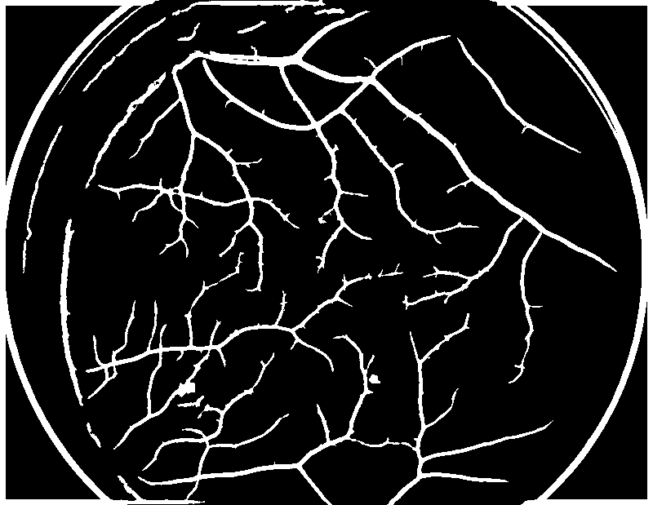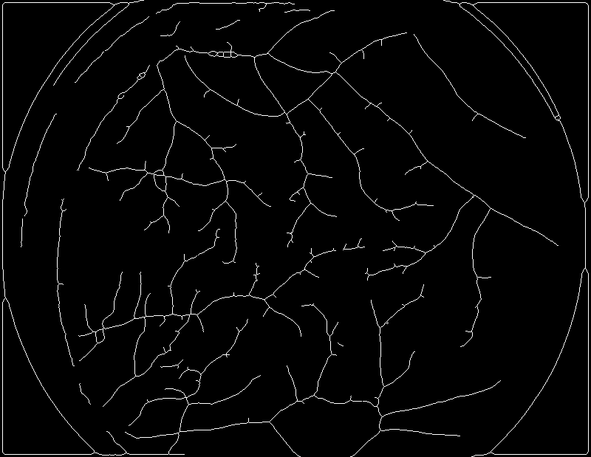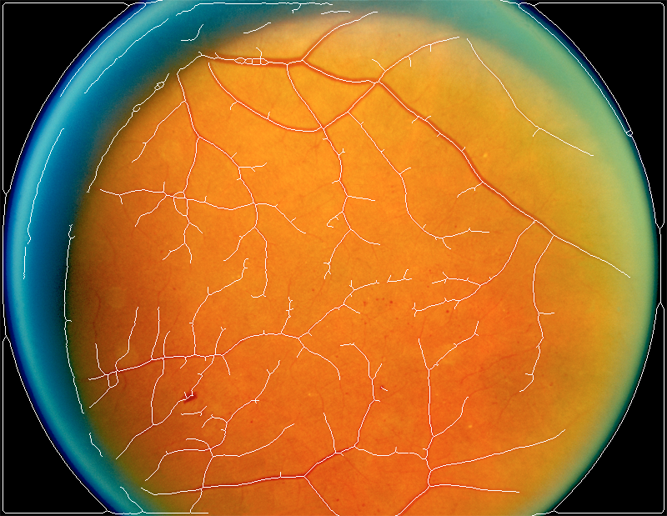
Matched filtering detection Thinning result Superimposed result

