**Kessler Syndrome**

Game Design Document

Alexandre Parent

April 2021

Revision 1.0

**General overview of the game**

Kessler Syndrome is an endless turn-based bullet hell game. The scenario of the game is set in a sci-fi apocalyptic version of our world two centuries in the future. The player’s goal is to keep their ship intact for as many turns as they can while dodging as much space debris as they can. The more turns the player survives, the higher their score. Score in this game is depicted as the player’s ‘altitude’, with multiple altitude milestones described as their current ‘trajectory’.

**Target System and Requirements**

As this game is programed using Allegro 5, the game should be compatible on any operating system supported by the Allegro 5 programming library. Due to the game’s turn-based nature and simple programming, it is conceivable that Kessler Syndrome can run on any computer that meets the minimum hardware system requirements for the operating system they intend to use.

**Story**

The story of the game is one of desperation. In the year 2238, the entire surface of Earth has been completely ecologically devastated by over a decade of bombardment by falling orbital debris. This hail of debris is caused by a condition called ‘Kessler Syndrome’, which is also the title of the game. Generations of reckless space exploration and exploitation has littered Earth’s orbit with space junk, and collision between these pieces of space junk have multiplied the debris, causing even more collisions. This positive feedback cycle is called ‘Kessler Syndrome’. As a last-ditch effort for survival, humanity has created a Generation Ship; A type of ship intended to be self-sustaining, in order to house all future generations of humanity. The project intended to create this ship is called ‘Project Jericho’, and the ship itself is called the Jericho. The intention behind naming the ship ‘Jericho’ is to evoke a sense of cyclicality to humanity’s fate, as both humanity’s first and last home share the name ‘Jericho’.

The player is put into the role of the commander of the Jericho. As the ship’s commander, they are given the impossible job of escaping Earth’s orbit, given the number of obstacles in their way. They are told that the hope if that the mission succeeds so that the Jericho can travel across space to find a new planet for humanity.

Since the game is endless, the player will almost certainly die eventually. When they do, they are put into the mind of the Jericho’s commander during his last moments alive. In these moments, the commander reflects on why the Jericho was created in the first place. They question what could have led to such a fate, where humanity spends its final moments in a doomed spacecraft. As the commander ponders, he realizes that he will never know. The message ends on a poetic note, with the game mentioning that “Just as Jericho was humanity’s first city, it now becomes its last.”

**Theme: Graphics and Sound**

This section describes the overall theme of the game, whether it is set in ancient times in a land of fantasy or two thousand years in the future on planet Neptune. It should also contain descriptions or at least hints of the scenery and sound to be used.

The game is set on Earth, in the year 2238. The theme of the game is overtly sci-fi, which is reflected in the game’s menus and assets. Even the font used is made to look sci-fi. Graphical assets are also meant to reflect the sci-fi theme, but they are also meant to reflect the melancholic nature of the story. As such, dark colors are used in most situations. Greys and blacks are used for the menus to reflect this. The main game page employs more varied color use, but dark colors are still employed. Dark purple/blue is used as the main page color to make it look depressing and space-y. The main play area is darkened to make the color look closer to real space to help with the player’s immersion. The heads up display is meant to look like computer screens, with green text and a background that is black with a green hue.

As the main developer of this game has no artistic talent, the sprites used in this game are borrowed from the game Starsector[1]. As the main developer was unable to find assets for space debris that fit the theme of the game, the main developer implemented asteroids from Starsector as placeholders for debris. This change is reflected in the naming conventions inside the game’s code. The sprite used to represent the Jericho is the texture for the ‘Apogee’ ship from Starsector. As the Jericho is supposed to represent humanity’s last hope, it is the only thing in the game to feature a lighter color scheme.

Since ‘Kessler Syndrome’ is a turn’ based game, the game has a much more relaxed atmosphere compared to other games in the bullet hell genre. This is reflected in the game’s sound design. The game’s main theme music is slow paced, with notes spaced in a way to reflect the vast expanse of space. Unfortunately, the main developer was unable to find appropriate royalty-free crash or explosion sound effects for when the Jericho collides with space debris, so a placeholder noise is used instead. If the developer were willing to spend any amount of money on the creation of this game, this is the sound effect that would be used[2]. For the final collision, the noise used would be this one[3].

**Pages**

‘Kessler Syndrome’ contains 4 pages: A welcome page, an instruction/help page, the main game page, and the results page.

**Welcome page:**  
The welcome page gives the player a message introducing the game and its story. From here, the player may proceed to the instruction page by pressing the ENTER key on their keyboard.

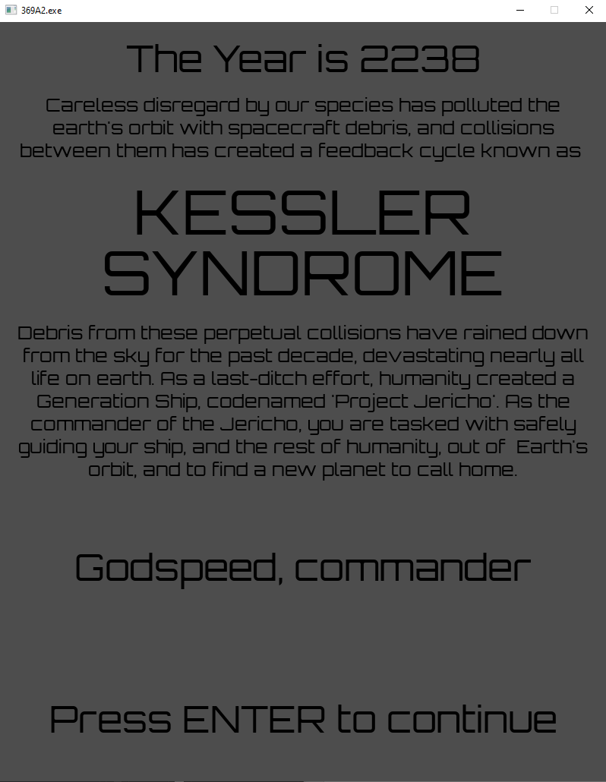

**Instructions page:**  
The instructions page tells the player what the goal of the game is, what to expect, and how to play the game. This page can be returned to at any time by pressing LCTRL+h on the keyboard.  
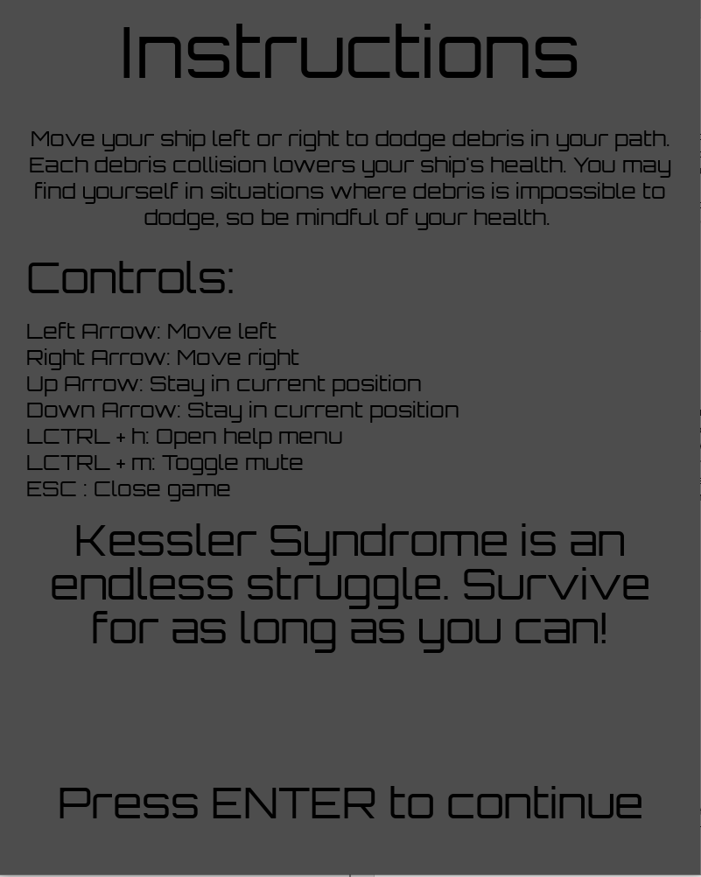

**Main game page:**  
This is the page where the player actually plays the game. The controls used in this page are described in the Instructions page, which can be returned to by pressing LCTRL+h. On this page, the player is given a playable area with asteroids, which they must avoid. The heads up display on the left of the playable area shows the player’s current health, current altitude (score), and the player’s current trajectory.  
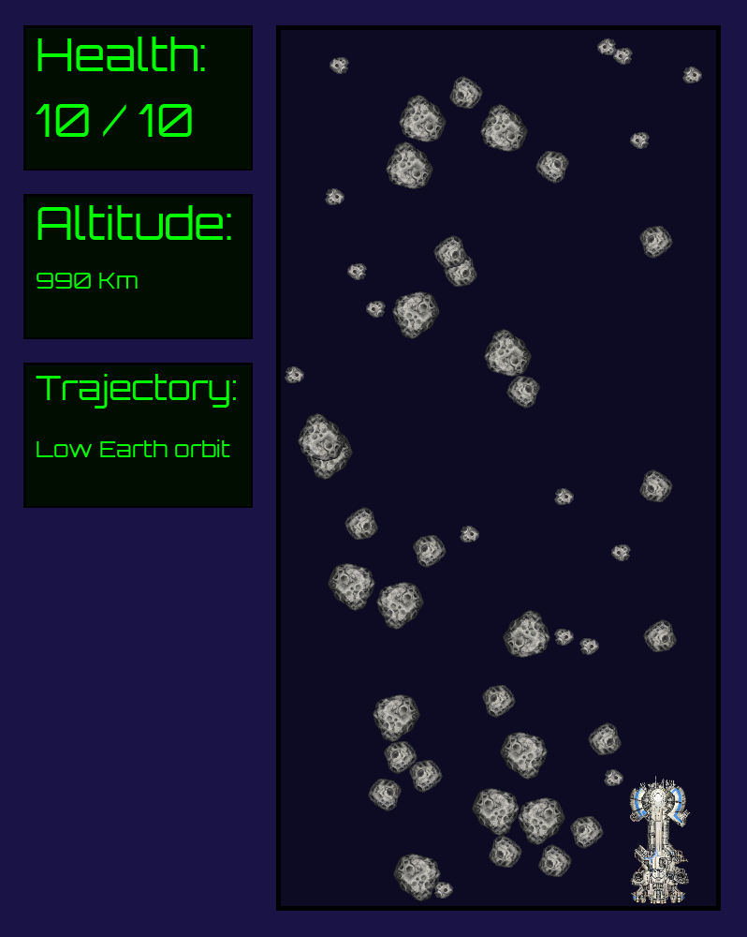

**Result Page:**  
The result page is entered automatically once the player’s health is reduced to 0. Here, a death message is presented, along with their final altitude and trajectory.  
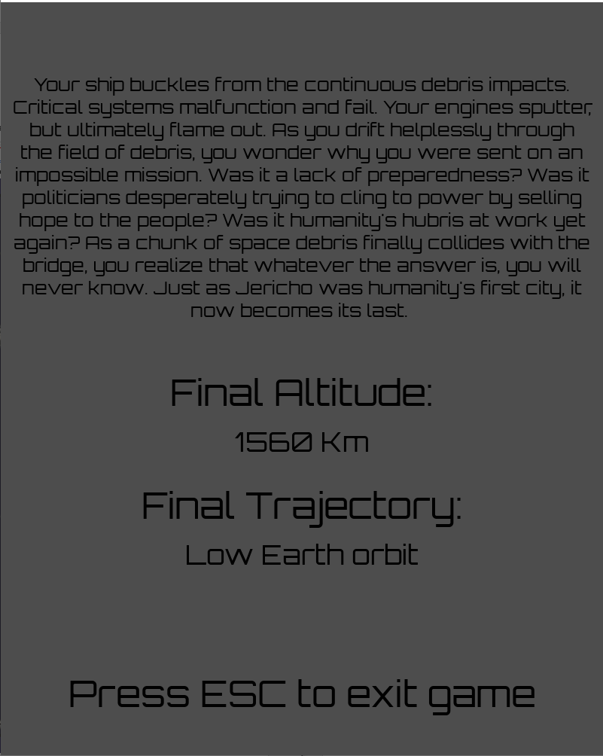

**Playing the Game**

Kessler Syndrome is a very simple game to play. There are only 8 possible user inputs, 7 of which are detailed in the Instructions page. The eighth is the player’s ability to close the game by pressing the close display button at the top right of the game window.

**Movement controls:**  
The player moves the Jericho by using the arrow keys. The player can move right by pressing the right arrow key or left by pressing the left arrow key. If the player wishes to pass the turn without moving the Jericho, they may do so by pressing the up or down arrow keys.

**Utility controls:**  
The player may mute all game sounds by pressing LCTRL+m. This immediately disables all future sounds from playing, and disables all currently play sounds. This function is a toggle, so LCTRL+m can be pressed again in order to re-enable all game sounds.  
The player may re-open the Instructions page by pressing LCTRL+h at any time. Opening this page during gameplay does not affect the player’s progress, as the current game state is kept in memory while the Instructions page is open.  
To close the game immediately, the player may either press the ESC key on their keyboard, or they may press the close display button on the top right of the game window.

**How to play:**  
The player plays Kessler Syndrome by moving the Jericho left and right to dodge space debris. Every time the player presses an arrow key, the Jericho moves, the space debris moves down, and the turn ends. The player must try their best to dodge the falling space debris, but this may not always be possible. This is by design. The player is thus incentivised to not play recklessly, as their health is treated as currency to pass through areas where collisions are unavoidable. This forces the player to strategize their path, which they are given as much time to do as they please. Each turn the player survives increases their altitude, which is treated as the game’s score. The amount by which the player’s altitude increases is dependent on the player’s current trajectory. The player’s trajectory changes on a milestone basis, with each progressive milestone requiring more turns to reach than the last. The acceleration of the altitude gain based on these milestones is meant to represent the Jericho gaining speed as it ascends.

**Characters and NPCs Description**

The player plays as the commander of the Jericho. They are the only character specifically referenced at any point in the game, though it is alluded to that there are other humans in this world also. The commander’s character motivation is to guide the Jericho to safety in order to preserve humanity’s future. No description, details, or backstory is provided for the commander so that the player can project themselves onto them, in a similar way to the main protagonist from ‘The Elder Scrolls V: Skyrim’, or the main protagonist from ‘Fallout: New Vegas’.

**Return codes:**  
Return codes are additive. For example, if both -1 and -10 were to be returned, -11 would be returned instead.

|  |  |
| --- | --- |
| -1 | Display was closed via the ALLEGRO_EVENT_DISPLAY_CLOSE event. |
| -10 | ESC key was pressed. |
| -100 | The page enum was not properly handled by the page switch, and the default case was entered. |
| 0 | Program exited abnormaly. |

Although logging would be a better approach to this, the program is simple enough that this is sufficient.

**Conclusion**

Kessler Syndrome is a very simple game. Although games in the bullet hell genre are extremely common, turn-based bullet hell games are extremely uncommon. This unique twist on the genre makes the player completely rethink the way in which they should play the game, allowing them to adopt a more strategic approach to the game. This sets it apart from similar games, as other bullet hell games are usually played at a frantic pace, requiring players to play reactively rather than strategically. Although the story isn’t rich in detail, it is sufficient and appropriate for the game’s scope. ~~(This game basically has the same level of world-building as Battlestar Galactica)~~

**Appendix:**

[1] <https://fractalsoftworks.com/>

[2] <https://www.pond5.com/sound-effects/item/42387194-8-bit-crash-2>

[3] <https://www.dreamstime.com/bit-explosion-delay-bit-explosion-delay-sound-effect-game-development-audio150218262>