DIGITAL BEHAVIOUR ARCHETYPES
Clustering, PCA, and Classification Analysis

Statistical Project Report
Dataset: Mental Health and Digital Behaviour (n = 500)
June 2026

An exploratory analysis of how screen habits, sleep, social media, notifications, and anxiety relate to digital wellbeing.

Contents
1. Executive Summary
2. Introduction and Objectives
3. Dataset and Data Quality
4. Exploratory Data Analysis
5. Feature Engineering and Scaling
6. Cluster Selection
7. K-Means Clustering and Archetypes
8. PCA Visualisation
9. Classification Models
10. Discussion
11. Limitations
12. Conclusion
Appendix A. Workflow and Visual Inventory

1. Executive Summary
This report examines digital behaviour and wellbeing in a dataset of 500 observations. The analysis combines data-quality checks, exploratory data analysis, feature engineering, K-Means clustering, principal component analysis (PCA), and supervised classification.
Three exploratory digital behaviour archetypes were selected using K-Means clustering. Random Forest was the strongest classifier for distinguishing these archetypes, achieving 93.88% test accuracy, compared with 87.76% for the Decision Tree.
The central descriptive finding is that anxiety level has a strong negative association with digital wellbeing (r = -0.836), while sleep hours (r = 0.440) and focus score (r = 0.411) are positively associated with wellbeing. These are associations, not causal effects.

2. Introduction and Objectives
Digital technology use can vary substantially across people. This project investigates patterns in screen time, social-media activity, sleep, notifications, focus, mood, anxiety, and digital wellbeing, then groups observations into interpretable behavioural profiles.

Objectives
- Assess dataset quality and describe the main variables.
- Explore relationships between digital behaviour and wellbeing.
- Engineer behavioural indicators and standardise the clustering inputs.
- Identify digital behaviour archetypes using K-Means clustering.
- Visualise the archetypes with PCA.
- Compare Decision Tree and Random Forest models for cluster classification.

3. Dataset and Data Quality
The dataset contains 500 records and 9 numeric variables. No missing values and no duplicate records were identified. This provides a clean base for the exploratory and modelling stages.
Variable | Mean | SD | Minimum | Median | Maximum
Daily screen time (min) | 360.44 | 58.78 | 180.0 | 360.80 | 591.2
App switches | 49.84 | 7.34 | 30 | 50 | 72
Sleep hours | 6.56 | 1.19 | 3.0 | 6.50 | 10.0
Notifications | 79.51 | 23.98 | 20 | 80 | 158
Social-media time (min) | 121.77 | 43.81 | 30.0 | 119.55 | 296.7
Focus score | 7.00 | 0.62 | 5.5 | 7.00 | 8.6
Mood score | 8.99 | 0.52 | 7.4 | 9.00 | 10.0
Anxiety level | 8.45 | 2.13 | 1.0 | 9.70 | 10.0
Digital wellbeing | 52.31 | 7.94 | 34.6 | 51.00 | 80.8

Table 1. Descriptive statistics for the analysed variables.
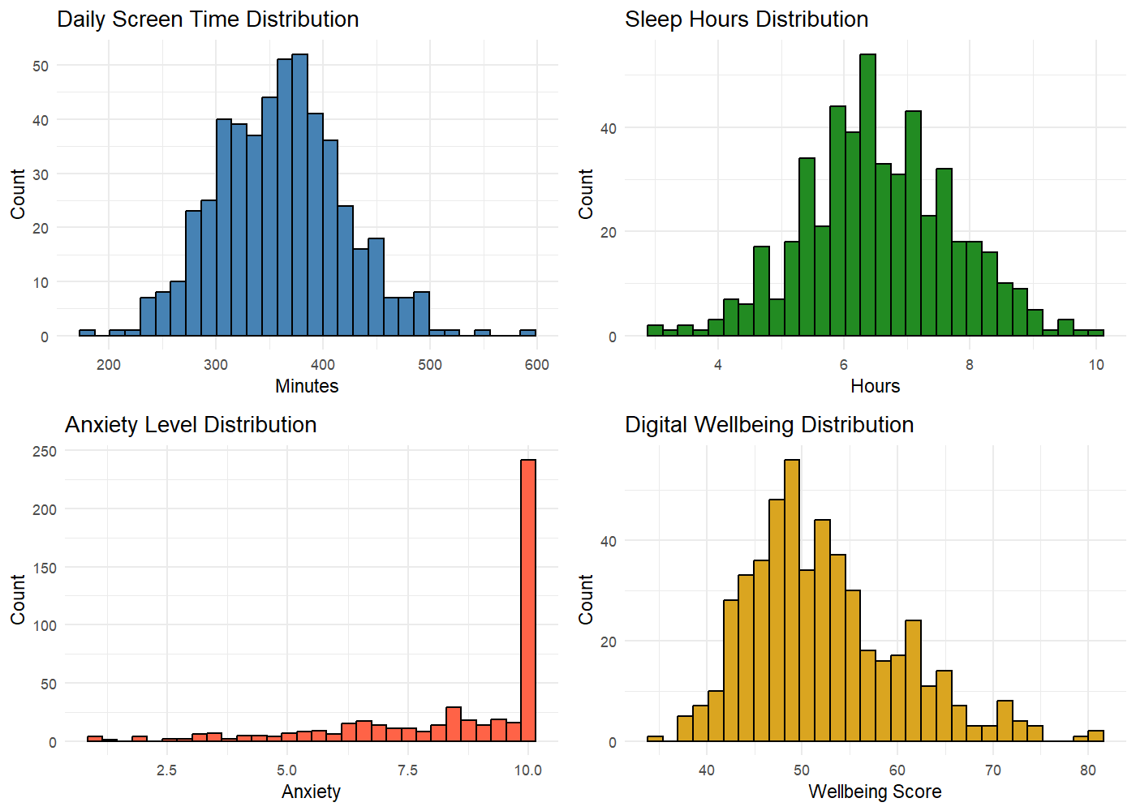
Figure 1. Distributions of daily screen time, sleep hours, anxiety level, and digital wellbeing.
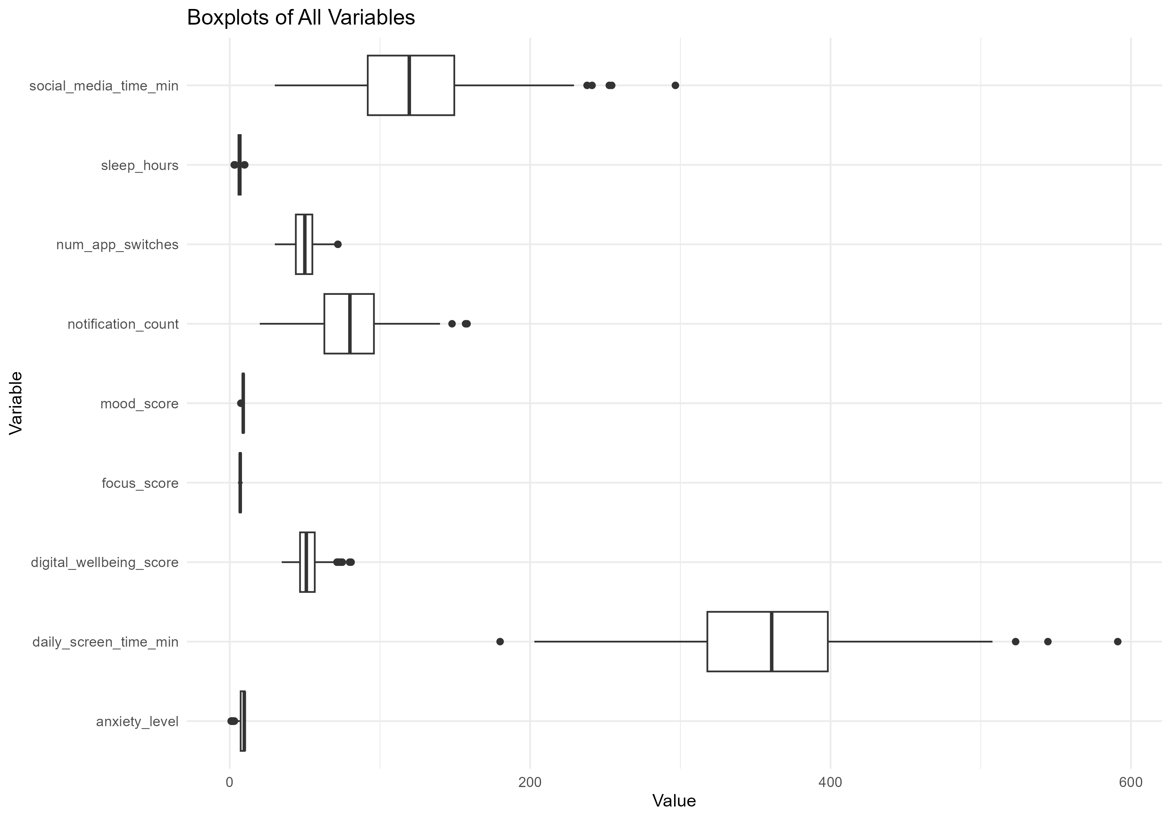
Figure 2. Boxplots of the original variables; scales differ substantially, motivating feature standardisation before clustering.

4. Exploratory Data Analysis
The correlation analysis identifies anxiety as the variable most strongly associated with lower digital wellbeing. Sleep and focus show moderate positive associations with wellbeing, whereas notifications and social-media use show negative associations.
Variable | Correlation with wellbeing
Anxiety level | -0.836
Sleep hours | 0.440
Focus score | 0.411
Notification count | -0.380
Social-media time | -0.263
Daily screen time | -0.088
Mood score | 0.127

Table 2. Selected correlations with digital wellbeing.
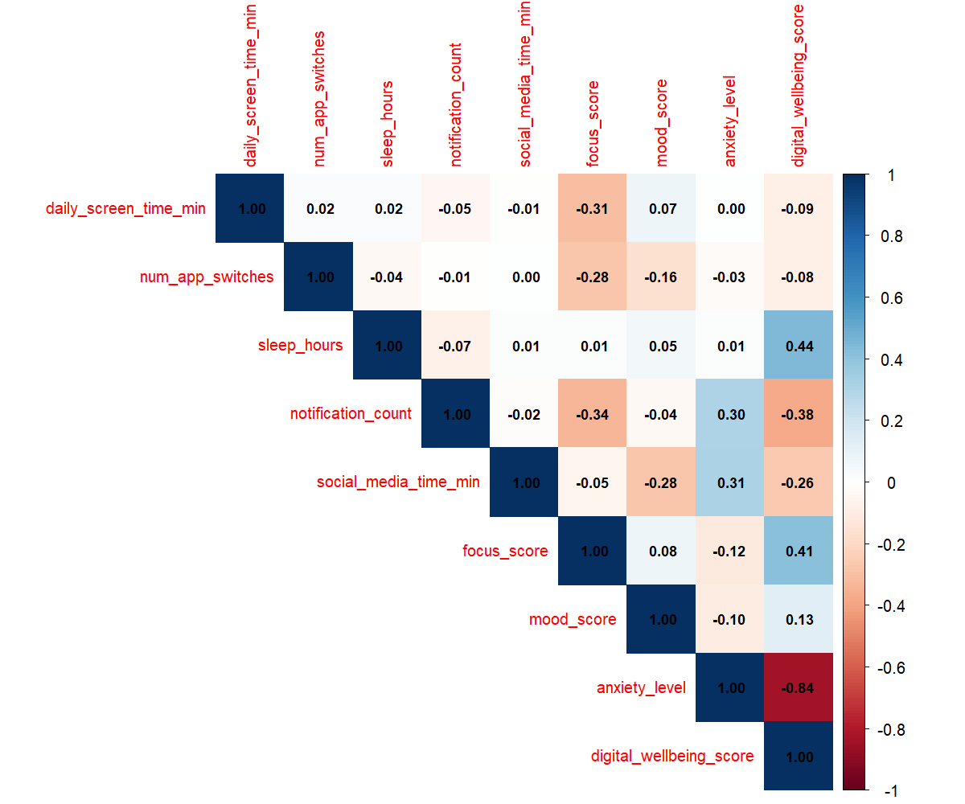
Figure 3. Correlation matrix of the original variables.
The relationships should be interpreted descriptively. For example, the negative association between social-media time and wellbeing does not establish that social-media use causes lower wellbeing.
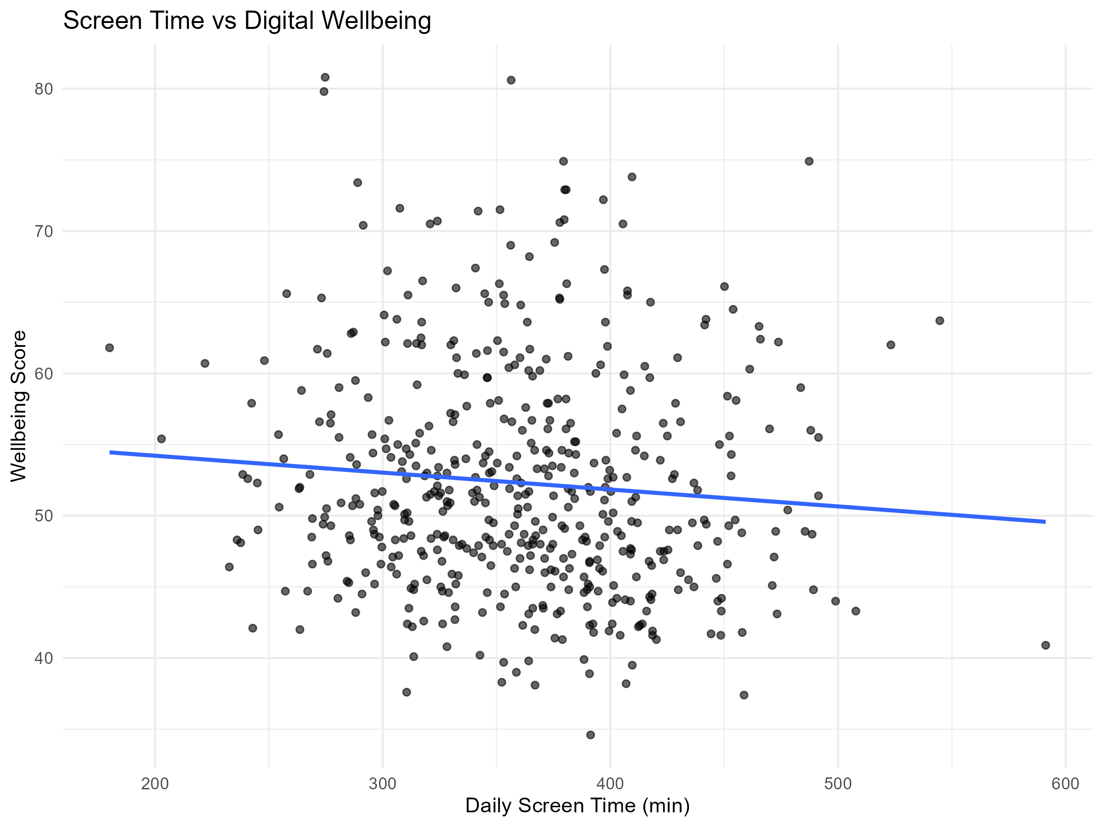
Figure 4. Daily screen time versus digital wellbeing, with fitted linear trend.
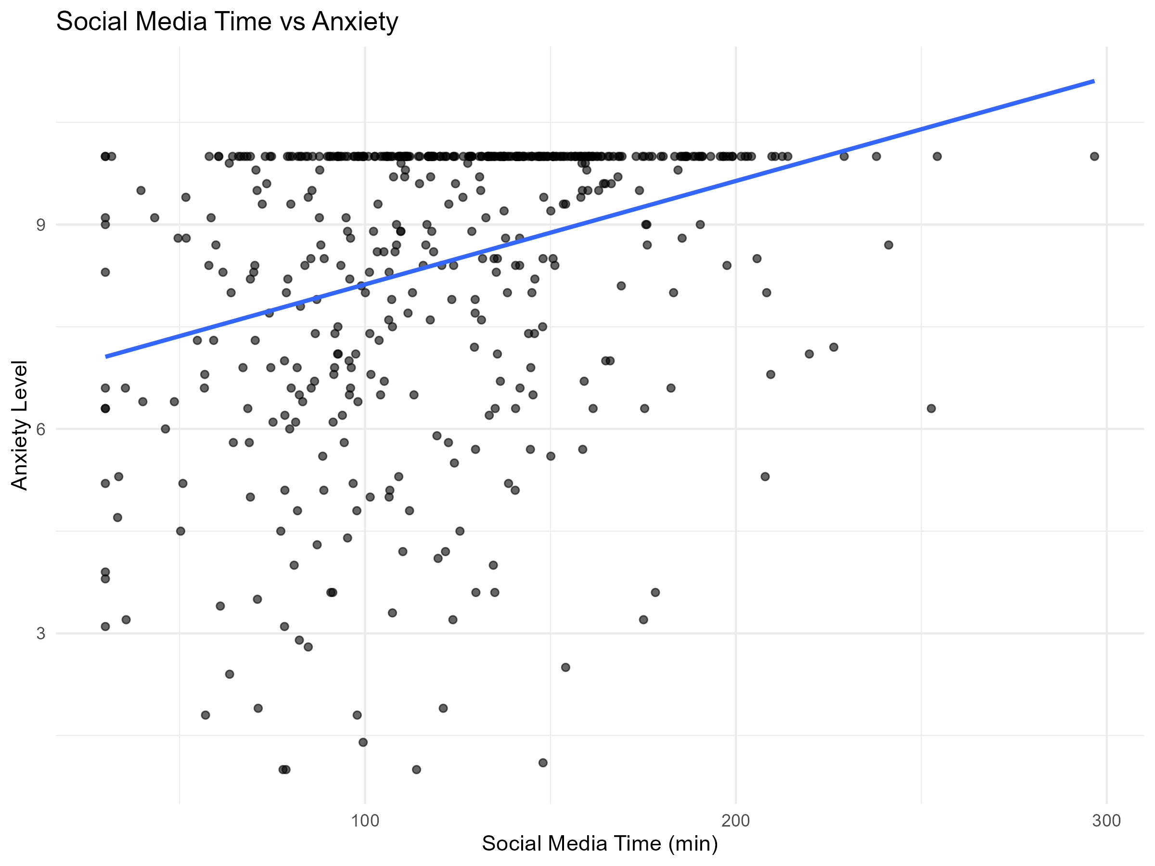
Figure 5. Social-media time versus anxiety level, with fitted linear trend.
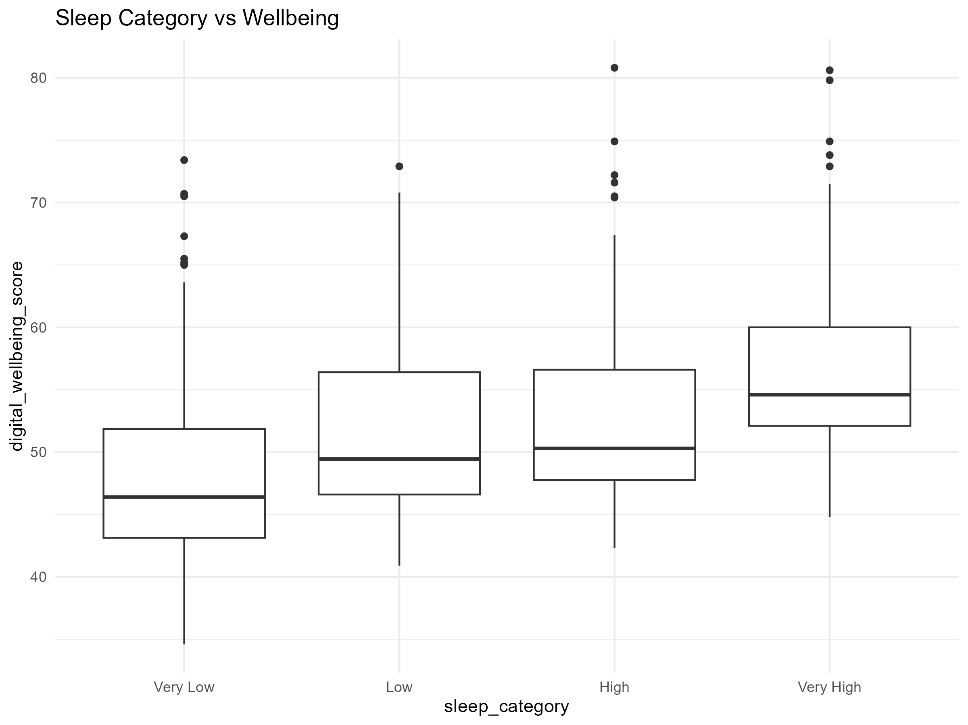
Figure 6. Digital wellbeing across sleep-hour quartile categories.

5. Feature Engineering and Scaling
Four derived indicators were created to represent behaviour in more interpretable ratios and rates. The clustering model used daily screen time, social-media time, sleep, notifications, focus, anxiety, social-media share, and the screen-to-sleep ratio. Each input was standardised to mean approximately 0 and standard deviation approximately 1.
df <- df %>%
mutate(
screen_time_hours = daily_screen_time_min / 60,
social_media_share = social_media_time_min / daily_screen_time_min,
screen_sleep_ratio = daily_screen_time_min / sleep_hours,
notification_intensity = notification_count / screen_time_hours
)

Engineered feature | Mean | SD
Screen time hours | 6.007 | 0.980
Social-media share | 0.347 | 0.141
Screen-to-sleep ratio | 56.993 | 15.083
Notification intensity | 13.634 | 4.806

Table 3. Summary of engineered features.

6. Cluster Selection
The Elbow Method and average silhouette analysis were used to assess candidate cluster counts. The maximum observed average silhouette score occurred at k = 3 (0.1736), so three clusters were retained for the archetype analysis.
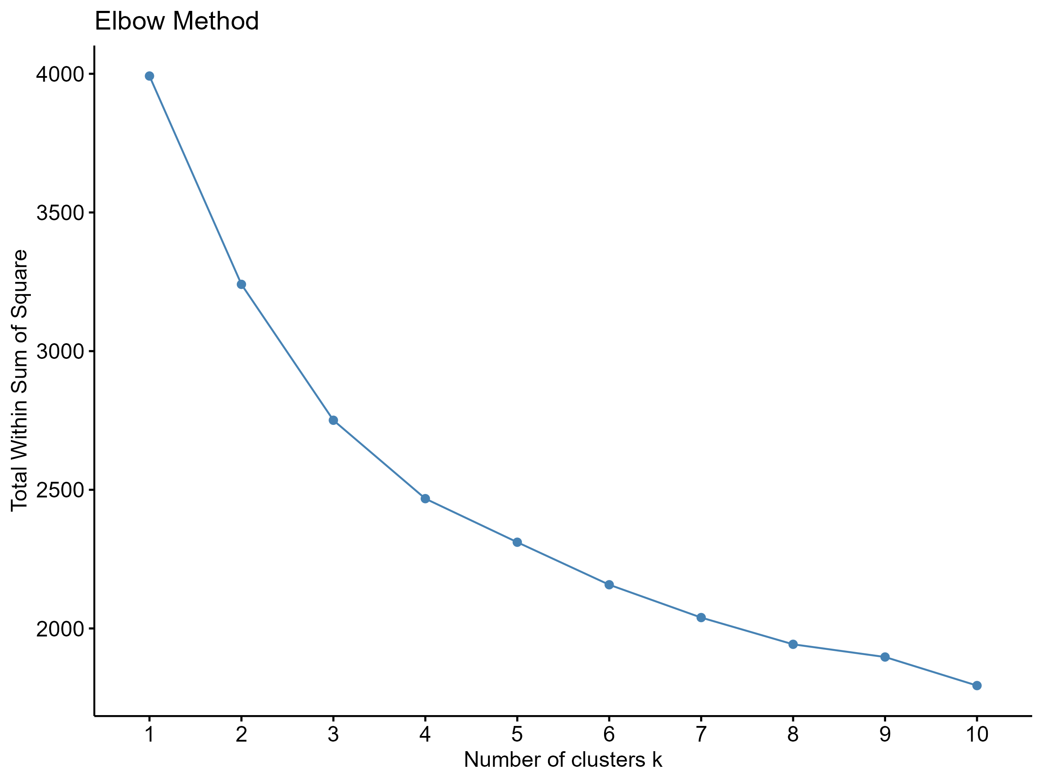
Figure 7. Elbow plot showing total within-cluster sum of squares across candidate k values.
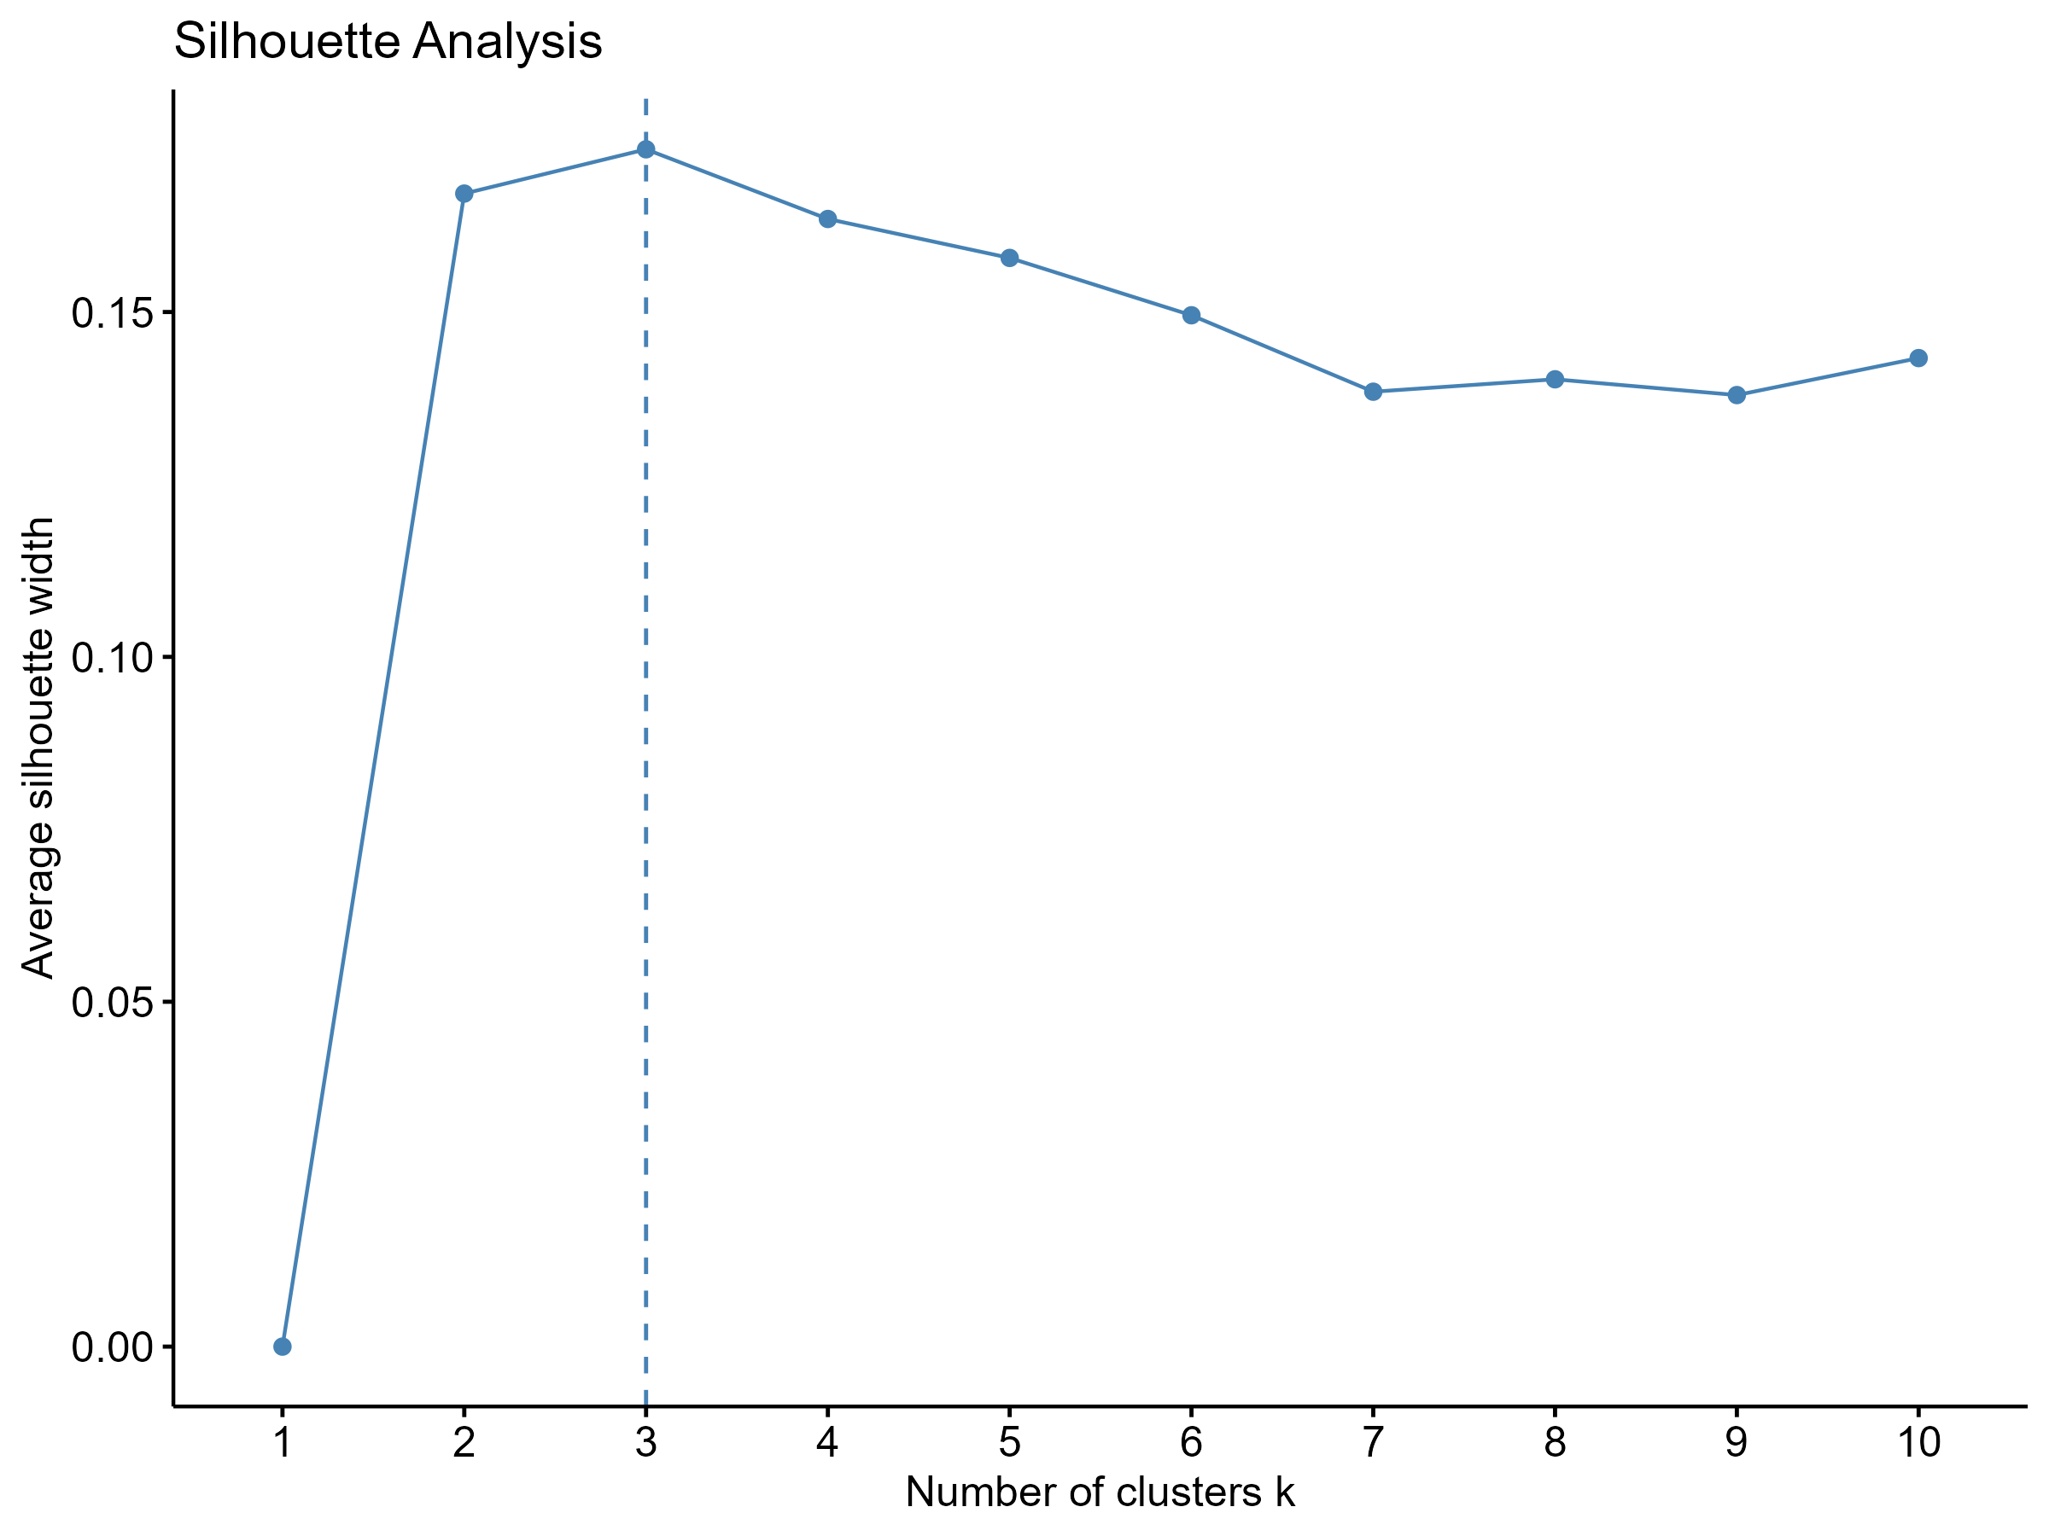
Figure 8. Average silhouette scores; k = 3 gives the highest tested score.
The best silhouette value is relatively low. Accordingly, the clusters are best treated as useful exploratory segments rather than sharply separated natural populations.

7. K-Means Clustering and Digital Behaviour Archetypes
K-Means clustering was fitted with three centres and 50 random starts. Cluster sizes are balanced: Cluster 1 has 164 observations, Cluster 2 has 179, and Cluster 3 has 157.
Cluster | Suggested profile | Screen time | Social media | Sleep | Notifications | Focus | Anxiety | Wellbeing | n
1 | High social-media, high-anxiety | 324.67 | 155.84 | 7.06 | 82.38 | 7.13 | 9.42 | 51.41 | 164
2 | Lower social-media, higher-wellbeing | 359.55 | 87.25 | 6.90 | 69.27 | 7.11 | 6.85 | 58.58 | 179
3 | High screen-time, low-sleep | 398.81 | 125.54 | 5.65 | 88.19 | 6.73 | 9.27 | 46.10 | 157

Table 4. Cluster profiles. Time variables are measured in minutes except sleep, measured in hours.
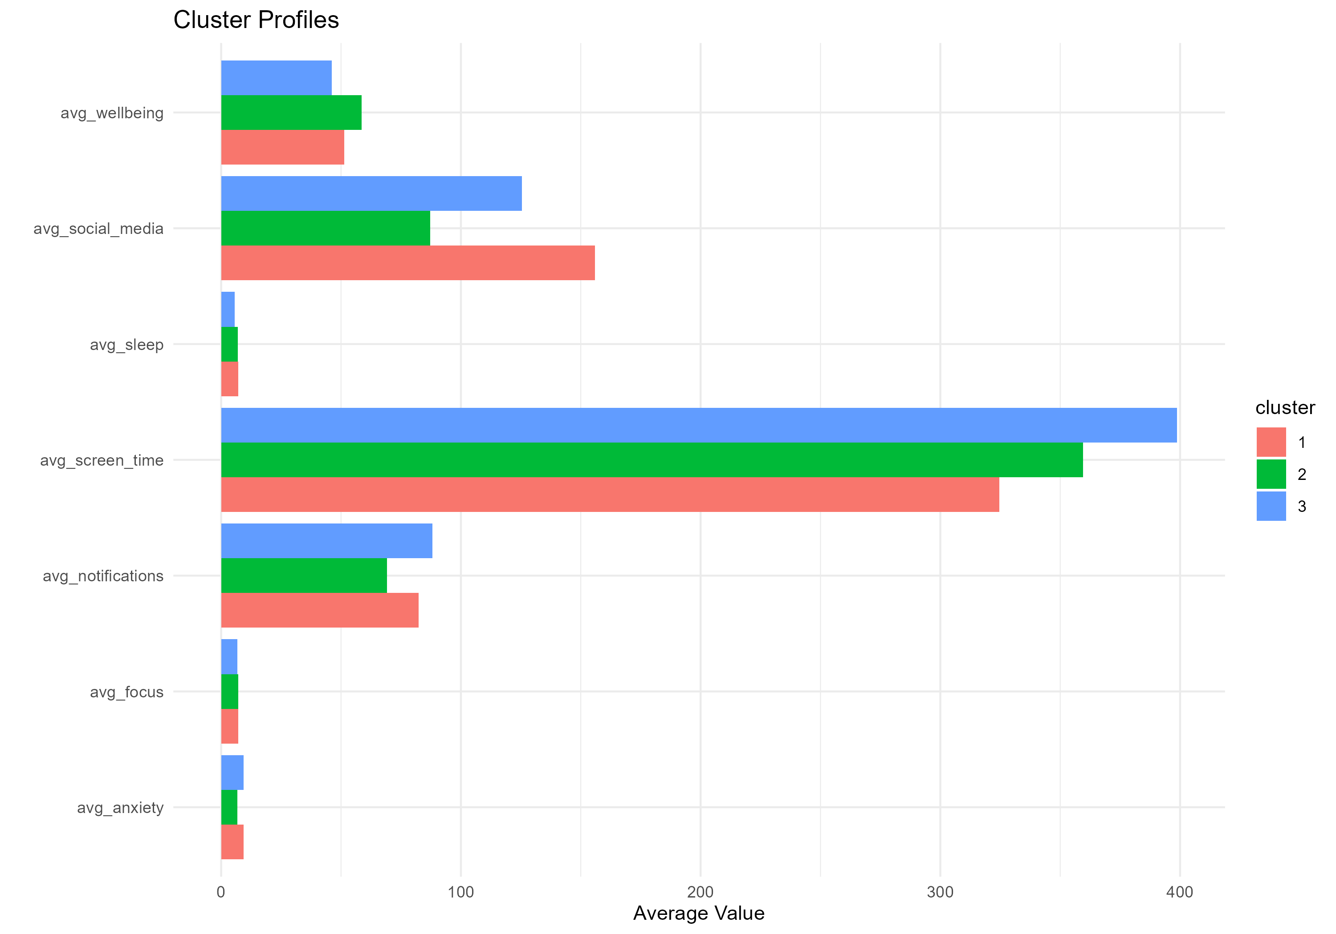
Figure 9. Average values by cluster across selected behavioural and wellbeing variables.

Interpretation of the archetypes
- Cluster 1 has the greatest social-media activity and the highest average anxiety level.
- Cluster 2 has the lowest social-media use and anxiety, together with the highest wellbeing score.
- Cluster 3 has the highest screen time, least sleep, most notifications, and lowest wellbeing score.

8. PCA Visualisation
PCA projects the standardised clustering inputs into a smaller set of components. PC1 explains 29.24% of total variation and PC2 explains 23.73%, so the first two components jointly explain 52.97%. The first five components account for 93.48% of the variation.
pca_result <- prcomp(
scaled_data,
center = TRUE,
scale. = TRUE
)

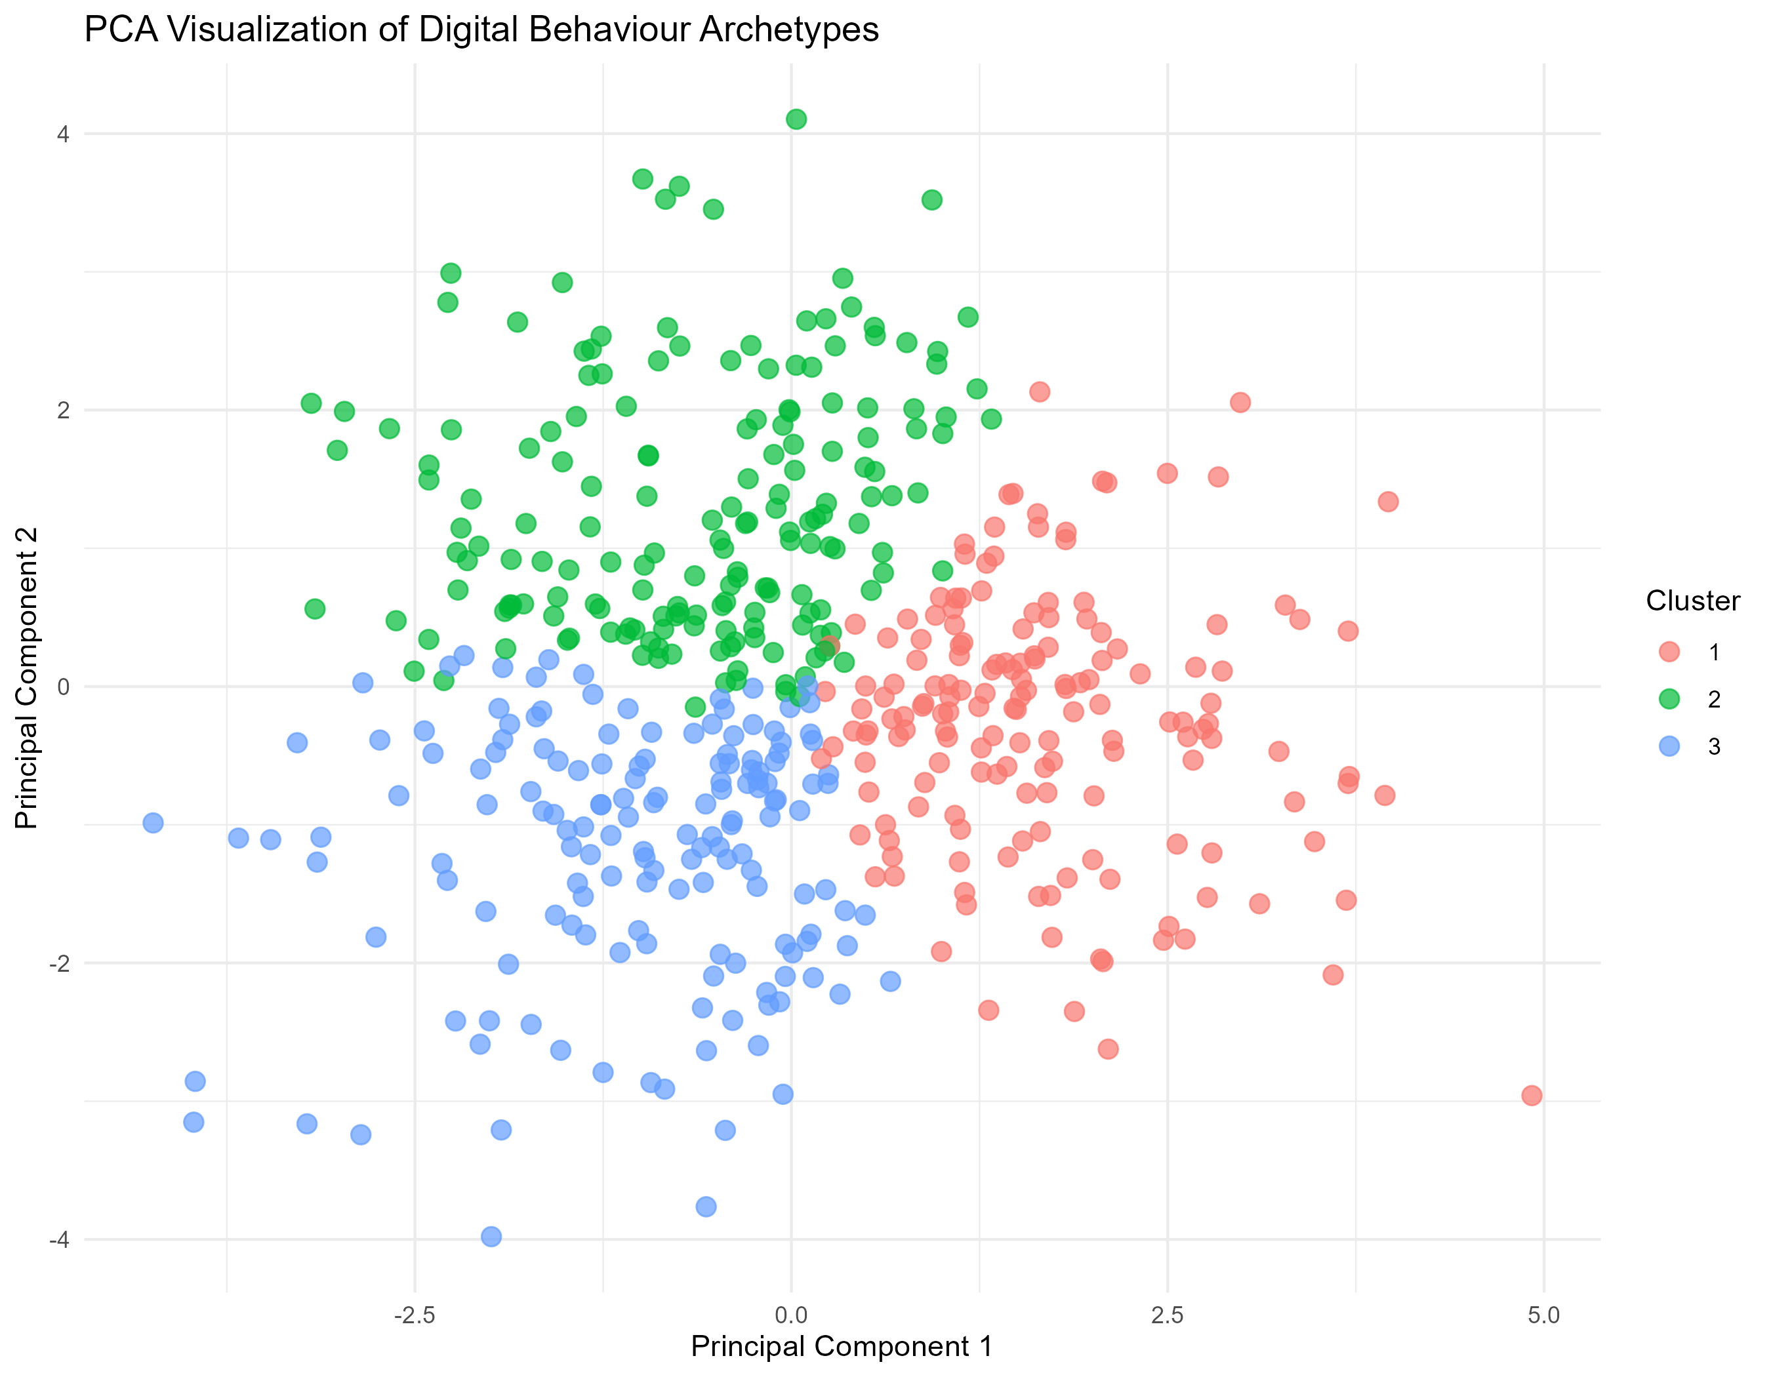
Figure 10. PCA scatter plot of observations coloured by K-Means cluster.
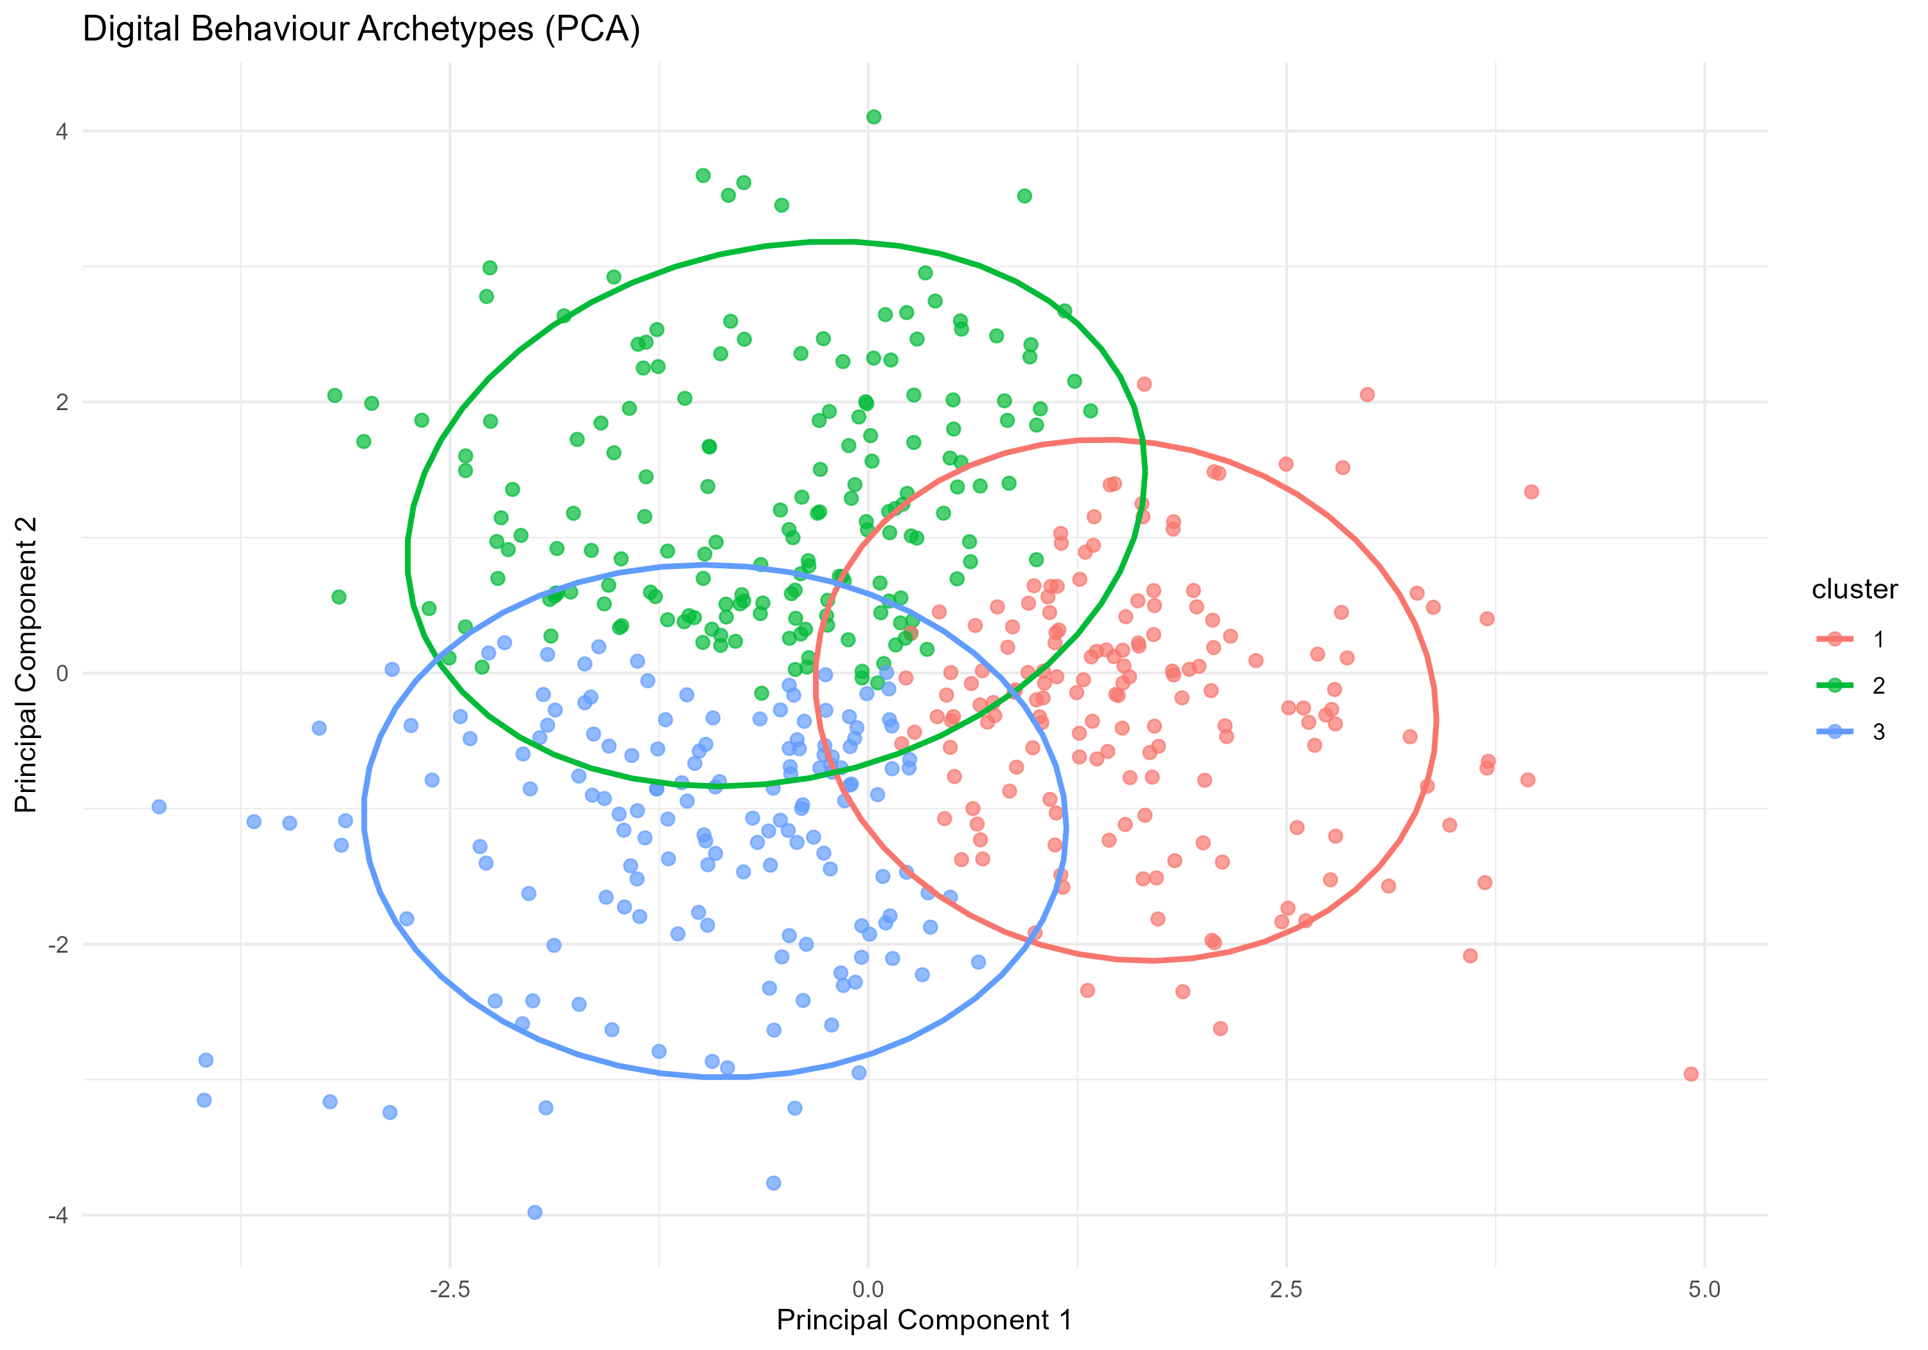
Figure 11. PCA plot with cluster ellipses. Some overlap is visible, consistent with the modest silhouette score.

9. Classification Models
A stratified 80/20 train-test split was used to predict cluster membership from the behavioural features. Two classifiers were evaluated: a Decision Tree and a Random Forest with 300 trees.
train_index <- createDataPartition(
classification_data$cluster,
p = 0.80,
list = FALSE
)
rf_model <- randomForest(
cluster ~ .,
data = train_data,
ntree = 300,
importance = TRUE
)

Model | Accuracy | Kappa | Precision | Recall | F1 score
Decision Tree | 0.8776 | 0.8161 | 0.8807 | 0.8781 | 0.8794
Random Forest | 0.9388 | 0.9081 | 0.9383 | 0.9383 | 0.9383

Table 5. Test-set performance of the classification models.
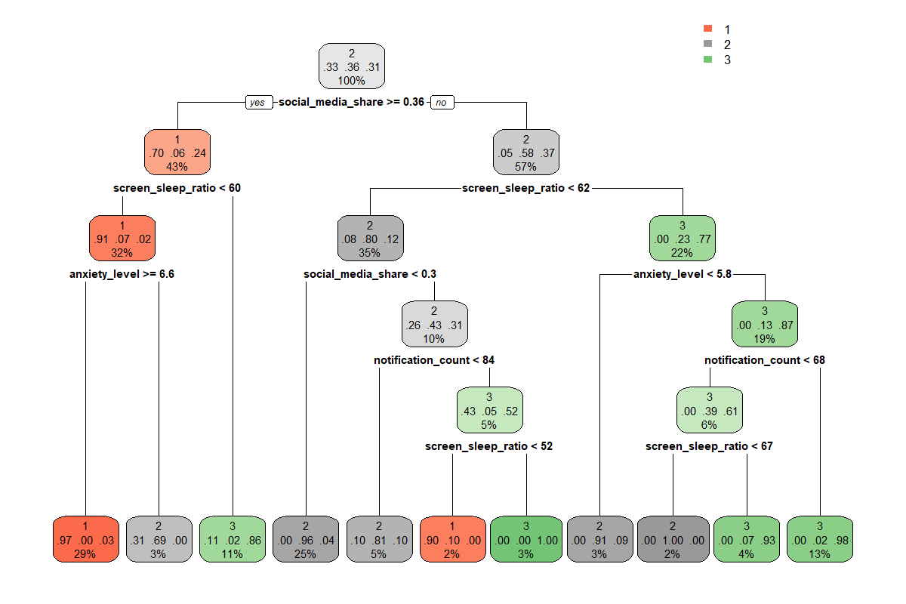
Figure 12. Decision Tree used to predict cluster membership.
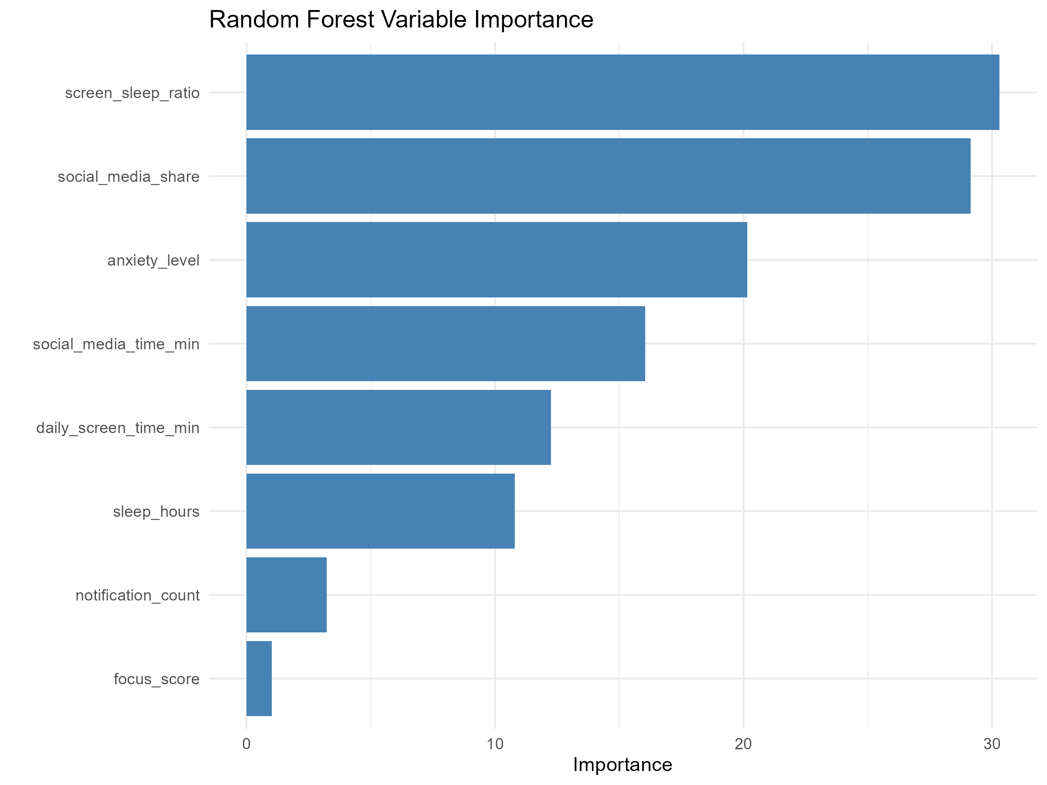
Figure 13. Random Forest variable importance ranking.
The Random Forest model achieved the highest accuracy (93.88%). The screen-to-sleep ratio and social-media share were the two most influential predictors, followed by anxiety level, social-media time, and daily screen time.
Methodological note: the target cluster labels were created from the same behavioural feature space used for classification. The high accuracy therefore shows that the discovered clusters are internally distinguishable using those variables; it is not an independent estimate of real-world predictive performance.

10. Discussion
The results consistently point to the importance of sleep, anxiety, and patterns of digital engagement. Anxiety has the strongest negative relationship with digital wellbeing, while sleep duration and focus are positively related to wellbeing. Cluster 2 illustrates the most favourable average profile, with comparatively lower social-media use and anxiety alongside the highest wellbeing.
Cluster 3 represents the least favourable average profile in this sample: it combines the greatest daily screen time with the least sleep, the highest notification volume, high anxiety, and the lowest wellbeing. Cluster 1 differs from Cluster 3 by having lower screen time and more sleep, but it has the highest social-media activity and anxiety.

11. Limitations
- The analysis is observational and cannot establish causal relationships.
- The generalisability of findings depends on the dataset source and representativeness.
- The maximum silhouette score is modest, so cluster boundaries are not strongly separated.
- Archetype names are interpretive descriptive labels, not clinical diagnoses.
- Classification performance is optimistic for external prediction because labels were produced from the same behavioural feature space.

12. Conclusion
This project identified three exploratory digital behaviour archetypes using K-Means clustering. The strongest wellbeing profile was the lower-social-media, lower-anxiety cluster, whereas the lowest wellbeing profile combined high screen time, low sleep, high notifications, and high anxiety. Random Forest most accurately distinguished the three profiles, with 93.88% test accuracy.
Future work should validate the archetypes on an independent dataset, test whether the segments remain stable over time, and investigate broader contextual variables that may influence both digital habits and wellbeing.

Appendix A. Workflow and Visual Inventory

Analysis workflow
- Data quality assessment
- Exploratory data analysis
- Feature engineering and scaling
- Selection of cluster count
- K-Means clustering
- PCA visualisation
- Decision Tree classification
- Random Forest classification
- Model evaluation

Figures included
- Distribution plots
- Boxplots
- Correlation matrix
- Screen time versus wellbeing
- Social-media time versus anxiety
- Sleep category versus wellbeing
- Elbow plot
- Silhouette plot
- Cluster profiles
- PCA scatter plot
- PCA cluster ellipses
- Decision Tree
- Random Forest variable importance
Source: project scripts, generated tables, model outputs, and figures supplied with the Digital Behaviour Archetypes project.

