# Abstract

Decommissioning of conventional power plants and the installation of inverter-based renewable energy technologies decreases overall power system inertia. This reduction in system inertia has an impact in the power system frequency response when an imbalance between generation and load occurs, increasing the rate of change of frequency (RoCoF) of the system. In a future scenario where renewables are predominant in power systems and due to the natural variability of the resource, imbalances of 40 percent or more are prompt to happen. When a system is islanded or operates as such and combined with low inertia, it may lead to frequency collapse. This expected high values of RoCoF shorten the response time needed before load shedding or generation curtailment take place and a subsequent possible black out occurs. Through the simulation of two scenarios with different primary reserve response, the requirements for the fleet of connected inverters was determined in terms of activation time and total power to be provided in order to avoid load shedding. This activation time was determined to be the time at which frequency would reach the load shedding value, known as critical time. With such value and knowing the time required for the synchronous reserve to deploy the imbalance power, a simple expression based on nullifying RoCoF at the critical time was obtained for the required inverter based fast power reserve. It was obtained that full activation time for inverter fast power reserve with penetration above 80% of inverter based generation would need to be between 50-500 ms for imbalances up to 40%; meaning that current frequency measurement techniques and renewable deployment times would not ensure system stability under the foreseen future possible power system conditions. A power ramp in the order of 300% the load per second is necessary for fast power reserve to maintain frequency within the allowed limits.

# Introduction

As part of the international efforts set to counteract global warming, the deployment of renewable energies in the electric sector has been considered an energetic priority as a measure to reduce CO2 emissions. This objective is also reflected in the regulatory energy policies and plans of some countries. For instance, in Germany the transformation of the electricity sector through renewables, known as “*Energiewende*”, contemplates to achieve a share in electricity consumption from renewables of 80 percent [3]. As part of it, the renewable energy act, “*Erneuerbare Energien Gesetz*”, regulates the expansion of renewables and decommissioning of convectional generation.

Even though power systems have grown in size and complexity, frequency control has been always performed through power balancing between generation and demand due to synchronous generator characteristics. The variation of load during a given period of time is followed by a change on the prime mover power of the synchronous generator. When an imbalance occurs, the excess or lack of power is injected to or released from the kinetic energy in the rotor. Therefore, the magnitude of the rate of change of frequency (RoCoF) during an imbalance is inversely proportional to the system’s inertia.

Decommissioning of convectional generating power plants and its replacement with inverter-based renewables power plants has as an effect a reduction of system inertia and consequently increasing values of RoCoF. The relevance of system inertia is to avoid rapid changes in frequency as load-generation imbalance occurs; in this way enough time is given to the activation of primary power reserve to recover balanced stable conditions. Therefore the need of new frequency control strategies is evident in this context; where inverter-based generation has a significant share in the grid. Due to the expected higher values of RoCoF, load shedding caused by low frequency and generation curtailment due to over-frequency may occur faster than nowadays grid configuration. Hence, the participation of non-synchronous generation in providing frequency support ancillary service is a key factor in achieving high integration of renewables without jeopardizing power system reliability.

So far, some ancillary services have been included in inverter’s capabilities; inverter based generation from PV has been employed to contribute to voltage regulation by meanings of providing reactive power into the grid at cost of some active power. Similar approaches have been implemented for over frequency limitations, by curtailment implementation and ramping limitation of inverters when system frequency approaches an upper limit allowed by local codes [4, 5]. In the same sense, new techniques have been developed in order to enable inverter based generation, such as PV and Wind, to also participate in frequency support for under-frequency cases. The most common techniques try to emulate the droop power-frequency characteristic of the synchronous machine by leaving some power headroom during normal operation, so when a system frequency sag occurs, the inverter is able to push part or the total available power headroom to counteract the frequency drop [6]. Hence renewable sources are not any longer operating at its maximum power point, therefore these methods also have some economic constraints. Another approach to limit the frequency drop during the seconds after the event leading to a frequency decay, is to mimic the inertial response of synchronous machines. Since PV systems do not count with rotating masses, this approach is only achievable with wind turbines and called synthetic or hidden inertia ref. Due to the decoupling of wind turbines from the grid dynamics, modified control strategies in the power electronics allows the controller to extract part of the stored kinetic energy in the rotating masses of the wind turbine [6].

In this investigation the conditions, which should be fulfilled by inverters in highly penetrated grids by non-synchronous generation, to provide an inverter based fast power reserve (IBFPR) are investigated. Then the required triggering time and power response to avoid under-frequency load shedding (UFLS) in such kind of islanded grids are estimated. Over-frequency phenomenon is treated with the same approach as the under-frequency case. The alternative of synthetic inertia is evaluated to see how effective it is under some assumed future scenario conditions. With the consideration of two cases, a benchmark taken as a micro-grid and an electric island in the European scale; a methodology to determine the requirements of the fleet of inverters to offer frequency support is developed. The subsequent chapters will be covering the following content: Chapter 2 corresponds to the literature related to power system operation and primary reserve. Here an overview to the aspects behind the operation of typical power systems is presented, as well as how frequency is stablished and controlled. Additionally, the influence and contribution from inverter based generators is noted. Chapter 3 presents the methodology to estimate the power rate needed to avoid transient frequency instability. The developed method and expression for power rate are then evaluated in two cases: A micro-grid with fast primary reserve response and an electric island in a European scale with relative slow primary reserve response. A detailed demonstration of parameter setting and assumptions is presented as well. The simulation results of the implemented method in each scenario is then shown in Chapter 4; critical times, frequency nadir and power responses are obtained. A detailed discussion and analysis of the main features and trends observed in the results section, is then followed in Chapter 5. The main conclusions and areas for future work are outlined in Chapters 6 and 7 respectively.

# Methodology

As it was explained in chapter 2, the transitory frequency response of the system and therefore its stable and reliable operation after a perturbation, depends on the inherent characteristics of the power system (system inertia) and the counteraction measurements engaged automatically by the system (primary reserve). As the share of inverter based generation increases, the more sensible to instability the power system becomes. In this sense the added inverter based fast power reserve (IBFPR) must be capable of maintaining transitory frequency value within the allowed limits.

Two terms commonly found in the literature of power system stability will be used along this section:

* Inertia constant H: It has units of seconds (s) and it is the ratio of the kinetic energy stored in the rotating masses of the generators (*Ek* in MWs) and its nominal capacity (*Snom* in MVA).
* Acceleration time constant Ta: It also has the units of seconds (s) but this is the ratio of double the kinetic energy (MWs) and generators nominal power output (*Pnom* in MW).

Acceleration time constant is a measure of the robustness before disturbances of the system. It could be interpreted as the required time to remove the kinetic energy from the rotating masses of the generators connected in a grid, at the rate of the supplied power load. Hence the higher the time constant, the higher the kinetic energy available. Nowadays Europe’s acceleration constant is around 14 seconds [1]. As the share of synchronous generations decreases, this constant decreases proportionally.

With *f* as frequency, *f0*as nominal frequency and *ΔP* as power imbalance the swing equation can be expressed as follows:

**Equation 3‑1**

To describe the penetration of inverter based generation into the grid, these terms can be related to the overall power system. Even though the inertia constant *H* is most commonly used in the literature, the term of system acceleration time constant *Ta* is used instead when the penetration of non-synchronous generation in a power system is evaluated ref this due to the fact it relates the load real power term (MW).

In this section the steps and methods applied in order to calculate the required Inverter Based Fast Power Reserve (IBFPR) to maintain frequency stability are presented as well as the inclusion of control strategies to enable wind turbines in the power system to provide inertial power.

**Synthetic Inertia**

Synthetic inertia was explained in chapter 2 as one of the new techniques that manufactures and researchers are considering to tackle with the low inertia problem in power systems [23, 24]. Frequency support through synthetic inertia was considered with the following assumptions [6, 25]:

1. Power output from synthetic inertia is limited to 10% of wind turbine nominal power.
2. Due to mechanical and thermal stresses, the additional power can be delivered only for a maximum time of 10 s.
3. It’s assumed that all wind turbines operate at its maximum power output. The value of 1.5 MW was selected for such purpose.
4. In order to avoid wind turbine stall, the removed kinetic energy from the blades (injected to the grid in electrical form) it is limited to half [26].

To be able to extract energy from the rotating blades of the wind turbine, an adequate control system is needed. From the expression of power as the derivative of energy and the kinetic energy stored in the blades, the rate of energy extracted from the wind turbine can be obtained, considering that rotational speed changes in time.

; ;

**Equation 3‑4**

Where *Ek* is kinetic energy, *Hwt* is the turbine inertia constant, *w* the rotational speed, *Swtc*is turbine’s nominal power and *Jwt* the turbine inertia.

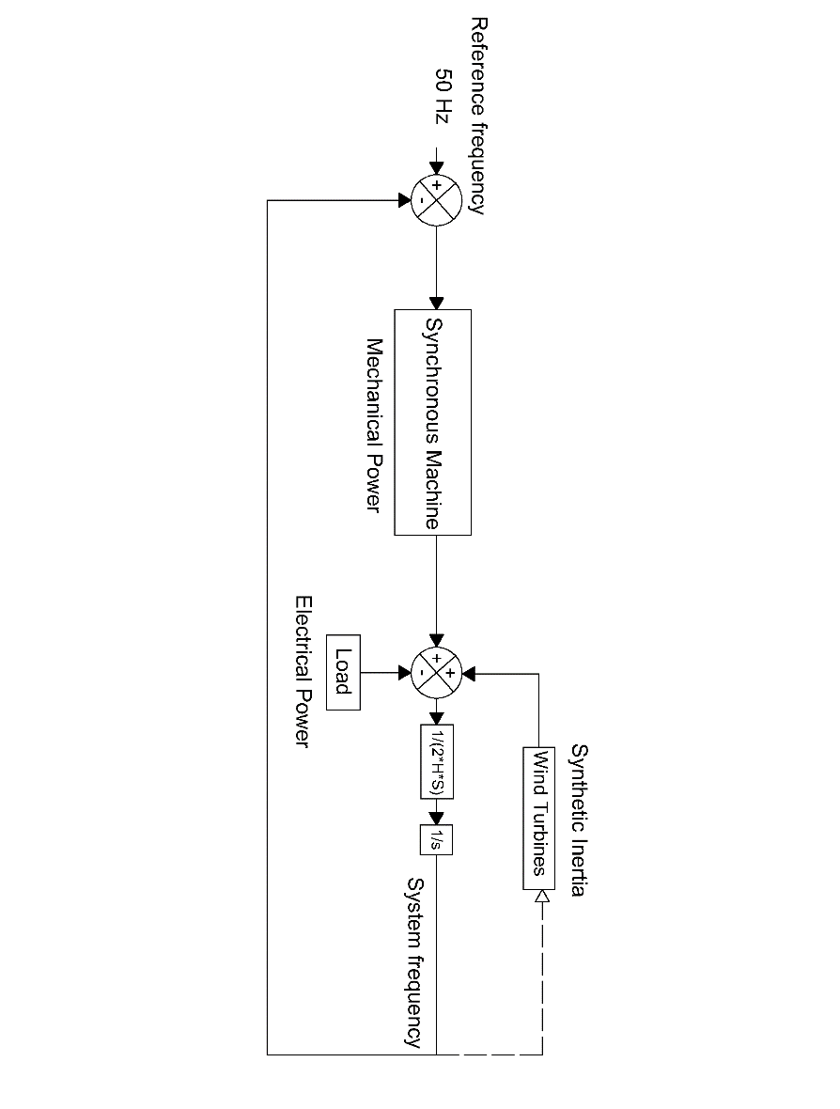

**Figure 3‑8: Implementation of synthetic inertia in the simplified IEEE model.**

**Equation 3‑4** represents the rate of change of kinetic energy extracted from the rotating masses of the wind turbine in per unit. The implementation of such equation in SIMULINK is shown in **Figure 3‑9**. Additionally, a gain block *Ki* was added in order to inject more power from the very beginning of the power imbalance. A filter at the signal entrance was added in order to suppress non desired oscillations on the system [24, 25].

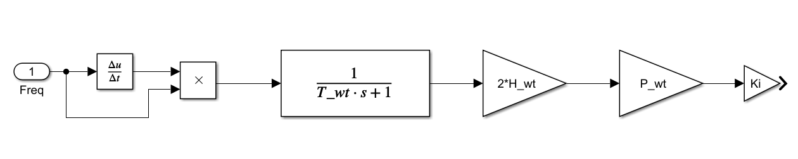

**Figure 3‑9: Synthetic inertia control model where Twt is the filter constant, Hwt is the turbine’s inertia constant, Pwt is the nominal wind capacity (MW) and Ki is a gain constant. Frequency input in pu and system output is power in MW.**

Typical values for inertia constant of wind turbines are not openly available from the manufacturers to the public. Hence an approximate value was calculated with the utilization of an equation which relates nominal power and inertia constant for wind turbines [27].

**Equation 3‑5: Wind turbine inertia constant as function of the nominal power in MW.**

For a wind turbine with nominal power output of 1.5 MW the value of *H* corresponds to 4.37 s, which is in an acceptable range [28].

It is assumed that all the wind turbines, when operating, are delivering their nominal power output. A nominal rotational speed of 18 rev/min was considered [28]. To avoid the wind turbine to stall, only a reduction of 5 rev/min it is allowed by the implementation of the control system. This change of rotational speed equals a change of 3 MWs reduction on kinetic energy out of a total of 6 MWs.

**Table 3‑1: Constants for implementation of synthetic inertia.**

**Inverter based fast Power Reserve**

**Figure 3‑1** depicts the typical frequency response when a negative power imbalance occurs in a power system. If the imbalance is high enough or the system inertia is too low, the initial RoCoF can lead to frequency excursions below the UFLS value. The value of RoCoF is brought to zero normally by the action of the primary reserve; equalizing the power imbalance assuming no load frequency dependency. At this time the minimum value of frequency (frequency nadir) is reached as well.

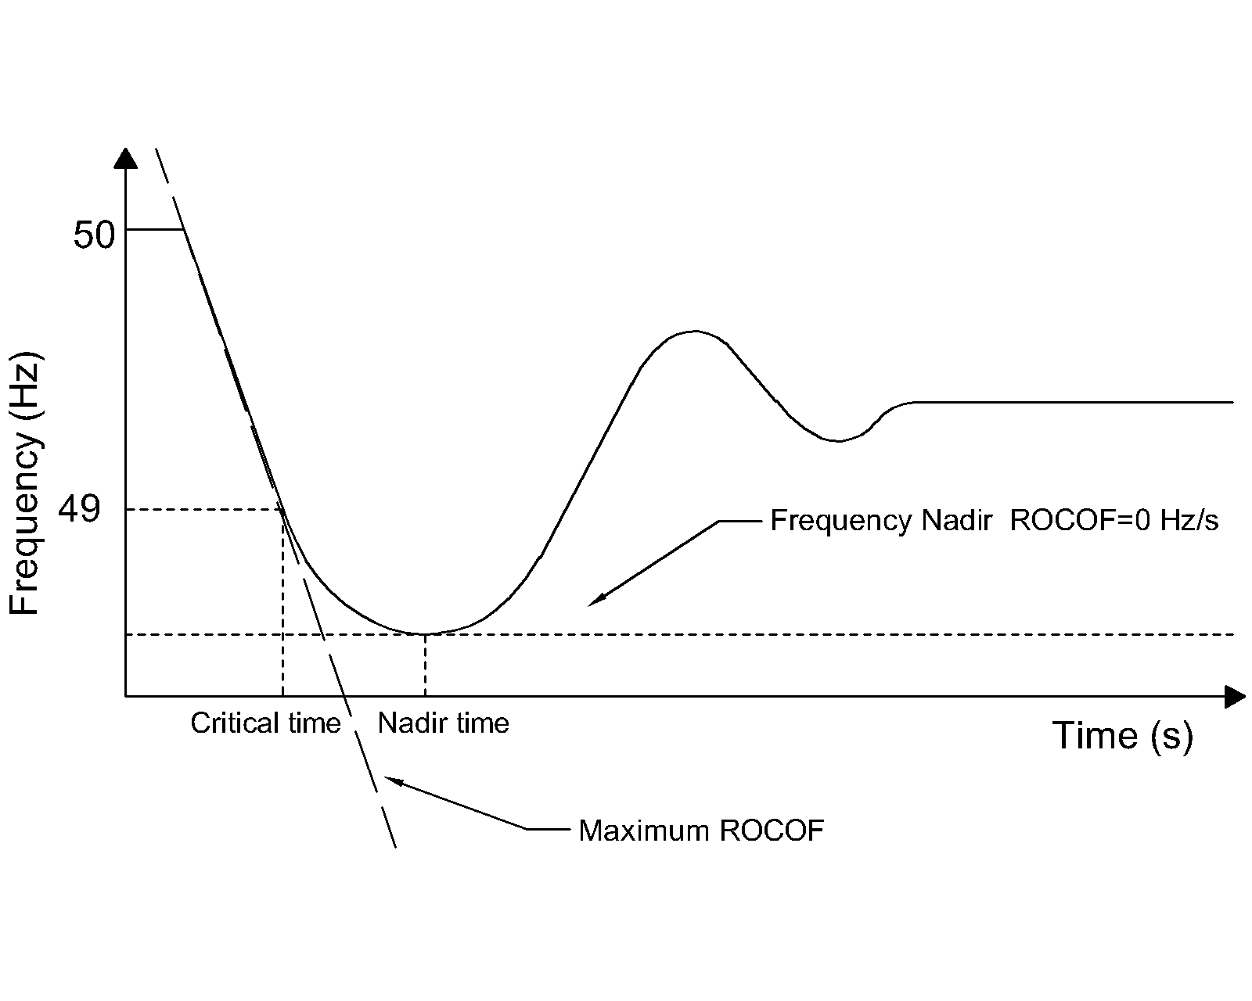

**Figure 3‑1: Frequency response of a typical power system subjected to a severe negative power unbalace.**

When it is assumed that no load is rejected at UFLS frequency, the frequency continues dropping below 49 Hz. The time at which the system frequency equals the UFLS value is called in this thesis as critical time. This is the maximum available time for the inverter based reserve to deploy the required power to the system.

In the critical condition that would lead to load shedding, it is expected from the IBFPR to at least counteract the ROCOF at the critical time, as illustrated in **Figure 3‑2**.

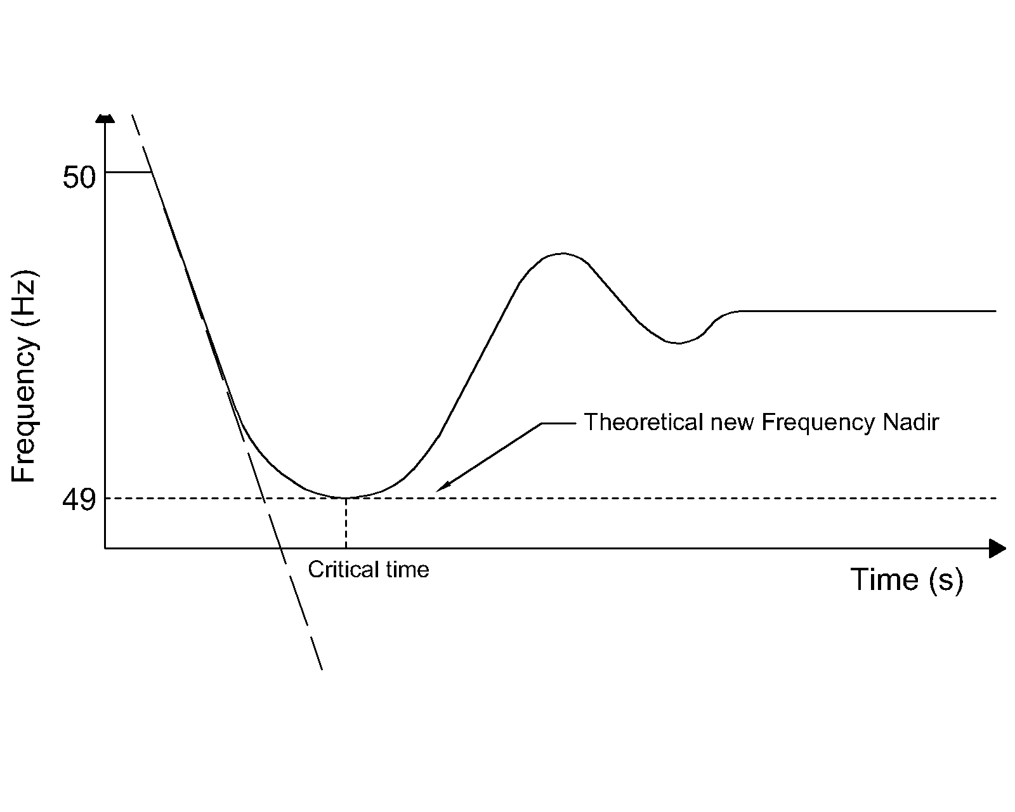

**Figure 3‑2: Expected power systeem frequency response with the addition of Inverter Based Fast Power Reserve.**

Recalling **Equation 3‑1**; it is necessary that the machine’s accelerating power (power imbalance) become zero at the critical time.

**Equation 3‑1**

Where *Pa* is accelerating power, *Pmech* is mechanical power, *Pelec* is electrical power (load), *tcr* is the critical time and *PIBFPR* is inverter based fast power reserve.

Typical primary power reserve response follows the indicated behavior shown in **Figure 3‑**. Conventional turbine governor response is frequency dependent and may not respond linearly. For the estimation of IBFPR it was assumed a linear power deployment over time until the critical time. Inspecting **Equation 3‑1**; it can be notice that only the power imbalance determines the rate of change in frequency in the system along with the kinetic energy stored in the rotating masses of the generators. For this reason the analysis is focused on the change on mechanical power after the event, ignoring the electrical load and mechanical power in the stable operation before the perturbation.

From the assumption of a linear mechanical deployment given from the synchronous machines governors, the rate of change in mechanical power, after a power imbalance ΔP, is given by *ΔP/tnadir*, where *tnadir* represents the time at which the frequency nadir occurs. Given the power balance **Equation 3‑1** at the critical time, *tcr*; the IBFPR response must be equal to *Pelec-Pmech*, being *Pelec* equal to *ΔP*. **Figure 3‑** illustrates the behavior of both responses together. The sum of both at critical time counteracts power imbalance.

Substituting *Pmech* by *ΔP* tcr /tnadir* and *Pelec* by *ΔP* in **Equation 3‑1**, the following expression is obtained for the PIBFPR at time *tcr*.

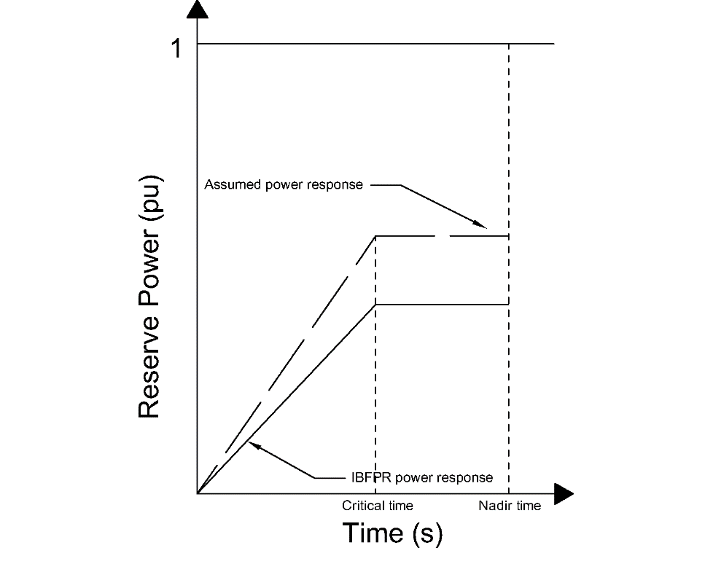

**Figure 3‑4: Assumed primary power reserve and IBFPR.**

Synchronous primary response

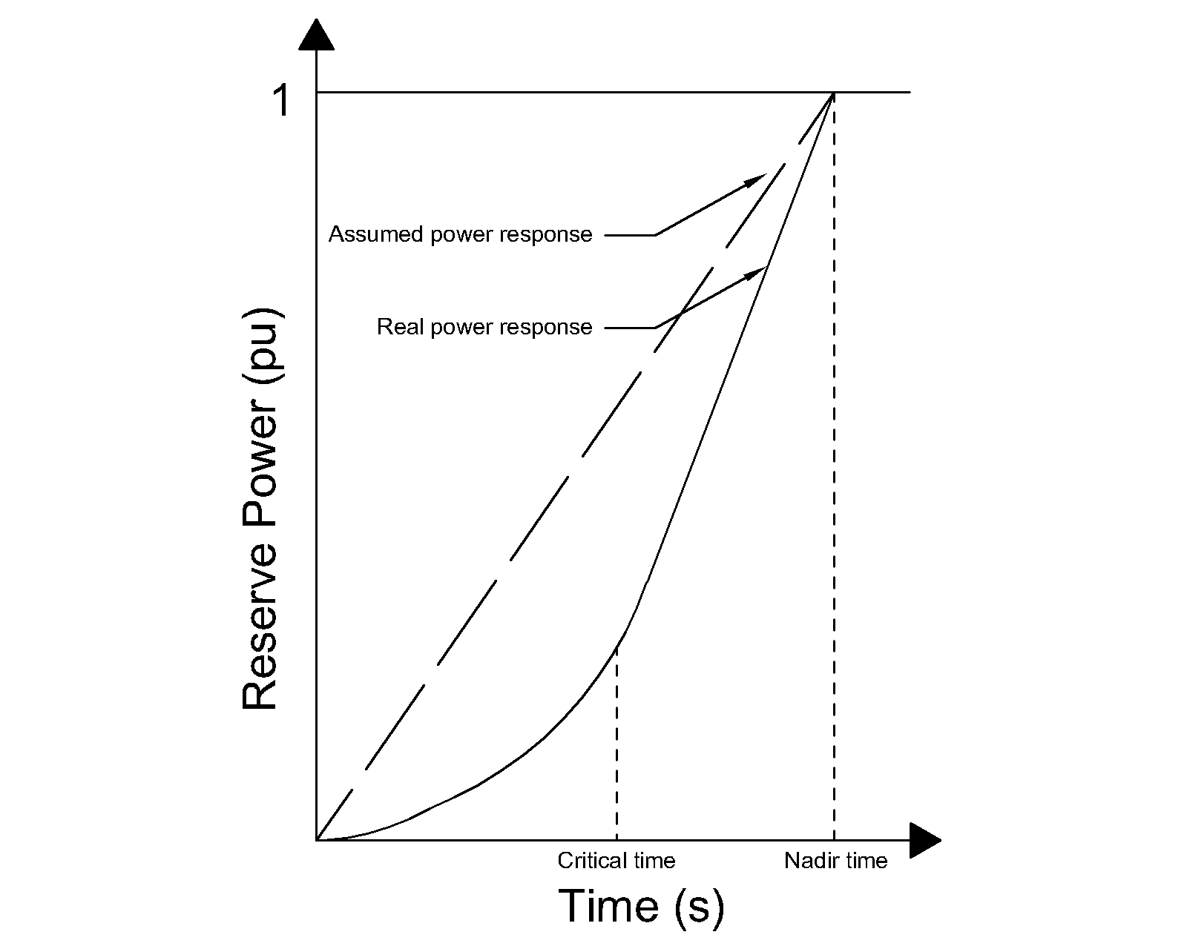

**Figure 3‑3: Comparisson of assumed power reserve deployment and typical real response.**

**Equation 3‑2**

It is assumed that *PIBFPR* remains with a constant power output after *tcr* long enough to stabilize the system frequency. The result of the previous equation represents the slope of the power output since the inception of the incident until the critical time, which with the implementation of IBFPR, it will be not any longer critical but rather it will be the new desired frequency nadir time.

**Equation 3‑3: IBFPR before critical time.**

The positive value of **Equation 3‑3** represents the injection of fast power response from renewables or storage to counteract frequency drop below of the load shedding frequency setting of 1 Hz below nominal. Nevertheless when there is an over-frequency phenomenon with surplus in generation, the negative value of **Equation 3‑3** can be taken as the power rate required to limit over-frequency to no more than 1 Hz above nominal. Similarly, critical times would apply for upper and down frequency thresholds.

According to the obtained expression; it can be realized that the desired power response from the inverters depends exclusively on parameters which cannot be directly measured from the grid connection point. In a real situation the values of *ΔP*, *tnadir* and *tcr* cannot be known in advance, representing this factors a challenge in the implementation of this ideal power response. Those values are dependent on the grid characteristics; depending on the primary conventional reserve deployment time and the overall system inertia [18]. Thus two main cases are considered for the remaining analysis with the intent of covering a wider range of systems with different characteristics.

**Simulation Cases**

As presented in the previous section, the values of critical time and frequency nadir time depend on the system imbalance and primary reserve deployment time. In chapter 2 it was illustrated the different governor response for different primary reserve type. To be able to assess the influence of the grid size and the primary reserve characteristics, two main cases are considered. In all cases is assumed that the initial steady frequency is the nominal 50 Hz.

* Small scale grid scenario: For the evaluation of this case; typical governor data is considered in a well-known and studied benchmark grid topology as the WSCC model, also known as the IEEE 9 bus model. Synchronous reserve deployment time in the order of ~3 s due to governor response [7, 11]
* Large scale grid scenario: The European island scale all synchronous machines are modeled and simplified as one single machine, provided with the characteristic expected from the overall system. Synchronous primary reserve deployment in the order of ~30 s [1, 19]

### Scenario Summary

**Small Scale Grid Case**

Implementation of individual governor response to generators.

Scenario A-Simplified Model: One machine, one load and no losses representation to the IEEE 9 bus model.

* Determination of critical time.
* Determination of IBFPR and impact of SI and frequency measurement delay in frequency response.

Scenario B-Extended Model: All the power system components (transmission lines, transformers, exciters and governors of the three generators) and its dynamic characteristics are considered in the IEEE 9 bus model.

* Determination of critical time.
* Influence of the full dynamic grid model.

**Large Scale Grid Case**

Case-Split operation: Analysis with imbalances up to 40% with variation of primary power reserve deployment in 30 s in an islanded system. Island frequency response is assumed to be the same that the European response analyzed by ENTSOE.

* Determination of critical time.
* Determination of IBFPR and impact of SI and frequency measurement delay.

**Simplified IEEE 9 bus Model**

Microgrids can operate connected to the bulk transmission/distribution system or stand alone. In any case, it is assumed that imbalances could occur due to internal faults when island configuration is considered or islanding from the external system results from a contigency while a considerable amount of power load of the microgrid was being ‘imported’ or ‘exported’. For the study of power systems and the increasing interest in stability analysis in micro-grids, the IEEE benchmarks represent a widely used option, based on some real data. This is also the case of the IEEE 9 bus model or WSCC (Western System Coordinated Council). The IEEE 9 bus model is a representation of the former western interconnected power system of North America of 1967. For stability and reliability studies, this system has been employed in many publications as study case [20], which allows the comparison of results. **Figure 3‑3** illustrates grid’s configuration.

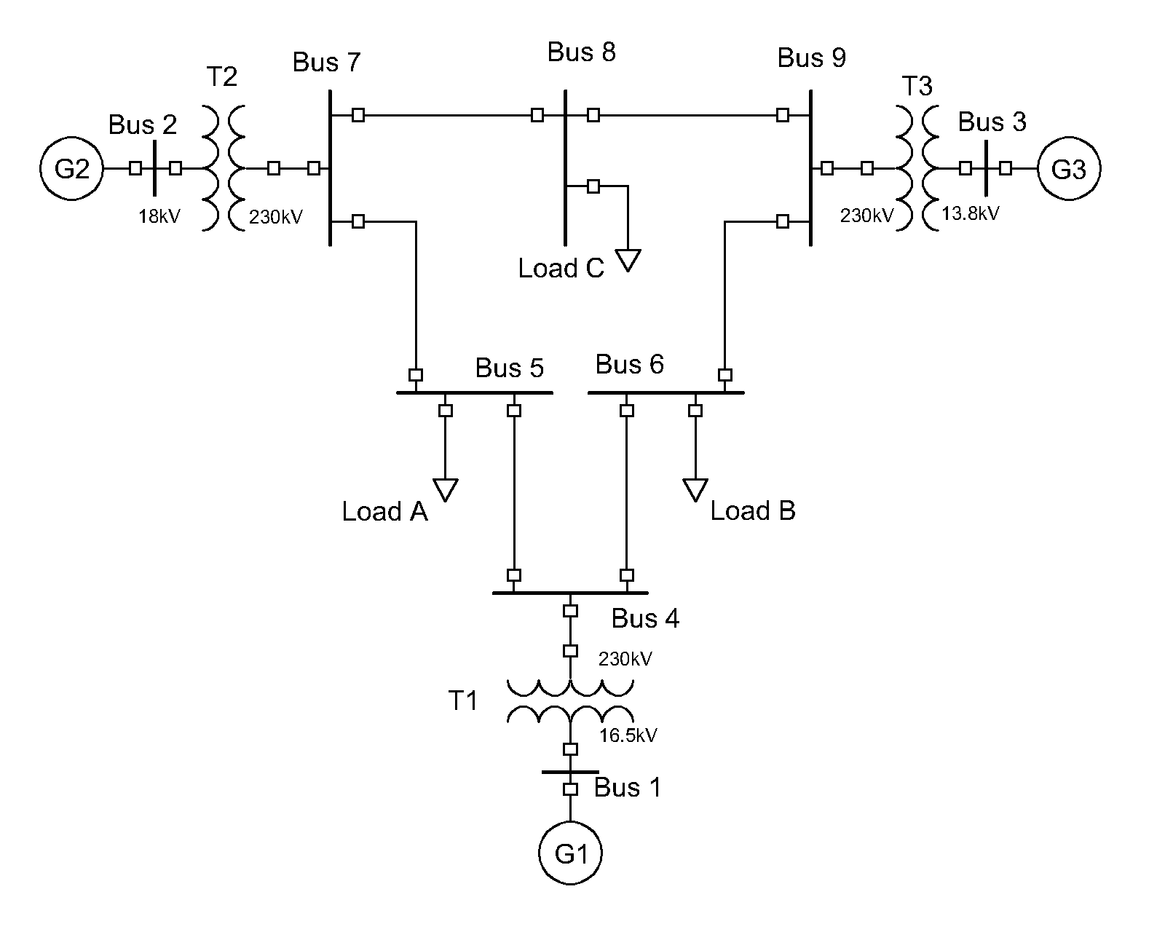

**Figure 3‑3: WSCC or IEEE 9 bus model used for stability studies.**

|  |  |
| --- | --- |
|  | Quantity |
| Buses | 9 |
| Transformers | 3 |
| Transmission lines | 6 |
| Generators | 3 |
| Load | 3 (315MW total) |

As a first step to evaluate the impact of inverter based generation and power imbalances in the grid, the whole system is simplified as one single generating unit; neglecting all losses in the system (Transformers, transmission lines and generators) with the assumption that the mechanical output of the prime mover is the same than the electrical power output at generator terminals. A schematic representation of such system is presented in **Figure 3‑4**.

**Figure 3‑4: Single machine representation of the IEEE 9 bus model.**

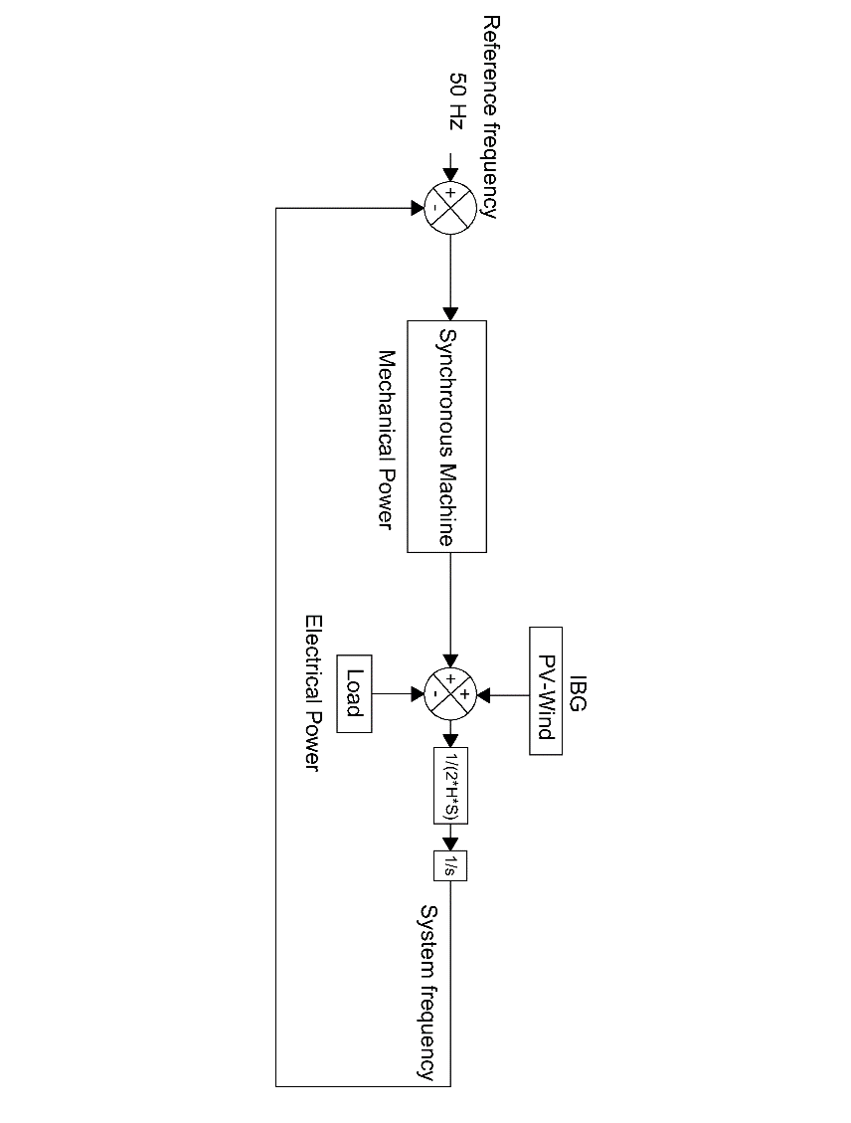

**Figure 3‑4** is the block representation of the swing equation, it only differs in the fact that a source representing the inverter based generation has been included. This power source output would typically remain constant during an imbalance. The mechanical power is represented by the output of a steam turbine governor model, which is used to represent the synchronous machine [8]. The addition of the former sources represents the total generation. When steady state conditions are met, the accelerating power resulting from the subtraction of the load from the total generation is zero. When equilibrium is lost, the accelerating power is multiply by the transfer function *1/(2*H*S),* where *H* is the machine’s inertia constant and *S* is the machine’s power rating. From **Equation 2-1** this product equals the derivative of frequency, therefore an integrator block, denoted by *1/s* is added to obtain the frequency response [7, 21, 22]. A feedback loop is added and an error signal obtained from the reference frequency so the synchronous machine can react as frequency deviates from nominal. The step response of the governor model under a three different penetration of non-synchronous generation is presented in **Figure 3‑5**. From that, rise time is between 1.14-3.24 s.

The values of kinetic energy and time constants of a synchronous machines of 835 MVA were selected to represent the synchronous response, with the load of 315 MW the system acceleration time constant is 14 s [8], which is approximately today’s Europe acceleration constant [1]. This is the base scenario, assuming 100% synchronous generation. To evaluate the impact of the penetration of inverter based generation; the values of lower capacity generators were selected [8], assuming the compensation of the remaining power by a constant power source representing the inverter based generation, decreasing in this manner the total system acceleration time constant, thus the kinetic energy of the generator. Up to this point, neither synthetic inertia nor frequency support from renewables is considered. Inverter based power output remains constant before, during and after the perturbation. Therefore the system imbalance is covered only by the synchronous equivalent machine.

**Figure 3‑6: Kinetic energy stored in generator rotating masses as function of generator capacity. A linear relation is exhibited between the machine capacity and its store kinetic energy .**

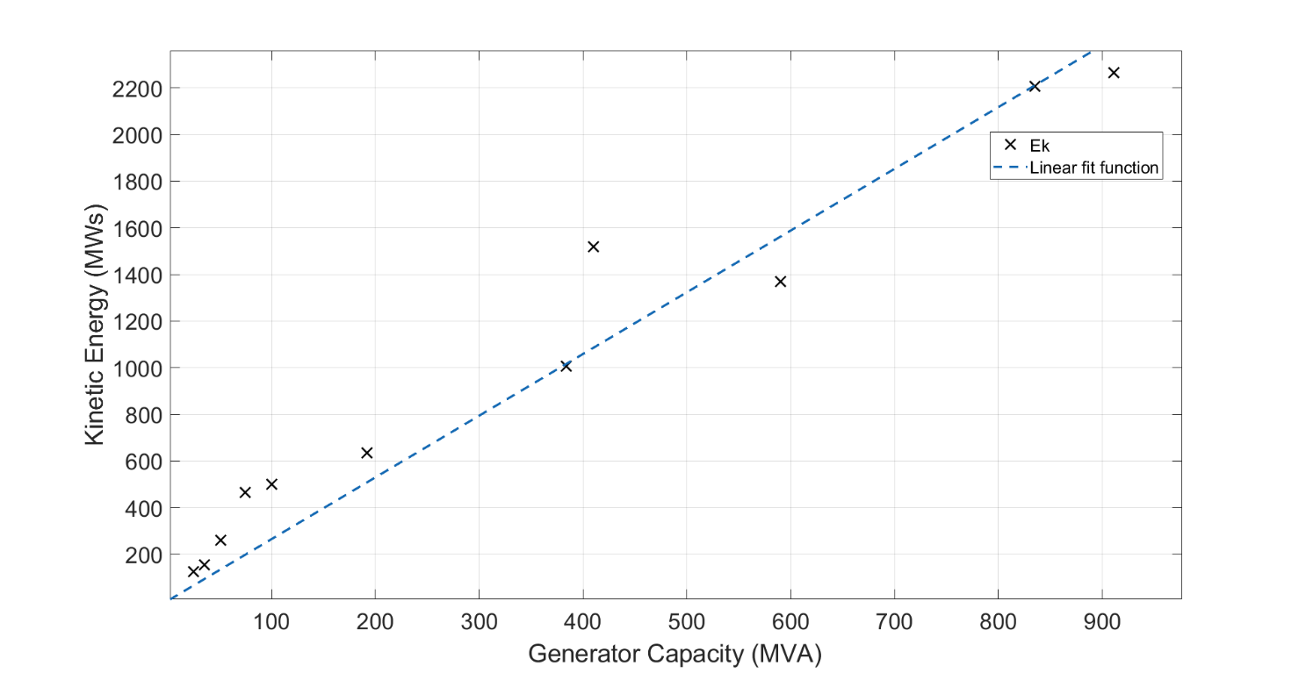

Even though load imbalances up to 40% were simulated in each inertia scenario, the power capacity limit of the generators was disregarded for estimation of the critical time. The negative imbalance was simulated by increasing the system load by the corresponding factor. A block diagram representing the system in the given conditions was designed in MATLAB-SIMULINK. With the help of a MATLAB code several simulations were run and the critical and nadir times acquired for each scenario. With the calculated times, the IBFPR to avoid load shedding under each scenario was calculated as given by **Equation 3‑3** and it is shown in the Results section.

All the acquired values of critical time, as result from the simulations, are then related with the system RoCoF, so a regression can be performed and link the critical time with system RoCoF.

For the system conditions and the employment of the fitting tool provided by MATLAB, an expression is obtained for critical time as a function of RoCoF.

As it will be detailed shown in the result section, for unstable conditions the maximum critical time is 2.7 seconds. Therefore critical time must be lower or equal to that value; calculating in this way that the minimum RoCoF for activation as 0.6143 Hz/s, when the fitting equation obtained from the regression is used.

**Extended IEEE 9 bus Model**

It was previously stated that in the first approach, only the total load was considered in the simulations as well as the synchronous generation represented by one single machine and no system losses. Since it is desired to compare the results of the system with such simplifications against some model that takes into account the whole system components, losses and dynamics; An extended representation of the IEEE 9 bus model was implemented in SIMULINK [20]. In this representation, simulations for different values of system inertia and load imbalance were performed, similarly as it was done with the simplified representation of the model. **Figure 3‑11** shows the extended IEEE 9 bus grid architecture with IBG added.

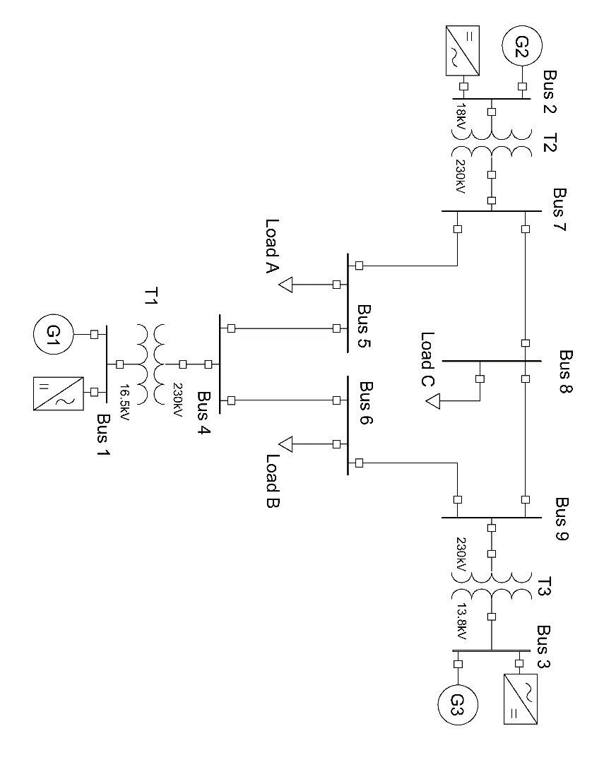

**Figure 3‑11: IEEE extended model with IBFPR implementation.**

In order to evaluate the validity of the equation describing the IBFPR needed to avoid ULFS, the Extended model was modified with the insertion of ideal controlled power sources blocks, which were set up to inject power into the grid accordingly to the simulated scenario. Therefore, no means of frequency measurement were included and only IBFPR was assessed.

### System settings for stability study

Since it is desired to compared the complete representation of the IEEE 9 bus model against the simplified model representation; it is assumed in the same manner that the total acceleration time constant of the system equals 14 s, similarly as in the block representation. Hence the same kinetic energy should be distributed among the three generators rotating masses in the extended model as in the simplified representation. From **Equation 3‑6** for system acceleration time constant, it can be easily calculated that the system kinetic energy with 14 s (100% synchronous generation) is 2205 MWs.

**Equation 3‑6**

Due to the fact that inverter based generation reduces the system kinetic energy; for different levels of inverter based generation, the generators nominal capacities (*S*, MVA) values were kept constant and the inertia constant (*H*, s) of each machine multiplied by the synchronous share factor (*fss*). Total system kinetic energy is the summation of all units together. In this way, the synchronous generators in the initial state of equilibrium represent both power sources, inverter based plus synchronous.

**Equation 3‑7**

In order to start the simulations in steady state, a load flow calculation of the grid must be carried out with the objective of calculate the initial conditions for the exciter and prime mover models.

***Table 3‑2*** summarizes the main values for setting system initial conditions; acquired from the power flow tool provided by SIMSCAPE.

***Table 3‑2: System steady state-initial conditions***

|  |  |  |  |  |
| --- | --- | --- | --- | --- |
| Bus number | Bus type | Voltage | Power | Reactive Power |
| Per unit | MW | MVAr |
| 1 | Slack | 1.04 ∠0° | 72.2 | 25.64 |
| 2 | PV | 1.025 ∠9.83° | 163 | 8 |
| 3 | PV | 1.025 ∠4.63° | 85 | -9.41 |
| 5 | PQ | 0.9949 ∠-4.42° | 125 | 50 |
| 6 | PQ | 1.01211 ∠-4.16° | 90 | 30 |
| 8 | PQ | 1.0172 ∠0.17° | 100 | 35 |

### IBFPR representation

Similarly as it was done in the simplified block model, a subsystem is implemented in the extended model in order to represent the IBFPR and analyze the system behavior with the addition of this power. To do so, the IBFPR was modeled as controlled current sources; such controlled sources inject active power according to the load imbalance and system inertia simulated. Continuous voltage measurement is required in order to determine the amount of current needed to supply the requested power. **Figure 3‑12** depicts the schematics of the IBFPR control.

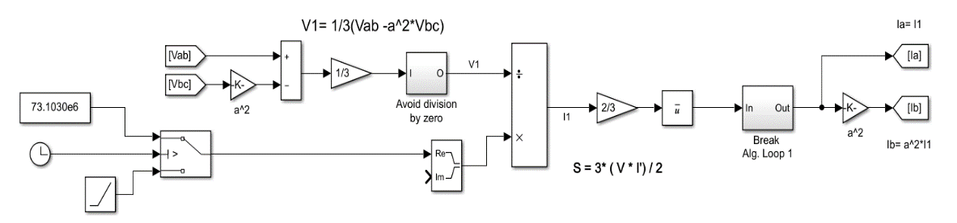

**Figure 3‑12:Model implemented to calculate the required current to meet the specified power rate from measured voltage signal shown in Figure 3‑13.**

FPR steady value (W)

FPR ramp (W/s)

It can be noticed from **Figure 3‑13** that the IBFPR is composed of 2 current sources, 2 voltage readers (complex measurement), two resistance and 3 connecting ports.

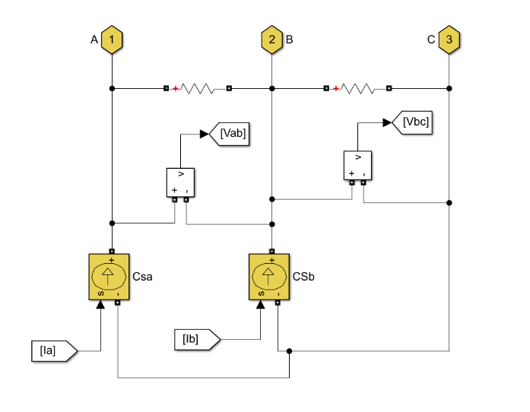

**Figure 3‑13: Controlled current sources acting as grid following inverters. Signals Ia and Ib comes from model in figure 3-14; similarly signals Vab and Vbc go to the same model.**

Current Source

Current Source

The IBFPR will have symmetrical and balanced characteristics. Due to this reason, the magnitude and angle of the current phasor will be obtained from the positive sequence of the measured voltage, since unsymmetrical line voltages may be present on the system.

Given a symmetrical IBFPR; only two current sources are needed because the addition of balanced currents in a three phase system equals 0. Hence, leg c will be fed with the negative of the sum of both sources.

The ports are connected at the medium voltage side of the system (generator’s side). The resistance must have a high value (negligible current flowing through); this is a requirement for the implementation of SIMSCAPE current sources.

**Figure 3‑12** shows the block diagram implemented to obtain the positive symmetrical component of line voltage and the positive sequence of current that will be provided by the subsystem to meet to needed power from the ramp input depending on the voltage readings. From the definition of complex power and voltage symmetrical components in three phase systems, the positive sequence component of phase voltage and line current are obtained. The positive sequence component of complex power is equal to the complex balanced power [21]:

**Equation 3‑8**

This equation is valid for RMS values of voltage and current; nevertheless the measured voltage values and the sought current values are given in peak values, the equation for power and current become:

**Equation 3‑9**

**Equation 3‑10**

With the help of the **a** operator (-0.5+j or 1∠120°) the values of the positive sequence component of phase voltage can be obtained.

From and

Since , and then after some algebraic manipulation the expression for becomes:

**Equation 3‑11**

With the obtained expressions for the positive sequence of phase voltage and complex power, the needed current to supply the IBFPR related to the measured voltages can be implemented. The ramping function will last until the critical time is reached, afterwards, the IBFPR output will remain constant.

**Euro Case**

Under normal operation ENTSOE has reported values of RoCoF in the range of 5-10 mHz/s for power outages of 1 GW in the current interconnected power system. If an imbalance event of more than 3 GW occurs with depleted primary reserve, extraordinary values of frequency and RoCoF might be reached. After serious disturbances the Continental European Power System has experienced RoCoF between 100 mHz/s and 1 Hz/s. Imbalances of 20% or more along with RoCoF greater than 1 Hz/s have been determined by experience to be critical [1].

ENTSOE has determined that under the case of the reference scenario (The loss of 3 GW generation with 150 GW load and 2%/Hz self-regulation) in the interconnected operation, the influence of inverter based generation, and therefore the reduction of system inertia would not jeopardize system stability. Due to the expected increase of non-synchronous generation in the future, international power trade and renewables variability; ENTSOE estates in its future split reference scenario that the power system must be capable of withstanding imbalances greater than 40% with RoCoF of 2 Hz/s or higher. Under these circumstances the resulting islands must avoid load shedding. Hence, only the split scenario is considered for further analysis.

**Figure 3‑14: Simplified European power system.**

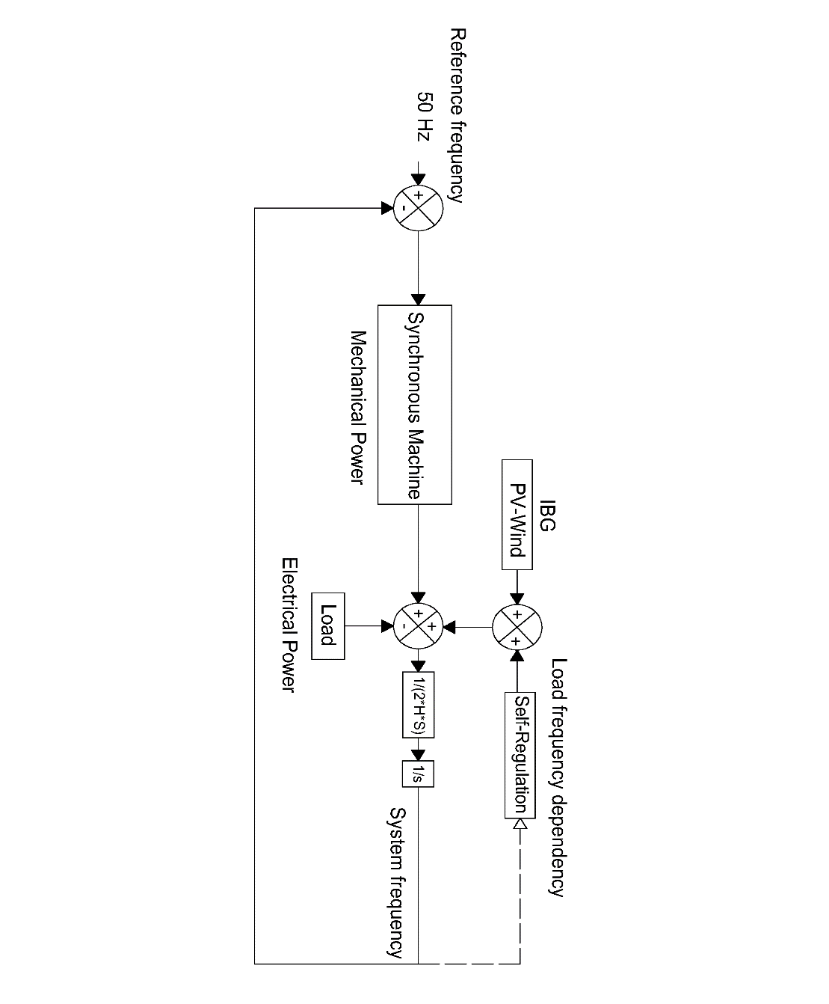

When considering the system blackout of November 4th 2006, in which four electric islands resulted from the European system split; system blackout due to under frequency was experienced in the so known western area. This island, at the moment of split, had approximately a load of 190 GW (27% more than the low load ENTSOE scenario) [29]. For its comparable ‘size’ and the uncertainty of knowing beforehand the resulting islands after a major contingency, the selected load for simulation was the same as the ENTSOE reference scenario as well as the primary reserve deployment time.

To simulate the behavior of the resulting island in the European split scenario; a simplified approach was selected. Similarly as it was done with the simplified block model for the IEEE 9 bus model, in the equivalent European representation all the synchronous generation will be represented by a single machine, which will provide governor response when a perturbation takes place. Additional to the synchronous response, a load response of 2% was added to the model, which means that for every Hertz reduced or augmented, the load will reduce or increase by a 2% [1].

**Figure 3‑15** depicts the results of ENTSOE for the interconnected reference scenario frequency response model. It is intended that the implemented model for the island would perform in a similar way like the ENTSOE model for the same conditions [1].

**Figure 3‑15: Comparisson between the modeled reference scenario by ENTSOE and the adjusted model. Power loss of 3GW, load of 150 GW (2%), self-regulation of 2%/Hz and acceleration time constant of 10 s.**

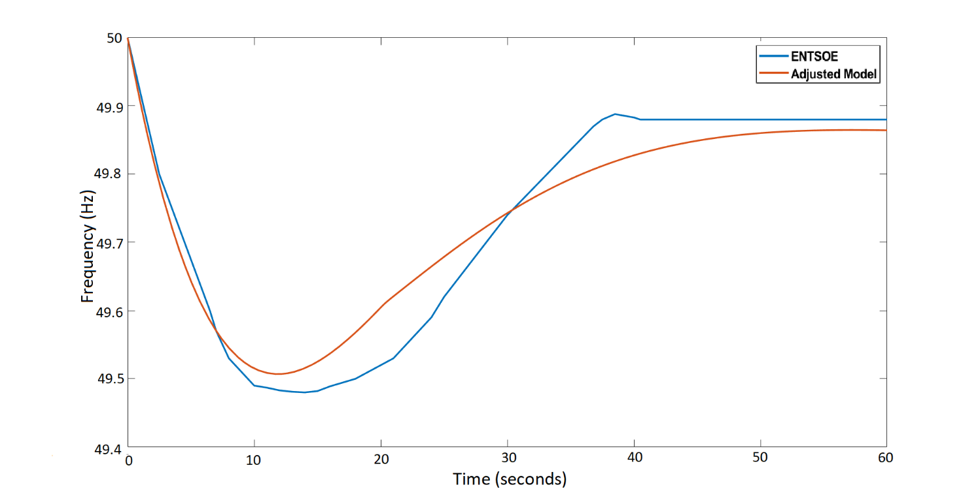

To fit the behavior of the system to the modeled by ENTSOE, a PID controller was added in the SIMULINK micro-grid model to the steam turbine governor; this was done with the intention of adjusting the time response of the primary reserve as much as possible to the desired one. With the PID approach, the primary power reserve can be easily tuned with the assistance of the Control System Tuner App available in MATLAB. The period of time of utmost interest for analysis is from the inception of the power imbalance and the nadir time. Therefore, the system must perform as similar as possible in this region compared to the ENTSOE reference, whereas after the nadir time, the disparity between responses can be neglected. In the European scale the reserves must be completely deployed within 30 s after the occurrence of the disturbance.

### System parameters

A power system of *n* number of synchronous machines is assumed; having each of them a capacity *S* in MVA, a nominal power *Pn* in MW and a nominal power factor.

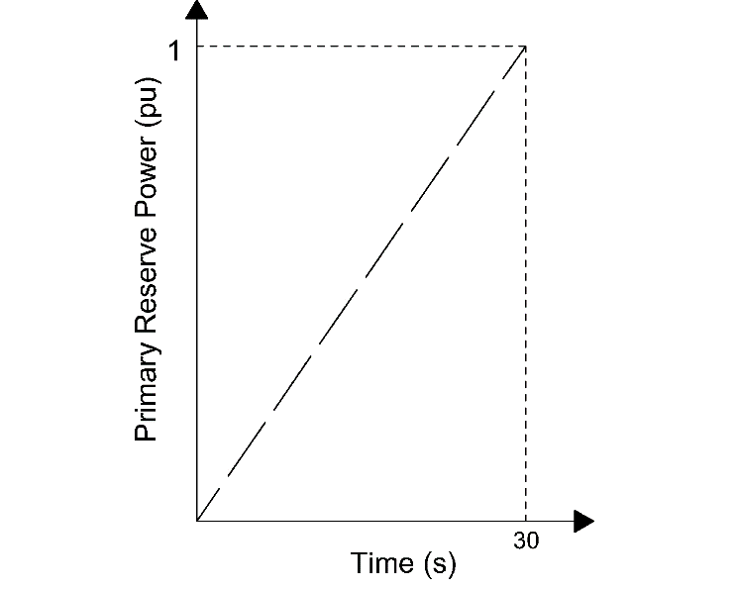

**Figure 3‑16: Primary reserve deployment time of the interconnected European system**

Assuming that each machine operates at a de-load factor *dl* of *Pnom*; with an acceleration constant equal to *Tnom* then the number of machines *n*, for the synchronous load *Pload_sync* is:

**Equation 3‑12**

Then the time acceleration constant of the system Tsys can be obtained as follows:

**Equation 3‑13**

In this sense the base system time acceleration constant (synchronous share 100%) is calculated from the values of *Tnom*=10 s [1, 8], synchronous share *Sync_share*=1, and a de-load factor *dl*=0.8 having as a result *Tsys*=12.5 s

The values of the PID controller and the step response characteristics of the model are set in order to have a step response with 2% overshoot and a time constant of 8 seconds [22]. Step response before and after PID tuning can be observed in **Figure 3‑** and **Figure 3‑**.

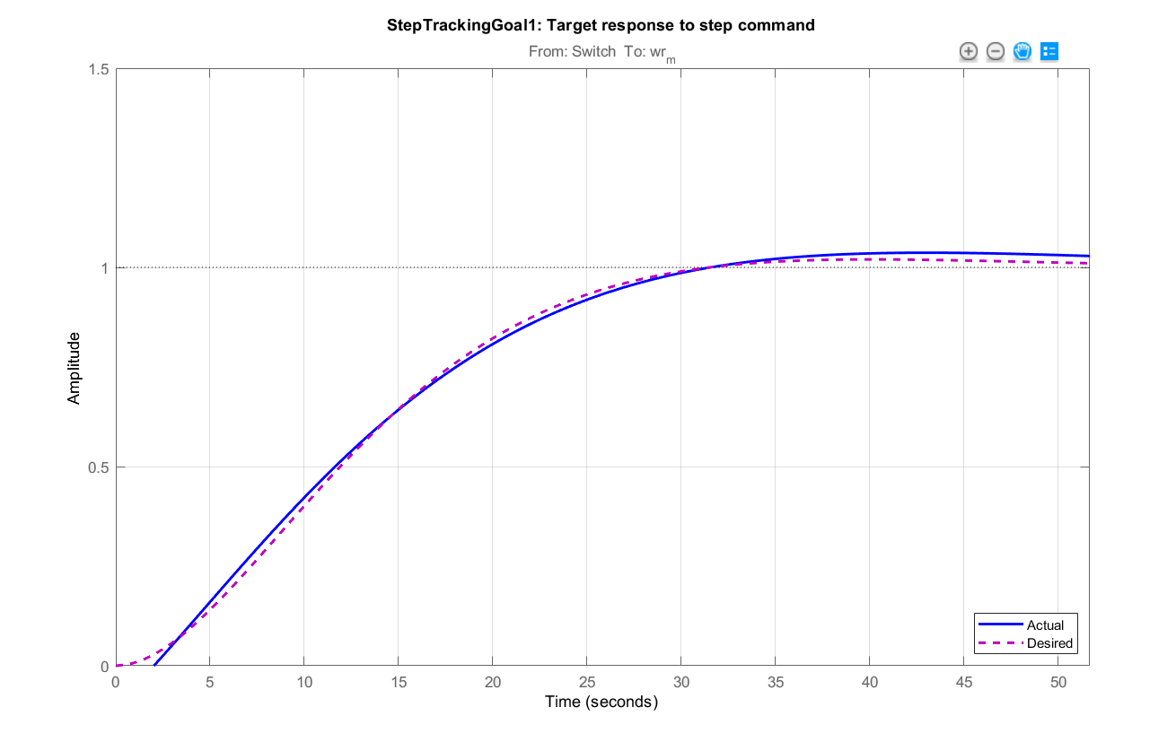

**Figure 3‑20: Comparisson between the actual response (blue) and the desired step response of the system (purple); after PID tunning.**

Amplitude

Time (s)

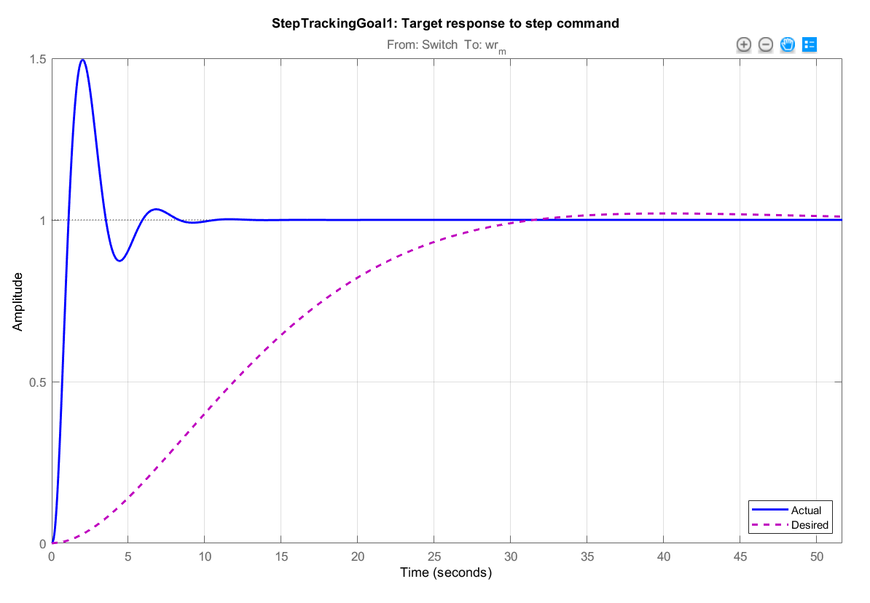

**Figure 3‑19: Comparisson between system step response before the PID tunning (blue) and the desired step response of the system (purple).**

Time (s)

Amplitude

Considering only the swing equation, as done in the model, it can be demonstrated that the RoCoF and therefore the frequency response of the system is only dependent on the percentage of load imbalance and the system acceleration time constant.

From the definition of RoCoF as and :

**Equation 3‑14**

In **Equation 3‑14**, the value of *∆Ppu* is the normalized value of power imbalance having as base power the value of load *PLOAD*. As shown in the equation, when only the swing equation is considered, the frequency response is only dependent on system acceleration constant and the relative value of imbalance. This relative value of imbalance varies during time, depending on load response to change on frequency and the response of primary reserve of the system.