# Results

### Determination of critical time (three cases)

In this section a deeper look is given to the obtained results out of the simulated cases. In order to allow understandable comparisons between each approach and models; the chapter is divided in three main sections, in which the main results of the simulations will be discussed. This chapter is divided in the following sub-sections:

* Analysis of critical time.
* Analysis of Synthetic Inertia and Fast Power Reserve
* Synchronizing effect and lack of damping torque.

## Analysis of Critical Time

Due to the nature of the swing equation, which describes the frequency response in synchronous machines, a reduction of the available time for the inverters to react to perturbations was found as RoCoF increases.

As it was expected, the frequency response is highly dependent on the primary reserve response (governor response). When the IEEE 9 bus model is simplified to one machine and losses are disregarded; critical time deviations from the full dynamic extended model are observed to reach values up to 34%. From the fit plots it can be noticed that the highest deviations occur at high system acceleration constants and in the low range of RoCoF, allowing primary reserve to take effect. Therefore, it can be stated that the simplifications in the model have a greater influence on the results for low RoCoF and IBG penetration values; in this sense, the simplifications become less significant as the RoCoF increases in such a manner that the activated synchronous primary reserve is not relevant in frequency support.

Despite the discrepancy in the critical time between both approaches in the IEEE 9 bus model; the power ramp calculated for the simplified model and the extended model does not differ from each other in a great manner as exhibit later in **Figure 5‑2**. It is then inferred that the discrepancy in critical time estimation is compensated by the factor of nadir time, which due to non-linearity characteristics considered in the Extended model, varies upon change in inertia and load imbalance (perturbation); contrary as the linear simplified model in which the nadir time is invariable for perturbations.

In the theory section, the typical frequency measurement time and technologies activation time were discussed [14]. **Figure 5‑1** contrasts the critical times obtained from the models with the required time for frequency measurement and full power activation from different technologies.

**Figure 5‑1: Critical time for all scenarios at 80% IBG penetration.**

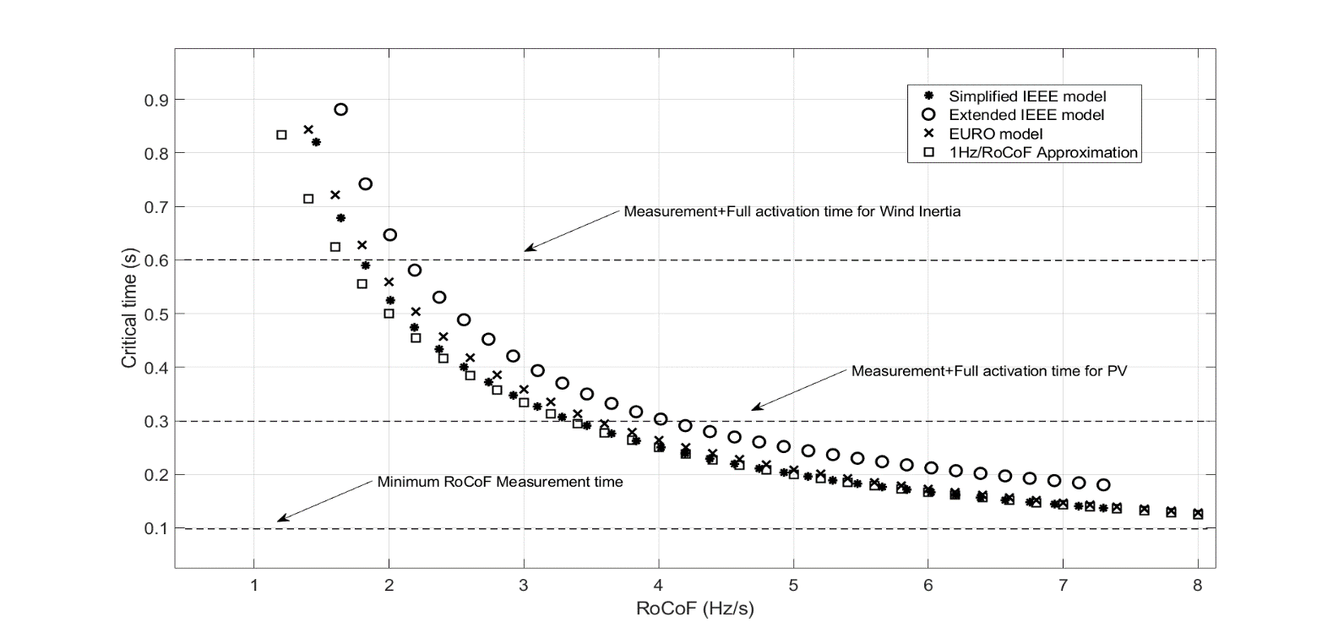

It is observed that in the range higher than 2 Hz/s; the critical time trend for the European island and the simplified IEEE model get closer each to other as RoCoF increases. In the same way the extended model but for very high values. Therefore, it is infered that under high RoCoF conditions in any of the models, the primary reserve does not significantly counteract the frequency drop [16]. **Figure 5‑1** demonstrates that primary reserve can be neglected for determination of the critical time when the combination of inverter based generation and load imbalances would lead to high values of RoCoF (>2 Hz/s); as RoCoF increases, the approximation of critical time as 1(Hz)/RoCoF narrows the difference with the results obtained from simulations [14]. Nevertheless such simplification is applicable to the simplified IEEE model and the European island. Hence, the influence of all the dynamics and machine components, such as generator exciter and armotisour windings, seems to improve the critical time; extending up to a 34% the calculated time with the simplified approach. Damping torque in swing equation [7, 8] was not considered for the IEEE simplifed model; the inclution of such may lead to more precise times when comparing with the extended model.

Also it is then stated the need of a fast power response to avoid frequency collapse of islanded micro-grid or an electric island in the European scale. Even assuming that power reserve can immediately fully activated after RoCoF reading, the 100 ms limitation is a constraint for high unbalanced islands with high penetration of IBG in the European case as demonstrated in the result section. Additionally, the direct measurement of RoCoF in the 100 ms interval can lead to misleading readings [14]. In general, when penetration of IBG is higher than 90%; for the 40% imbalance an activation time between 30 and 50 ms would be needed to keep frequency within the allowed limits.

Due to the fact that the characteristics of the interconnected scenario provided by ENTSOE were assumed to be the same than the resulting islands after a severe event; the results for the European island can be understood as the behavior of the whole European system with bigger perturbations. The dimensioning scenario assumes a power imbalance of 3 GW, which corresponds to a 2% of the 150 GW load [1]. If in future a bigger dimensioning case is utilized, then synchronous response would not be enough to balance the system before load shedding occurs.

**Table 5‑1** exhibits the required time when the dimensioning scenario is increased up to 10% for different IBG penetration.

|  |  |  |  |  |  |  |  |  |
| --- | --- | --- | --- | --- | --- | --- | --- | --- |
| IBG share (%) | Load imbalance (%) | | | | | | | |
| 3 | 4 | 5 | 6 | 7 | 8 | 9 | 10 |
| 20 | - | - | 6.081 | 4.517 | 3.629 | 3.050 | 2.638 | 2.316 |
| 40 | - | 6.226 | 4.169 | 3.215 | 2.628 | 2.222 | 1.934 | 1.705 |
| 60 | 7.142 | 3.639 | 2.623 | 2.062 | 1.698 | 1.451 | 1.263 | 1.122 |
| 80 | 2.753 | 1.744 | 1.277 | 1.018 | 0.843 | 0.722 | 0.628 | 0.559 |
| 92 | 1.109 | 0.700 | 0.514 | 0.406 | 0.338 | 0.288 | 0.252 | 0.224 |
| 95 | 0.697 | 0.436 | 0.322 | 0.254 | 0.211 | 0.179 | 0.157 | 0.140 |

**Table 5‑1: Critical times for European case in seconds.**

Scenarios with higher imbalance than the reference scenario combined with high penetration of renewables will require fast power reserve as indicated in **Table 5‑1**. Even though it was assumed enough synchronous reserve, this is too slow under such conditions.

**Nadir freq.**

**Nadir for 3 cases with no support: behavior of governor response**

**Nadir for 2 cases with synthetic inertia/critical time improvement with synthetic inertia**

**Nadir for 3 cases with inverter based fast power reserve**

### Fast Power Reserve: Effect of Ramp response

When the power ramp required to meet the power load imbalance at the critical time was calculated in chapter 3; the contribution from the ramping power in diminishing system RoCoF during the inception of the perturbation until the critical time was disregarded. Therefore the fast inverter based power response values at the critical time correspond to the accelerating power at that time. Assuming an instant switching of the IBFPR at critical time, the frequency nadir would be 49 Hz (no ramping power before critical time). Nevertheless, a ramp power response was assumed instead. Therefore the calculated power ramp, when applied to the unbalanced system, commonly exhibits a frequency nadir higher than 49 Hz, due to the contribution of the ramping period. In this sense, it can be inferred that the longer the ramping period (shorter measuring time), the higher frequency nadir will be obtained. Here again the relevance of the prompt activation in time of the IBFPR. On the other hand, with the faster IBFPR activation, the ramp slope and the steady power output (Inverter based power reserve) can be diminished compromising frequency nadir.

When the activation does not takes place instantaneously, frequency nadir and therefore system stability can be compromised for some combination of system inertia and load imbalance as demonstrated in the result section. In order to assure stability a stepper ramp slope is required in order to meet the required power before critical time. That is achieved by changing equation 3-2 by the adjusted expression:

**Equation 5‑1**

Where *td* is the time delay needed to start the activation of IBFPR.

When a comparison is established beween all the calculated power ramp slopes in per unit[1] (pu), it is noted that with high penetration of non-synchronous power in the power system, the required power to ensure no UFLS have a consistent trend between the three models, and a close proximity in the values for RoCoF in the range of 2 to 5 Hz/s is observed between both IEEE models. Such trends can be seen in **Figure 5‑2**.

**Figure 5‑2: Power ramp slope with 80% of IBG penetration.**

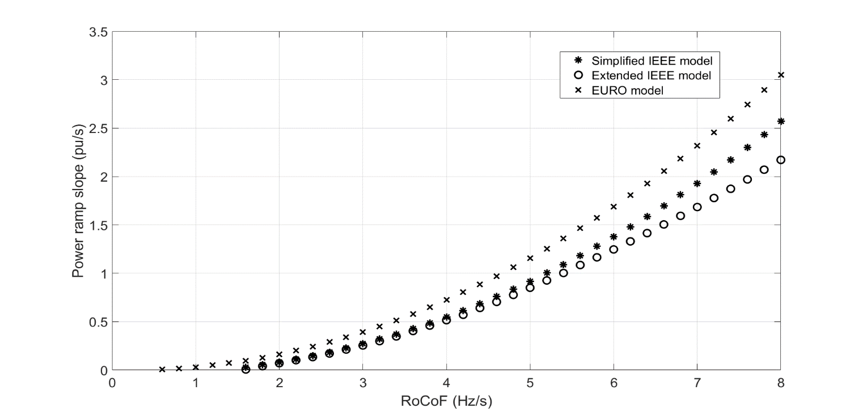

A bigger amount of power ramp slope is needed in all the range of RoCoF for the European case. After inspecting **Equation 3-2**, it is noticed that the IBFPR is affected by the factor, then as nadir time increases, IBFPR increases as well. The nadir time for the European case, due to the action of the self-regulation and primary reserve deployment of 30 seconds, is in the range of 3-12 seconds (6 seconds for 80% IBG penetration) whereas the nadir time for the simplified IEEE model is between 1-3 seconds. See **Appendix III** for more details in regards of nadir time.

### Fast Power Reserve

So far, the power ramp required to avoid load shedding has been found for the IEEE 9 bus model with a fast governor response and for the European island with conventional primary reserve response. Hence, the investigated inverter based fast power response at critical time which remain constant afterwards, would be accounted as the fast power reserve. Similarly as primary reserve estimations are performed considering the loss of generation at certain level; for fast power reserve the results are presented for the scenarios in which imbalance could reach even 40%

**Figure 5‑3** shows the results of the needed fast power reserve for each case under 80% of IBG penetration. A linear behavior is exhibit by the simplified model and the European.

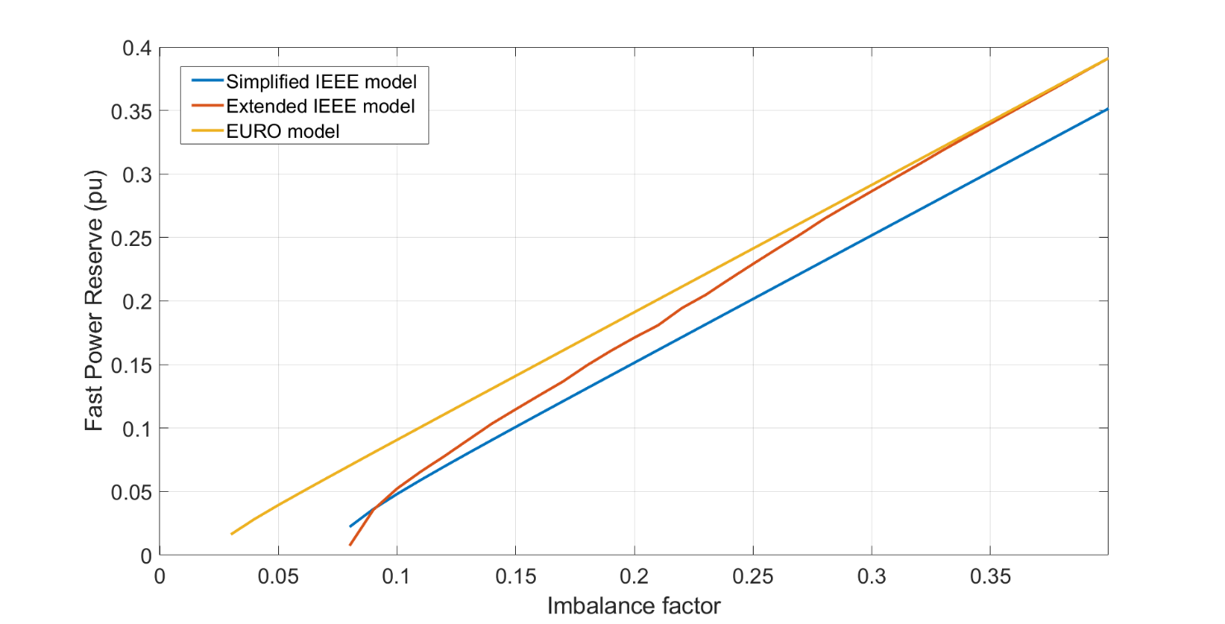

**Figure 5‑3: Fast power reserve at 80% of IBG.**

A proportion of almost one to one is observed for the European model, this is caused by the slow primary reserve. Therefore for imbalances higher than 3% the fast power reserve has to cover all the imbalance. The observed offset from the one to one relation is due to the load reduction caused by the frequency drop (load self-regulation). The dashed line represents the one to one proportion. In the case of the IEEE grid; the simplified model exhibits a permanent offset from the dashed line of around 0.05 pu, this due to the action of a faster governor response. Therefore, it can be said that in such scenario, the conventional governor response of synchronous machines would cover 5% of the imbalances starting at 8%. Since the values for nadir time are not independent from the imbalance in the Extended model, due to the non-linearity of the model, the calculated power reserve tend to equalize the whole imbalance. As imbalance increases, the critical time decreases and the nadir time increases, this makes the reducing factor tcr/tnadir from **Equation 3-2** to decrease and narrows the difference between the calculated reserve and power imbalance.

Similarly as critical time was presented in **Table 5‑1** the required fast power reserve in the European context is shown in **Table 5‑2** for extraordinary events[2]

**Table 5‑2: Fast power reserve in per unit for European case**

|  |  |  |  |  |  |  |  |  |
| --- | --- | --- | --- | --- | --- | --- | --- | --- |
| IBG share (%) | Load imbalance (%) | | | | | | | |
| 3 | 4 | 5 | 6 | 7 | 8 | 9 | 10 |
| 20 | - | - | 0.025 | 0.038 | 0.049 | 0.060 | 0.070 | 0.081 |
| 40 | - | 0.016 | 0.030 | 0.041 | 0.052 | 0.063 | 0.073 | 0.083 |
| 60 | 0.005 | 0.024 | 0.035 | 0.045 | 0.056 | 0.066 | 0.077 | 0.087 |
| 80 | 0.016 | 0.028 | 0.039 | 0.049 | 0.062 | 0.070 | 0.080 | 0.09 |
| 92 | 0.021 | 0.033 | 0.043 | 0.054 | 0.064 | 0.074 | 0.084 | 0.094 |
| 95 | 0.024 | 0.035 | 0.045 | 0.055 | 0.065 | 0.075 | 0.085 | 0.096 |

As IBG increases the closer to the imbalance the fast power reserve needs to be. As it was demonstrated in the result section; with a faster conventional reserve, reduction in fast power reserve can be observed.

## Synchronizing effect, lack of damping torque and implications.

When the IEEE model was implemented using SIMULINK-SIMSCAPE blocks, in order to incorporate all system component dynamics; system instability was found for low inertia values in the system and due to high imbalances (with no IBFPR). In non-linear systems, the stability is not only determined by the equivalent transfer function but also it is dependent on the inputs or sources [7, 22]. In this sense the loss of stability due to huge load imbalances is explained by the non-linearity of the system. When the system is perturbed by a small change in one of the state variables in such a way that the system returns to its initial state or remains close to it; a linearization of the system can be performed and a so called small signal stability analysis can be performed [7].

In the simulations it was found how the extended model is unstable for imbalances above 15 % with a penetration of non-synchronous generation of 85%, corresponding to a system acceleration time constant of 2.1 seconds. The diminishing of synchronous machines, and the dependency of system frequency and voltage signal from them, lead to a very weak network, where synchronizing and damping torque, which are inherent characteristics of synchronous machines are not enough to stabilize the system (assuming that such excursion of frequency and rotor speed would be allowed to happen) [7]. Although the implementation of IBFPR contributes keeping synchronous machine on step[3], low frequency oscillations in the rotor speed/frequency response are observed. This oscillations are created by the lack of damping torque which is provided mainly by the synchronous machines, through damping windings, field exciter and Power System Stabilizer (connected to the machines exciter). For the simplified IEEE model and the European island, only transfer functions describing an equivalent system governor were modeled. Hence in such approaches, the effect and dynamics of synchronous generator’s exciters and inter-machine interaction were not taken into account. The before mention factors influence greatly small signal stability [7, 8]

**Figure 5‑4: Oscillatory effect in synchronous generators rotor speeds in the Extended IEEE model with 85% IBG and 35% load imbalance and IBFPR support.**

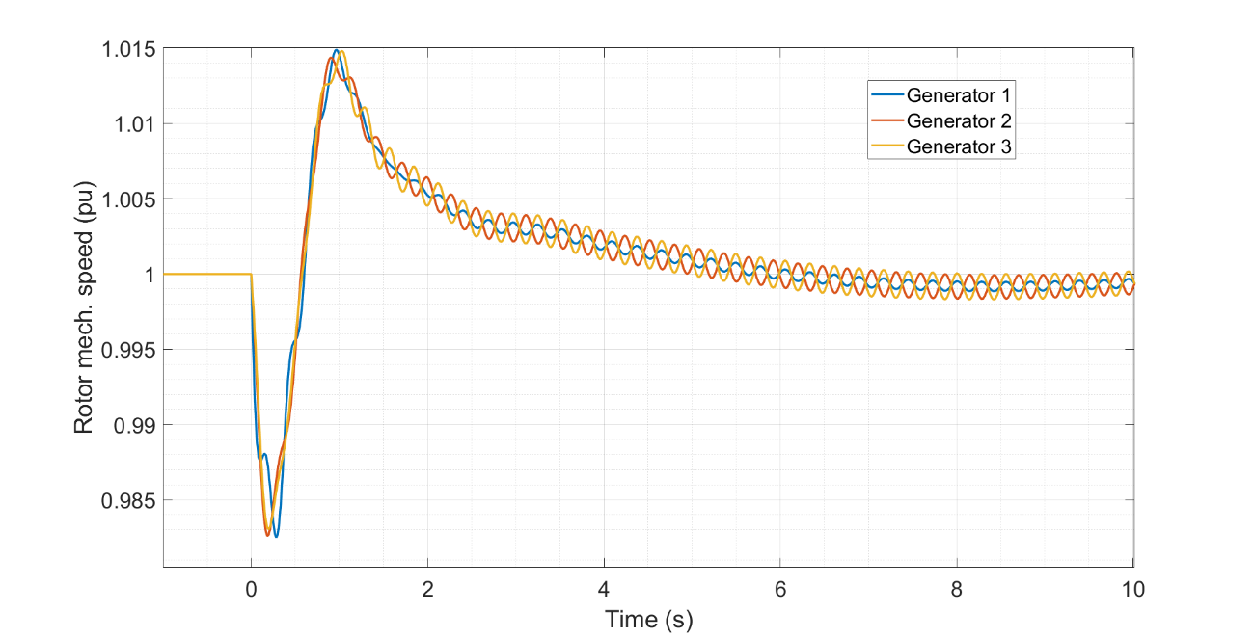

Even though the scoop of this thesis is to analyze the power-time characteristics needed to avoid frequency collapse; oscillations associated to big perturbation were observed but they could not been addressed by the simple injection of power to the system. Also in the IEEE model, when a penetration of 95% of inverter based generation and 2% of load imbalance are considered, UFLS is not reached but the system becomes unstable as shown in **Figure 5‑6** and **Figure 5‑5**. From penetrations levels above 85% complete frequency stability is not ensure with the injection of fast power reserve, only UFLS on the first 10 seconds approximately. Then the system becomes unstable with increasing amplitude oscillations.

**Figure 5‑5: Oscillatory behavior from extended IEEE model with 95% IBG and 2% imbalance. No IBFPR is provided.**

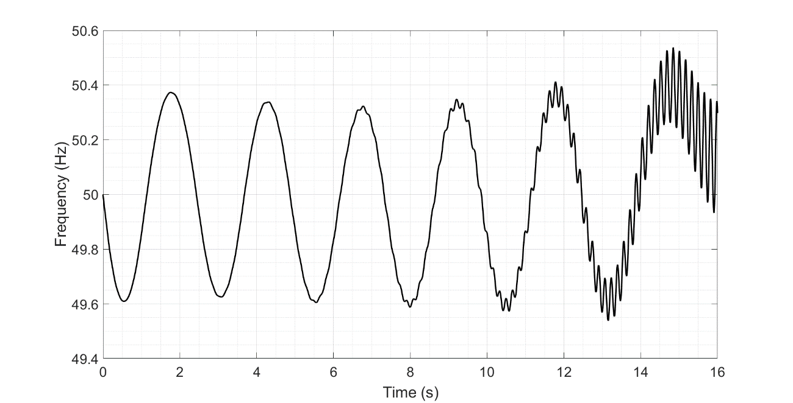

It is important to note that ENTSOE in its EUROPEAN interconnected scenario, determined that there is no UFLS when an unbalance of 2 % with high contribution of non-synchronous generation occurs. Nevertheless, no inter-machine interaction was considered and therefore a similar effect as the one in **Figure 5‑6** could be experienced.

**Figure 5‑6: Oscillatory behavior from extended IEEE model with 95% IBG and 2% imbalance. IBFPR is provided**

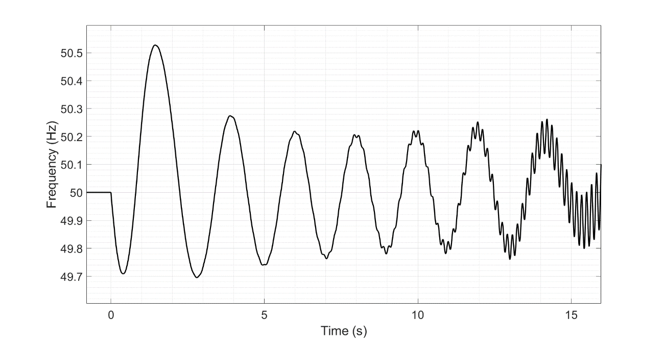

1. Power base for each cases is given by the load power; 315 MW for the IEEE model and 150 GW for the European electric island.
2. Referred to an imbalance event higher than 3 GW (2% of load).
3. Synchronized rotor speeds.