Below you will find technical information and in the zip-file two data sets with simulated scenarios.

The Scenarios consists of one Battery-System (BESS) coupled with Photovoltaic (PV) and the Grid.

1. Technical Data about
2. Two scenarios, same hardware, different setpoint for peak shaving
3. Grid Prices
4. Questions for your Presentation

Feel free to choose you most convenient way to handle this challenge.

Thanks a lot for your motivation and participation!

Best regards,

Your Future System Architecture Simulation Team

# BESS Daten

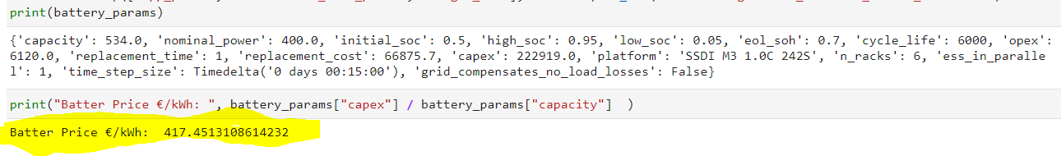

* Capacity: 534 kWh
* Power: 400kW
* CAPEX €/kWh: 417.45€/kWh

# Peak Shaving Plots

## Grid Limit 400

Ein Bild, das Text, Schreibgerät, Briefpapier, Bleistift enthält.

## Grid Limit 500

Ein Bild, das Text, Schreibgerät, Briefpapier, Bleistift enthält.

# Cost of energy/a (w/o CAPEX)

* ENERGY_COST = 22ct/kWh (Energy Price)
* DEMAND_CHARGE = 200€/kWh/a (Demand Charge)
* PV_ENERGY_PRICE = 7ct/kWh (PV Energy Price)

Cost = Energy_Grid * ENERGY_COST + Power_max * DEMAND_CHARGE + Energy_PV * PV_ENERGY_PRICE

Ein Bild, das Text enthält.

# Questions

1. Choose one or more customer friendly plots and show which scenario is better for the customer?
2. Please calculate at least three statistics from the data and explain the relevance. (e.g. Renewable Share, BESS_Full_Cycles, Capacity and Power usage of the BESS,…)