Multi-Class Classification with SVM
ELC4028 — Artificial Neural Networks Applications

1. The Binary Building Block
At its core, an SVM is a binary classifier: it finds the single optimal hyperplane that separates two classes of data, maximising the gap — called the margin — between them. The points that lie exactly on the margin boundaries are called support vectors, and they are the only training examples that actually determine where the boundary ends up.

The SVM’s objective is to find the hyperplane that maximises this margin width. This is illustrated in Figure 1 below for a two-dimensional feature space, where each data point has two features and can therefore be plotted as a point on a plane.

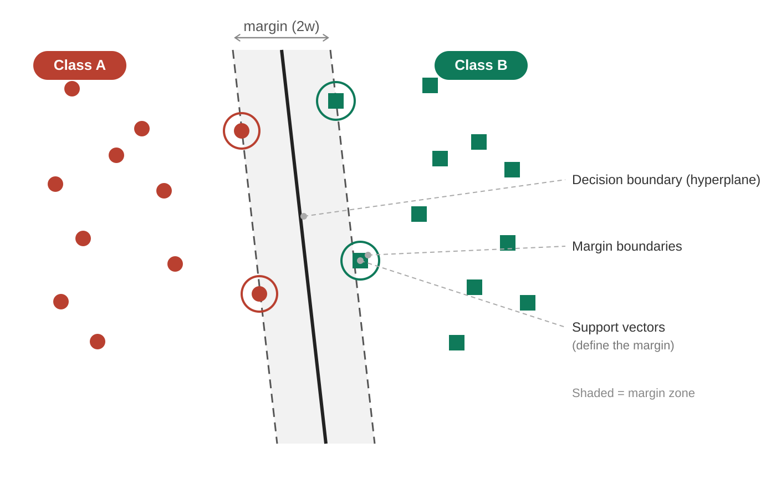
Figure 1. Binary SVM: the decision boundary (solid line) separates two classes by maximising the margin. Support vectors (circled) are the only points that define the boundary.
An important property of the SVM is that the support vectors are the only training points that matter — all other points could be removed and the boundary would not change. This is what makes SVMs computationally efficient and robust to outliers that lie far from the boundary.

The problem is that the real world — including the Indian digit dataset we are working with — rarely has just two classes. When we have K = 10 classes, we need a principled strategy for extending binary SVMs to handle all ten simultaneously.

2. Extending SVM to Multiple Classes
There are two standard strategies for turning a binary SVM into a multi-class classifier: One-vs-All (OvA) and One-vs-One (OvO). They differ in how many binary classifiers they build and how they combine the results into a single prediction.

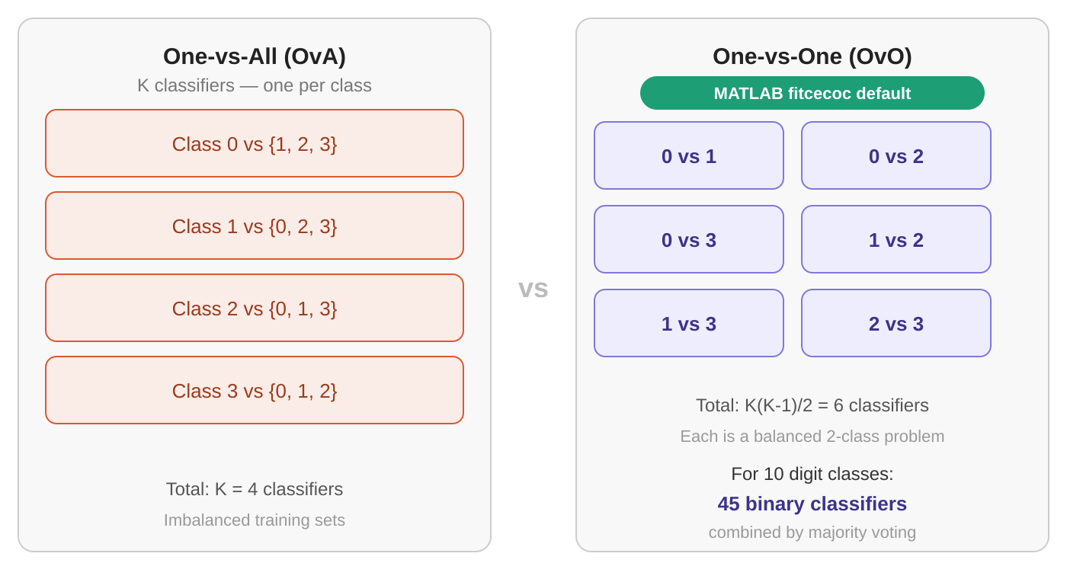
Figure 2. Comparison of One-vs-All (OvA) and One-vs-One (OvO) strategies for multi-class SVM. MATLAB’s fitcecoc uses OvO by default.

One-vs-All (OvA)
In OvA, one binary classifier is trained per class. Each classifier answers the question: “Is this image my class, or anything else?” For K classes, OvA trains K classifiers.

The weakness of OvA is that the training sets are highly imbalanced: the positive class contains roughly N/K examples, while the negative class contains the remaining N (K–1)/K examples. For 10 classes this means each classifier sees 9 times as many negative examples as positive ones, which can skew the decision boundary.

One-vs-One (OvO)
In OvO, a separate binary classifier is trained for every pair of classes. Each classifier only ever sees exactly two classes, so the training sets are always balanced. For K classes, OvO trains K(K−1)/2 classifiers. At prediction time, every classifier casts a vote for one class, and the final label is assigned to the class with the most votes.

3. How the Voting Works in Practice
After all binary classifiers make their prediction for a new image, each one casts a vote for one class. The final label is assigned to whichever class receives the most votes. Figure 3 below shows a concrete three-class example step by step.

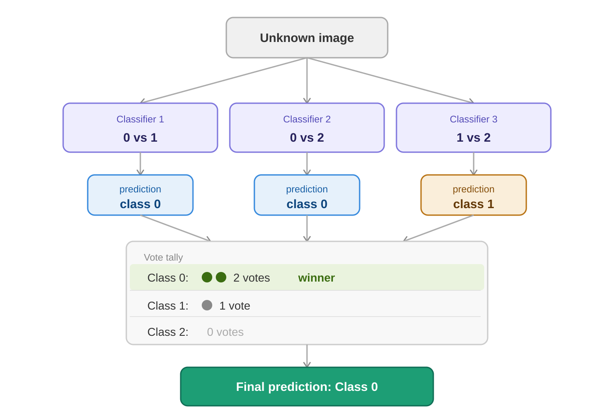
Figure 3. Step-by-step OvO voting for a three-class problem. Three binary classifiers each cast one vote; Class 0 wins with two votes out of three.
In the example above, Classifier 1 (0 vs 1) predicts Class 0, Classifier 2 (0 vs 2) predicts Class 0, and Classifier 3 (1 vs 2) predicts Class 1. The vote tally is Class 0: 2, Class 1: 1, Class 2: 0 — so the final prediction is Class 0.

In cases of a tie — which can occur when the number of classes K is even — MATLAB resolves it using the accumulated decision function scores rather than raw vote counts, so there is always a unique winner.

4. Decision Scores and the Margin
Beyond just predicting a class, the SVM also produces a numerical decision score for each binary classifier. For a given image, the score of a binary classifier tells us how far the image lies from that classifier’s decision boundary — a large positive score means the image is comfortably on one side, while a score near zero means it sits right on the boundary.

In MATLAB, the predict function returns both the predicted labels and the full matrix of decision scores:

[predictedLabels, scores] = predict(SVMModel, X);
% scores is an N x K matrix: one column per class.
% Each entry is the accumulated vote score from all OvO classifiers.
% Compute the margin for each image:
% margin = difference between the top score and the second-best score.
sorted = sort(scores, 2, 'descend');
margin = sorted(:, 1) - sorted(:, 2);
% Small margin --> image near a decision boundary --> uncertain
% Large margin --> image far from any boundary --> confident

The margin vector is the key tool in both Pipeline 1 and Pipeline 2. It gives us a quantitative, objective measure of how confident the classifier is about each image, without requiring any manual inspection. The two uses in the pipelines are:

- Active learning (boundary labeling): select the images with the smallest margin and send them to a human annotator. These are the images the classifier is most likely to get wrong, so human effort is spent where it matters most.
- Self-training (pseudo-labeling): select the images with the largest margin and accept the classifier’s own predictions as trusted labels. These are the images the classifier is most confident about, so adding them to the training set safely extends the labeled pool without any human involvement.

Together, these two uses create a feedback loop: the margin directs the human toward the hardest cases while simultaneously allowing the classifier to grow its own training data on the easiest cases. This is the core mechanism driving both pipelines toward the 99% accuracy target.

5. Summary of MATLAB Functions
The following three MATLAB functions are all you need to build and use a multi-class RBF-SVM for the assignment:

% 1. Define the SVM template
t = templateSVM('KernelFunction', 'rbf', 'Standardize', true);
% 2. Train the multi-class model (OvO, 45 binary classifiers for K=10)
mdl = fitcecoc(X_train, y_train, 'Learners', t, 'Weights', w);
% 3. Predict labels and compute confidence margins
[labels, scores] = predict(mdl, X_all);
sorted = sort(scores, 2, 'descend');
margin = sorted(:, 1) - sorted(:, 2);
% 4. Select the N most uncertain images (smallest margin)
[~, idx] = sort(margin, 'ascend');
boundary_images = idx(1:N);
% 5. Select high-confidence pseudo-labels (margin above 75th percentile)
thresh = prctile(margin, 75);
confident_images = find(margin > thresh);

Note that the Weights argument in fitcecoc is what allows the pipelines to assign higher trust to human-labeled examples (weight = 100) compared to machine-generated pseudo-labels (weight = 1). This is covered in detail in the pipeline specifications.

