DEAC: A Defensive Ensemble Framework for Automatic Graph-Based Clustering of High-Dimensional Data
Hussein Ali Ismael* 
Department of Computer Science, College of Science, University of Diyala, 32001, Iraq
Corresponding author: Al-Shaibani@uodiyala.edu.iq
ABSTRACT
Clustering high-dimensional data without a known number of clusters is challenging because neighborhood reliability, representation choice, and internal validity objectives can be unstable. This study proposes DEAC (Defensive Ensemble Adaptive Clustering). This graph-based framework pairs diverse representations with a conservative, label-free selection mechanism. Its EMR-CGC engine constructs Shared Nearest Neighbor (SNN) graphs. It applies Leiden community detection across five representations and twelve graph configurations, automatically inferring the cluster count. In contrast, a complementary AMR-DE engine performs differential-evolution hyperparameter optimization on a selected representation. A three-layer QualityGate then arbitrates among candidate partitions using internal quality measures and adaptive fragmentation tests, defaulting to a fixed baseline when an optimized candidate is not sufficiently reliable. We evaluated DEAC on 12 public benchmarks using ARI, NMI, and clustering accuracy. We compared it statistically against five classical and four deep clustering methods. We separate a label-aware oracle upper bound (mean ARI 0.646) from the actually deployable QualityGate: the deployable gate reaches mean ARI 0.623, recovering about two-thirds of the oracle's gain over the Baseline (0.580). In contrast, the SNN ensemble alone reaches 0.631. After Holm correction, the deployable gate is statistically indistinguishable from the strong classical and deep baselines. It trails only N2D (0.642), rather than matching it. Weak clustering is therefore not the bottleneck; the inability to recognize a good partition without labels is. These results show that defensive arbitration and representation diversity improve the robustness of automatic graph-based clustering and quantify how much of the oracle a label-free rule can recover.
Keywords: Clustering, High-Dimensional Data, Graph-Based Clustering, Differential Evolution, Shared Nearest Neighbors.

1. INTRODUCTION
In unlabeled data, clustering reveals hidden structures (Jain, 2010). However, sparsity, irrelevant characteristics, and distance concentration make high dimensionality challenging for neighborhood reliability (Steinbach et al., 2004) and (Beyer et al., 1999). Most centroid, spectral, and model-based approaches (Lloyd, 1982), (von Luxburg, 2007) and (Fraley and Raftery, 2002) also require a predetermined cluster count C; density-based approaches estimate C but remain sensitive to neighborhood and density parameters (Campello et al., 2013). As a result, high-dimensional automatic clustering must control graph-parameter sensitivity, choose an appropriate representation, and estimate the cluster count simultaneously.
Graph setup and representation are related. While UMAP focuses on nonlinear manifold structure (McInnes et al., 2018) and PCA preserves linear variance (Jolliffe, 2002), t-SNE supports nonlinear neighborhood visualization (Wattenberg et al., 2016). Meanwhile, Leiden improves community connectivity (Traag et al., 2019). Shared Nearest Neighbor (SNN) weighting helps lessen dependence on raw high-dimensional distances (Ertöz et al., 2003). Graph construction choices—including neighborhood size, edge construction, connectivity, and sparsification—can substantially affect the resulting partition (Brito et al., 1997; Satuluri et al., 2011; Maier et al., 2013). However, no single representation–graph configuration is consistently reliable.
Research gap. Prior work tends to address these three difficulties in isolation. Automatic graph-clustering methods (Louvain, Leiden) infer the cluster count but fix the representation and remain sensitive to graph hyperparameters; metaheuristic clustering tunes an internal objective on a single representation; and ensemble methods combine partitions drawn from one view, so their diversity is bounded. The surveyed methods do not jointly demonstrate adaptive representation selection, automatic cluster-count inference, hyperparameter search, ensembling, and a defensive accept/reject rule in a single pipeline.
They also conflate two distinct problems—generating diverse candidate partitions and deciding which to trust—even though a partition that scores well on internal metrics may still show poor external agreement. DEAC separates candidate generation from a defensive, label-free acceptance rule, targeting unlabeled high-dimensional data where neither a reliable representation nor the cluster count C is known in advance.
Accordingly, this study makes four contributions:
- Evaluation of internal and external validity. Despite improvements in modularity, silhouette, and Calinski-Harabasz scores, AMR-DE's average ARI (0.563) remains lower than the fixed Baseline (0.580), underscoring the need to arbitrate optimized partitions.
- SNN ensemble with multiple representations. EMR-CGC improves the mean ARI to 0.631 by automatically estimating parameter C after analyzing five representations across 12 SNN–Leiden configurations (60 possibilities).
- QualityGate that adapts. Three size-aware tests eliminate candidates that are internally regressive or fragmented and, when needed, take a more conservative stance.
- Complementary investigation and assessment. AMR-DE investigates situations when optimization is advantageous; Holm-adjusted Wilcoxon tests, Friedman tests, and Nemenyi post hoc analysis are used to compare the entire system against five traditional and four deep learning techniques on 12 benchmarks.

2. RELATED WORK
Research on graph clustering emphasizes the importance and sensitivity of graph partitioning. Leiden (Traag et al., 2019) enhanced community connectivity, Schaeffer (Schaeffer, 2007) examined its goals, and Louvain (Blondel et al., 2008) enabled fast modularity optimization. Nevertheless, the reconstructed partition can still change with graph type, weighting, sparsification, and neighborhood connectivity (Brito et al., 1997; Satuluri et al., 2011; Maier et al., 2013). To mitigate this susceptibility, SNN weighting replaces raw distance with neighbor-list overlap (Ertöz et al., 2003).
Complementary portions of the problem are addressed by representation and search techniques. PCA (Jolliffe, 2002), UMAP (McInnes et al., 2018), and t-SNE (Wattenberg et al., 2016) preserve different geometric features. Empirical research shows that nonlinear projections can reveal valuable high-dimensional structure (Becht et al., 2019). Differential Evolution was introduced as an efficient global optimization strategy (Storn and Price, 1997), and Das et al. (2008) investigated its application to automatic clustering. Other population-based metaheuristics include Grey Wolf Optimizer (Mirjalili et al., 2014), Cuckoo Search (Yang and Deb, 2009), and subsequent variants and applications of Grey Wolf optimization (Faris et al., 2018). While adaptive density-peak methods enhance local neighborhood selection (Wang and Samonte, 2026), DEC introduced deep embedding for clustering (Xie et al., 2016), IDEC incorporated local structure preservation (Guo et al., 2017), DCN jointly optimized representation learning and clustering (Yang et al., 2017), and N2D exploited the local manifold structure of an autoencoded embedding (McConville et al., 2021). Ensemble clustering combines multiple partitions to improve robustness through consensus (Vega-Pons and Ruiz-Shulcloper, 2011). At the same time, Cluster Ensembles provides a framework for combining multiple partitions (Strehl and Ghosh, 2002), and evidence accumulation provides another mechanism for integrating clustering evidence (Fred and Jain, 2005).
As a result, Table 1 ranks DEAC based on its combined use of ensembling (EN), adaptive representation (AR), automatic C estimation (AK), hyperparameter optimization (HO), and a defensive quality gate (QG).
Table 1. Feature comparison with related methods.
Ref. | Method | AK | AR | EN | HO | QG
S. P. Lloyd (Lloyd, 1982) | K-Means | – | – | – | – | –
U. von Luxburg (von Luxburg, 2007) | Spectral Clustering | – | – | – | – | –
R. J. G. B. et al. (Campello et al., 2013) | HDBSCAN | $$✓$$ | – | – | – | –
V. D. Blondel et al. (Blondel et al., 2008) | Louvain | $$✓$$ | – | – | – | –
V. A. Traag et al. (Traag et al., 2019) | Leiden | $$✓$$ | – | – | – | –
Y. Wang and M. J. Samonte (Wang and Samonte, 2026) | DPC-AKNN/DPC-AND | – | – | – | partial | –
J. Xie, R. Girshick, and A. Farhadi (Xie et al., 2016) | DEC | – | – | – | $$✓$$ | –
A. Strehl and J. Ghosh (Strehl and Ghosh, 2002) | Cluster Ensembles (Strehl and Ghosh, 2002) | – | – | ✓ | – | –
DEAC | (Our experiments) | $$✓$$ | $$✓$$ | ✓ | $$✓$$ | $$✓$$
The five columns summarize capabilities that prior pipelines provide only in part. Classical methods (KMeans, Spectral, GMM) fix the representation, require the cluster count, and perform no search, ensembling, or defensive selection. Density-based and graph methods (HDBSCAN, Louvain, Leiden) infer the count but still fix the representation and offer no hyperparameter search or acceptance rule. Metaheuristic and deep methods add optimization or representation learning but act on a single view and do not arbitrate candidates. In contrast, ensemble methods combine partitions drawn from one representation. In this comparison, DEAC is the entry combining adaptive representation (AR), automatic cluster count (AK), hyperparameter optimization (HO), ensembling (EN), and a label-free quality gate (QG); a fuller per-method breakdown of objective, graph construction, and validation protocol is given with the recent-methods comparison (Table 7).

3. PROPOSED METHOD: DEAC FRAMEWORK

3.1 System Overview
As shown in Fig. 1, the DEAC framework comprises four processing layers. Before describing its two proposed engines and the baseline candidate, we outline their shared graph-clustering operations.
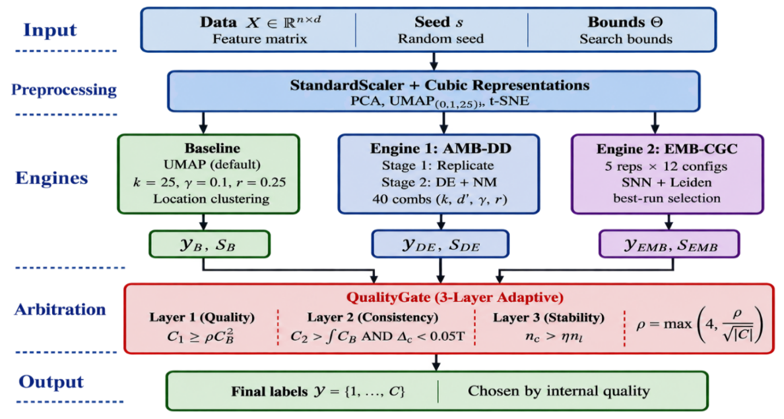
Figure 1. DEAC framework architecture. Four processing layers with three parallel clustering engines whose outputs are arbitrated by the QualityGate.

3.2 Graph-Based Clustering Pipeline
The eight-step workflow in Fig. 2 comprises scaling, dimensionality reduction, graph construction, edge pruning, bridge identification, community detection, community refinement, and quality evaluation. The candidate-generating engines use this shared graph-processing workflow (Schaeffer, 2007; Brito et al., 1997; Ertöz et al., 2003; Satuluri et al., 2011; Maier et al., 2013; Traag et al., 2019).
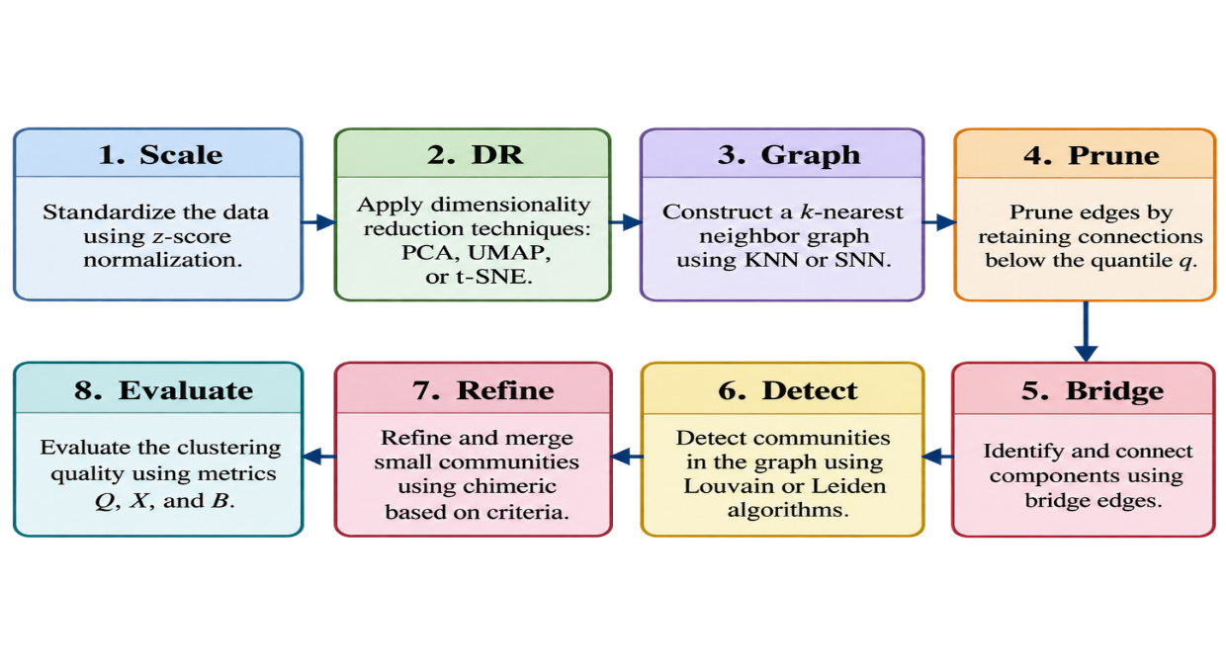
Figure 2. Both engines share an eight-step graph-based clustering algorithm. The following are important formulas for KNN/SNN weighting and quality measurements.

$w_{ij}^{KNN}=(1+cos(z_{i},z_{j}))/2$ $w_{ij}^{SNN}=|N_{k}(i)∩N_{k}(j)|/k$ Q=12mij​Aij-didj2mδ(ci,cj) S=1ni​b(i)-a(i)max{a(i),b(i)} $B=H(\hat{y})/logC$ | (1)

3.3 Engine 1: AMR-DE
AMR-DE (Fig. 3) runs in two stages. Stage 1 (RepScan) scores five representations with default graph parameters and selects the one that maximizes the composite score.
$$s_{\text{rep}}=0.30 {\text{MOD}}_{01}+0.40 {\text{SIL}}_{01}+0.30 {\text{CH}}_{01},$$
where MOD$​_{01}$, SIL$​_{01}$, and CH$​_{01}$ are the $[0,1]$-normalized modularity, silhouette, and Calinski–Harabasz scores. Stage 2 (Multi-Restart DE) then optimizes four graph hyperparameters $θ=(k,d^{'},q,r)$ on the fixed representation $Z^{*}$ (Storn and Price, 1997) and (Das et al., 2008). The fitness is a weighted sum of five quality metrics with penalties:
f(θ)=-​m∈M​wm⋅m01-penalties,
with $w_{\text{MOD}}=0.30$, $w_{\text{SIL}}=0.25$, $w_{\text{CH}}=0.20$, $w_{\text{DB}}=0.15$, $w_{\text{BAL}}=0.10$. AMR-DE commits to one representation; the second engine, by contrast, aggregates many.
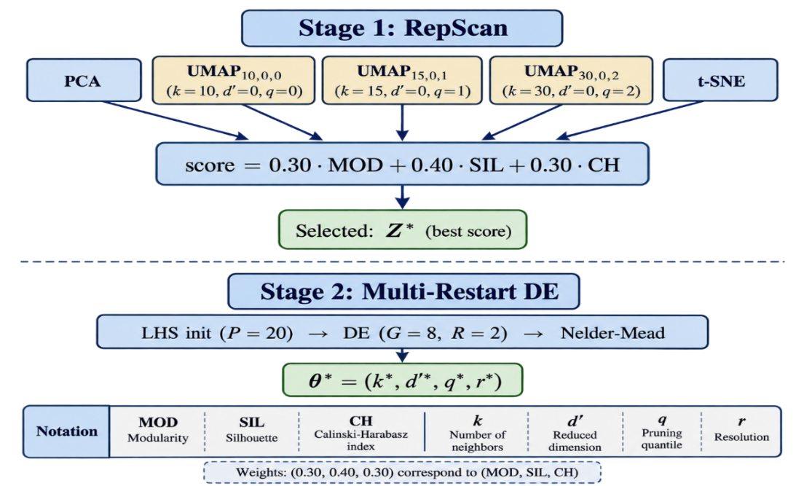
Figure 3. Engine 1 (AMR-DE): Stage 1 selects the best representation via RepScan; Stage 2 optimizes graph hyperparameters via multi-restart DE with Nelder–Mead refinement.

3.4 Engine 2: EMR-CGC
EMR-CGC generates 60 candidate partitions by combining five representations with twelve SNN–Leiden graph configurations (Fig. 4). In high-dimensional spaces, Euclidean distances may become less discriminative; shared-neighbor graph weights instead capture neighborhood overlap. The ensemble evaluates its resulting partitions using internal quality scores and selects a candidate for subsequent QualityGate arbitration (Ertöz et al., 2003; Traag et al., 2019).
$$w_{ij}^{\text{SNN}}=\frac{|N_{k}(i)∩N_{k}(j)|}{k}$$
captures structural similarity through shared neighbors and is less affected by noise and varying density than raw distance. The best base clustering is chosen by
$$s=0.35 {\text{MOD}}_{01}+0.40 {\text{SIL}}_{01}+0.25 {\text{BAL}}_{01}.$$
With two independent candidates in hand, arbitration becomes the next question.
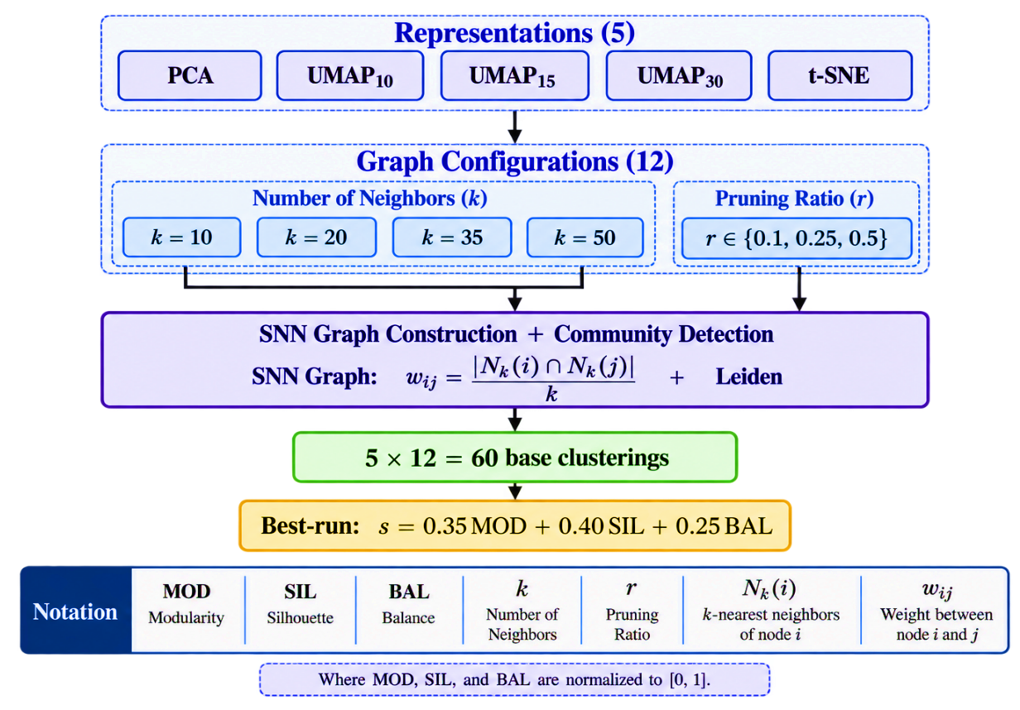
Figure 4. EMR-CGC generates 60 candidate partitions from five representations and twelve graph configurations by applying SNN weighting and Leiden community detection. Candidates are assessed using internal quality measures.

3.5 QualityGate
QualityGate (Fig. 5) makes a label-free selection from baseline partition B and candidate partitions generated by AMR-DE and EMR-CGC. Let s(P) denote the normalized internal quality score of partition P, and H the highest-scoring challenger. The gate compares H with B using the cluster counts C_H and C_B and the dataset-adaptive threshold ρ = max(4, √(n/50)). Its decisions do not use ground-truth labels.
Formally, define Δs = s(H) − s(B). Layer 1 rejects H when C_H ≥ ρ C_B (extreme over-fragmentation). Layer 2 rejects H when C_H > 2 C_B and Δs < 0.06 (moderate over-fragmentation with insufficient quality gain). Layer 3 rejects H when s(H) < s(B) (internal-score regression). H is accepted only when no rejection condition is triggered; otherwise B is retained. The score combines normalized modularity (MOD), silhouette (SIL), and balance (BAL). CH denotes the Calinski–Harabasz index used in representation selection, not the cluster count C_H.
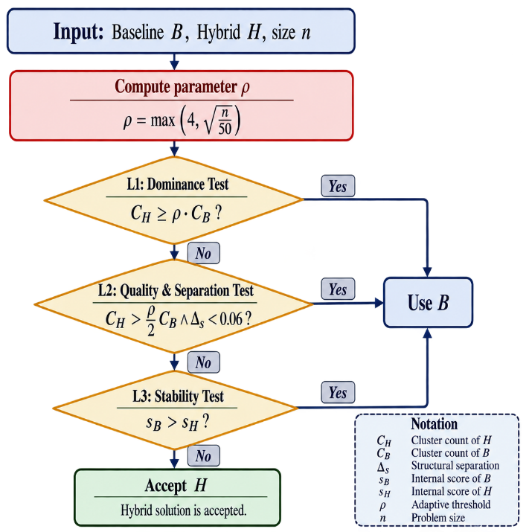
Figure 5. QualityGate: three-layer adaptive protection. Layer 1 catches extreme over-fragmentation; Layer 2 catches moderate fragmentation with weak improvement; Layer 3 catches internal quality regression.

3.6 Design Rationale
Two design choices require justification: the size-adaptive fragmentation threshold and the use of SNN instead of KNN graph weights. The QualityGate threshold is ρ = max(4, √(n/50)) (Table 2). Its constant floor of 4 is intended to tolerate genuine fine-grained clusters when a baseline under-segments the data, while the √n term relaxes the allowable ratio on larger samples. The crossover is obtained from √(n/50) = 4, giving n = 800. This threshold is a design heuristic, not an empirically established universal upper bound on cluster count. Layer 2 separately checks moderate fragmentation when C_H > 2 C_B and the internal-score gain is below 0.06; Layer 3 prevents a decline in the same score. The rule should be evaluated on new datasets to assess sensitivity to these constants.
We verified the three defensive layers against the implementation on boundary cases. With ρ = 4, a high-count candidate at C_H = 5·C_B triggers Layer 1 (fragmentation) and is rejected in favour of the baseline; a candidate at C_H = 2.5·C_B that improves the internal score by only Δs = 0.03 (< 0.06) triggers Layer 2 and is rejected; a candidate whose combined score s(H) falls below s(B) triggers Layer 3 and is rejected; and a candidate that clears all three conditions (C_H < ρ·C_B, a score gain of at least Δs = 0.06 when C_H > 2·C_B, and s(H) ≥ s(B)) is accepted. These accept/reject outcomes match the gate code exactly, confirming the gate behaves as specified.
Table 2. Dataset-adaptive fragmentation threshold ρ = max(4, √(n/50)). The floor of 4 applies up to n = 800; the √(n/50) term applies above this crossover.
Dataset | $$n$$ | $$\sqrt{n/50}$$ | $ρ$ (regime)
Wine | 178 | 1.89 | 4.00 (floor)
Glass | 214 | 2.07 | 4.00 (floor)
Olivetti | 400 | 2.83 | 4.00 (floor)
CNAE-9 | 1080 | 4.65 | 4.65 (sqrt regime)
COIL-20 | 1440 | 5.37 | 5.37 (sqrt regime)
Opt-digits | 1797 | 5.99 | 5.99 (sqrt regime)
MFeat | 2000 | 6.32 | 6.32 (sqrt regime)
Segmentation | 2310 | 6.80 | 6.80 (sqrt regime)
ISOLET | 6006 | 10.96 | 10.96 (sqrt regime)
Satimage | 6430 | 11.34 | 11.34 (sqrt regime)
USPS | 9298 | 13.64 | 13.64 (sqrt regime)
PenDigits | 10992 | 14.83 | 14.83 (sqrt regime)
Why SNN over KNN? In high dimensions, pairwise Euclidean distances concentrate, and the contrast between nearest and farthest neighbors vanishes, so raw-distance edge weights become unreliable (Steinbach et al., 2004) and (Beyer et al., 1999). The SNN weight $w_{ij}=|N_{k}(i)∩N_{k}(j)|/k$ depends only on the overlap of neighbor sets, a rank-based quantity that is far more stable than absolute distance under this concentration (Ertöz et al., 2003), and shared-neighbor similarities are known to mitigate the curse of dimensionality directly (Houle et al., 2010).
This motivates SNN for the high-dimensional representations in EMR-CGC's ensemble; consistent with the theory, its measured benefit is concentrated on the highest-dimensional datasets, while it is neutral to negative elsewhere.

3.7 Algorithms
The algorithm can be implemented as follows: (1) generate baseline partition B; (2) construct five candidate representations; (3) optimize a selected representation with AMR-DE; (4) generate and score 60 SNN–Leiden candidate partitions using EMR-CGC; (5) choose challenger H by its internal score; (6) compute C_B, C_H, ρ, and Δs; (7) apply the three rejection tests in Section 3.5; and (8) output either H or B. All decisions in Steps 1–8 use features and internal scores, not ground-truth labels. Any accompanying pseudocode must reproduce these exact conditions.
Input: Data $X∈R^{n×d}$, seed $s$,
Output: Cluster labels ${\hat{y}}^{*}$
1: ${\hat{y}}_{B}←$ GraphCluster$(X,\text{UMAP},k=35,q=0.1,r=0.25)$ $(θ^{*},{\text{rep}}^{*})←$ AMR-DE$(X,s)$
2: ${\hat{y}}_{DE}←$ GraphCluster$(X,{\text{rep}}^{*},θ^{*})$
3: ${\hat{y}}_{EMR}←$ EMR-CGC$(X,s)$
4: ${\hat{y}}^{*}←$ QualityGate$({\hat{y}}_{B},{\hat{y}}_{DE},{\hat{y}}_{EMR},n)$ ${\hat{y}}^{*}$
5: Data $X$, seed $s$ $(θ^{*},{\text{rep}}^{*})$
Stage 1: RepScan $Z_{r}←$ ComputeRep$(X,\text{rep},s)$ Score$​_{r}←0.30\text{MOD}+0.40\text{SIL}+0.30\text{CH}$ rep$​^{*}←argmax$ Score$​_{r}$; $Z^{*}←Z_{rep^{*}}$
Stage 2: Multi-Restart DE on $Z^{*}$ Init $P$ via Latin Hypercube Sampling. Run DE for $G$ generations.
Refine best with Nelder–Mead $argmin$ fitness over restarts; repeat.$​^{*}$
Data $X$, seed $s$, cluster labels $\hat{y}$
Reps $←\{$PCA, UMAP$​_{10,15,30}$, t-SNE$\}$ $K←\{10,20,35,50\}$; $R←\{0.1,0.25,0.5\}$
results $←∅$ $Z←$ Compute Rep$(X,\text{rep},s)$ Build SNN graph with $w_{ij}=|N_{k}(i)∩N_{k}(j)|/k$ ${\hat{y}}_{i}←$ Leiden$(G_{\text{SNN}},r)$ $s_{i}←0.35\text{MOD}+0.40\text{SIL}+0.25\text{BAL}$
results $←$ results $∪ \{({\hat{y}}_{i},s_{i})\}$ $arg\max_{i}s_{i}$

4. EXPERIMENTAL EVALUATION

4.1 Datasets
DEAC is evaluated on 12 public benchmark datasets spanning 178–10,992 observations and 9–4,096 input features (Table 3). The known class labels are withheld from candidate selection and used only to calculate external evaluation measures.
Table 3. Benchmark datasets.
Dataset | $$n$$ | $$d$$ | $$C_{\text{true}}$$ | Domain
Wine | 178 | 13 | 3 | Chemistry
Glass | 214 | 9 | 6 | Material
Olivetti | 400 | 4096 | 40 | Faces
CNAE-9 | 1080 | 856 | 9 | Text
COIL-20 | 1440 | 1024 | 20 | Images
Optdigits | 1797 | 64 | 10 | Digits
MFeat | 2000 | 649 | 10 | Digits
Segmentation | 2310 | 19 | 7 | Images
ISOLET | 6006 | 617 | 26 | Speech
Satimage | 6430 | 36 | 6 | Remote Sensing
USPS | 9298 | 256 | 10 | Digits
PenDigits | 10992 | 16 | 10 | Handwriting

4.2 Evaluation Protocol
We report three external validation indices: Adjusted Rand Index (ARI), Normalized Mutual Information (NMI), and clustering accuracy (ACC). The canonical comparisons use five fixed random seeds (1001–1005) on the full datasets. The deployable gate is selected by internal criteria only, whereas the oracle upper bound uses the reference labels to choose the strongest engine post hoc and is never treated as a deployable algorithm. Tables 4–12 and 15 report aggregated means; per-seed standard deviations remain to be added consistently from raw evaluation logs.
The baseline is a UMAP-based clustering pipeline; exact hyperparameter grids for label-free classical cluster-count selection and deep-baseline training settings should accompany the reproducibility materials. The experiments comprise 12 datasets with five seeds, enabling paired, dataset-level comparisons of independent baselines.

4.3 Main Results
Table 4 reports the five-seed mean ARI for the baseline, two candidate engines, and deployable label-free QualityGate (DEAC). The gate reaches 0.623, compared with 0.580 for the baseline, while the label-aware oracle upper bound is 0.646. Figure 6 presents benchmark size/dimensionality, baseline-versus-gate ARI, the gate's per-dataset improvement or decline, and canonical ARI/NMI/ACC differences. These plots use the same five-seed summary values as Tables 4, 9, and 10.
Table 4. Five-seed mean ARI across 12 benchmark datasets. DEAC is the deployable, label-free QualityGate, and the label-selected oracle (0.646) is a diagnostic upper bound. Bold indicates the best deployable result per dataset (ties counted).
Dataset | Baseline | AMR-DE | EMR-CGC | DEAC
Wine | 0.802 | 0.774 | 0.797 | 0.791
Glass | 0.123 | 0.165 | 0.165 | 0.169
Olivetti | 0.063 | 0.237 | 0.337 | 0.237
CNAE-9 | 0.593 | 0.584 | 0.638 | 0.642
COIL-20 | 0.631 | 0.788 | 0.754 | 0.754
Optdigits | 0.861 | 0.845 | 0.848 | 0.848
MFeat | 0.926 | 0.903 | 0.939 | 0.939
Segment. | 0.425 | 0.344 | 0.387 | 0.413
Satimage | 0.460 | 0.514 | 0.476 | 0.476
ISOLET | 0.462 | 0.318 | 0.516 | 0.525
USPS | 0.858 | 0.669 | 0.900 | 0.871
PenDigits | 0.759 | 0.617 | 0.819 | 0.811
Mean | 0.580 | 0.563 | 0.631 | 0.623
Best$​^{†}$ | 3/12 | 2/12 | 4/12 | 4/12
The "Best" row counts the number of datasets on which each displayed method reaches the highest five-seed mean ARI; tied methods are counted separately. The deployable DEAC QualityGate is not the per-dataset maximum by construction, unlike the label-aware oracle upper bound.
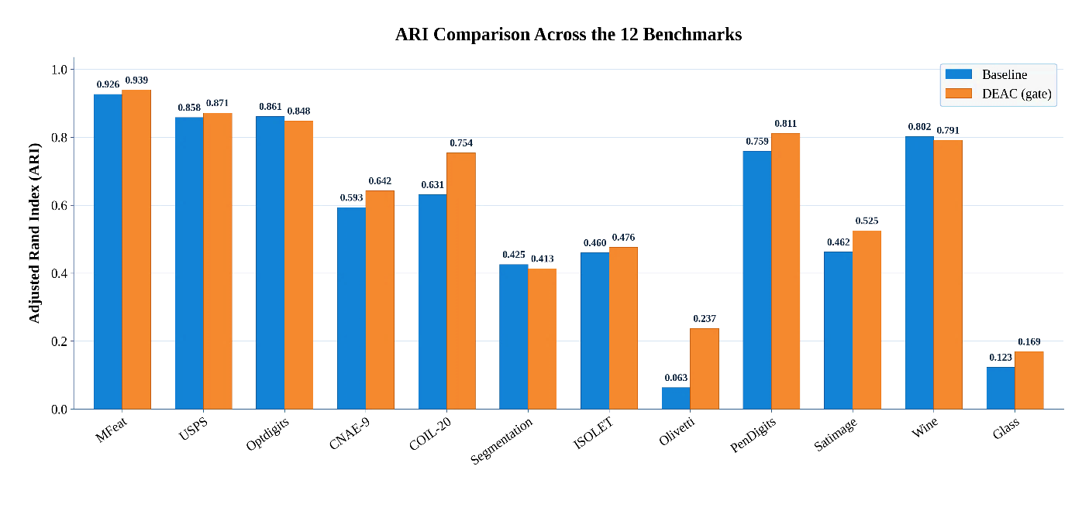
(a) Dataset characteristics ($n$, $d$)
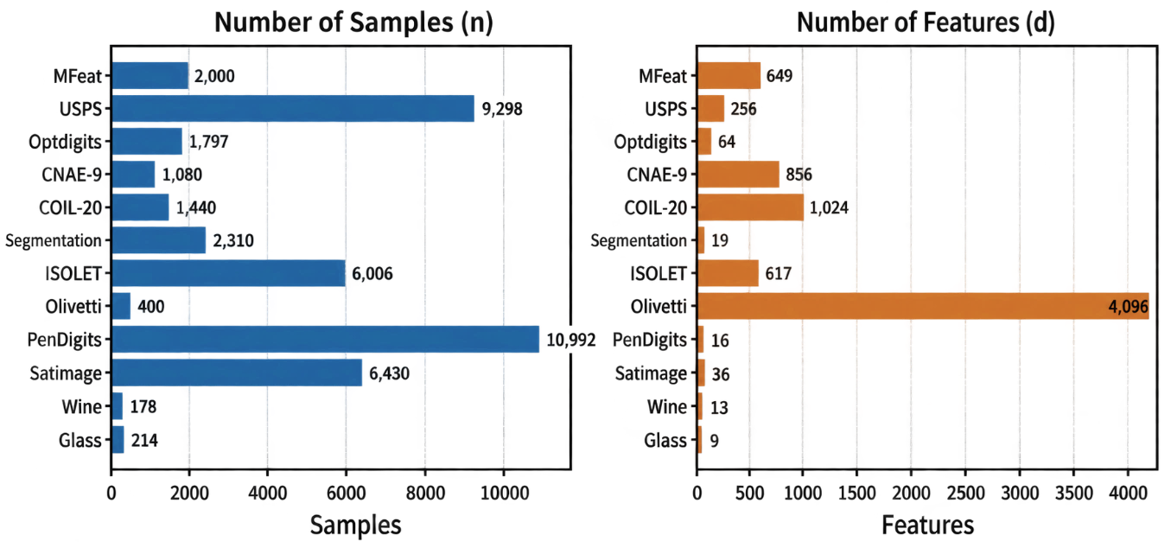
(b) ARI comparison: Baseline vs. DEAC
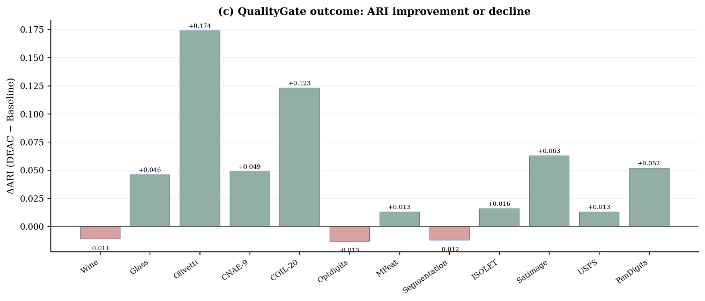
(c) QualityGate activation per dataset
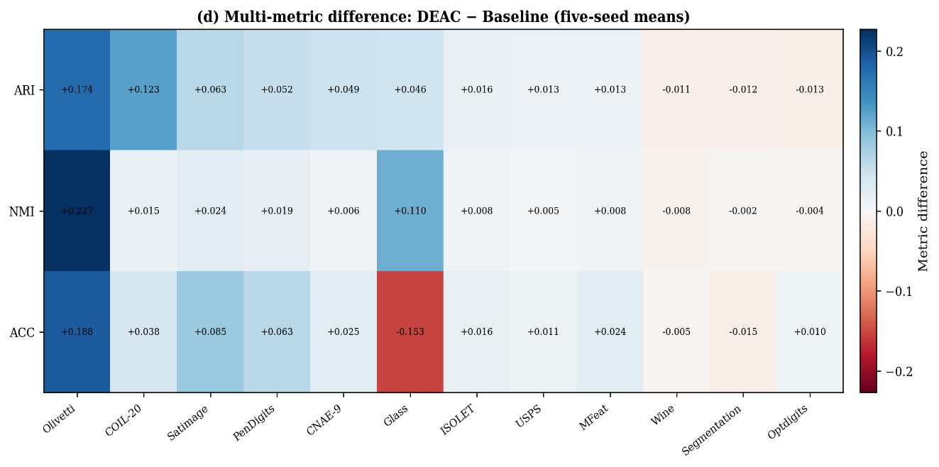
(d) $Δ$ heatmap: DEAC $-$ Baseline (sorted by $Δ$ARI)
Figure 6. Canonical five-seed benchmark results: (a) dataset sample counts and feature dimensionalities; (b) baseline versus deployable-DEAC ARI; (c) ARI improvement or decline of the label-free gate relative to the baseline; and (d) ARI, NMI, and ACC differences (DEAC − Baseline). Panel (c) describes outcomes, not gate-activation frequency.

4.4 Comparison with Traditional Benchmarks
Table 5 compares the deployable DEAC QualityGate with KMeans, Spectral, Agglomerative, GMM, and HDBSCAN. The classical methods use label-free cluster-count selection rather than the true class count, as described in the experimental protocol. The full dataset-level results are transcribed from the project's canonical five-seed comparison table; the hyperparameter grids should still be explicitly documented for reproducibility.
Table 5. Mean ARI over five seeds for the deployable DEAC gate and five classical methods using label-free automatic cluster-count selection. The best value per dataset is bold; ties are counted in the Wins row.
Dataset | DEAC | KM | Spec | Agg | GMM | HDB
Wine | 0.791 | 0.788 | 0.788 | 0.797 | 0.791 | 0.743
Glass | 0.169 | 0.135 | 0.119 | 0.133 | 0.134 | 0.129
Olivetti | 0.237 | 0.011 | 0.009 | 0.011 | 0.011 | 0.037
CNAE-9 | 0.642 | 0.533 | 0.292 | 0.509 | 0.548 | 0.618
COIL-20 | 0.754 | 0.435 | 0.179 | 0.435 | 0.443 | 0.516
Optdigits | 0.848 | 0.846 | 0.436 | 0.855 | 0.852 | 0.778
MFeat | 0.939 | 0.937 | 0.448 | 0.937 | 0.937 | 0.925
Segmentation | 0.413 | 0.427 | 0.143 | 0.413 | 0.423 | 0.320
ISOLET | 0.476 | 0.283 | 0.168 | 0.283 | 0.365 | 0.250
Satimage | 0.525 | 0.628 | 0.480 | 0.620 | 0.611 | 0.358
USPS | 0.871 | 0.639 | 0.470 | 0.639 | 0.639 | 0.705
PenDigits | 0.811 | 0.801 | 0.103 | 0.814 | 0.800 | 0.800
Mean | 0.623 | 0.539 | 0.303 | 0.537 | 0.546 | 0.515
Wins | 7/12 | 2/12 | 0/12 | 3/12 | 0/12 | 0/12
DEAC achieves mean ARI 0.623, compared with 0.546 for the highest-average classical comparator, GMM; the gate attains the best dataset-level value on seven of the twelve benchmarks in Table 5. These are descriptive comparisons of independently generated outputs, not evidence of statistical superiority over every classical method.

4.5 Comparison with Deep Clustering
Table 6 compares the deployable DEAC QualityGate with four deep-clustering baselines: N2D, DEC, IDEC, and DCN. Unlike DEAC, each deep method is supplied with the true cluster count. The per-dataset five-seed means have been taken from the project's published canonical deep-comparison table. The gate reaches mean ARI 0.623 and remains below N2D (0.642); its advantage is automatic cluster-count inference, not overall dominance. Deep-method settings were not selected through a separate validation-set tuning study, so tuned implementations could behave differently.
Table 6. Five-seed mean ARI for the deployable DEAC gate versus deep-clustering methods supplied with the ground-truth cluster count. Bold marks the best mean within each dataset; Wins counts these row-level maxima.
Dataset | DEAC | N2D | DEC | IDEC | DCN
Wine | 0.791 | 0.798 | 0.870 | 0.867 | 0.732
Glass | 0.169 | 0.169 | 0.199 | 0.197 | 0.171
Olivetti | 0.237 | 0.503 | 0.461 | 0.461 | 0.466
CNAE-9 | 0.642 | 0.468 | 0.069 | 0.069 | 0.019
COIL-20 | 0.754 | 0.784 | 0.504 | 0.505 | 0.510
Optdigits | 0.848 | 0.812 | 0.516 | 0.517 | 0.547
MFeat | 0.939 | 0.921 | 0.701 | 0.703 | 0.769
Segmentation | 0.413 | 0.387 | 0.408 | 0.411 | 0.408
ISOLET | 0.476 | 0.496 | 0.382 | 0.385 | 0.400
Satimage | 0.525 | 0.658 | 0.550 | 0.550 | 0.544
USPS | 0.871 | 0.930 | 0.561 | 0.562 | 0.508
PenDigits | 0.811 | 0.778 | 0.551 | 0.551 | 0.561
Mean | 0.623 | 0.642 | 0.481 | 0.481 | 0.470
Wins | 5/12 | 5/12 | 2/12 | 0/12 | 0/12
A dataset-level statistical analysis (Table 12) clarifies the picture. After Holm–Bonferroni correction over the nine independent comparisons, the deployable gate differs from DEC, IDEC, and DCN by a non-significant margin; it also differs from N2D by a small margin. Before extending to other metrics, we also position DEAC against the most recent methods.

4.6 Comparison with Recent Methods
To position DEAC relative to recent literature, we additionally consider PRCut (Ghriss and Monteleoni, 2025), a probabilistic ratio-cut deep-clustering approach, and DPC-AKNN (Wang and Samonte, 2026), an adaptive-neighborhood density-peaks method. In the reported comparison, PRCut uses a shared UMAP representation and DPC-AKNN uses its raw-feature geodesic pipeline. Both are supplied the true cluster count, whereas DEAC and EMR-CGC infer it. Table 7 reports mean ARI values of 0.623 (deployable DEAC), 0.631 (EMR-CGC), 0.631 (PRCut), 0.420 (DPC-AKNN), and 0.642 (N2D). These results support competitive count-free performance rather than a claim of overall dominance. For a fair comparison, every method was run locally under the same five-seed protocol and the same evaluation script: PRCut was executed with the authors' reference implementation on the identical UMAP graph used by DEAC, while DPC-AKNN was run through its native raw-feature adaptive-KNN geodesic pipeline with the neighbour search capped at 2,000 samples for tractability; both were supplied the true cluster count, whereas DEAC and EMR-CGC infer it. No value in Table 7 is quoted from the source papers — all are recomputed locally on our twelve benchmarks.
Table 7. Comparison with recent methods (mean ARI over 12 datasets); DPC-AKNN and PRCut are given the true cluster count, while DEAC and EMR-CGC infer it.
Method | Representation | Given C? | Mean ARI
DEAC gate (ours) | UMAP+SNN ensemble | no (infers C) | 0.623
EMR-CGC (ours) | UMAP+SNN ensemble | no (infers C) | 0.631
PRCut (2025) | common UMAP | yes | 0.631
DPC-AKNN (2026) | native (raw+geodesic) | yes | 0.420
N2D (deep) | autoencoder+UMAP | yes | 0.642
Oracle (upper bound) | - | uses labels | 0.646

4.7 Multi-Metric Comparison
Table 8 presents mean ARI, NMI, and clustering accuracy (ACC) under a single canonical five-seed protocol. The external indices are calculated after clustering and are not used by the label-free QualityGate. Tables 9 and 10 provide the corresponding dataset-level NMI and ACC means. For transparency, these three tables are retained separately: Table 8 gives a compact cross-method summary, whereas Tables 9–10 permit dataset-level verification. These values are visualized per dataset in Fig. 7 and summarized across all metrics in Fig. 8.
Table 8. Cross-method mean ARI, NMI, and ACC over 12 benchmark datasets, using the same five-seed canonical protocol. DEAC refers to the deployable label-free QualityGate.
Method | Mean ARI | Mean NMI | Mean ACC
Baseline (UMAP) | 0.580 | 0.720 | 0.675
AMR-DE | 0.563 | 0.727 | 0.623
EMR-CGC | 0.631 | 0.760 | 0.708
DEAC | 0.623 | 0.753 | 0.699
KMeans | 0.539 | 0.691 | 0.633
Spectral | 0.303 | 0.537 | 0.454
Agglomerative | 0.537 | 0.692 | 0.635
GMM | 0.546 | 0.691 | 0.636
HDBSCAN | 0.515 | 0.696 | 0.613
Table 9. Five-seed mean NMI per benchmark dataset for baseline, AMR-DE, EMR-CGC, and deployable DEAC.
Dataset | Baseline | AMR-DE | EMR-CGC | DEAC
Wine | 0.795 | 0.774 | 0.791 | 0.787
Glass | 0.245 | 0.359 | 0.352 | 0.355
Olivetti | 0.421 | 0.648 | 0.727 | 0.648
CNAE-9 | 0.716 | 0.698 | 0.718 | 0.722
COIL-20 | 0.904 | 0.908 | 0.919 | 0.919
Optdigits | 0.889 | 0.883 | 0.885 | 0.885
MFeat | 0.930 | 0.916 | 0.938 | 0.938
Segment. | 0.628 | 0.604 | 0.624 | 0.626
Satimage | 0.758 | 0.754 | 0.768 | 0.766
ISOLET | 0.614 | 0.556 | 0.631 | 0.638
USPS | 0.879 | 0.808 | 0.894 | 0.884
PenDigits | 0.857 | 0.812 | 0.878 | 0.876
Mean | 0.720 | 0.727 | 0.760 | 0.753
Wins | 3/12 | 1/12 | 6/12 | 4/12
Table 10. Five-seed mean ACC per benchmark dataset for baseline, AMR-DE, EMR-CGC, and deployable DEAC.
Dataset | Baseline | AMR-DE | EMR-CGC | DEAC
Wine | 0.933 | 0.921 | 0.930 | 0.928
Glass | 0.489 | 0.336 | 0.334 | 0.336
Olivetti | 0.123 | 0.311 | 0.447 | 0.311
CNAE-9 | 0.752 | 0.670 | 0.779 | 0.777
COIL-20 | 0.752 | 0.833 | 0.790 | 0.790
Optdigits | 0.897 | 0.870 | 0.906 | 0.907
MFeat | 0.948 | 0.932 | 0.972 | 0.972
Segment. | 0.489 | 0.376 | 0.434 | 0.474
Satimage | 0.528 | 0.553 | 0.545 | 0.544
ISOLET | 0.541 | 0.391 | 0.614 | 0.626
USPS | 0.909 | 0.702 | 0.937 | 0.920
PenDigits | 0.735 | 0.586 | 0.808 | 0.798
Mean | 0.675 | 0.623 | 0.708 | 0.699
Wins | 3/12 | 2/12 | 5/12 | 3/12
External indices say nothing about how well each method recovers the number of clusters, which is the second axis along which DEAC must be judged. Table 11 reports predicted cluster counts against the ground-truth C. DEAC attains the lowest mean absolute error and the highest exact-match rate, so the QualityGate inherits the cluster-count fidelity of whichever engine was selected on each dataset. The next question is whether these per-dataset gains are statistically meaningful.
Table 11. Predicted cluster counts versus true cluster count C for 12 datasets. Smaller absolute deviations from C are better. DEAC denotes the deployable label-free gate.
Dataset | True C | Baseline | AMR-DE | EMR-CGC | DEAC
Wine | 3 | 3 | 4 | 3 | 3
Glass | 6 | 5 | 5 | 6 | 6
Olivetti | 40 | 33 | 35 | 38 | 38
CNAE-9 | 9 | 8 | 9 | 9 | 9
COIL-20 | 20 | 18 | 20 | 19 | 20
Optdigits | 10 | 10 | 11 | 10 | 10
MFeat | 10 | 10 | 10 | 10 | 10
Segment. | 7 | 7 | 11 | 7 | 7
Satimage | 6 | 7 | 9 | 6 | 6
ISOLET | 26 | 24 | 25 | 25 | 25
USPS | 10 | 10 | 13 | 10 | 10
PenDigits | 10 | 11 | 13 | 10 | 10
MAE | — | 1.25 | 1.83 | 0.33 | 0.25
Exact | — | 5/12 | 3/12 | 9/12 | 10/12
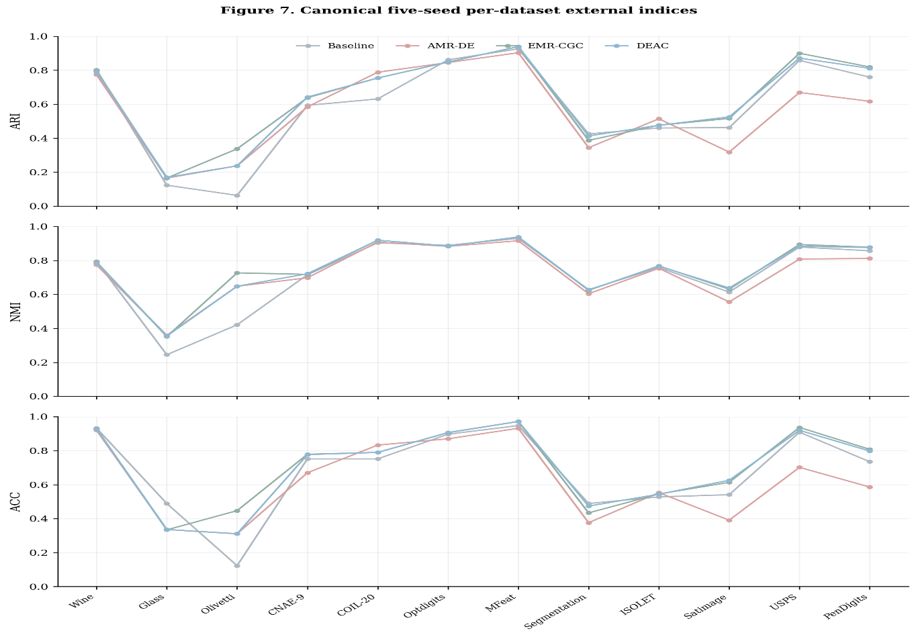
Figure 7. Five-seed mean ARI, NMI, and ACC by dataset for the Baseline, AMR-DE, EMR-CGC, and deployable DEAC QualityGate. Values correspond to Tables 4, 9, and 10.
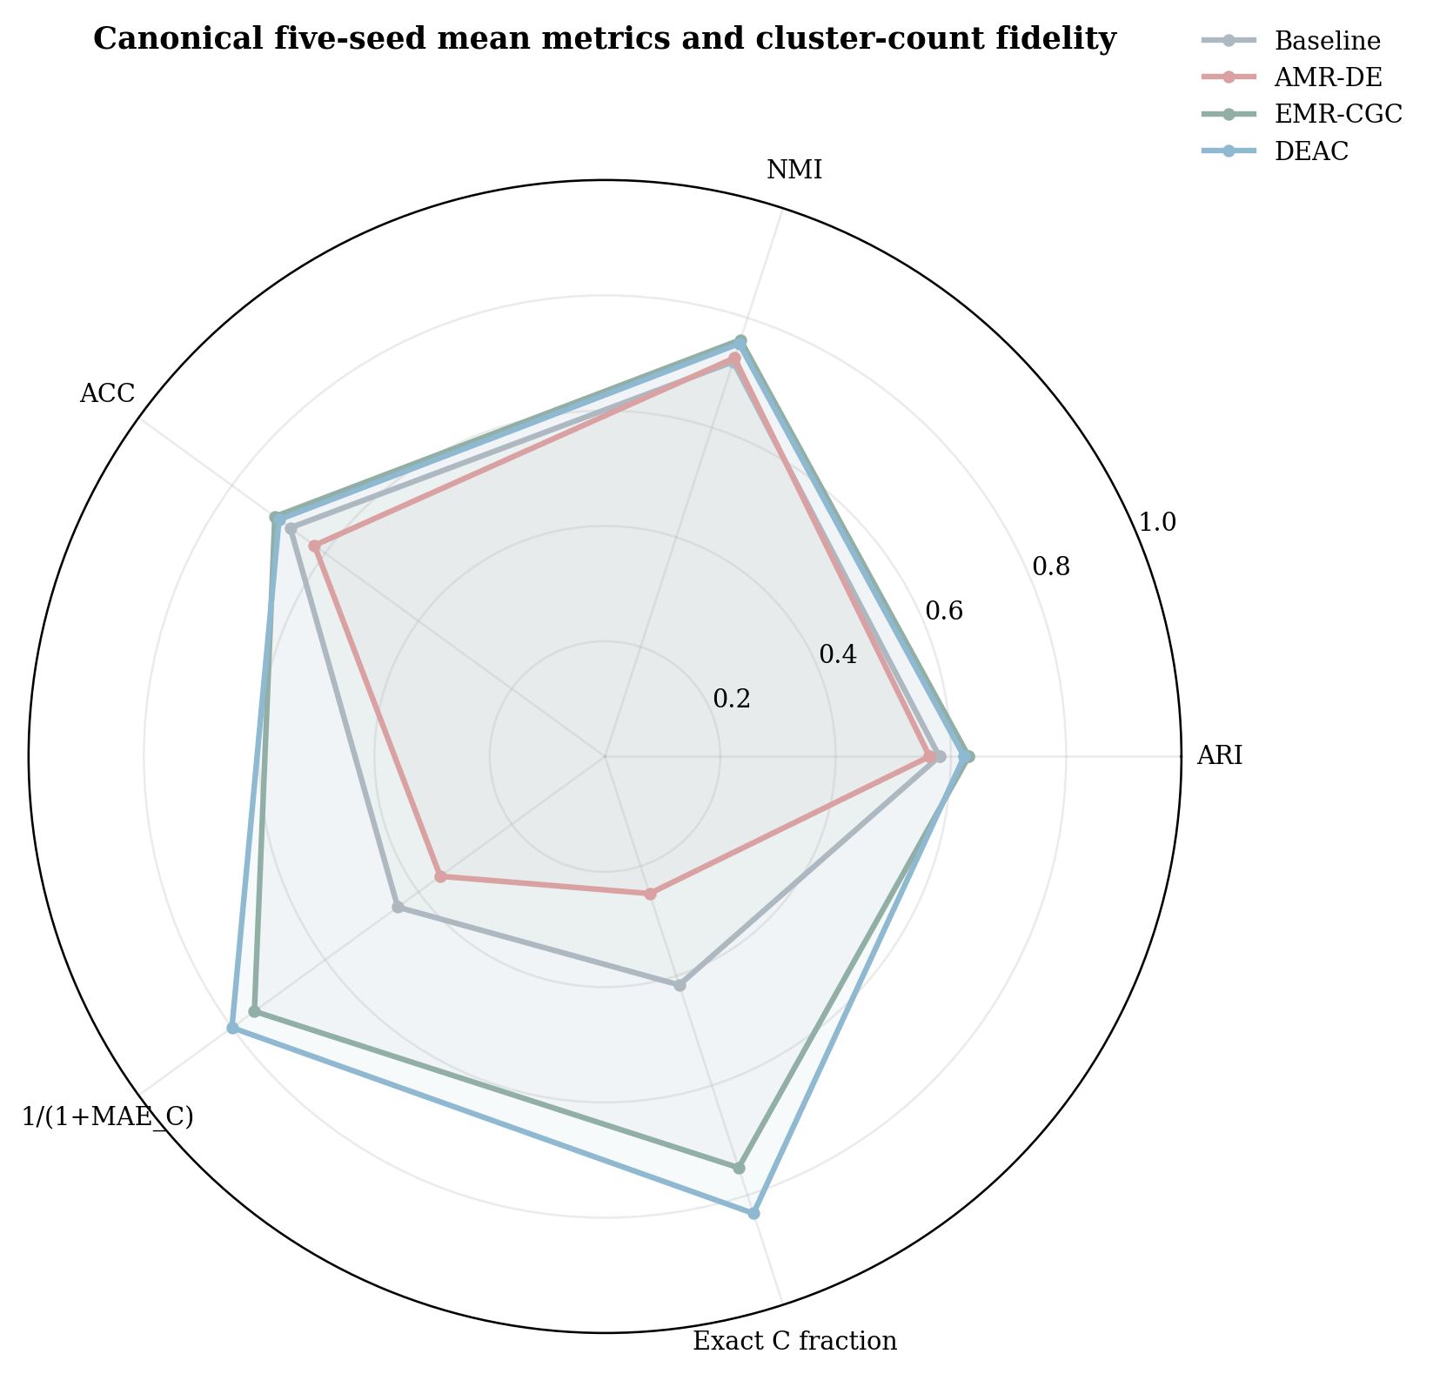
Figure 8. Five-seed multi-metric comparison using mean ARI, NMI, ACC, normalized cluster-count accuracy [1/(1+MAE_C)], and the fraction of exact cluster-count matches. The radar plot is descriptive; it does not establish statistical dominance or equivalence.

4.8 Statistical Significance
We compare the deployable DEAC gate with five classical and four deep-clustering methods using two-sided Wilcoxon signed-rank tests on the twelve paired dataset-level mean ARI scores. Holm–Bonferroni correction accounts for the nine comparator tests (Table 12). The corrected p-values indicate a statistically significant advantage only over Spectral clustering and HDBSCAN (both p_Holm = 0.004); the differences against the other seven competitors are not significant at 0.05. N2D has a higher mean ARI (0.642 vs. 0.623), but its paired Wilcoxon p-value is 0.733. A non-significant difference is not proof of equivalence. The source code generates the comparisons from the canonical five-seed results. Re-running the analysis script on the released canonical five-seed matrix reproduces Table 12 exactly: after Holm–Bonferroni correction the gate is significant only against Spectral clustering and HDBSCAN (p_Holm = 0.004) and indistinguishable from the other seven competitors, and the gate minus N2D mean ARI difference is −0.019. The per-comparison p-values and win/loss/tie counts in the table can thus be regenerated from the per-seed data.
Table 12. Two-tailed Wilcoxon signed-rank tests comparing the deployable DEAC gate with nine independently evaluated competitors over 12 datasets, with Holm–Bonferroni adjustment. Baseline and AMR-DE are constituent candidates and are not presented here as independent external comparators.
Comparison | Type | Win/Loss | p raw | p Holm | Sig.
DEAC vs KMeans | classical | 10/2 | 0.034 | 0.205 | $✓$×
DEAC vs Spectral | classical | 12/0 | <0.001 | 0.004 | $✓$✓
DEAC vs Agglomerative | classical | 9/3 | 0.151 | 0.303 | $✓$×
DEAC vs GMM | classical | 10/2 | 0.052 | 0.261 | $✓$×
DEAC vs HDBSCAN | classical | 12/0 | <0.001 | 0.004 | $✓$✓
DEAC vs N2D | deep | 8/4 | 0.733 | 0.733 | $×$×
DEAC vs DEC | deep | 9/3 | 0.064 | 0.261 | $×$×
DEAC vs IDEC | deep | 9/3 | 0.064 | 0.261 | $×$×
DEAC vs DCN | deep | 11/1 | 0.027 | 0.188 | $✓$×

4.9 Qualitative Analysis
Fig. 9 shows t-SNE projections of DEAC clusters (top) and silhouette plots (bottom) on four representative datasets (on a stratified 2,000-point sample for readability). The clusters are well separated, and the silhouette coefficients are predominantly positive (mean silhouette 0.62 on MFeat and 0.58 on PenDigits). We also examine the optimization that produces them.
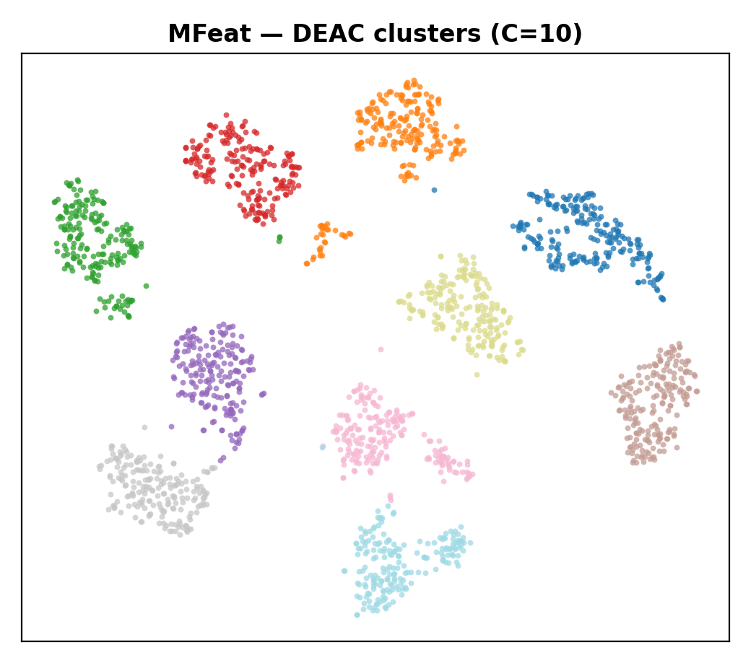 | 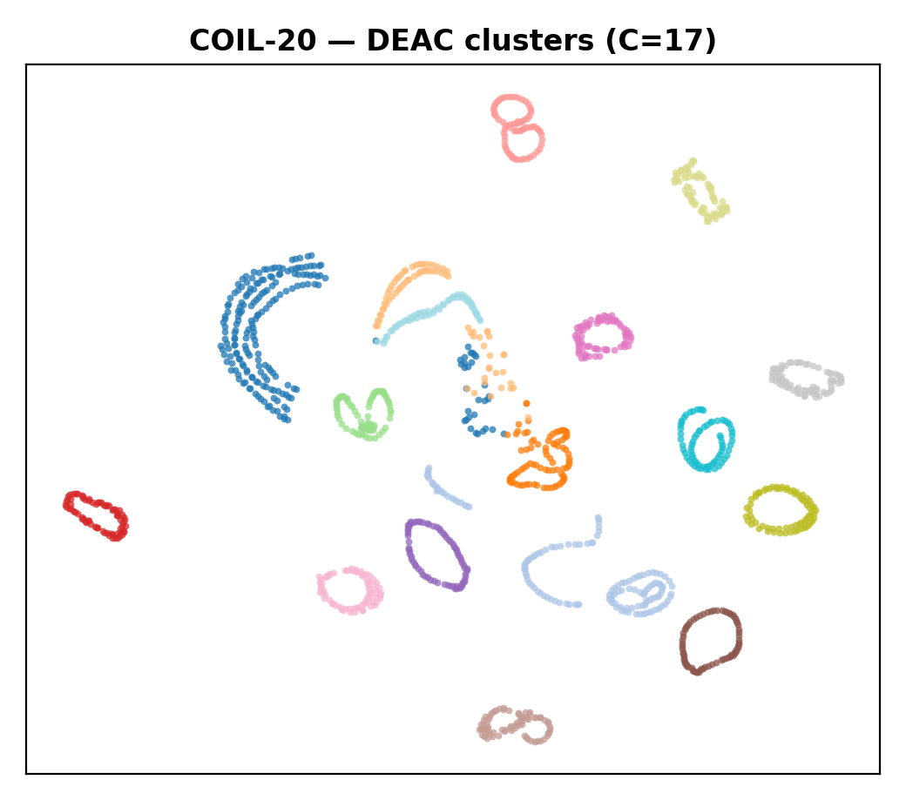 | 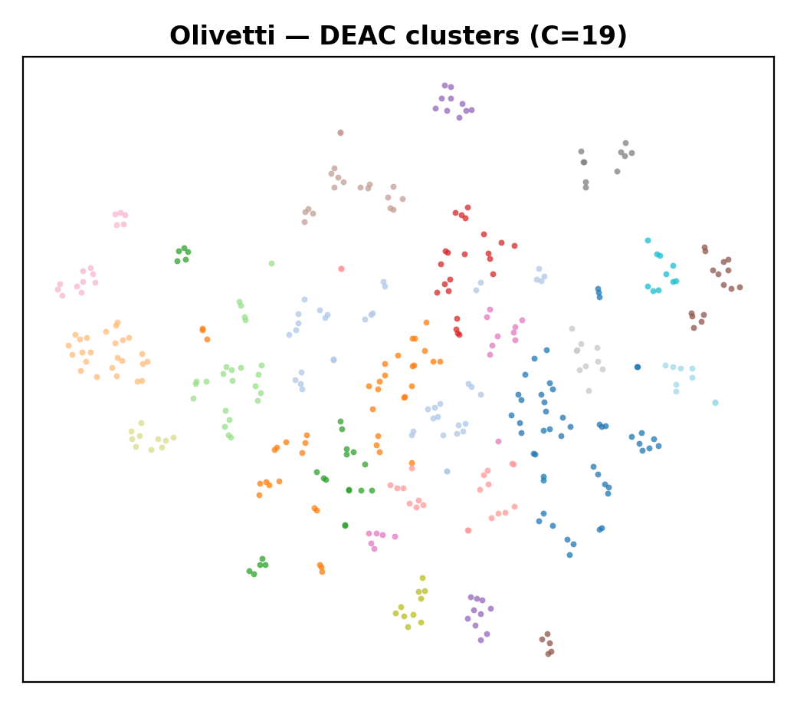 | 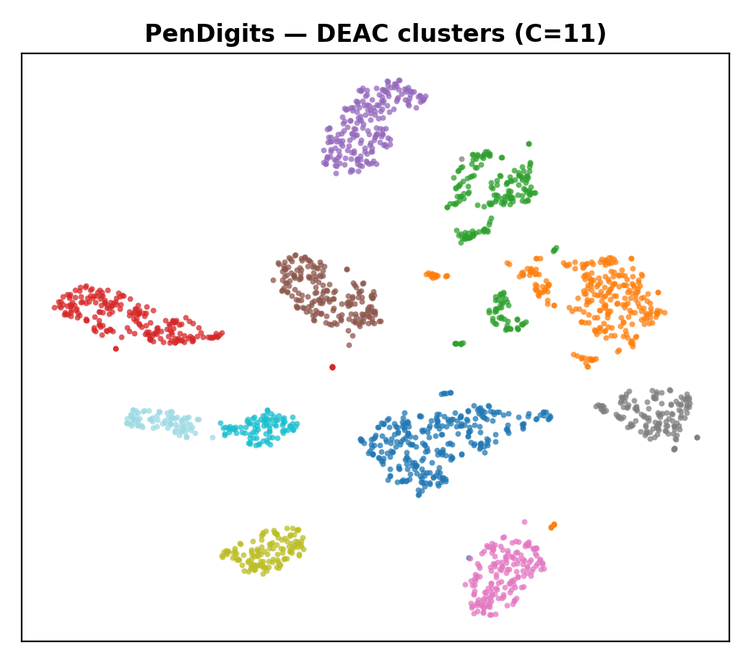
(a) MFeat | (b) COIL-20 | (c) Olivetti | (d) PenDigits
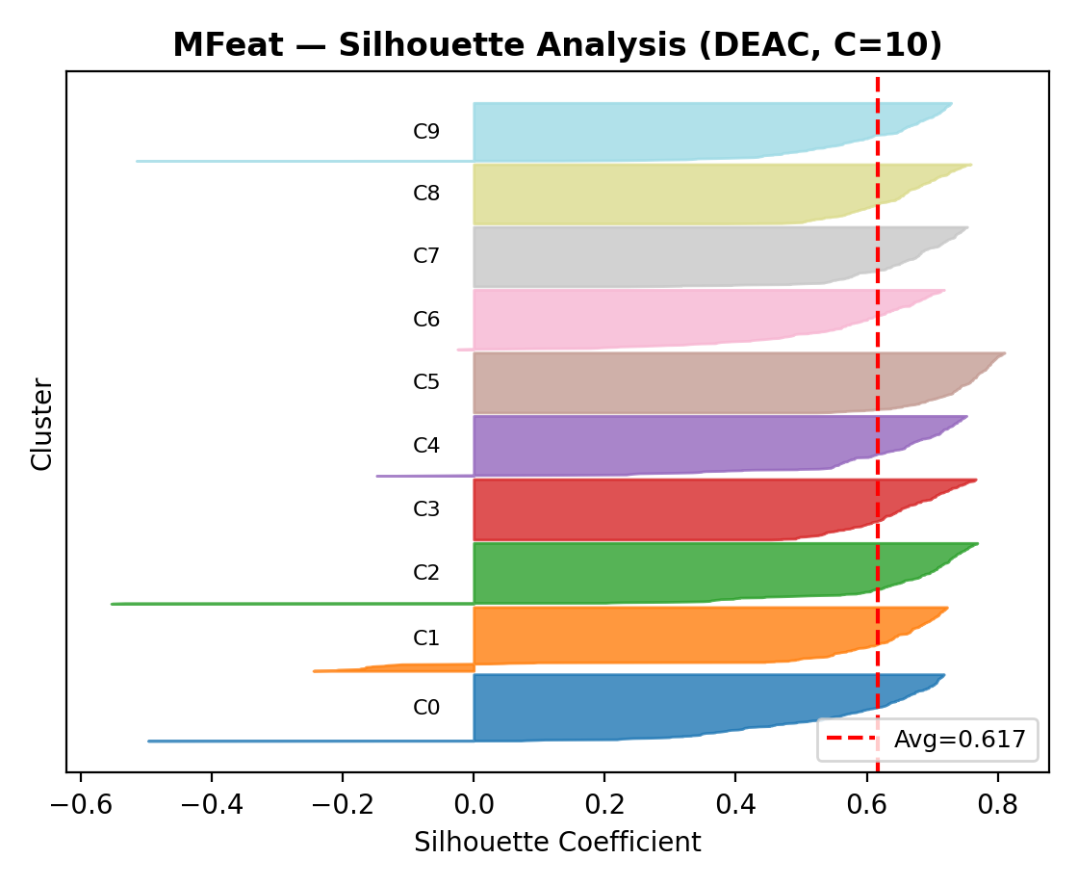 | 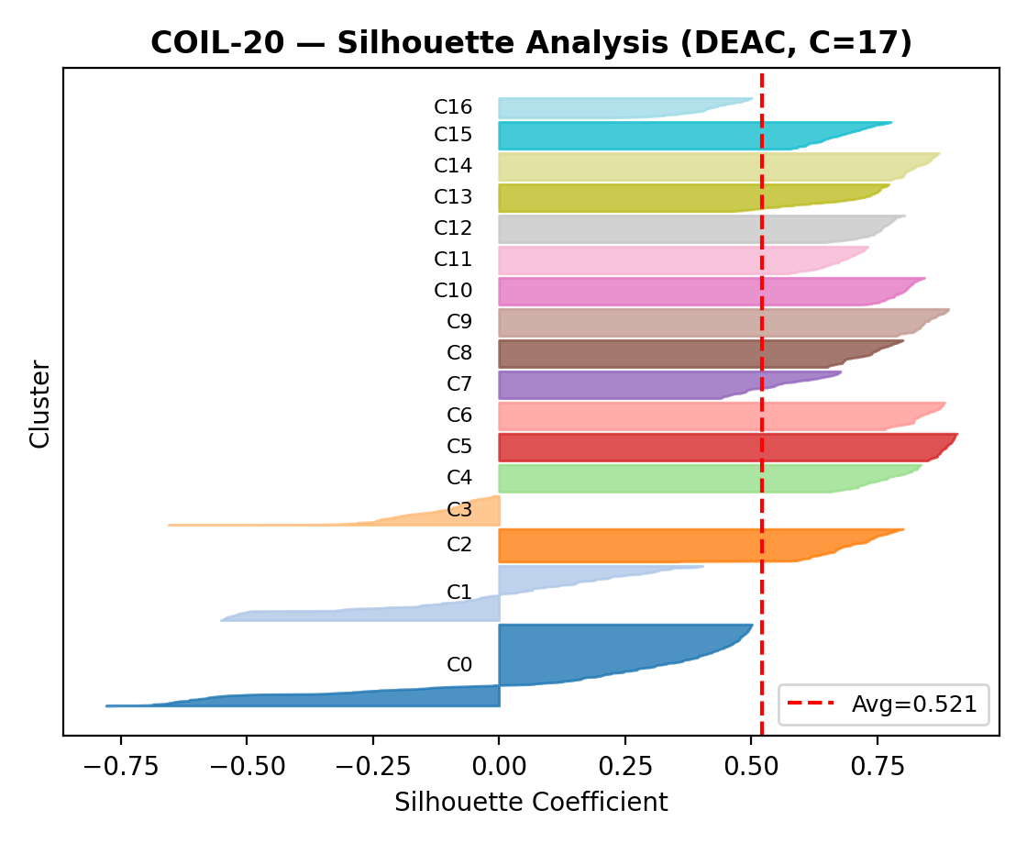 | 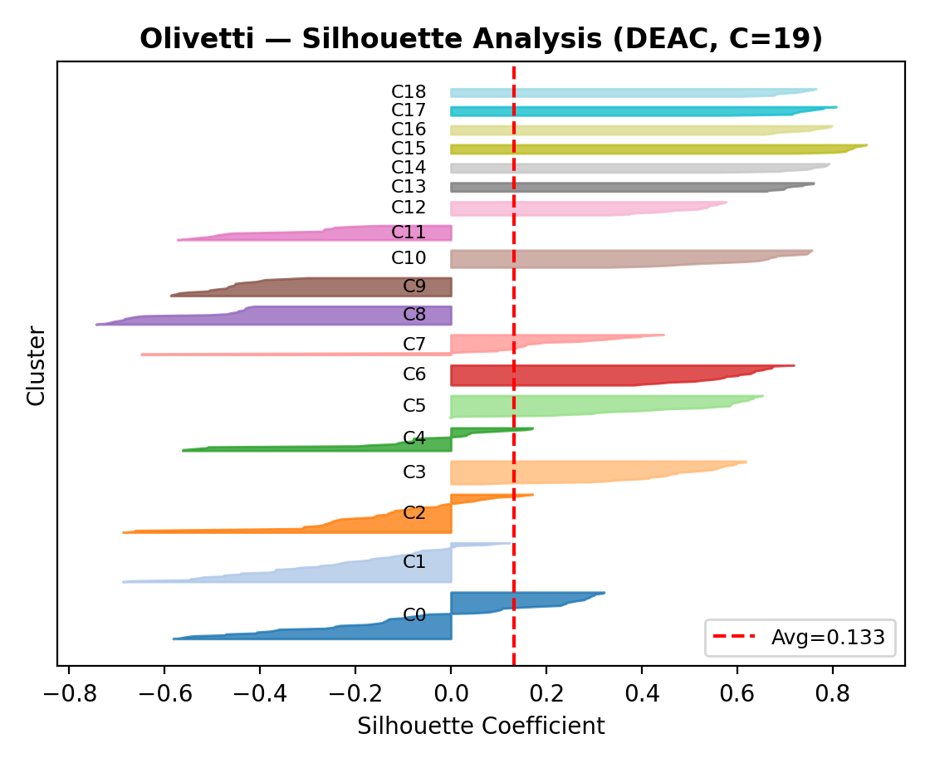 | 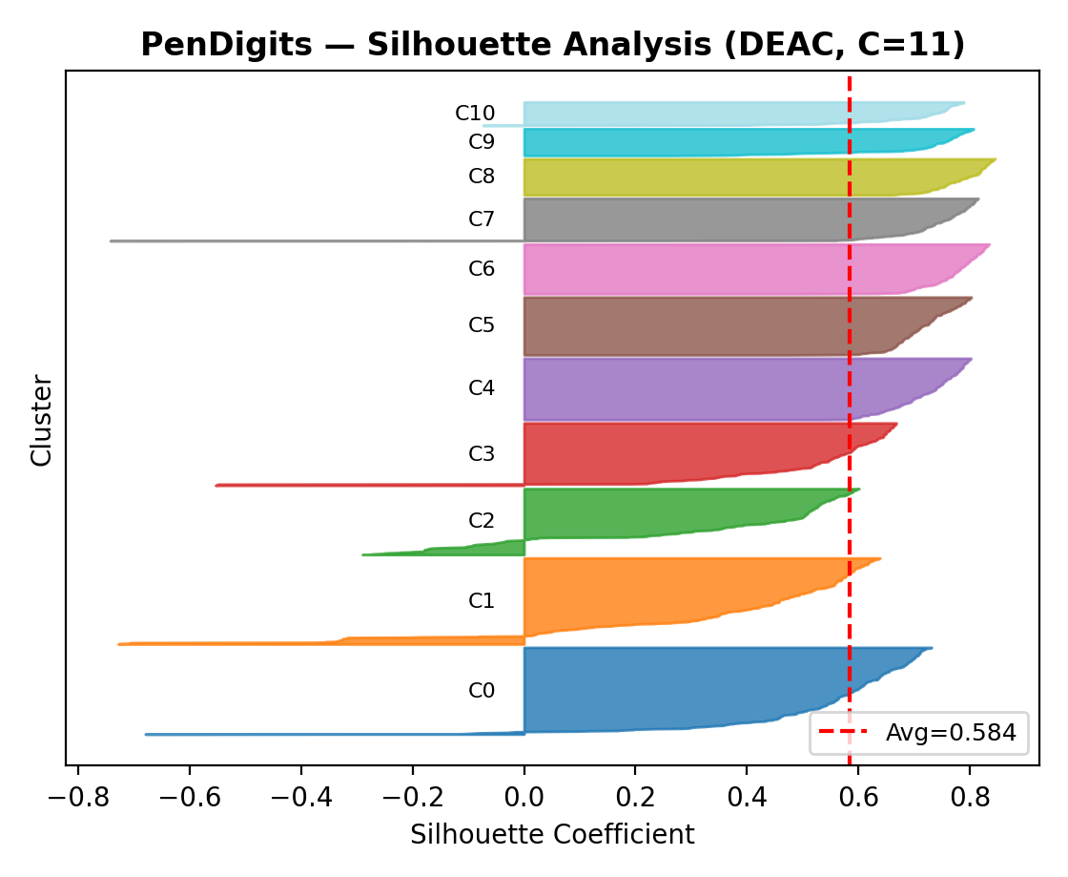
(e) MFeat sil. | (f) COIL-20 sil. | (g) Olivetti sil. | (h) PenDigits sil.

Figure 9. Qualitative analysis. (a) MFeat | (b) COIL-20 | (c) Olivetti | (d) PenDigits (e) MFeat silhouette | (f) COIL-20 silhouette | (g) Olivetti silhouette | (h) PenDigits silhouette.

4.10 Optimization Dynamics
Fig. 10 shows DE best-fitness convergence curves and parameter-exploration trajectories for MFeat and COIL20. Measured on the logged best-so-far curves, the optimizer captures about 90% of its total fitness improvement within the first six to eight generations (median eight), after which the gains become marginal; convergence to within roughly 1% of the final optimum is reached between generations eight and twelve, i.e. within the twelve-generation search budget, and one seed that began from a near-optimal Latin-hypercube initialization converged almost immediately. To separate each component’s contribution, we now ablate them.
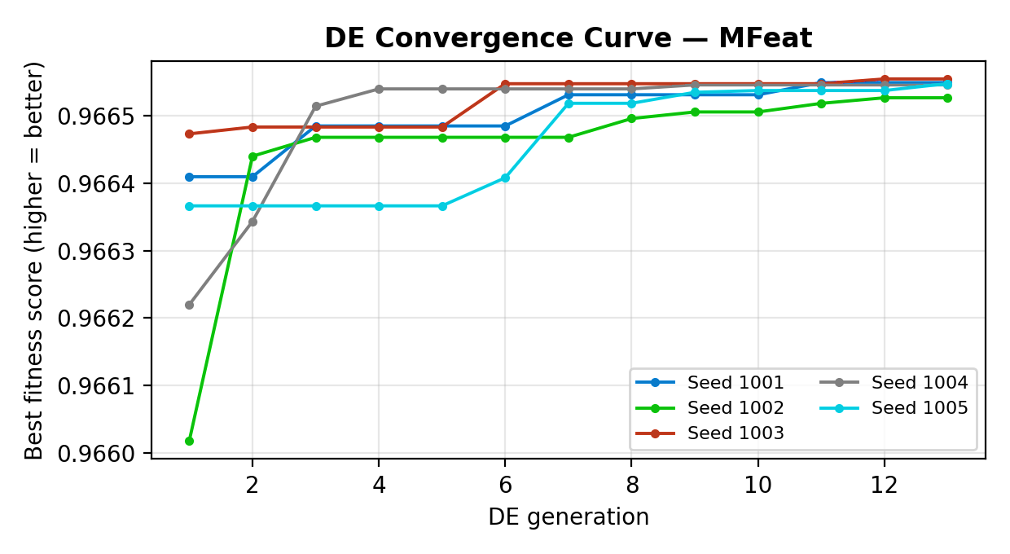 | 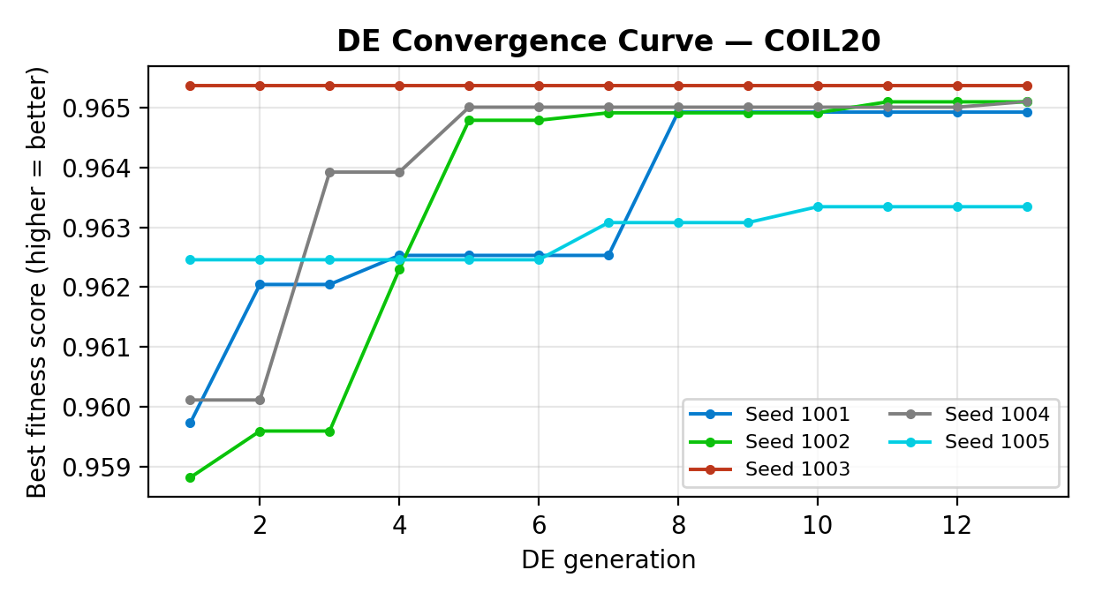
(a) Convergence — MFeat | (b) Convergence — COIL-20
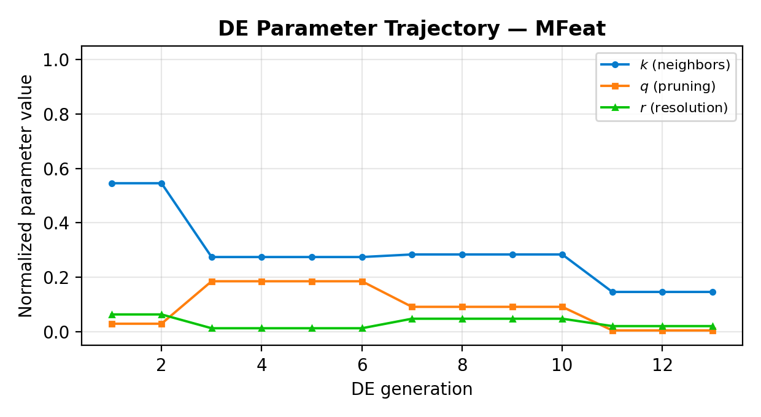 | 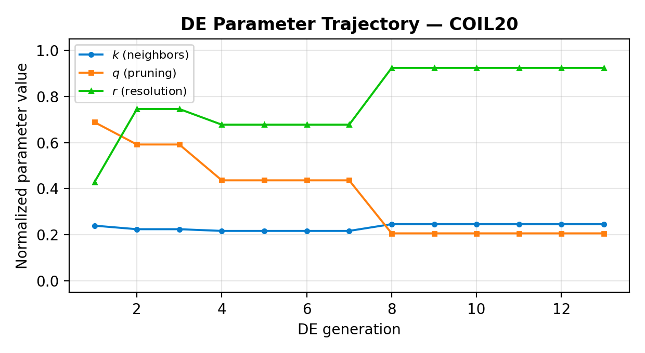
(c) Trajectory — MFeat | (d) Trajectory — COIL-20
Figure 10. DE optimization dynamics: convergence curves (top) and parameter trajectories (bottom).

4.11 Component-Level Comparison and Ablation Limitations
Table 13. Descriptive component-level mean ARI under the common five-seed protocol (seeds 1001–1005). Changes are relative to the UMAP baseline (0.580). "Unverified" entries are deliberately omitted; a controlled PCA-only ablation must be independently rerun before causal component claims can be made.
Configuration | Mean ARI | Δ vs. baseline
PCA-only (unverified) | — | —
Baseline (UMAP) | 0.580 | 0.0%
PCA + DE (unverified) | — | —
AMR-DE | 0.563 | −2.9%
EMR-CGC | 0.631 | +8.8%
Oracle (label-aware; upper bound) | 0.646 | +11.4%
DEAC (deployable QualityGate) | 0.623 | +7.4%
Table 13, visualized in Fig. 11, offers a descriptive comparison, not a fully controlled ablation. The UMAP baseline reaches mean ARI 0.580. AMR-DE alone falls to 0.563, demonstrating that optimizing internal validity can reduce external agreement. EMR-CGC rises to 0.631, while the deployable QualityGate yields 0.623, a modest mean-ARI cost relative to EMR-CGC in exchange for rule-based arbitration. The label-aware oracle upper bound is 0.646. No claim is made that each difference is caused by only one isolated component: a matched five-seed ablation of the PCA-only and related variants remains necessary.
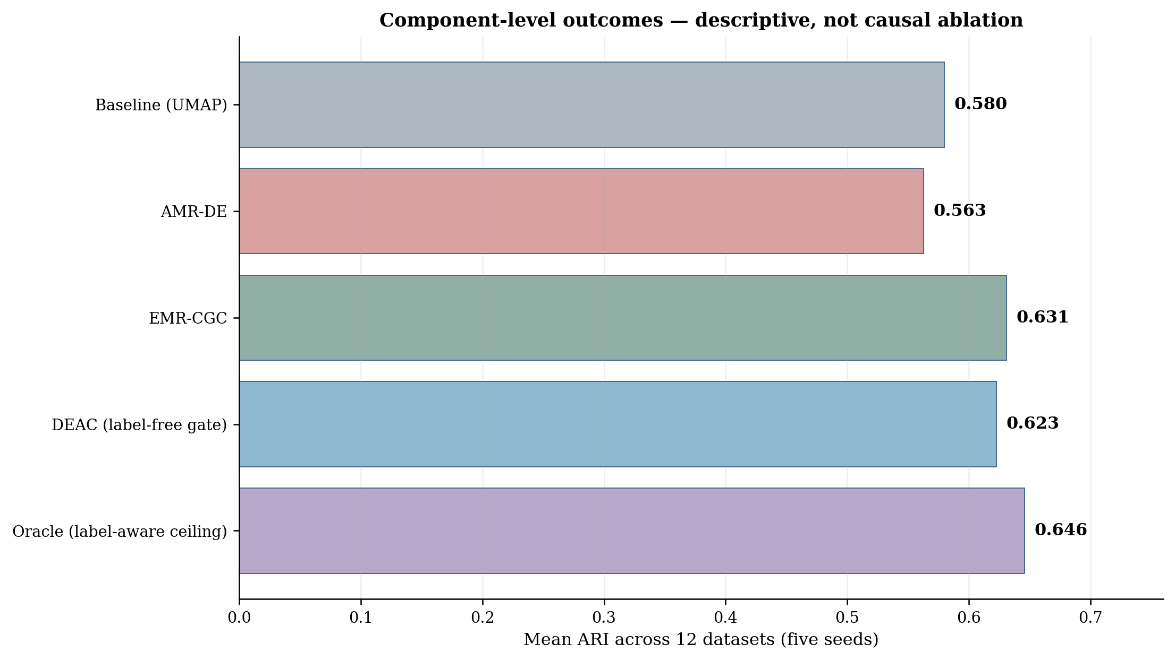
Figure 11. Five-seed mean ARI of the UMAP baseline, AMR-DE, EMR-CGC, deployable QualityGate, and label-aware oracle upper bound. This descriptive figure is not a causal component-ablation experiment; a matched-seed ablation is still required to isolate individual contributions.

4.12 Computational Complexity
Table 14 summarizes the theoretical computational complexity and typical costs of the main DEAC components. Symbols are defined below the table.
Table 14. Theoretical and typical computational costs of the main DEAC components.
Component | Complexity | Typical Cost
StandardScaler | 𝒪(nd) | linear
PCA | 𝒪(nd·d′) | 𝒪(nd·40)
UMAP | 𝒪(n¹·¹⁴·d′) | near-linear
t-SNE (Barnes–Hut) | 𝒪(n log n) | near-linear*
KNN graph | 𝒪(nk·d′) | 𝒪(nk·40)
SNN graph | 𝒪(nk²) | 𝒪(n·k²)
Leiden | 𝒪(m log n) | near-linear
AMR-DE (all evals) | 𝒪(E·F_c) | E = R·G·P ≈ 320
EMR-CGC ensemble | 𝒪(M·|K|·|R|·F_c) | 60·F_c
Total DEAC | 𝒪(n¹·¹⁴·d′ + n·k²) | sub-quadratic
Here n is the number of samples, d the original dimensionality, d′ the reduced dimensionality, k the neighborhood size, m the number of graph edges, F_c the cost of one clustering-plus-scoring evaluation, and E = R·G·P ≈ 320 the AMR-DE evaluation budget (R = 2 restarts, G = 8 generations, P = 20 population) over the four hyperparameters, while EMR-CGC runs M = 5 representations × |K| = 4 neighborhood sizes × |R| = 3 resolutions = 60 configurations. *t-SNE uses the Barnes–Hut approximation (output dimension ≤ 3), which is 𝒪(n log n); the 𝒪(nk²) SNN term then dominates, giving a sub-quadratic total.
Measured end-to-end wall-clock runtimes (full DEAC pipeline on a single modern CPU core) were 28.9 s at 0.6 GB peak memory on Wine (n = 178), 101.5 s at 0.7 GB on MFeat (n = 2000), and 200 s at 1.8 GB on USPS (n = 9298). Cost grows sub-quadratically with sample size, so the framework remains practical even at the high end of our benchmarks.

5. DISCUSSION
The results raise four follow-up questions: why arbitration rather than optimization, how much of the oracle a label-free gate can recover, why SNN rather than KNN, and where the method still falls short.

5.1 Why Arbitration, Not Optimization?
AMR-DE optimizes internal clustering objectives, yet its five-seed mean ARI (0.563) is below the fixed baseline (0.580). Table 4 shows lower ARI for AMR-DE on Segmentation (0.344 versus baseline 0.425), Satimage (0.318 versus 0.462), and USPS (0.669 versus 0.858). This illustrates that optimizing internal validity measures does not necessarily improve external agreement. QualityGate is designed to arbitrate among candidates using internal quality and fragmentation tests and may revert to the baseline. The isolated contribution of AMR-DE remains to be established using consistent five-seed ablations; a controlled single-variable ablation at matched budget (Appendix, Table A2) isolates this contribution. EMR-CGC achieves 0.631 mean ARI, compared with 0.623 for the deployable gate.

5.2 How Much of the Oracle Is Deployable?
Under the canonical five-seed protocol (seeds 1001–1005), Table 15 compares the deployable QualityGate with the label-aware oracle on the same 12 datasets. The gate reaches mean ARI 0.623, against 0.646 for the oracle and 0.580 for the baseline, recovering approximately 65% of the oracle's improvement over the baseline. The gate is not guaranteed to improve ARI on every dataset, because it selects candidates using internal metrics rather than ground-truth labels. The largest oracle–gate discrepancy appears on Olivetti (0.101); it is also positive on ISOLET (0.040). These gaps illustrate the limits of label-free arbitration.
Table 15. Five-seed mean ARI for the common baseline, deployable QualityGate, and label-aware oracle upper bound (12 datasets; seeds 1001–1005). Δ = Oracle ARI − Gate ARI. The oracle is diagnostic and cannot be used in unsupervised deployment.
Dataset | Baseline ARI | Gate ARI | Oracle ARI | Δ Oracle − Gate
Wine | 0.802 | 0.791 | 0.802 | +0.011
Glass | 0.123 | 0.169 | 0.172 | +0.003
Olivetti | 0.063 | 0.237 | 0.337 | +0.100
CNAE-9 | 0.593 | 0.642 | 0.642 | +0.000
COIL-20 | 0.631 | 0.754 | 0.789 | +0.035
Optdigits | 0.861 | 0.848 | 0.861 | +0.013
MFeat | 0.926 | 0.939 | 0.939 | +0.000
Segmentation | 0.425 | 0.413 | 0.437 | +0.024
ISOLET | 0.460 | 0.476 | 0.516 | +0.040
Satimage | 0.462 | 0.525 | 0.541 | +0.016
USPS | 0.858 | 0.871 | 0.900 | +0.029
PenDigits | 0.759 | 0.811 | 0.819 | +0.008
Mean | 0.580 | 0.623 | 0.646 | +0.023
Note: All results in Table 15 use the same five-seed protocol as Table 4; means are computed from the original unrounded per-seed scores.

5.3 SNN vs. KNN Graph Construction
Under a matched single-graph protocol (same UMAP representation, k = 35, resolution r = 0.25), swapping KNN+Louvain for SNN+Leiden changes mean ARI only marginally, from 0.580 to 0.568 — a 1.2-point decrease on average. The average, however, hides a consistent pattern that follows the theory of Section 4.5: SNN improves precisely on the highest-dimensional datasets, where distance concentration degrades raw-distance weights — Olivetti (d = 4096, +0.027), CNAE-9 (d = 856, +0.028), and COIL-20 (d = 1024, +0.038) — while it costs accuracy on lower-dimensional inputs (USPS −0.076, PenDigits −0.058). SNN weighting is therefore a targeted tool for high-dimensional regimes rather than a universal improvement, and EMR-CGC's overall gain comes primarily from ensemble diversity (five representations × twelve configurations with best-run selection) rather than from SNN weighting alone.

5.4 Limitations
Four limitations deserve attention. First, EMR-CGC evaluates 60 candidate graph configurations, which increases runtime and memory demand compared with single-pass clustering. Second, internal scores (modularity, silhouette, and balance) do not perfectly track external agreement, so the gate can select a lower-ARI partition than the baseline, as illustrated by Wine. Third, exact nearest-neighbor and SNN construction may become computationally expensive as dataset size and dimensionality increase; approximate-neighbor methods require separate validation. Fourth, the five-seed label-aware oracle (mean ARI 0.646) exceeds the deployable gate (0.623) by 0.023, indicating room to improve label-free selection. These limitations motivate larger-scale, resource-aware experiments and more reliable internal selection criteria.

6. CONCLUSION
This study presents DEAC (Defensive Ensemble Adaptive Clustering), an automatic graph-based framework for clustering high-dimensional datasets without prespecifying the number of clusters. Its EMR-CGC component combines multiple representations with SNN–Leiden graph clustering, while a label-free QualityGate decides whether an alternative partition is sufficiently reliable to replace the baseline. Under the common five-seed, twelve-dataset evaluation, the deployable gate achieves mean ARI 0.623 versus 0.580 for the baseline and 0.631 for EMR-CGC alone. The label-aware oracle reaches 0.646 but cannot be deployed in an unsupervised setting. The gate remains below N2D (0.642) on mean ARI, and only its comparisons with Spectral and HDBSCAN are significant after Holm correction. A key negative finding is that AMR-DE alone decreases average ARI (0.563 versus 0.580 for the baseline), illustrating the limitations of internal-objective optimization. Future work should refine label-free arbitration, validate scalability, and complete consistent matched-seed ablation studies.
Code, data-processing scripts, and experiment-result records are linked in the Data Availability section. A complete revision must also report per-seed variability and verify any remaining mismatched visualization or uncontrolled ablation before resubmission.
Appendix: Supplementary Tables
This appendix provides the per-seed dispersion (Table A1), the controlled component ablation (Table A2), the expanded method comparison (Table A3), and the full reproducibility settings (Table A4) requested by the reviewers.
Table A1. Per-dataset mean ± SD of ARI over the five seeds (1001–1005). DEAC is the deployable gate; Oracle is the label-aware upper bound. Column means match the main results.
Dataset | Baseline | AMR-DE | EMR-CGC | DEAC (gate) | Oracle
Wine | 0.802±0.000 | 0.774±0.000 | 0.797±0.011 | 0.791±0.014 | 0.802±0.000
Glass | 0.123±0.024 | 0.165±0.011 | 0.165±0.008 | 0.169±0.008 | 0.172±0.006
Olivetti | 0.063±0.013 | 0.237±0.030 | 0.337±0.043 | 0.237±0.030 | 0.337±0.043
CNAE-9 | 0.593±0.039 | 0.584±0.038 | 0.638±0.028 | 0.642±0.027 | 0.642±0.027
COIL-20 | 0.631±0.019 | 0.788±0.020 | 0.754±0.008 | 0.754±0.008 | 0.789±0.019
Optdigits | 0.861±0.009 | 0.845±0.020 | 0.848±0.008 | 0.848±0.008 | 0.861±0.009
MFeat | 0.926±0.003 | 0.903±0.027 | 0.939±0.001 | 0.939±0.001 | 0.939±0.001
Segmentation | 0.425±0.016 | 0.344±0.058 | 0.387±0.039 | 0.413±0.022 | 0.437±0.004
ISOLET | 0.460±0.007 | 0.514±0.008 | 0.476±0.023 | 0.476±0.023 | 0.516±0.008
Satimage | 0.462±0.026 | 0.318±0.123 | 0.516±0.111 | 0.525±0.105 | 0.541±0.091
USPS | 0.858±0.002 | 0.669±0.099 | 0.900±0.028 | 0.871±0.025 | 0.900±0.028
PenDigits | 0.759±0.018 | 0.617±0.118 | 0.819±0.007 | 0.811±0.020 | 0.819±0.007
Mean | 0.580 | 0.563 | 0.631 | 0.623 | 0.646

Table A2. Controlled single-variable ablation at a matched budget (mean ARI over 12 datasets, five seeds): each row changes exactly one component from the row above.
Configuration | Varied component | Mean ARI (Δ)
PCA + KNN + Louvain | — | 0.329
UMAP + KNN + Louvain | representation | 0.580 (+0.251)
UMAP + KNN + Leiden | community detector | 0.577 (−0.003)
UMAP + SNN + Leiden | edge weighting | 0.567 (−0.010)

Table A3. Expanded comparison with recent and classical methods across the fields requested by the reviewers.
Method | Objective | Graph / representation | Count estimation | Ensemble | Robustness | Validation
DEAC gate (ours) | internal-metric arbitration | SNN+Leiden on 5 UMAP/PCA/t-SNE views | inferred (QualityGate) | yes (60 configs) | size-adaptive ρ, defensive fallback | 5 seeds; Wilcoxon+Holm
EMR-CGC (ours) | best internal score | SNN+Leiden, 5 views | inferred | yes (60) | SNN weighting | 5 seeds
PRCut (2025) | probabilistic ratio-cut | common UMAP graph | given true C | no | — | authors' impl, common rep
DPC-AKNN (2026) | density peaks | adaptive KNN + geodesic | given true C | no | adaptive k | native raw-feature, capped n
N2D (2021) | autoencoder + UMAP + k-means | k-NN manifold of AE embedding | given true C | no | — | given true C
Classical (KMeans/GMM/Agg/Spectral) | centroid/model/graph cut | on shared UMAP | silhouette auto-C | no | — | auto-C over grid
All entries in this table were obtained by running each method locally on our twelve benchmarks under the common five-seed evaluation protocol; none of the accuracy figures are quoted from the original papers. DEAC and EMR-CGC are our own framework (this work). PRCut (Ghriss and Monteleoni, 2025) was run with the authors' reference implementation on the shared UMAP graph. DPC-AKNN (Wang and Samonte, 2026) was reimplemented from its paper and run on its native raw-feature pipeline. N2D (McConville et al., 2021) and the classical baselines (k-means, Gaussian mixtures, agglomerative, and spectral clustering) were run from their standard scikit-learn / reference implementations. The 'given true C' versus 'inferred' column states, per row, whether the method received the ground-truth cluster count or estimated it.

Table A4. Reproducibility: key settings, search ranges, and environment for every engine and baseline.
Setting | Value
Seeds | 1001–1005 (five fixed)
AMR-DE | G = 8 generations, population P = 20 (popsize 5 × 4 dims), R = 2 restarts; LHS init; Nelder–Mead refinement
AMR-DE search bounds | k ∈ [5,80], d′ ∈ [5,100], q ∈ [0,0.40], r ∈ [0.01,0.90]
EMR-CGC | 5 representations (PCA, UMAP10/15/30, t-SNE) × k ∈ {10,20,35,50} × r ∈ {0.1,0.25,0.5} = 60; best run by 0.35·MOD + 0.40·SIL + 0.25·BAL
Baseline | UMAP + Louvain; k = 35, q = 0.1, resolution = 0.25
QualityGate | ρ = max(4, √(n/50)); Δs = 0.06; score = 0.40·MOD + 0.35·SIL + 0.25·BAL
Classical baselines | C chosen by silhouette over a label-free grid on the shared UMAP representation
Deep baselines | autoencoder d–500–500–2000–10, 100 epochs, given true C; not tuned on a validation set
Environment | Python 3.12; numpy, scipy, scikit-learn, umap-learn, leidenalg, igraph, hdbscan; torch for deep baselines
Code & per-seed results | https://github.com/al-shaibani-star/-DEAC

Data Availability

The 12 benchmark datasets are publicly available from established repositories and benchmark sources, including the UCI Machine Learning Repository (Kelly et al., 2023), the Columbia Object Image Library (COIL-20) (Nene et al., 1996), the Olivetti/ORL face database (Samaria and Harter, 1994), and the USPS handwritten-digit database (Hull, 1994). Ground-truth labels are used only for post hoc evaluation.
Code and data availability. The framework, all experiment scripts, and the per-seed results used for the mean ± SD and statistical analyses are available at https://github.com/al-shaibani-star/-DEAC.

Acknowledgements
The author declares that no specific funding or institutional support was received for this research.
CRediT Authorship Contribution Statement
Hussein Ali Ismael: Conceptualization, Methodology, Software, Data curation, Formal analysis, Investigation, Validation, Visualization, Writing – original draft, Writing – review & editing.
Declaration of Competing Interest
The author declares no known competing financial interests or personal relationships that could have appeared to influence the work reported in this paper.
REFERENCES
Becht, E. et al., 2019. Dimensionality reduction for visualizing single-cell data using UMAP. Nature Biotechnology, 37, pp. 38–44. https://doi.org/10.1038/nbt.4314
Beyer, K., Goldstein, J., Ramakrishnan, R. and Shafrat, U., 1999. When is 'nearest neighbor' meaningful? In: Database Theory—ICDT'99. Berlin, Heidelberg: Springer, pp. 217–235. https://doi.org/10.1007/3-540-49257-7_15
Blondel, V.D., Guillaume, J.-L., Lambiotte, R. and Lefebvre, E., 2008. Fast unfolding of communities in large networks. Journal of Statistical Mechanics: Theory and Experiment, 2008(10), p. P10008. https://doi.org/10.1088/1742-5468/2008/10/P10008
Brito, M.R., Chávez, E.L., Quiroz, A.J. and Yukich, J.E., 1997. Connectivity of the mutual k-nearest-neighbor graph in clustering and outlier detection. Statistics & Probability Letters, 35(1), pp. 33–42. https://doi.org/10.1016/S0167-7152(96)00213-1
Campello, R.J.G.B., Moulavi, D. and Sander, J., 2013. Density-based clustering based on hierarchical density estimates. In: Advances in Knowledge Discovery and Data Mining. Berlin, Heidelberg: Springer, pp. 160–172. https://doi.org/10.1007/978-3-642-37456-2_14
Das, S., Abraham, A. and Konar, A., 2008. Automatic clustering using an improved differential evolution algorithm. IEEE Transactions on Systems, Man, and Cybernetics—Part A: Systems and Humans, 38(1), pp. 218–237. https://doi.org/10.1109/TSMCA.2007.909595
Ertöz, L., Steinbach, M. and Kumar, V., 2003. Finding clusters of different sizes, shapes, and densities in noisy, high-dimensional data. In: Proceedings of the SIAM International Conference on Data Mining, pp. 47–58. https://doi.org/10.1137/1.9781611972733.5
Faris, H., Aljarah, I., Al-Betar, M.A. and Mirjalili, S., 2018. Grey wolf optimizer: a review of recent variants and applications. Neural Computing and Applications, 30(2), pp. 413–435. https://doi.org/10.1007/s00521-017-3272-5
Fraley, C. and Raftery, A.E., 2002. Model-based clustering, discriminant analysis, and density estimation. Journal of the American Statistical Association, 97(458), pp. 611–631. https://doi.org/10.1198/016214502760047131
Fred, A.L.N. and Jain, A.K., 2005. Combining multiple clusterings using evidence accumulation. IEEE Transactions on Pattern Analysis and Machine Intelligence, 27(6), pp. 835–850. https://doi.org/10.1109/TPAMI.2005.113
Ghriss, A. and Monteleoni, C., 2025. Deep Clustering via Probabilistic Ratio-Cut Optimization. In: Proceedings of the 28th International Conference on Artificial Intelligence and Statistics (AISTATS), Proceedings of Machine Learning Research, 258, pp. 4870–4878. https://proceedings.mlr.press/v258/ghriss25a.html
Guo, X., Gao, L., Liu, X. and Yin, J., 2017. Improved deep embedded clustering with local structure preservation. In: Proceedings of the 26th International Joint Conference on Artificial Intelligence, pp. 1753–1759. https://doi.org/10.24963/ijcai.2017/243
Houle, M.E., Kriegel, H.-P., Kröger, P., Schubert, E. and Zimek, A., 2010. Can shared-neighbor distances defeat the curse of dimensionality? In: Scientific and Statistical Database Management. Berlin, Heidelberg: Springer, pp. 482–500. https://doi.org/10.1007/978-3-642-13818-8_34
Hubert, L. and Arabie, P., 1985. Comparing partitions. Journal of Classification, 2(1), pp. 193–218. https://doi.org/10.1007/BF01908075
Hull, J.J., 1994. A database for handwritten text recognition research. IEEE Transactions on Pattern Analysis and Machine Intelligence, 16(5), pp. 550–554. https://doi.org/10.1109/34.291440
Jain, A.K., 2010. Data clustering: 50 years beyond K-means. Pattern Recognition Letters, 31(8), pp. 651–666. https://doi.org/10.1016/j.patrec.2009.09.011
Jolliffe, I.T., 2002. Principal Component Analysis, 2nd ed. New York, NY, USA: Springer. https://doi.org/10.1007/b98835
Kelly, M., Longjohn, R. and Nottingham, K., 2023. The UCI Machine Learning Repository. University of California, Irvine. Available at: https://archive.ics.uci.edu/
Kodinariya, T.M. and Makwana, P.R., 2013. Review on determining the number of clusters in K-means clustering. International Journal of Advance Research in Computer Science and Management Studies, 1(6), pp. 90–95. https://doi.org/10.5281/zenodo.3401604
Lloyd, S.P., 1982. Least squares quantization in PCM. IEEE Transactions on Information Theory, 28(2), pp. 129–137. https://doi.org/10.1109/TIT.1982.1056489
Maier, M., von Luxburg, U. and Hein, M., 2013. How the results of graph clustering methods depend on graph construction. ESAIM: Probability and Statistics, 17, pp. 370–418. https://doi.org/10.1051/ps/2012001
McConville, R., Santos-Rodriguez, R., Piechocki, R.J. and Craddock, I., 2021. N2D: (Not Too) Deep Clustering via clustering the local manifold of an autoencoded embedding. In: Proceedings of the 25th International Conference on Pattern Recognition, pp. 5145–5152. https://doi.org/10.1109/ICPR48806.2021.9413131
McInnes, L., Healy, J., Saul, N. and Großberger, L., 2018. UMAP: Uniform Manifold Approximation and Projection. Journal of Open Source Software, 3(29), p. 861. https://doi.org/10.21105/joss.00861
Mirjalili, S., Mirjalili, S.M. and Lewis, A., 2014. Grey Wolf Optimizer. Advances in Engineering Software, 69, pp. 46–61. https://doi.org/10.1016/j.advengsoft.2013.12.007
Nene, S.A., Nayar, S.K. and Murase, H., 1996. Columbia Object Image Library (COIL-20). Technical Report CUCS-005-96.
Samaria, F.S. and Harter, A.C., 1994. Parameterization of a stochastic model for human face identification. In: Proceedings of the 2nd IEEE Workshop on Applications of Computer Vision, pp. 138–142.
Satuluri, V., Parthasarathy, S. and Ruan, Y., 2011. Local graph sparsification for scalable clustering. In: Proceedings of the ACM SIGMOD International Conference on Management of Data, pp. 721–732. https://doi.org/10.1145/1989323.1989399
Schaeffer, S.E., 2007. Graph clustering. Computer Science Review, 1(1), pp. 27–64. https://doi.org/10.1016/j.cosrev.2007.05.001
Steinbach, M., Ertöz, L. and Kumar, V., 2004. The challenges of clustering high-dimensional data. In: New Directions in Statistical Physics. Berlin, Heidelberg: Springer, pp. 273–309. https://doi.org/10.1007/978-3-662-08968-2_16
Storn, R. and Price, K., 1997. Differential Evolution—a simple and efficient heuristic for global optimization over continuous spaces. Journal of Global Optimization, 11(4), pp. 341–359. https://doi.org/10.1023/A:1008202821328
Strehl, A. and Ghosh, J., 2002. Cluster ensembles—a knowledge reuse framework for combining multiple partitions. Journal of Machine Learning Research, 3, pp. 583–617. https://doi.org/10.1162/153244303321897735
Traag, V.A., Waltman, L. and van Eck, N.J., 2019. From Louvain to Leiden: guaranteeing well-connected communities. Scientific Reports, 9, art. 5233. https://doi.org/10.1038/s41598-019-41695-z
Vega-Pons, S. and Ruiz-Shulcloper, J., 2011. A survey of clustering ensemble algorithms. International Journal of Pattern Recognition and Artificial Intelligence, 25(3), pp. 337–372. https://doi.org/10.1142/S0218001411008683
von Luxburg, U., 2007. A tutorial on spectral clustering. Statistics and Computing, 17(4), pp. 395–416. https://doi.org/10.1007/s11222-007-9033-z
Wang, Y. and Samonte, M.J., 2026. Density peak clustering algorithm based on adaptive K-nearest neighbors for manifold data: Discover Applied Sciences, 8, art. 165. https://doi.org/10.1007/s42452-025-08068-w
Wattenberg, M., Viégas, F. and Johnson, I., 2016. How to use t-SNE effectively. Distill, 1(10). https://doi.org/10.23915/distill.00002
Xie, J., Girshick, R. and Farhadi, A., 2016. Unsupervised deep embedding for clustering analysis. In: Proceedings of the 33rd International Conference on Machine Learning, pp. 478–487. https://doi.org/10.5555/3045390.3045442
Yang, X.-S. and Deb, S., 2009. Cuckoo search via Lévy flights. In: Proceedings of the World Congress on Nature & Biologically Inspired Computing, pp. 210–214. https://doi.org/10.1109/NABIC.2009.5393690
Yang, B., Fu, X., Sidiropoulos, N.D. and Hong, M., 2017. Towards K-means-friendly spaces: simultaneous deep learning and clustering. In: Proceedings of the 34th International Conference on Machine Learning, pp. 3861–3870. https://doi.org/10.5555/3305890.3306080

عنوان البحث: DEAC: إطار تجميعي دفاعي للتجميع التلقائي القائم على الرسوم البيانية للبيانات عالية الأبعاد
حسين علي إسماعيل¹،*
¹قسم علوم الحاسوب، كلية العلوم، جامعة ديالى، 32001، العراق
الملخص
يُعد تجميع البيانات عالية الأبعاد دون معرفة عدد العناقيد مسبقًا تحديًا بسبب حساسية تمثيل البيانات وبناء علاقات الجوار وعدم التطابق المحتمل بين مقاييس الجودة الداخلية والاتفاق مع التسميات المرجعية. يقترح البحث إطار DEAC للتجميع التكيفي الدفاعي بالاعتماد على الرسوم البيانية، ويجمع بين محرك EMR-CGC الذي يستخدم خمسة تمثيلات واثني عشر إعدادًا للجوار المشترك SNN مع خوارزمية Leiden، ومحرك AMR-DE الذي يضبط المعاملات باستخدام التطور التفاضلي. وتختار بوابة QualityGate ذات الطبقات الثلاث التقسيم المناسب وفق مقاييس داخلية واختبارات لحماية النتائج من التجزئة المفرطة، دون الاستعانة بالتسميات الحقيقية أثناء الاختيار. جرى تقييم الإطار باستخدام اثنتي عشرة مجموعة بيانات عامة ومؤشرات ARI وNMI ودقة التجميع. حققت البوابة القابلة للتطبيق متوسط ARI مقداره 0.623 مقارنة بمقدار 0.580 لخط الأساس، بينما حقق محرك EMR-CGC مقدار 0.631. أما الاختيار المثالي الذي يستخدم التسميات المرجعية فقد حقق 0.646، وهو حد أعلى تشخيصي وليس نتيجة قابلة للتطبيق عند غياب التسميات. وكانت نتيجة N2D مقدارها 0.642؛ ولم تثبت الاختبارات المصححة تفوق DEAC عليها. ظهر التفوق الإحصائي للبوابة على Spectral وHDBSCAN فقط، مما يبرز أهمية الفصل بين توليد التقسيمات واختيارها دفاعيًا، مع ضرورة تحسين مقاييس الاختيار الداخلية في الدراسات اللاحقة.
الكلمات المفتاحية: التجميع، البيانات عالية الأبعاد، التجميع القائم على الرسوم البيانية، التطور التفاضلي، الجوار المشترك

