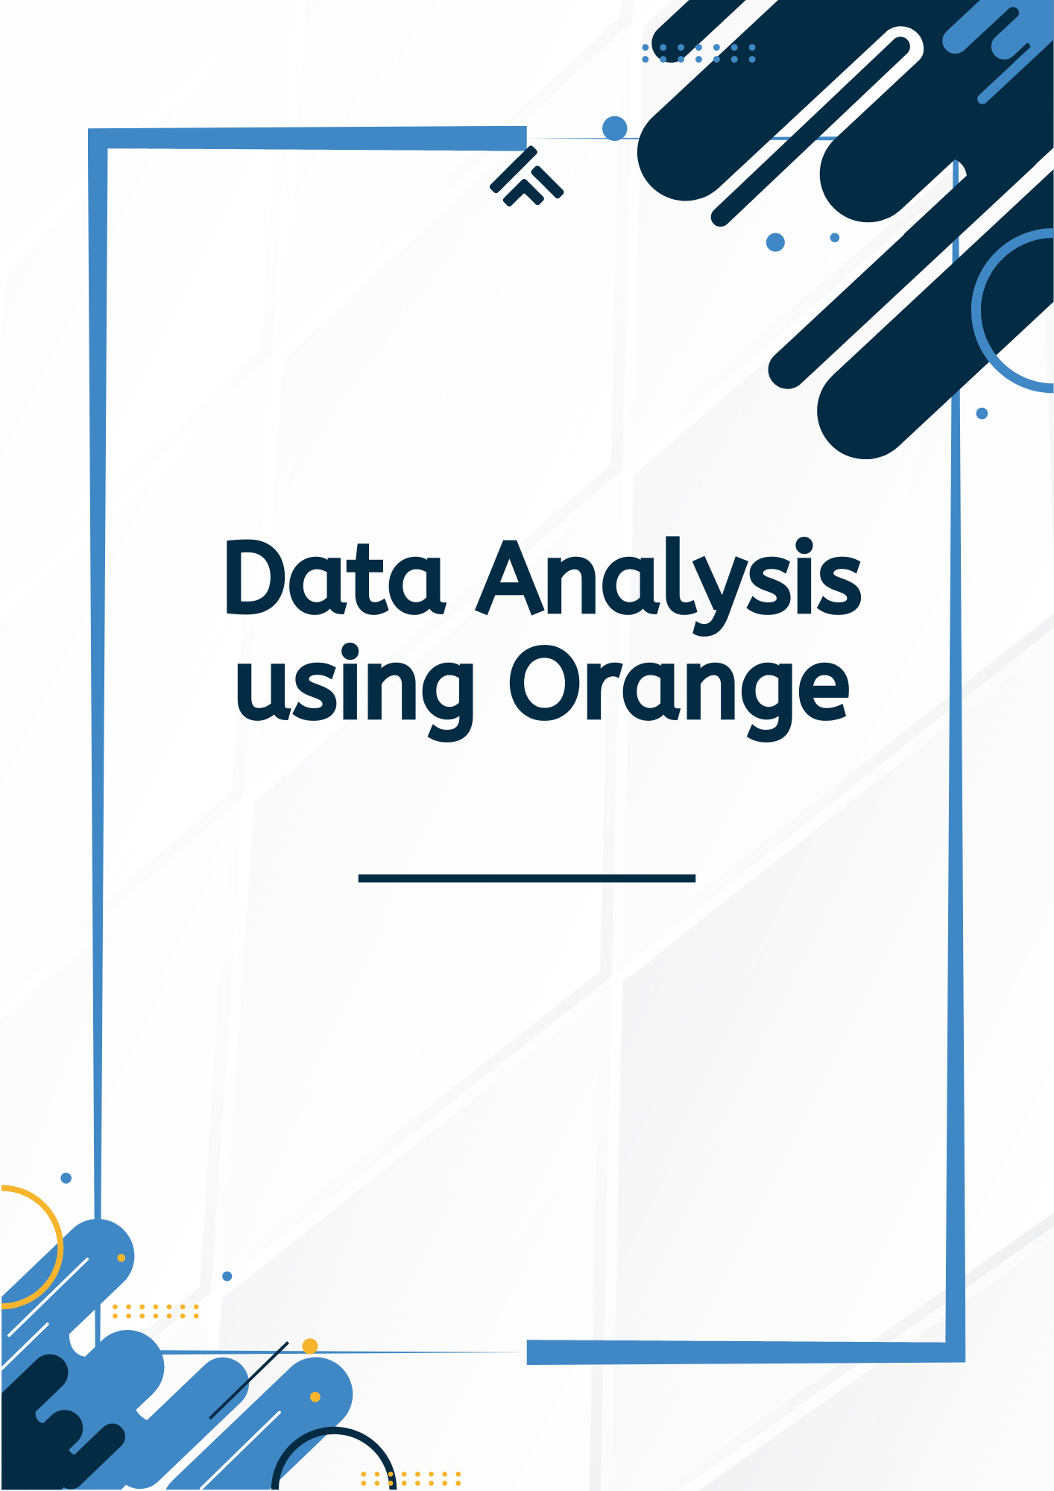

First we have selected a csv file in Orange platform :

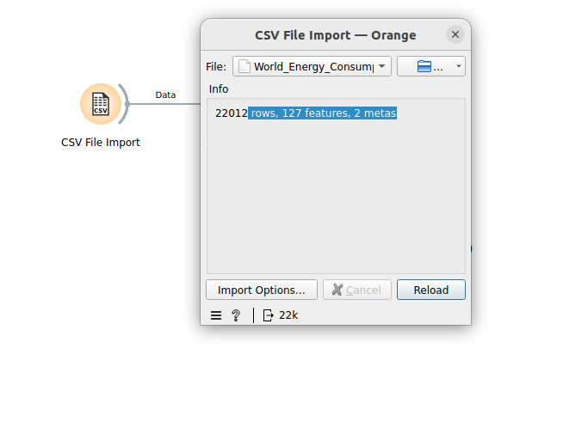

Next we have made DataTable and connected it with csv in orange .

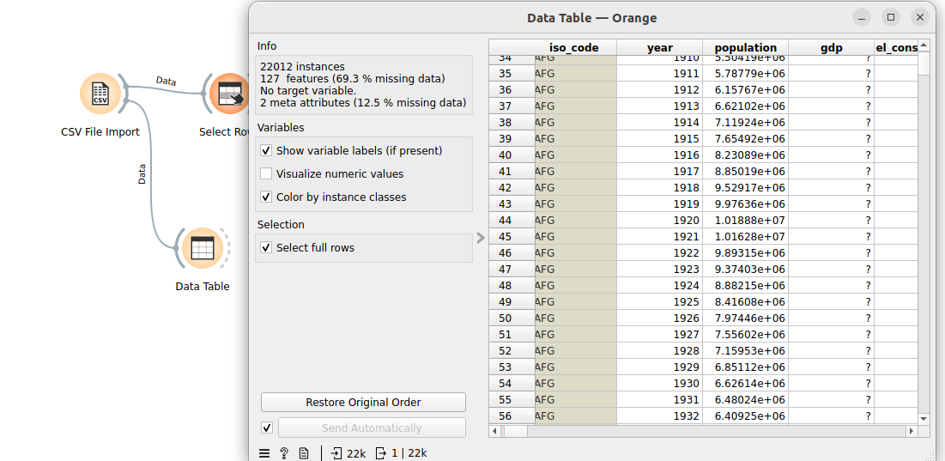

Next we are analyzing data by selecting rows and implementing conditions

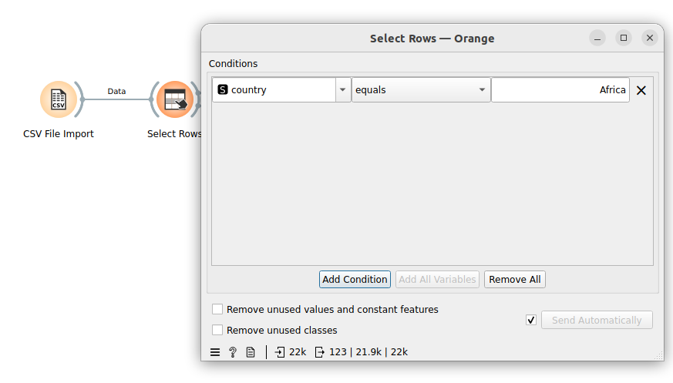

Viewing the bar plot by connecting it with visualizing tools available in our ORANGE dataviewer.

**BAR PLOT BY ENERGY CONSUMPTION**

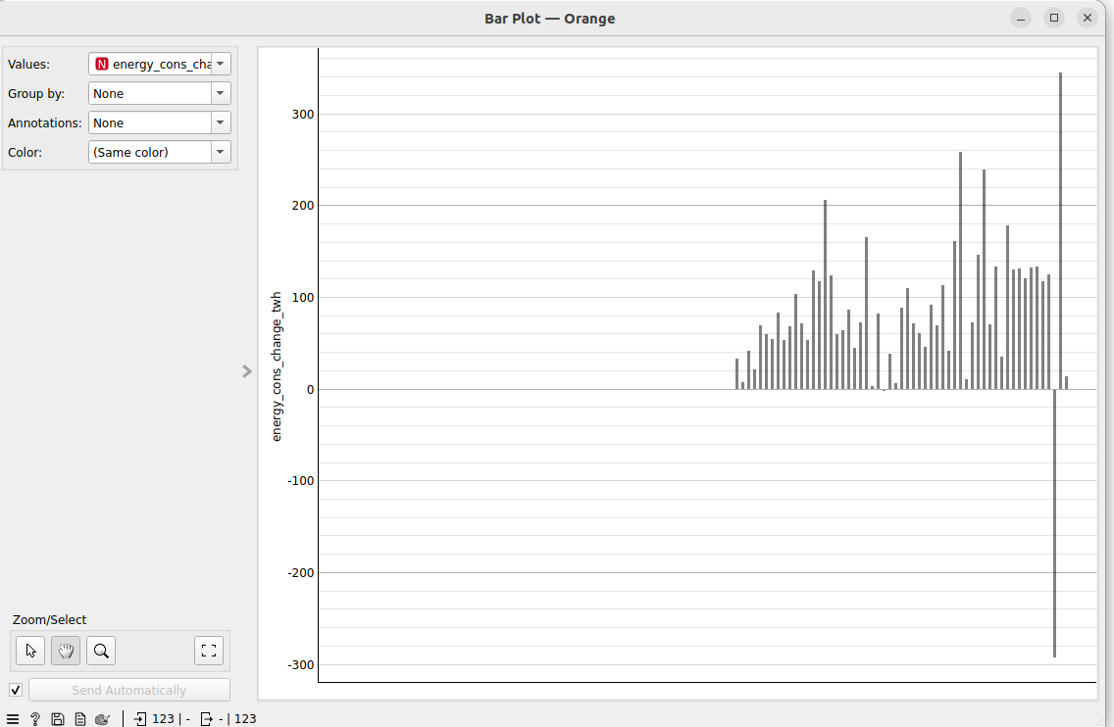

**BAR PLOT BY YEAR**

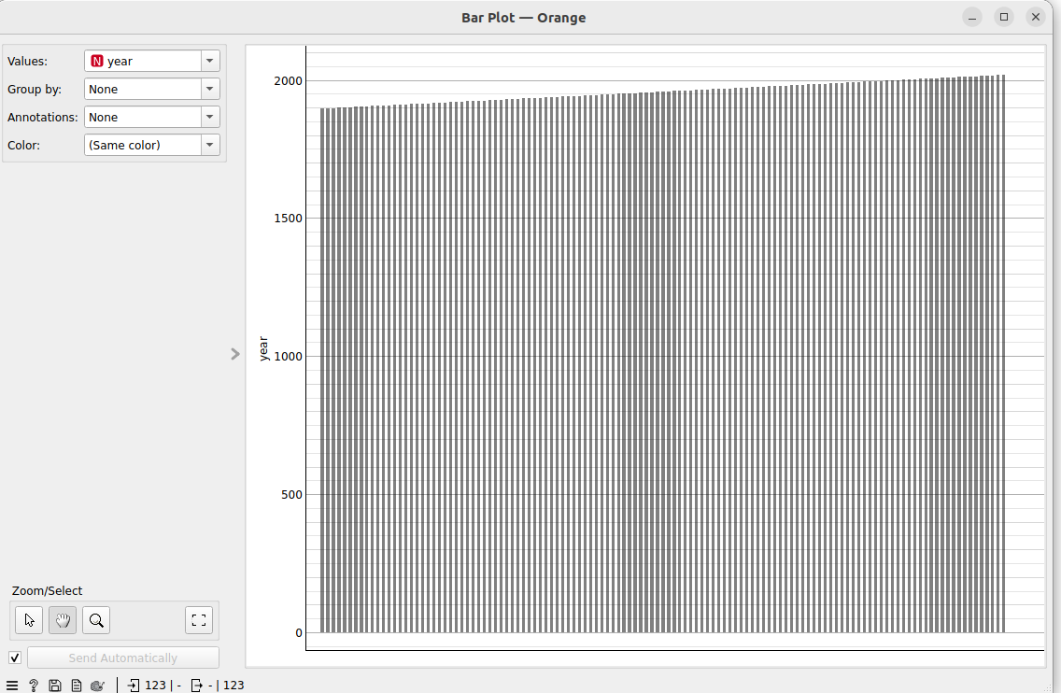

**BAR PLOT BY POPULATION**

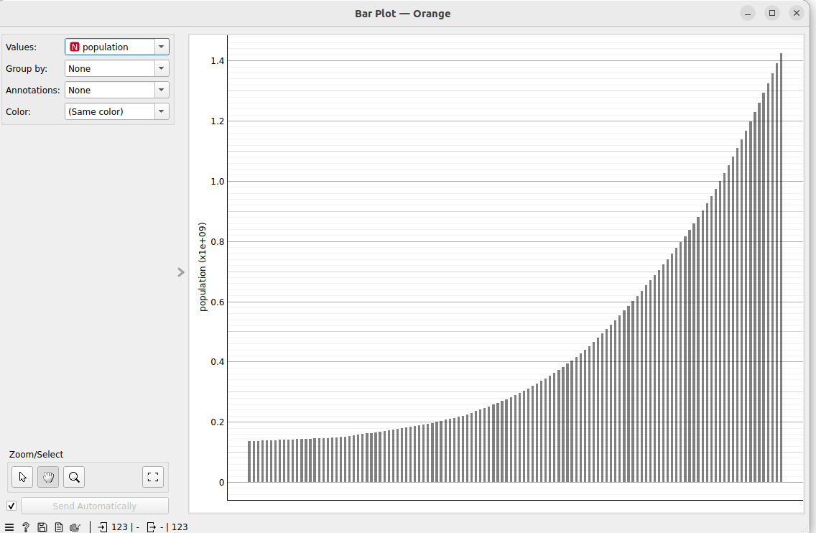

**BAR PLOT BY BIO FUEL CONSUMPTION PER CAPITA**

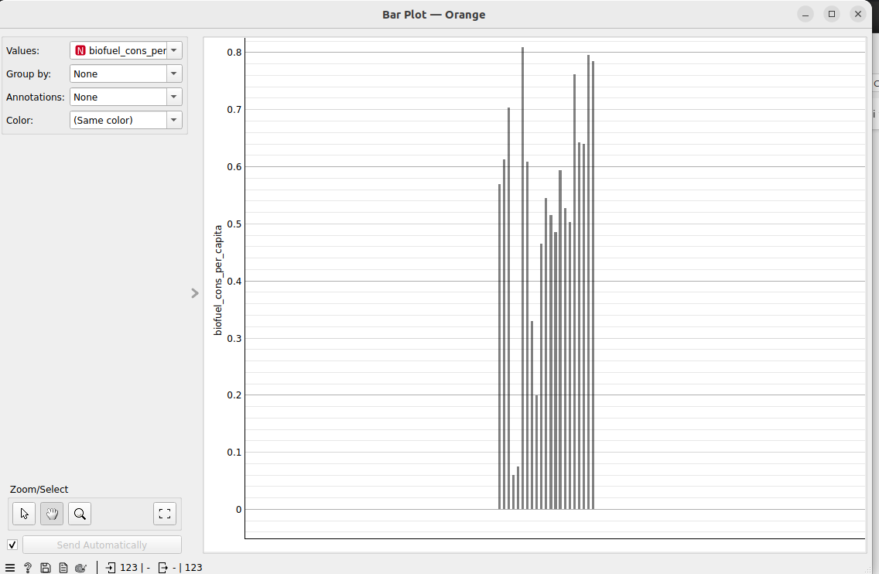

**SCATTER PLOTS:**

**Scatter plot 1**

**Year and population**

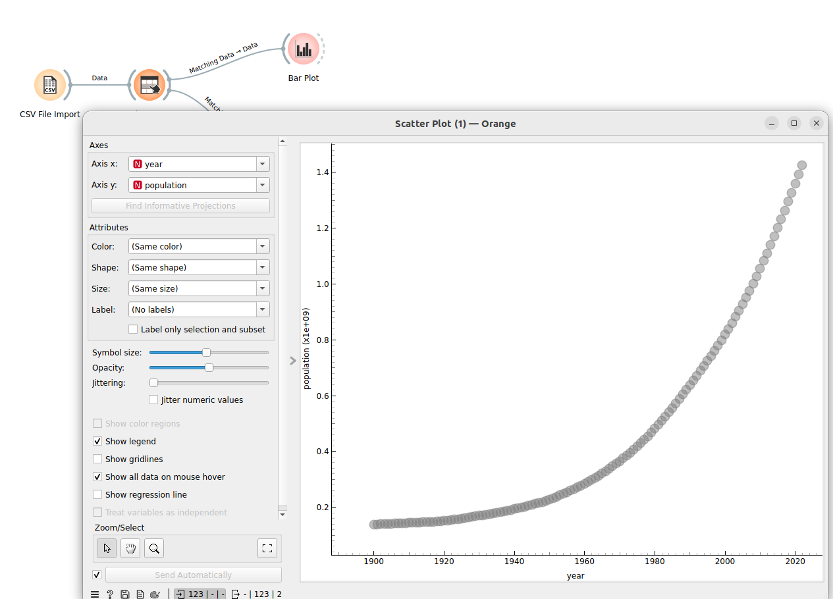

**Scatter plot 2**

**Year and Bio fuel consumption per capita**

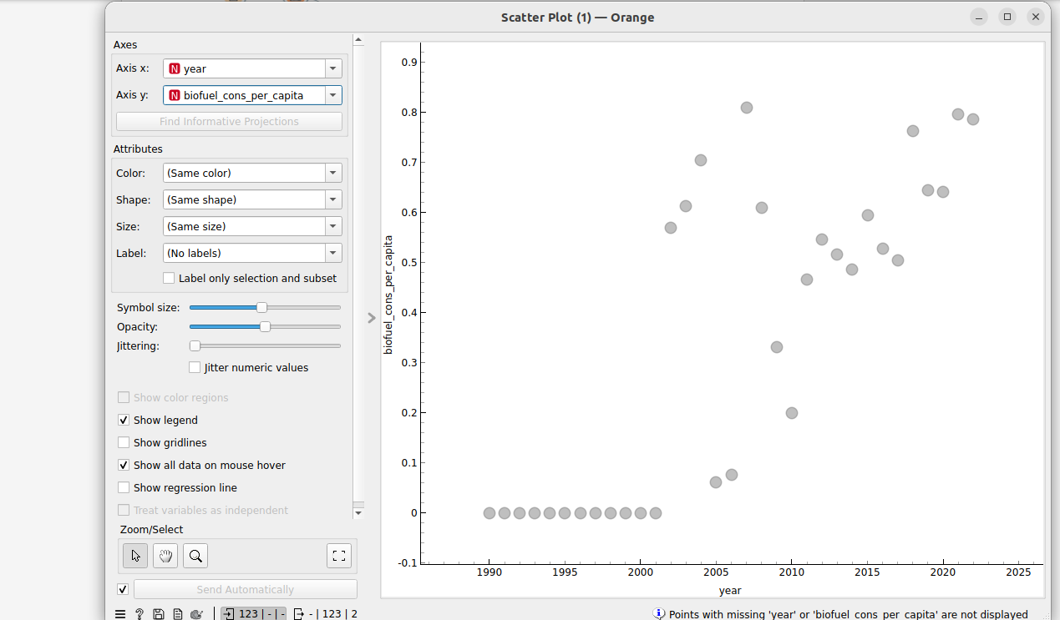

**Scatter plot 3**

**Year and Coal Production**

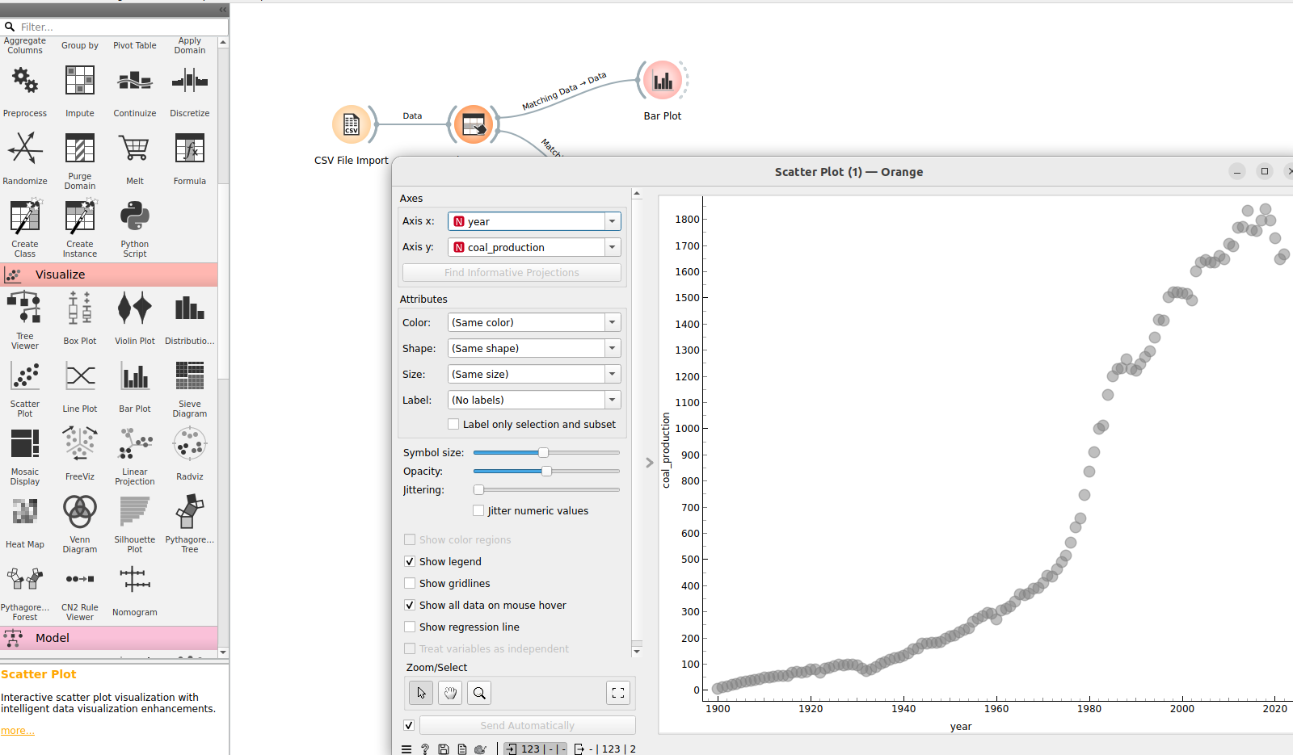

**NORMAL DISTRIBUTION USING IMPUTER**

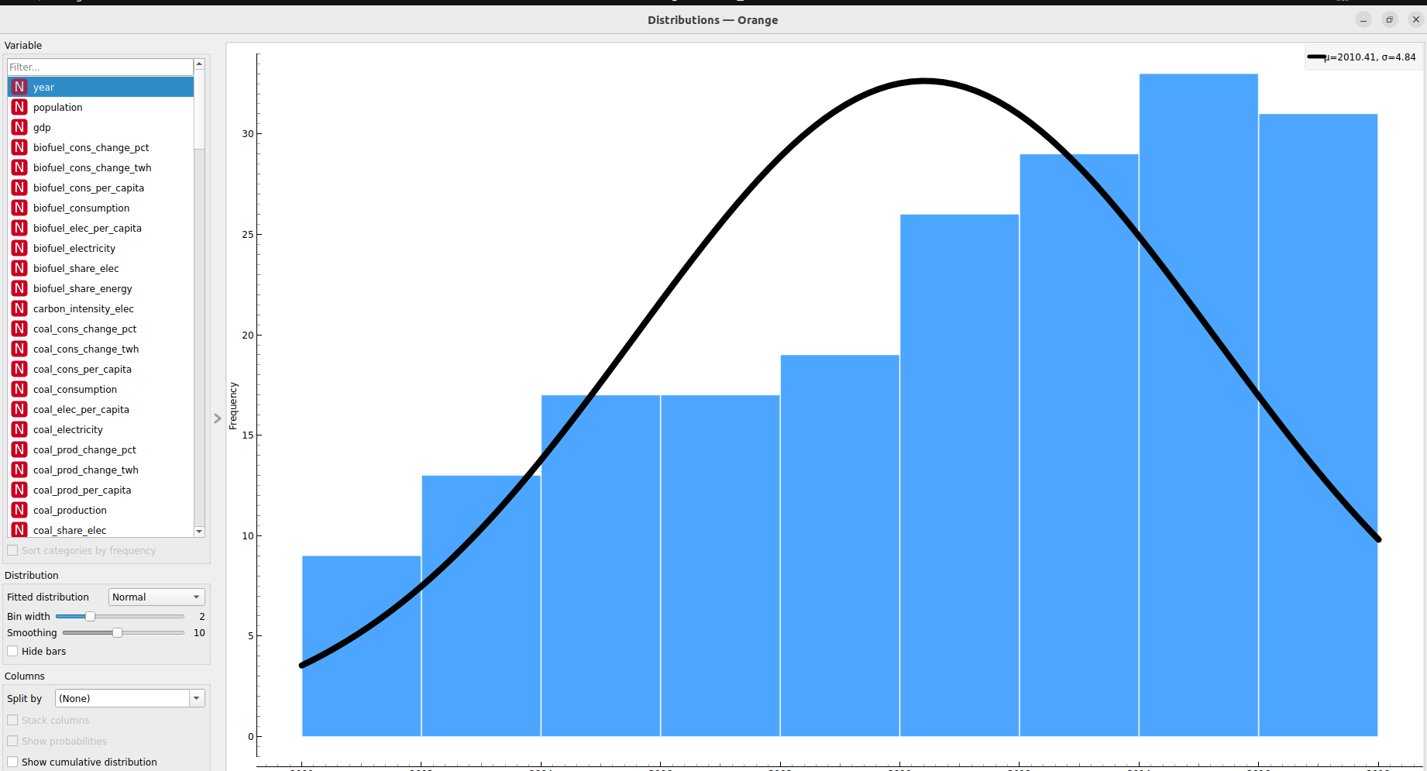

**COMMULATIVE NORMAL DISTRIBUTION USING IMPUTER**

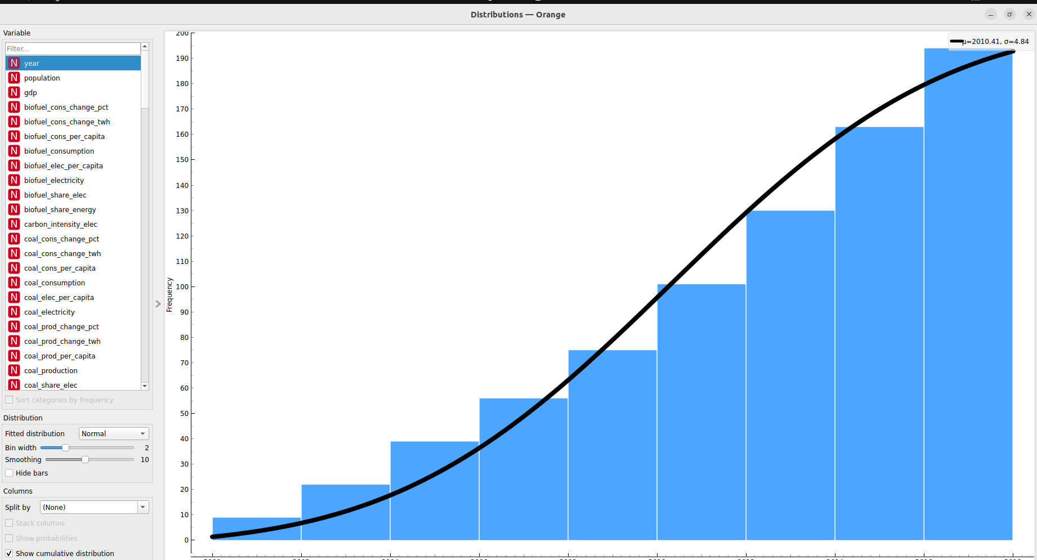

**PERETO DISTRIBUTION USING IMPUTER**

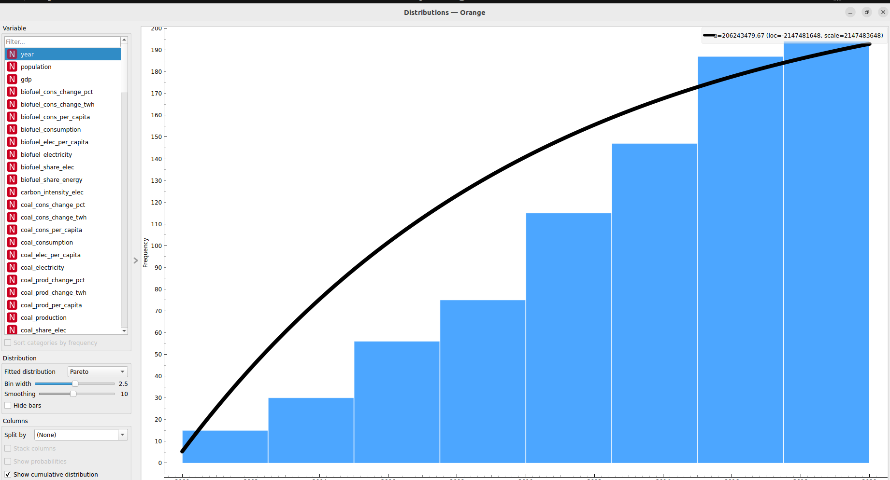

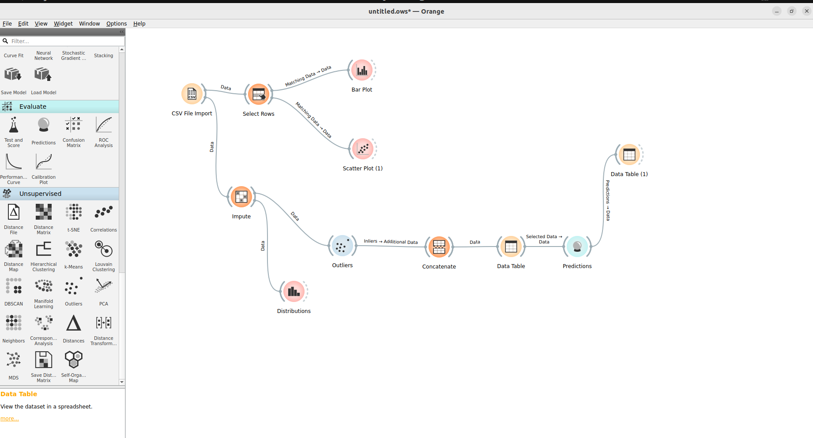

HAVE A LOOK we are making predictions

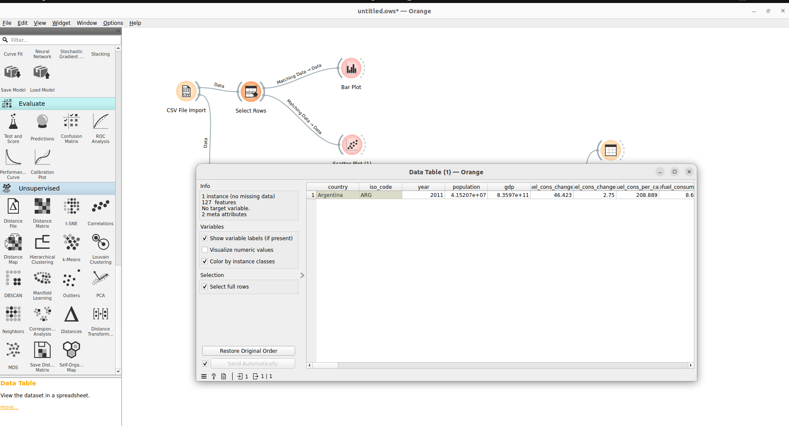

WE HAVE MADE DATA ANALYSIS BY GROUPING DATA

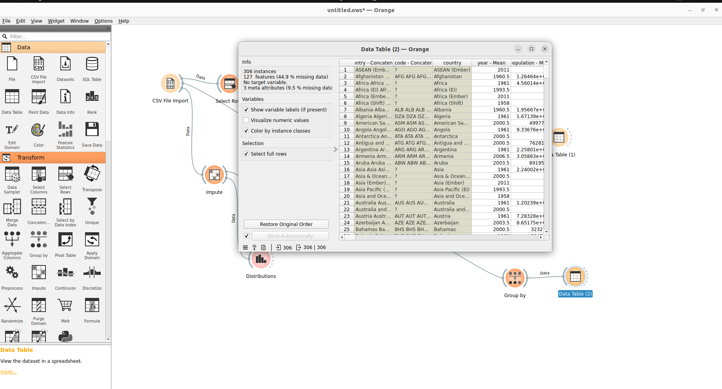

**APPLYING CO RELATION:**

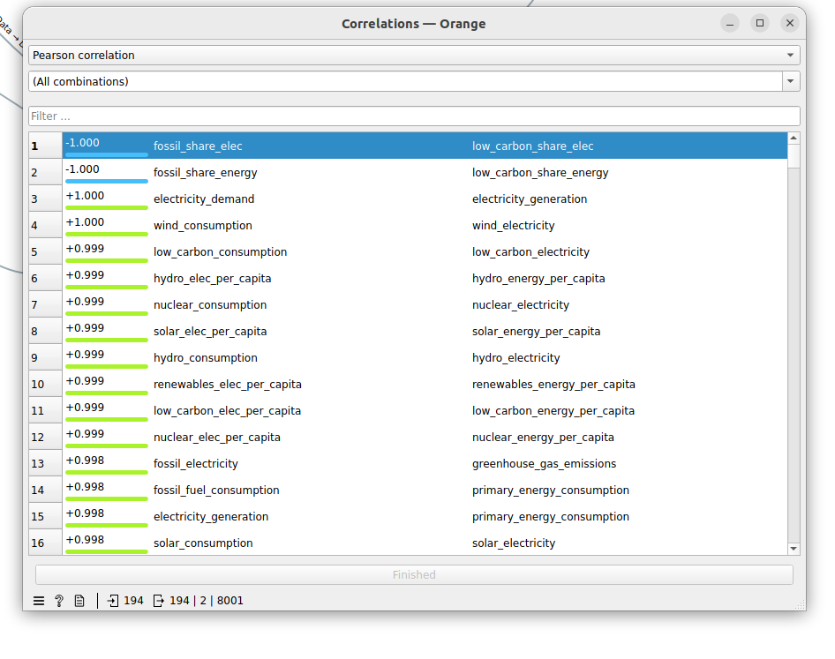

**LOVIAN CLUSTERING :**

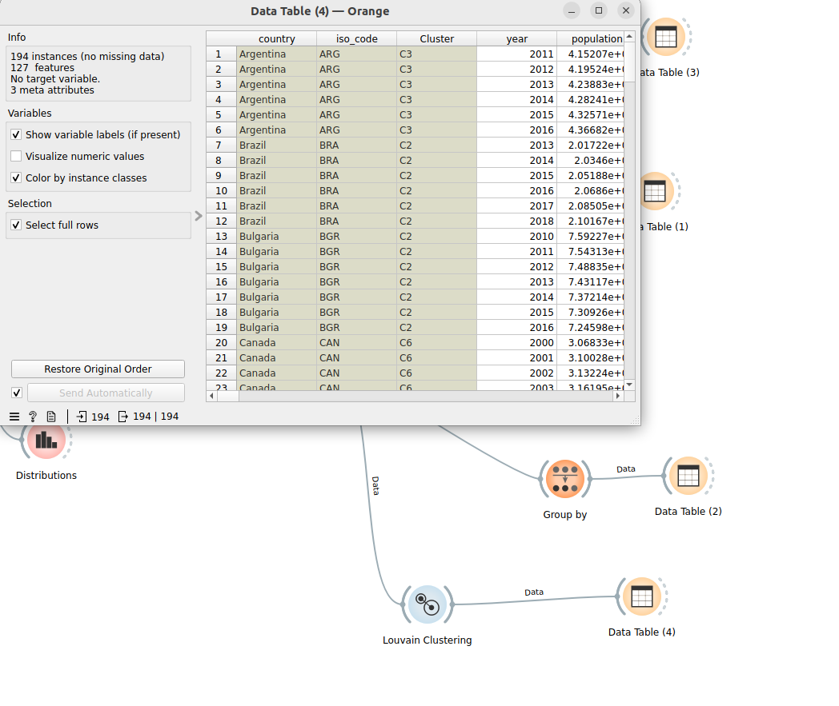

**APPLYING PCA ANALYSIS ON DATA**

