SwarmCircuit — Backend Schema
SQLite relational model, event provenance, runtime control, and reproducible experiments
SwarmCircuit · Technical specification
November 1, 2026

SwarmCircuit
Backend Schema Specification (BSS) · Version 1.0 · Document 2 of 6
Status: Proposed schema, executable and smoke-tested locally; not a deployed product.
Companion: SwarmCircuit_PRD_v1.docx · Implementation artifact: 001_initial.sql
Primary use: Local-first, single-node hackathon research MVP.
Backend: Python/FastAPI · SQLite · OpenTelemetry · optional GateKeep402 adapter.

0. Schema decision record
Decision | v1 determination | Reason
Database | SQLite 3.38+ using STRICT tables, JSON functions, WAL | Simple local setup and explicit type constraints
Keys | App-generated UUID text, never SQLite rowids as public identifiers | Framework-neutral SDK and idempotent ingest
Timestamps | UTC Unix milliseconds for domain events; original Unix nanoseconds for OTel spans | Exact correlation without floating-point drift
Source of truth | Versioned domain tables + persisted, source-classified event evidence | UI graph and spans alone do not prove task dependencies
Safety boundary | Runtime control hooks + authenticated acknowledgements | OpenTelemetry by itself cannot pause a task
Graph | Read-model projection with explicitly labeled edges | Prevent span nesting from being mistaken for business causality
Payments | Optional GateKeep402 evidence tables; no wallet keys | Payment security remains a component, not a dependency
Experiments | Protocol, trials, seeds, code revision and metric rows | Reproduce graphs and avoid ungrounded claims
Personal data | Metadata only by default; no prompts, credentials, full HTTP headers | Minimize exposure in local demo and future deployment
Design rule: An OpenTelemetry span says an operation was observed. An explicit task dependency says the application declared a dependency. An authenticated runtime acknowledgement says a supported control action was applied. These are different evidence strengths and must never be collapsed.

1. Data domains and relationship diagrams
The schema has 31 tables across seven bounded contexts, including schema_migrations. The entire proposed schema is supplied as working SQL. Tables are intentionally normalized enough for relational integrity but retain small redacted JSON fields for interoperable telemetry metadata.

1.1 Projects, runs, agents, tasks, approvals
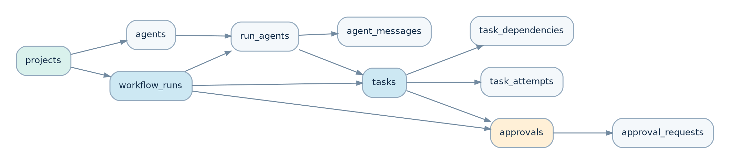
Execution and approval relationships
Every run belongs to a project. An agent has a stable project identity, but only an explicit run_agents membership can assign it tasks in that run. task_dependencies represent directed blocking relationships; approval_requests count repeated requests against a canonical approval without conflating distinct authorizations.

1.2 Telemetry, incidents, and control
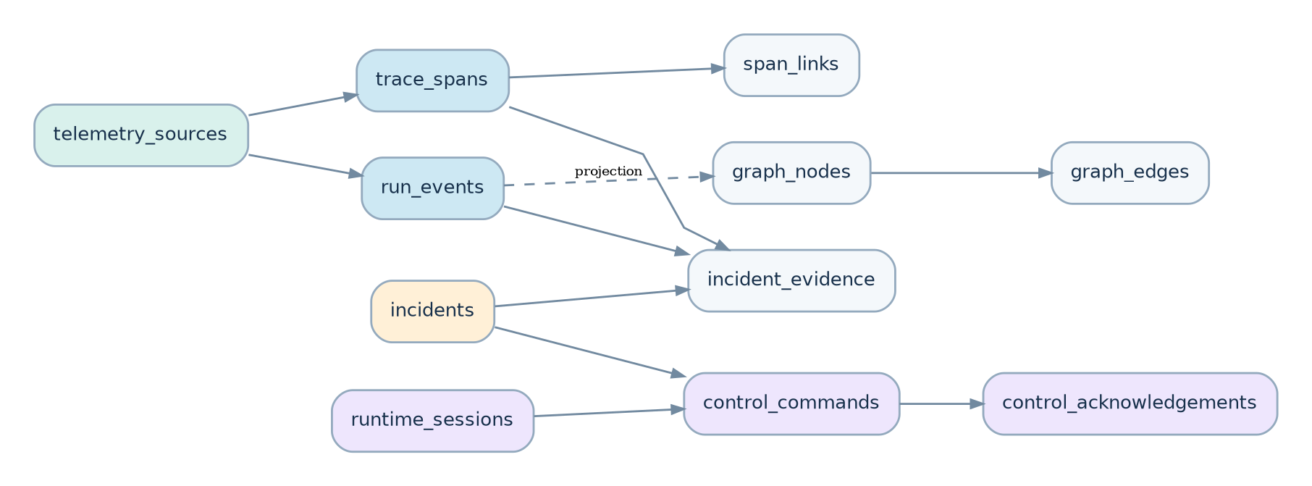
Evidence and control relationships
run_events hold source-classified observations. trace_spans hold exact OTel timings. incidents link detector findings to evidence. control_commands and control_acknowledgements establish whether a trusted runtime actually applied an intervention. The rendered graph is a projection, not a policy authority.

1.3 Optional payments and research evaluations
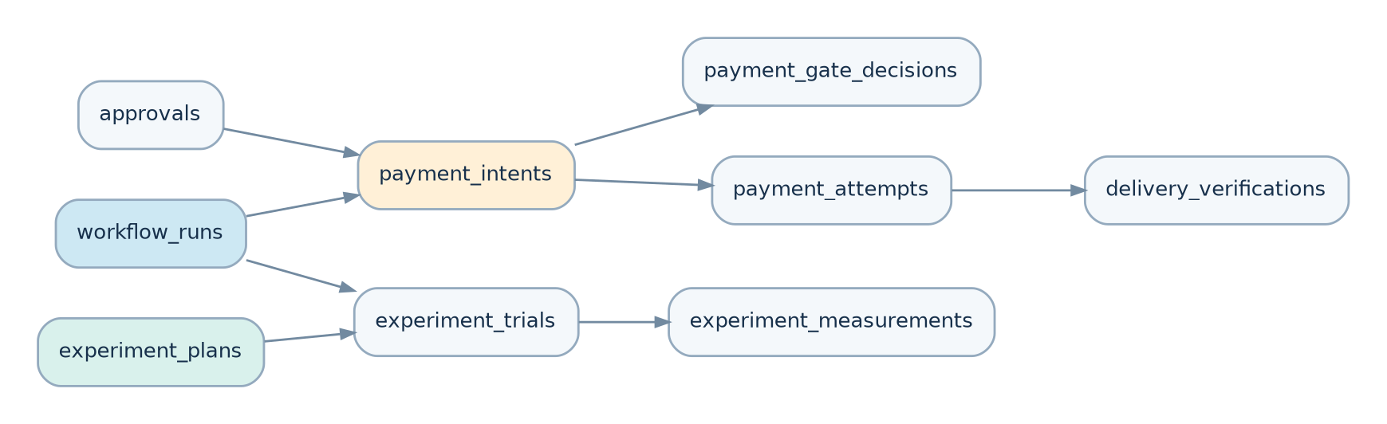
Payments and experiment relationships
GateKeep402’s allow / ask / deny remains separate from the effect of a transaction. payment_attempts only claim settled_confirmed when backed by service-verified or simulator-truth evidence. Experiment trials link directly to workflow runs and recorded policy arms.

2. Complete table inventory
Domain | Tables | Responsibility
Identity / execution | projects, telemetry_sources, workflow_runs, agents, run_agents | Ownership, sources, active runs and agent identities
Task coordination | tasks, task_dependencies, task_attempts, approvals, approval_requests, agent_messages | Directed waits, retries, duplicate approvals and handoffs
Observability | trace_spans, span_links, run_events | OTel timing, causal hints, timestamped event evidence
Graph / incidents | graph_nodes, graph_edges, incidents, incident_evidence | Visual projection, detector findings, linked observations
Control plane | control_policies, runtime_sessions, control_commands, control_acknowledgements | Runtime capabilities, idempotent interventions and real acknowledgements
GateKeep402 | payment_intents, payment_gate_decisions, payment_attempts, delivery_verifications | Payment gating, verified effects and structural delivery checks
Experiment / delivery | experiment_plans, experiment_trials, experiment_measurements, ui_outbox, schema_migrations | Reproducibility, UI notifications, schema versioning

2.1 Execution identity and tenancy
Table | Primary fields | Important constraints
projects | project_id, slug, settings_json | Unique slug; validated JSON
telemetry_sources | source_id, project_id, source_key, source_kind | Unique (project_id, source_key); provenance assigned server-side
workflow_runs | run_id, project_id, mode, status, root_trace_id | Run-mode observe/control; per-project external run dedup
agents | agent_id, project_id, external_agent_key, role | One stable identity per project/key
run_agents | (run_id,agent_id), project_id, joined_at_ms | Composite foreign keys reject cross-project membership
Why retain both agents and run_agents: A stable researcher or buyer can appear in multiple runs. A run-specific membership prevents assigning another project’s agent to an unrelated workflow.

2.2 Tasks, dependencies, and human reviews
Table | Primary fields | Important constraints
tasks | task_id, run_id, external_task_key, assigned_agent_id, state_version | Unique external key within a run; optimistic state_version
task_attempts | attempt_id, task_id, attempt_no, idempotency_key | Unique attempt number; optional run-level idempotency key
task_dependencies | blocked_task_id, prerequisite_task_id, is_explicit | Same-run FKs, non-self edge, no duplicate relation
approvals | approval_id, canonical_approval_key, action_fingerprint, state | One logical approval per run/key; resolution timestamps
approval_requests | request_id, approval_id, request_key, disposition | Repeated asks recorded separately, even when coalesced
agent_messages | from_agent_id, to_agent_id, task_id, content_sha256 | Sender and receiver must be members of run; body capture opt-in
Approval-key design: The SDK constructs a canonical fingerprint from the same principal, purpose, requested resource, counterparty, amount/asset if relevant, permission scope, and policy revision. Similar-looking requests are not necessarily equivalent. The database enforces key uniqueness but cannot prove semantic equivalence: the runtime adapter must implement and test the normalization.

2.3 Telemetry, graph, incidents
Table | Primary fields | Important constraints
trace_spans | run_id, trace_id, span_id, parent_span_id, start_unix_ns, end_unix_ns | Unique (run_id,trace_id,span_id); original nanoseconds retained
span_links | source_span_row_id, target_trace_id, target_span_id | External targets permitted; link is not proof of task causality
run_events | source_event_key, trust_class, event_kind, occurred_at_ms, ingested_at_ms | Global idempotence per source/event key; no UPDATE trigger
graph_nodes | node_kind, entity_ref_id, projection_json | Unique projected entity per run/type/id
graph_edges | relation_kind, evidence_kind, confidence, evidence_event_id | Same-run endpoints; inferred edges explicitly labeled
incidents | detector_key, fingerprint, kind, severity, state | One detector finding per run/fingerprint
incident_evidence | event_id, span_row_id, incident_id | At least one supporting event or span
Event provenance classes: self_report, sdk_observation, service_receipt, simulation_truth, derived. A sender does not get to choose its own trust class; the ingestion boundary maps authenticated sources to classes. Even a service receipt is evidence of a specific fact (for example a mock settlement), not proof that an entire task was ethically or semantically correct.

2.4 Runtime control and payment truth
Table | Primary fields | Important constraints
runtime_sessions | runtime_session_id, runtime_key, capabilities_json, fencing_epoch | Same-run session; heartbeat and disconnect state
control_policies | policy_key, revision, config_json, auto_apply | Immutable policy revisions by convention; auto-actions default off
control_commands | command_id, idempotency_key, required_capability, expected_task_version, state | One effective command per run/idempotency key
control_acknowledgements | acknowledgement_id, command_id, ack_key, result | Append-only runtime acknowledgements; dedupe by session/ack key
payment_intents | intent_key, domain, asset_code, amount_decimal, state | Amount stored as decimal string, never float
payment_gate_decisions | payment_intent_id, decision, trust_score, decided_at_ms | Append-only ALLOW / ASK / DENY observations
payment_attempts | payment_intent_id, phase, idempotency_key, receipt_trust | Cannot record confirmed settlement from self-report alone
delivery_verifications | payment_attempt_id, structural_ok, reason_code | Structural validation recorded post-payment
Important distinction: a control_commands row in queued or dispatched is a request, not success. The database trigger prevents transition to applied before a matching runtime acknowledgement. Likewise, a payment intent cannot transition to settled without a verified receipt record. Neither mechanism makes the database itself tamper-proof; the FastAPI endpoint must authenticate and validate who is allowed to create these records.

2.5 Reproducibility and UI delivery
Table | Primary fields | Important constraints
experiment_plans | protocol_version, protocol_sha256, specification_json | Frozen protocol and research question
experiment_trials | scenario_key, policy_arm, seed, implementation_sha, run_id | Unique (experiment_id,scenario,policy,seed)
experiment_measurements | metric_key, metric_value, unit, denominator | One result per trial/metric; preserve denominator
ui_outbox | topic, payload_json, published_at_ms, attempts | At-least-once UI delivery; never control-system truth
schema_migrations | version, name, applied_at_ms | Applied migration history

3. Event contract and ingestion semantics
A normalized event is emitted by an SDK adapter or the simulator. An OTel trace export can arrive independently, and may be buffered or sampled. The backend correlates records by project_id, run_id, and optional trace/span association, but it must not infer a real task dependency from parent span nesting alone.
Normalized event envelope:
{
"schema_version": "1.0",
"event_id": "c2fe8ac6-e30d-49a4-95e4-c208b914b289",
"project_id": "e0cb81b1-2f59-43ac-86ce-66c94f53f99a",
"run_id": "e4b1cf9e-5cd1-4f70-8aac-04a90fdb0ef4",
"source_id": "681d1b13-4ec9-48fe-996b-160a1fd837ca",
"source_event_key": "agent:buyer:approval:0001",
"event_kind": "approval.requested",
"trust_class": "sdk_observation",
"occurred_at_ms": 1793570000000,
"agent_id": null,
"task_id": null,
"trace_id": null,
"span_id": null,
"payload": {"approval_key": "research/vendor-1/quote"}
}
The executable event_envelope.schema.json describes the wire envelope. run_events stores its normalized counterpart. The service ignores client-asserted trust_class for privileged decisions and assigns the validated class from authenticated source configuration.
MVP event types: workflow.started, agent.started, message.sent, task.created, task.started, task.dependency_added, task.retry_requested, task.waiting_for_approval, task.completed, approval.requested, approval.resolved, payment.gate_decision, payment.attempted, payment.settlement_confirmed, delivery.checked, incident.detected, control.requested, control.applied, workflow.completed.
Ingest requirements:
- Resolve the source and run within the same project; reject an unknown run or mismatched source.
- Apply allowlisted schema validation, size limits and metadata redaction before writing.
- Deduplicate by (source_id, source_event_key); a conflicting replay with different payload is an error, not an overwrite.
- Persist raw classified evidence first; update materialized task/approval/incident projection transactionally where feasible.
- Enqueue a ui_outbox update for active dashboards, but do not use WebSocket delivery as runtime acknowledgement.
- Use event time for timeline display and ingest time to diagnose clock skew / delayed delivery.
OTLP transport: Standard OTLP/HTTP Protobuf trace exports use /v1/traces; a collector can normalize/export into the ingest service. Supporting all OTLP codecs directly is a TRD implementation decision, not a prerequisite for the database schema. The OTel GenAI conventions include agent, tool, and workflow operations such as invoke_agent and invoke_workflow; the application SDK adds the business dependency IDs they cannot always provide. [S2, S3]

4. Canonical state machines
Entity | States | Permitted transition examples
Run | created, running, waiting, stalled, recovering, completed, failed, cancelled | created→running; running→waiting; waiting→recovering; recovering→running; active→terminal
Task | created, ready, running, waiting_for_human, held, recovering, completed, failed, cancelled | ready→running; running→waiting_for_human; waiting→held; held→recovering; recovering→running
Approval | pending, approved, denied, expired, cancelled | pending→one terminal resolution; no re-approval of a denied fingerprint
Incident | open, acknowledged, resolved, suppressed | open→acknowledged→resolved; open→suppressed with audit
Command | queued, dispatched, applied, rejected, timed_out, unknown | queued→dispatched; dispatched→applied only after verified ack; timeout does not prove no effect
Payment attempt | authorized, submitted, settlement_unknown, settled_confirmed, failed | submitted→settlement_unknown when finality is unknown; never blindly resubmit
Application transaction rule: Compare tasks.state_version at command submission, then use a conditional update (WHERE state_version=:expected) to reject stale interventions. A successful acknowledgement must match the current runtime_session_id and fencing_epoch; old disconnected runtimes cannot authorize current control effects. unknown is a first-class state when the runtime disconnects before confirmation.
Control authority is separate from approval authority: Dashboard Hold and Resume may be enabled only for demonstrated capabilities. There is no generic Force Approve operation. GateKeep402 DENY cannot be changed by a recovery event, and ASK resolves only through the separately authorized approval process.

5. Transaction boundaries and critical invariants
TX-A — Ingest and projection: validate event → INSERT run_events (idempotently) → update task/approval read models → insert outbox. If the event repeats, do not repeat the state transition.
TX-B — Issue intervention: read mode/capabilities/current task version → INSERT unique control_commands row → dispatch to connected runtime. queued must remain distinguishable from applied.
TX-C — Verify command acknowledgement: authenticate SDK runtime → validate command/session/epoch/idempotency → INSERT acknowledgement → conditionally transition control_commands.state → record evidence/outbox. On lost acknowledgements use unknown, never invented success.
TX-D — Payment evidence: persist GateKeep402 gate decision → record authorization/attempt → record independent settlement receipt if available → record structural delivery outcome. A delivery failure cannot retrospectively undo a confirmed payment.
TX-E — Trial measurements: seal trial metadata (seed, code SHA, scenario, policy arm, run ID) → compute metrics from run facts, not agent self-reports → persist values and denominators → export reproducible CSV/JSON.
SQL-enforced guardrails in migration: unique source-event keys, unique command idempotency keys, run-consistent agent/task membership, immutable updates to raw events / gate decisions / acknowledgements, requirement for a matching applied-command ack, and requirement for a trusted receipt before setting a payment intent to settled. This is not a replacement for process authentication or semantic policy evaluation.

6. Indices, SQL access paths and query recipes
UI or service operation | Main access path
Overview: active runs | idx_runs_project_status
Workflow detail: tasks | idx_tasks_run_state
Timeline waterfall | idx_spans_waterfall
Events / incident reconstruction | idx_events_timeline, idx_events_kind, idx_incident_evidence_event
Pending approvals | partial index idx_approvals_pending
Runtime commands to execute | idx_commands_poll
Payment inspector | idx_payment_intents_run, idx_payment_attempts_intent
Experiment evaluation | idx_trial_group and trial/metric uniqueness
Dashboard live stream | partial index idx_outbox_pending
Examples, using SQLite ? parameter binding:
-- Timeline records for one run
SELECT event_kind, trust_class, occurred_at_ms, ingested_at_ms, payload_json
FROM run_events WHERE run_id = ?
ORDER BY occurred_at_ms, event_id LIMIT 500;
-- All open incidents with evidence counts
SELECT i.incident_id, i.kind, i.severity, COUNT(e.evidence_id) AS evidence_count
FROM incidents i LEFT JOIN incident_evidence e ON e.incident_id=i.incident_id
WHERE i.run_id=? AND i.state='open'
GROUP BY i.incident_id ORDER BY i.opened_at_ms DESC;
-- Pending human approvals with duplicate request counts
SELECT a.approval_id, a.canonical_approval_key, COUNT(r.request_id) AS requests
FROM approvals a LEFT JOIN approval_requests r ON r.approval_id=a.approval_id
WHERE a.run_id=? AND a.state='pending'
GROUP BY a.approval_id ORDER BY requests DESC;
Performance design limits: WAL improves concurrent reader/writer behavior but SQLite still serializes concurrent writers. Ingest in bounded batches with one short write transaction, expose queue depth, avoid heavyweight graph queries in the ingest request path, and benchmark against PRD targets. Large-scale telemetry warehousing belongs in a later PostgreSQL/ClickHouse or dedicated observability backend design, not this local MVP. [S4]

7. Data security, retention and provenance
- Store no raw prompts, conversation content, credentials, wallet secrets, full payment headers, bearer tokens or private tool arguments by default.
- agent_messages persist sender, receiver, time and optional digest; content_preview_redacted stays NULL unless a developer explicitly enables redacted capture.
- trace_spans.attributes_json must use an allowlist (run/task identifiers, model name, operation type, duration-related metadata); sensitive OTel GenAI content attributes must be removed before persistence.
- SQLite is a local storage engine, not a tamper-proof evidence ledger. Experiment truth requires a trusted simulator log or independently verified service receipts with controlled filesystem access.
- Use session-level identity and capability validation at the HTTP/WebSocket boundary; database fields alone do not authenticate messages.
- Proposed defaults (product decisions, not implemented guarantees): 7 days for raw spans, 30 days for run events, and shorter transient outbox retention. Export trial artifacts before purging. Research data retention may require explicit opt-out from cleanup.
- Use project isolation in SDK and API queries even for a local single-user MVP. The schema enforces source/run project consistency for spans and events; other cross-entity references also need API validation where only an event ID is stored.

8. Migration and deployment notes
SQLite initialization:
import sqlite3
conn = sqlite3.connect("swarmcircuit.db", timeout=5)
conn.execute("PRAGMA foreign_keys = ON") # every connection
conn.execute("PRAGMA busy_timeout = 5000")
conn.execute("PRAGMA journal_mode = WAL")
conn.executescript(open("001_initial.sql", encoding="utf-8").read())
All public IDs are application-generated UUID text. All domain timestamps use UTC Unix milliseconds (INTEGER); span timestamps preserve OTLP nanoseconds (INTEGER). Amounts use decimal strings and Python decimal.Decimal, never SQLite REAL for financial accounting.
Migration policy: One irreversible versioned migration per change; record version/checksum in the application migrator; back up DB before destructive migrations. schema_migrations is a metadata table and the SQL script does not insert a version automatically. Never edit 001_initial.sql after deployed adoption; create 002_...sql instead.
Persistence distinction: run_events, payment_gate_decisions and control_acknowledgements cannot be updated by SQL. Explicit retention purges can delete them, so the schema provides immutability against accidental UPDATEs, not permanent retention or adversary-proof audit.
PostgreSQL path: Maintain logical IDs and event envelopes. Move nanosecond timestamps and decimal strings carefully; replace SQLite JSON strings with appropriate PostgreSQL jsonb only during an explicit migration. Avoid relying on SQLite rowids or autoincrement behavior in the SDK.

9. P0 / P1 delivery sequence for the hackathon
Priority | Required tables / functions | Product value
P0-A | Projects, sources, runs, agents, tasks, attempts, explicit dependencies, approvals/requests | Reproducible six-agent workflow
P0-B | Spans, events, incidents, incident evidence | Traces and explainable cascade detection
P0-C | Runtime sessions, commands, acknowledgements | Demonstrable safe hold/resume control
P0-D | Payment intents, gate decisions, attempts; trial plans/trials/measurements | GateKeep402 demonstration and research results
P1 | Persisted graph projection, span links, stored message metadata, policy revision UI, outbox optimizations, delivery-detail table | UX refinements / future performance
The migration creates the complete relational model, but the hackathon build should only implement the P0 data paths. The other tables can remain empty and be introduced once core experiments work. This avoids spending three days building a generalized telemetry warehouse.

10. Test gates and known limitations
The supplied schema_smoke_test.py creates an actual SQLite database and verifies: migrations execute, foreign-key consistency, source/project isolation, cross-run task membership rejection, source-event deduplication, append-only raw events, command idempotency, verified-ack requirement, payment-settlement proof requirement, and independent experiment measurement storage.
Must test next during implementation: rollback on partial ingest, conflicting replay payloads, stale task versions, runtime fencing under disconnect/reconnect, interleaved control/approval events, concurrent SQLite writers, retention effects, out-of-order event delivery, OTLP payload size limits, and loss of telemetry from sampling.
Known limits: (1) agent/runtime trust depends on authenticated SDK integration; (2) deliberate absence of a node-level external action firewall; (3) semantic similarity for approval coalescing is not proven by fingerprints alone; (4) graph projections can lag raw events; (5) single-process SQLite throughput; (6) synthetic scenarios don’t prove production generalization; (7) service receipts don’t necessarily prove blockchain finality; (8) trusted receipt assertions are only as reliable as the verifier; (9) no hosted multi-user RBAC in MVP; (10) no ability to retroactively cancel completed irreversible actions.

11. Acceptance checklist and handoff to TRD
- ☐ SQL migration applies on a clean local SQLite database.
- ☐ Every connection explicitly enables foreign keys and uses bounded busy timeout.
- ☐ Ingestion deduplicates repeated events and rejects cross-project source/run combinations.
- ☐ UI shows Observe vs Control accurately; no control without a current runtime capability.
- ☐ A task’s dependency edge is explicit, or clearly labeled inferred and non-authoritative.
- ☐ ASK payment is not silently approved, DENY cannot be overridden, and uncertain settlements are not automatically replayed.
- ☐ Controller buttons never claim success until a matching trusted runtime ack exists.
- ☐ A seeded experiment links metrics to raw events and records its policy arm and code revision.
- ☐ Schema smoke test passes and no API stores sensitive prompt or payment credentials by default.
Handoff: The TRD (Document 3) will specify the service/process topology; OTLP receiver implementation; FastAPI endpoints, request/response schemas, controller algorithms, capability authentication, realtime streaming, execution semantics, transaction boundaries and deployment scripts. The Backend Schema deliberately does not claim those APIs have been implemented.

Sources
- [S1] SwarmCircuit PRD v1, approved product scope and non-goals (companion document).
- [S2] OpenTelemetry semantic conventions for GenAI agents and workflows: https://github.com/open-telemetry/semantic-conventions-genai/blob/main/docs/gen-ai/gen-ai-agent-spans.md
- [S3] OpenTelemetry OTLP protocol specification: https://opentelemetry.io/docs/specs/otlp/
- [S4] SQLite foreign keys, JSON and WAL documentation: https://www.sqlite.org/foreignkeys.html · https://www.sqlite.org/json1.html · https://www.sqlite.org/wal.html
- [S5] GateKeep402 public implementation: https://github.com/al1-nasir/gatekeep402
Scope and verification: The schema and smoke-test were executed locally. No complete SwarmCircuit application, benchmark, or security guarantee is claimed here.

