SWARMCIRCUIT / DESIGN SPECIFICATION

UI/UX Design Brief
A calm command center for complex agent workflows.
DOCUMENT | STATUS | DESIGN TARGET
06 / 06 · Version 1.0 | Proposed design · November 1, 2026 | Next.js Studio + React Flow

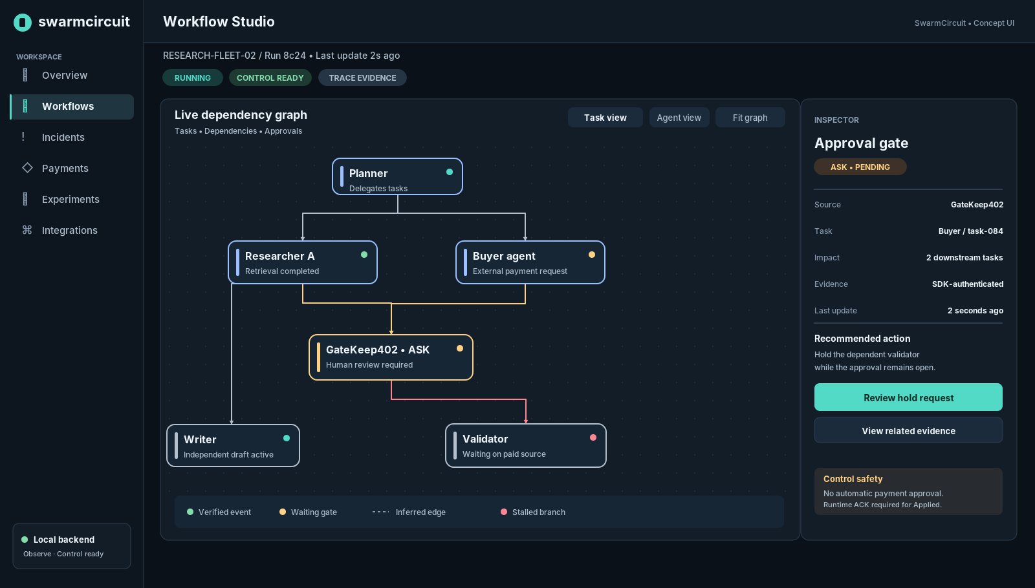
CONCEPT UI 01 • Illustrative workflow, not a running application or experimental result
Source-of-truth alignment: PRD v1.0 · Backend Schema v1.0 · TRD v1.0 · Implementation Plan v1.0 · App & UI Flow v1.0.
The Studio observes every connected run; it controls only runtimes that explicitly support safe checkpoint actions.

01 Design direction
SwarmCircuit is an operational developer tool—not an AI chatbot, graph editor or generic analytics dashboard. Its interface must make the state of a multi-agent execution understandable, connect every diagnosis to evidence, and make supported interventions clear without implying authority that the runtime has not granted.

Product personality
Attribute | We want | Avoid
Calm under pressure | Clear hierarchy, restrained alerting, deliberate controls | Permanent alarm red, flashing badges, chaotic motion
Technically credible | Raw IDs, timestamps, evidence sources and precise status labels | Fake AI intelligence percentages and invented certainty
Product-grade | Consistent spacing, native-feeling panels, fast navigation | A hackathon slide disguised as a SaaS dashboard
Framework-neutral | Agent/workflow language, OTel vocabulary and explicit capability flags | LangGraph-only terms or framework-specific node conventions
Human accountable | Review impacts before hold; audit all requested commands | Click-to-fix magic, autopay overrides

Who the design serves
- Developer: connect existing OpenTelemetry/SDK instrumentation, find their first run, inspect event context and copy reproducible links.
- Operator: identify stalls, approval amplification and downstream impact; distinguish what is waiting from what is broken.
- Researcher: compare policies and inspect metrics, seeds, raw traces and negative controls without hiding uncertainty.

North-star moment
An operator opens an active run, finds one GateKeep402 ASK blocking several dependent tasks, sees why the detector flagged repeated escalations, requests a supported hold on one reversible task, and observes queued → dispatched → applied only after a trusted runtime acknowledgement. Other branches keep making progress.
Research first: the live UI must show the controlled experiment, not replace it with decorative telemetry.

02 Information architecture & shell
The shell is intentionally stable: navigation left, context and connection status above, task work area in the middle, and a contextual right inspector. Navigation labels and routes follow Document 5; no new speculative MVP screens are introduced.
Area | Desktop treatment | Behavior
Left sidebar | ~220px expanded; 72px collapsed | Overview, Workflows, Incidents, Payments, Experiments, Integrations
Top bar | 64px high; run ID and freshness | Backend and runtime state appear separately; show last successful update
Main workspace | Flexible width, 24px gutters | Graph/table/timeline occupy majority of space
Right inspector | 320–380px width when open | Selected entity, evidence, affected tasks, permitted commands
Panel rhythm | 8px spacing scale, 12px radius | No arbitrary card sizes; related data grouped
Global feedback | Compact inline/toast for benign changes | Durable banners for offline, unknown commands and missing evidence

Navigation hierarchy
1) Overview → 2) Workflows → 3) Workflow Studio (Graph / Timeline) → 4) Incident/evidence inspector → 5) Optional control confirmation. Payments and Experiments are first-class destinations but must deep-link to the same workflow/entity context.
A user should never need to leave the current run to inspect an approval or incident. Deep-links preserve run ID, selected task, active tab and relevant filter whenever supported.

Proposed desktop breakpoints
Viewport | Layout | Graph access
≥ 1440px | Expanded sidebar, wide graph and persistent right inspector | Full React Flow interactions
1024–1439px | Compact sidebar, collapsible inspector | Graph plus drawer inspector
768–1023px | Icon rail, one main canvas, bottom/side drawer | Graph or list switch
< 768px | Mobile navigation; list-first workflow detail | Dedicated graph tab; full-screen inspector

These breakpoints are design targets, not claims that responsive interfaces have already been implemented.

03 Visual system: color, typography and density
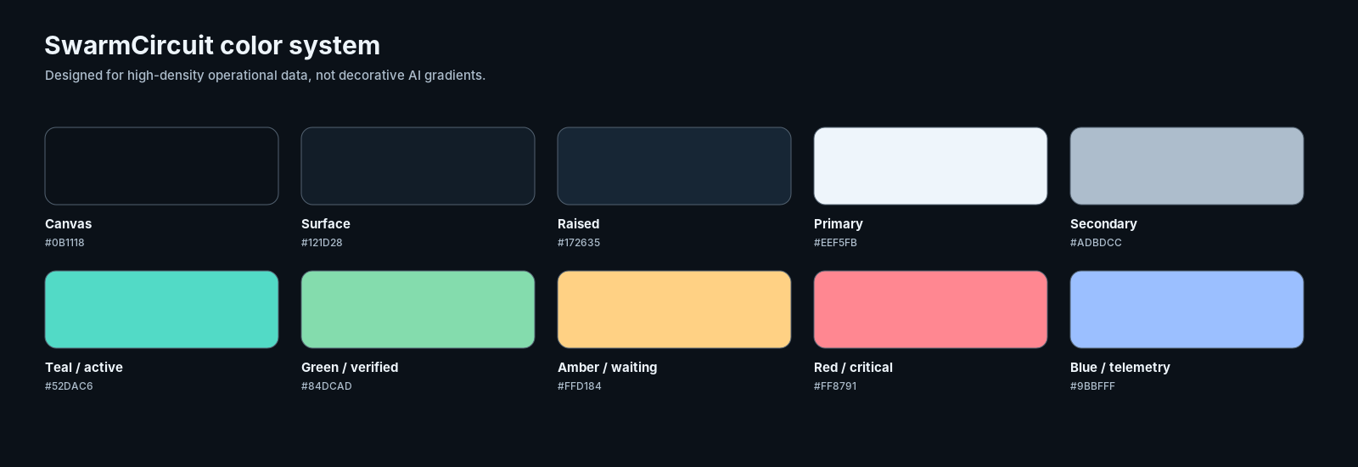
PALETTE • Proposed dark operational theme with explicit semantic colors

Color semantics
Token | Dark value | Meaning
surface.canvas | #0B1118 | App background
surface.panel | #121D28 | Cards, inspectors, graph surface
surface.raised | #172635 | Selected nodes, popovers
border.default | #2D3E50 | Structural separation
text.primary | #EEF5FB | Headings and data
text.secondary | #ADBDCC | Descriptions and metadata
accent.action | #52DAC6 | Active controls and main CTA
status.verified | #84DCAD | SDK-confirmed and verified outcomes
status.waiting | #FFD184 | Human approval waits and warning
status.critical | #FF8791 | Stall, failed action, serious incident
status.telemetry | #9BBFFF | Agent and trace information
status.held | #C6B2FF | Held / manually controlled state

Red means confirmed critical incident or failed execution, not every ordinary pending approval. Green must not be applied to self-reported settlements. Use text labels and distinct shapes/icons as parallel encodings.

Type and spacing
Element | Specification | Rule
Display / page title | Inter Display 24–30 / 650–700 | Only one dominant title per page
Section title | Inter 16–20 / 600–650 | Inside panels and inspectors
Body / table | Inter 13–14 / 400–500 | Keep compact without 11px dense lists
Metadata | Inter 12 / 400–600 | ID labels, timestamps, muted helper text
Code / identifiers | JetBrains Mono 12, fallback monospace | Trace IDs, command IDs and durations
Spacing scale | 4 / 8 / 12 / 16 / 24 / 32 | 8px base; 4px fine adjustment
Corner radius | 6 / 8 / 12 | Buttons / panels / major shells
Icon system | Lucide, 16 or 20px | Meaning-first; consistent 1.75–2px strokes

Light-theme fallback
Dark is the recommended initial theme. A later light theme should use #F7FAFC canvas, #FFFFFF panels, #E1E8ED borders, #152A3B primary text, #526779 secondary text and a darker teal action (#087F78). Semantic meanings stay identical. Store semantic tokens as CSS variables rather than hardcoded component colors.

04 Graph language: the signature interaction
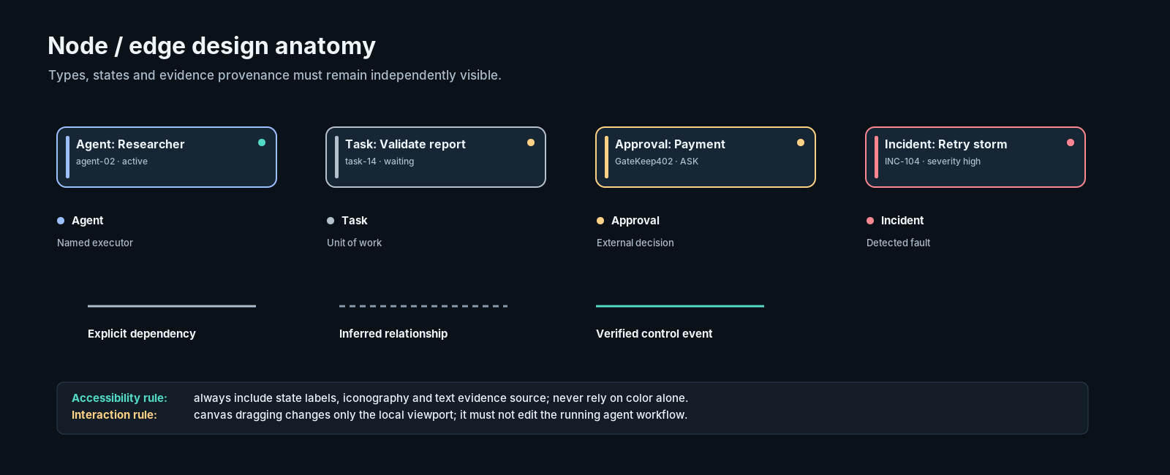
GRAPH GRAMMAR • Node type, runtime state and evidence source are distinct dimensions

Two equally important graph projections
Projection | Primary nodes | Edge semantics
Task / dependency | Task, approval gate, operation, incident | depends_on, waits_for, retry_of, triggers
Agent network | Agent identity, tool/resource endpoints | delegates_to, messages_to, uses_tool
No inferred rewrite | Missing causal edges stay unknown | Span ancestry never silently becomes a business dependency

Node anatomy
Every node has: primary name; stable short ID on demand; type-specific icon/stripe; explicit state word; one short status line; evidence indicator; and selected/focused state. Avoid embedding full conversation text or raw prompt payloads inside nodes.

Graph state encoding
State | Appearance | Accessible label
Running | Teal state dot + subtle current-progress indicator | Running
Waiting approval | Amber gate border + clock icon | Waiting for human approval
Stalled | Red incident accent; reason shown in inspector | Stalled: no progress under detector rule
Held (confirmed) | Violet pause icon and visible command ID | Held; runtime acknowledged
Queued hold | Neutral queued badge, NOT violet held status | Hold requested; awaiting acknowledgement
Unknown | Muted outline + question mark | State unknown; runtime disconnected
Completed | Green completion icon | Completed (SDK/verified source indicated)

Edge trust and controls
- Solid line: explicit SDK dependency/transfer. Dashed line: inferred association and confidence note.
- Highlighted path: selected dependency chain; de-emphasize unrelated branches, do not remove them from data.
- Node dragging, auto-layout, zoom, minimap and Fit are visual-only operations. The canvas never edits agent prompts or orchestration topology.
- Every graph element must have a list/table equivalent; keyboard navigation and screen-reader descriptions are mandatory.

05 Workflow Studio — primary screen
SCREEN A • Illustrative six-agent research workflow with GateKeep402 approval and dependent stalls

Visual hierarchy and affordances
- Header context: project/run, status, Observe or Control capability, freshness and trace completeness. A pending approval is not called a workflow failure by default.
- Graph toolbar: Agent/Task view, Fit, zoom, inferred-edge toggle and filter. Select nodes to populate inspector; pan/zoom never alter execution.
- Inspector: name → evidence class → effect on downstream tasks → recommended safe action → action eligibility explanation.
- Primary action: “Review hold request,” not “Stop agent.” A preview identifies targeted task, reversible checkpoint, dependent scope and impact.
- Post-action: show queued → dispatched → applied/unknown with persistent command ID and a link to control history.

Design-specific acceptance
The operator can determine, within one screen, which agent first became blocked, which branches remain healthy, whether the relation is observed or inferred, and whether a current runtime actually supports any intervention. User research should time this task; the brief does not claim the target is already achieved.

06 Incident investigation — evidence before action
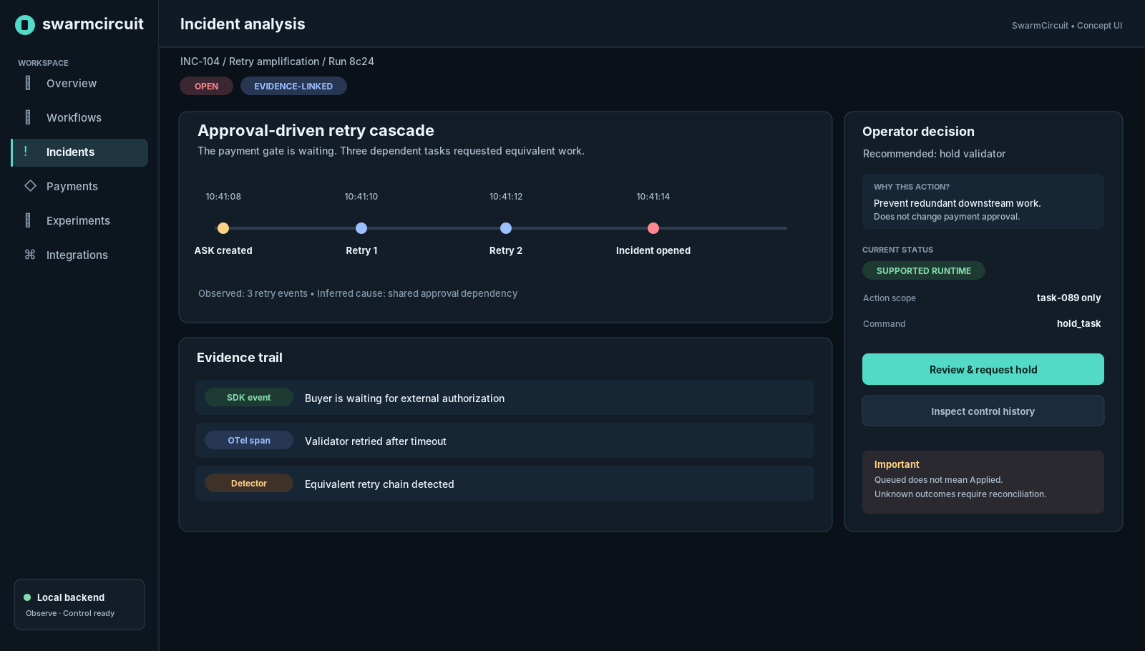
SCREEN B • Incident story, evidence trail and guarded control request; illustrative events only

Three-layer incident explanation
Layer | Answers | Mandatory content
Summary | What happened? | Type, severity, run, timing, affected tasks, current status
Evidence | Why do we believe it? | Event references, source class, detector version, threshold, timestamp
Decision | What can be done safely? | Capability, target, known impact, risks, action state, independent branches

Operators should be able to read the full evidence explanation without opening a separate monitoring product. Source links can deep-link into the local trace waterfall. Inferred root causes must be explicitly labeled “Hypothesis” or “Likely”, not “Verified cause”.

Hold request confirmation: required UI
- Action name and target: “Request hold on task-089”, never “Hold whole swarm”.
- Capability check: active runtime session, declared reversible checkpoint, task version and permission status.
- Impact preview: affected tasks, untouched branches, no hidden payment side effect.
- Confirmation: reason field, cancel path, network feedback, durable command ID and state polling/reconnect reconciliation.
- No automatic escalation to wallet action; GateKeep402 ASK/DENY decisions remain external/authoritative.

07 Experiments & research presentation
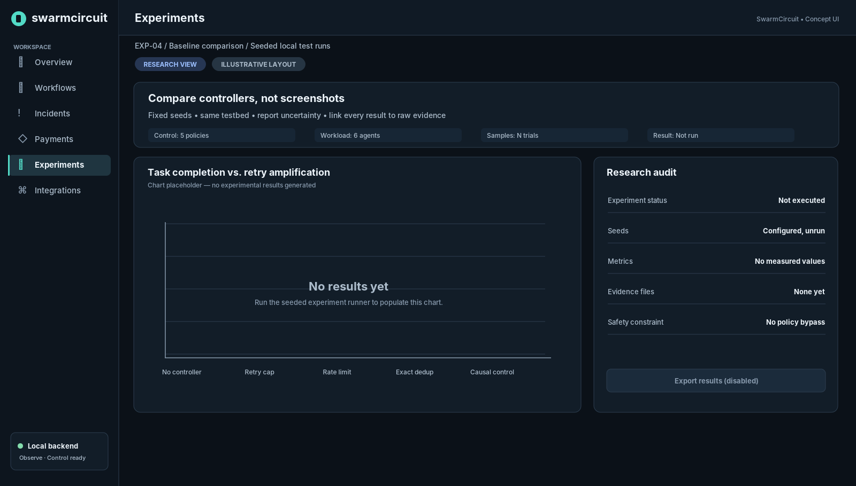
SCREEN C • Results intentionally blank until the experiment runner provides actual measurements
Research credibility takes priority over aesthetics. Distinguish baseline labels from measured results; blank or failed trials remain blank or failed. The interface must not pre-fill example success percentages, smooth away uncertainty, or imply first-place outcomes.

Preferred research visuals
Visualization | Purpose | Non-negotiable annotation
Detection / intervention versus baseline | Test whether graph-aware controller adds value | Seeds, trial count, confidence interval / uncertainty
Amplification versus agents | Identify an escalation threshold if it exists | Topology and workload definition
Recovery vs legitimate throughput | Show benefit/cost trade-off | Hold eligibility and blocked legitimate tasks
Event-to-action case study | Trace source gate → retries → intervention | Absolute/relative timestamps and evidence provenance
Ablation summary | Test exact dedup vs causal grouping | Same event budget and matching configurations

Every figure has a “View evidence” path to experiment ID, code commit, runner configuration, raw per-trial CSV/JSON and excluded/failed trials. Disabled Export is preferable to a fake export. Chart metadata must distinguish demo/sample from real experimental results.

08 Secondary screens and reusable patterns
Screen | Primary layout | Design guidance
Setup | Two-column setup: status + copyable SDK code | Observe and Control snippets show different capability expectations; copy never includes secrets
Overview | Hero status line + recent workflows + incidents | Use no fabricated “global incidents” if only loaded-run data is available
Workflows | Filterable table/list + per-run status | Clear data freshness and paging; visual scan of active, blocked and completed
Timeline | Time waterfall + inspector | UTC event time vs local display; late-arriving badge; source evidence and duration
Payments | Read-only gate decisions and approval queue | ALLOW/ASK/DENY; settlement unknown clearly labeled; no retry-payment button
Integrations | Connection diagnostics + copyable setup | Langfuse is an optional export, not a dependency or primary navigation obligation

Command / event microcopy
Incorrect or vague | Required wording
“Paused successfully” (on POST 202) | “Hold requested · Waiting for runtime acknowledgement”
“Paused” (runtime offline) | “Hold status unknown · Runtime disconnected”
“Payment succeeded” (agent message) | “Agent reported payment · Settlement unverified”
“The swarm is compromised” (heuristic) | “Possible retry cascade · Evidence linked; cause not confirmed”
“Approve purchase” in Studio | “Open host approval” only if trusted host link exists
“All incidents: 3” on loaded page | “Incidents in loaded runs: 3”

09 Component behavior and state matrix
Component | States | Must communicate
Connection indicator | ready / degraded / disconnected / reconnecting | Backend and runtime connection are separately identified
Entity chip | observed / inferred / verified / reported | Evidence source is explicit and not a confidence score alone
Incident badge | open / resolved / not established | Severity independent from source certainty
Control button | eligible / disabled / confirming / queued / applied / unknown | Reason disabled; no optimistic application
Graph node | idle / active / waiting / stalled / held / completed / unknown | Text status and icon beyond color
Toast/banner | info / success / warning / critical | Critical and unknown remain in durable activity/audit log
Table | loading / empty / stale / paginated / error | Do not erase last good data during refresh
Chart | no data / incomplete / valid / exportable | Never fabricate measurements

Empty-state writing style
Explain the absence of data and the next feasible action: “No workflows recorded yet. Connect a Python SDK client or send OTLP traces, then refresh.” For incomplete graph data: “Agent timing is available; task dependencies require lifecycle events.” For unavailable control: “This run is observable but not controllable. Add SDK checkpoints.”

10 Evidence hierarchy, privacy and trust
The visual system must encode the credibility of a statement separately from its severity. A high-severity alert supported only by a model self-report is not the same as a trusted settlement receipt or a current-session SDK acknowledgement.
Source | UI label | What it can prove
Independent simulator / trusted service receipt | Verified receipt | A specific sandbox outcome recorded by trusted service
Authenticated SDK checkpoint | SDK-confirmed | Runtime reached or acknowledged an eligible point
OpenTelemetry span | Telemetry | Timing, trace structure and recorded metadata; not payment settlement
Agent-authored report | Agent-reported | What an agent claims, not independent verification
Derived heuristic graph | Inferred | A tentative relationship supported by evidence; not authoritative control input

Privacy by default
- Do not capture or render raw model prompts, messages, API credentials, payment headers, signed payloads or wallet secrets in the default UI.
- Show message-to-message metadata (participants, event time, size/count) where available; full content requires separate host opt-in and redaction policy.
- Never expose sensitive values in deep links, screenshots exported by the app, search filters, browser logs or copyable snippets.
- Use status indicators independent of color; avoid unexplained security scores and “verified” labels without an evidence source.

11 Accessibility, responsiveness, and motion

WCAG 2.2 AA target
- Minimum 4.5:1 contrast for normal text and 3:1 for large text; verify semantic pairings rather than relying on a palette sheet.
- Provide visible keyboard focus for every button, graph element, list item, dialog action, and evidence link. Target ≥ 24×24 CSS px at minimum, preferably 40–44px for primary actions.
- Offer a keyboard-operable List view equivalent to graph selection; focus on node opens the same inspector as pointer selection.
- All dialogs trap focus, identify the affected task and return focus to the invoking control on close.
- Do not announce every streaming span via screen reader. Announce major status transitions or incident escalation in a controlled live region.
- Respect prefers-reduced-motion; avoid persistent pulsating edges or animated gradients. Use 120–180ms soft transitions for noncritical panels.

Responsive priority
Mobile is an incident triage experience, not a miniature desktop hairball. Start with run summary → task list → inspector sheet → timeline; graph is an optional dedicated view. Hide the minimap on narrow screens, maintain list equivalents, and use a full-width modal/drawer for risk-bearing actions.

Performance requirements for the UI implementation
- Cap visible nodes/edges for the MVP and support semantic filtering, collapsible subgraphs and “expand selected branch” before adding complex graph layouts.
- Batch WebSocket updates into controlled React state updates, preserve viewport and selection on refresh, and show “Live updates paused” on disconnection.
- Virtualize long event tables and make time windows/cursor scope visible; network latency and redaction must not block local graph pan/zoom.
- React Flow is loaded in a client component within Next.js App Router. SSR-compatible surrounding shell and metadata can stay server-rendered.

12 Frontend implementation handoff
Translate this brief into reusable semantic tokens and component contracts. The exact physical pixels are design guidance; behavior and evidence boundaries from Documents 1–5 remain authoritative.
Artifact | Required delivery
Figma / visual file | Desktop shell, Workflow Studio, Incident Inspector, Experiments, mobile triage; labeled states
Tokens | CSS variables for surfaces, typography, spacing, radii, borders, status and focus; JSON source
React components | Shell, StatusChip, EvidenceBadge, AgentNode, TaskNode, ApprovalNode, IncidentNode, Inspector, Timeline, CommandDialog
Storybook / fixtures | Observe-only, Control-ready, runtime disconnected, command unknown, approval pending, inferred edge
Accessibility checks | Keyboard graph/list equivalence, focus return, contrast, reduced-motion and screen-reader naming
Behavior contract | Disabled controls accurately map to TRD capability checks; commands read durable status
Research QA | Charts show real provenance or explicit no-data placeholders; example/demo data watermarked

Visual acceptance checklist
- A new developer can find SDK setup and understand the difference between observing and controlling.
- A workflow operator can identify one blocked dependency and distinguish independent healthy branches.
- GateKeep402 ASK is shown as an unresolved external decision, not automatically a fault or payment success.
- Inferred edges cannot be mistaken for explicit dependencies; edge legend and evidence inspect work.
- Hold request → queued → dispatched → applied/rejected/unknown are distinct visual states.
- A disconnected runtime shows uncertainty and does not enable unsupported controls.
- A research graph with no data stays empty; no invented performance values are presented.
- Keyboard-only and reduced-motion workflows provide comparable diagnosis and control access.
- Layout remains usable at 1440px, 1024px, 768px and narrow mobile widths.

P0 / P1 design boundaries
P0: one coherent local project shell, Workflow Studio graph + timeline, linked incident inspector, read-only payment/approval decisions, basic experiment display, connection/setup. P1: polished global inbox, broad search, more framework adapters, collaborative incident review, custom policy authoring, optional Langfuse export configuration, themes beyond dark-first, and cloud tenancy.

13 References and specification precedence
When there is ambiguity, follow the PRD for scope, Backend Schema for stored truth, TRD/OpenAPI for available operations, and Document 5 for button/interaction states. This document defines visual presentation, not new API authority.
- OpenTelemetry semantic conventions: https://opentelemetry.io/docs/concepts/semantic-conventions/
- OpenTelemetry GenAI agent/workflow span conventions (development status): https://github.com/open-telemetry/semantic-conventions-genai/blob/main/docs/gen-ai/gen-ai-agent-spans.md
- React Flow accessibility: https://reactflow.dev/learn/advanced-use/accessibility
- React Flow theming: https://reactflow.dev/learn/customization/theming
- WCAG 2.2: https://www.w3.org/TR/WCAG22/
- Next.js App Router / server and client components: https://nextjs.org/docs/app

14 Visual release / engineering sign-off
The following conditions are acceptance tests for the Studio design, not visual decoration. The build is not ready to demo until the controls, evidence badges and live-state copy pass these checks.
Test scenario | Expected visual outcome
OTel-only run imported | Readable timings and graph; control actions disabled with integration explanation
GateKeep402 returns ASK | Amber pending gate; no approved/successful payment implication
Multiple tasks depend on one approval | Shared blocker highlighted; unrelated branches remain visually distinct
Operator requests Hold | Command ID displayed; state queued and not held
Runtime acknowledges hold | Held state shown only after authenticated ACK; audit link visible
Runtime disconnects after dispatch | Unknown state; no optimistic completion or automatic retry
Telemetry dependency inferred | Dashed edge, source badge and evidence inspector explanation
No experiment results loaded | No invented charts; explicit empty state; export disabled

Pre-hackathon priority: implement the core interaction and reliable command-state language. Post-hackathon priority: deepen layouts, polish navigation transitions, and expand framework adapters only after safety and evidence behavior is stable.
FINAL DESIGN PRINCIPLE • State truthfully. Diagnose with evidence. Intervene only with authority.

