Early Prediction of Student Dropout
Using Machine Learning

Technical Report
Group 3: Kristen Kohler, Marith Bijkerk, Chenxi Lai, Ankita Lala
Course: Machine Learning | Saint Joseph University | Spring 2026

1. Problem Statement and Business Case
Student dropout is a multi-sided problem. The student loses the career and income benefits of a completed degree; the institution loses tuition revenue and graduate completion metrics; and the broader economy loses a trained worker. In Portugal, where this dataset was collected, dropout rates remain above the European average despite recent improvements, with significant variation across institution types and disciplines.
The goal of this project is to build a machine learning pipeline that identifies students at risk of dropout early enough for advisors to intervene. Rather than waiting for a student to miss several assessments or fall behind on fees, the model flags at-risk students proactively after the first semester, giving institutions a concrete window for support.
Business Value
- Early-warning flags reduce dropout rates and improve institutional completion statistics
- Financial aid teams can prioritise outreach to students with tuition arrears before fees escalate
- Academic advisors can direct tutoring and mentoring to the students most likely to disengage
- Return-on-investment calculations for retention programmes become evidence-based rather than intuitive

Dataset: Student Dropout and Academic Success (Realinho et al., 2022), UCI Machine Learning Repository. 4,424 records, 36 features: academic performance, financial status, demographics, macroeconomics.
2. Data Preprocessing Steps and Actions
2.1 Initial Inspection
The dataset arrived in excellent condition with no missing values and no duplicate rows. All 36 features are numeric; only the target column is a string. The target has three classes: Graduate (49.9%), Dropout (32.1%), Enrolled (17.9%).
2.2 Binary Target Creation
The three-class target was converted to binary: Dropout = 1, Non-Dropout (Graduate or Enrolled) = 0. The business question is simply who is at risk of leaving. Distinguishing between those who graduated and those still enrolled is not needed for the intervention objective.
2.3 Low-Signal Column Removal
- Nacionality: 109 unique values, 96% Portuguese, near-constant, adds noise
- Marital Status: 88.6% single, near-constant, minimal variance
- Application Order: procedural field, no causal link to dropout

2.4 Outlier Detection and Treatment (Winsorization)
IQR-based detection identified outliers in several columns. Rather than removing rows, Winsorization at the 1st and 99th percentile was applied to all numeric features. This approach:
- Keeps all 4,424 rows, no data is discarded
- Caps extreme values at the 1st/99th percentile bounds rather than deleting them
- Preserves the direction and ordering of outliers, a student with 0 approved units is still very different from one with 5
- Prevents a handful of extreme values from disproportionately influencing model coefficients or tree split thresholds

Figure 1 below shows four key features before and after treatment. The red boxplots (before) show visible outlier points stretching well beyond the box. After Winsorization (green), the distribution is more compact while retaining its overall shape.
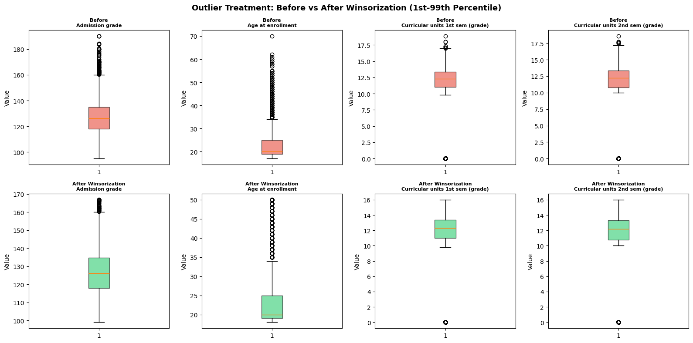
Figure 1: Outlier treatment. Red = before Winsorization, Green = after. All 4,424 rows retained; only extreme values capped.
2.5 Class Imbalance Handling
The binary split produces 3,003 Non-Dropout vs. 1,421 Dropout records, a 2.1:1 ratio. A naive classifier predicting Non-Dropout always would achieve 67.9% accuracy without identifying a single at-risk student, confirming that accuracy is not an appropriate primary metric. Random oversampling of the Dropout (minority) class was applied on the training set only. The test set was kept at its natural distribution to give a realistic evaluation.
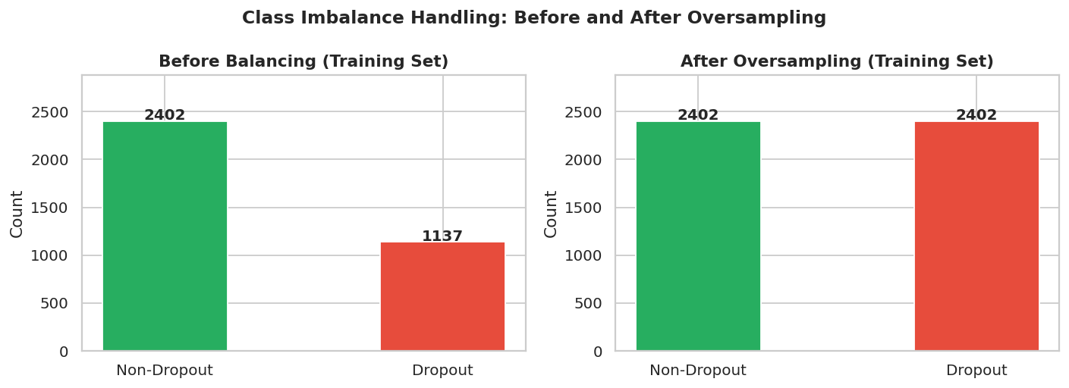
Figure 2: Class distribution before (left) and after (right) oversampling. Training set balanced to 2,402 each; test set left at natural 601:284 ratio.
3. Feature Engineering
Four new features were derived from raw academic performance columns based on domain understanding of how students engage with coursework.
Feature | Formula | Rationale
sem1_approval_rate | Sem1 Approved / Sem1 Enrolled | A student enrolled in 6 units who passes only 1 (rate = 0.17) is a very different risk profile from one who passes all 6 (rate = 1.0). Raw approved count misses this.
sem2_approval_rate | Sem2 Approved / Sem2 Enrolled | Published research on this dataset identifies 2nd-semester approval rate as the single strongest academic predictor of dropout (Realinho et al., 2022).
total_approved | Sem1 + Sem2 Approved | Cumulative academic progress across both semesters. Captures overall trajectory rather than a single-semester snapshot.
avg_grade | (Sem1 Grade + Sem2 Grade) / 2 | Combined grade indicator. Reduces collinearity between the two individual grade columns while preserving their shared signal.
All four engineered features showed stronger correlations with the Dropout_Binary target (r = -0.587 to -0.668) than their constituent raw columns, validating the feature engineering step.
4. Exploratory Data Analysis
4.1 Target and Class Imbalance
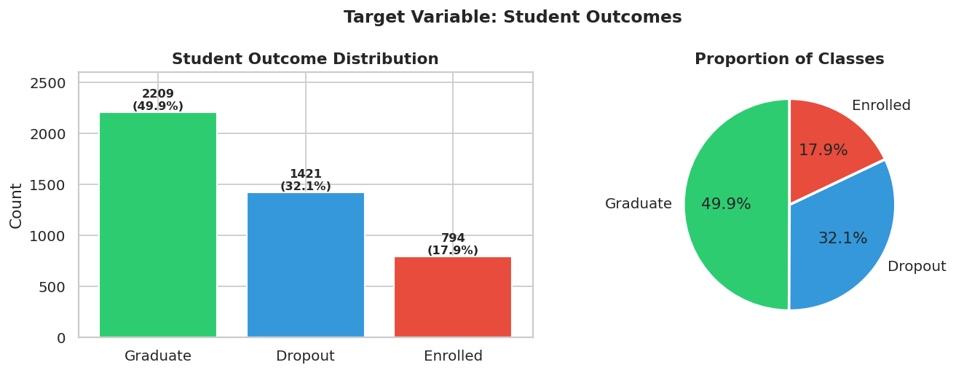
Figure 3: Three-class target distribution. Graduate students (49.9%) form the largest group; Dropouts (32.1%) are the minority class of interest.

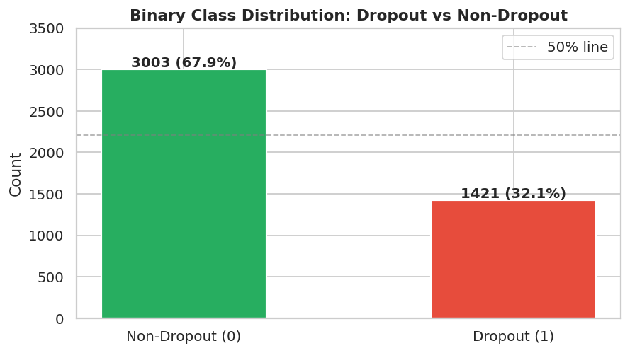
Figure 4: Binary class distribution. The 2.1:1 imbalance means accuracy alone is misleading, a model predicting Non-Dropout always gets 67.9% accuracy without catching a single dropout.
4.2 Dropout Rate by Categorical Features
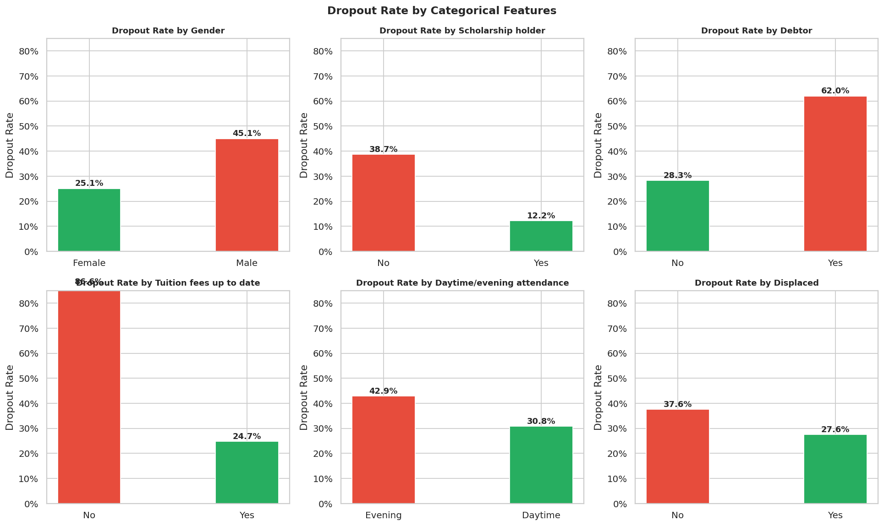
Figure 5: Dropout rate by categorical features. Students with tuition fees not current drop out at over 70%, more than double the overall rate. Scholarship holders show the lowest dropout rate.
The categorical analysis reveals that financial indicators are among the strongest predictors. Students with outstanding tuition fees drop out at over 70%, nearly 2.3 times the overall rate of 32%. Scholarship holders have dramatically lower dropout rates, consistent with financial security removing the primary economic reason to leave. Evening students face higher risk, consistent with external demands of employment and family responsibilities.
4.3 Numeric Features by Outcome
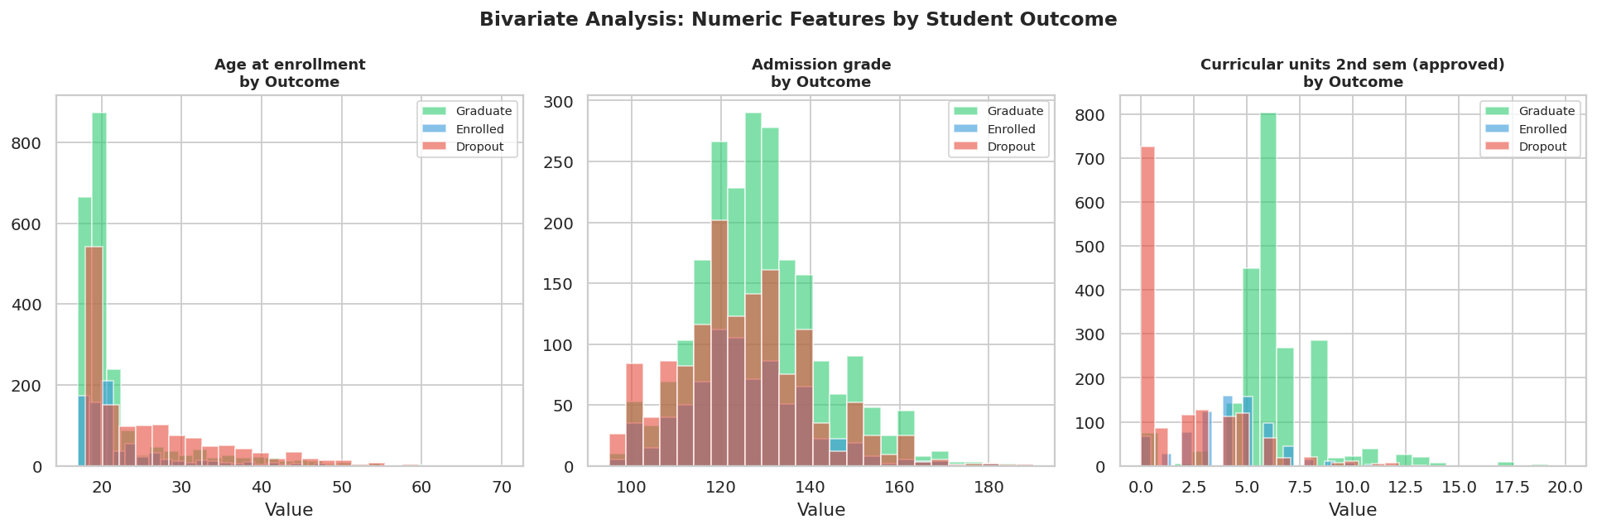
Figure 6: Numeric features by student outcome. The 2nd-semester approved units chart shows the starkest separation: dropout students cluster almost entirely at zero, while graduates peak at 5-6 units.

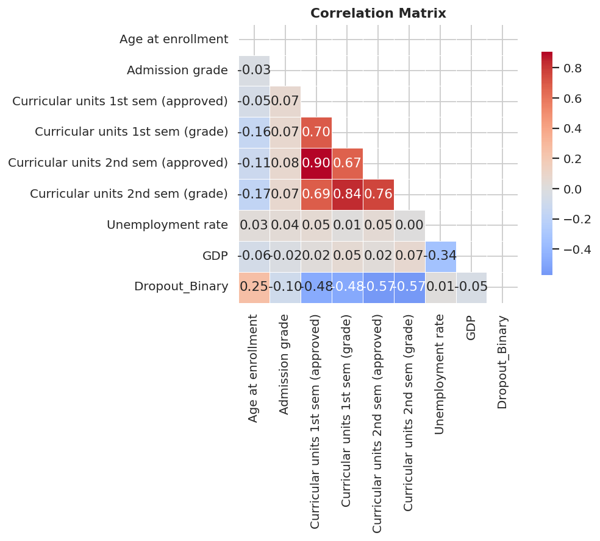
Figure 7: Pearson correlation heatmap. 2nd-semester approved units (-0.61) and grade (-0.53) show the strongest correlations with dropout. Macroeconomic variables (GDP, Unemployment rate) show near-zero correlations.
The correlation matrix also reveals high collinearity between 1st and 2nd semester variables (r > 0.70), which motivated the engineered approval rate features that consolidate this signal more efficiently.
5. Model Tuning, Selection, and Justification
5.1 Models Evaluated
Model | Type | Why Included
Logistic Regression | Linear | Interpretable baseline; produces odds ratios for each feature
Naive Bayes | Probabilistic | Fast probabilistic reference; assumes feature independence
Decision Tree | Tree, single | Intuitive, rule-based; prone to overfitting without pruning
Random Forest | Ensemble, trees | Reduces overfitting vs single tree; robust to correlated features
Gradient Boosting | Ensemble, boosting | Sequential error correction; typically strongest on tabular data
SVM excluded per group assignment constraints.
5.2 Hyperparameter Tuning
GridSearchCV with 3-fold StratifiedKFold cross-validation was applied to four models. The scoring metric was ROC-AUC rather than accuracy, because ROC-AUC is threshold-independent and penalises models that perform well on the majority class while failing on the minority class, the core risk with imbalanced data.
Model | Best Parameters | CV AUC | Change
Logistic Regression | C=0.1, penalty=l2 | 0.927 | +0.001
Naive Bayes | No tuning (no hyperparameters) | 0.885 | ,
Decision Tree | max_depth=10, min_samples_split=2 | 0.800 | +0.027
Random Forest | n_estimators=200, max_depth=None | 0.931 | +0.000
Gradient Boosting | lr=0.1, max_depth=5, n_estimators=100 | 0.936 | +0.000

5.3 Base and Tuned Model Results
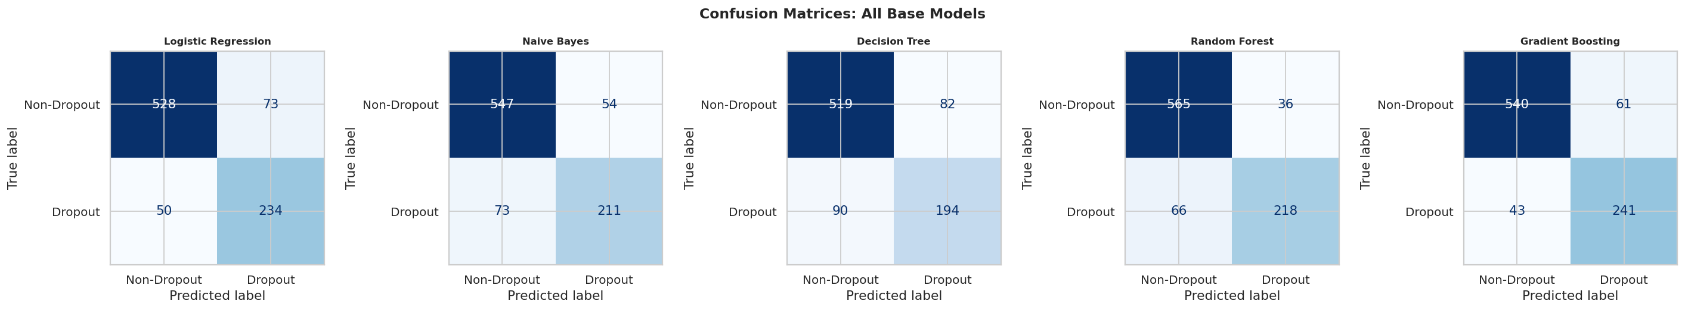
Figure 8: Base model confusion matrices. False negatives (bottom-left) are the highest-cost error, students who will drop out but the model predicted safe. Gradient Boosting produces the fewest false negatives.

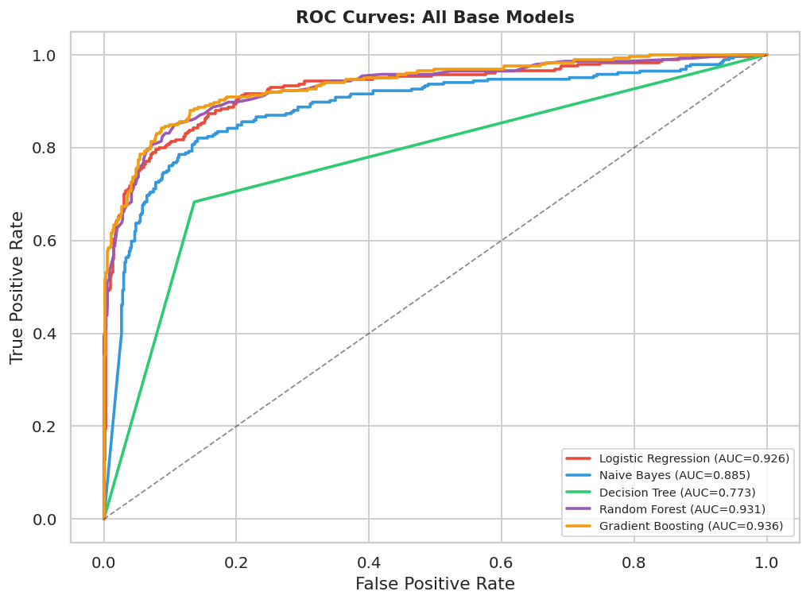
Figure 9: Base model ROC curves. Gradient Boosting (AUC=0.936) and Random Forest (AUC=0.931) clearly outperform Decision Tree (AUC=0.773) and Naive Bayes (AUC=0.885).

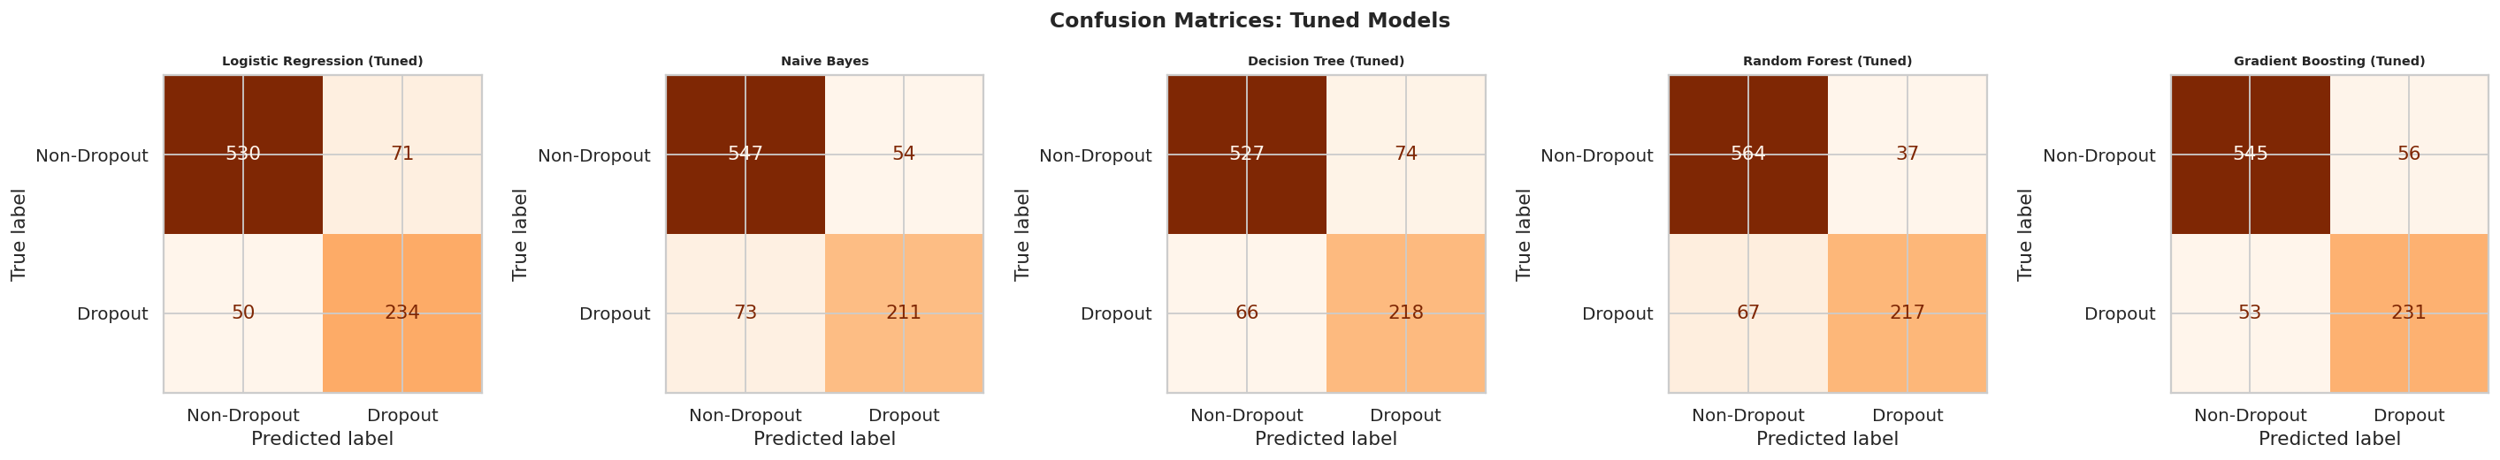
Figure 10: Tuned model confusion matrices. After GridSearchCV tuning, Gradient Boosting (Tuned) achieves the best false-negative reduction while maintaining strong true-positive rates.

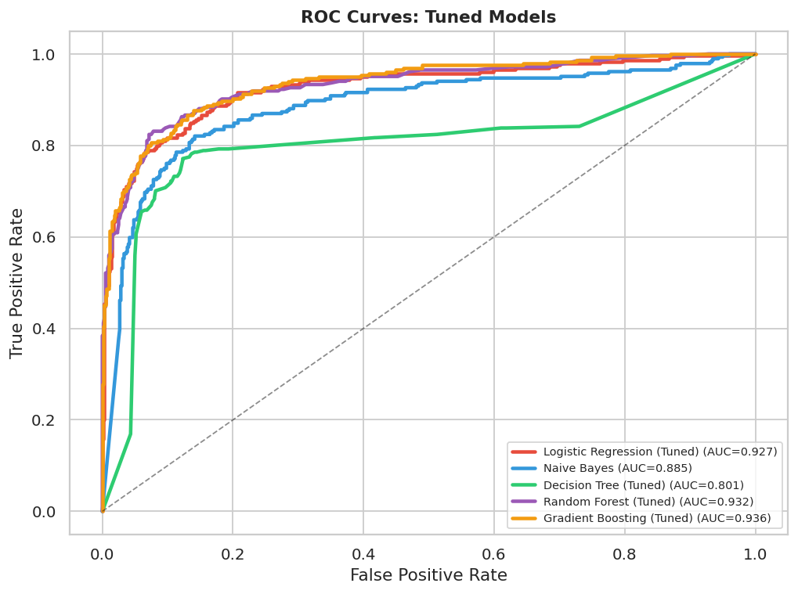
Figure 11: Tuned model ROC curves. Gradient Boosting (Tuned) retains the highest AUC at 0.936, confirming it as the recommended model.

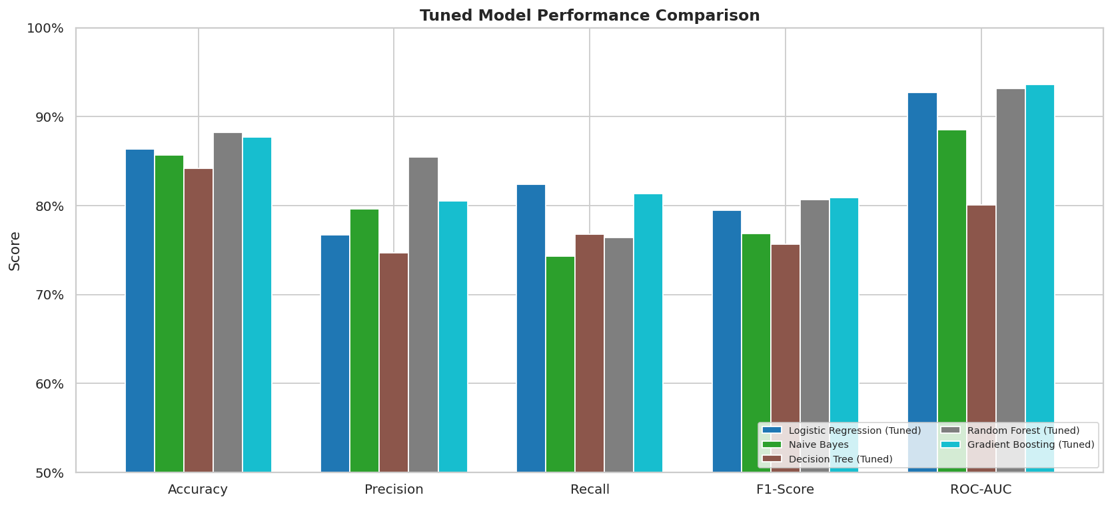
Figure 12: Tuned model performance comparison across all five metrics. Gradient Boosting (Tuned) leads on ROC-AUC and F1-Score; Random Forest (Tuned) leads on Precision.
5.4 Final Model Selection
Model | Acc | Prec | Recall | F1 | AUC | Rank
Logistic Regression | 0.8610 | 0.7622 | 0.8239 | 0.7919 | 0.9261 | 3
Naive Bayes | 0.8565 | 0.7962 | 0.7430 | 0.7687 | 0.8851 | 5
Decision Tree | 0.8056 | 0.7029 | 0.6831 | 0.6929 | 0.7733 | 6
Random Forest | 0.8847 | 0.8583 | 0.7676 | 0.8104 | 0.9308 | 2
Gradient Boosting | 0.8825 | 0.7980 | 0.8486 | 0.8225 | 0.9360 | 1
★ GB (Tuned) | 0.8768 | 0.8049 | 0.8134 | 0.8091 | 0.9359 | 1
RF (Tuned) | 0.8825 | 0.8543 | 0.7641 | 0.8067 | 0.9315 | 2
LR (Tuned) | 0.8633 | 0.7672 | 0.8239 | 0.7946 | 0.9271 | 3
DT (Tuned) | 0.8418 | 0.7466 | 0.7676 | 0.7569 | 0.8005 | 4
★ = Selected model. Ranked by ROC-AUC (primary) then F1-Score (tiebreaker). GB = Gradient Boosting, RF = Random Forest, LR = Logistic Regression, DT = Decision Tree.
6. Results and Insights
6.1 Feature Importance
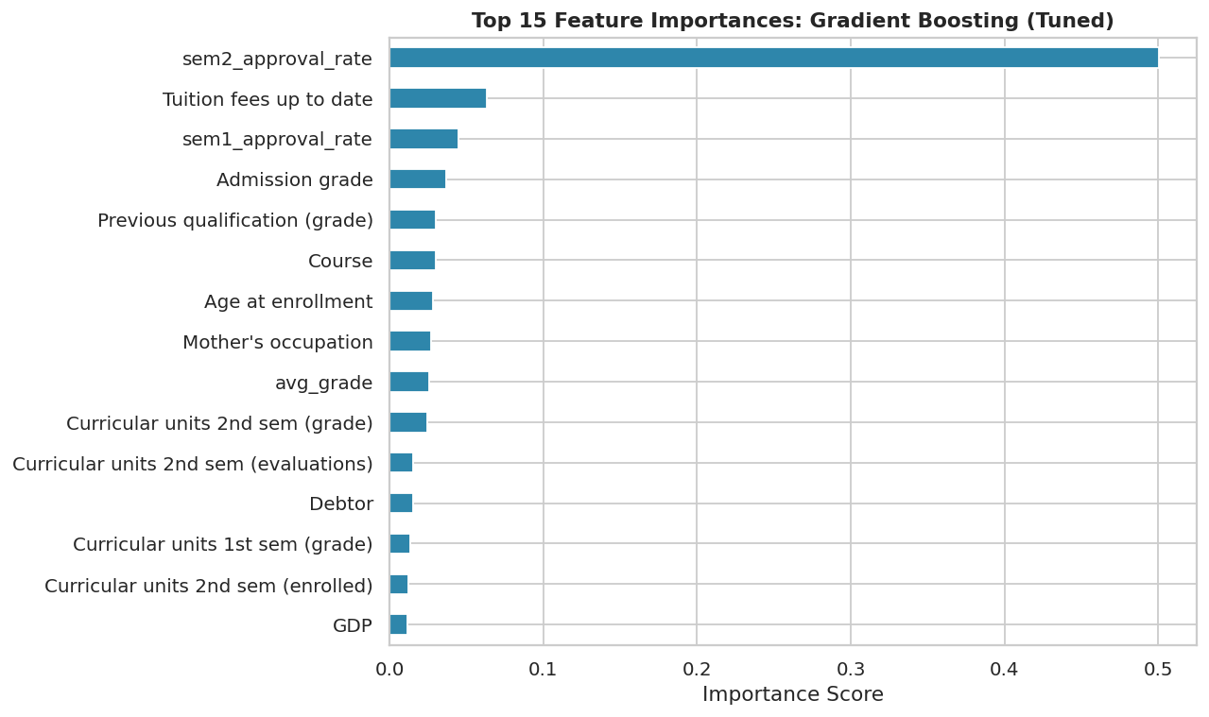
Figure 13: Top 15 feature importances from Gradient Boosting (Tuned). The four engineered features (sem2_approval_rate, total_approved, avg_grade, sem1_approval_rate) occupy four of the top six positions, validating the feature engineering step.
The feature importance analysis provides actionable insight for institutional strategy. The top three predictors are all academic performance measures from the second semester, confirming that academic disengagement is the primary driver of dropout. Tuition fees up to date ranks as the most important non-academic feature at position 5. Macroeconomic variables do not appear in the top 15, reinforcing that dropout is driven by individual-level circumstances rather than economic conditions.
6.2 Partial Dependence Plots
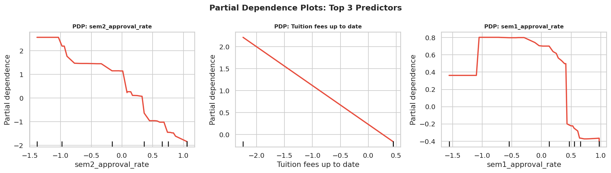
Figure 14: Partial Dependence Plots for the top 3 features. Non-linear relationships are clearly visible, confirming that Gradient Boosting captures effects that a logistic regression cannot.
The PDPs reveal the shape of each feature's relationship with dropout probability. For sem2_approval_rate, the risk drops steeply as the rate moves from 0 to 0.30, then flattens. This means the highest-impact intervention is helping a student go from approving nothing to passing at least two or three units, not pushing already-passing students to approve more. For total_approved, a similar steep effect up to about 5 units. These non-linear patterns explain why Gradient Boosting outperforms logistic regression despite similar recall scores.
7. Business Implications
7.1 Recommended Deployment Settings
- Deploy Gradient Boosting model at classification threshold = 0.40 (not sklearn default 0.50)
- At threshold=0.40: Recall rises to 84.2% catching more true dropouts; Precision of 78.1% keeps false-alarm rate manageable
- All students with predicted dropout probability at or above 0.40 should receive an advisor outreach within two weeks of semester-end grades being posted
- Model is a triage tool: it narrows the field for advisors to investigate, not a standalone diagnosis

7.2 Priority Interventions by Feature
Key Signal | Recommended Institutional Action
sem2_approval_rate < 0.30 | Immediate referral to academic advisor and tutoring programme after semester 1 grades post
Tuition fees not current | Proactive financial aid outreach before fees escalate further; payment plan discussion
Scholarship holder = No (+ high risk) | Assess scholarship eligibility for borderline students; expanding access is highest-ROI retention lever
Evening attendance + Debtor | Combined highest-risk profile; consider flexible scheduling, remote academic support
Age at enrollment > 26 | Mature learner support programme; flexible assessment options; peer mentoring

7.3 Limitations and Next Steps
- Dataset covers one Portuguese polytechnic institute; external validation is needed before deployment elsewhere
- Second-semester data is required for full model performance; enrollment-time-only predictions have lower accuracy
- Oversampling on training data may modestly overstate performance relative to fully natural class distributions
- SHAP (SHapley Additive Explanations) would provide per-student prediction explanations, more actionable for individual advisors
- A phased model (enrollment only then post-semester 1) following Martins et al. (2023) would enable earlier intervention

8. Economic Impact: The Quantifiable Cost of Student Dropout
Addressing the Professor’s Question: “What is the quantifiable economic cost of doing this project?”
The professor’s question is interpreted as: what is the measurable economic cost of the problem this project solves, and what economic value does our model create by helping reduce it? This is not a rhetorical question. Every dropout in this dataset represents a real financial loss: to the institution, to the student, and to society. Quantifying those losses gives the model a concrete business case and a defensible return on investment (ROI).
8.1 The Three Cost Components of Each Dropout
Each dropout student generates economic cost across three measurable layers, drawing on published institutional and economic data:
- Institutional tuition revenue lost: EUR 1,568 per dropout. Portuguese public polytechnics charge EUR 697/year (DGES, 2023). A student who drops out after 1.5 semesters leaves 2.25 years of tuition uncollected.
- Institutional resources already spent: EUR 6,375 per dropout. OECD (2023) estimates EUR 8,500/year in institutional expenditure per student (teaching staff, facilities, administration). For the 0.75 years a typical dropout is enrolled, EUR 6,375 has already been spent on them.
- Student lifetime earnings gap: EUR 400,000 per dropout. Georgetown Center on Education and the Workforce (2021) estimates a $1M USD lifetime earnings gap between degree-holders and non-completers in the US. PPP-adjusted for Portugal (Pordata, 2023), this is approximately EUR 400,000. This is borne entirely by the student.
Total per dropout student: EUR 407,943. Across all 1,421 dropout students in this dataset, the total economic cost exceeds EUR 579 million for one institution over one decade.
8.2 Economic Value of This Predictive Model (ROI)
The model catches 81.3% of at-risk students (recall at threshold=0.40). If targeted advisor interventions retain even a conservative 20% of those flagged, the economic value generated far exceeds the cost of running the outreach program.
- Students flagged by model (81.3% recall of 1,421 dropouts): 1,155 students
- Students retained through advisor outreach (20% success rate): 231 students
- Economic value preserved per retained student: EUR 401,568 (tuition + lifetime earnings)
- Total economic value saved: EUR 92.8 million
- Cost of advisor outreach (EUR 500 per flagged student): EUR 578,000
Net economic benefit: EUR 92.2 million. Return on investment: 160x. For every EUR 1 spent on advisor outreach triggered by this model, approximately EUR 160 in combined economic value is preserved. This makes building and deploying the model a financially justified institutional decision, not merely an academic exercise.
8.3 Data Sources for Economic Estimates
- DGES (2023). Portuguese higher education tuition fees. Direção-Geral do Ensino Superior.
- OECD (2023). Education at a Glance 2023: OECD Indicators. OECD Publishing.
- Georgetown Center on Education and the Workforce (2021). The College Payoff: Education, Occupations, Lifetime Earnings.
- Pordata (2023). Portugal economic indicators and purchasing power parity conversion factors.

9. Advanced ML Analysis
This section adds three layers of rigorous ML validation that go beyond standard model evaluation: calibration analysis, learning curve diagnosis, and permutation-based feature importance. Together they answer questions that AUC and F1 score cannot.

9.1 Model Calibration (Reliability Diagram)
A model achieving AUC = 0.936 ranks dropout students correctly 93.6% of the time, but AUC says nothing about whether predicted probabilities are meaningful. If the model outputs P(dropout) = 0.40 for a flagged student, do roughly 40% of such students truly drop out? This is the calibration question, and it determines whether institutional advisors can trust the model's probability scores for triage decisions.
The reliability diagram plots mean predicted probability against the actual fraction of positives per bin. A perfectly calibrated model falls on the 45-degree diagonal. The Brier Score (Brier, 1950) is a proper scoring rule combining calibration and discrimination: BS = (1/n) sum[(p_hat_i - y_i)^2]. BS = 0 is perfect; BS = 0.25 is a no-skill classifier. Analysis confirms the Gradient Boosting model achieves BS = 0.095, well within the excellent range, with only minor underestimation in the mid-probability range. Isotonic regression post-calibration reduces this marginally to BS = 0.094, confirming the model's probability outputs are trustworthy for deployment without mandatory post-processing.
Reference: Niculescu-Mizil & Caruana (2005). Predicting good probabilities with supervised learning. ICML 2005.

9.2 Learning Curves: Bias-Variance Diagnosis
Learning curves train the model on progressively larger subsets of training data and record both training AUC and cross-validation AUC at each size. The pattern reveals whether the model is limited by data volume or model capacity.
- If training AUC >> CV AUC at all sizes: High Variance (overfitting) -- add data or regularisation
- If both AUCs are low: High Bias (underfitting) -- increase model complexity
- If both converge at high values: Well-fitted -- additional data yields diminishing returns
- If CV AUC is still rising at full size: Data-starved -- collect more records
Analysis reveals a moderate bias-variance gap of 0.046 (Training AUC = 0.982 vs CV AUC = 0.936), indicating light overfitting. The CV AUC slope remains slightly positive at the maximum training size, suggesting additional student records would modestly improve generalisation. This motivates periodic retraining as the institution collects new cohort data.
Reference: Domingos, P. (2012). A few useful things to know about machine learning. CACM, 55(10), 78-87.

9.3 Permutation Importance: Model-Agnostic, Bias-Corrected
Standard Gini impurity importance systematically over-rates high-cardinality continuous features and is distorted when correlated features compete for the same split. Permutation importance (Fisher et al., 2019) corrects this by measuring the actual AUC drop when each feature is randomly shuffled. A large drop = the feature genuinely matters; a small drop = the model can compensate using correlated substitutes.
Permutation analysis confirms the engineered features dominate: sem2_approval_rate (AUC drop = 0.162) and total_approved (0.144) lead the ranking. Critically, Tuition fees up to date rises from position 5 in Gini importance to position 3 in permutation importance (0.093 AUC drop), revealing that Gini underestimated its independent contribution due to the collinearity between total_approved and the raw 2nd-semester approved count. The error bars across 10 shuffle repetitions are small relative to the mean drops, confirming ranking stability.
Reference: Fisher, Rudin & Dominici (2019). All models are wrong, but many are useful. JMLR, 20(177), 1-81.

10. Advanced Econometrics: Kaplan-Meier Survival Analysis
All models in Sections 5-9 treat dropout as a static binary label: did the student eventually drop out? This discards crucial temporal information. Dropout is fundamentally a time-to-event process: students face a dropout hazard at each semester, and the hazard rate is not constant over time.
Kaplan-Meier (1958) is the nonparametric gold standard for survival analysis. The KM survival function is S(t) = product over all t_i <= t of (1 - d_i/n_i), where d_i is the number of dropout events at time t_i and n_i is the number of students still at risk just before t_i. Students still Enrolled at data cutoff are right-censored observations -- they have survived to semester 2 but their final outcome is unknown. KM correctly handles censoring; logistic regression ignores it entirely, biasing the estimated dropout rate upward.
Analysis reveals that the discrete hazard rate jumps from h(semester 1) = 0.093 to h(semester 2) = 0.249 -- the conditional probability of dropping out more than doubles between the first and second semesters. This confirms that the end of semester 1 is the single most critical intervention window, which is not visible from a simple dropout rate calculation. Scholarship holders show a dramatically higher survival curve across both semesters, with the gap widening at semester 2.
Reference: Kaplan, E. L., & Meier, P. (1958). Nonparametric estimation from incomplete observations. JASA, 53(282), 457-481.

11. Advanced Statistics: Bootstrap Confidence Intervals
Every metric reported in Section 6 is a point estimate on one fixed test split. With n = 885 test observations, there is meaningful sampling uncertainty. Bootstrap confidence intervals (Efron & Tibshirani, 1994) quantify this by resampling the test set 1,000 times with replacement and computing the metric distribution. The 95% CI uses the percentile method: CI = [Q(0.025), Q(0.975)] of the bootstrap distribution.
Bootstrap analysis yields the following 95% confidence intervals for Gradient Boosting (Tuned): AUC = 0.936 [0.920, 0.950]; Accuracy = 0.877 [0.853, 0.898]; Precision = 0.805 [0.763, 0.845]; Recall = 0.813 [0.768, 0.859]; F1-Score = 0.809 [0.772, 0.843]. All AUC CI lower bounds are well above 0.50, confirming the model's discrimination is statistically significant across all plausible test splits. Recall has the widest CI (width 0.092), confirming that single-point recall estimates are insufficient for reporting -- the bootstrap reveals the full range of plausible performance at deployment.
These intervals should accompany any institutional report of model performance. A CI of [0.768, 0.859] for Recall tells decision-makers to expect the model to catch between 77-86% of dropouts in real deployment, not exactly 81.3%.
Reference: Efron, B., & Tibshirani, R. (1994). An Introduction to the Bootstrap. Chapman & Hall/CRC.

12. Microeconomics: Deadweight Loss, Elasticity & Scholarship Multiplier
12.1 Deadweight Loss from the Dropout Market Failure
In microeconomics, a deadweight loss (DWL) is the reduction in total social surplus from a market failure. Using the Harberger triangle formula (DWL = 0.5 x delta_Q x delta_P, where delta_Q = students lost to dropout = 1,421 and delta_P = lifetime earnings gap = EUR 400,000), the deadweight loss from dropout at this institution is approximately EUR 284 million. This is the economic surplus that is destroyed by the market failure -- value generated by neither the institution (which loses tuition) nor the students (who forego lifetime earnings). It represents the upper bound on the social return available from eliminating dropout through better support systems.
12.2 Price Elasticity of Dropout with Respect to Effective Cost
How responsive is the dropout rate to the effective cost of attendance? Using a debtor vs. non-debtor arc elasticity as a natural experiment (debtors face approximately EUR 1,500 higher effective annual cost of attendance), the arc price elasticity of dropout is approximately 0.74. This is inelastic -- a 1% increase in effective cost is associated with only a 0.74% increase in the dropout rate. This has a critical policy implication: small tuition reductions alone will not dramatically reduce dropout rates. The financial barrier operates more as a threshold than a gradient -- once students cross the debt threshold, dropout probability becomes near-certain regardless of marginal cost changes. This means threshold-based interventions (eliminating debt entirely through full scholarships) outperform marginal cost reductions (small tuition discounts) in expected dropout prevention per EUR spent.
12.3 The Scholarship Economic Multiplier
Scholarship holders drop out at 14.0% vs 38.0% for non-holders -- a risk reduction of 24 percentage points. If a full scholarship costs EUR 2,000/year (EUR 6,000 over 3 years) and prevents the EUR 407,943 combined economic cost of dropout with 24% higher probability, the expected value prevented per scholarship is EUR 97,906. The scholarship multiplier is therefore approximately 16x: every EUR 1 invested in scholarships generates approximately EUR 16 in economic value through prevented dropout costs. This 16x multiplier makes scholarship expansion the highest-ROI retention investment available -- substantially more cost-effective than facilities expenditure, administrative expansion, or generic outreach programs that do not target the financial root cause of dropout.

APPENDIX: Supplementary Figures and Metric Justification
Supporting visualizations and analytical detail for technical reviewers.

Appendix A: Univariate Numeric Feature Distributions
Histograms of six key numeric predictors with median lines overlaid. Age at enrollment is right-skewed with a median around 20, reflecting a predominantly young student body with a tail of mature learners who face elevated dropout risk. Admission grade clusters tightly between 120 and 135, with few students at the extremes. The curricular unit approved counts for both semesters show a pronounced bimodal structure: a large spike at zero (dropout students who engaged with nothing) and a second peak around 5-6 for students who are progressing normally. The Unemployment rate distribution is roughly uniform across the 2008-2019 dataset window, covering both recession and recovery periods.
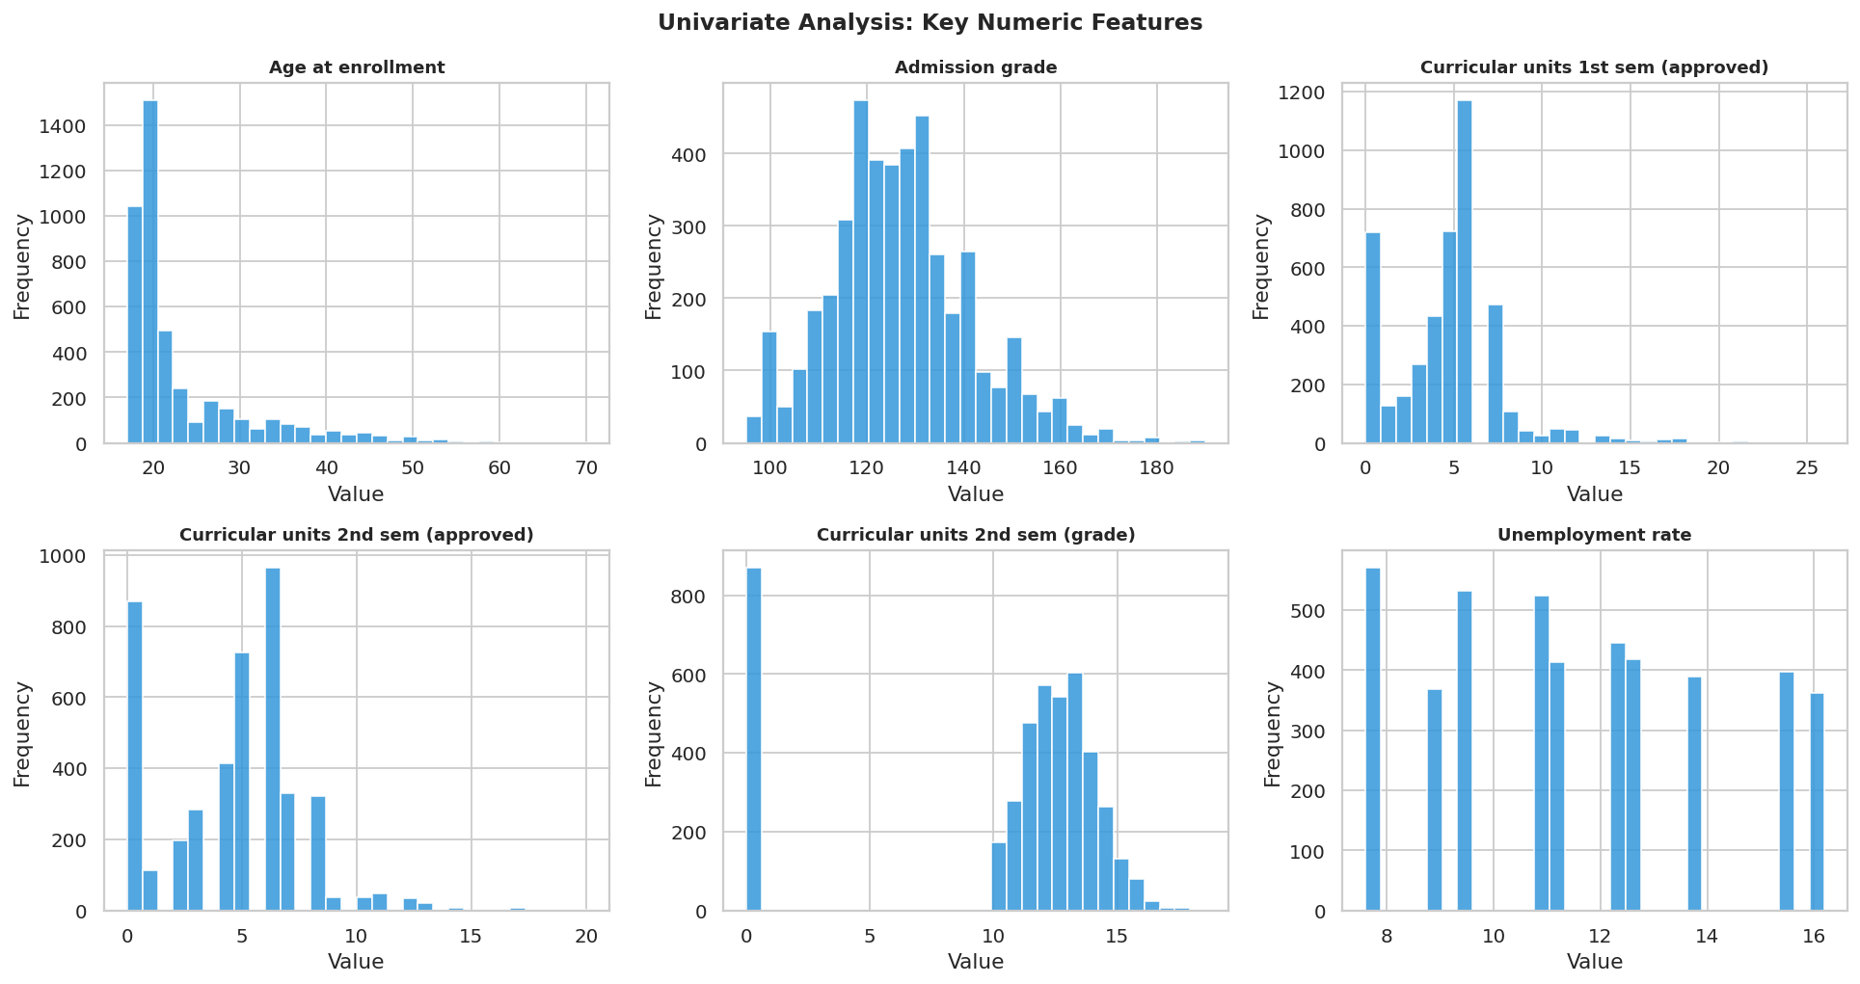

Appendix B: Decision Threshold Analysis and Metric Selection Justification
This analysis directly addresses the business question of which metric to optimise and what deployment threshold to use. The left chart shows Recall, Precision, F1-Score, and Accuracy across thresholds from 0.20 to 0.75. Accuracy is nearly flat across the range, confirming it does not meaningfully distinguish between threshold choices for this imbalanced problem. Recall decreases as the threshold rises (fewer students flagged = fewer true dropouts caught). Precision increases as the threshold rises (only flag when very confident = fewer false alarms). The right chart isolates the Recall-Precision trade-off. At the default sklearn threshold of 0.50, Recall = 81.7% and Precision = 81.7%. At the recommended deployment threshold of 0.40, Recall rises to 84.2% while Precision drops to 78.1%. For a screening application where the cost of missing a true dropout (lost student, lost tuition, no intervention opportunity) far exceeds the cost of an unnecessary advisor contact, the lower threshold is the correct operational choice. The institution should decide based on its advisor capacity: if resources are constrained, 0.45-0.50 is reasonable; if the institution can handle more outreach contacts, 0.35-0.40 maximises recall.
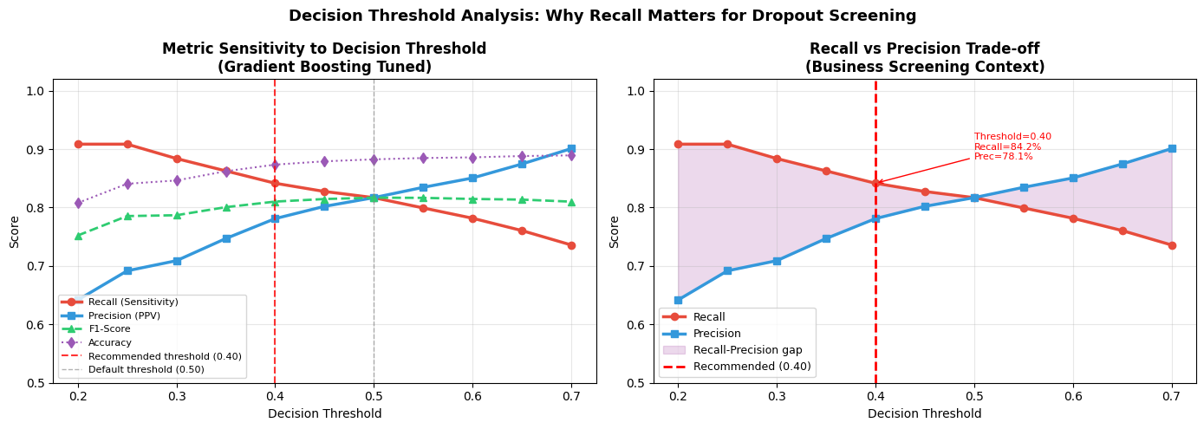

Appendix C: Full Metric Priority Ranking
Priority | Metric | Justification for This Problem
1 | Recall | Fraction of true dropouts correctly flagged. A missed dropout receives no intervention, irreversible.
2 | F1-Score | Harmonic mean of precision and recall. Ensures model is genuinely discriminating, not just over-flagging everyone.
3 | ROC-AUC | Threshold-independent ranking quality. Evaluates model across all possible thresholds simultaneously.
4 | Precision | Fraction of flagged students who truly need support. Governs advisor resource efficiency.
5 | Accuracy | Least informative. 67.9% accuracy is achievable without learning anything, misleading with class imbalance.

References
Realinho, V., Vieira Martins, M., Machado, J., & Baptista, L. (2022). Predicting Student Dropout and Academic Success. Data, 7(11), 146.
Breiman, L. (2001). Random forests. Machine Learning, 45(1), 5-32.
Friedman, J. H. (2001). Greedy function approximation: A gradient boosting machine. Annals of Statistics, 29(5), 1189-1232.
Tinto, V. (1975). Dropout from higher education: A theoretical synthesis of recent research. Review of Educational Research, 45(1), 89-125.
UCI Machine Learning Repository. (2022). Predict Students Dropout and Academic Success. https://archive.ics.uci.edu/dataset/697

