**CS 389**

**GitHub**

Deadline: 2/5/2014 by 23:59 pm. Use the class time to do this work and seek help from your classmates.

In CS 389 we are using GitHub for code versioning, bug tracking, project management and project documentation.

The goal of this exercise is to get you started with GitHub. Even if you are using GitHub regularly you need to do this exercise.

**Part 1:**

Install GitHub bash <http://git-scm.com/downloads> and browse the documentation. Create an account if you do not have one.

**Part 2:**

What is GitHub? When was it created? Why? By who? What similar platforms exist? Why would you use such a platform? (Answer between 5 and 10 lines) **GitHub is an internet hub where an individual can upload their developer projects with ease using the Git repository host. Git is a distributed revision control system. Version control systems allow a person to have multiple version of the same project. This helps so that if an issue occurs overtime a person can backtrack and figure out the issue of that problem. A man named Tom Preston-Werner released Git on April 10 2008. A similar platform on GitHub includes bitbucket.**

**Part 3:**

Go through the Git tutorial here: <https://try.github.io/levels/1/challenges/1>. While doing the tutorial, save your work in a Word file called FirstnameLastnameGitTutorial-mm-dd-yyyy.docx.

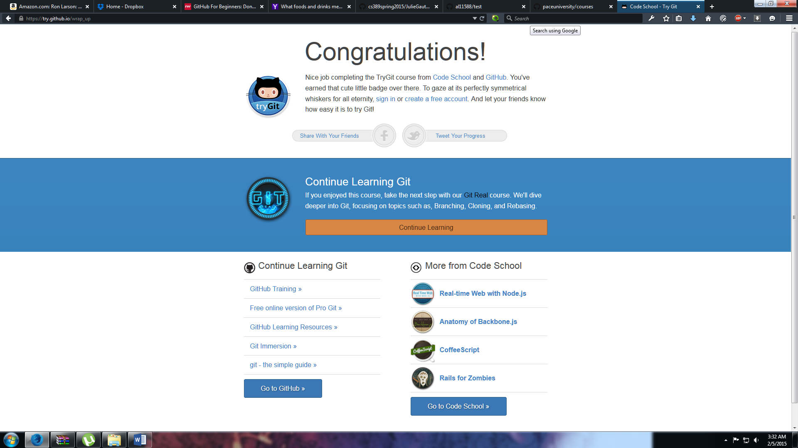

**Part 4:**

Define the following terms (in 2 lines maximum) in the context of Git:

* Repository – **A repo is a space where an individual’s developer projects live online.**
* Commit- **A commit creates a snapshot of your repository so an individual can look over the project.**
* Push – **A push uploads existing code on your computer to the individual’s server.**
* Branch – **When there are multiple individuals collaborating on a project a branch helps to create a timeline of revisions. This helps so that a person can be able to look back to fix issues.**
* Fork – **A fork is a copy of a repository.**
* Merge – **A merge helps to merge changes to a master branch so that individuals can see changes on the master.**
* Clone- **A clone makes a copy of that existing repository on your local computer.**
* Pull – **A pull helps to get the most up to date version of your repository so it is able to work**.
* Pull request - **A pull helps to get the most up to date version of your repository so it is able to work**.

**Part 5:**

Push the Word file in your GitHub account in a repository called *cs389spring2015*. You will use this repository this semester.

**Part 6:**

Retrieve the file README.md at:

<https://github.com/paceuniversity/courses>

Add your name (firstname lastname) in the file, add a comment, and update the file README.md at: <https://github.com/paceuniversity/courses>.

List the commands and strategy you use to do this part of the exercise.

Please note that the changes must be in <https://github.com/paceuniversity/courses> (my repository).

Please note that I may have to accept the change before it appears for you.

**Part 7:**

Add an issue with title “GitHub training” in your repository called cs389spring2015. Issues will be used for tasks and bug reports.

**Part 8:**

Edit the main page of the wiki in your repository called cs389spring2015. Add the title “CS 389 Spring 2015” to the page. The wiki will be used for documenting the project.

**Part 9:**

Put the information about your GitHub account in the file here:

<https://docs.google.com/spreadsheets/d/14vYl8zjw_AX6mJZ5DzLwTObvtDs4hqCtxK6fPWWfgWY/edit#gid=0>

The link you will put should be of the form: <https://github.com/yourpseudo/cs389spring2015>.

I will check your work directly on GitHub using the information you provided.

Please note that the file needs to be organized in alphabetical order.

**Part 10:** **(only for people who had and used GitHub before this class)**

What is your experience with GitHub? Describe it in 5-10 lines.

**I have been using GitHub for many years. Most of what I have used my GitHub for is pushing out .Net code so that the public can have access to the code. The last job that I worked for was Taktical, which is a tech startup inside of Fueled collective in Soho. At my job old, all we used was GitHub when it came to pushing WordPress code before it was put live on the site. Right now, I am developing on Python Django, which is a web framework for a startup, and I have been utilizing GitHub a lot to push out working code to the public.**

**Part 11: (only for people who had and used GitHub before this class)**

Check what GitHub has to say about you: <http://osrc.dfm.io/>

(Unfortunately the link is broken as of now but it should be up again sooner!)

**References and more resources:**

Tutorials

<https://try.github.io/levels/1/challenges/1>

<https://help.github.com/>

<https://guides.github.com/activities/hello-world/>

<https://www.udacity.com/course/ud775>

Software  
<http://git-scm.com>

Videos

<https://www.youtube.com/watch?v=73I5dRucCds>  
<https://www.youtube.com/watch?v=0fKg7e37bQE>

<https://www.codeschool.com/paths/git>

Who are you on Git?

<http://osrc.dfm.io>