A Cat, a Parrot, and a Bag of Seed

1.

a. The man on the boat must transport the three items across the river without leaving two behind that will eat something.

b. That no matter what you do if there is only one space available something is getting eaten.

c. To get everything over the river without losing one.

2.

a. The constraints are that the man only has room for one other item in his boat at a time.

b. There are no sub goals.

3.

a. A solution for all the problems would be 2 cages one for the cat and one for the bird to keep the cat away from bird and the bird away from the seeds.

4.

a. The solution does meet the goals.

b. And it will work in ALL cases.

5.

a. First you would put the cat and bird in the cage, then you would take the bird across the river, then you would take the cat, and finally the seeds.

b. I drew a map and drew lines showing how they would go across the river.

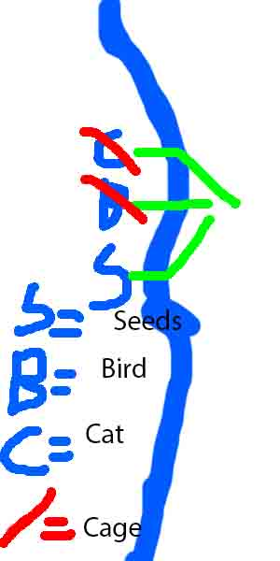

Socks in the Dark

1.

a. Its dark and you are required to sort the socks.

b. The socks are dark and its dark so it makes it hard to see the socks.

c. The overall goal is to get all the socks into a pair.

2.

a. The constraints are that you can only check after each selection is made, and its dark.

b. One matching pair.

One matching pair of each color.

3.

a. A solution to only checking after each selection is to make sure to check. And a solution to the darkness is to use a flashlight.

4.

a. Yes the solution meets the goals because if you check and have a flashlight its really hard to mess up.

b. If you check and have a flashlight its really hard to mess up.

5.

a. Fist you would grab the flashlight and shine it on the socks then you would start matching them according to their color. While doing that you would match one matching pair for each color.

b. In the picture it shows how the socks would go togeather.

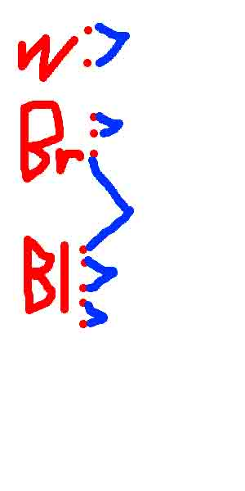

Predicting Fingers:

1.