Zebra Handheld RFID Reader: End-to-End IoT Connector (IoTC) Deployment Guide

Introduction
This guide provides a highly detailed, step-by-step walkthrough for deploying a Zebra handheld RFID reader (such as the RFD40 or RFD90) using the MQTT-based IoT Connector. It covers establishing a local testing environment using MQTTX, bootstrapping the device via 123RFID Desktop, configuring dedicated Control and Data endpoints using the IOTC Utility, and executing RFID inventory commands over native MQTT.

Phase 1: Environment and Network Baseline
Before configuring any Zebra hardware, you must ensure your testing environment allows raw TCP/IP MQTT traffic. Corporate IT firewalls frequently block traffic between different subnets (e.g., an Employee Wi-Fi vs. an IoT Wi-Fi).

Step 1.1: Unify the Subnet
To prevent corporate AP Isolation or firewall rules from dropping your packets:
- Connect your PC (which will run the MQTTX software) to your local Wi-Fi network.
- Note the exact SSID (Network Name) and password. You will need to connect the Zebra reader to this exact same SSID in Phase 2.

Step 1.2: Setup the MQTT broker on a server

Step 1.3: Set Up MQTTX
MQTTX is an elegant, cross-platform MQTT desktop client that we will use to listen and publish messages.
- Download and open the MQTTX application.
- Click the + New Connection button.
- In the configuration panel:
- Name: Zebra Local Test
- Client ID: Leave as the randomly generated default.
- Host: Enter the IP address of the MQTT broker you retrieved in Step 1.2 (e.g., mqtt://10.233.46.53).
- Port: 1883 (for unencrypted testing).
- Click Connect in the top right corner. MQTTX is now actively listening on your broker’s IP address.

Phase 2: The Bootstrap Provisioning (123RFID Desktop)
Out of the box, you must bootstrap the device using a direct USB or Bluetooth connection to give it its initial Wi-Fi credentials and endpoint instructions. 123RFID Desktop automatically creates the Management (MDM) Endpoint, which acts as the IT lifeline to the device.

Step 2.1: Discover and Connect

Phase 1: Discover and Connect the Reader
Before configuring Wi-Fi or MQTT, you must first discover and connect the reader to your PC via a direct connection.
- Launch the Application: Open the 123RFID Desktop application. The Welcome screen will appear.
- Initiate Discovery: Click the FIND READERS button on the main screen.
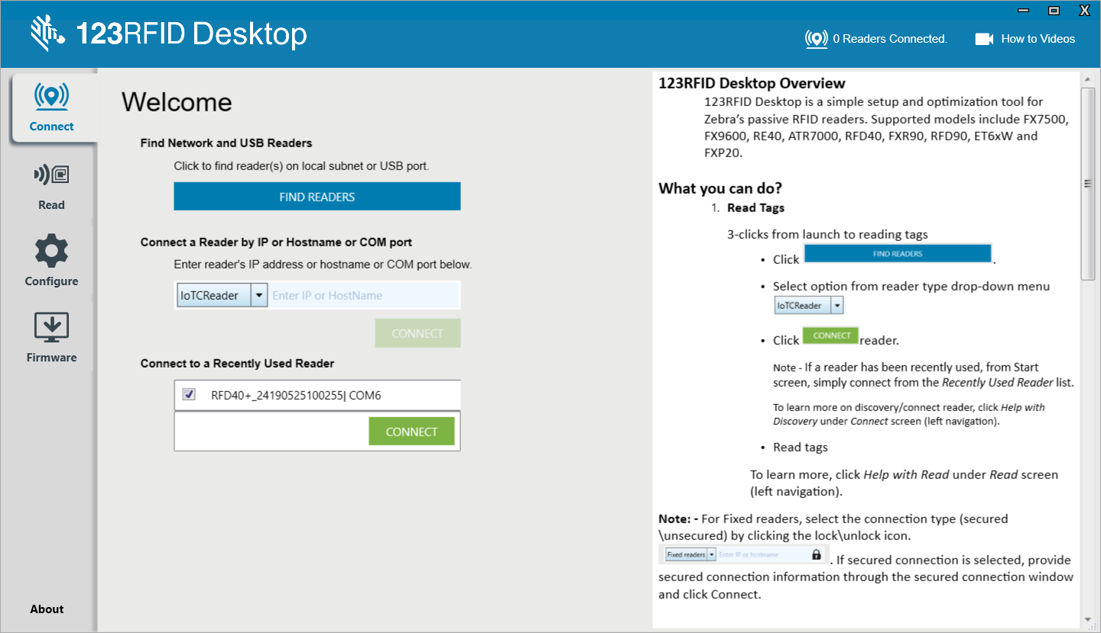
- Select Connection Type: In the Reader Discovery screen, click the Bluetooth icon (or USB if connecting directly via cable) to scan for nearby devices.
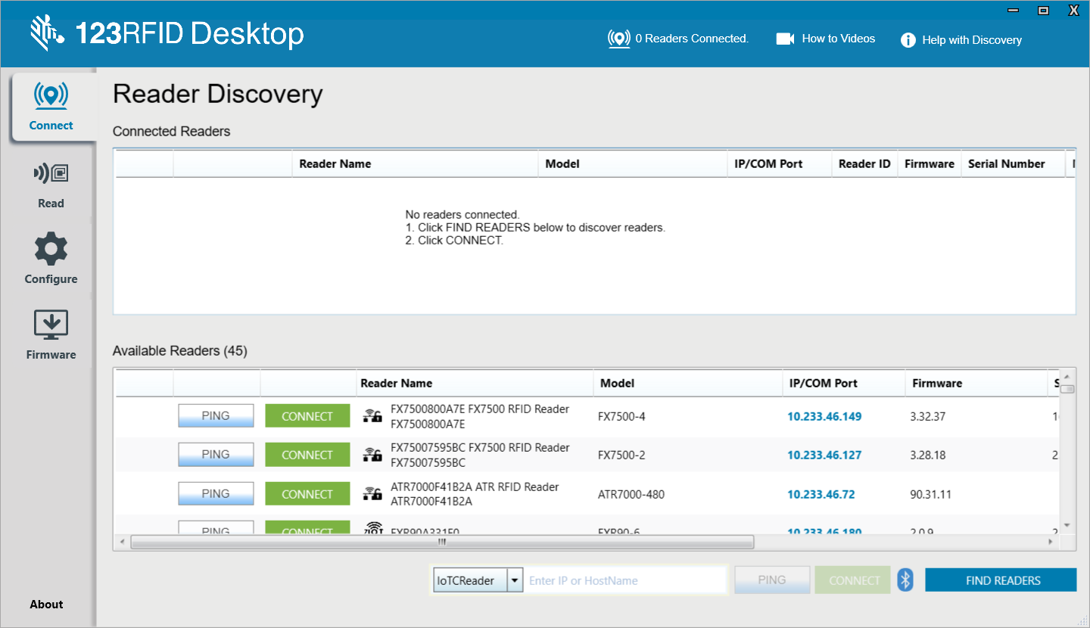
- Choose Your Device: An "Add a device" pop-up window will open. Select the correct handheld reader from the list. Verify that the serial number displayed matches the serial number printed on your physical device.
- Confirm Selection: Click Next.
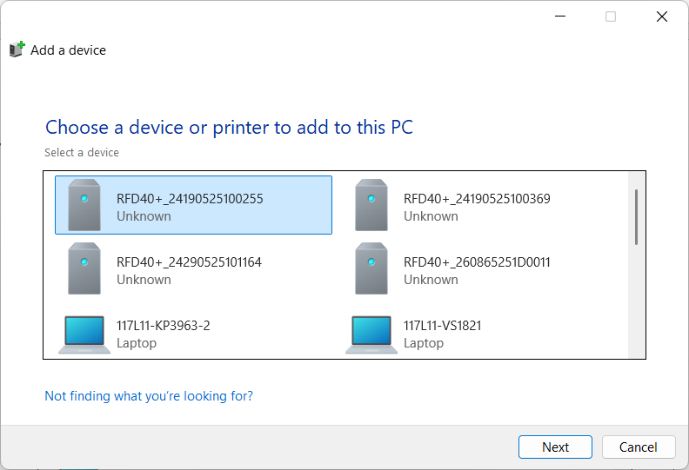
- Connect: Locate your device in the "Available Readers" list and click the green CONNECT button next to it.
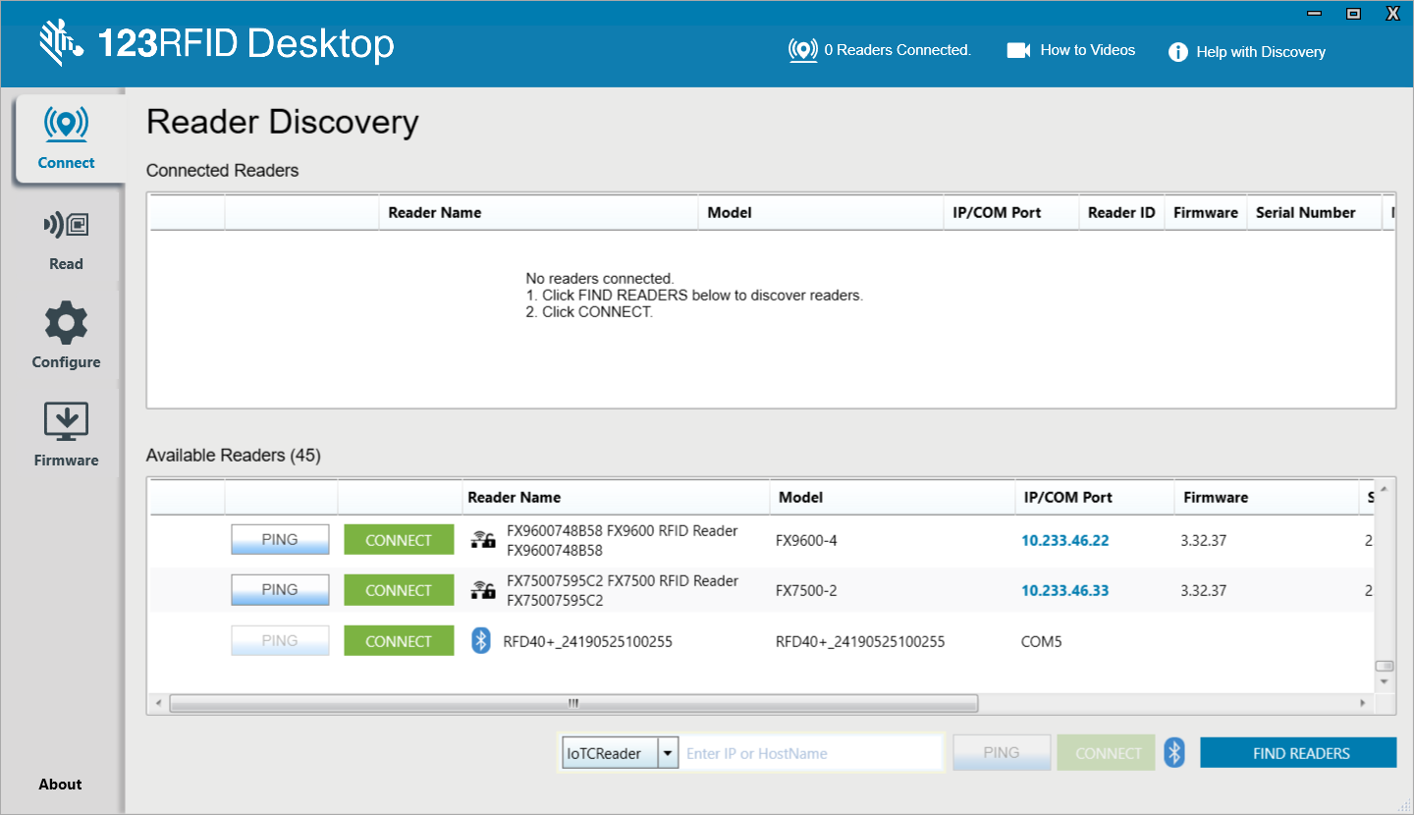
- Verify Connection: Once connected, the handheld reader will move from the bottom list to the Connected Readers section at the top of the interface.
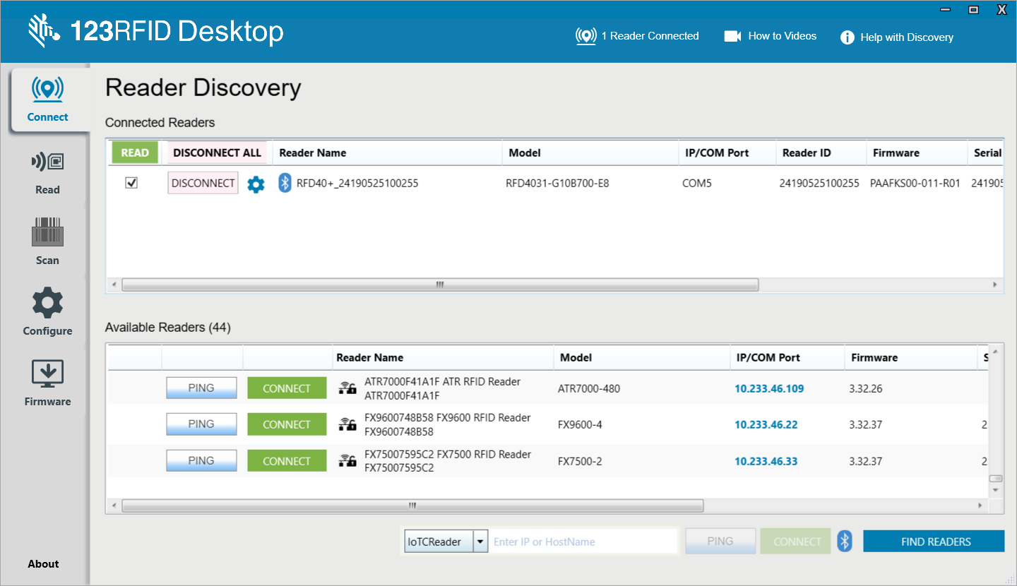

Phase 2: Configure Wi-Fi Connectivity
For MQTT and other network-dependent protocols to function in a production environment, the reader requires a stable network connection. Wi-Fi is the simplest way to provide this connectivity.
- Open Configuration: Click the Configure icon (gear symbol) from the left-hand navigation panel.
- Select Reader: The Reader Configuration window will appear. Click on the picture of the connected reader to edit its settings.
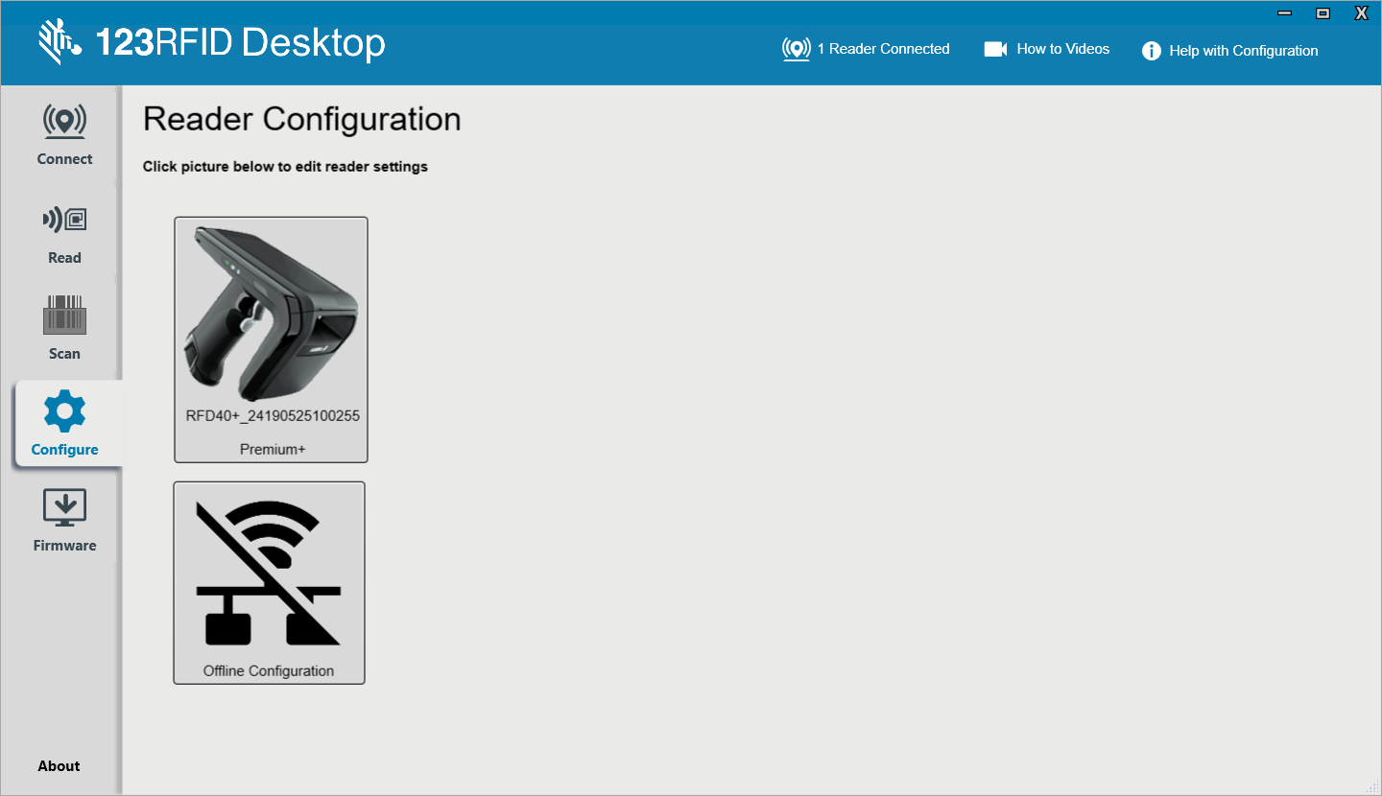
- Edit Configuration: A page will open with two buttons. Click the Edit Configuration on Reader button.
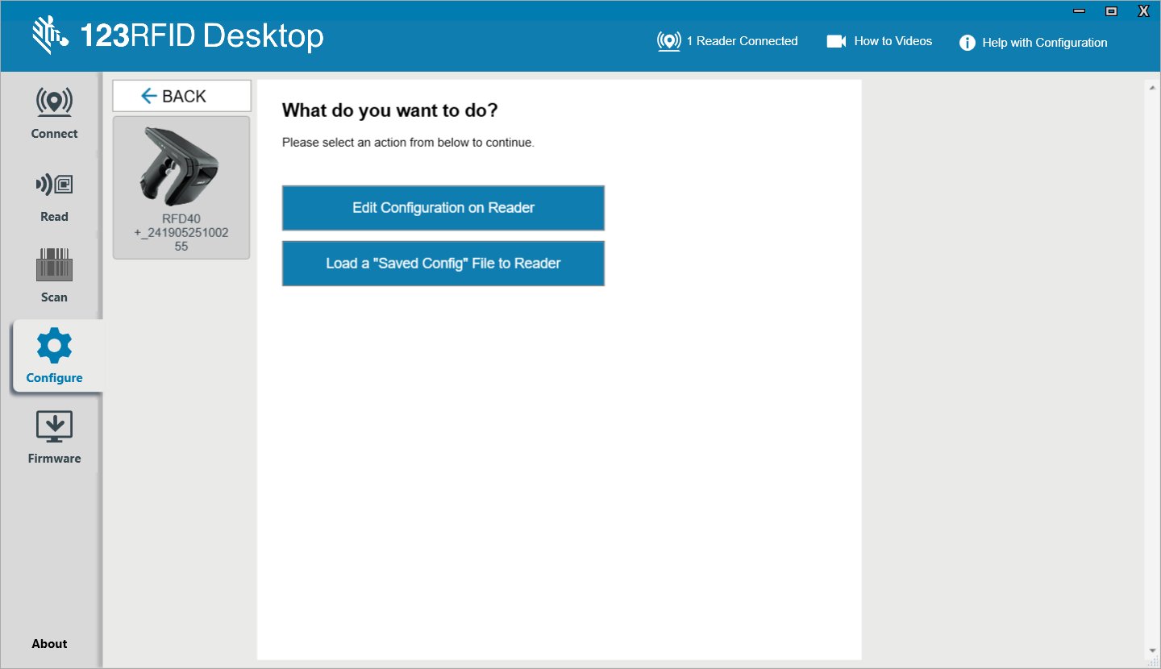
- Navigate to Communication: From the left-hand menu in the settings view, select Communication.
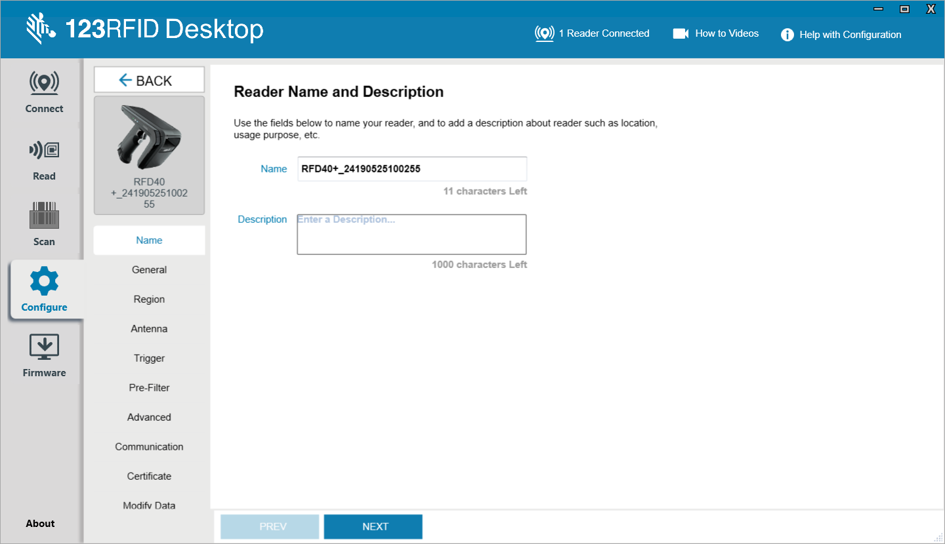
- Access Wi-Fi Settings: The Wi-Fi Configuration window will open by default.
- Add Network: Select the Scan and Choose Network radio button to search for available networks. Select your desired network's SSID from the drop-down list. Alternatively, you can use "Enter SSID" to input a hidden network manually.
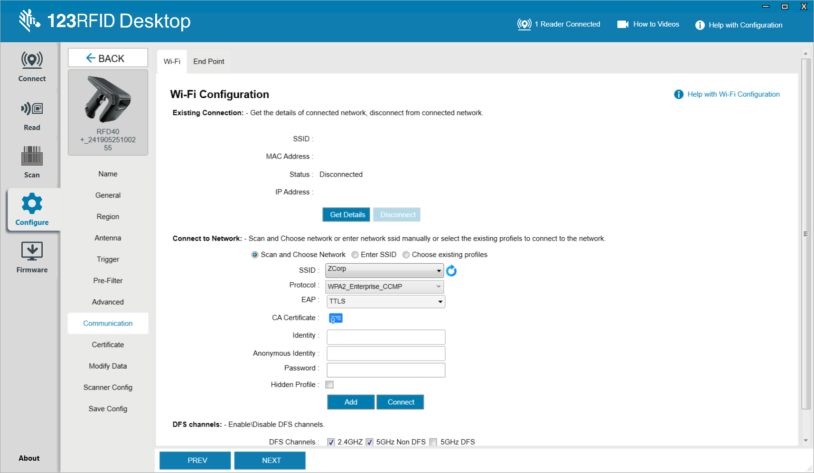
- Enter Credentials: Choose the appropriate protocol (e.g., WPA2_Personal_CCMP) and enter the correct passkey.
- Connect to Wi-Fi: Click Add, and then click Connect.
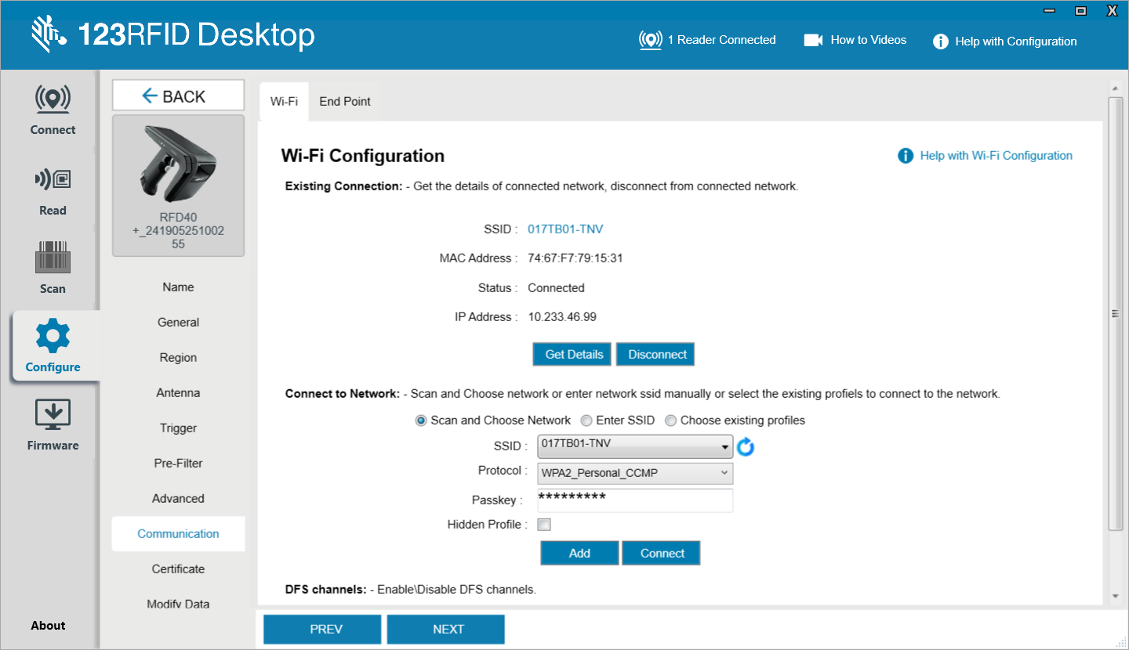
- Verify Network: Check the "Existing Connection" section. It should now display the Connected network name (SSID), assigned IP Address, MAC Address, and the Status should show as "Connected".

Step 2.3: Configure the MDM Endpoint
Configure the MQTT broker to send and receive commands using the End Point Configuration screen.
- Navigate to End Point Tab: While still in the Communication section, click on the End Point tab at the top.
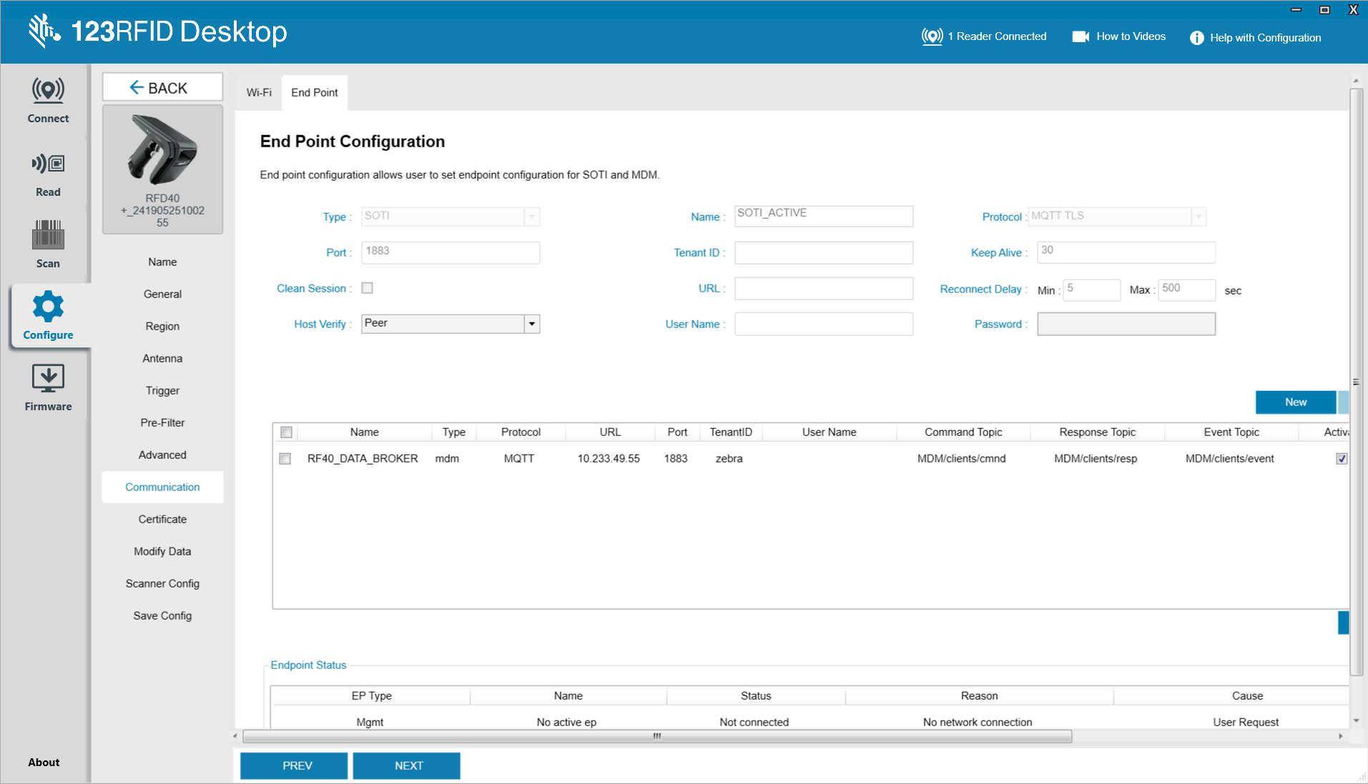
- Create New Endpoint: Select the New button on the right side of the screen.
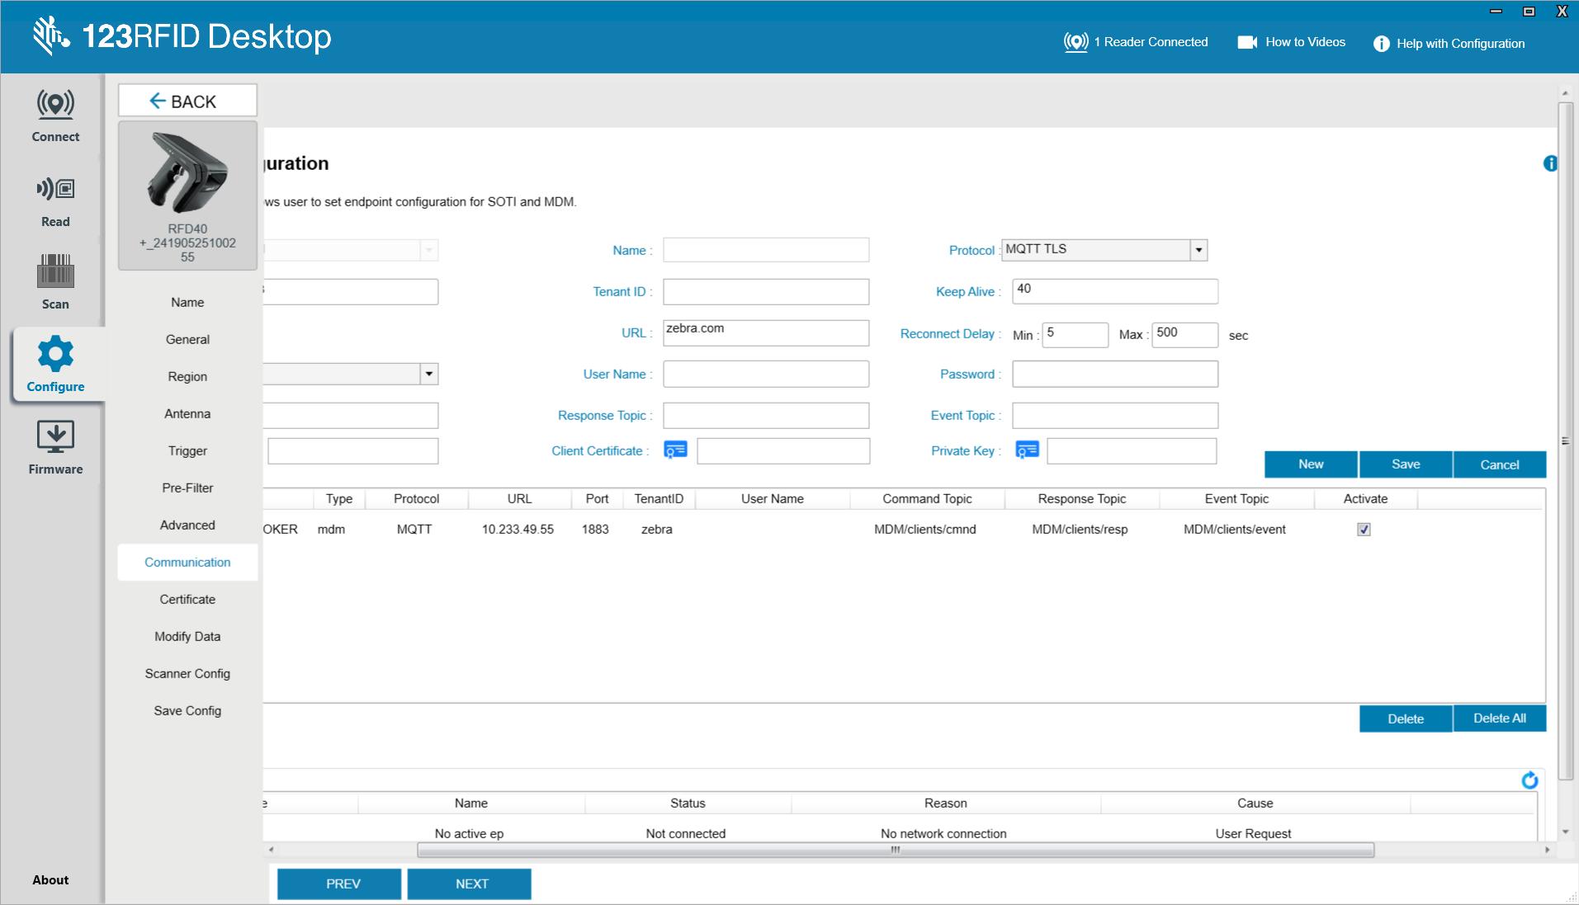
- Fill in Configuration Details: Enter the required connection details for your MQTT broker. Below is a reference table for the configuration fields:
Field | Description
Type | Select MQTT (other options may include SOTI or MDM).
Protocol | The transport protocol (MQTT or MQTTS).
URL | The MQTT broker URL.
Port | 1883 for standard MQTT or 8883 for TLS/secure MQTT.
Keep Alive | Interval (in seconds) used to keep the connection active.
Tenant ID | Prefix applied to all MQTT topics.
Clean Session | Check to start a fresh session on each connection.
Host Verify | Validates the broker hostname (used for TLS connections).
Command Topic | Topic where the device receives commands (default: MDM/clients/cmnd).
Response Topic | Topic where the device publishes responses (default: MDM/clients/resp).
Event Topic | Topic where the device publishes alerts/tags (default: MDM/clients/event).

Note: Command Topic, Response Topic, and Event Topic are optional. If left blank, default values are automatically populated when you select Add.
- Add Endpoint: Once all required fields are filled, click Add. The newly created endpoint will appear in the endpoint list at the bottom of the screen.
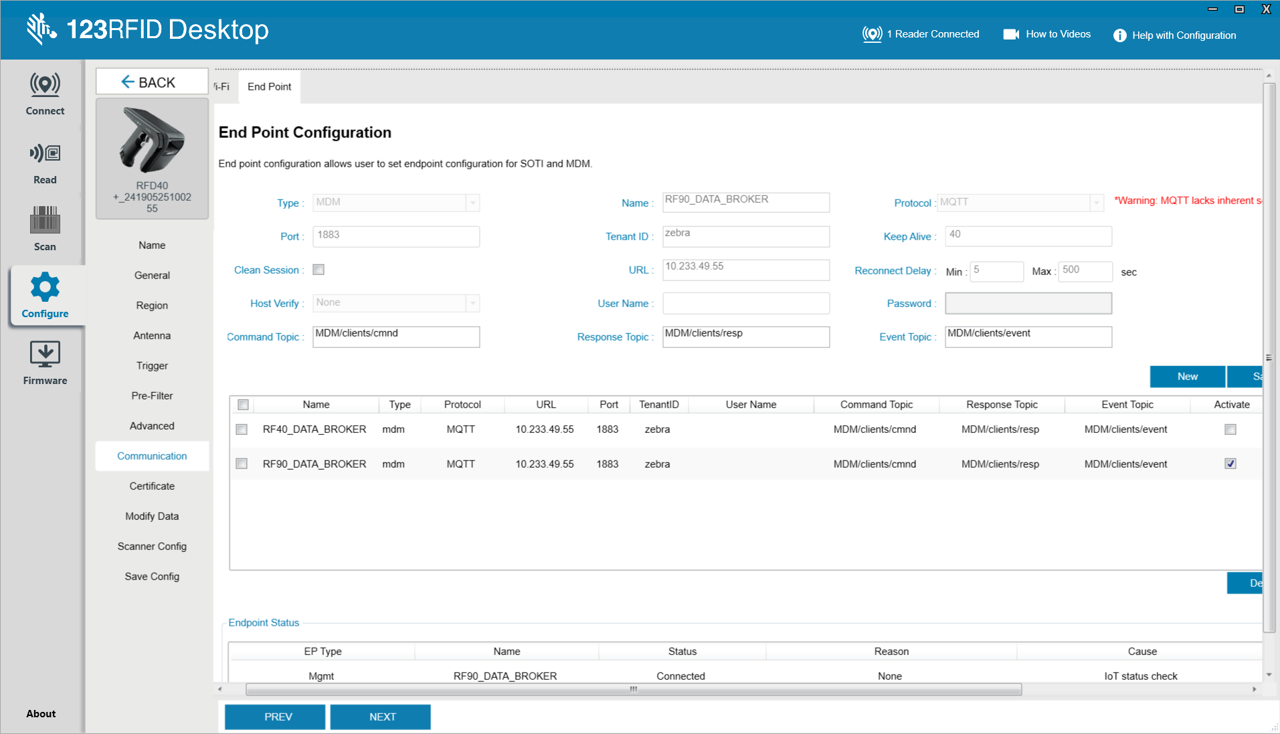

- Activate Endpoint: Select the Activate checkbox in the row corresponding to your new endpoint.
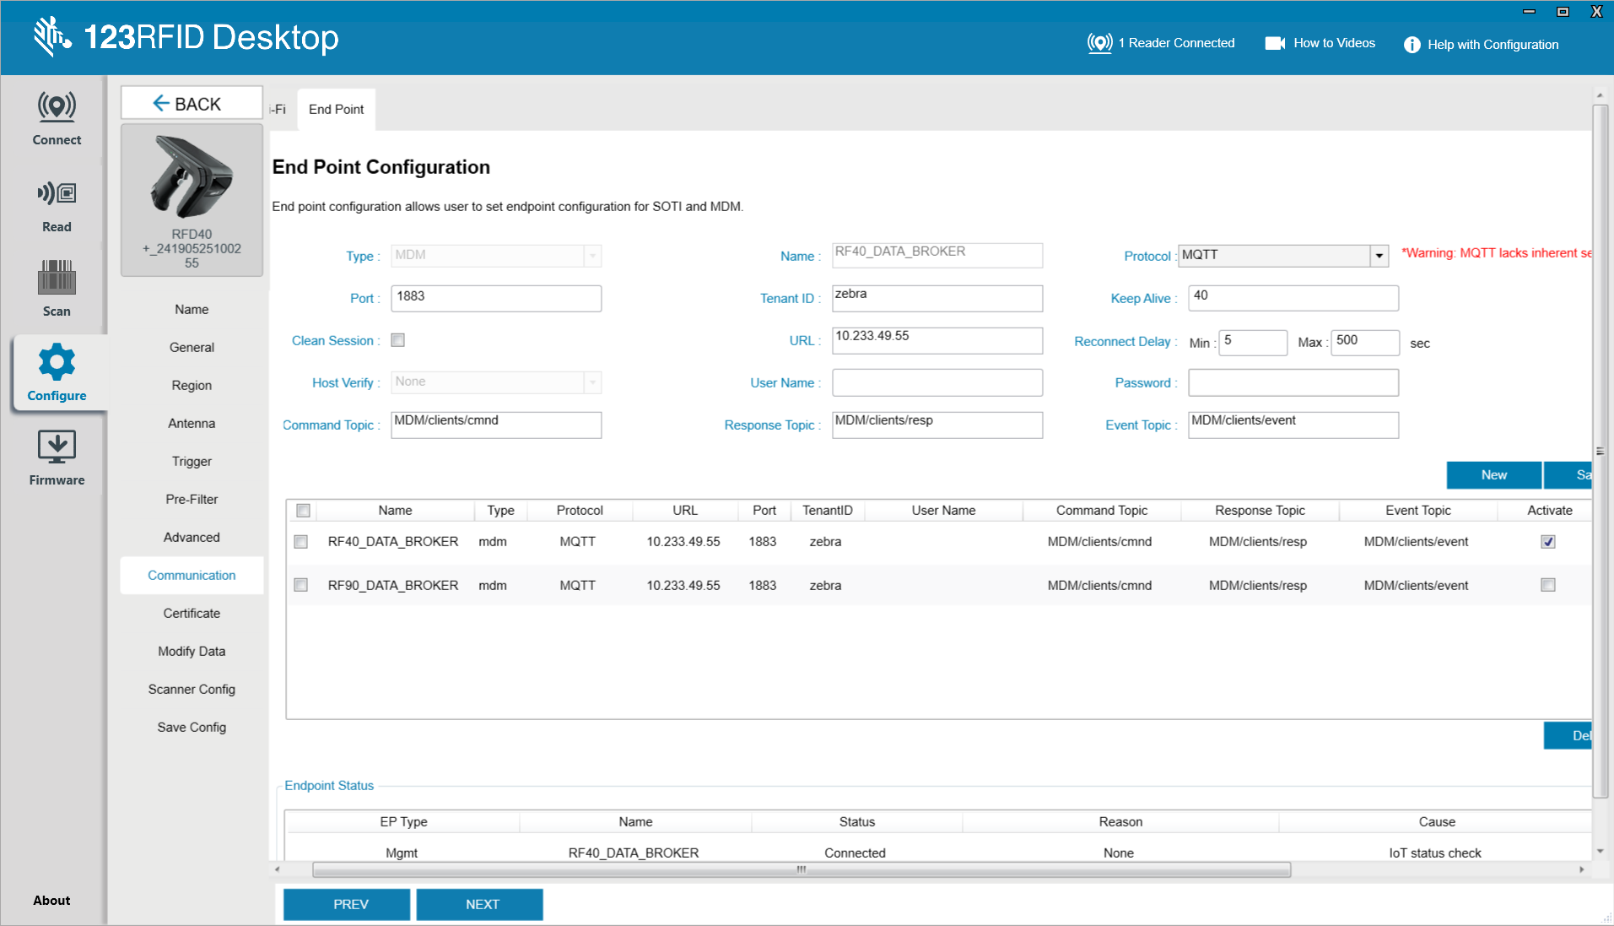
- Verify Status: Under the "Endpoint Status" section, select Refresh to confirm that the connection has been successfully established and reads "Connected".
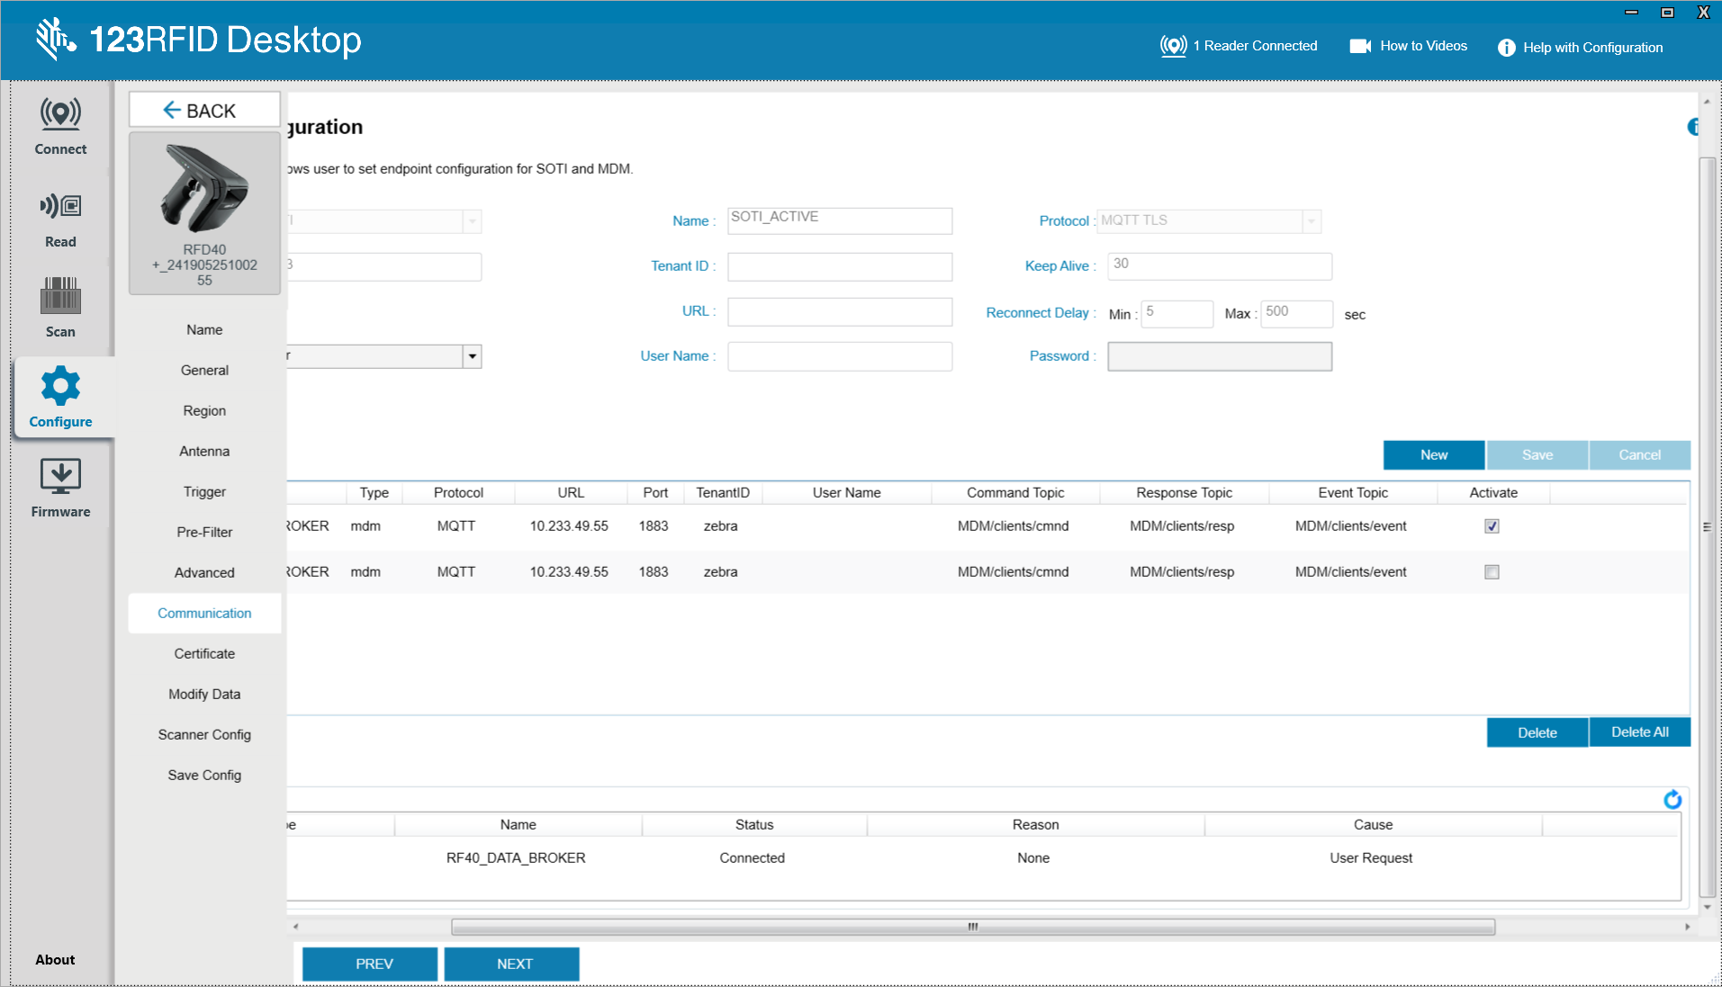
- Save: Click Save to commit all your new configurations to the reader.
Your Zebra handheld RFID reader is now successfully connected to your network and actively communicating with your MQTT broker.

Phase 3: Connection Validation and Topic Architecture
The Zebra firmware dynamically appends the device's Serial Number to the end of the topics you configured. You must intercept the first message using an MQTT client called MQTTX to identify this exact string.

Step 3.1: Subscribe to the Wildcard Topic
- In your active MQTTX connection, click New Subscription.
- In the Topic field, enter the wildcard path: zebra/#
- Click Confirm. MQTTX will now catch any message published by the reader.

Step 3.2: Spot the Connection Event
- Watch the MQTTX message feed. Within a few seconds of the reader booting up on Wi-Fi, you will see a message pop up.
- The payload will be an mqttConnEVT (MQTT Connection Event).
- Look at the exact topic path where that event was published. It will look like:
zebra/MDM/clients/event/RFD40-24190525100255
- Note your exact Serial Number. Your MDM topics are established as zebra/MDM/clients/cmnd/[Your_Serial_Number].

Phase 4: Sending the First API Command (Read-Only)
We will test the connection loop using a read-only command on the Management endpoint.

Step 4.1: Prepare the Target Topic
In MQTTX, set your Publish Topic to: zebra/MDM/clients/cmnd/[Your_Serial_Number]

Step 4.2: Draft and Execute the Command
- Enter the following native MQTT JSON format:
{
"command": "get_version",
"requestId": "test_version_req_001"
}
- Click Publish.
- You will receive a response on the zebra/MDM/clients/resp/[Your_Serial_Number] topic containing code: 0 (Success) and a readerVersion object detailing the exact OS and firmware versions.

Phase 5: Configuring Control and Data Endpoints and Activating them.
Configuring dedicated endpoints for RFID control and data telemetry should be done by sending config_endpoint command requests to the broker via the MGMT endpoint, as shown below:
{
"command": "config_endpoint",
"requestId": "1233",
"epConfig": {
"operation": "add",
"configuration": {
"endpointName": "ctrlEP",
"epType": "CTRL",
"protocol": "MQTT",
"activate": false,
"url": "17L11-GG6663-1",
"verificationType": "NONE",
"port": 1883,
"qosCommon": 1,
"tenantId": "zebra",
"mqttParams": {
"keepAlive": 300,
"cleanSession": true,
"reconnectDelayMin": 50,
"reconnectDelayMax": 500,
"publishTopics": [
{
"topic": "CTRL/clients/resp",
"qos": 1,
"retain": false
},
{
"topic": "CTRL/clients/event",
"qos": 1,
"retain": false
},
{
"topic": "CTRL/clients/rfid",
"qos": 0,
"retain": true
}
],
"subscribeTopics": [
{
"topic": "CTRL/clients/cmnd",
"qos": 0,
"retain": false
}
]
}
}
}
}
The command request is (https://aa5123.github.io/RFID-40-90-handled-reader-api-reference-documentatiion/#op-config-endpoint)
Mention steps here:

Step 5.4: Reboot to Activate New Endpoints
reboot (https://aa5123.github.io/RFID-40-90-handled-reader-api-reference-documentatiion/#op-reboot)

Step 5.5: Confirm that the endpoints have been added:
Get_endpoint_config

Phase 6: Starting Inventory and Capturing Data

Step 6.1: Subscribe to Data Outbox
In MQTTX, create a new subscription to capture the incoming tag stream:
zebra/DATA/clients/data1event/#

Step 6.2: Start the Radio (Via Control Endpoint)
To activate the RFID inventory read, send this exact (control_operation) command payload to your active Control command topic (zebra/CTRL/clients/cmnd/[Your_Serial_Number]):
{
"command": "control_operation",
"requestId": "abcd1432",
"ctrlOprPayload": {
"controlType": "RFID",
"operation": "START"
}
}

Step 6.3: Capture Data
Once the start command is accepted, hold RFID tags near the reader antenna. You will instantly see a flood of JSON payloads streaming into your data1event topic in MQTTX. These payloads contain the EPCs, RSSI signal strengths, and event numbers for every tag scanned.

Step 6.4: Stop the Radio
To halt the inventory process and conserve battery, send the control_operation command payload with the STOP operation value to the same Control command topic:
{
"command": "control_operation",
"requestId": "stop1432",
"ctrlOprPayload": {
"controlType": "RFID",
"operation": "STOP"
}
}
Congratulations! You have completely configured, managed, and executed an RFID inventory operation using the Zebra IoT Connector over native MQTT, employing proper endpoint segregation according to official Zebra best practices!

