**OA_color_whitebkgd_200.gif**

**Oracle Academy Individual Membership**

Registration Guide

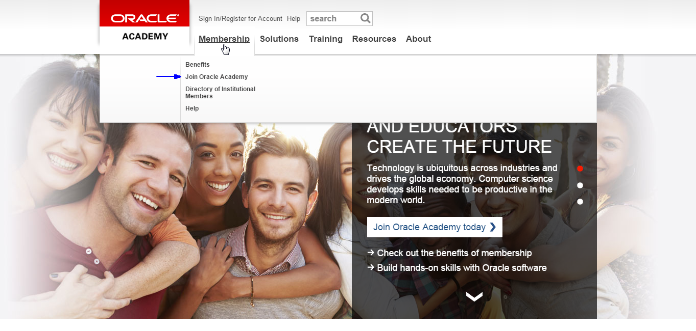

Kunjungi website: <http://academy.oracle.com/> and klik pada bagian “Join”

Go to the Academy website ([www.academy.oracle.com](http://www.academy.oracle.com)) and click on any of the “Join” links.

**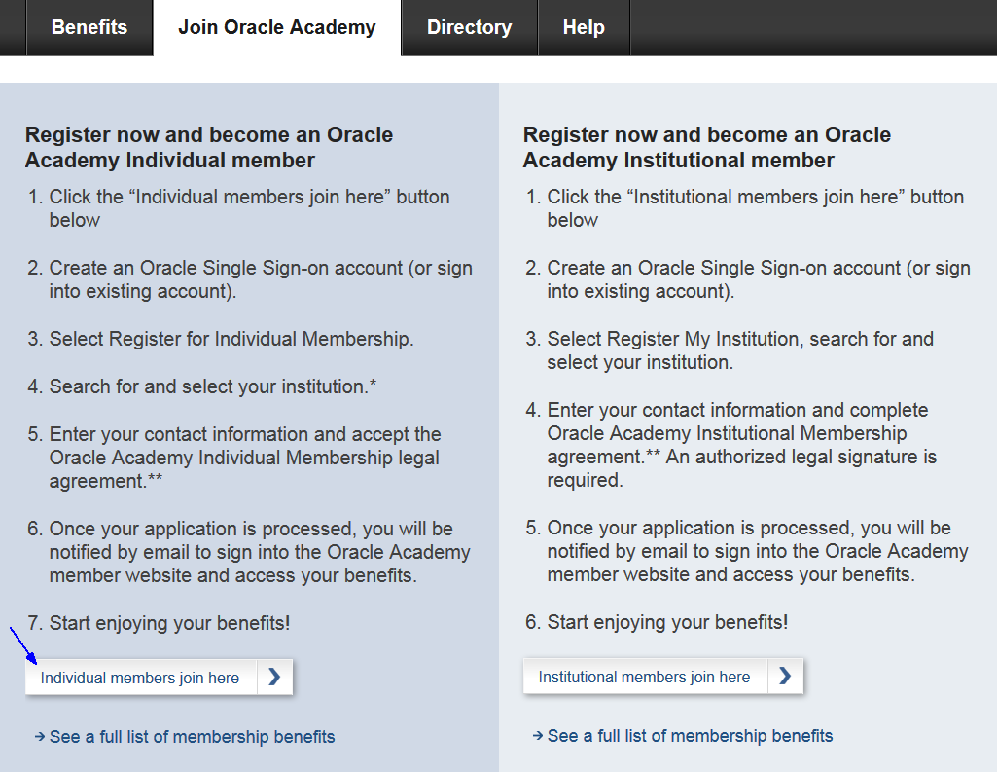**

Review the registration instructions. Click “Individual members join here”.

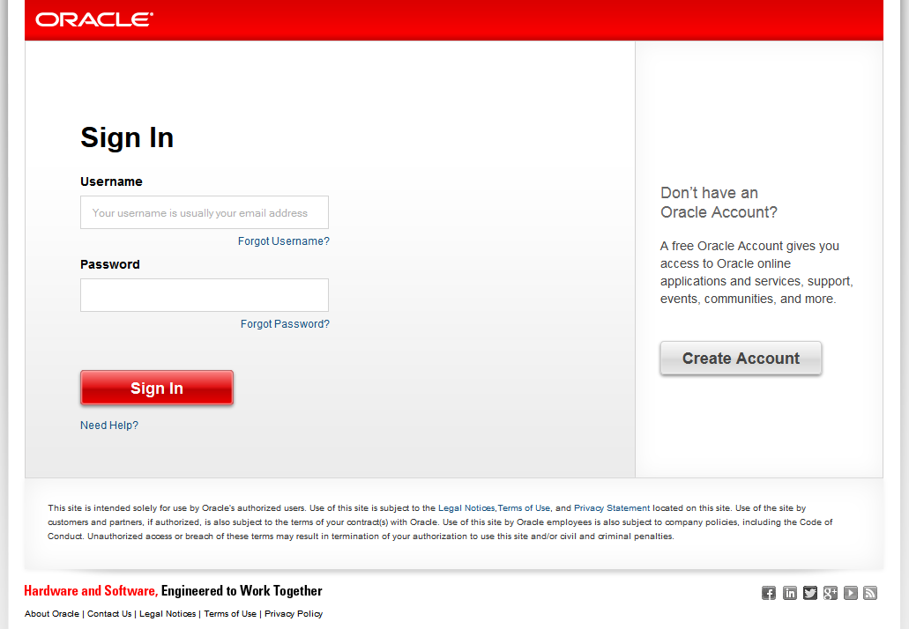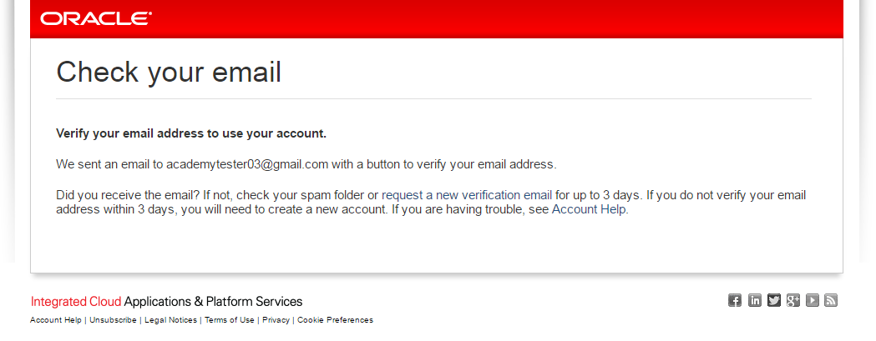

On the Oracle Sign In page, click the “Create Account” button.

* Follow the instructions for creating your Oracle account. This account will become your Oracle Academy member account.
* Once your account is created, click “Continue” and sign into your new Oracle account.

If you already have an Oracle account, skip this step and sign into your existing account.

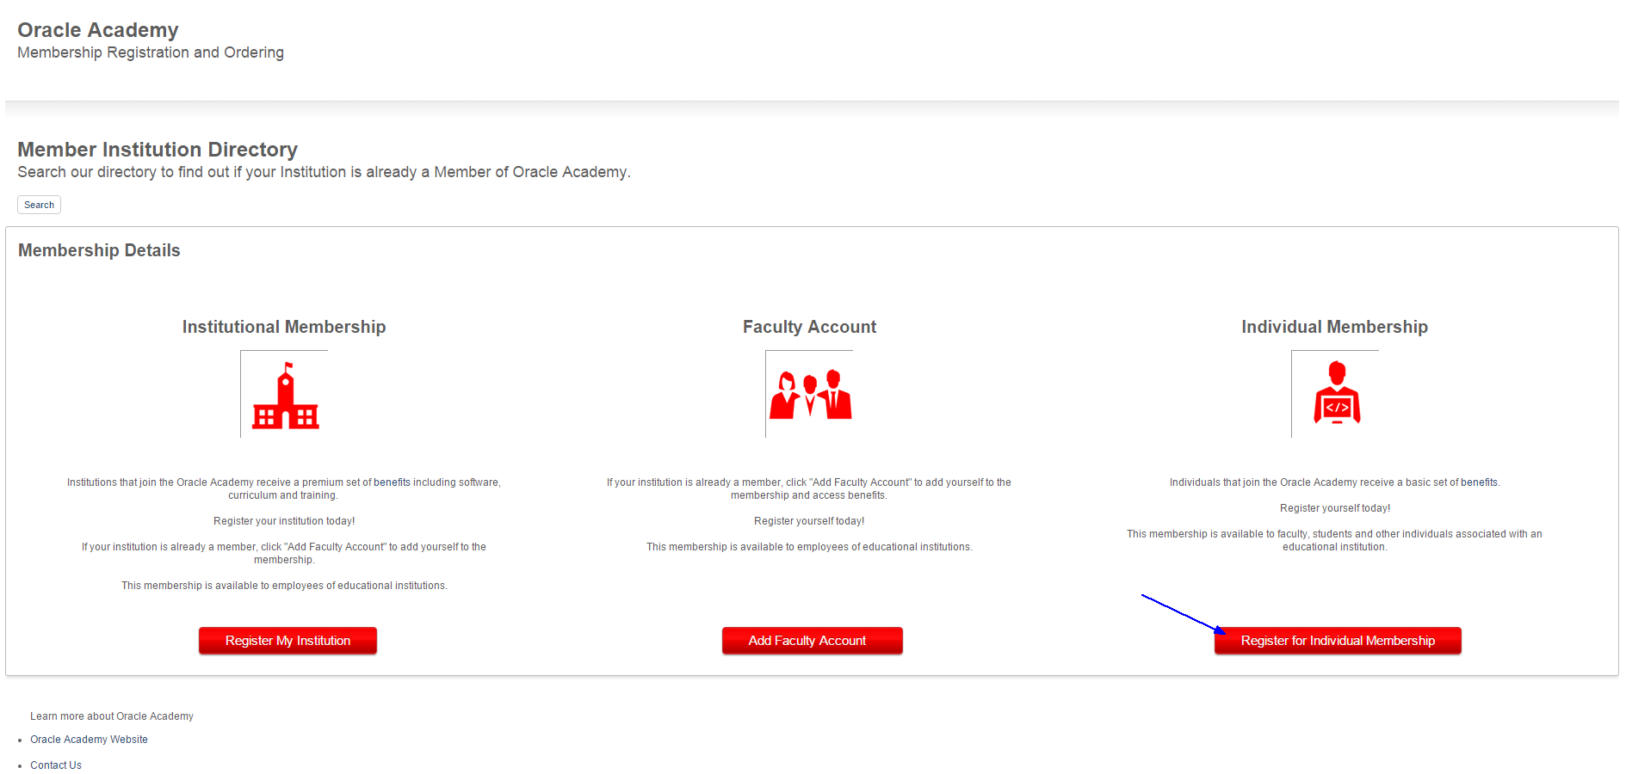

Click the “Register for Individual Membership” button.

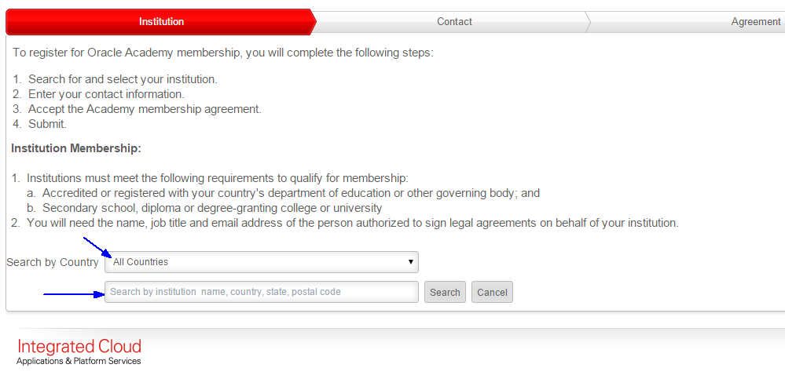

Select your country from the “Search by Country” menu. Enter your institutions name and click the “Search” button.

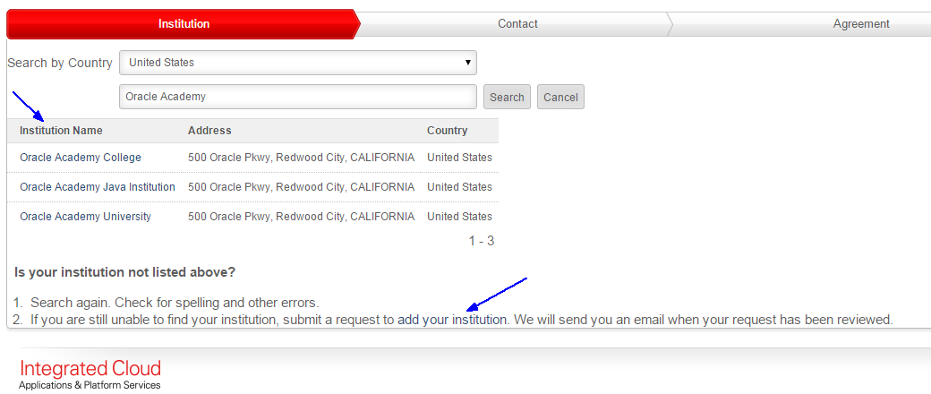

Click on your institutions name in the search results list.

**Note:** If you cannot find your institution, check for spelling errors and search again. If you’re still unable to locate your institution, click on the “add your institution” link.

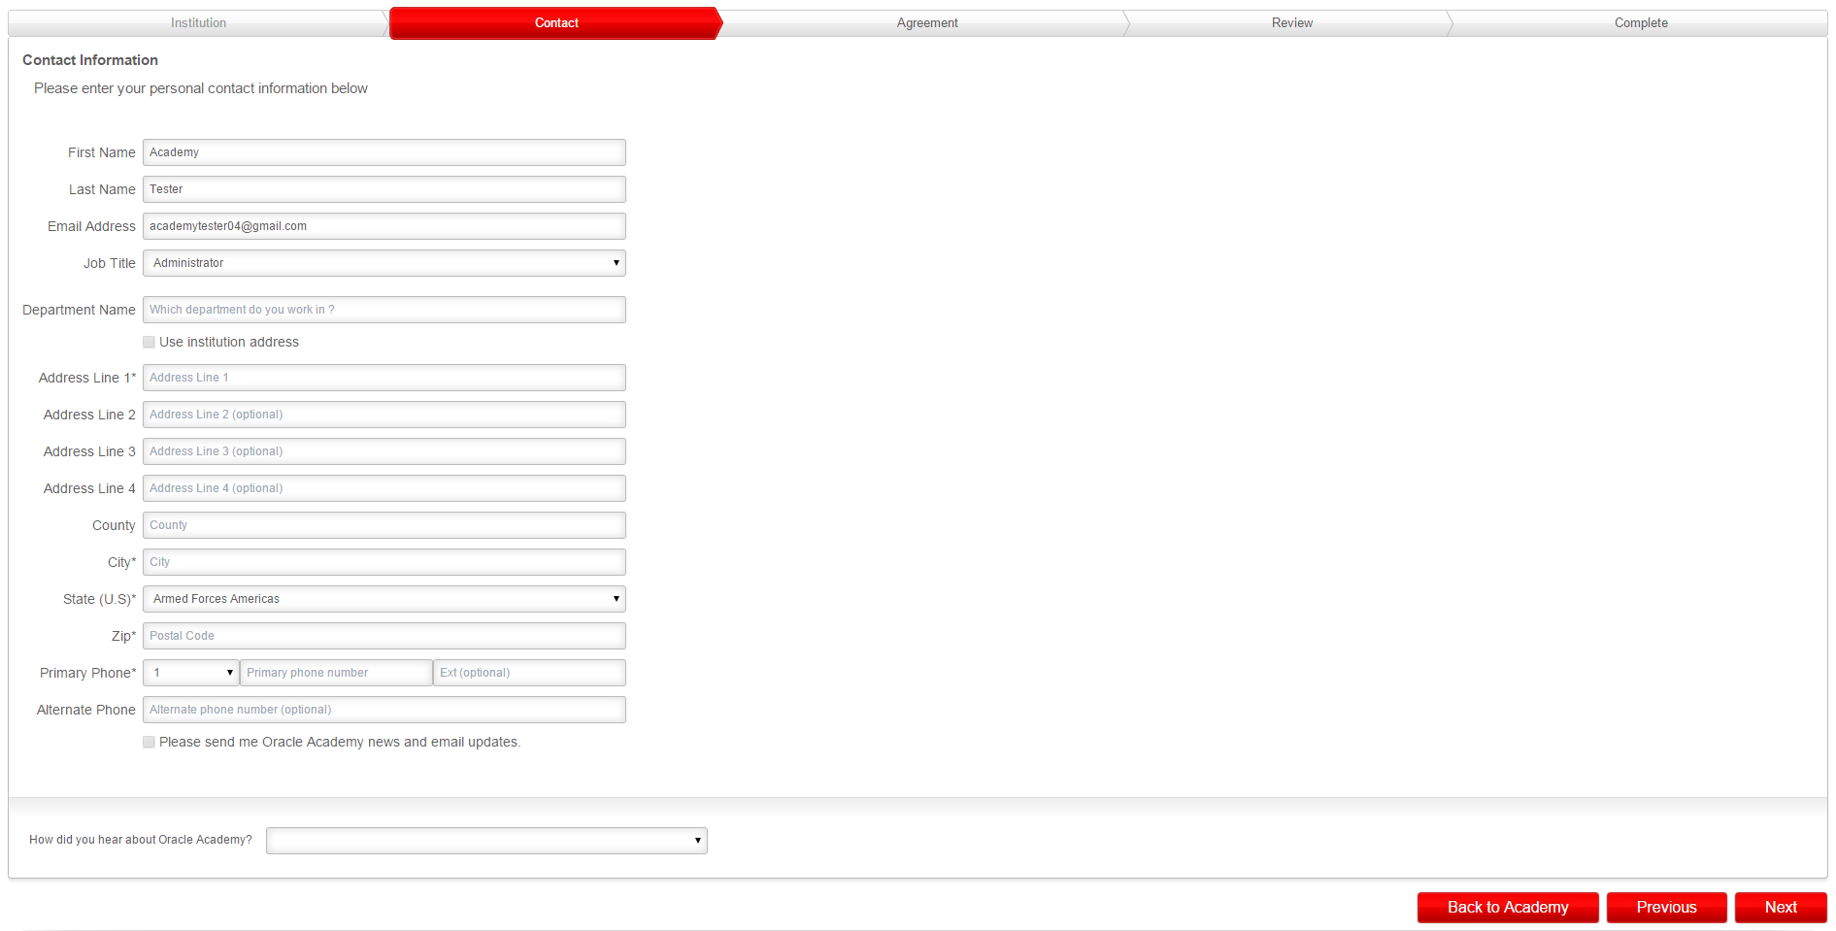

Enter your information into the form on the “Contact Information” page.

Your name and email address are pre-populated into the form using information from your Oracle account.

Click the “Next” button.

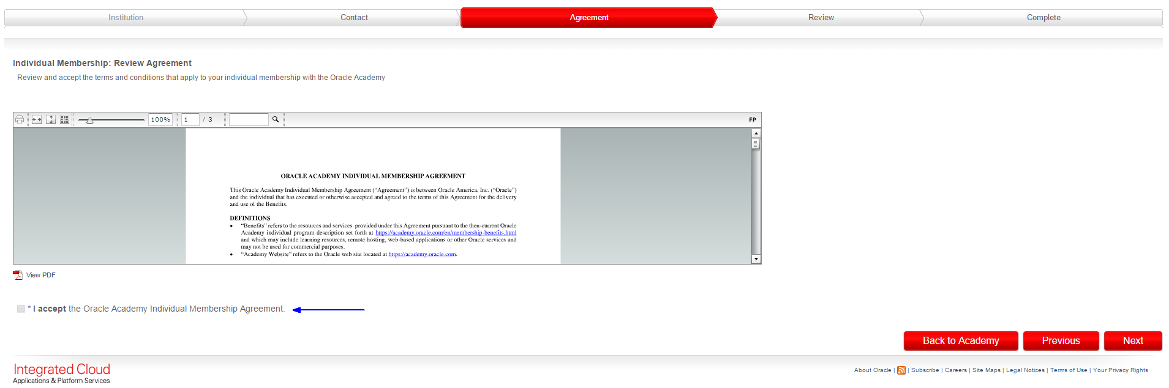

Review and accept the “Oracle Academy Individual Membership Agreement”

Click the “Next” button

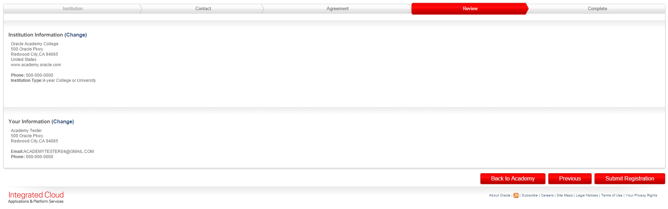

Review your application

* Institution Information – Click “Change” if you need to edit your institution information.
* Your Information – Click “Change” if you need to edit your information.

Click the “Submit Registration” button

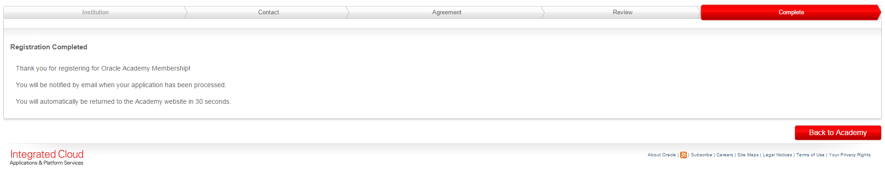

Your application is complete.

Once your membership has been processed, you will receive a “Welcome to Oracle Academy” email inviting you to sign into the Academy member website. You must sign into the member website to enroll in workshop training events.