##Life v1.0.2
(С) al2718x

Conway's Game of Life was invented in the middle of the last century by mathematician John Horton Conway. The game simulates processes similar to the development of a colony of living organisms. The game is played on a rectangular grid board. A living organism occupies one cell. The birth, evolving and death of organisms occur according to special rules (genetic laws):
1) Evolving: Each organisms that has two or three live neighbours survives on to the next generation.
2) Death: Each organisms that has fewer than two live neighbors dies from loneliness. Each organisms that has more than three live neighbors dies from overcrowding.
3) Birth: If the number of live neighbours that an empty cell borders is three, then a new organism is born on that cell.
All three possible events occur simultaneously during one step (one generation). The basic idea is to start with some simple arrangement of organisms and follow the evolution of the initial position under the rules of genetic laws.

This program allows you to create, edit, save and load initial configurations of the game Life, as well as follow the evolving of a given configuration.

File View Tools Run Help

##File View Tools Run Help

New - clear window, load default settings
Open - open configuration file
Reload - re-open currently loaded configuration
Save - save created configuration
Save As - save configuration under a new name
Recent File - list of recently opened configurations
Exit - close program

about

File ##View Tools Run Help

Toolbar - show/hide toolbar
Status Bar - show/hide status bar
Refresh - refresh window

about

File View ##Tools Run Help

Setup - set up configuration parameters
Default - set default colors and sizes
Clear - clear the field or selected area from all organisms, reset all counters
Random Fill - fill the field or selected area with organisms randomly
Flip Horizontal - flip the field or selected area horizontally
Flip Vertical - flip the field or selected area vertically
Select - select an area; the selection can be moved with the mouse or copied (Ctrl+Mouse)

about

File View Tools ##Run Help

Go - do one step in the colony evolving
Run - start non-stop evolving of the colony
Stop - stop evolving of the colony

about

File View Tools Run ##Help

About Life - author and version info
Help - this help

about

File View Tools Run Help

##Setup

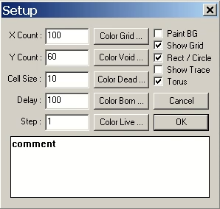

X Count - number of cells horizontally
Y Count - number of cells vertically
Cell Size - cell size (width and height in pixels)
Delay - timer delay (in milliseconds)
Step - number of generations changed in one step

Color Grid - color of the grid
Color Void - color of a void cell
Color Dead - color of a cell with a dead organism
Color Born - color of a cell with just born organism
Color Live - color of a cell with a living organism

Paint BG - paint background outside the field with the color of a free cell
Show Grid - show the grid
Rect / Circle - draw organisms as rectangles or circles
Show Trace - leave a trace of just dead organisms on the field
Torus - activate a topologically toroidal field

about

# main
# file
#view
# tools
# run
# help
#Setup

