E1)
- pipeline in absorbing_loop
- pipeline in init_loop
- inline off in keccakf_asconp12()
- st intermediate copy (stl) in keccakf_asconp12()
  - array partition
  - unrolling copy loops
- inline in diffusiuon()
- bc intermediate copy in diffusion()
  - array partition
  - unrolling copy loops
- inline in chi()
- bc intermediate copy in chi()
  - array partition
  - unrolling copy loops
- pipeline in top_chi
- unrolling chi_nlin
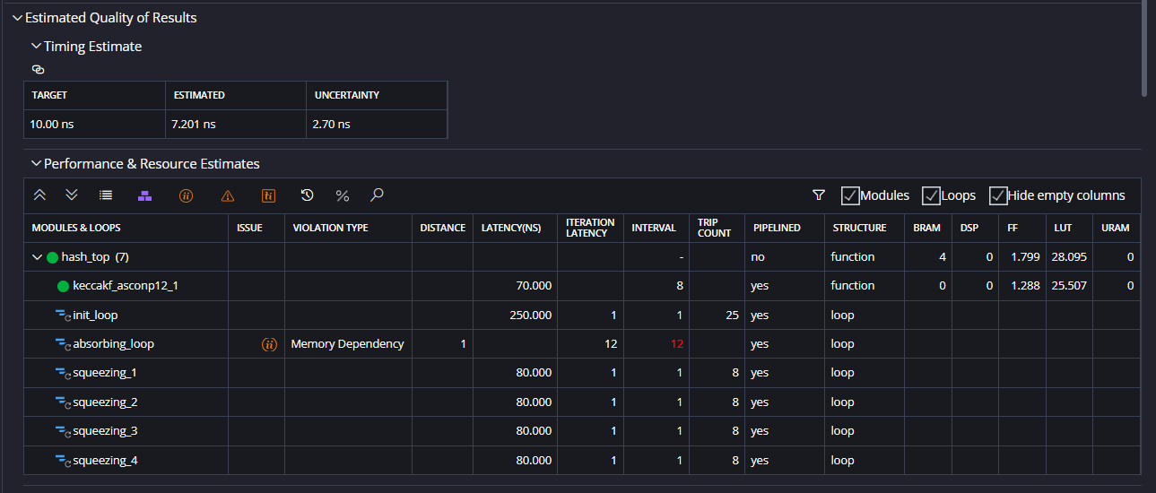
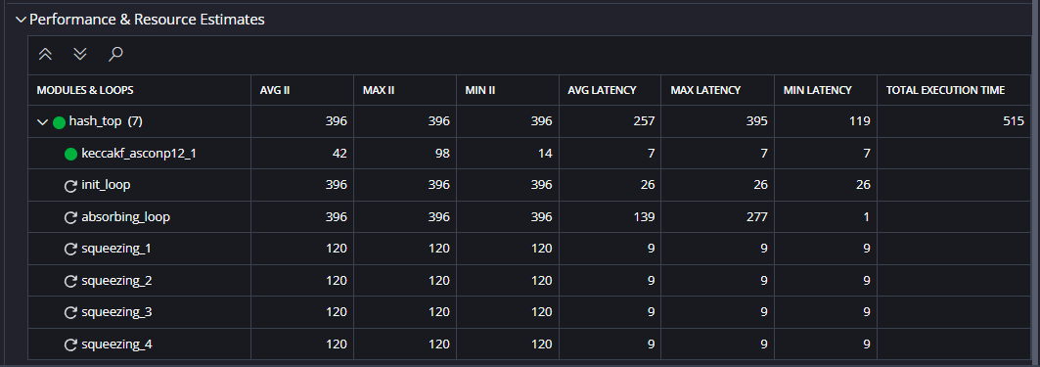

E2)
- pipeline in absorbing_loop
- pipeline in init_loop
- inline off in keccakf_asconp12()
- st intermediate copy (stl) in keccakf_asconp12()
  - array partition
  - unrolling copy loops
- inline in diffusiuon()
- bc intermediate copy in diffusion()
  - array partition
  - unrolling copy loops
- inline in chi()
- bc intermediate copy in chi()
  - array partition
  - unrolling copy loops
- pipeline in top_chi
- unrolling chi_nlin
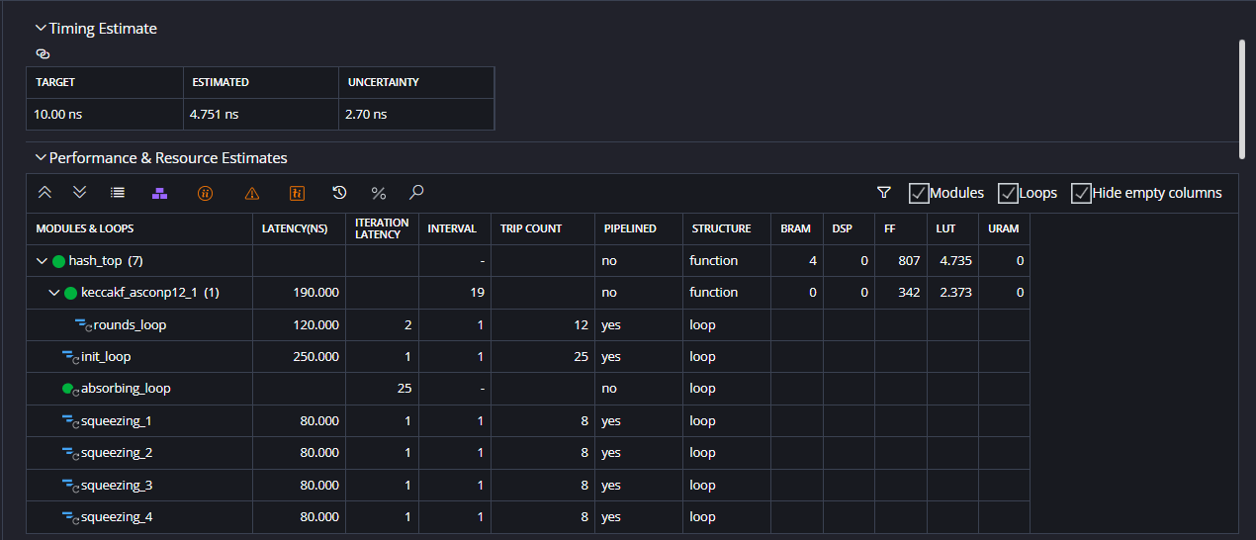
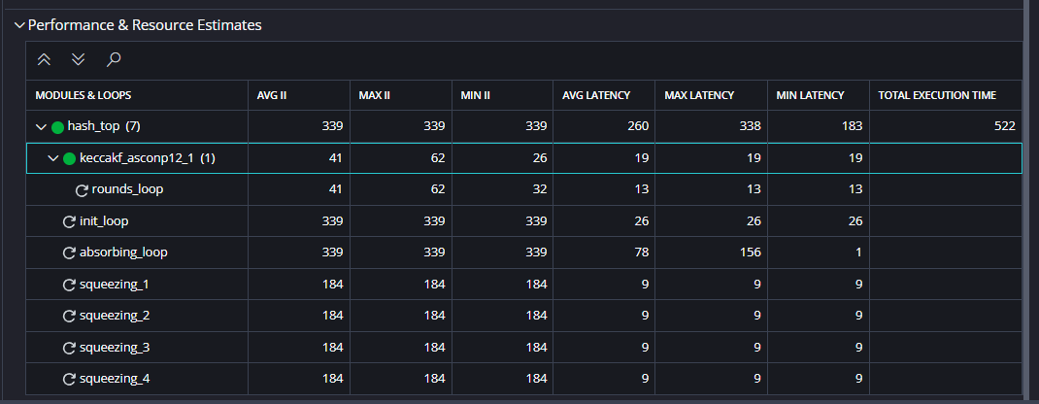

E3)
- pipeline in absorbing_loop
- pipeline in init_loop
- inline off in keccakf_asconp12()
- st intermediate copy (stl) in keccakf_asconp12()
  - array partition
  - unrolling copy loops
- pipeline in keccakf_asconp12() - ignored (fully unroll)
- inline in diffusiuon()
- bc intermediate copy in diffusion()
  - array partition
  - unrolling copy loops
- inline in chi()
- bc intermediate copy in chi()
  - array partition
  - unrolling copy loops
- pipeline in top_chi
- unrolling chi_nlin
E4)
- pipeline in absorbing_loop
- pipeline in init_loop
- inline off in keccakf_asconp12()
- st intermediate copy (stl) in keccakf_asconp12()
  - array partition
  - unrolling copy loops
- pipeline in keccakf_asconp12() - ignored (fully unroll)
- inline in diffusion()
- bc intermediate copy in diffusion()
  - array partition
  - unrolling copy loops
- inline in chi()
- bc intermediate copy in chi()
  - array partition
  - unrolling copy loops
- pipeline in top_chi
- unrolling chi_nlin

E5)
- pipeline in absorbing_loop
- pipeline in init_loop
- inline off in keccakf_asconp12()
- st intermediate copy (stl) in keccakf_asconp12()
  - array partition
  - unrolling copy loops
- pipeline in keccakf_asconp12() - ignored (fully unroll)
- inline in diffusion()
- bc intermediate copy in diffusion()
  - array partition
  - unrolling copy loops
- inline in chi()
- bc intermediate copy in chi()
  - array partition
  - unrolling copy loops
- pipeline in top_chi
- unrolling chi_nlin
E6)
- pipeline in absorbing_loop
- pipeline in init_loop
- inline off in keccakf_asconp12()
- st intermediate copy (stl) in keccakf_asconp12()
  - array partition
  - unrolling copy loops
- pipeline in keccakf_asconp12() - ignored (fully unroll)
- inline in diffusion()
- bc intermediate copy in diffusion()
  - array partition
  - unrolling copy loops
- inline in chi()
- bc intermediate copy in chi()
  - array partition
  - unrolling copy loops
- pipeline in top_chi
- unrolling chi_nlin
E7)
- pipeline in absorbing_loop
- pipeline in init_loop
- inline off in keccakf_asconp12()
- st intermediate copy (stl) in keccakf_asconp12()
  - array partition
  - unrolling copy loops
- pipeline in keccakf_asconp12() - ignored (fully unroll)
- inline in diffusion()
- bc intermediate copy in diffusion()
  - array partition
  - unrolling copy loops
- inline in chi()
- bc intermediate copy in chi()
  - array partition
  - unrolling copy loops
- pipeline in top_chi
- unrolling chi_nlin
E8)
- pipeline in squeezing_1

E9)
- pipeline in absorbing_loop
- pipeline in init_loop
- inline off in keccakf_asconp12()
- st intermediate copy (stl) in keccakf_asconp12()
  - array partition
  - unrolling copy loops
- pipeline in keccakf_asconp12() - ignored (fully unroll)
- inline in diffusion()
- bc intermediate copy in diffusion()
  - array partition
  - unrolling copy loops
- inline in chi()
- bc intermediate copy in chi()
  - array partition
  - unrolling copy loops
- pipeline in top_chi
- unrolling chi_nlin
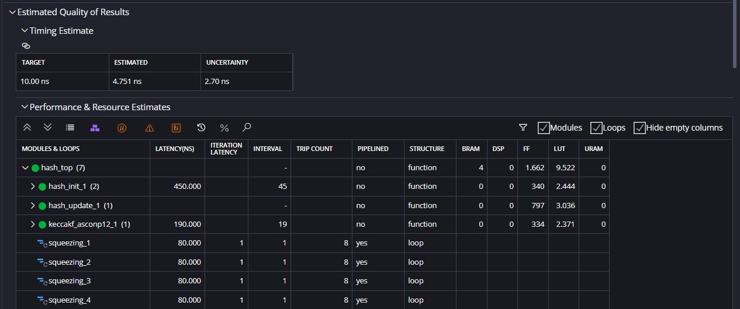
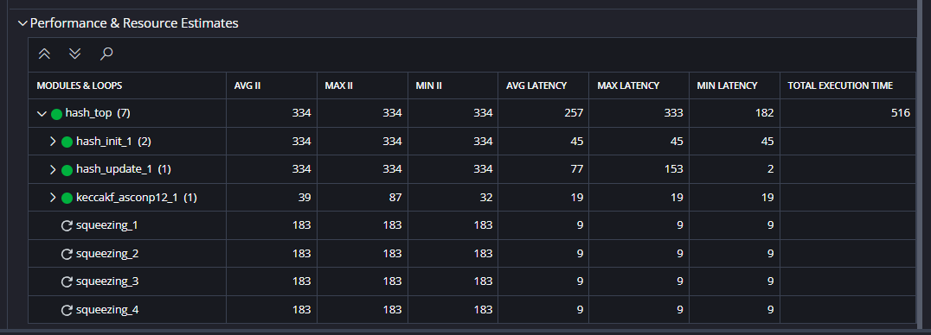

E10)
- unrolling in squeezing_1
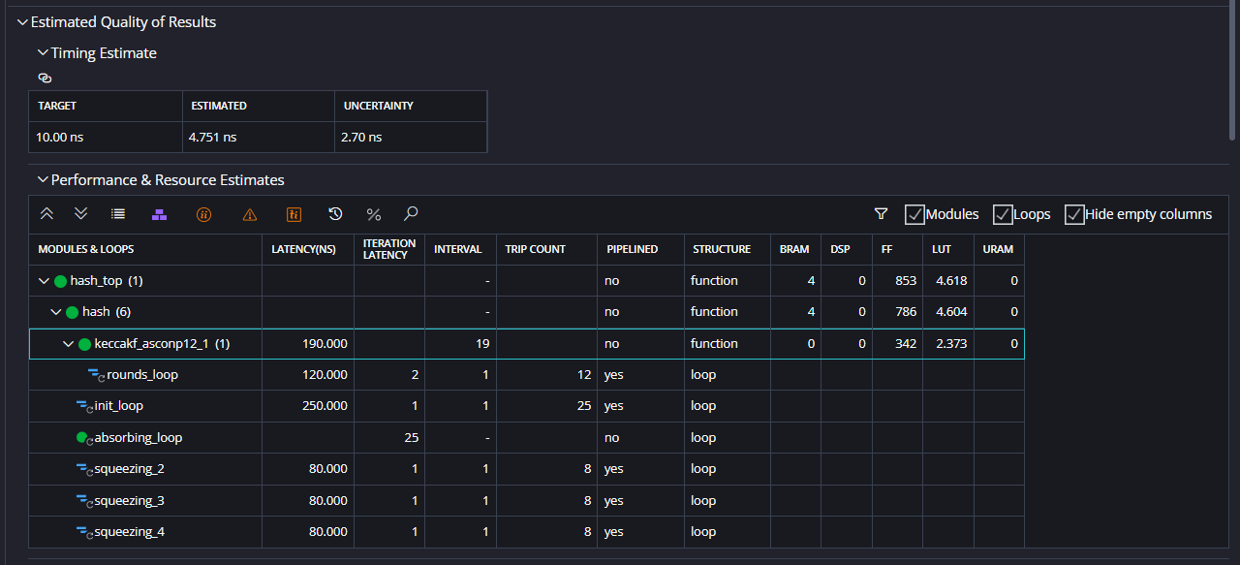
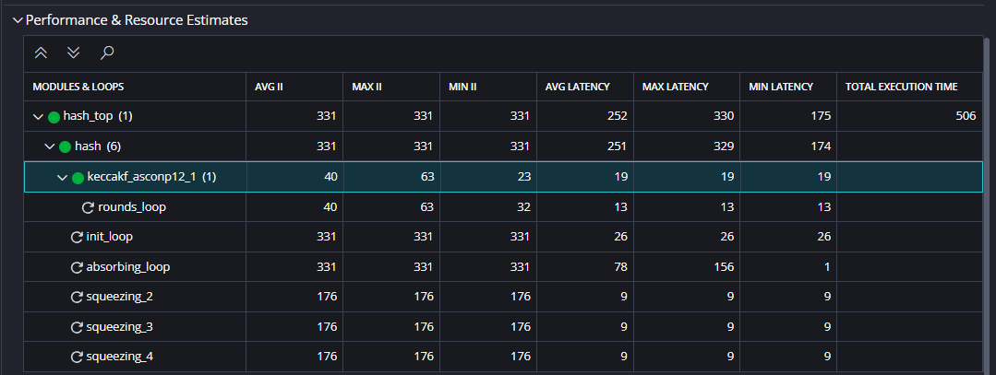
E12)
- unrolling in squeezing_1
- unrolling in squeezing_2
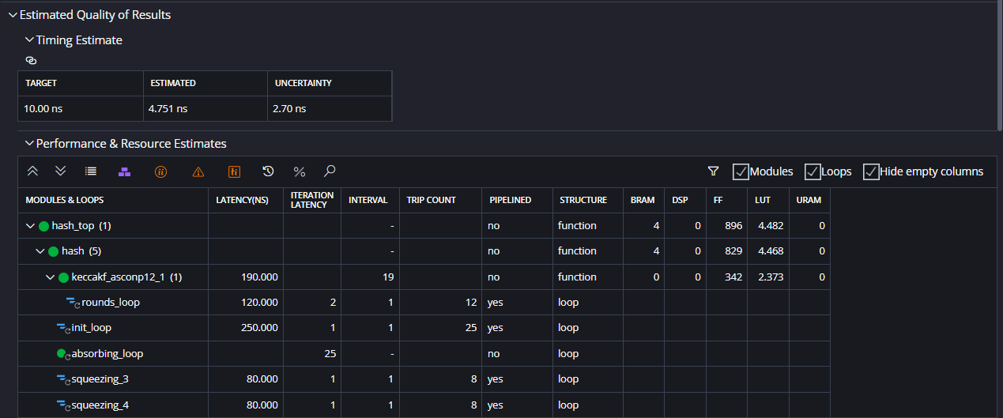
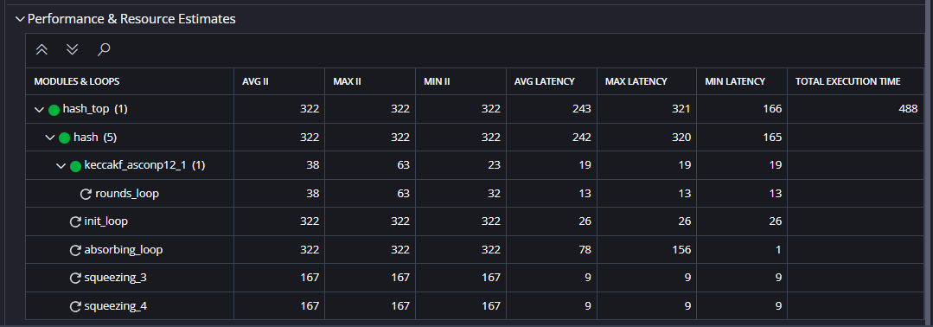

E12)
- unrolling in squeezing_1
- unrolling in squeezing_2
- unrolling in squeezing_3
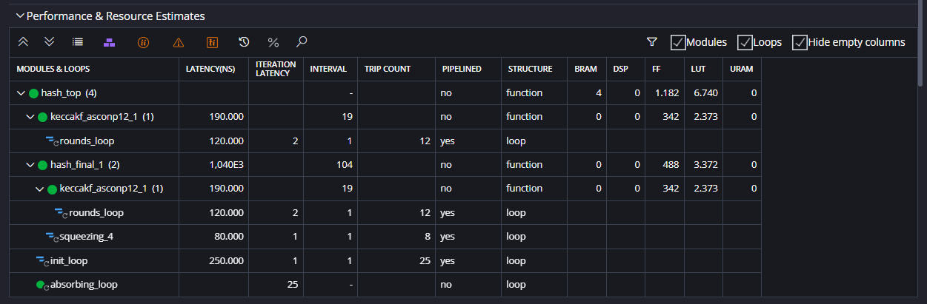
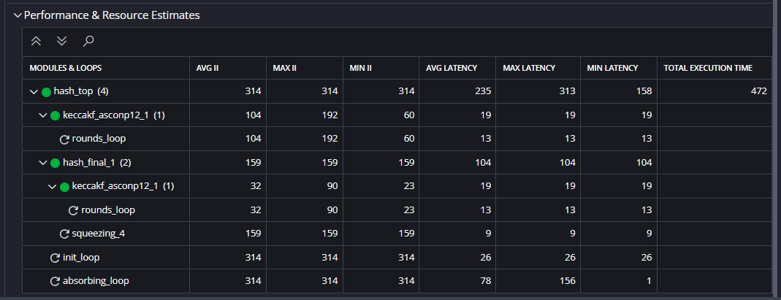

E11)
- unrolling in squeezing_1
- unrolling in squeezing_2
- unrolling in squeezing_3
- unrolling in squeezing_4
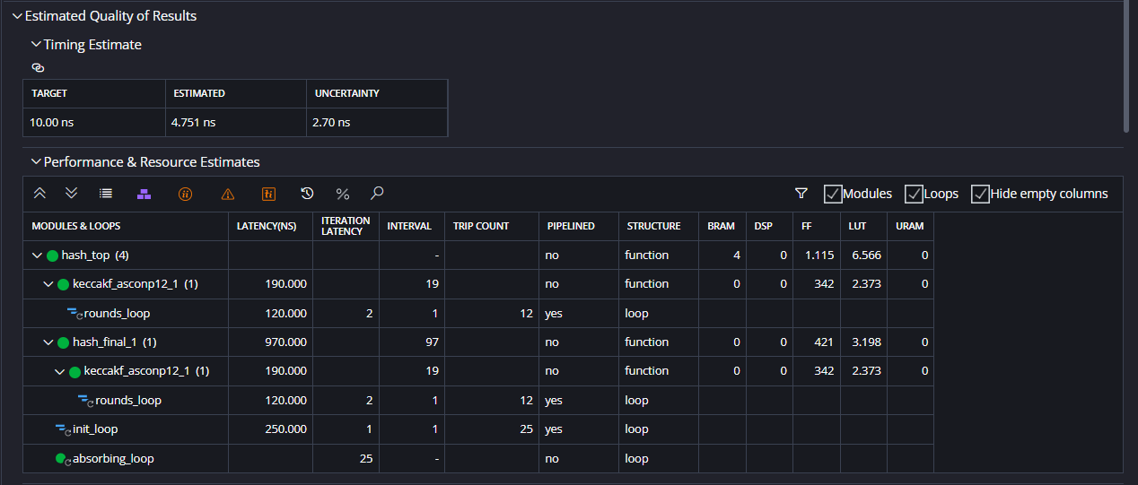
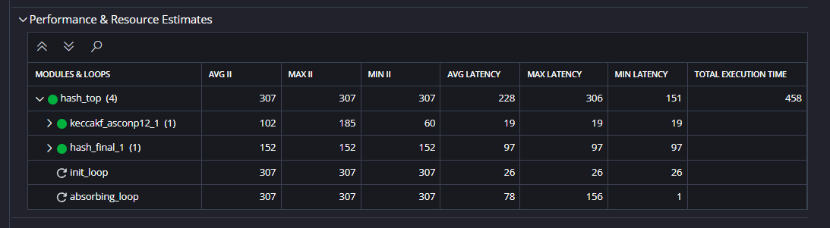

ASCON NEW EXPLORATIONS
The first new experiment (NE0) is composed of the following pragmas:
- chi inline + loops pipelining + no bc array partition
- diffusion inline + loops pipelining + no bc array partition
- keccakf_asconp12 inline off + rounds_loop pipelining
- init_loop pipelining
- squeezing_loops pipelining
Results are shown in the screenshots below.
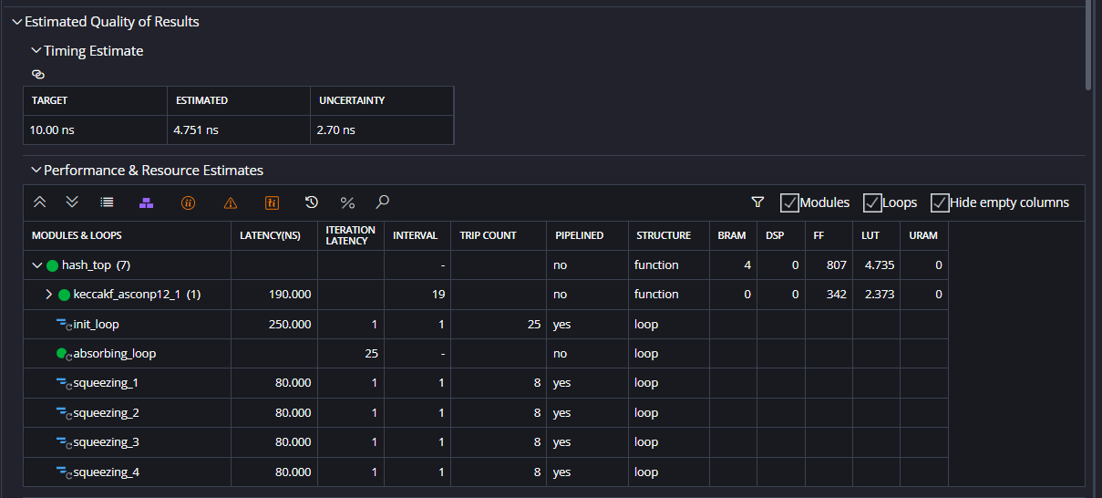
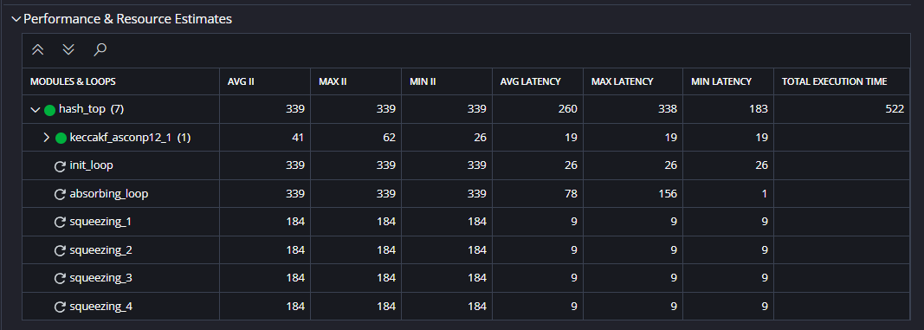

The baseline (E0) is composed of the following optimization pragmas:
- keccakf_asconp12() inline off → to reuse the same logic
- init_loop pipelining → applied by default
The first experiment (E1) is composed of the baseline and the following optimization pragmas:
- iota inlining
The results remain unchanged.
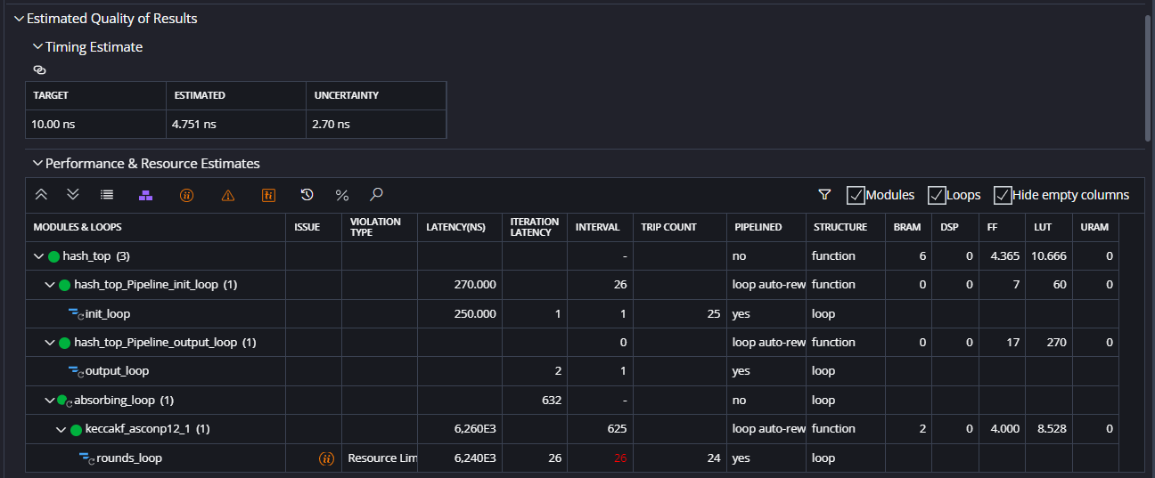
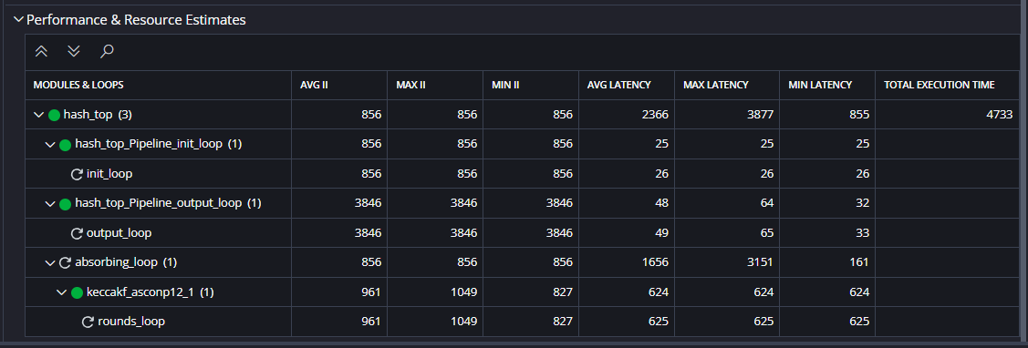

The second experiment (E2) is composed of the baseline and the following optimization pragmas:
- chi inlining
- chi bc array partition
- chi outermost loop pipelining
The results are shown in the screenshots below.
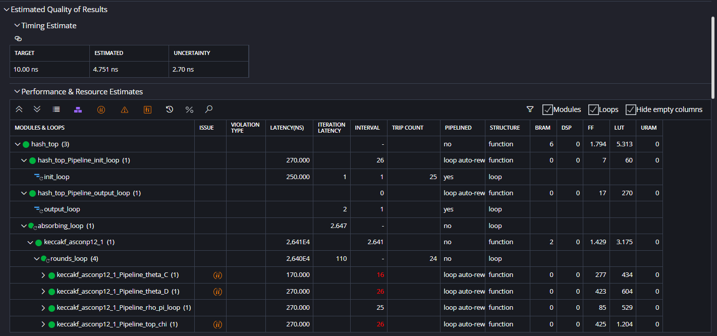
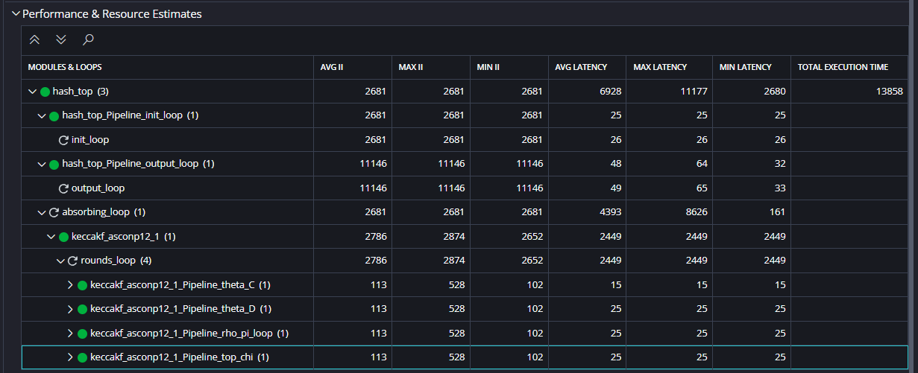

If we apply pipeline also to innermost loops we get the following results:
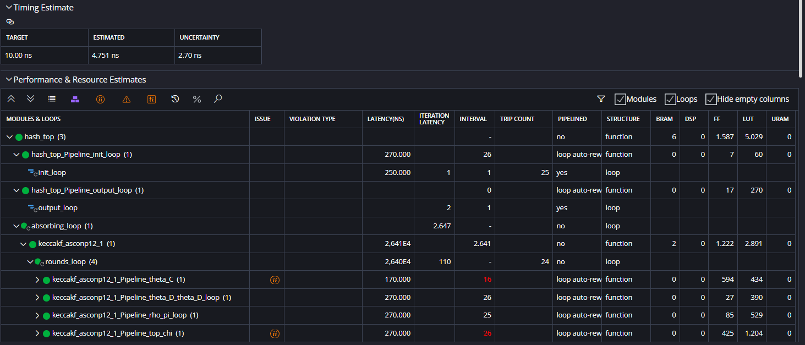
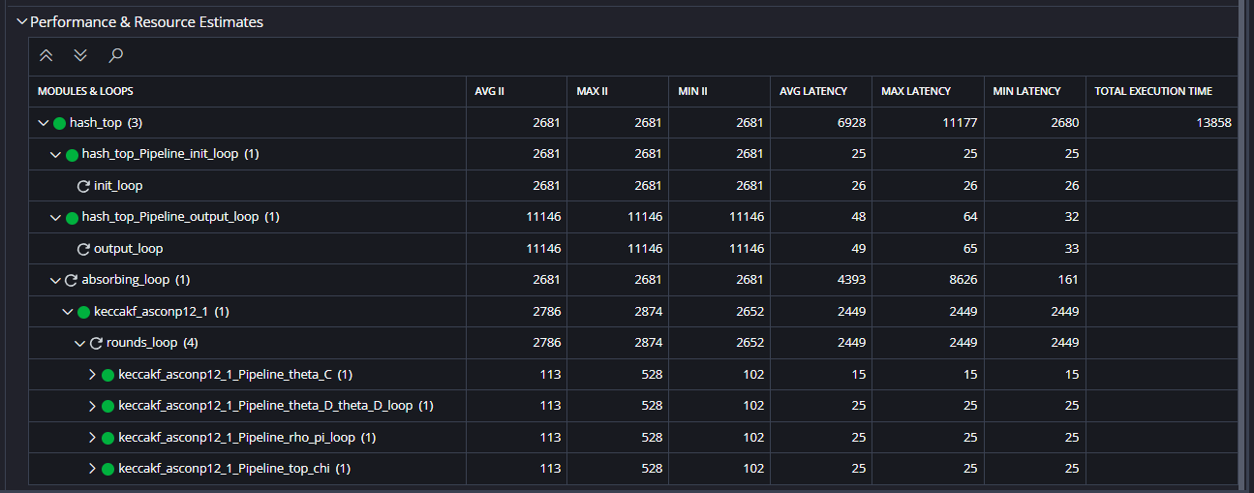

If we apply pipeline just the innermost loop (and not to the outermost loop) we get the following result:
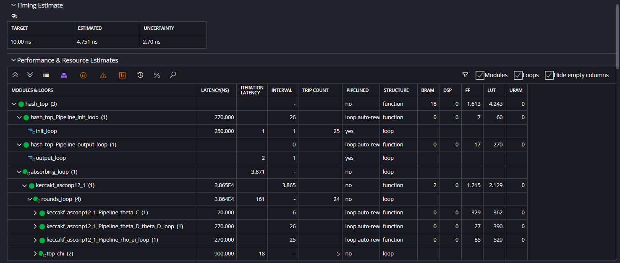
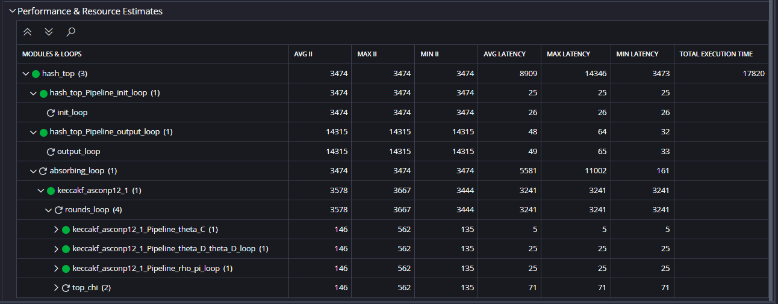
If we unroll the loops instead of pipelining we get the same result as the baseline. This is because the pipeline pragmas are disabled when loops are fully unrolled. This is valid each time loops are unrolled.

The third experiment (E3) is composed of the baseline and the following optimization pragmas:
- rho_pi inlining
- rho_pi bc array partition
- rho_pi_loop pipelining
The results are shown in the screenshots below. Applying the unrolling to the loop instead of pipelining we get the same result as the baseline.
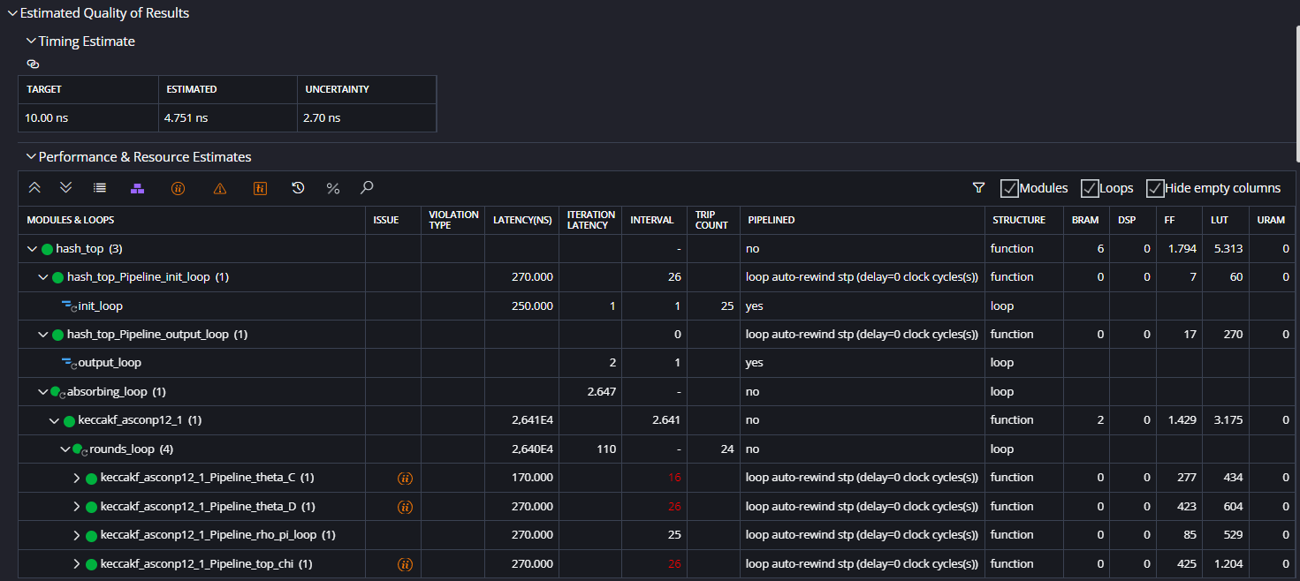
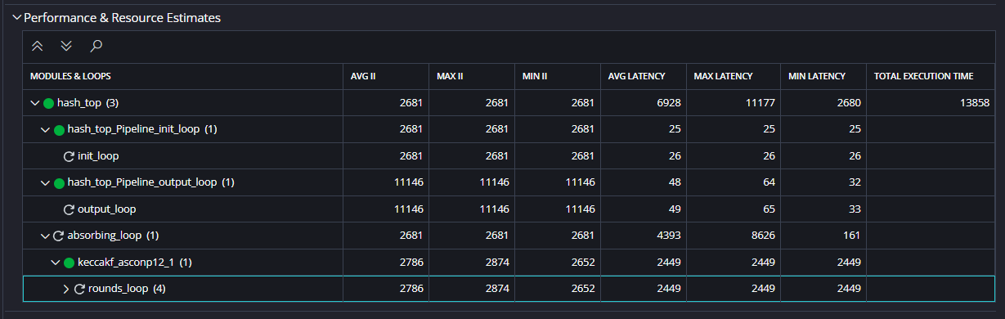

The fourth experiment (E4) is composed of the baseline and the following optimization pragmas:
- theta inline
- theta bc array partition
- theta loops pipelining
The results are shown in the screenshots below. Applying the unrolling to the loop instead of pipelining we get the same result as the baseline.
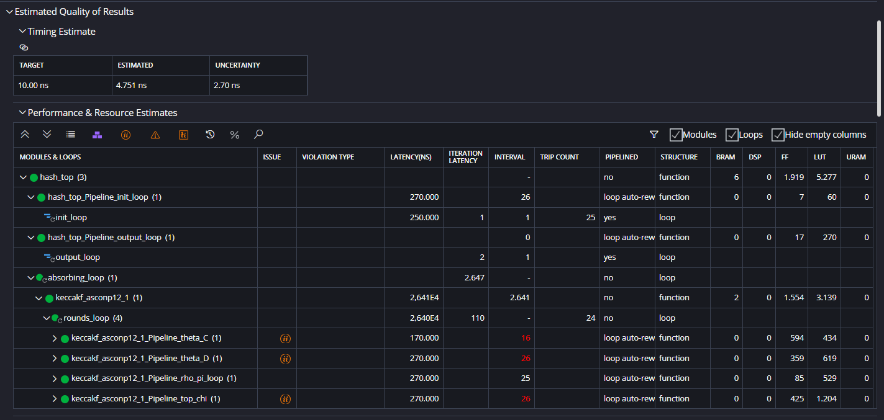
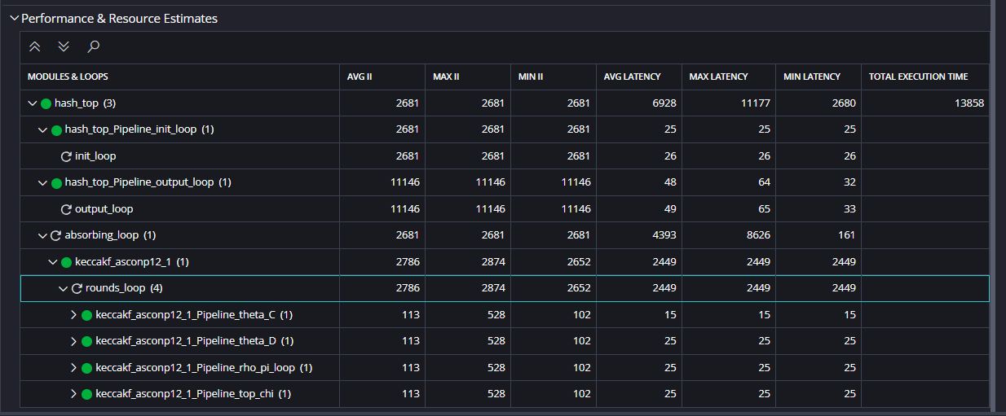

The fifth experiment (E5) combine all the previous experiments as we apply the pipelining to all the loops of:
- chi
- rho_pi
- theta
The results are shown below.
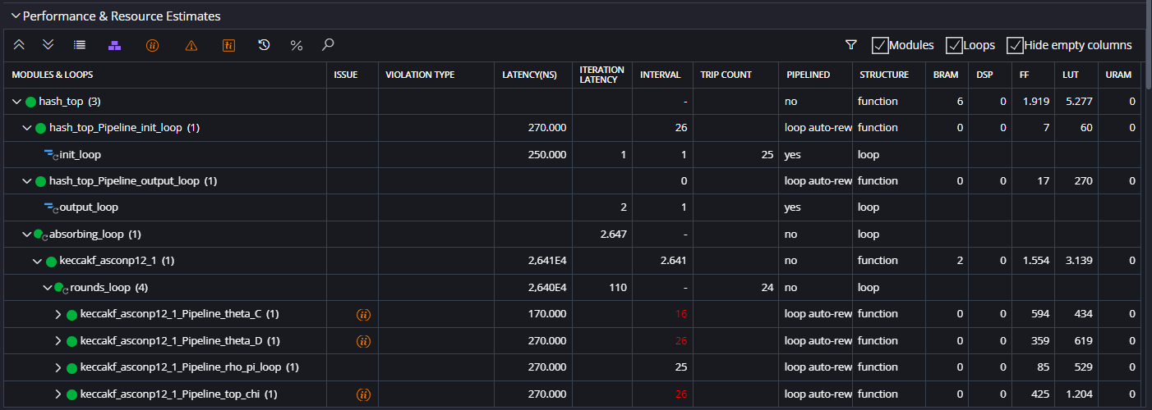
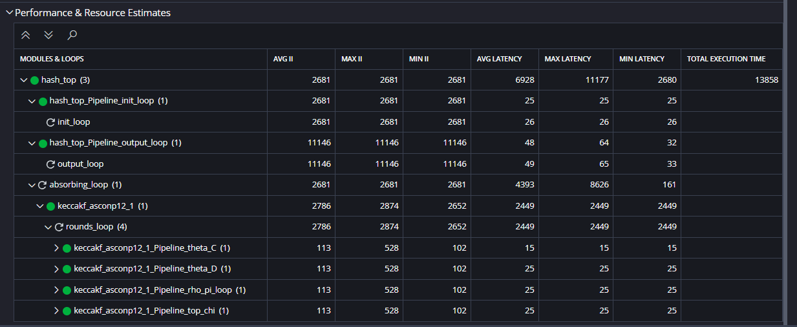

If we pipeline also the rounds_loop inside the keccakf_asconp12 function we get the following results.
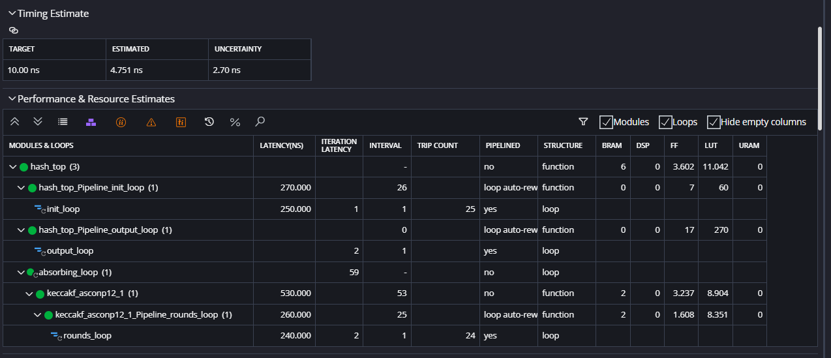
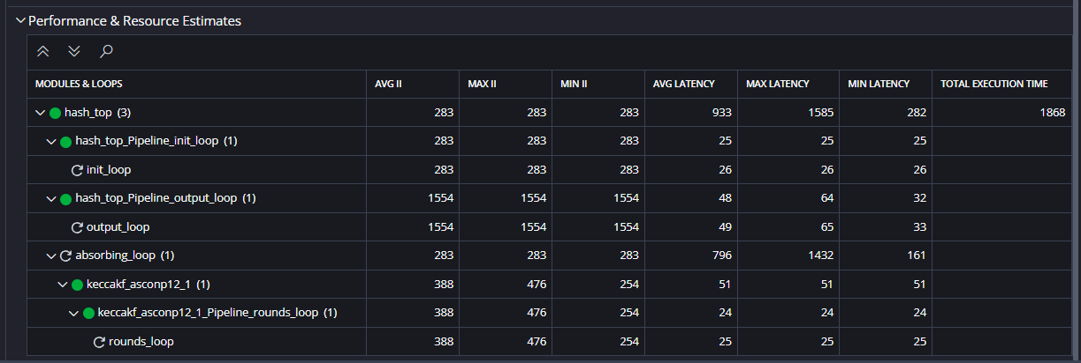

HYBRID IMPLEMENTATION
