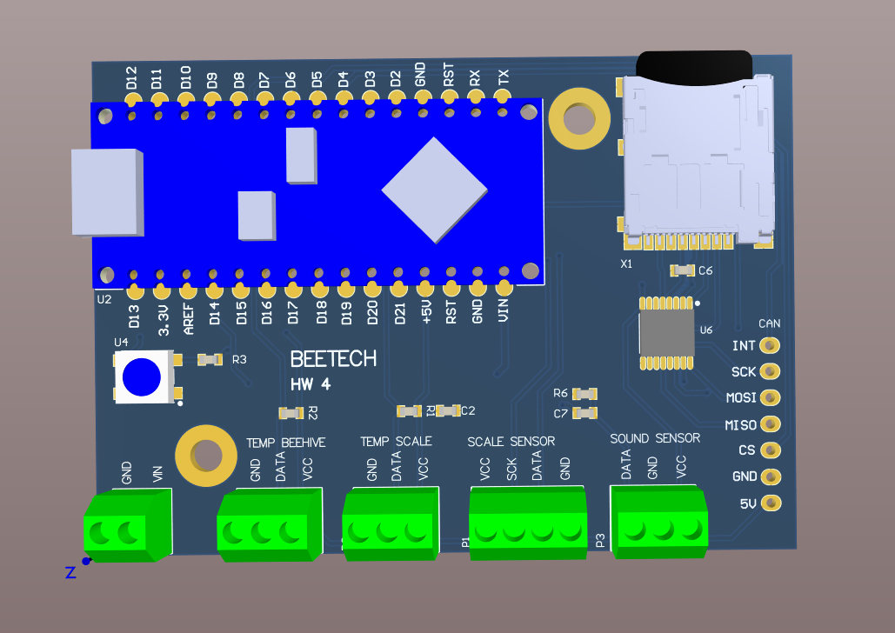

+12V

+5v

+5v

+5v

+5v

+5v



+3.3v

+5v

