

**PROJECT PLAN**

**From:** **Group 9**

**Version 4 – 29/09/2018**

* **Le Viet An**
* **NguyenBao Quoc**
* **Elahe Seyedkabirian**
* **Amin Jahromi**

Contents

1 Project statement 3

1.1 Formal client 3

1.2 Project leader 3

1.3 Project members 4

1.4 Current situation 4

1.5 Problem description 4

1.6 Project Goal 5

1.7 Project deliverables 5

1.8 Project non-deliverables 5

2 Project Management 6

2.1 Project constraints 6

2.2 Project risks 6

2.3 Project phasing 9

2.3.1 Phase 1: Initiation 10

2.3.2 Phase 2: Design 10

2.3.3 Phase 3: Building 11

2.3.4 Phase 4: Testing 12

2.3.5 Phase 5: Deploy 13

2.3.6 Skills 13

3 Organization 14

4 Time Line 15

# Project statement

## Formal client

A company represented by Mr. Vladimir Kabzar.

**Contact information:**

Mr. Vladimir Kabzar.

Rachelsmolen 1, Eindhoven

Room 2.74

[V.Kazbar@fontys.nl](mailto:V.Kazbar@fontys.nl)

(040) 123 45 67

06 – 123 45 678

Working days: Saturday-Friday

## Project leader

Amin Jahromi, studying ICT in Fontys University of Applied Sciences is the project leader.

Contact information:

Amin Jahromi

Rachelsmolen 1, Eindhoven

Room 2.74

[A.Masoumzadeanjahromi@student.fontys.nl](mailto:A.Masoumzadeanjahromi@student.fontys.nl)

(040) 123 45 67

06 – 555 00 564

Working days: Monday-Friday.

## Project members

Elahe Seyedkabirian

Le Viet An

NguyenBao Quoc

## Current situation

The client has hired us to develop a system for his music festival which will last 3 days- from Friday to Sunday. The system has to be sustainable to maintain and handle the event properly. So our client wants a software solution to monitor the whole event because there would be thousands of participants. So we need to create a database, a website and an application to monitor and keep update about the event status

A commercial company wants to organize a music festival, in order to so they need a system to keep track and control the events. Furthermore, they want to make profit from the events, which can be done by selling tickets, food, drink, souvenirs and loaning products (such as photo cameras, flashlights, …). For ease, visitors can complete their transactions on their account. This event will last several days so it is possible for the participants to rent a camping spot. Finally, ATM machines, which provide log files, will be placed on places for visitors to deposit money on their account and make applications to control the event which can be reusable.

## Problem description

As noted above, the commercial company wants a system to keep tracks and monitors their music event and they want a software solution to do this.

To solve this problem:

* a website will be needed. This website will notify people about the event and allows participants to reserve their tickets as well as camping spots.
* some applications should be created to help the company monitors the event. Therefore, these applications should be able to check visitors check in and out of the event and camping, support the shops (food/drink/souvenirs) and loan stands, allow the organizers to keep track with the status of the event and changes the balance of the visitors based on ATM log files.
* a database should be designed to support all applications and organize all information.

# Project Goal

The goal of this project is to deliver a well- functioning software system which includes a website, some applications and a database.

The website should be able to perform these tasks:

* Notify people about the events.
* Reserve tickets and camping spots.
* Should have a review page for visitors to comment about the events.

The applications should be able to do:

* Have visitors status (check in, check out).
* Help shops sell food, drink, souvenirs and the loan stands.
* Give the event organizers an overview and current status of the event.
* Change balance of visitor account based on ATM log files.

Finally, the database should be able to store all the information needed to support the website and the applications.

## Project deliverables

* Website software solution pack
* designed database which support all applications.
* User-friendly applications.
* Setup document
* Process report
* Project plan

## Project non-deliverables

* Hardware solutions
* Minute-Taker document

# Project Management

## Project constraints

Constraint 1: Time

The project must be completed within 20 weeks

Constraint 2: Budget

The budget for this project is 2000 euro’s including our payments.

Constraint 3: Programming languages

Website must be created with HTML, CSS and PHP

Database must be designed with oracle

Applications must be created with C++, java and C#

Build the database with PHPmyAdmin and user Hera server for the website

## Project risks

Risk 1: The budget is inaccurate

Probability: Very low.

Impact on project: High.

Steps to prevent: Try to calculate all the costs

Clean up action: Cut some unnecessary expenses

Risk 2: Preparing the project takes time more than 20 weeks

Probability: low.

Impact on project: Medium.

Steps to prevent: Make an organized plan of work with an estimate of time for each group member

Clean up action: Have a meeting with client and talk about the problem

Risk 3: Client is not satisfied with the result

Probability: Medium.

Impact on project: High.

Steps to prevent: Having review meetings for making important decisions

Clean up action: Redo that part of the project that client is not satisfied with

Risk 4: Software bugs

Probability: Medium.

Impact on project: High.

Steps to prevent: Having a tester in group to test the project in every step

Clean up action: fix the bugs

Risk 5: Someone decides to leave the group

Probability: Medium.

Impact on project: High

Prevention: Make group with people who have the same goals

Action: Divide the work equally between the rest of the team members, ask the mentor/client if we could have more time.

Risk 6: the database not working properly

Probability: Low

Impact: High

Steps to prevent: Spend much time to design the ERD properly and check the database carefully when it is created

Clean up action: Change the design or check with the database (Check the constraint… in tables)

Rick 7: RFID-chip is damaged

Probability: Low

Impact: Medium

Steps to prevent: Make sure the RFID chips are working properly, test them several time to be sure

Clean up action: Replace the damaged RFID-chip with a new one and update the ID on the database.

## Project phasing

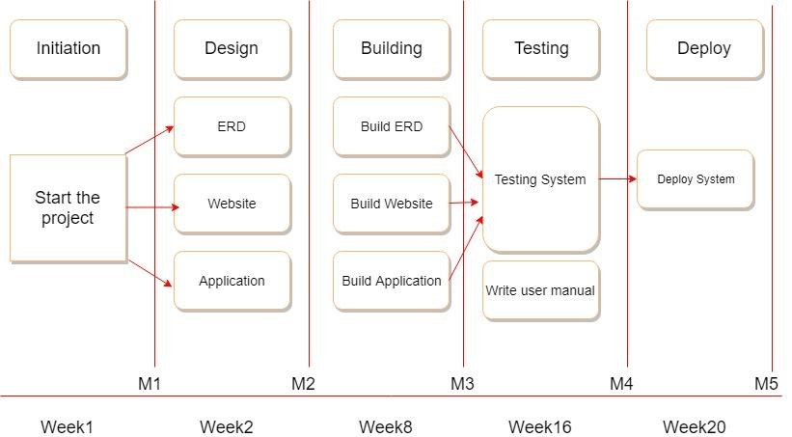

**Initiation and Research**

**Design**

**Building**

**Testing**

**Deploy**

**Start the project and Documentation**

Week4

## Phase 1: Initiation

Start-up project:

* Arrange meeting with the client
* Interview the client
* Organize resources
* Define each task for each team member( team leader, secretary, developers)
* Discuss the situation with the team members, try to foresee scenarios as mush as possible
* A draft of project plan

Estimate Time: 3 weeks

Deliverable for phase M1:

* Project plan
* Process Report
* Event scenario

## Phase 2: Design

Design the ERD:

* Analyze the event decide which data should be stored and kept track.
* Interview the client for more detail about which should be kept track.
* How the database would be able to support the website and the application
* Make Data Model by designing the ERD.
* Discuss with the team to finalize the ERD.
* Which database should be used to store the data

Estimate Time: 1 week

Design the website:

* Discuss with team members to come up with the wireframe, the functionalities, the design of the website, how can the database support the website
* Decide which programming languages should be used to design the website
* Interview with the client to decide the visual design of the website
* Do research on the internet to support the design of the website
* Create a static website.

Estimate Time: 1 week

Design the Application:

* Discuss with the team members to decide about the interface of the application, which functionalities should the database have, how can the database support the application
* Which programming languages should be used
* Interview with the client to decide the interface of the application
* Do research on the internet to get a general idea of how to implement the application functionalities
* Finalize the design of the application interface.

Estimate Time: 2 weeks

Deliverable for M2:

* Complete design of the ERD
* The complete design of the website
* A static website
* Interface design of the application
* Process report

## Phase 3: Building

Build the ERD:

* Build database based on design.
* Discuss with the group members about the inadequacies while building to fix.

Estimate Time: 2 weeks

Build the application:

* Making UML diagram for the application.
* Build the interface of the application based on the GUI.
* Add a property or function into the interface.
* Connect the application to Database.
* Discuss with the group members about the functions of the application while building to add or remove.

Estimate Time: 5 weeks

Build the website:

* Build the site’s pages based on wireframes by using HTML and CSS.
* Discuss with the group members about the website’s color, structure, etc… for the most attractive.
* Making a responsive website.
* Connect to the database.

Estimate Time: 1 week.

Deliverable for M3:

* An application with all functions.
* Complete Database (tables, attributes, etc)
* Website with all functions and information about the event.
* Responsive and friendly user interface website.

## Phase 4: Testing

Testing the application:

* Testing the application to make sure all the functions can work perfectly.
* Do we need to change anything?
* Check the database connection.
* Make user’s manual

Estimate Time: 2 weeks

Testing the website:

* Check website is responsive or not.
* Check the connection between website and database.
* Check if it is secured.
* Check payment method work or not.
* Let the user test website to make sure its stable, if not change it based on the survey.

Estimate Time: 1 week

Testing the database:

* Testing the database to make sure all the functions can work perfectly.
* Do we need to change anything?

Estimate Time: 1 week

Deliverable for M4:

* Completed application with all functions working smoothly.
* Website with a friendly interface, attractive and all functions stable operation.
* Completed database.

## Phase 5: Deploy

Database

* Publishing database

Application

* Upload the application.

Website

* Upload and host it on the server.

## Skills

* Logical and Structured Thinking
* Attention to Detail
* C# and website Programming Experience
* Ability to analyze User Needs
* Share knowledge and expertise with other team members
* Being able to communicate with each other and also know how to listen to other ideas.
* Make plan and divides the workload among team members

## Organization

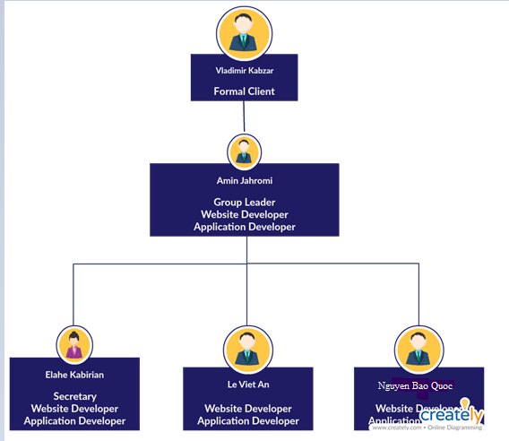

## Time Line and deliverables

1.Project plan

2.Process Report

3.Event scenario

1.Completed website

2.Completed application

3.Completed database.

1.An application with all functions.

2.Complete Database (tables, attributes,.)

3.Website with all functions and information about the event.

4.Responsive website.

1.Complete design of the ERD

2.The complete design of the website

3.A static website

4.Interface design of the application

Process report