Name: Abdullah Al Soad   
ID: 20-43425-1  
Course: [COMPUTER VISION AND PATTERN RECOGNITION](https://portal.aiub.edu/Student/Section?q=hgKfrNIJld3Td5snDrgWuw%3D%3D)   
Section: B

**Activation function:**

An activation function is a critical component of a neural network. It is used to determine the output of a neuron, or a set of neurons, given a set of inputs. Activation functions are also responsible for introducing non-linearity into the neural network, allowing for more complex decision boundaries and more accurate predictions. So popular activation functions are described below.

**Step Activation Function**

A simple function known as the step Activation function detects whether an input value is above or below a specified limit by producing a binary result of 0 or 1. The curve is a horizontal line that reaches the threshold and moves from 0 to 1. It is simple and effective in some situations, but it is not differentiable and can encounter vanishing gradient issues. However, it has some limitations. For example, it is not differentiable, which makes it unsuitable for use in backpropagation. It can make training difficult. It cannot be used for multi-class classification.

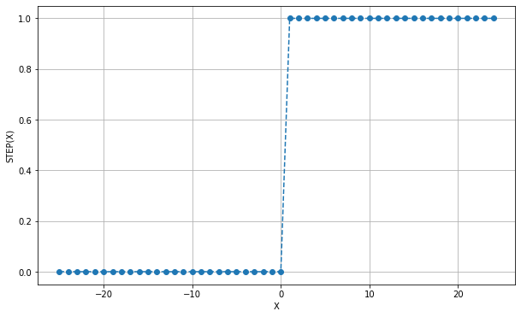

**Sigmoid or Logistic Activation Function**

The sigmoid function provides a value between 0 and 1 in the form of a smooth, S-shaped curve. It is beneficial in binary classification problems where predicting probabilities is the main objective. As the input rises or decreases, the curve gradually flattens out after being steep at the origin. It may be distinguished and is a better match for algorithms for gradient-based optimization algorithms such as backpropagation. However, the sigmoid function also has some limitations. For very large or very small inputs, the output of the function approaches 0 or 1 and the gradient approaches 0, which can slow down learning.

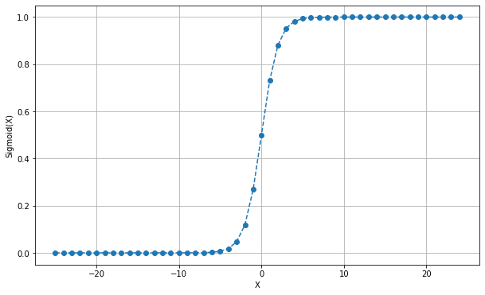

**TanH Activation Function**

The sigmoid function and the hyperbolic tangent, often known as the tanh function, both are smooth, S-shaped curves with outputs between -1 and 1. It is useful in neural networks where both positive and negative input is available. Learning can gain from the curve's higher slope and roots shape, being more obvious than the sigmoid function. This type of activation function is most commonly used in classification problems. It also solves the problem of the values all being of the same sign. This function is non-linear in nature, so it can easily back propagate the errors. There is a similar drawback to the sigmoid function.

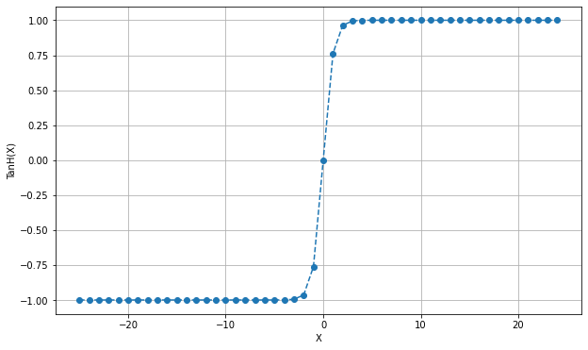

**ReLU Activation Function**

A simplistic function named the rectified linear unit, or ReLU, outputs the input if it is positive and 0 otherwise. Beginning at the origin and proceeding to the right, the curve is a straight line. Due to its simplicity and ability to avoid the vanishing gradient problem, it is well-liked in deep learning. It is capable of outputting a true zero value. One potential drawback of the ReLU function is that it is not differentiable at zero. However, this is not typically a problem in practice because the probability of the input being exactly zero is small, and the derivative is well-defined for all other inputs. In some cases, the ReLU function can suffer from a problem known as "dying ReLU", where a neuron may become inactive and stop contributing to the output due to a consistently negative input. To address this problem, variations of the ReLU function have been proposed, such as Leaky ReLU or Parametric ReLU. Overall, many neural network designs, especially those used in deep learning, benefit from the ReLU activation function since it is straightforward and efficient.

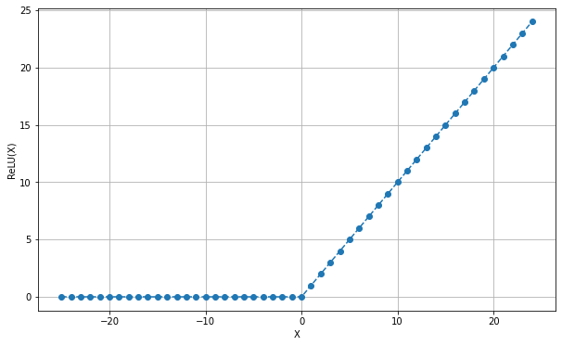

**ELU Activation Function**

Similar to the ReLU function, the ELU (Exponential Linear Unit) function produces a negative value for negative inputs. because it guarantees that neurons are active despite negative inputs. The issue of disappearing gradients and expanding gradients is not a concern at ELU.ELU does not experience the issues associated with decaying neurons like ReLU does. In comparison to ReLU and its derivatives, using ELU results in a shorter training time and greater accuracy in neural networks. At any location, the ELU activation function is continuous and differentiable. The possibility of negative ELU values causes the mean of the activations to be pushed closer to zero. Moreover, learning and convergence occur more quickly when mean activations are closer to zero. ELU is slower to compute due to its non-linearity with negative inputs.

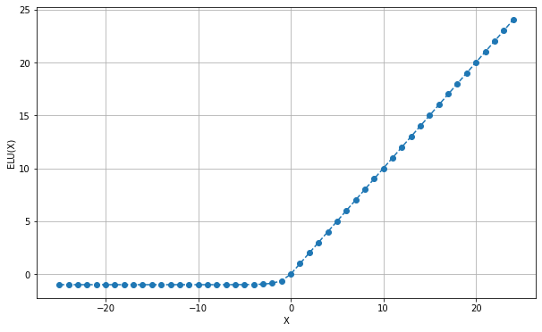

**SELU Activation Function**

The activation functions known as SELUs, or Scaled Exponential Linear Units, cause self-normalization. Neuronal activations in the SELU network automatically converge to zero mean and unit variance. The output of the entire layer will remain constant since this function, while comparable to the ELU function, is scaled. As a result, the output doesn't get too small, which helps to lessen the issue of vanishing gradients. SELUs cannot expire as ReLUs can. Compared to other activation functions, SELUs can learn more quickly and more effectively without additional processing. Since this activation feature is still quite new, it is not yet commonly utilized in daily life.

