

**Software Requirements**

**Elicitation Project**

**Dr. Majed Ayyad**

**Suzan Ayesh**

**Hamzah Hammoudeh**

**Mouhammed Bseleh**

**Rayn Issa**

**Ala’ Abuzer**

**Rami Abuayyash**

**Contents**

1. Preparation
2. Interviews
3. Repertory grid
4. Analysis
5. User Stories
6. personas
7. Empathy Maps
8. Functional Requirements
9. Non-Functional Requirements
10. conclusion

**Preparation:**

**1- Abstract:-**

Information gathering and analyzing has become the most important tool to facilitate sense-making and discovery of requirements for any scientific problem we found out that the elicitation technique was effective in finding out that different customers care for different things; this hints that discovering customer personas might be a good route to take. As the elicitation technique lets the interviewee take their freedom in expressing their ideas and stories, it was especially helpful in drawing out constructs for our repository grid. The repository grid in turn is what helped us derive the different Personas, and getting to know the needs of the users and analyzing them helped us get the most important features needed to get a successful platform to compete with other platforms.

**2- Methodology:-**

First, the information was collected through a questionnaire, but we knew that this was not the required job, then we prepared new questions and started conducting interviews to collect the information

We did several interviews with university students of different ages and majors and asked them some questions about the social media platforms they use frequently. We recorded the students’ opinions about each platform, then we analyzed all the interviews to create the rep-grid and determine its contracts. Also with help of the interviewees' opinions, we created two empathy maps for the most successful interviews. After that, we asked other students to fill a grid that represents our repository grid. Finally, we calculated the final rep-grid.

**Interviews:-**

**Our journey in interviewing students:**

In this part, we'll outline our process when conducting the interviews for this project. First, we conducted the interviews, then we typed down the constructs we gathered from them. Finally, we allowed the interviewee to fill out the Repgrid themselves.

Our trip was divided into three parts, and this document details the improvements we made to our techniques and how we used the laddering methodology throughout the interviews to enhance our elicitation and interviewing abilities.

**First Phase:**

We first conducted two interviews, but the results weren't what we had hoped for. They lacked some components and were also somewhat short. And when we attempted to use the laddering strategy on the first two interviewers, we were unsuccessful.

**The first interview (Q/A):-**

* **Q-**What social media platforms do you use?

**A:** Snapchat, Instagram, WhatsApp

* **Q-**Which one do you use most?

**A:** Instagram

* **Q-**Why?

**A:** To watch the news and because everyone is on it

* **Q-**What about Snapchat?

**A:** To see friends and celebrities

* **Q-**What about Whatsapp?

**A:** for messages and consider it more secure

* **Q-**If you wanted to improve each of these applications, what would you add?

**A:** I can see who forwards my account or story on Instagram, Fix the stack issue in Snapchat, Nothing much to say on WhatsApp

**Repgrid:**

| 5 | Instagram | WhatsApp | Snapchat | 1 |
| --- | --- | --- | --- | --- |
| high approach | 5 | 2 | 4 | Low approach |
| high-security chat | 3 | 5 | 2 | Low-security chat |
| High Application performance | 4 | 5 | 3 | Low Application performance |

**RepGrid analysis:**

Depending on the RepGrid’s rate we can see that the interviewee believes that Instagram approaches most of the people, unlike WhatsApp which has been said that it is only used for sending messages, On the other hand, when speaking about chat security, WhatsApp was the highest rate of the 3 mentioned applications when Snapchat’s rate came as Poor security, Also both WhatsApp and Instagram’s performance was High.

**The Second interview (Q/A):-** **(Audio recording is not accepted)**

* **Q-**What social media platforms do you use?

**A:** Snapchat, Instagram, Telegram

* **Q-**Which one do you use most?

**A:** Telegram

* **Q-**Why?

**A:** To follow the news and events in the country

* **Q-**What about Instagram?

**A:** The Reels feature is fun

and diverse in content and I like the funny videos in it

* **Q-**What about Snapchat?

**A:** I only view people’s stories

* **Q-**If you wanted to improve each of these applications, what would you add?

**A:** Create a profile on Telegram, and upload long video clips to Instagram.

* **Q-**Compare all of them or just two?

**A:** Telegram provides news faster and it is simpler to use. On the other hand, Snapchat and Instagram provide Reels that are better and more comprehensive in content than Reels on Snapchat

**Repgrid:**

| 5 | Instagram | Snapchat | Telegram | 1 |
| --- | --- | --- | --- | --- |
| high variety of content | 5 | 3 | 4 | low variety of content |
| Good Short videos(reels) | 5 | 3 | 1 | Bad Short videos(reels) |
| high content limit | 5 | 4 | 1 | Low content limit |
| High-performance chat | 3 | 3 | 5 | low-performance chat |

**RepGrid analysis:**

Using this interviewee’s answers we can tell that he cares about news a lot so his favorite communicating application is the Telegram due to its high-performance chat and its limitless freedom of posting without getting banned for not applying the app’s Terms & Conditions. Also as a human he sometimes wants to be entertained, so he found Instagram Reels as a solution to his boredom.

**Second Phase:**

As a result of the laddering strategy we used to obtain more contracts and information from the respondents, we then modified our questions and conducted two better interviews.

**The third interview (Q/A):-** **(Audio recording is not accepted)**

* **Q-**What social media platforms do you use?

**A:** Snapchat, Instagram, Whatsapp

* **Q-**Which one do you use most?

**A:** Instagram

* **Q-**Why?

**A:** I enjoy the Reels and the posts, and I find it more entertaining because of the close-friends feature which allows you to post only to your close friends, the events more on it, and because It has everyone on the app including celebrities and other friends and family.

* **Q-**What about Snapchat?

**A:** Snap**-**Streaks and keeping memories on it.

* **Q-**What about Whatsapp?

**A:** Use it only for sending messages and university study groups.

* **Q-**What addition can you add to the application to make it better?

**A:**Instagram: See who forwarded your story or post.

Snapchat and Whatsapp are good.

* **Q-** What similarities are found between all of them or two?  
   **A:** Massages and stories
* **Q-**If you wanted to improve each of these applications, what would you add?

**A:** For all: Unsend certain messages by putting a timer on the selected message.

**Repgrid:**

| 5 | Instagram | Whatsapp | Snapchat | 1 |
| --- | --- | --- | --- | --- |
| high variety of content | 5 | 1 | 3 | low variety of content |
| Good Short videos(reels) | 5 | 1 | 2 | Bad Short videos(reels) |
| Flexible postings | 5 | 2 | 4 | Inflexible postings |
| Keeps memories | 3 | 1 | 5 | Discard memories |
| high-security chat | 4 | 5 | 3 | low-security chat |
| high-performance chat | 3 | 5 | 4 | low-performance chat |

**RepGrid analysis:**

Studying this RepGrid, we can see that Instagram has a very high variety of content unlike WhatsApp which is only for messages, Although both Instagram and Snapchat added entertaining short videos called “Reels” but depending on the RepGrid it is clear that Instagram outperformed Snapchat’s reels in user’s opinion, But when talking about saving memories and having easy access to them, Snapchat is our winner! On the other hand, high-security chat and performance are also important for a successful application - for example, here - WhatsApp has the best chatting settings.

**The fourth interview (Q/A):-**

* **Q-**What social media platforms do you use?

**A:** Snapchat, Instagram, and WhatsApp

* **Q-**Which one do you use most?

**A:** Instagram

* **Q-**Why?

**A:** Story properties, Streak, communication

* **Q-**what about WhatsApp?

**A:** Messages and calls are easier and everyone uses them for this purpose for easy access to people.

* **Q-**what about Snapchat?

**A:** I love the camera because it is clear and has fun filters. Streaks with friends and it’s also fun to watch their stories, Snapchat allows us to post stories with specific friends that we choose(private Stories), and it’s also more secure because it tells if anybody screenshotted my story.

* **Q-**What are the problems with all of them?

**A:** Instagram: I consider that there is no privacy even if the account is private like

Snapchat, where anyone can take a screenshot of the story or post without my knowledge.

Snapchat: There is no Live like Instagram

WhatsApp: has no problems, It is only used for messages and calls.

**Repgrid:**

| 5 | Instagram | Whatsapp | Snapchat | 1 |
| --- | --- | --- | --- | --- |
| high variety of content | 5 | 2 | 4 | low variety of content |
| Good Short videos(reels) | 5 | 1 | 2 | Bad Short videos(reels) |
| Flexible postings | 4 | 2 | 3 | Inflexible postings |
| Keeps memories | 4 | 2 | 5 | Discard memories |
| high-security chat | 3 | 5 | 3 | low-security chat |
| high-performance chat | 3 | 5 | 3 | low-performance chat |
| High camera quality | 5 | 3 | 5 | low camera quality |
| High camera filters quality | 4 | 2 | 5 | Low camera filters quality |

**Special RepGrid:-**

After the second phase of interviews, we created a rep grid from which we extracted the constructs. We then distributed 10 copies of the rep grid to 10 different university students with a variety of ages and majors. The average response of the student results is also displayed in this rep grid.

**Results:-**

| 1 | Tiktok | Telegram | Snapchat | Whatsapp | Instagram | 5 | conducts description |
| --- | --- | --- | --- | --- | --- | --- | --- |
| low-performance chat | 2 | 3 | 3 | 5 | 4 | high-performance chat | All files types support, messaging responsive |
| bad desktop support | 2 | 2 | 1 | 4 | 3 | good desktops supported | Easy to use at desktop |
| low approach | 4 | 2 | 3 | 2 | 5 | high approach | contains a wide range of influencers |
| low-security chat | 3 | 4 | 3 | 5 | 3 | high-security chat | Chat Encryption |
| low privacy | 2 | 5 | 4 | 5 | 4 | high-privacy | privacy |
| low content limit | 3 | 1 | 3 | 2 | 5 | high content limit | sensitive content delete |
| low camera quality | 3 | 1 | 4 | 3 | 4 | high camera quality | camera quality |
| low camera filters quality | 2 | 1 | 5 | 1 | 4 | high camera filters quality | camera filters |
| low variety of content | 5 | 2 | 3 | 1 | 5 | high variety of content | variety of content |

**RepGrid Analysis:-**

**Instagram:**

It appears in the following grid that Instagram has the most number of influencers, the best camera quality, and is one of the most apps that have a variety of content, on the other hand, it got fairly low scores in privacy and chat performance conducts.

**Whatsapp:**

It appears in the following grid that Whatsapp considers the best app in chat performance and ease of use by a browser, but it got a really low score in conducts related to variety of content, camera and camera filters quality.

**Snapchat:**

In the case of Snapchat the grid shows that it has a great advantage in privacy and camera filters, but it has weaknesses with desktop/browser support.

**Telegram:**

In the Telegram case, the following grid shows that it sticks to the average score in most of the conducts, but got low scores in topics related to camera and camera filters.

**Tiktok:**

This grid shows that Tiktok has strong points in content variety, on the other hand, it has low-performance chat and low-security chat.

**Third Phase:**

Then our third phase began, we improved our interview questions, and we conducted two further interviews.

**The Fifth interview (Q/A):-**

* **Q-**What social media platforms do you use?

**A:** Snapchat, Instagram, Tiktok

* **Q-**Which one do you use most?

**A:** Instagram.

* **Q-**Why did you choose these three?

**A:** because everyone uses them and they have fun short videos.

* **Q-**Why do you use Instagram the most?

**A:** Because the interaction is better and contains all the features including messages, calls, reels, and posts.

* **Q-**Why, not TikTok?

**A:** Because TikTok is only for videos.

* **Q-**How do you see TikTok content?

**A:** Diverse and entertaining content so that everyone shows their interests, It shows educational videos and world events.

* **Q-**What are the features of Snapchat?

**A:** Streaks and chats

* **Q-**What are the problems with each of them?

**A:**Instagram: tragic news

Snapchat and Tiktok: no problem

* **Q-**What are the similarities between the applications?

**A:** The Stories

* **Q-**What addition can you add to the application to make it better?

**A:** The presence of a content filter every time you enter the application facilitates the search according to the mood of each day, and I want the ability to search for specific topics rather than use another app so I can quickly find what I am looking for.

* **Q-**If you wanted to improve each of these applications, what would you add?

**A:** That there be a new application to exchange life experiences and benefit from the experiences of people around the world.

**Repgrid:**

| 5 | Instagram | Snapchat | TikTok | 1 |
| --- | --- | --- | --- | --- |
| high approach | 5 | 3 | 4 | low approach |
| Good Short videos(reels) | 5 | 2 | 5 | Bad Short videos(reels) |
| High-security chat | 4 | 3 | 2 | low-security chat |
| High-performance chat | 5 | 4 | 2 | low-performance chat |
| Good camera filters | 5 | 4 | 3 | Bad camera filters |
| High content limit | 5 | 3 | 4 | Low content limit |

**RepGrid analysis:**

As shown in the RepGrid above, we can tell that this interviewee prefers Instagram out of the three mentioned apps because of its great entertainment content, also known as Instagram Reels, and because it simply has all the features from any other application, for example, Instagram has a good variety of camera filters, 24 hours stories that can be saved in your profile in icons called “Highlights”, however, the highlights feature is an exclusive feature for the Instagram app, and it also has a very high-performance chatting experience along with a high-quality video call. On the other hand, we can see that our interviewee uses TikTok only for watching videos and not communicating and interacting with other users. When talking about Snapchat, our interviewee is only concerned about Snap-Streaks, which is an exclusive feature for Snapchat.

**The Sixth interview (Q/A):-**

* **Q-**What social media platforms do you use?

**A:** Snapchat, Instagram, Whatsapp

* **Q-**Which one do you use most?

**A:** Snapchat

* **Q-**Why?

**A:** Story properties, Streak, communication

* **Q-**Why do you like Snapchat photography?

**A:** The characteristics of the story are better and the Streaks make us constantly in touch with friends.

* **Q-**What about Instagram?

**A:** The posts are better, and the stories are also distinctive.

* **Q-**Why?

**A:** Because most of them are friends and celebrities, which attracts more users.

* **Q-**What about Whatsapp?

**A:** I use it for massages only and because most people use it for chatting and it’s a great way to order and book something - and it's more secure because of its connection to the phone number.

**Q-**What are the problems with all of them?

**A:** Snapchat: On Android, it does not work well and sometimes searches and streaks disappear.

Instagram: In its latest updates, the report has become easy to close any account, and this is a big problem. My account can go away at any moment.

WhatsApp: I do not see any problems, as it is one of the most encrypted and easy to access.

* **Q-**What are the similarities between the applications?

**A:** Stories - messages - calls - voices messages.

Instagram and Snap have a profile while WhatsApp does not.

* **Q-**What are the best features of each of these applications?

**A:** Snapchat: Snap Streaks

Instagram: Stories

WhatsApp: is easier to send and receive messages, photos and videos instantly so I can stay connected with my loved ones.

* **Q-**What updates would you like to see in the apps?

**A:** Instagram, enhance the “Report Account” property, which is currently easy for anyone to delete any account with few reports.

In Snapchat, The snap streaks suddenly disappear on Android devices, and the stories don't reach everyone.

* **Q-**What addition can you add to the application to make it better?

**A:** That each one of them is more professional, and the search feature is available in them, which enables them to dispense with Google for example.

**Repgrid:**

|  | Instagram | Whatsapp | Snapchat |  |
| --- | --- | --- | --- | --- |
| High camera quality | 4 | 2 | 5 | low camera quality |
| High camera filters quality | 3 | 2 | 5 | low camera filters quality |
| high approach | 5 | 3 | 4 | low approach |
| High-security chat | 3 | 5 | 3 | low-security chat |
| High-performance chat | 4 | 5 | 3 | low  performance chat |
| Good responsiveness on several operating systems | 2 | 4 | 3 | Bad responsiveness on several operating systems |
| High content limit | 5 | 3 | 5 | Low content limit |

**RepGrid analysis:**

When we analyze the RepGrid above, we can tell that this interviewee tends to be interactive with friends instead of just viewing their stories, and he does that by using the Snap Streaks on the Snapchat app, which allows the users to be continuously in touch by sending pictures AKA “Snaps” featuring it’s beauty or entertainment filters. But when he wants to check or view other people’s lives, and by people I mean friends, family, acquaintances, or celebrities, for sure he’ll use Instagram due to its high number of users and the high variety of features for example stories, reels, and so on. Although when it comes to sending messages our interviewee prefers WhatsApp because, in his opinion, it's easier to access messages and it's a much more secure and efficient messaging app.

**Final RepGrid:**

|  | Instagram | Whatsapp | Snapchat | Telegram | TikTok |  |
| --- | --- | --- | --- | --- | --- | --- |
| High camera quality | 5 | 3 | 5 | 3 | 4 | low camera quality |
| High camera filters quality | 4 | 1 | 5 | 1 | 3 | low camera filters quality |
| high approach | 5 | 4 | 4 | 2 | 4 | low approach |
| High-security chat | 4 | 5 | 3 | 5 | 2 | low-security chat |
| High-performance chat | 4 | 5 | 3 | 5 | 2 | low  performance chat |
| Good responsiveness on several operating systems | 3 | 5 | 4 | 3 | 2 | Bad responsiveness on several operating systems |
| High content limit | 5 | 2 | 4 | 3 | 5 | Low content limit |
| Good Short videos(reels) | 5 | 1 | 3 | 1 | 5 | Bad Short videos(Reels) |
| High privacy | 4 | 5 | 3 | 4 | 2 | Low privacy |
| Flexible postings | 3 | 5 | 4 | 5 | 2 | Restricted posting |
| Keeps memories | 4 | 3 | 5 | 2 | 3 | Removes memories |

**Final RepGrid analysis:**

We have collected all the features and put them in one Final RepGrid, our 5 main Applications that has been selected by our Student-interviewees are Instagram, Snapchat, WhatsApp, Telegram and Tiktok, They have many similarities and many differences as well, for example both the camera and the filter quality in the Instagram and the Snapchat app are better than any other mentioned apps, however Instagram has the highest approach of them all because it has the highest users all due to its extreme diversity of features, for example , the Reels (short entertaining videos) which is also present as the basic content in the Tik Tok app. On the other hand, when it comes to sending high-quality messages with top privacy settings, our interviewees agreed that both WhatsApp and Telegram are the right applications to send messages and to chat in general, Where you can message and post stories with complete freedom without any restrictions and controls on the shared content, unlike Instagram, which restricts the content pretext of compliance with the Terms & Conditions which became a bit annoying because they limited the freedom of speech when it comes to politics and other sensitive topics.

**Overall difficulties we encountered throughout the interviews:**

* Some interviewees wouldn't allow us to interview them.
* Because several of the interviewees' responses were irrelevant and off-topic, we were somewhat distracted during the interview.
* We became lost since some interviews had an uncomfortable atmosphere.
* Some of the interviewees were reluctant to speak
* The initial two interviews did not go as planned.
* Some interviewees declined to take part in the process.
* Some of the people interviewed were afraid to be asked questions concerning their personal affairs

**User Stories**

| **# of the story** | **As A** | **I want** | **So that I can** |
| --- | --- | --- | --- |
| **1** | User of Instagram | to easily share my photos and videos with my friends and followers | keep them updated on my life and interests. |
| **2** | User of Tiktok | to see short videos that contain the world events and see what my friends send of videos. | enjoy and spend some time and stay updated on world events |
| **3** | User of Whatsapp | to be able to send and receive text messages, as well as share images, videos, and other files | Communicate with others easily and with fast chat performance |
| **4** | User of Snapchat | to easily share photos and videos with my friends and followers and to see updates on Snapchat new filters | Catch up with my people I'm interested in |
| **5** | Users of telegram | to be able to create group chats and channels for sharing information | Communicate with larger groups of people. |

**personas:-**

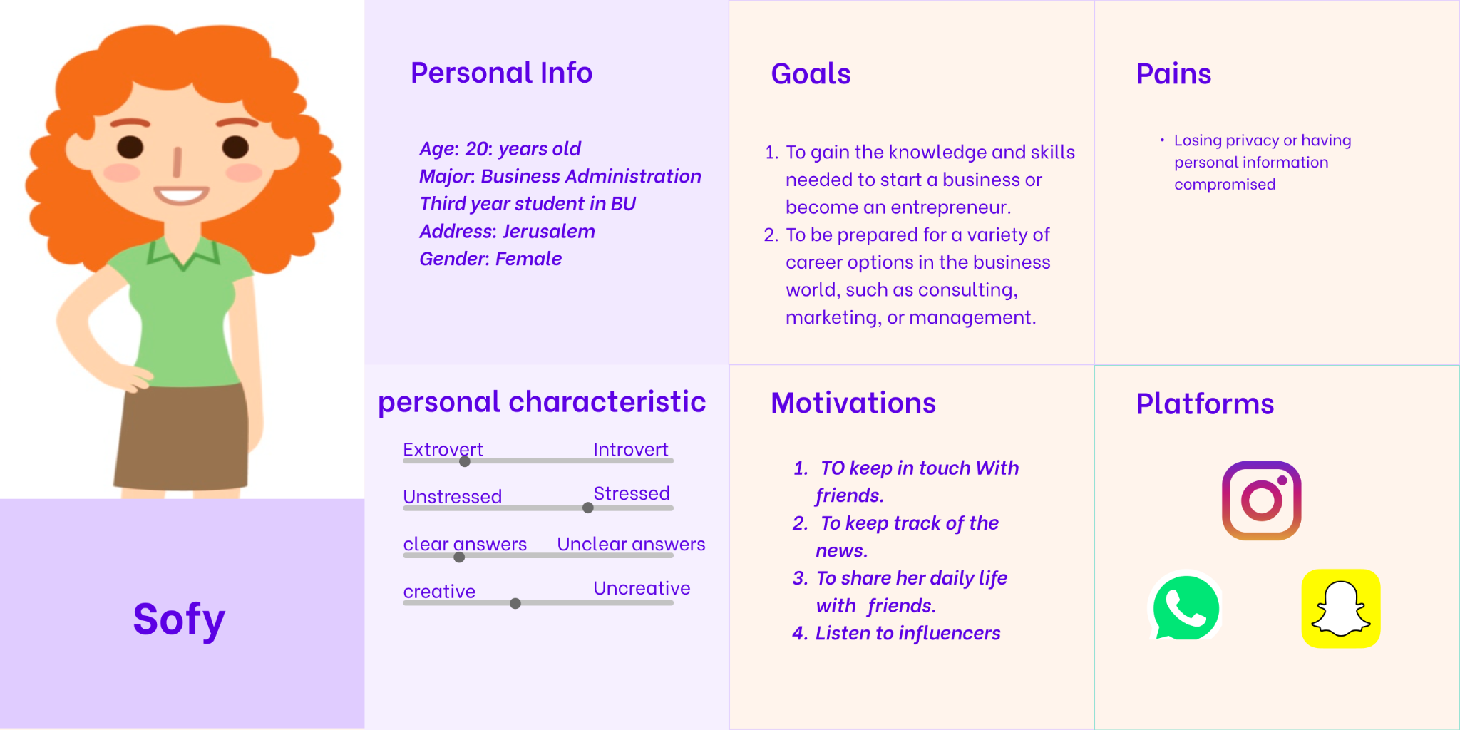

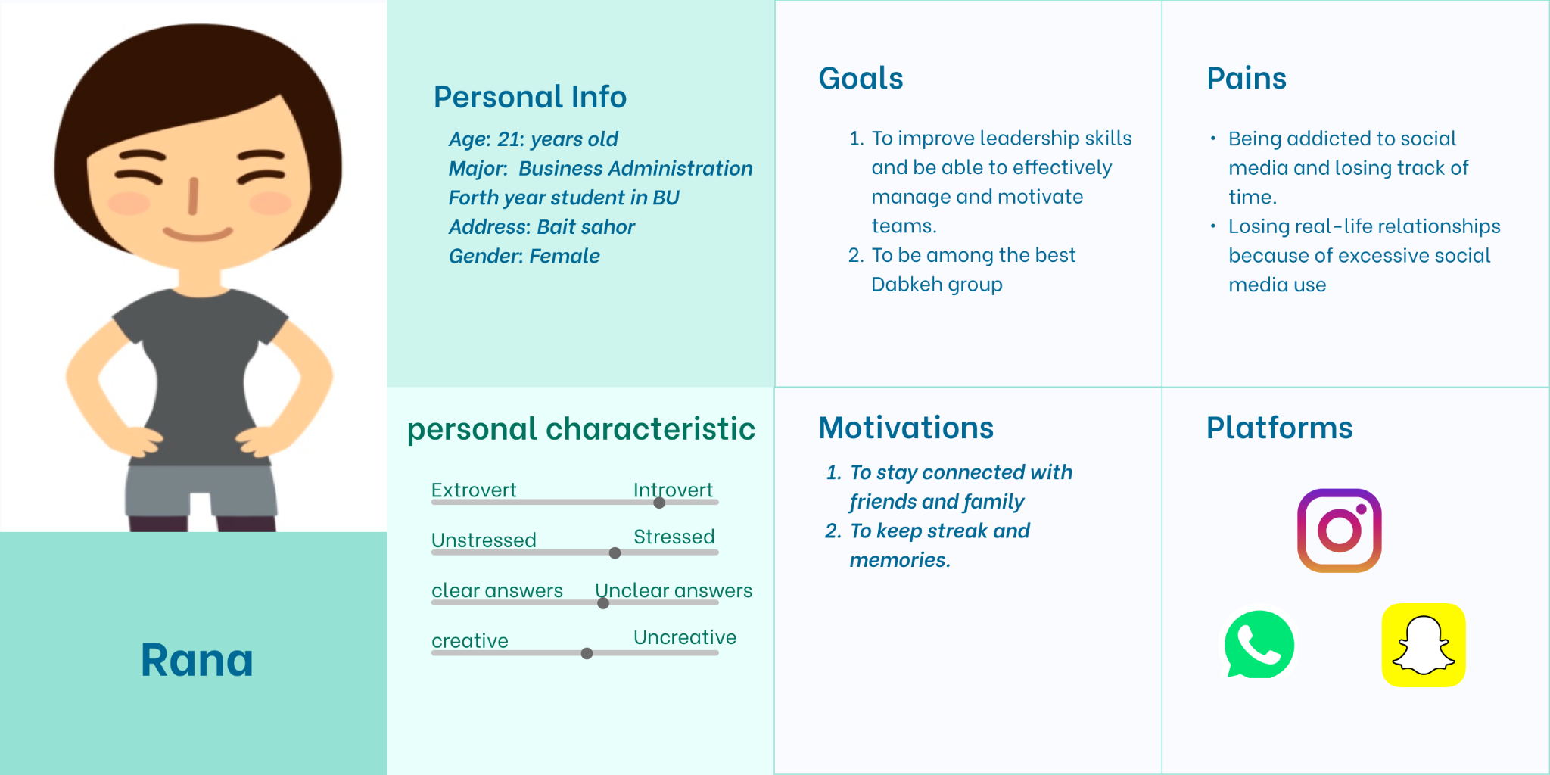

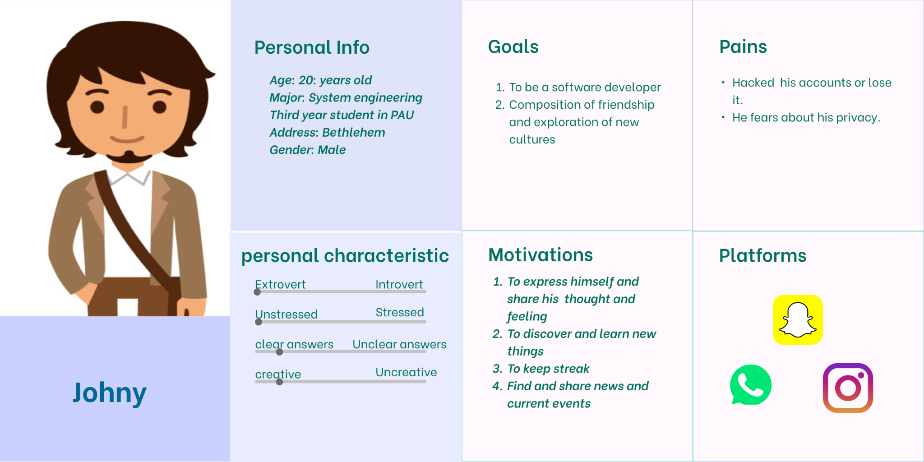

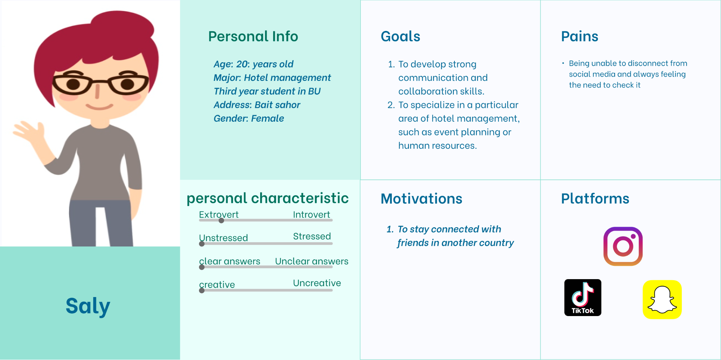

**Empathy Map:-**

**~~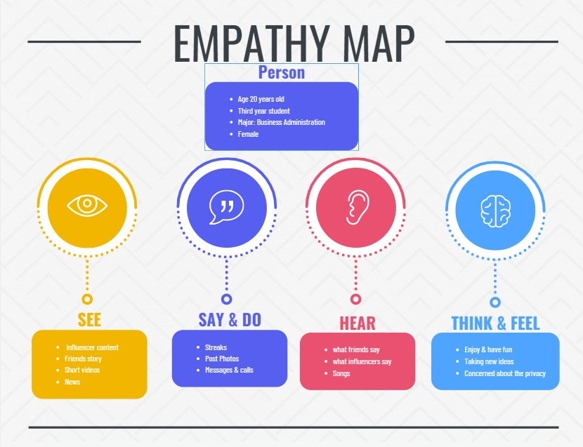~~**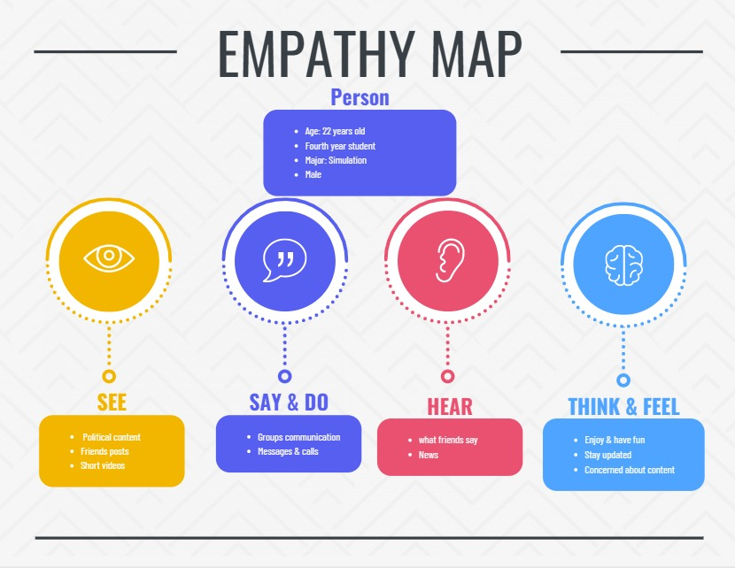

**Functional Requirements**

1. **Posting and sharing:** Users should be able to create and share posts, including text, images, and videos.
2. **Notification system:** Users should receive notifications for events such as when someone likes or comments or screenshots on their post.
3. **Messaging:** Users should be able to send private messages to other users and be able to send big data folders.
4. **Privacy controls:** Users should be able to control who can see their posts and profile information.
5. **Commenting and liking:** Users should be able to like and comment on other users' posts.
6. **Explore:** Users should be able to discover new users and content through a feature such as an "Explore" page.
7. **Video creation:** Users should be able to record and edit short videos, including adding music, text, and other special effects.
8. **Filters support:** Users should be able to include filters in their stories.
9. **Message delivery status:** Users should be able to see when their messages have been delivered and read by the recipient.
10. **Group chats:** Users should be able to create and participate in group chats with multiple contacts.
11. **Personalization:** Users should be able to personalize their profile and settings, such as their profile picture, bio, and privacy settings.

**Non-Functional Requirements:**

1. **Performance**: The platform should be fast and responsive, with minimal delays or downtime.
2. **Security**: The platform should be secure, protecting users' personal information and preventing unauthorized access to accounts, it also, includes attributes like Authorization, authentication, and Encryption
3. **Scalability**: The platform should be able to handle a large number of users and a high volume of activity without experiencing performance issues.
4. **Usability**: The platform should be easy to use and intuitive, with a clear and simple interface.
5. **Compatibility**: The platform should be compatible with a variety of devices and web browsers.
6. **Accessibility**: The platform should be accessible to users with disabilities, providing features such as alternative text for images and support for screen readers.
7. **Localization**: The platform should be available in multiple languages and support different cultural conventions.
8. **Availability**: The platform should be available for use at all times, or at least have high uptime. Users should be able to access the platform and use its features without interruptions or errors.
9. **Data Integrity**: prevents information loss and preserves the correctness of data entered into the system.
10. **Robustness**: by determining the conditions under which the system may receive unexpected or invalid input, such as incorrect data types or invalid parameter values.
11. **Maintainability**: we can ensure that the system is designed and built in a way that makes it easy to maintain and update over time.

**Conclusion:-**

In conclusion, we gathered all the information related to popular social media platforms selected from different college students by doing interviews with them using the laddering technique, to gain the most information possible about these platforms, and to reach our phones, the goal which is to elucidate both the good and the bad features by using the students' rates of these platforms and building an easy-to-understand RepGrid which contains the rates of each feature for every social media platforms selected, and to collect this information to build the perfect application featuring this good features.