

AAU Wallet

الأسم : عبدالحافظ محمد جدوع
الأسم : لؤي عصام القماز
الأسم : علاء جمال البايض
الأسم : حسن محمد أبوعيد

____________________________________________________________________________

Introduction
  - Purpose of the system
The purpose of this document is to present a detailed description of the AAU-Wallet System that we will be implementing for AAU Campus. It will explain the purpose and features of the AAU-Wallet system, the interfaces of the system, what the system will do, and how the students will be able to use the system for carrying out payment at any of the outlets/ business owner within the AAU Campus.

  - Scope of the system
This system will be an e-Wallet designed for use by the students of al ahliyya Amman university. The main objective is to provide the students/vendors at al ahliyya Amman university with a simple software that will enable easy, secure payment at all of the outlets available on campus and therefore facilitate a new technology-driven means by virtue of which, every student can do away with the burden of having to worry about carrying cash around campus.

  - Definitions, acronyms, and abbreviations
AAU: Al Ahliyya Amman university.
MTTR: mean time to repair.
MTBF: mean time between failures.

Proposed system
  - Overview
After logging in, the student can use the wallet and pay through it by QR-code, and he can benefit from offers and services, and he can transfer money to another student, he will be able to see the payment history of the e-wallet.

  - Functional requirements
Logging in
Req.1 The system shall provide the user with the ability to choose is he/she business owner or student.
Req.2 The system shall provide the student with the ability to login through university ID number and university password.

  - First time logging in, the system shall prompt the student to enter his/her phone number.
  - The system shall be send a 2-factor authentication code SMS to student phone numbers.
  - The student should be able to enter the 2-factor authentication code to the system to verify his/her account.
  - If the student login, The AAU-Wallet system shall show the student main screen.
Req.3 The system shall provide the business owner with the ability to login through business ID number and business password.
  - If the business owner login, The AAU-Wallet system shall show the business owner screen.

Student main screen
Req.4 The system shall provide the student with the ability to view the wallet balance.
Req.5 The system shall provide the student with the ability to view the offers.
Req.6 The system shall provide the main screen with ability to show menu.
Req.7 The menu shall be contain (dashboard, settings, contact us, instruction for use, logout).
Req.8 The student shall be able to send money to another student.
Req.9 The student shall be able to see last 3 payment history in main screen.
Req.10 The system shall provide the student with the ability to see all payment and transaction history.
Req.11 The system shall provide the student with the ability to pay with QR-code.

Offer screen
Req.12 The system shall provide the student with the ability to place order.
12.1 The system shall be able to deduction of the amount from the AAU-wallet balance.
12.2 The system shall be able to show the student the receipt.
12.3 The system shall be able to send the receipt SMS to student phone number.
12.4 The system shall be able to send the receipt to student email if it exists.

Setting screen
Req.13 The system shall provide the user with ability to change his/her phone number.
Req.14 The system shall provide the user with ability to change his/her password by entering current password and then the new password.
Req.15 The AAU-Wallet system shall provide setting with ability to student to add his/her Email.

Send money screen
Req.16 The system shall provide the student with the ability to send money to another student.
Req.17 The student shall be able to enter the received student id to send money.
Req.18 The student shall be able to enter the amount he/she want to send.

business owner screen
Req.19 The business owner shall be able to see the shop balance.
Req.20 The business owner shall be able to see all payments and orders in his/her shop.
20.1 The business owner shall be able to refund the money to student.
20.2 The business owner shall be able to change the amount he/she got just less than what the student paid.
Req.21 The business owner shall be able to make offers.
21.1 The system shall provide the business owner with the ability to enter the item picture.
21.2 The system shall provide the business owner with the ability to enter the item price.
21.3 The system shall provide the business owner with the ability to enter the discount amount.
21.4 The system shall be able to calculate the new price after discount.

Req.22 The business owner shall be able to see the shop statistics.
22.1 The system shall provide the business owner with the ability to view {hourly, daily, weekly, monthly, yearly} income by the AAU-Wallet.
22.2 The system shall provide the business owner with the ability to view {hourly, daily, weekly, monthly, yearly} orders made by AAU-Wallet offers.

  - Nonfunctional requirements

2.3.1 Availability
- The System must be Available from 8:00 Am to 5:00 PM.

2.3.2 Usability
- Ease of use of the application: The application should be easy to operate, easy to use and does not require more than two hours of training to use it.

2.3.3 Reliability
- Mean Time Between Failure (MTBF) once a year, 2000 hours.
- No more than 8 test runs out of 1,000 can be lost due to application failure.

2.3.4 Performance
- At a minimum, the system must be able to complete 1,000 message transactions per second.
- Server response time for rendering the user interface should be no more than 1 second.
- Average user interface load time should be no more than 3 seconds.

2.3.5 Maintainability
- In the event of a failure of the application system, the time to repair (MTTR) should not be more than 3 hours.

2.3.6 Security
- The system is linked to the university to confirm login.
- The system will send a text message to the phone number for the login process containing a 4-digit code for confirmation.

2.3.7 Portability
- The mobile wallet app must support the best operating system (Apple iOS, Android).

2.3.8 Efficiency
- On a standard workload, the application's CPU usage should be less than 35%.

2.3.9 Process requirements (Design Constraints)
- The system must use a database management system associated with the university.
- The system should be available in 2022.
- Java and associated technologies must be used for application development.

  - System models

Use case model

Student:

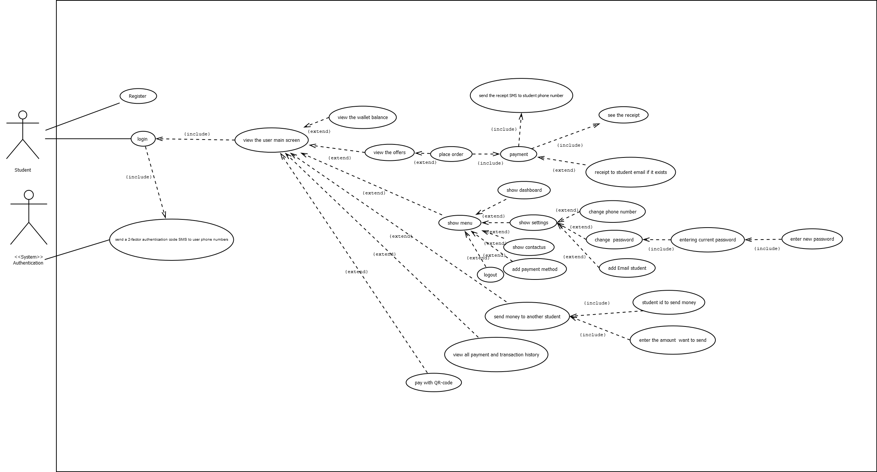

3.sequnce

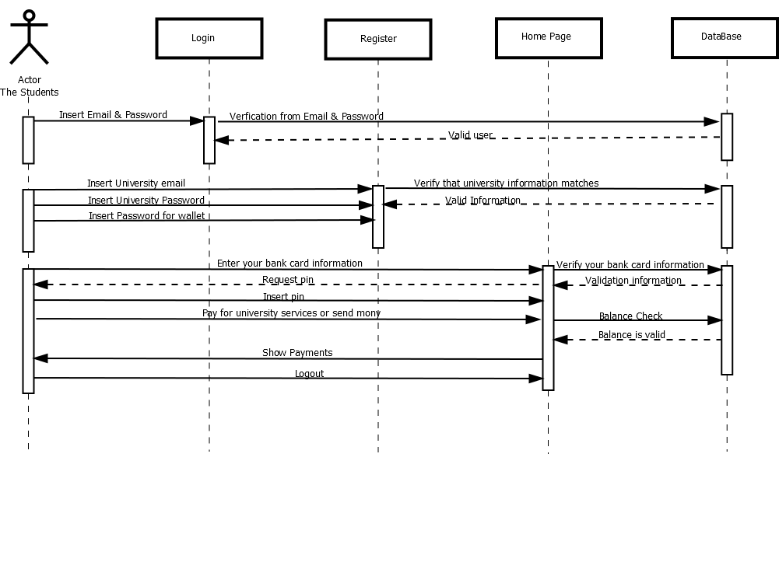

4.Class diagram

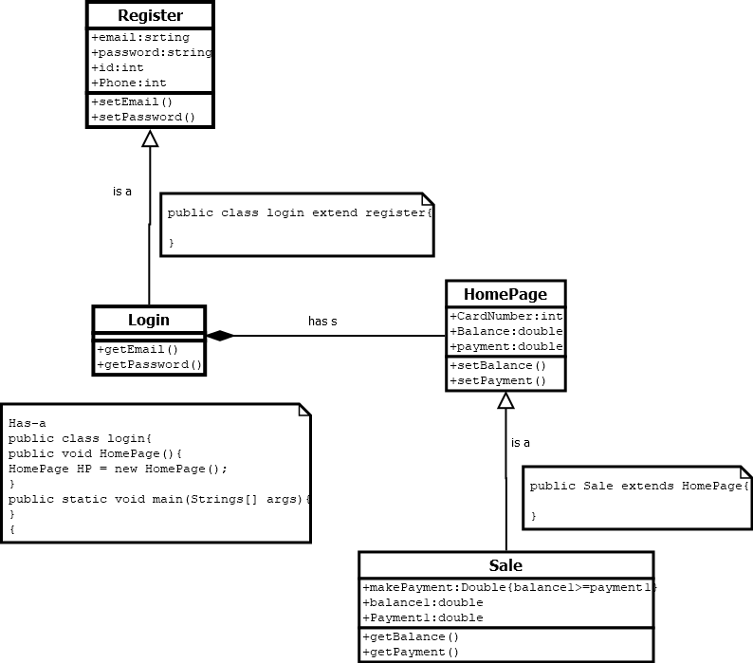

4.sketch

