DATABASE MID EXAM 18/11/2012

دكتور فواز الزغول

Q) Consider the transactions below .

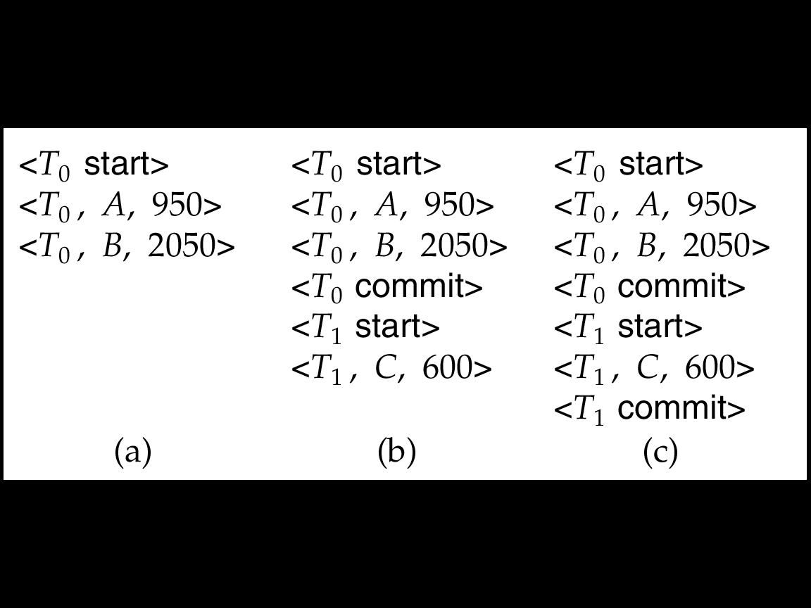

<*T*1**star**t>

<*T*1, *A*, 0, 10>

<*T*1 **commit**>

<*T*2 **start**>

<*T*2, *B*, 0, 10>

**<checkpoint > physically execute the above records**

<*T*2, *C*, 0, 10>

<*T*2  **commit**>

<*T*3 **start**>

<*T*3, *A*, 10, 20>

<*T*3, *D*, 0, 10>

<*T*3 **commit**>

<*T*4 **start**>

<*T*4, *A*, 20, 30>

**failure**

What will happen in :

1. (T0)

Undo (T0)

1. (T0 and T1)

Undo (T1) and Redo (T0)

1. (T0 and T1)

Redo (T0) and Redo (T1)

Q) if system never crash do we have an recovery system .

Yes , suppose there is earth quick

Q) Consider the relational Db like below .

Give an expression in the relational algebra to express each of the following queries

Employee( person name, street, city)

Works( person name, company-name, salary)

Company(company-name, city )

1. Find the names of all employee who live in city "Miami"

Π person name (6 city="Miami" (Employee))

1. Find the names of all employee whose salary is greater than $100,000.

Π person name (6 salary >100000(works))

1. Find the names of all employee who live in "Miami" and whose salary is greater than >$100,000.

Π person name (6 city="Miami" ^ salary >100000 (Employee works))

Q) R (A,B,C)

FD {A -> B , AB -> C }

1. Find all Candidate keys for relation R

( A ) is the candidate Key A+ = ABC

1. Find the minimal cover ( Canonical Cover )

( A->B ) , ( B->C )

1. Decompose the relation R into a set of relation that satisfy the definition of a 3rd normal form (3NF)

R1 = ( A->B )

R2 = ( B->C )

1. Is the relation lossless decomposition

R1 ᴖ R2 = B and B is a key for 2nd relation So it’s a **LOSSLESS JOIN**

Q) write the Definition of BCNF

X -> a € F+

If a is none-prime, prime

Then x must be a SK

Q)

-----True------- The Select, Rename and Project operation are called Unary.

----- True------We say that relation R and Relation T have the same arrity if they have the same number of keys.

------ True ---- The Cartesian Product (x), allows us to combine information form any two relation having at least on common attribute.

----------------- The Relation algebra ex : Π Ra ( 6 R.a = S.b (RXS)) is equivalent to the SQL

Select R.a from R.s Where R.a = S.b

----------------- When multiple users access the DB almost at the same time, we need to worry about atomicity problems.

------False---- The given Relation below has only **insertion anomaly**

Acc ( Sid, Act, Fee )

Key ( Sid )

|  |  |  |
| --- | --- | --- |
| Sid | Act | Fee |
| 100 | Skill | 200 |
| 150 | Swim | 50 |
| 175 | Sqush | 50 |
| 200 | Swim | 50 |

Q) write the Definition of BCNF

Examples of Division A/B



*A*

*B1*

*B2*

*B3*

*A/B1*

*A/B2*

*A/B3*