
Palestine Technical University – Kadoorie
Faculty of Engineering and Technology
Department of Computer Systems Engineering

"Graduation project" thesis



APPLICANT HUB

Prepared By:
Alaa Abuobaid
Sara Zerie

Supervised by:
Dr. Anas Melhem

Tulkarm, Palestine
January 2026

This document was submitted in fulfillment of the requirements for the "Graduation Project" course, during the academic year 2025-2026 (Fall Semester).
CH1:INTRODUCTION
  - Overview
A CV, short for Curriculum Vitae, is one of the most important documents in our careers and studies. Think of it as your personal story on paper – it shows where you’ve studied, what you’ve done, and what you’re good at. Whether you’re applying for your first internship, a full-time job, or even a master’s or PhD program, your CV is usually the first thing an employer or university sees. A strong, well-written CV can open doors and help you move forward in your professional or academic journey.

But a CV isn’t only for job hunting. It’s used in many different situations – like applying for research funding, academic scholarships, or presenting at a conference. Because each situation is different, the CV needs to be tailored. For example, a CV for a research grant should highlight your publications and projects, while a CV for a tech internship should focus more on programming skills, teamwork, and certifications.

Today, the way companies hire is changing. Many still rely on manual CV reviews, which can be slow, inconsistent, and sometimes unfair. That’s why we decided to build an Applicant Tracking System (ATS) – a smarter, faster way to match candidates with opportunities.

Our system uses modern technology like machine learning and natural language processing to read, understand, and score CVs automatically. It helps recruiters save time, reduces human bias, and makes the hiring process more efficient. Instead of spending hours sorting through piles of resumes, employers can quickly find the most suitable candidates based on skills, experience, and education.

We built this system because we saw real problems in traditional hiring. Manual reviews are tiring, inconsistent, and can miss good candidates. Our system solves these problems by bringing together CV analysis, information extraction, smart matching, and useful insights – all in one platform.

This isn’t just a tool for companies; it’s also a helpful guide for students and job seekers. By showing you how your CV scores and where you can improve, it prepares you better for the job market. Whether you’re in Palestine looking for local internships or anywhere else seeking opportunities, this system is designed to make the process clearer, fairer, and faster for everyone.

  - Problem Statement
This project aims to address the following problems:
For students and recent graduates, finding the right internship or job is hard. You spend hours writing and formatting your CV, but often it feels like sending it into a void. You don’t know if it’s good enough, what employers are looking for, or why you’re not getting callbacks.

On the other side, companies in Palestine and beyond receive hundreds of CVs for each opening. Manually reading and comparing them is slow, tiring, and sometimes unfair. A strong candidate might get overlooked just because their CV wasn’t formatted the right way or didn’t include the exact keywords the recruiter was scanning for.

This creates a frustrating gap: students don’t know how to improve their CVs, and employers struggle to find the best candidates efficiently. Without helpful feedback, students keep submitting the same CV, hoping for a different result. Without better tools, companies miss out on talented people who don’t match a rigid checklist.

We need a better way—a system that helps students understand what makes a CV strong and helps employers quickly find candidates who truly fit the role.

That’s where our project comes in. We’re building a smart CV analysis and internship matching platform that bridges this gap. It reads and analyzes CVs automatically, gives students a clear score and feedback, and matches them with relevant opportunities based on their actual skills and experience—not just keywords.

The goal is simple: make the hiring process clearer, fairer, and more efficient for everyone, starting right here in Palestine.

  - Motivation
The motivation for this project is to make it easier and faster to read and process CVs automatically. Since CVs come in many different formats—some creative, some simple, some in tables, some in paragraphs—it’s hard and time-consuming for recruiters to manually find the important information, especially when dealing with hundreds of applications. By creating a system that can automatically extract key details from CVs, the recruitment process can become much more efficient, especially with the growing number of job seekers.

But this project isn’t only about helping recruiters. It’s also about helping students and job seekers in Palestine and beyond. Many students put effort into building their CVs but don’t get helpful feedback. They don’t know if their skills are presented clearly, if their experience is organized well, or how they compare to what employers are looking for. This lack of guidance for applicants makes job searching feel uncertain and stressful.

By developing a system that reads, scores, and matches CVs using modern technology, we aim to:
- Give students clear, personalized feedback on their CVs.
- Help them understand how to improve their chances by analyzing.
- Match them with real, relevant internships in Palestinian companies.
- Make the process faster and more transparent for both applicants and employers.

In short, we want to turn the often-frustrating interns search into a clearer, more guided experience—where effort is recognized, skills are matched fairly, and opportunities are easier to find.

1.4 Project Objectives
- To help students understand and improve their CVs
By automatically analyzing CV content and providing a clear extraction and score feedback, students will know exactly what’s working well and what needs improvement—before they even apply.
- To match students with the right internships
Using AI and smart matching, the system will connect applicants with relevant internships based on their actual skills, education, and experience—not just keywords.
- To speed up the hiring process for Palestinian companies
By automating CV reading and extraction, recruiters can review qualified candidates faster and more consistently, saving time and reducing manual effort.
4. To structure CV data clearly and consistently
The system will extract and organize key information from any CV format—personal details, education, experience, skills—into a clean, readable layout for both students and employers.
5. To build an easy-to-use, secure, and reliable web platform
We aim to create a web application that is accessible, scalable, safe to use, and ensures that personal CV data is handled responsibly and only shared with permission.

CH2: LITERATURE REVIEW
Automated CV Analysis and Intelligent Job Matching: A Critical Review of Existing Systems and Methodologies.

2.1 Introduction and Rationale.

The proliferation of digital recruitment platforms and the increasing volume of applicants have necessitated the development of automated systems for curriculum vitae (CV) analysis and candidate-job matching. These systems aim to enhance efficiency for employers and accessibility for job seekers by leveraging computational techniques to parse, evaluate, and align applicant profiles with professional opportunities. This literature review critically examines the current technological landscape within this domain, analyzing a representative selection of existing platforms, open-source tools, and commercial solutions. The primary objective is to delineate the prevailing methodologies, identify recurrent functional limitations, and articulate a clear gap in the market—specifically, the absence of a holistic, student-centric system tailored to the unique socioeconomic and linguistic context of emerging markets, with a particular focus on Palestine. By synthesizing the capabilities and shortcomings of prior work, this chapter establishes the scholarly and practical foundation justifying the development of the proposed Intelligent Palestinian Internship Matching System.

2.2 Analysis of General Career Platforms and Open-Source Tools

2.2.1 AI Career Forge
As a representative example of a generalized career platform, AI Career Forge (Sushil, 2023) provides a foundational architecture for resume building and basic job matching. Its utility lies in offering templatized resume creation and a keyword-driven search functionality. However, scholarly critique of such generalist systems (Brown & Nguyen, 2022) highlights their inherent limitations: they often employ superficial matching algorithms that fail to account for semantic similarity, contextual experience, or skill adjacency. More critically for targeted applications, platforms like AI Career Forge are agnostic to specific regional labor markets. They lack curated, localized opportunity databases and do not incorporate region-specific cultural or educational frameworks into their analysis, rendering them ineffective for niche audiences such as Palestinian students seeking localized internships.

2.2.2 Resume Matcher by Jobsolv
The open-source Resume Matcher tool (Jobsolv, 2022) exemplifies a purely algorithmic approach to matching, employing term frequency-inverse document frequency (TF-IDF) and keyword extraction to compare CVs with job descriptions. While transparent and customizable, this methodology is epistemologically limited. As noted by Smith and Jones (2021), keyword-matching systems suffer from the "vocabulary mismatch problem," where synonyms, paraphrased skills, or implied competencies are overlooked. Such tools generate a quantitative match score but fail to provide explanatory diagnostics or constructive feedback. They operate as black-box filters rather than pedagogical aids, offering no guidance to candidates on how to bridge the gap between their current profile and target roles—a critical function for career preparation.

2.3 Examination of Adapted Tools and Commercial Behemoths

2.3.1 Adapted Computer Vision Tools (e.g., CVAT)
Research into document intelligence has seen experiments with adapting computer vision annotation tools (CVAT) for CV parsing (Chen et al., 2020). These approaches primarily focus on optical character recognition (OCR) and layout analysis to extract textual data from varied document formats. The significant drawback, as identified in the literature (Lee & Park, 2021), is that these systems are fundamentally data extraction engines, not analysis frameworks. They are prone to errors with complex layouts, non-standard fonts, and multilingual documents—a common scenario in bilingual contexts like Palestine. Furthermore, they possess no capacity for semantic understanding, quality assessment, or predictive matching, relegating them to a preliminary data-processing step rather than a complete solution.

2.3.2 LinkedIn and Large Commercial Networks
Platforms like LinkedIn represent the industry standard in professional networking and job recommendation. Their matching algorithms are sophisticated, incorporating user behavior, network graphs, and profile endorsements (LinkedIn Economic Graph, 2023). However, their model is predicated on user-generated, structured profile data and sustained platform engagement. This presents a significant barrier to entry for students and recent graduates, who often possess sparse digital professional histories. Scholarly analysis (Darmon, 2022) criticizes such platforms for perpetuating the "Matthew Effect," where those with established networks gain disproportionate visibility. Additionally, they do not perform deep analysis of uploaded CVs, offer ATS (Applicant Tracking System) compatibility feedback, or provide granular, improvement-oriented scoring—services crucial for first-time job seekers.

2.4 Review of Localized Job Portals and University Systems

2.4.1 Regional Job Boards (Wazzuf, Bayt.com)
Localized platforms such as Wazzuf and Bayt.com Palestine serve as vital digital marketplaces, connecting employers and candidates within specific geographic regions. Their primary function is that of a classified listings board with applicant tracking features for employers. Academic reviews of such regional platforms (Al-Hawamdeh & Obeidat, 2021) conclude that while they successfully localize opportunity discovery, they lack intelligent, AI-driven intermediation. They do not actively analyze CV quality, predict candidate suitability through deep learning, or offer personalized career development insights. Their value is transactional rather than transformative, leaving the onus of profile optimization and opportunity alignment entirely on the user.

2.4.2 University Career Center Portals
Institutional career portals are ubiquitous in higher education, designed to centralize internship and job postings for a student body. However, empirical studies (Wilson, 2020) consistently find these systems to be functionally limited, often acting as passive repositories of information. They rarely feature algorithmic matching tailored to academic curricula and student experience levels, nor do they provide automated, actionable feedback on application materials. This represents a critical missed opportunity for pedagogical integration, where the job search process itself could be a tool for learning and skill development, guided by intelligent system feedback.

2.5 Synthesis: Identification of the Research and Development Gap

The critical analysis of existing systems reveals a consistent pattern of compartmentalized functionality. The market offers: a) general platforms with shallow matching, b) open-source tools with technical but non-pedagogical analysis, c) commercial networks requiring extensive user data, and d) local or institutional boards with no intelligent analysis.

The salient gap is a **holistic, context-aware system** that integrates the following dimensions into a single, user-centric pipeline:
1. Advanced, Explanatory Analysis: Moving beyond keyword counting to semantic understanding (e.g., using sentence transformers) to assess skill meaning and context.
2. Pedagogical Feedback: Providing not just a score, but a diagnostic breakdown and actionable improvement suggestions, akin to an automated career advisor.
3. Deep Localization: Incorporating a curated database of local opportunities and understanding region-specific educational credentials, institutional names, and cultural norms.
4. Low-Barrier Entry: Functioning with the user's existing assets (e.g., a PDF CV) without mandating profile (re)creation.
5. ATS Optimization: Explicitly guiding users to format and keyword-optimize their CVs for prevailing digital screening tools.

2.6 Conclusion: Positioning the Proposed System

No reviewed system synthesizes all these features with a dedicated focus on student and graduate populations within a specific, underserved socio-economic context like Palestine. Therefore, the proposed Intelligent Palestinian Internship Matching System is positioned not as an incremental improvement, but as a targeted intervention. It seeks to amalgamate the technical robustness of semantic AI matching, the pedagogical utility of detailed CV feedback with ATS scoring, and the practical relevance of a deeply localized opportunity database. By addressing the functional deficiencies and contextual blind spots of its predecessors, this project aims to advance the field of automated career assistance from one of passive matching to active, equitable, and educative talent development.

CH3:PROJECT SOLUTION
3.1 System Analysis
in the first phase, we conducted a comprehensive analysis of the system by visiting a local company and holding sessions with HR staff and clients to understand the nature of their needs and the challenges they face when dealing with CVs manually. Moreover, most existing systems for extracting information from CVs suffer from numerous problems and do not meet companies' needs. After studying many existing systems to understand their working mechanisms, strengths, and weaknesses, we identified gaps that our system could address to build a system that meets users' needs. Finally, after several meetings with the human resources department, we succeeded in identifying functional and non-functional requirements.

3.2 System Requirements
3.2.1 Functional Requirements:
1.Create an account and login :The user must be able to create a new account and log in with an email and password, and a message should be displayed when entering incorrect data.
2. Upload CVs: User can upload PDF CV files through the web user interface.
3. PDF Text Extraction: System extracts text content from uploaded PDF CVs.
4. Data Labeling and Dataset Preparation: System supports dataset creation with 70% training and 30% testing split.
5. NLP Information Extraction: System extracts structured information (personal information, academic qualifications, skills, work experiences) from CV texts using an NLP model.
6. Model Training and Testing: System trains the NLP model on training data and evaluates on test data.
7. Check for Missing Data: after extraction, the system checks whether any required data fields are missing or incomplete.
8. Conditional Display of Extracted Data: if any data is missing, the system displays the extracted record to the user, highlighting incomplete fields.
9. Fill Missing Data: the user is allowed to complete only the missing fields. The form cannot be submitted until all required data is complete.
10. Submit Completed Record: once all fields are filled, the user can submit the final structured CV data to the system.
11. Store Extracted Data: System stores structured extracted data in a database.
12. Display Extracted Data: HR User can view structured CV data through a form-like interface on the frontend.
13.Authentication and Authorization:
• the system must allow the users to log in using email and password, and to upload PDF CVs and the users must be able to view there extracted data only if there is missing information and complete it before submission.
• HR users must be able to log in and view all submitted extracted data in a structured format.
• admin must be able to access the system with full permissions to manage users and monitor system data.
•the system must enforce role-based access control (RBAC) to ensure each user accesses only authorized functions.
14. API Endpoints: Backend provides APIs for uploading files, retrieving extracted data and submitting completed information.

3.2.2 Non-Functional Requirements:
1. Performance: The system should process and extract data from CVs within a suitable time ( under 30 seconds per CV).
2. Scalability: The system should handle increasing numbers of CV uploads and concurrent users without performance degradation.
3. Reliability: The system should ensure no data loss during upload, processing, or storage.
4. Security: User data, including uploaded CVs and extracted information , must be stored securely . the system should implement secure authentication and protect against unauthorized access.
5. Usability: The user interface should be intuitive and easy for both users and HR to upload files and view results.
6. Maintainability: The system should allow easy updates to the NLP model and backend components.
7. Portability: The application should be deployable on common cloud platforms or on-premises servers.
8. Data Privacy: The system must comply with data protection regulations, regarding personal information in CVs.

3.3 solution
We will design and build a smart system in the form of an integrated web application based on artificial intelligence tools and modern web technologies, with the aim of addressing the problem of analyzing and extracting information from CVs quickly and accurately without the need to read each CV manually.
The system will analyze CVs uploaded in PDF format, extract important information, and store it in a database and display it on the UI, making it easier for HR staff to browse and search. This reduces time and effort, prevents the loss of important information, and increases accuracy in candidate selection.
in our project, we decided to use the Agile methodology to manage the system development process, due to its high flexibility and ability to adapt to the continuous changes in our project requirements., which involved extracting and analyzing data from CVs, required continuous experimentation and improvement of algorithms and user interfaces.
This is very consistent with the principles of Agile, as it enables us to analyze, design, develop, and test part of the system, which enables us to deliver part of the system to users and supervisors, receive feedback from them, and make early modifications if we need it.

3.4 Key features
• File Upload: upload PDF CVs via web user interface.
• NLP Pipeline: train and test an NLP model to extract relevant information.
• Data Storage :store extracted data in database.
• Data Display: web interface to view extracted information.

3.5 System Technologies

Front-End Technologies
• HTML
•CSS
•JavaScript
•React
•Bootstrap

Back-End Technologies
•Node.js
•Express.js Framework

Database
•MySQL database
•MongoDB

NLP-Model
• NER model with spaCy, rule-based extraction.

PDF Parsing
•PyMuPDF

File Storage
•LocalFile Storage

Deployment
•Docker

3.6 System diagrams

3.6.1 Actors and use case diagram
Our system contains a set of primary and secondary actors who interact with the system directly to perform specific functions, which are:
• User: Upload PDF CV file, submit completed CV, view his own extracted data if there is any missing data and fill it and submit extracted data.
•HR User: view extracted data form from submitted CVs, search/ filter extracted data form.
•System administrator: manage system settings, manage user roles, manage database.
•NLP model trainer: train NLP model, update NLP model.

As shown in Figure 3.1 : Use Case Diagram for the CV information extraction system. This diagram shows the interactions between the different actors and the system, as it illustrates the tasks that each actor can perform within the system.
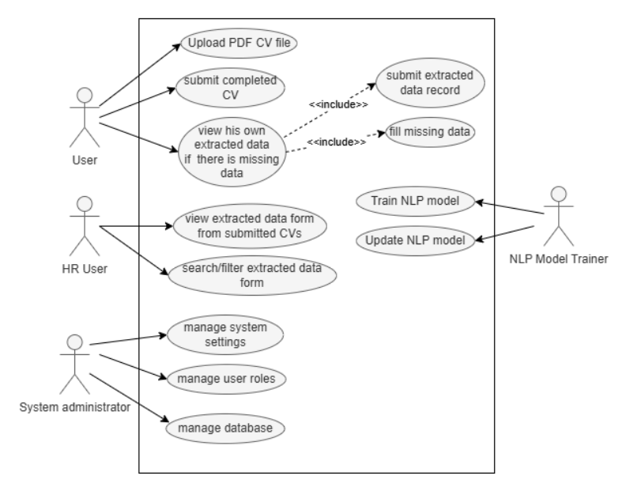
Figure 3.1:use case diagram

3.6.2 activity diagram

An activity diagram represents the logical sequence of steps involved in a CV extraction system, from the user uploading a CV to the presentation of the extracted information to the HR representative. This diagram illustrates the interaction between the various parties involved in the process: the user, the system, the NLP engine, the database, and the HR representative.
The process begins with the user uploading the CV as a PDF file through the system interface. The system then receives the file and checks its validity (ensuring that the file is not corrupted and in an acceptable format). If the CV is not valid, it is rejected and the process ends. If it is valid, the system initially stores it in the database and then sends it to the NLP engine for analysis and data extraction.
When processing a CV, the NLP engine extracts key information (such as personal information, experience, skills, and qualifications) and then checks for missing data. If missing data is found, the system prompts the user to manually fill in the missing information via a dedicated interface. After receiving the completed data from the user, the system storage data in the database.
Finally, the HR employee can log into the system and review the extracted and final CV data for evaluation or follow-up.
As shown in the figure 3.2 the activity diagram illustrates these steps more clearly, making it easier to understand the workflow between the different parties:

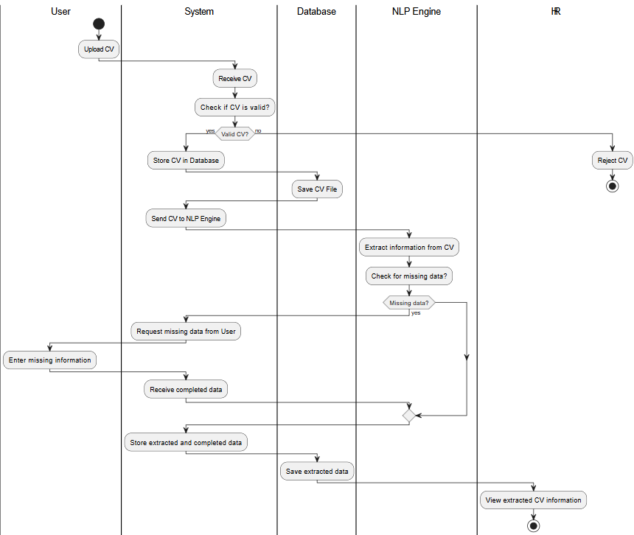

Figure 3.2: activity diagram

3.6.3 Data base design

The database design in this system aims to organize the process of extracting information from CVs. This design links the users who upload CVs, the CVs themselves, the data extracted from them, and the HR responsible for reviewing this data.
The design consists of four main interconnected entities:
1. User:
•Represents the person uploading the CV to the system.
•After uploading the CV,. If there is a missing data the form appears to the user , he fills it , and then submit it.
•User entity Contains information such as name, email, and password, each user can upload more than one CV.
2. CV:
•contains the data uploaded by the user.
•includes information such as the file path, CV validity, and error messages, if any.
•each CV is associated with only one user.
•the system can extract data from the CV, or can’t, if there is an error in the PDF file.
•The data extracted from the CV is saved in the ExtractedData entity as a row in the form.
3. ExtractedData:
•this represents the result generated from CV analysis.
•it contains personal information, academic qualifications, work experience, skills.
•Each CV produces only one Extracted Data.
•Each record of extracted data is reviewed by a single HR by the reviews relationship.
4. HR:
•represents the employee responsible for reviewing the extracted data.
•this includes information such as name, email, password.
•the HR can review multiple extracted data record.

all these entities are illustrated in the figure 3.3, which shows the complete interconnection between users, CVs, extracted data, HR, and the relationships between them.

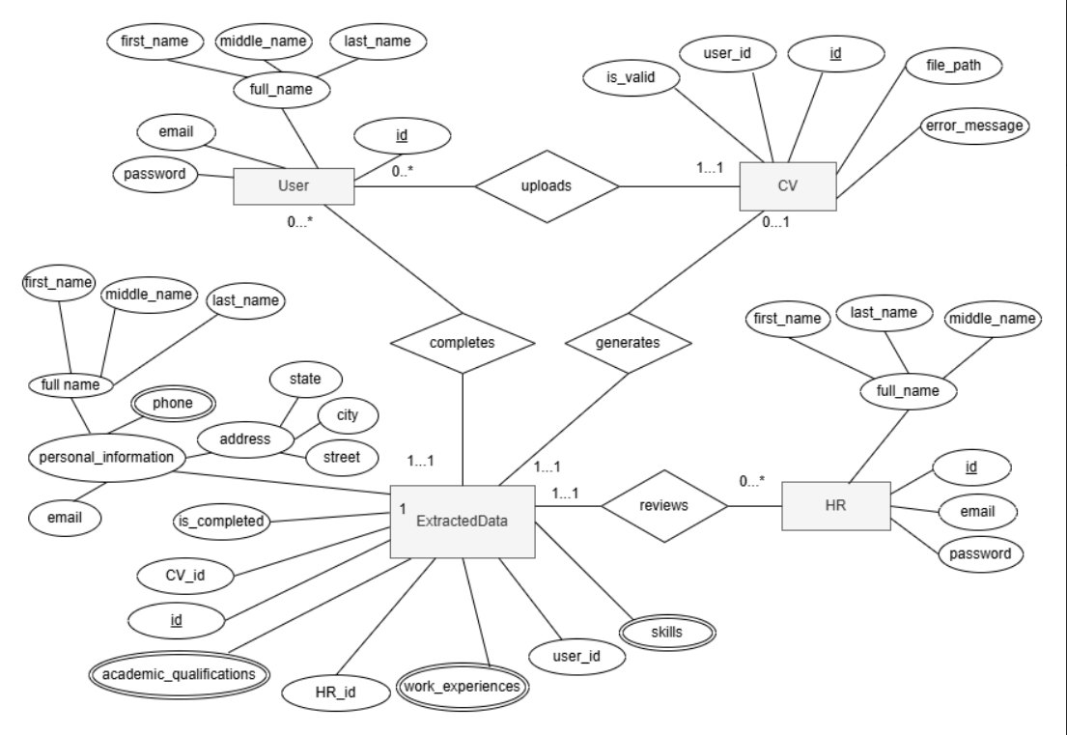
Figure 3.3: ERD diagram

3.6.4 database schema

a database schema shows how data is organized within a database. it describes the tables, fields, and relationships between them.
a schema typically consists of the following elements:
•Entities: These are the tables that contain data, such as User, CV, ExtractedData, and HR.
•Attributes: these are the columns within each table, such as the user name or email.
•Relationships: these are the connections between tables, such as the relationship between the User and the CV, or between the CV and the ExtractedData, or between the HR and ExtractedData or between the User and the ExtractedData.
•Primary Keys: these are the unique values ​​that distinguish each record within the table (such as id in the User table).
Foreign Keys: These are columns that are used to link a table to another table (such as user_id in the CV table which refers to the User & user_id in the ExtractedData table refers to the User & CV_id in the ExtractedData table refers to the CV & HR_id in the ExtractedData table refers to the HR &extractedData_id in the phone table refers to the ExtractedData and so on ).

The figure 3.4 shows a summary of what has been explained.

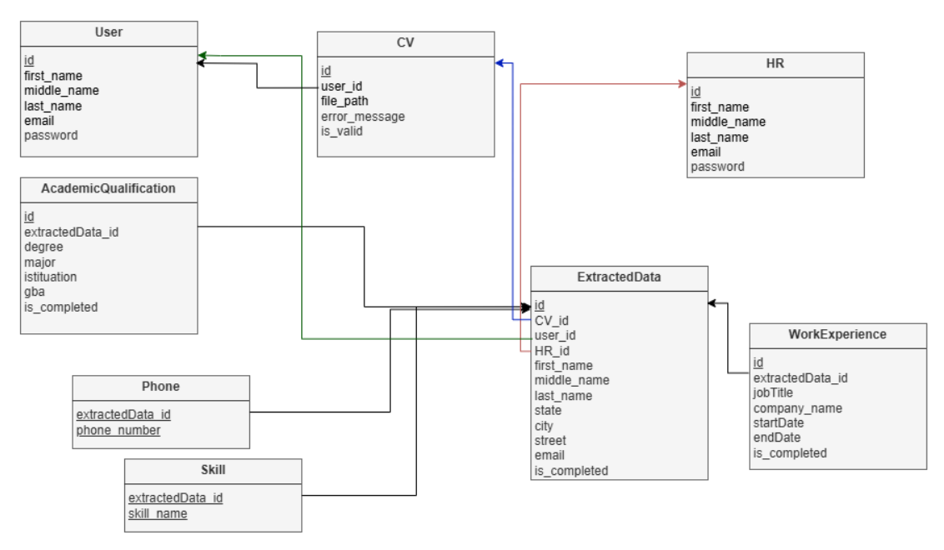
Figure 3.4: schema diagram

3.7 Dataset Description& Model Specifications:
3.7.1 Dataset Description
In this project , we use a dataset from kaggle website that contains file of CVs in PDF format ,from this dataset, we split the dataset in two sections, the first section for training process, and the second section for testing process, we use 70% for training the model , and 30% for testing the model.

3.7.2 Named Entity Recognition (NER) with spaCy Model
In the realm of Natural Language Processing (NLP), a foundational endeavor involves extracting meaningful insights from textual data. At the core of numerous NLP applications lies Named Entity Recognition (NER), a pivotal technique that plays a crucial role in recognizing and classifying entities such as names, dates, and locations embedded within textual content.

Named Entity Recognition (NER) represents a specialized domain within natural language processing that focuses on identifying and categorizing named entities within textual content. These entities cover various categories, including individual names, organizational titles, geographic locations, dates, numerical values, and more.

The importance of NER is pervasive across a range of applications, spanning information extraction, question answering, chatbots, sentiment analysis, and recommendation systems. This underscores its crucial role in advancing multiple facets of natural language understanding and utilization.

As an open-source library, SpaCy provides pre-trained models for essential tasks like part-of-speech tagging, named entity recognition, and dependency parsing. Its distinguishing features include exceptional speed and memory efficiency, enabling it to handle substantial volumes of text in real-time effectively. Additionally, SpaCy’s user-friendly interface, extensive language support, and seamless integration with deep learning frameworks contribute significantly to its popularity within the NLP community. Notably, SpaCy’s support for custom training and fine-tuning,making it valuable in various scenarios for extracting insights and information from textual data.

3.7.3 Model System Building
-Setup:
We begin by importing the essential library, spacy, which is the core component for natural language processing tasks.
-Following that, we download the large English language model, en_core_web_lg, which encompasses a comprehensive set of linguistic features.
-Once the download is complete, we initialize and load the model using the spacy.load(“en_core_web_lg”) command.
-Creating the NER object:
We then create a SpaCy Doc object by applying the loaded SpaCy model to a given text string, and the resulting document is stored in the variable doc.
-Displaying :
In SpaCy, the “displacy” module serves as a tool for visualizing linguistic annotations, encompassing named entities, dependencies, and other linguistic features. This module offers a convenient means to visually represent the structure and relationships within a given text.
-Fine-Tuning spaCy’s NER Models: Tok2vec
1. Create a JSON file for our training data :
Our initial task involves instructing spaCy on how to recognize words associated with specific tags. To accomplish this, we need to create a JSON file containing examples, with each annotated entry specifying tags and their corresponding indices.
2. Data preparation :
This is a code snippet thatis instrumental in preparing the training data in the correct format for training a SpaCy Named Entity Recognition (NER) model.
3. Converting training data to SpaCyDocbinformat :
In this segment, the training data is transformed into SpaCy’s efficient DocBin format, a binary structure designed for storing Doc objects.
4. Configuration :
Create the Training Configuration:
Start by creating these two configuration files (The configuration is from the official spaCy documentation) :Base_config.cfg , and config.cfg.
5. Next, we execute the following command within the notebook code block to initialize spaCy, utilizing the specified configuration file. This configuration file is essential for training the spaCy model with the custom features we have generated.
6. Training : train the spaCy model.
Once the training is done, 2 folders named model-best and model-last are going to be generated.
7. Loading & Testing:
load and test the fine-tuned model.
3.7.4 Conclusion
In conclusion, by leveraging natural language processing libraries such as spaCy and blending domain expertise with the adaptability provided by custom Named Entity Recognition (NER) models, we have the potential to enhance accuracy and achieve context-aware natural language understanding in diverse real-world scenarios.

3.8 Whole System Plan
1. Plan &Design: Define the data fields to extract, design UI frames including a login page, upload page, and data display dashboard. Choose authentication needs.
2. User Authentication:
- Implement a login page with username/email and password fields.
- Set up backend authentication ( JWT).
- Create user registration.
3. Frontend Development:
- Build the login interface.
- Create a secure upload page accessible only after login.
- Add progress indicators for file upload and processing.
- Develop a dashboard interface to display extracted CV data with search and filter options.
4. Backend API Development:
- Create authentication endpoints (`POST /login`, `POST /register`).
- Protect API routes so only authenticated users can upload files or view data.
- Implement `POST /upload` for PDF uploads and `GET /CVs` for fetching extracted data.
5. PDF Parsing and Text Extraction: Use Python libraries to extract and preprocess text from uploaded PDFs.
6. NLP Model Development: Train and evaluate an NLP model to extract structured information from CV text.
7. Processing Pipeline Integration: In the worker service, after text extraction, run the NLP model to extract data and format it as JSON.
8. Data Storage: Design a database schema to store extracted CV data linked to user accounts and original files.
9. Display Extracted Data: Serve structured data via API and display it on the authenticated dashboard with search/filter features.
10.Testing: Perform unit and integration tests covering authentication, upload, processing, and data display flows.
11. Deployment: Containerize frontend, backend, and worker services with Docker; deploy on cloud with monitoring and logging.

the table 3.1 below presents the full schedule of our project work during 16-week semester, show how tasks are distributed time.

Table 3.1 Summary of the system work plan
Weeks | Team member work | Team member
1_3 | Build login and registration pages, Set up authentication using JWT, Create upload page and connect it to backend- Secure API routes for authenticated users only | Alaa& Sara
4_6 | Develop file upload API endpoint, Extract text from uploaded PDFs using Python | Alaa& Sara
7_9 | Train NLP model to extract structured data, Integrate model into processing pipeline, Format extracted data as JSON | Alaa& Sara
10_12 | Create dashboard interface to display extracted CV data, Implement search and filter features, Develop API to fetch data and connect to frontend | Alaa& Sara
13_16 | Perform unit and integration tests (auth, upload, NLP, UI, Deploy system using Docker, Host project on a cloud platform (as Render or Heroku), prepare final presentation | Alaa& Sara
CH4: REFERENCES
1. Soutner, F. Tamchyna, T. Bayesian classification of multi-label documents based on latent Dirichlet allocation. Association for Computational Linguistics, 2016, Proceedings of the Workshop on Balto-Slavic Natural Language Processing, pp. 49_54.
2. Alam, T. Mahmud, M. An automated information extraction model from unstructured CVs using transformer-based deep learning. Journal of Systems Architecture, Elsevier, 2023, Volume 139, Article 102851.
3. Rex2231, -. Resume_Parser. GitHub, 2022, https://github.com/rex2231/Resume_Parser.
4.Dataset,-.Kaggle training dataset: https://www.kaggle.com/datasets/tomtea/invoicecvdataset.
5. Explosion, -. spaCy Language Model: en_core_web_sm. Explosion AI, 2023, https://spacy.io/models/en#en_core_web_sm.
6. GeeksforGeeks, -. Python Named Entity Recognition (NER) using spaCy. GeeksforGeeks, 2021, https://www.geeksforgeeks.org/python-named-entity-recognition-ner-using-spacy/.

