
Palestine Technical University – Kadoorie
Faculty of Engineering and Technology
Department of Computer Systems Engineering

"Introduction to graduation project" thesis



DESIGNING CVINFORMATION EXTRACTION PLATFORM

Prepared By:
Alaa Zeyad Abuobaid
Sara Ahmad Zerie

Supervised by:
Dr. AnasMelhem

Tulkarm, Palestine
May 2025

This document was submitted in fulfilment of the requirements for the "Introduction to Graduation Project" course, during the academic year 2024-2025 (Second Semester).
Ch1:Introduction
1.1Overview
The CV has main role in our daily life, it's important for the recruitment process, it has written in different formats that make the reading process hard, wasting a lot of time on reading and tracking the items that suitable for specific job .With the expansion of unemployment and required CVs, it's important to make this process automatically achieved by computers. Accordingly, in this project , we want to develop a system that extracts important informations from CVs automatically.

1.2 Problem Statement
This project aims to address the problem that building a user-friendly web application that helps HR teams manage and review CVs more efficiently. The app will allow HR staff to securely log in, upload PDF CVs, and have those CVs processed automatically in the order they arrive(queue order). Then Using natural language processing (NLP), the system will extract important details that include personal information, skills, academic qualifications and work experiences. All extracted data will be stored and displayed in an organized dashboard, making it easy for HR to search, filter, and review candidates.

1.3 Motivation
The motivation for this project is to make it easier and faster to read and process CVs automatically. Since CVs come in many different formats .it's hard and time consuming to find the important information manually for a large number of CV's. By creating a system that can automatically extract key details from CVs , the recruitment process will become more efficient , especially with the growing number of job seekers.

1.4 Project Objectives
1.To enhance choosing the highest suitable person for specific job position according to extracted information.
2. To reduce the unemployed people by making the decisions more rapidly than before, so this increase finding jobs for a lot of people .
3. To support the efficiency of data included in CVs , by extracting structured and ordered information.
4.To provide helpful web-based-application ,scalable ,safe, and authorized extracted data.

Ch2: Literature Review
The recent advances in Natural Language Processing have made it possible to
understand the diﬃcult patterns in textual corpus. This led to achieving the state of the art result in diﬀerent tasks of NLP such as Named Entity Recognition(NER),Text Classiﬁcation, Part of Speech tagging and Information
Extraction. As information extraction deals with extracting informative texts
from a given document, it has been used for many commercial purposes too. One
of which is CV parsing. Several commercial products related to HR automation
likeSovren ,Daxtra , Akken and many others have been performing CV
parsing.
There are several methods implemented for CV parsing, namely entity based
information extraction methods, rule based information extraction methods, statistical information extraction methods, learning based methods. In previous
implementations, CV parsing was performed by building a knowledge base system
with a huge amount of data and retrieving keywords from a new CV by looking
up on the knowledge base . Big data tools combined with text analytical tools
and Named Entity recognition have also been applied for CV parsing which
was able to achieve F-measure around 95% on CV parsing.
In a paper which is titled “Application of Machine Learning Algorithms to
an online Recruitment System”, similar research has been done with the vision
of making online recruitment eﬀective and eﬃcient. The author has tried multiple approaches like Linear Regression, M5 Model Tree, REPTree, SVM with
polynomial kernel and SVM with PUK universal kernel. Among all of these approaches, the author states that the SVM with PUK universal kernel gave the
best result.
2.1 RINX System
(Resume Information and Knowledge eXtractor)
RINX is a prominent system for information extraction from unstructured CV documents, it is a hybrid system that combines Natural Language Processing (NLP) techniques with ontology-driven knowledge modeling to semantically extract and organize information from CVs. It utilizes both rule-based methods and deep learning models, specifically BiLSTM (Bidirectional Long Short-Term Memory) networks, to perform named entity recognition (NER) and to identify relevant CV sections such as personal information, education, work experience, skills, and certifications. The system supports various file formats, including PDF, DOCX, and plain text, making it adaptable to real-world use cases. RINX is also capable of handling multilingual content, leveraging language-agnostic embeddings for cross-lingual generalization. The extracted information is structured into a unified, ontology-based format that can support advanced applications like intelligent CV ranking and job-candidate matching.
2.2 CV parser by Rex2231
CV Parser by Rex2231 is an open-source system designed to extract structured information from CVs using NLP techniques. The system primarily relies on the SpaCy library, which is a powerful NLP toolkit in Python, and it uses a custom-trained Named Entity Recognition (NER) model to identify entities such as name, email, phone number, education, skills, experience, and projects. Unlike systems built with deep neural networks like CNNs or RNNs, this parser is based on a rule-based and statistical NLP approach using SpaCy’s pipeline.
The parser supports multiple document formats, including PDF and DOCX, and is designed to be flexible for CVs with various layouts. The system is currently trained and optimized for English-language CVs only, It outputs structured data in formats like JSON or CSV, enabling easy integration with other HR or recruitment platforms. Although the system does not use deep learning models such as CNN or RNN, its reliance on SpaCy's efficient NLP pipeline makes it lightweight and relatively fast in real-time applications.
2.3 DocTag2Vec System
One advanced system for extracting information from unstructured documents is DocTag2Vec, which utilizes deep learning techniques by combining Convolutional Neural Networks (CNNs) and Recurrent Neural Networks (RNNs) specifically Long Short-Term Memory (LSTM) units. CNNs are used to capture local syntactic and semantic features, while RNNs are employed to understand the long range dependencies within the document, This hybrid architecture allows the system to process and interpret complex text structures effectively. DocTag2Vec incorporates Doc2Vec embeddings to represent entire documents as vectors, which enhances the system’s ability to perform semantic tagging and classification tasks, it is capable of extracting high-level information such as document topics, semantic labels, and contextual categories. The system supports multiple file formats including PDF, TXT, and HTML after text extraction and is currently optimized for processing documents written in English. DocTag2Vec is designed for general purpose document analysis and has demonstrated strong performance in terms of precision and recall across various datasets.
2.4 Comparison
the System | Technologies used | advantages | disadvantages
RINX | NLP,Ontology, BilSTM,Rule-based | High accuracy, supports multiple languages, and its output is organized and linkable, it based on science and knowledge. | Technically complex, difficult to customize, requires ontology design, no have user interface,It stores data in JSON format and is not secure for long-term storage.
CV parser by Rex2231 | SpaCy, python,NER Rules | Fast, simple, open source, easy to integrate. | It does not support multiple languages, it has less accuracy in parsing, and it does not have a user interface,It stores information in JSON format and is not secure.
DocTag2Vec System | CNN,LSTM,RNN  Python | Flexible design, excellent analysis accuracy, suitable for complex documents. | It does not store information by default, does not support other languages, and requires other resources (GPU),It works as a model only and requires custom programming to store data.
2.5 Conclusion
After analyzing and comparing a group of existing systems for extracting information from CVs, such as RINX, Rex2231, and DocTag2Vec, we identified the strengths and weaknesses of each system in terms of the tools and techniques used, language support, data storage mechanisms, and user interfaces. Although each system offers certain advantages, some lack a user interface or do not provide advanced storage capabilities for the extracted data.
Based on this study, our project aims to develop a system for extracting information from CVs that stands out from previous systems. This system integrates artificial intelligence techniques to achieve high accuracyand uses a better models, provides an easy-to-use, interactive web interface, and stores data in an organized, searchable manner in a dedicated database.
Since English is the most widely used global language in employment and business, we have decided at this stage that our system will support CVs written in English only, to ensure quality analysis and accuracy in extracting information, with the possibility of expanding in the future to support other languages ​​as needed,in addition, only PDF files will be accepted as an input format for CVs, as PDF is the most commonly used format by individuals when creating CVs, maintains the file format consistently and securely, and is more professional and popular in formal work environments.
Thus, we seek to provide a comprehensive and effective system that enhances the efficiency of automatic CV processing and supports modern recruitment systems with smart and organized tools.

Ch3:Project Solution:
3.1 System Analysis:
In the first phase, we conducted a comprehensive analysis of the system by visiting a local company and holding sessions with HR staff and clients to understand the nature of their needs and the challenges they face when dealing with CVs manually. Moreover, most existing systems for extracting information from CVs suffer from numerous problems and do not meet companies' needs. After studying many existing systems to understand their working mechanisms, strengths, and weaknesses, we identified gaps that our system could address to build a system that meets users' needs. Finally, after several meetings with the human resources department, we succeeded in identifying functional and non-functional requirements.

3.2 System Requirements:
3.2.1 Functional Requirements :
1.Create an account and login :The user must be able to create a new account and log in with an email and password, and a message should be displayed when entering incorrect data.
2. Upload CVs: HR and Administrator User can upload multiple PDF CV files through the web user interface.
3. Queue Management: System stores uploaded CVs in a FIFO queue for processing.
4. PDF Text Extraction: System extracts text content from uploaded PDF CVs.
5. Data Labeling and Dataset Preparation: System supports dataset creation with 70% training and 30% testing split.
6. NLP Information Extraction: System extracts structured information (personal information, academic qualifications, skills, work experiences) from CV texts using an NLP model.
7. Model Training and Testing: System trains the NLP model on training data and evaluates on test data.
8. Store Extracted Data: System stores structured extracted data in a database.
9. Display Extracted Data: HR User can view structured CV data via the frontend.
10. Authentication and Authorization: System restricts access to authorized HR users and admin.
11. API Endpoints: Backend provides APIs for uploading files, retrieving extracted data, and managing queue.

3.2.2 Non-Functional Requirements:
1. Performance: The system should process and extract data from CVs within a suitable time ( under 30 seconds per CV).
2. Scalability: The system should handle increasing numbers of CV uploads and concurrent users.
3. Reliability: The system should ensure no data loss during upload, processing, or storage.
4. Security: Uploaded CVs and extracted data must be securely stored and accessed only by authorized users.
5. Usability: The user interface should be intuitive and easy for HR users to upload files and view results.
6. Maintainability: The system should allow easy updates to the NLP model and backend components.
7. Portability: The application should be deployable on common cloud platforms or on-premises servers.
8. Data Privacy: The system must comply with data protection regulations, regarding personal information in CVs.

3.3 solution:
We will design and build a smart system in the form of an integrated web application based on artificial intelligence tools and modern web technologies, with the aim of addressing the problem of analyzing and extracting information from CVs quickly and accurately without the need to read each CV manually.
The system will analyze CVs uploaded in PDF format, extract important information, and store it in a database and display it on the UI, making it easier for HR staff to browse and search. This reduces time and effort, prevents the loss of important information, and increases accuracy in candidate selection. We will also limit access to the system to only administrators and HR staff.
3.4 Key features:
• File Upload: upload PDF CVs via web user interface.
• Queue Management: FIFO Queue to process CVs in order.
• NLP Pipeline: train and test an NLP model to extract relevant information.
• Data Storage :store extracted data in database.
• Data Display: web interface to view extracted information.

3.5 System Actors:
• HR User: Uploads CV PDF files ,views extracted data, manages queue.
• System Administrator: Manages system settings, user roles, and database.
• NLP Model Trainer: Responsible for training and updating the NLP model.
• System Backend services: handling file processing, queue, NLP extraction, and data storage.

3.6 System Technologies

Front-End Technologies
• HTML
•CSS
•JavaScript
•React
•Bootstrap

Back-End Technologies
•Node.js
•Express.js Framework

Database
•MySQL database
•MongoDB

NLP-Model
•spaCy with custom NER model, rule-based extraction.

Queue
•Redis with RQ(Redis Queue)

PDF Parsing
•PyMuPDF

File Storage
•Local File Storage

Deployment
•Docker

3.7 System Diagrams

3.7.1 use case diagram

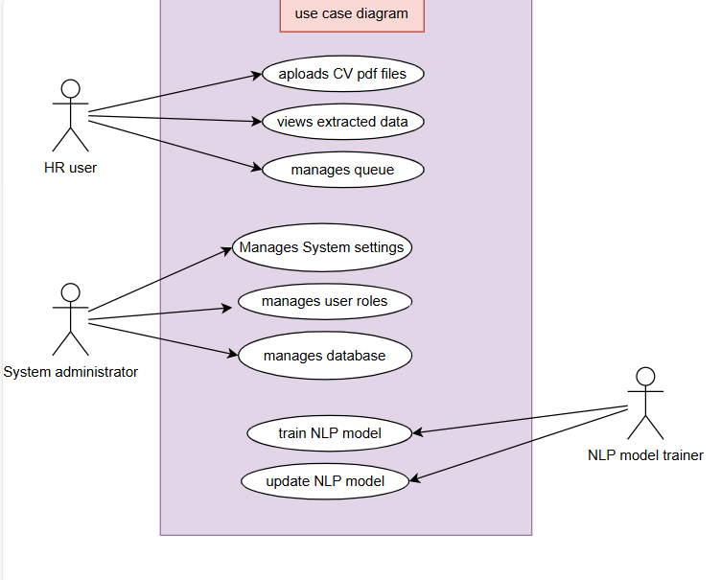

This figure shows the use case diagram of the CV extraction system, HR user and System administrator are primary actors, the HR interacts with the system to upload CVs, view extracted data and manages queue, the system administrator manages user roles, database operation, system settings and the overall system functionality.
NLP mode trainer is a secondary actor responsible for training and updating the NLP model used in the extraction process.
Primary actors initiate use cases directly, while secondary actor supports technical functions of the system.

3.7.2 activity diagram

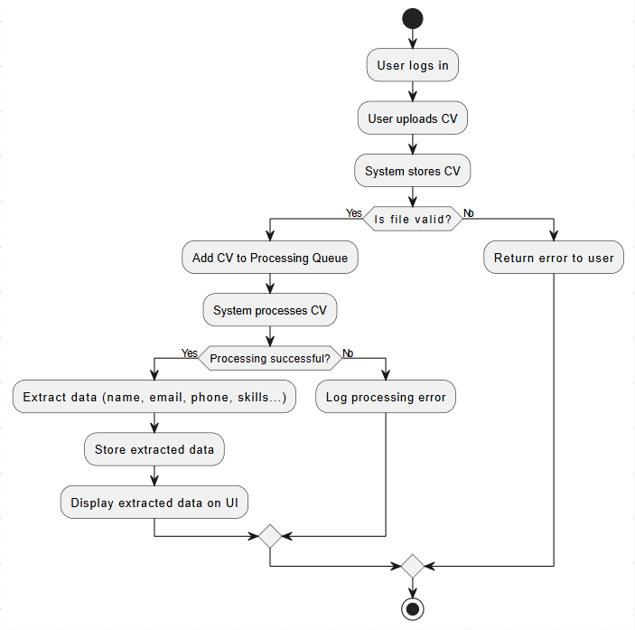

This activity diagram represents the process sequence for processing CVs in the system. The process begins when a user logs in and uploads a PDF CV. After the file is uploaded, the system stores it and then verifies its validity (such as ensuring it is not corrupted).
If the file is invalid, an error message is returned to the user and the process terminates. If the file is valid, it is added to the processing queue. The system then processes the CV. If processing is successful, the system extracts important data as we explained before, This data is then stored and displayed on the user interface . If the processing fails, the system logs the error without extracting any data. In all cases, the process ends after these steps.

3.8 Data base design

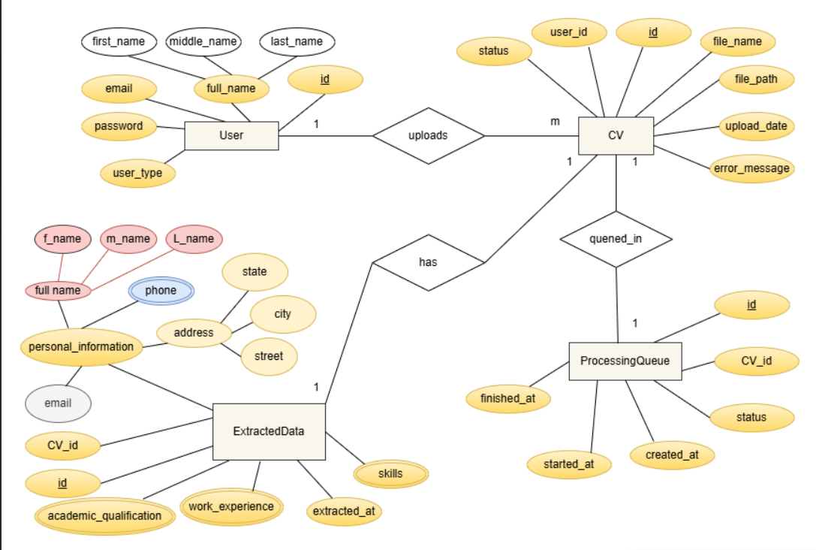

This figure shows the entity relationship diagram(ERD) for the CV extraction system.
The system contains the following main entities:

• user: represents system users, including HR users and administrators ,each user has simple attributes as id(unique attribute for each record) , email, password and user-type and composite attribute as full-name.

•CV: represents the uploaded CV files, each CV is linked to a user-id and includes simples attributes as status, id(unique attribute for each record), file-name, file-path, upload-date, error-message.

•ProcessingQueue: represents the queue for processing CVs , it contains simple attributes as shown in the figure.

•ExtractedData: contains the informations extracted from the CVs , this entity contains simple attribute as id(unique attribute for each record), CV-id, extracted-at and email and contains multi value attribute as skills, work-experience, academic-qualification and phone, also contains composite attributes as full-name, address, personal-information.

Relationships:
•a user can upload multiple CVs (a one-to-many relationship).
•each CV can be in a single queue item (a one-to-one relationship).
•each CV can have only one record of the extracted data (a one-to-one relationship).

3.9 Data base schema

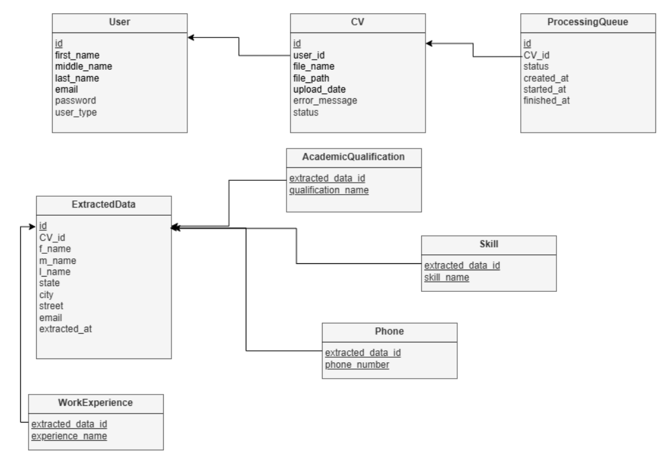

•In this system, we have several interconnected tables that represent the stages of CV processing, from the moment they are uploaded to the moment the data is extracted. The process begins with the user—the person uploading the CV, whether an employee in the human resources department or a administrator. Each user has a unique ID called a primary key, and the CVs they upload are linked to this ID via the CV table.
•When a CV is uploaded, information about it is recorded, such as the file name, path, upload date, and processing status (Uploaded or Failed). if the file is valid, it is then entered into the ProcessingQueue table, which tracks processing operations and includes the start and end times of each processing operation, along with its status.
•The CV table has a primary key id that uniquely identifies each CV. It also contains a foreign key user_id which references the id field in the User table, establishing a relationship between a CV and the user who uploaded it.
•The ProcessingQueue table is used to record and track each processing attempt made on uploaded CVs. This table acts as a "processing queue," meaning that every CV accepted for processing is entered into this table for processing by the extraction system. This table contains a primary key (id) that uniquely identifies each processing operation, as well as a foreign key (cv_id) that references the CV associated with that operation and is linked to the id column in the CV table.
•When processing is successful, the data is extracted from the CV and stored in the ExtractedData table, which is directly linked to the CV. This table contains basic data such as name, address, and email. Since some fields can be duplicated, each is placed in a separate table, such as Skill, Phone, WorkExperience, and AcademicQualification.
•The ExtractedData table has a primary key, id. Multiple tables such as Skill, Phone, WorkExperience, and AcademicQualification, are linked to it through a foreign key called extracted_data_id in each of these tables.
•The composite key for phone is extracted-data-id and phone-number, and for skill class is extracted-data-id and skill-name, and for WorkExperience is extracted-data-id and experience-name, and for AcademicQualification is extracted-data-id and qualification-name.

3.10 Whole Development Plan:
1.SystemPrepresent : asking the HR stakeholders to document the specific needs and for the CV extraction system.
2.System Design :designing the user interface focusing on usability and clarity, Defining the system architecture, including database schema and work processes.
3. Environment Setup :Prepare the necessary development tools,and cloud infrastructure to support scalable and efficient development.
4.Develop a secure login system with role-based access control to ensure authorized access to the application.
5.Uploading files Functionality :develop a reliable PDF upload feature with user progress indicators and error login notifications.
6.Queue Data Structure:Design and develop a queue mechanism to process CVs sequentially, ensuring data integrity and preventing loss.
7.Natural Language Processing (NLP) :develop an NLP model to automatically extract relevant information from CVs, includes personal details, skills, and experience ,Fine-tune the model to improve accuracy.
8.Database Storage :Create a structured database to store extracted information, connect it to the original CV files uploaded and HR user profiles.
9.DashboardArchiticture :Build a dashboard that allows HR staff to search, filter, and review candidate information efficiently.
10.SystemValidation :Perform testing to verify functionality, maintainability, security, and usability.
11.Deployment :Deploy the application platform to ensure scalability, reliability, and ease of maintenance.
12.SystemImprovement:Establish monitoring tools, collect users and plan for continuous updates.

3.2 Dataset Description:
In this project , we use a dataset that contains file of CVs in PDF format ,from this dataset used 70% for training , and 30% for testing.

-------------------------------------------------------------------------------------------------------
Another one :
1. Plan &Design:Define the data fields to extract, design UI frames including a login page, upload page, and data display dashboard. Choose authentication needs.
2. User Authentication:
- Implement a login page with username/email and password fields.
- Set up backend authentication ( JWT).
- Create user registration.
3. Frontend Development:
- Build the login interface.
- Create a secure upload page accessible only after login.
- Add progress indicators for file upload and processing.
- Develop a dashboard interface to display extracted CV data with search and filter options.
4. Backend API Development:
- Create authentication endpoints (`POST /login`, `POST /register`).
- Protect API routes so only authenticated users can upload files or view data.
- Implement `POST /upload` for PDF uploads and `GET /CVs` for fetching extracted data.
5. Queue Setup:UsingRedis to manage CV processing in FIFO order.
6. PDF Parsing and Text Extraction: Use Python libraries to extract and preprocess text from uploaded PDFs.
7. NLP Model Development: Train and evaluate an NLP model to extract structured information from CV text.
8. Processing Pipeline Integration: In the worker service, after text extraction, run the NLP model to extract data and format it as JSON.
9. Data Storage: Design a database schema to store extracted CV data linked to user accounts and original files.
10. Display Extracted Data: Serve structured data via API and display it on the authenticated dashboard with search/filter features.
11.Testing: Perform unit and integration tests covering authentication, upload, processing, and data display flows.
12. Deployment:Containerize frontend, backend, and worker services with Docker; deploy on cloud with monitoring and logging.

