DEAA-Hub User Guide
Functional guide with screenshots

DEAA-Hub User Guide

This guide explains what each part of the application is used for in simple terms.

It is written for daily users of the platform and focuses only on the functional side of the app.

1. What DEAA-Hub is for

DEAA-Hub is the central workspace used to manage academic and administrative activities.

With it, staff can:

- follow students
- manage grades and evaluations
- manage teachers
- organize classes
- manage modules and course structure
- manage rooms
- make room reservations
- follow diplomas and laureates
- manage documents
- monitor workflows and activity
- manage departments, filieres, options, and cycles

2. Login

The login page is the entry point to the platform.

What you do here:

- enter your identifier
- enter your password
- click `Se connecter`

What happens next:

- the app opens your workspace
- the main sidebar appears on the left
- your name and role appear at the top

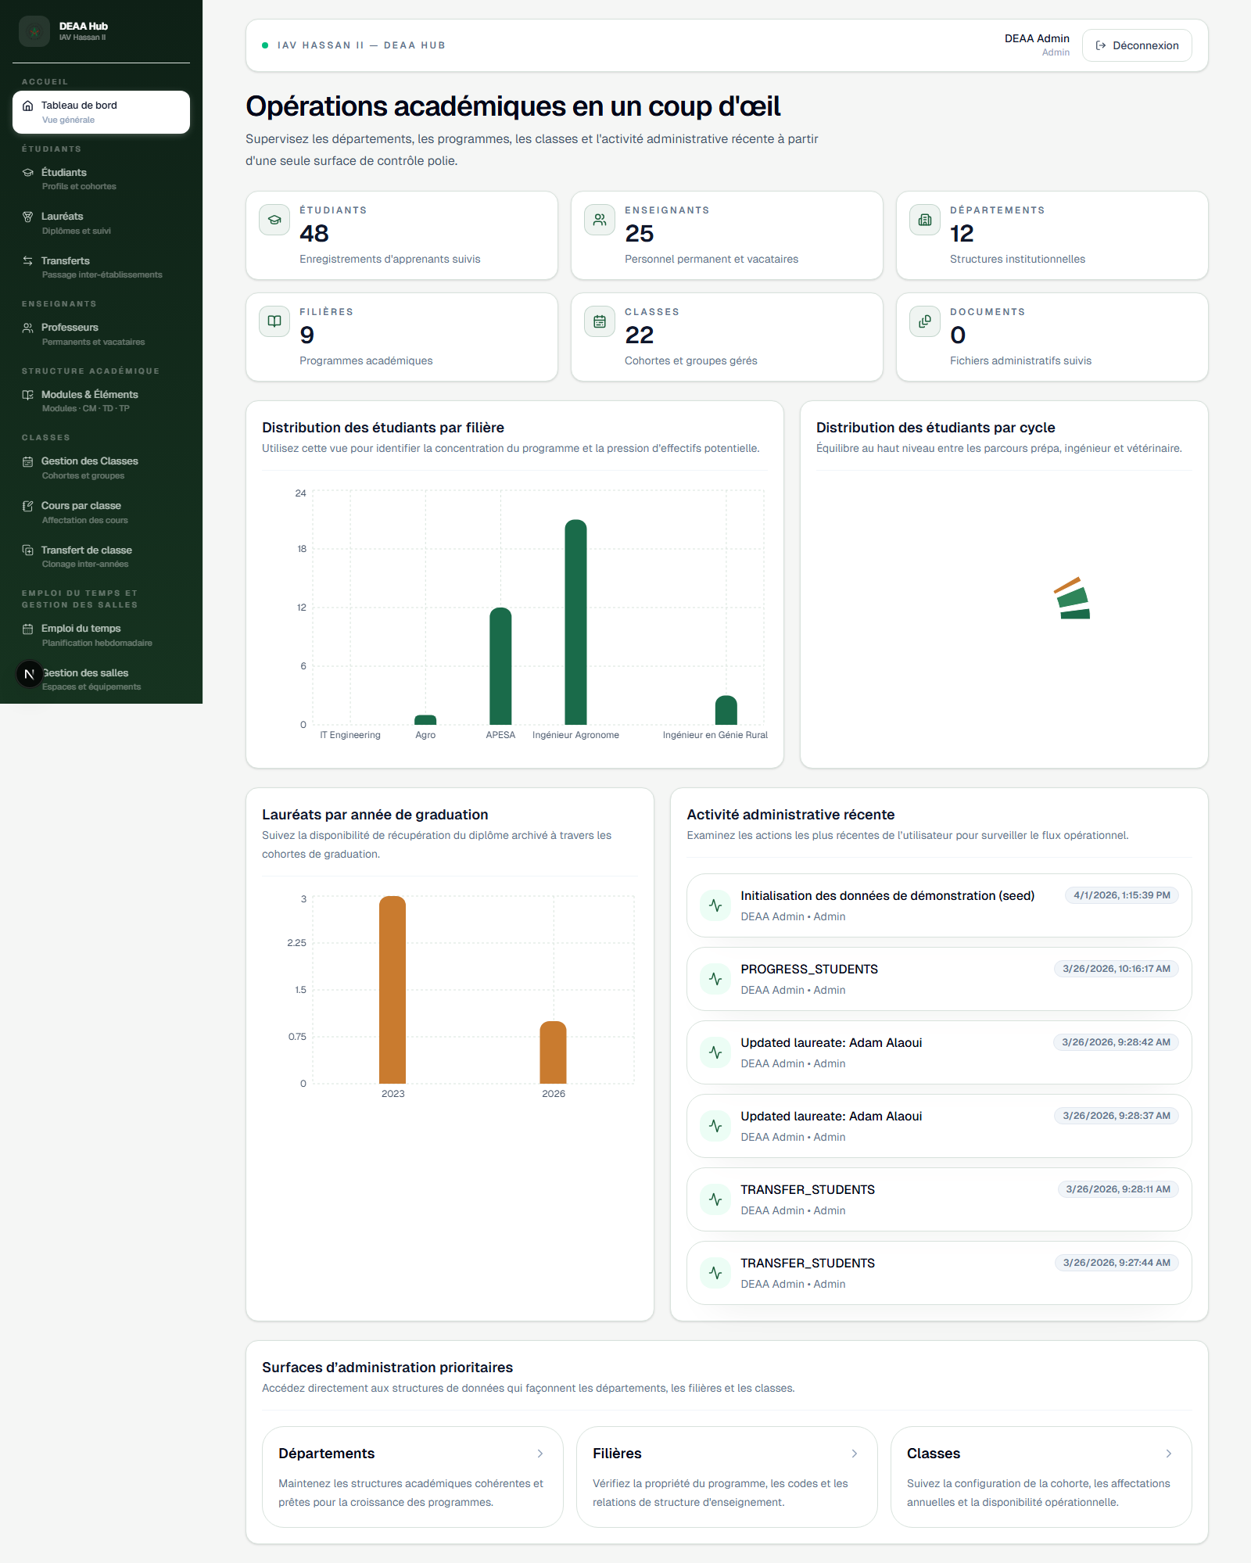
Login page

3. Dashboard

The dashboard gives a quick summary of the current academic situation.

What you can see:

- total number of students
- total number of teachers
- total number of departments
- total number of filieres
- total number of classes
- total number of documents
- distribution of students by filiere
- distribution of students by cycle
- laureates by year
- recent activity

Why this page matters:

- it gives management a fast overview
- it helps detect workload and volume by program
- it shows what has been happening recently in the system

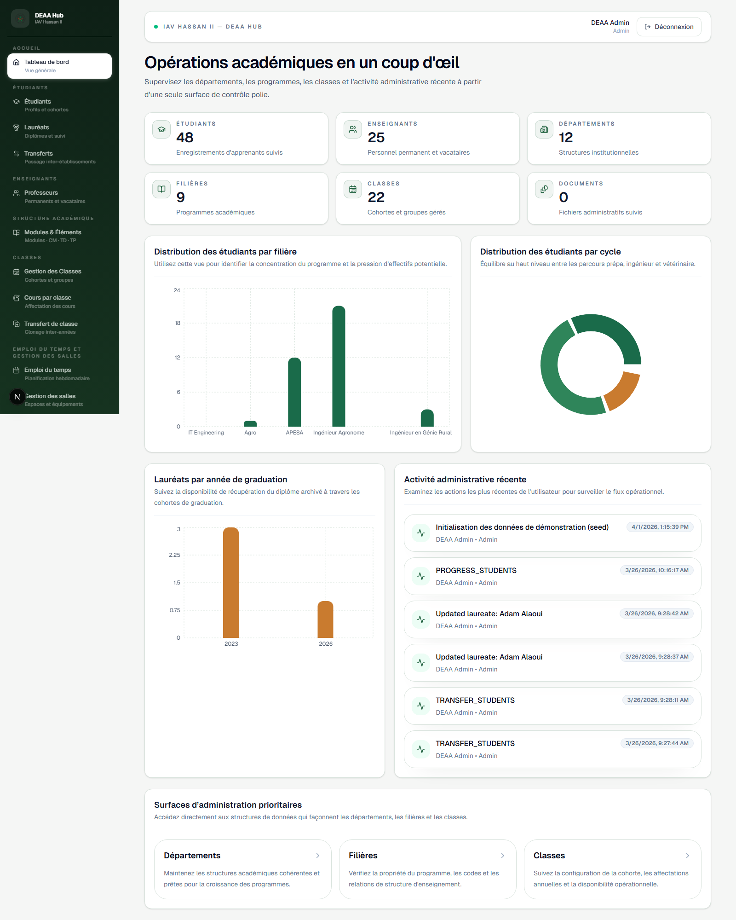
Dashboard page

4. Students

The Students section is used to manage student records.

What you can do:

- see the list of students
- search for a student
- filter student data
- add a new student
- edit a student
- delete a student
- open a student profile
- move students between classes
- follow student progress
- convert a student into a laureate when needed

Typical use cases:

- registering a new student
- correcting student information
- checking which class a student belongs to
- preparing transfers or progression

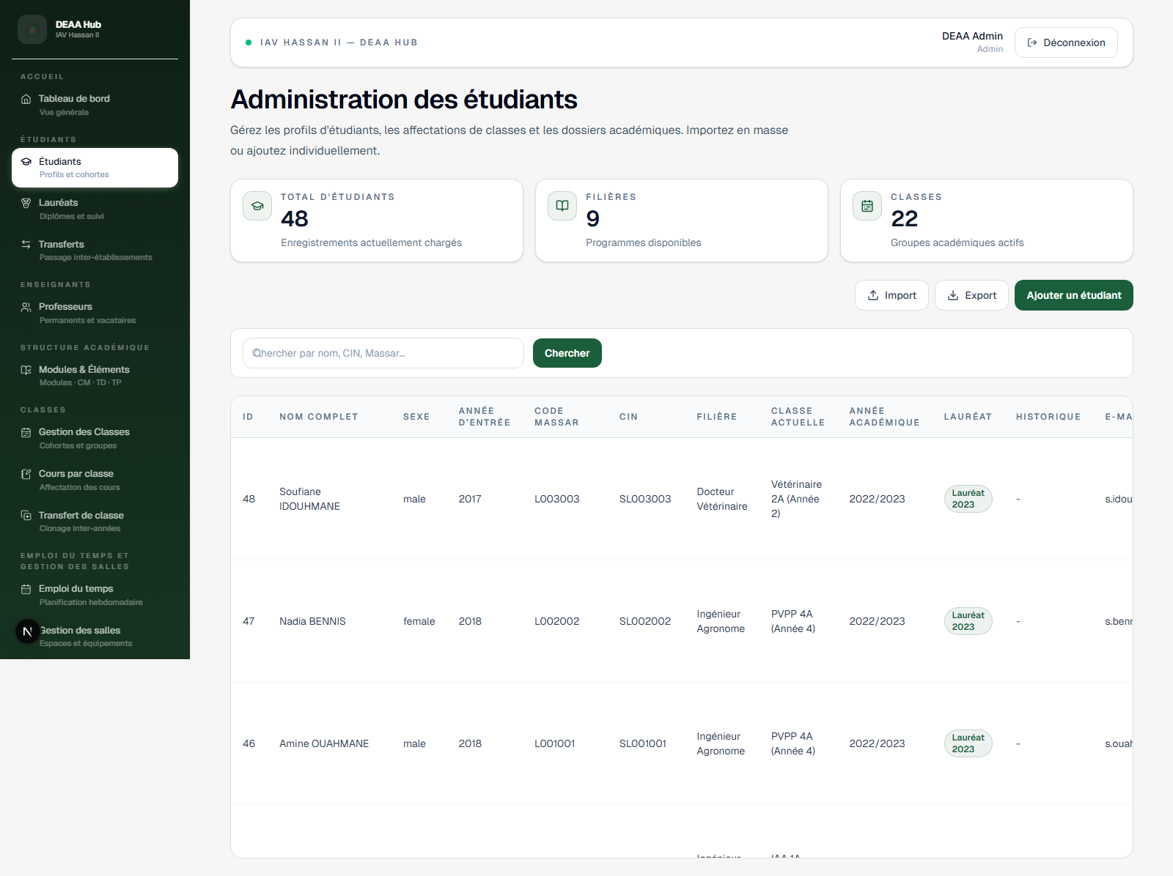
Students page

5. Student Profile

Each student can have a dedicated profile page.

What you can do there:

- read full student information
- review linked observations
- add a new observation
- review the student's grades
- review the student's uploaded documents
- upload a new document directly from the profile
- consult student-related documents
- follow the student more closely than from the list view

This page is useful when a staff member needs to work on one student in detail.

6. Teachers

The Teachers section is used to manage all teaching staff.

What you can do:

- view all teachers
- search teachers
- add a teacher
- edit teacher information
- delete a teacher
- review teacher assignments
- manage teacher roles
- manage teacher grades

Typical use cases:

- creating a teacher record
- updating contact information
- checking which classes or courses are assigned to a teacher

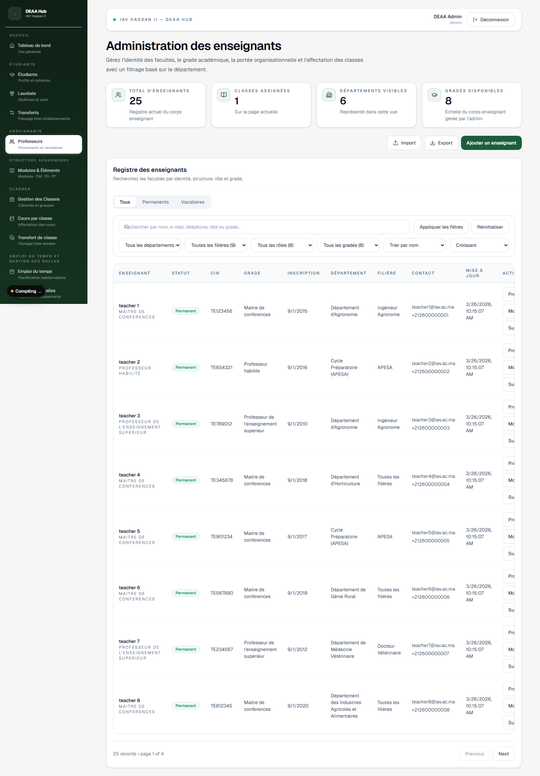
Teachers page

7. Teacher Profile

Each teacher can also have a profile page.

What you can do there:

- see the teacher's personal information
- review assigned classes
- review assigned courses
- review documents linked to the teacher
- upload a new teacher document directly from the profile
- follow the teacher's academic workload more clearly

8. Gestion des notes

The Notes section is used to manage student evaluations.

What you can do:

- add a note for a student
- link the note to a teacher
- link the note to a class
- define the subject
- define the semester
- define the type of evaluation
- enter the score and the grading scale
- add a comment
- edit a note
- delete a note
- search and filter notes

Typical use cases:

- recording continuous assessment marks
- recording exam marks
- following student performance by subject
- reviewing notes by student, teacher, or class

9. Classes

The Classes section is used to manage academic groups and cohorts.

What you can do:

- create a class
- edit a class
- delete a class
- view how many students are in a class
- follow class organization by year
- transfer a class structure to another academic year

Why this page matters:

- classes are the base for many other operations
- students, modules, courses, timetable, and reservations all depend on class organization

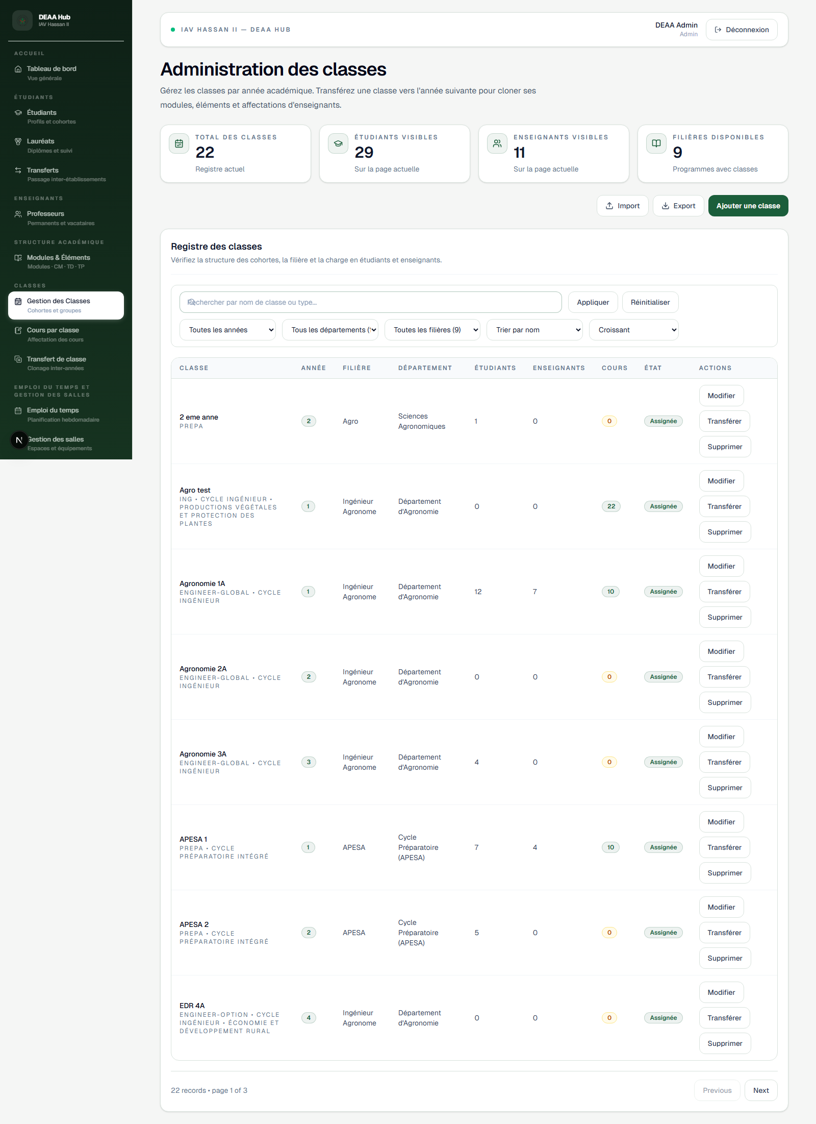
Classes page

10. Student Transfers

The platform includes transfer features for moving students between classes or stages.

What you can do:

- choose a source class
- select students
- choose the destination class
- validate the transfer

This is useful during:

- academic progression
- reorganization of cohorts
- correction of student assignment mistakes

11. Modules and Elements

The Academic section is used to define the teaching structure.

What you can manage:

- modules
- elements inside each module
- teaching formats such as CM, TD, and TP

What you can do:

- add a module
- edit a module
- delete a module
- add an element to a module
- edit an element
- organize how teaching content is structured for classes

Why this page matters:

- it defines what is taught
- it helps keep the academic structure clear and organized

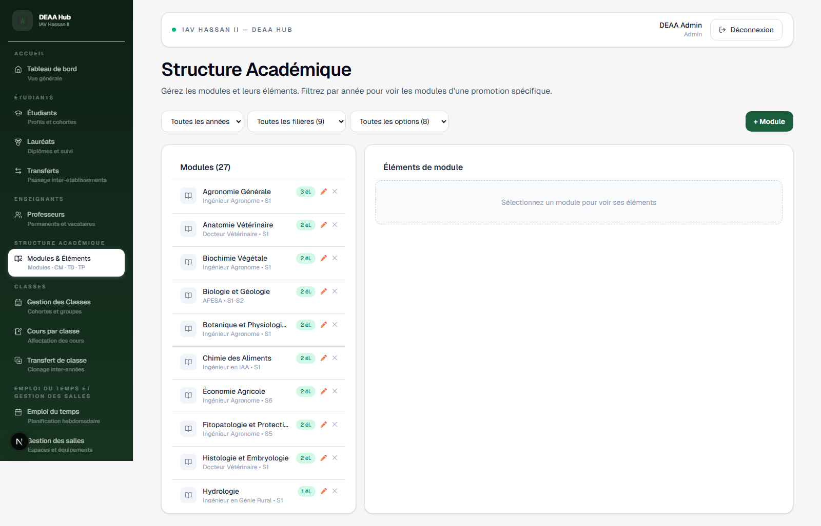
Academic modules and elements

12. Courses by Class

The app also includes course assignment pages connected to classes.

What you can do:

- assign courses to a class
- assign teachers to those courses
- review the teaching plan of a class

This is useful when preparing class-level delivery and academic organization.

13. Rooms

The Rooms section is used to manage physical spaces.

What you can do:

- add a room
- edit a room
- delete a room
- define room capacity
- record available equipment
- review available spaces

Examples of room information:

- amphitheaters
- classrooms
- laboratories
- conference rooms
- equipment such as projectors or computers

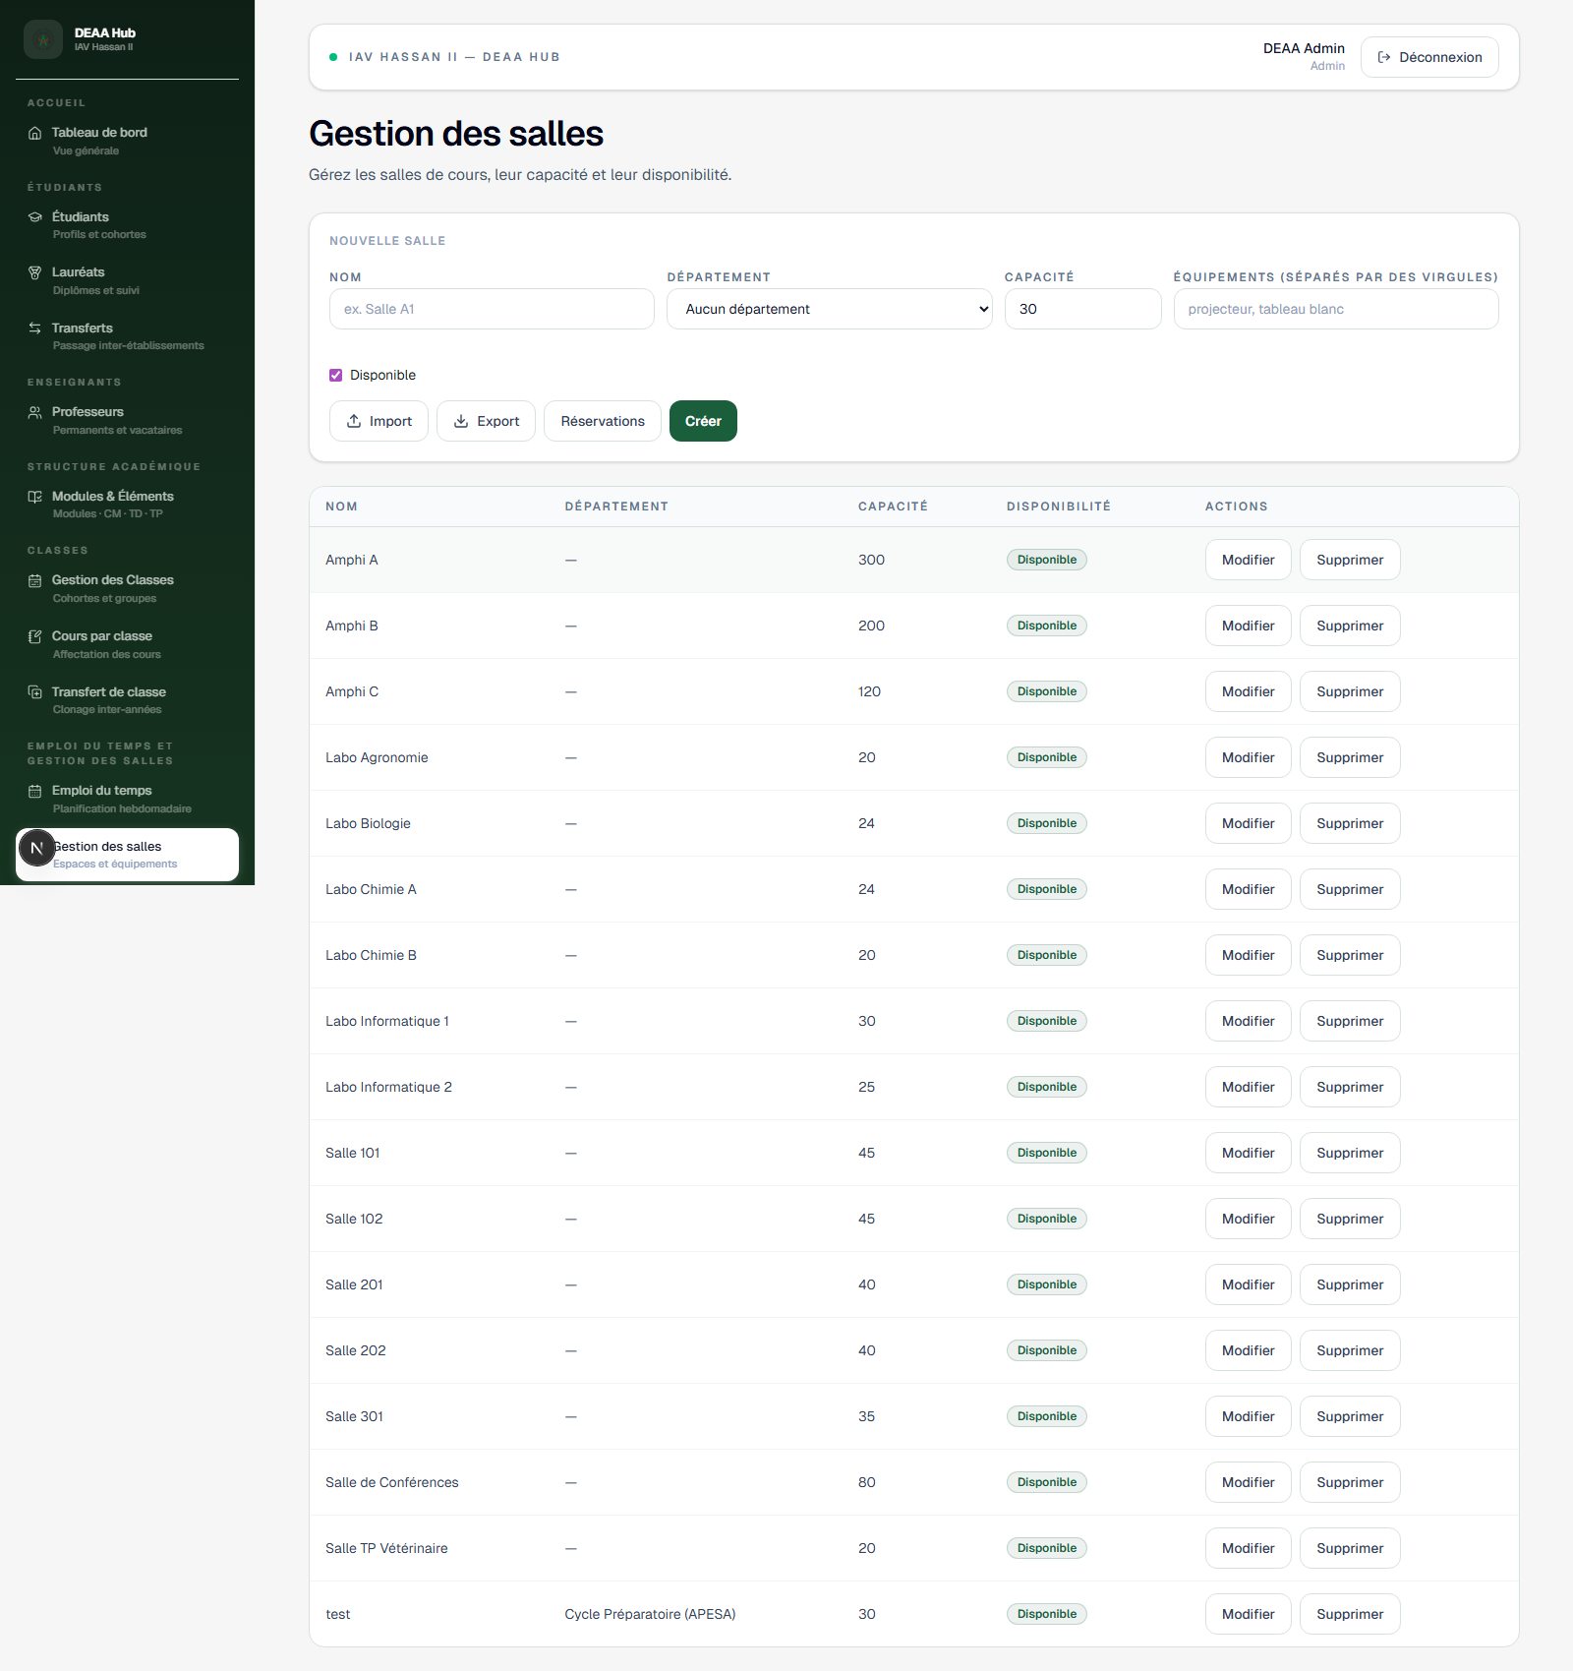
Rooms page

14. Room Reservations

The Room Reservations section is used to organize the occupation of rooms.

What you can do:

- create a reservation
- see reservations by week
- review pending reservations
- approve a reservation
- reject a reservation
- consult room occupation

Typical use cases:

- booking a room for a class
- booking a room for an exam
- booking a room for a meeting
- checking whether a room is already occupied

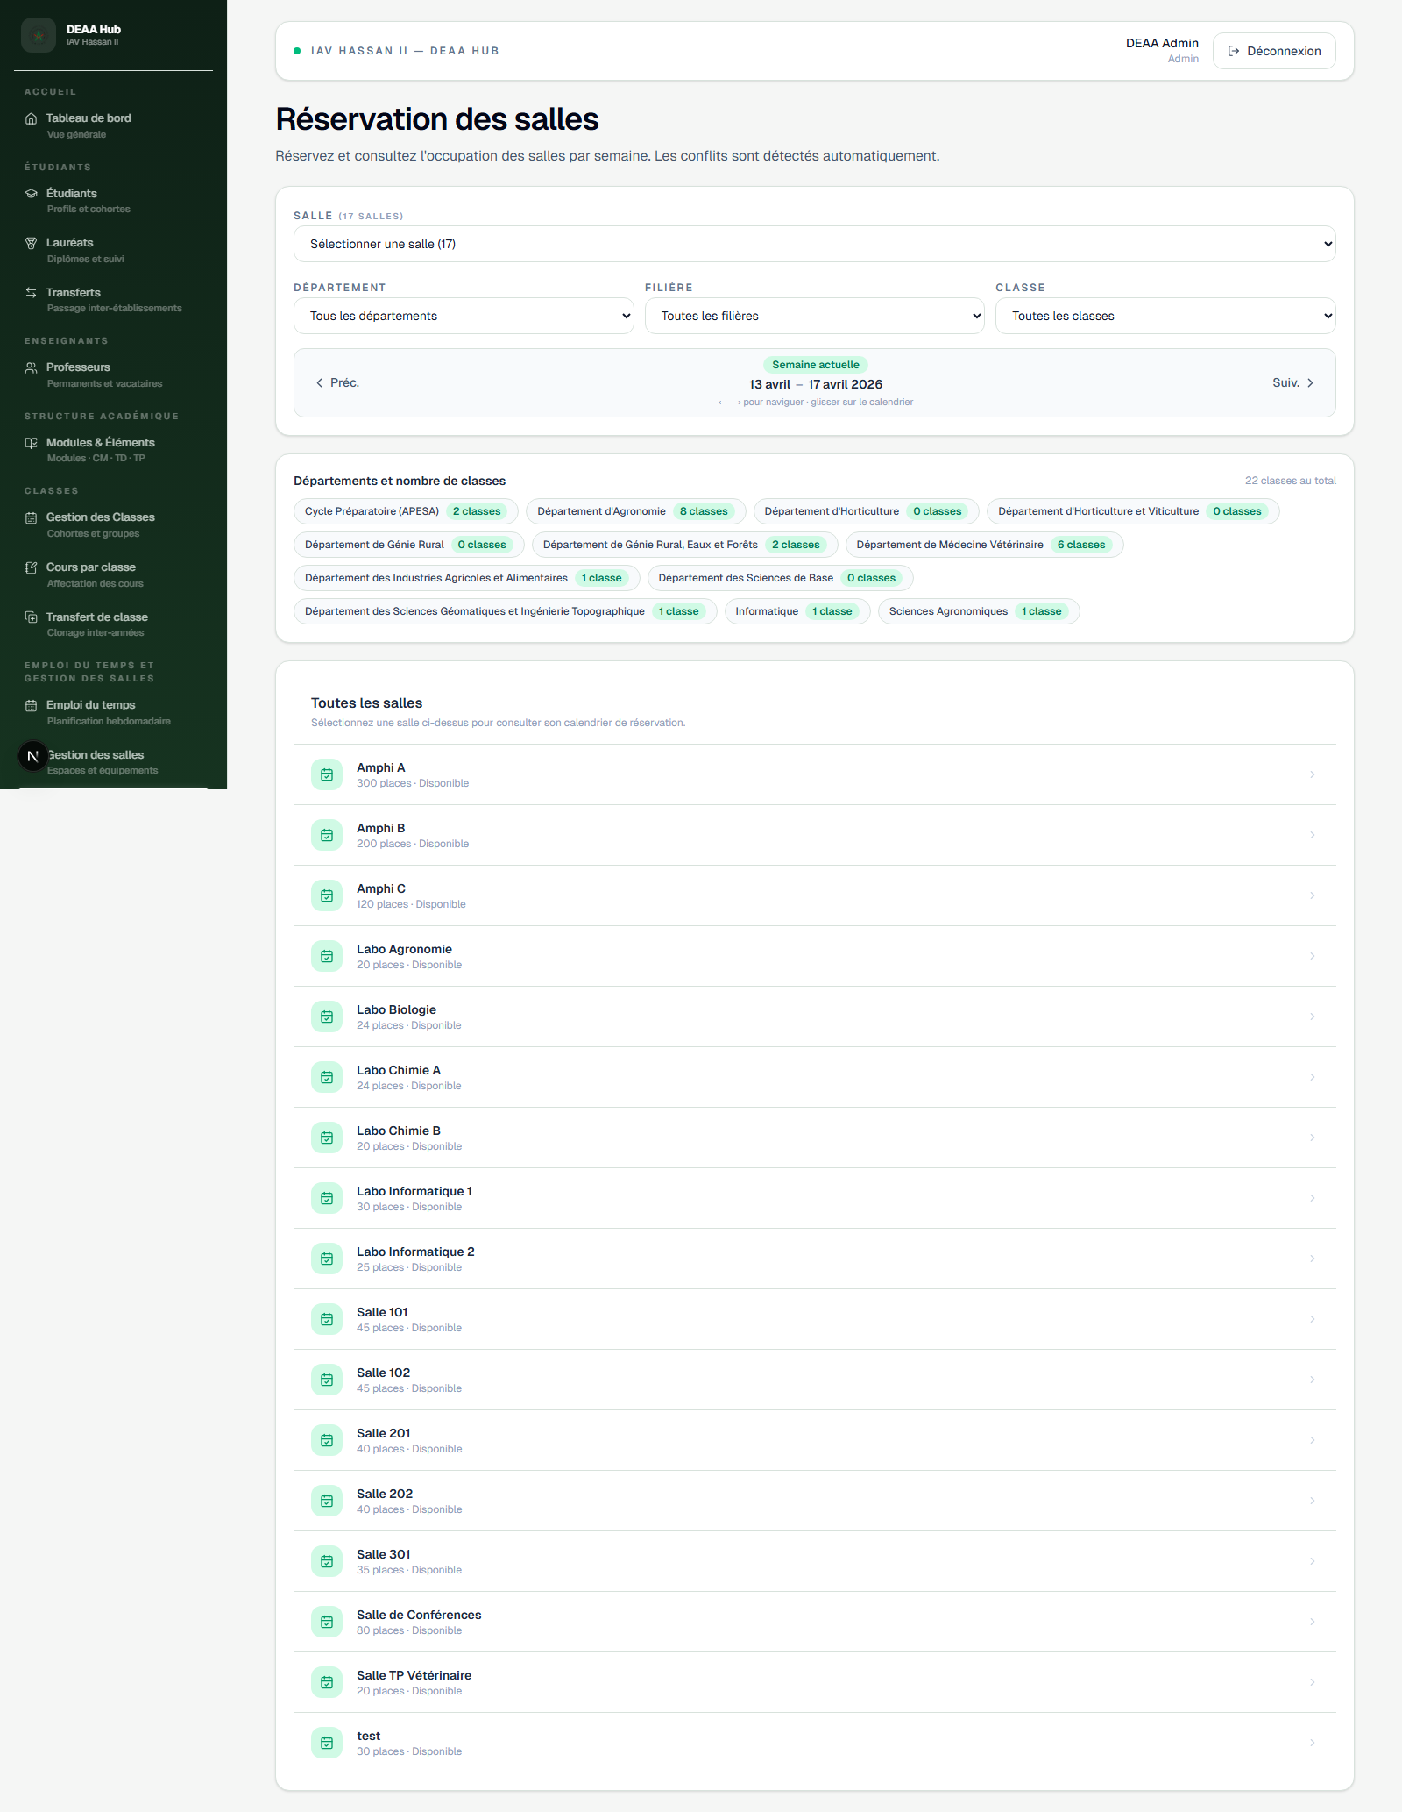
Room reservations page

15. Timetable

The Timetable section is used to plan teaching sessions.

What you can do:

- view the weekly schedule
- add a session
- move a session
- update a session
- delete a session

A session usually links:

- a class
- a teacher
- a room
- a day
- a time slot

This page is helpful for weekly planning and schedule control.

16. Departments

The Departments section is used to manage institutional academic departments.

What you can do:

- create a department
- rename a department
- remove a department if needed
- keep the organizational structure clean

This is useful for structuring access, staff organization, and academic ownership.

17. Filieres

The Filieres section is used to manage academic programs.

What you can do:

- create a filiere
- edit its information
- connect it to a department
- follow the number of students connected to it

This helps organize the main training paths of the institution.

18. Options

The Options section is used to manage specializations within a filiere.

What you can do:

- create an option
- assign an option to a filiere
- organize specialization paths

This is useful when a program splits into more precise directions.

19. Cycles

The Cycles section is used to manage the large academic levels or cycles.

What you can do:

- create a cycle
- edit a cycle
- delete a cycle if unused

Examples:

- preparatory cycle
- engineering cycle
- veterinary cycle

20. Laureates and Diplomas

The Laureates section is used to follow graduates and diploma status.

What you can do:

- create laureate records
- update laureate information
- delete laureate records
- follow diploma retrieval status
- identify students who became graduates

This is especially useful for post-graduation administrative follow-up.

21. Documents

The Documents section is used to manage student-related files.

What you can do:

- upload a document
- link it to a student
- link it to a teacher
- rename a document
- move a document from one student to another
- delete a document
- review missing documents for a student

Examples of possible documents:

- administrative forms
- scanned proofs
- supporting documents
- diploma-related files

22. Workflows

The Workflows section is used to track administrative tasks.

What you can do:

- create a task
- assign it to a user
- connect it to a student when needed
- update its status
- follow pending work
- mark work as completed

This is useful for:

- internal follow-up
- administrative processing
- making sure no important task is forgotten

23. Activity Logs

The Activity Logs section is used to see what happened recently in the platform.

What you can do:

- review actions done in the system
- see when an action happened
- see who performed it

This is useful for:

- supervision
- internal control
- checking recent work

24. Users

The Users section is used to manage who can access the platform.

What you can do:

- create a user
- update a user
- change user role
- delete a user
- review who has access

This is important for controlling responsibilities and permissions.

25. Main navigation logic

The sidebar is the main way to move through the app.

The usual working flow is:

- Start from the dashboard
- Open the section you need from the left menu
- Search, filter, create, or edit records
- Return to the sidebar to move to another area

The top bar is used to:

- confirm who is connected
- see the current role
- log out

26. Suggested daily usage by staff

For academic administration staff

Common daily flow:

- Open Dashboard
- Check Students
- Check Gestion des notes
- Check Teachers
- Review Classes
- Review Timetable
- Check Room Reservations
- Update Documents or Laureates when needed

For management

Common daily flow:

- Open Dashboard
- Review program volumes
- Review recent activity
- Check room occupancy
- Review workflows and pending operations

27. Quick summary of each section

`Dashboard`

- overall summary

`Students`

- student records and follow-up

`Gestion des notes`

- grades and evaluations

`Teachers`

- teaching staff management

`Classes`

- cohort and class structure

`Academic`

- modules and elements

`Timetable`

- session planning

`Rooms`

- room catalog

`Room Reservations`

- booking and approval of rooms

`Departments`

- organizational units

`Filieres`

- academic programs

`Options`

- specializations

`Cycles`

- academic levels

`Laureates`

- graduates and diplomas

`Documents`

- student and teacher files

`Workflows`

- task follow-up

`Activity Logs`

- history of actions

`Users`

- access management

28. Visual references

For quick review, these screenshots are already included in the project:

- Login
- Dashboard
- Students
- Teachers
- Classes
- Academic Modules and Elements
- Rooms
- Room Reservations

They are stored in:

- `docs/screenshots/`

29. Final note

This guide is meant to help a staff member, manager, or administrative user understand what each part of DEAA-Hub does without needing any technical knowledge.

If you want, I can also turn this into:

- a cleaner French user manual
- a PDF-style handbook layout
- a shorter training guide for staff onboarding

