C++ Programming Department

Student Course Management System
Comprehensive project report for the development of a functional C++ student record and enrollment application.

Prepared by:
Alaa Ahmed (ID: 12244)
Source Code on github
https://github.com/alaahmed675-cell/c-

I. Introduction
The Student Course Management System is a specialized software solution designed to streamline the administration of academic records using the C++ programming language. This project aims to provide a robust platform for managing student profiles, tracking academic performance through GPA metrics, and handling course enrollments. By leveraging Object-Oriented Programming (OOP) principles, the system ensures data integrity and modularity, making it an essential tool for educational environments that require efficient data handling without the overhead of heavy database management systems.

II. Table of Contents
I. Introduction ...............................................................
II. Table of Contents .........................................................
III. Detailed Project Description .............................................
Core Features .................................................................
IV. Project Beneficiaries .....................................................
V. Detailed Analysis ..........................................................
Unique Identifiers and Validation .............................................
Standard Template Library (STL) Usage .........................................
VI. Task Breakdown Structure ..................................................
VII. Time Plan ................................................................
VIII. System Architecture and Design ..........................................
Class Hierarchies .............................................................
IX. Testing Scenarios and Results .............................................
X. End-User Guide .............................................................
XI. Conclusion ................................................................
XII. References ...............................................................
XIII. Appendices ..............................................................
Sample Code Snippet (Sorting Logic) ...........................................
UML Diagram Overview ..........................................................

III. Detailed Project Description
The system is built to provide a seamless interface for both administrators and students. It encapsulates all necessary operations to maintain a digital ledger of student achievements and registrations. The core functionality revolves around the management of Student objects, which store personal information alongside academic history.
Core Features
- Add Student: Permits the entry of new student records into the system with unique identification numbers.
- Remove Student: Allows for the deletion of existing records based on a specific student ID to keep the database current.
- Search Records: Facilitates quick retrieval of student details using ID or name filters.
- Display All: Generates a comprehensive view of all registered students and their associated data.
- Enroll in Courses: Enables the dynamic addition of course codes to a student's active registration list.
- Show Courses: Lists all modules currently assigned to a specific student profile.
- Sort by GPA: Organizes the student list in descending order of academic performance for ranking purposes.

IV. Project Beneficiaries
- Students benefit from a clear and organized view of their course loads and performance metrics.
- Academic staff can efficiently manage large datasets and generate reports on student rankings.
- System administrators utilize the modular code for easy maintenance and future scaling.

V. Detailed Analysis
The technical implementation of this system focuses on three critical pillars: data uniqueness, input integrity, and efficient memory management. These pillars ensure that the application remains reliable under various operational conditions.

Unique Identifiers and Validation
Every student record is tied to a Unique ID. The system performs a check during the "Add" operation to ensure no duplicate IDs exist within the current session. Furthermore, GPA validation is strictly enforced; the system only accepts floating-point values between 0.0 and 4.0, preventing erroneous data entry that could skew academic rankings.

Standard Template Library (STL) Usage
The project heavily utilizes the C++ STL to optimize performance. Specifically, std::vector is used for dynamic storage of student records, allowing the system to scale without fixed array limitations. The std::sort algorithm is implemented with a custom lambda comparator to facilitate the "Sort by GPA" feature, ensuring O(n log n) efficiency.

VI. Task Breakdown Structure
The development process was divided into distinct phases to ensure a logical flow from conceptualization to final deployment.
Phase | Task Description | Status
Requirement Analysis | Defining classes, member functions, and attribute constraints. | Completed
System Design | Creating the UML structure and inheritance hierarchy. | Completed
Coding Phase | Implementing Person and Student classes and STL logic. | Completed
Testing & QA | Running edge-case scenarios and GPA validation checks. | Completed

VII. Time Plan
The following schedule outlines the two-week development sprint for the Course Management System.
Week | Focus Area | Key Deliverables
Week 1 | Foundational Architecture | Class structure, Person base class, and basic Add/Remove logic.
Week 2 | Advanced Features & UI | GPA sorting, course enrollment, search functionality, and terminal

VIII. System Architecture and Design
The system follows a hierarchical Object-Oriented approach. This design promotes code reusability and follows the "Dry" (Don't Repeat Yourself) principle.
Class Hierarchies
- Class Person: The base class containing protected attributes for common traits such as Name and Age.
- Class Student: A derived class inheriting from Person. It adds specific attributes like ID, GPA, and a vector of course strings.
IX. Testing Scenarios and Results
Rigorous testing was conducted to ensure the system handles both standard and unexpected user inputs gracefully.
Test Case | Input Provided | Expected Result
GPA Range | Input GPA: 4.5 | System rejects input and requests value <= 4.0.
Duplicate ID | Add ID: 12244 (Existing) | System triggers "ID already exists" warning.
Empty Search | Search: "Unknown" | System returns "No student found" message.

Sample Outputs
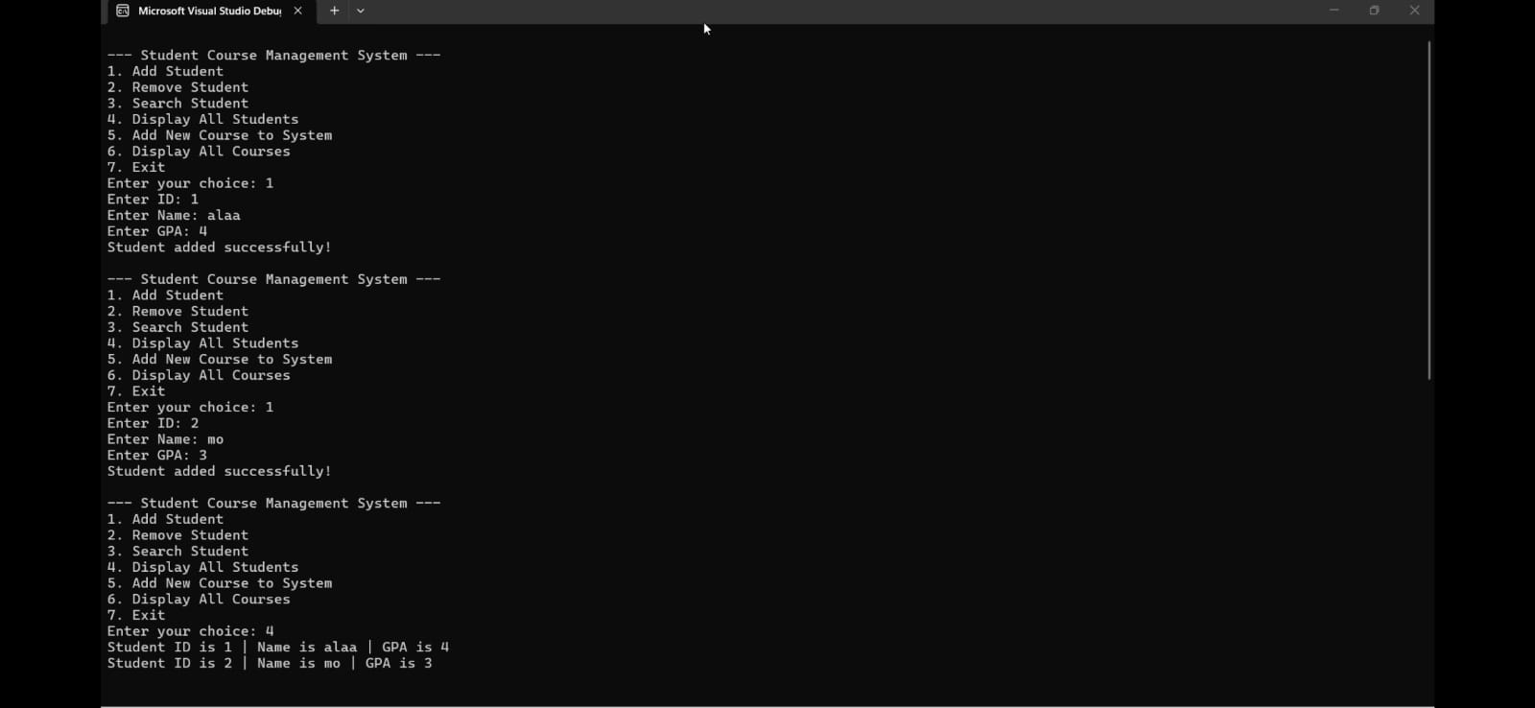

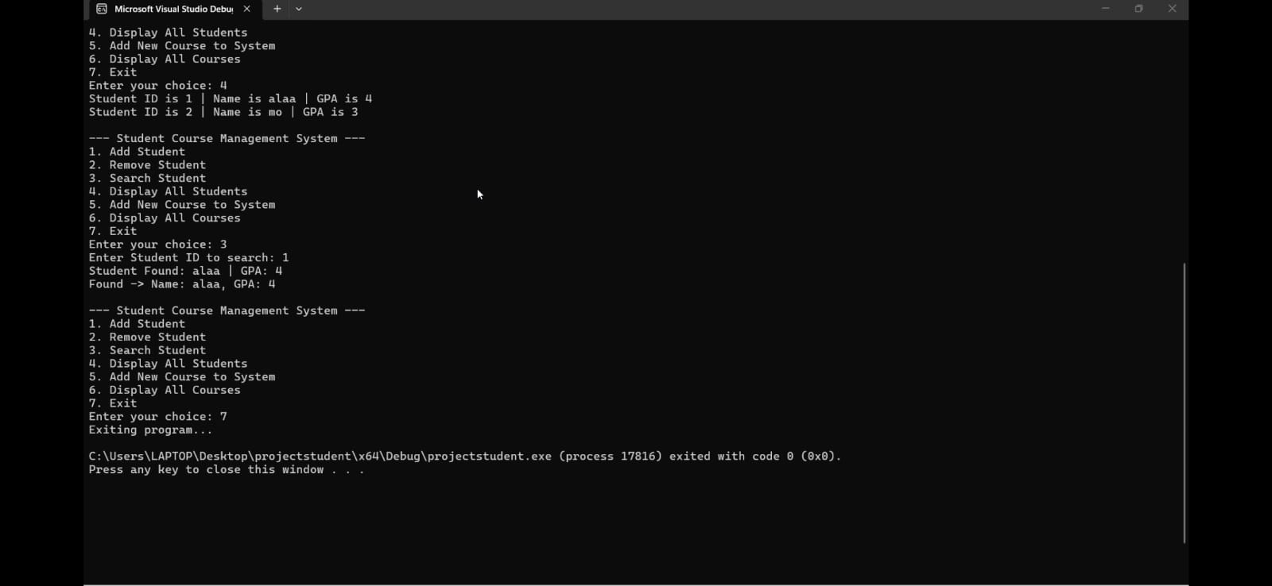

X. End-User Guide
To operate the system, follow these simple terminal-based commands:
- Launch the application through a C++ compiler or the provided executable.
- Select Option 1 from the main menu to register a new student.
- Enter the name, unique ID, and current GPA when prompted.
- Use Option 5 to enroll the student in specific course codes (e.g., CS101).
- Choose Option 7 to see a ranked list of all students by academic performance.
- Select Option 0 to safely save and exit the program.

XI. Conclusion
The Student Course Management System successfully meets all specified requirements, providing a functional and efficient tool for academic data management. Through the use of C++ and the Standard Template Library, the project demonstrates how Object-Oriented Design can solve real-world organizational challenges. The system is stable, user-friendly, and ready for further expansion, such as file-based persistence or a graphical user interface.
XII. References
The following resources were consulted during the development of this project:
- C++ Reference Documentation: https://en.cppreference.com/
- Standard Template Library Guide: https://isocpp.org/
- Object-Oriented Programming Principles: https://www.geeksforgeeks.org/object-oriented-programming-in-cpp/

XIII. Appendices
Sample Code Snippet (Sorting Logic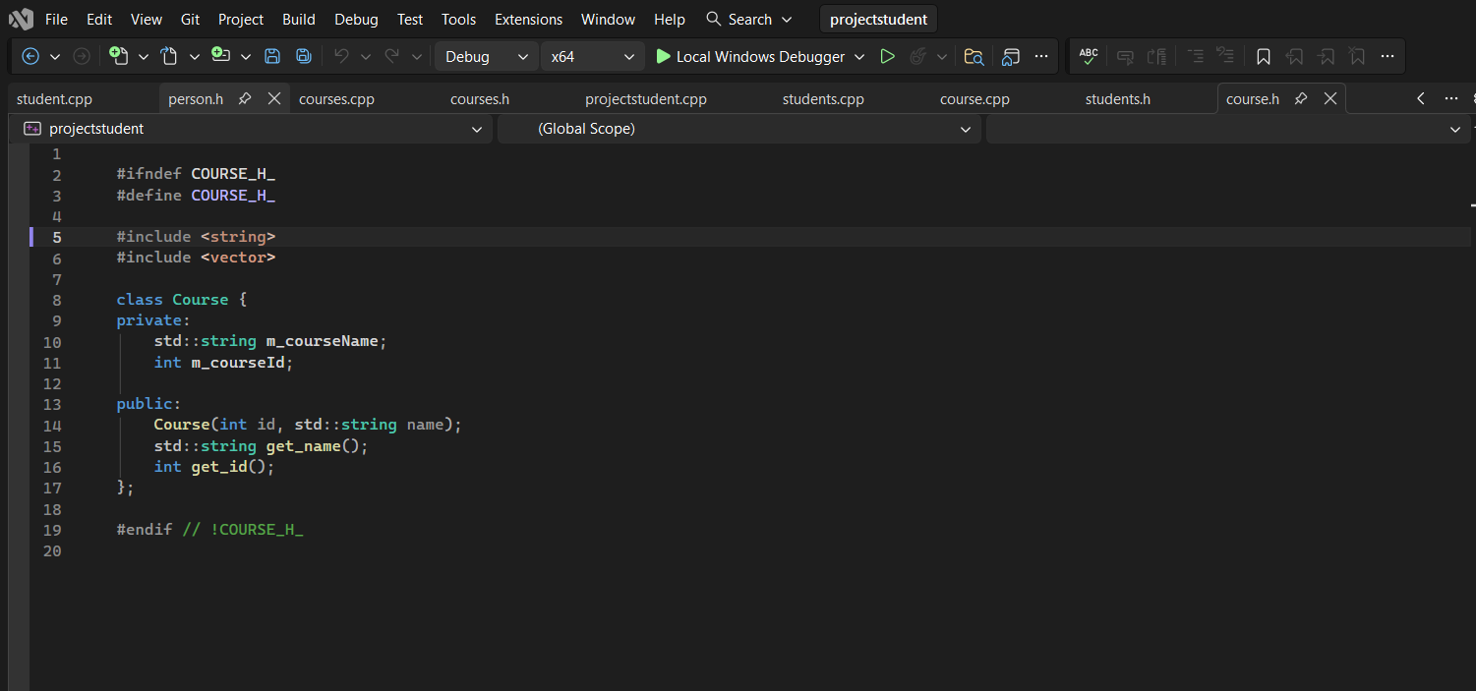

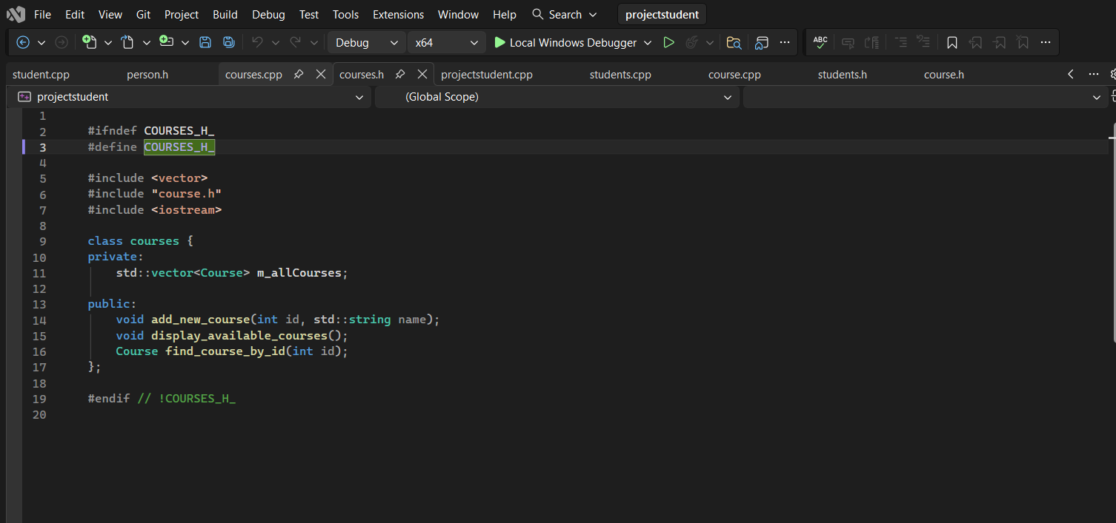
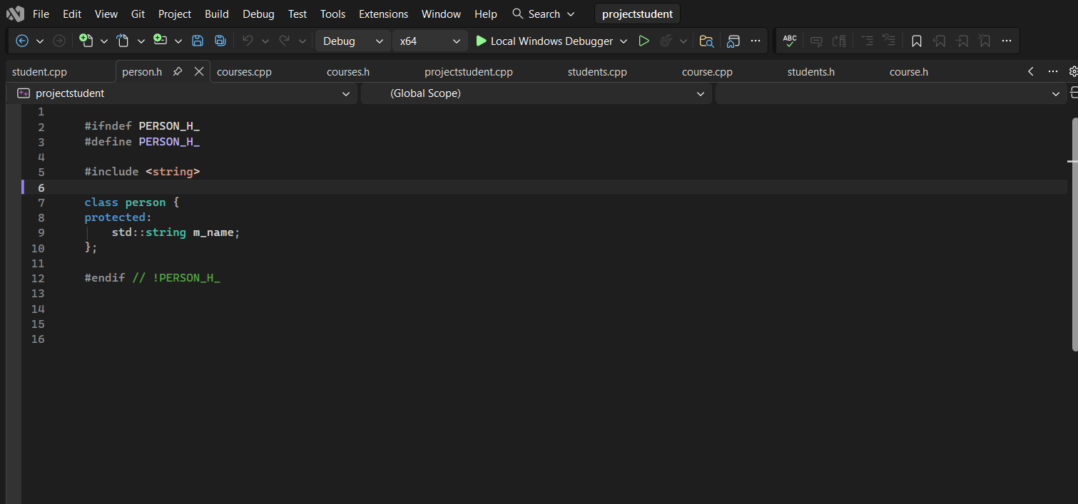

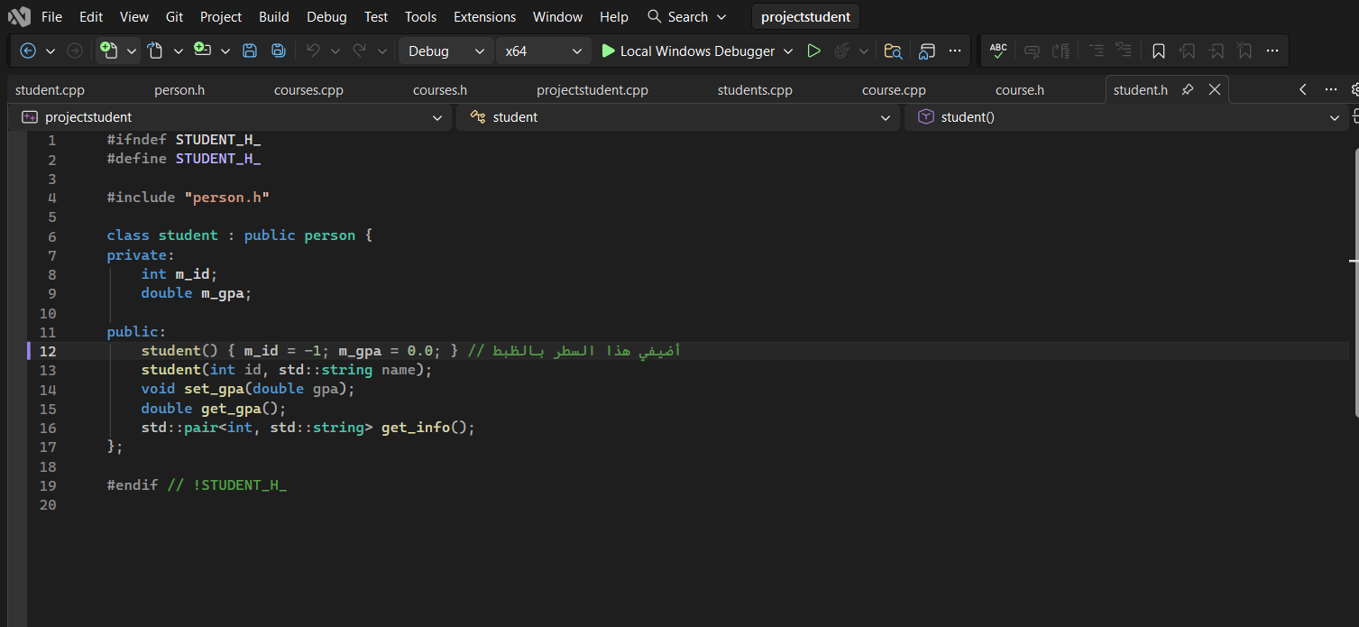
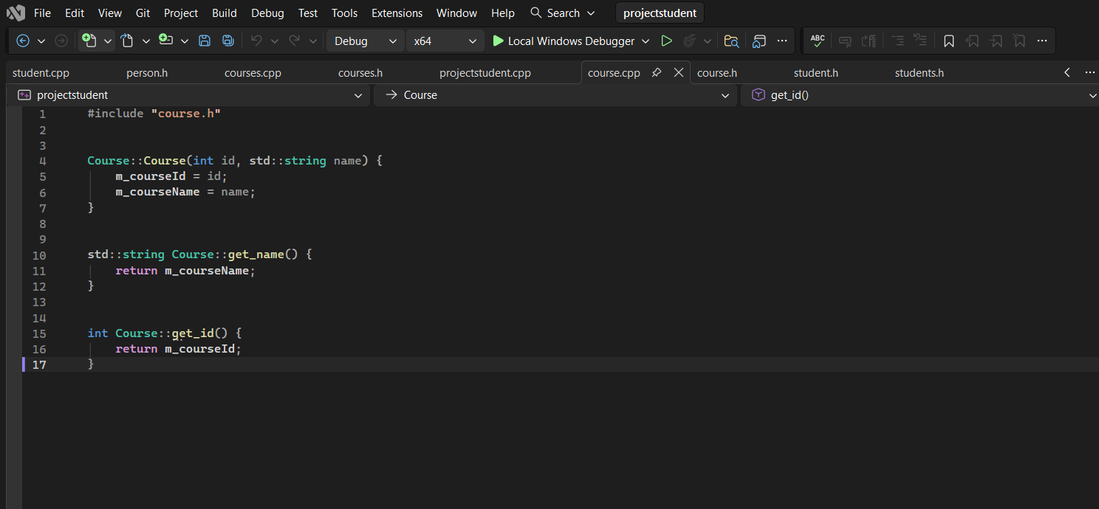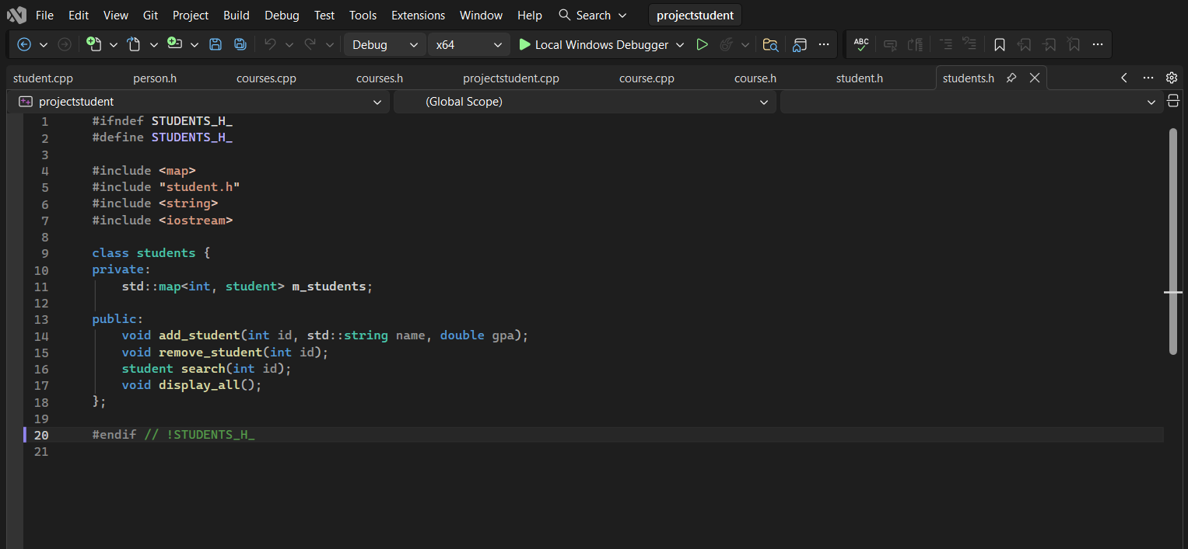
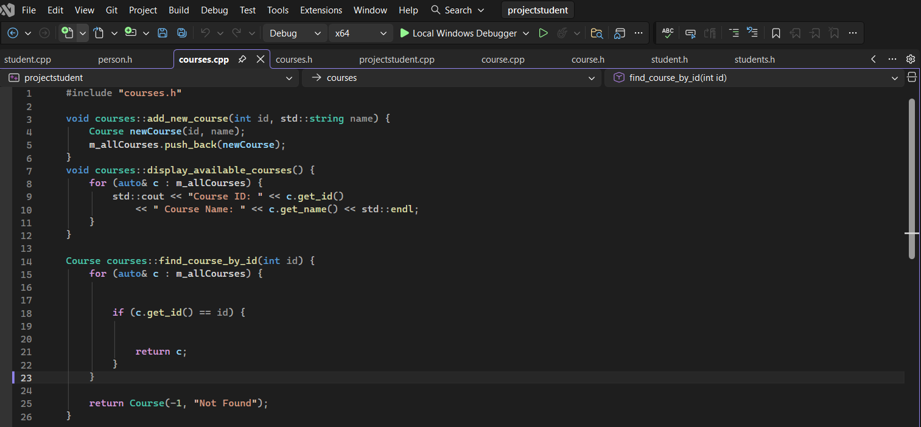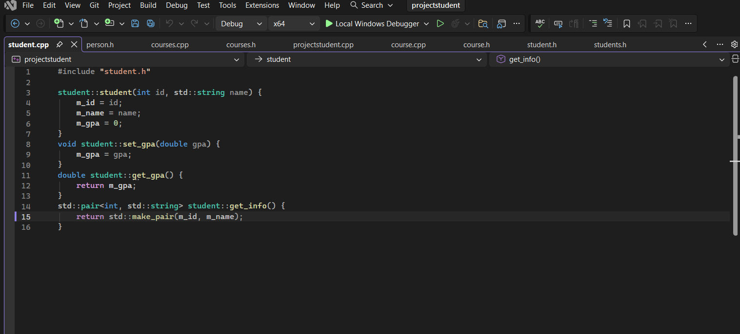

UML Diagram Overview

