Automation Task using Selenium java, Maven project and TestNG to test the google search functionality also using Page Object Design Patterns, screen shots in failure, generate allure report with screen shot and generate javaDoc

* **Task Structure**

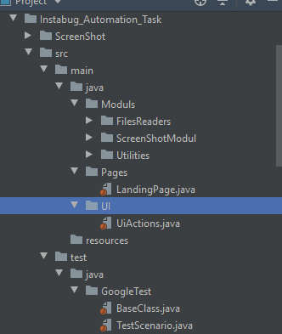

By using java project “src” contains both java classes and TestNG classes, java folder contains all files of modules and utilities like (exception handling, file readers and screen shots), the pages of page object design pattern and UI action class that contains all logic and actions of selenium, and TestNG classes contains all test scripts.

* **Task implementation**

- Implementing (Modular reusable methods and Data-driven) Test Automation Framework with an Object-Oriented Design and documented with java doc.

- Nothing hard-coded in the scripts:

Test data (like URLs, data, etc.) stored in external files (Properties, Excel.), make assertion using TestNG assertion

- Customizing reports including screenshots (allure report)

- Cross-browser support (IE, CH, FF) Selection of execution browser managed from a configuration file (base class file)

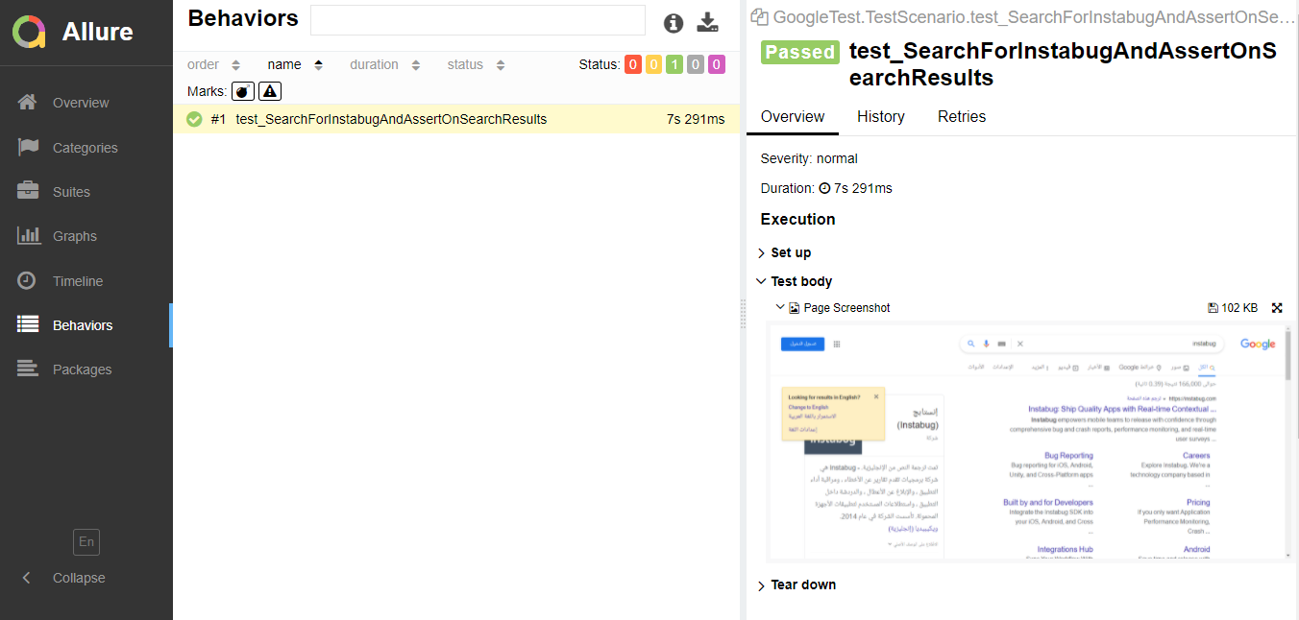

* **How can generate javaDoc**

1. Click on tools > generate javaDoc
2. Select the output directory
3. Click OK.

