الاء رزاق سويس كشاش
ا م د علي حمزة صاحب
Arduino + machine learning gesture recognition

البحث عباره عن 3 بحوث بواحد
- التحقق من هويه الشخص عبر استخدام بصمة الوجه اذا جانت صح مباشره يحول على الثانيه بالإمكان اضافه شخص جديد بصمه وجه بعد كتابه كلمه السر
- التحقق الثاني بصمه اصبع اذا جان الوجه صح راح يفح نافذه التحقق من بصمه الاصبع اذا صح يفتح برنامج التحكم بالإمكان اضافه بصمه اصبع وحذف القديمات
- الواجه التحكم الرئيسي تتستخدم الروئيه الحاسوبيه حته تتعرف على اليد وأشارت اليد والحركات وكل حرمه من المين تسوي عمل معين ومن اليسار تسوي عكس العمل
مقلا اليمين 1 تفتح باب اليسار 1 تغلف الباب ( عدد الأصابع المرفوعه من اليد )
نستخدم بايثون + اردوينو البصمه بالاردوينو

الاجخزه المذكور عمليه التحكم بيهن للتمثيل فقط مو شي رئيسي فحنمقلهن بكلوبات عدى الباب حيكون باب وسيرفو

كود التحقق من الوجه 1

import tkinter as tk
from tkinter import ttk, messagebox, simpledialog
import cv2
from deepface import DeepFace
import os
import pickle
import threading
import subprocess
import numpy as np
from PIL import Image, ImageTk
import time

class FaceRecognitionApp:
def __init__(self, root):
self.root = root
self.root.title("Face Recognition System")
self.root.geometry("600x600")

self.known_embeddings = {}
self.user_images_dir = "user_images"
self.embeddings_file = "embeddings.pkl"
self.is_recognition_running = False
self.is_adding_user = False
self.capture_count = 0
self.MAX_CAPTURES = 10
self.CAPTURE_INTERVAL = 1
self.ADMIN_PASSWORD = "12345678"

os.makedirs(self.user_images_dir, exist_ok=True)
self.create_widgets()
self.load_embeddings()

def create_widgets(self):
main_frame = tk.Frame(self.root)
main_frame.pack(pady=20, fill=tk.BOTH, expand=True)

self.user_list = tk.Listbox(main_frame, height=15, font=('Arial', 12))
self.user_list.pack(pady=10, fill=tk.BOTH, expand=True)

btn_frame = tk.Frame(main_frame)
btn_frame.pack(pady=10)

self.add_btn = ttk.Button(btn_frame, text="Add User", command=self.start_add_user)
self.add_btn.pack(side=tk.LEFT, padx=10)

self.remove_btn = ttk.Button(btn_frame, text="Remove User", command=self.remove_user)
self.remove_btn.pack(side=tk.LEFT, padx=10)

self.start_btn = ttk.Button(main_frame, text="Start Recognition", command=self.toggle_recognition)
self.start_btn.pack(pady=10)

self.status_label = tk.Label(main_frame, text="", font=('Arial', 12))
self.status_label.pack()

self.webcam_label = tk.Label(main_frame)
self.webcam_label.pack()

def load_embeddings(self):
if os.path.exists(self.embeddings_file):
with open(self.embeddings_file, 'rb') as f:
self.known_embeddings = pickle.load(f)

self.user_list.delete(0, tk.END)
for user in self.known_embeddings:
self.user_list.insert(tk.END, user)

def save_embeddings(self):
with open(self.embeddings_file, 'wb') as f:
pickle.dump(self.known_embeddings, f)

def start_add_user(self):
if self.is_recognition_running:
messagebox.showwarning("Warning", "Stop recognition first before adding new user")
return

password = simpledialog.askstring("Authentication", "Enter admin password:", show='*')
if password != self.ADMIN_PASSWORD:
messagebox.showerror("Error", "Incorrect password!")
return

name = simpledialog.askstring("New User", "Enter user name:")
if not name:
return

if name in self.known_embeddings:
messagebox.showwarning("Warning", "User already exists!")
return

self.is_adding_user = True
self.capture_count = 0
self.status_label.config(text=f"Capturing {self.MAX_CAPTURES} images...")
threading.Thread(target=self.capture_user_images, args=(name,), daemon=True).start()

def capture_user_images(self, name):
user_dir = os.path.join(self.user_images_dir, name)
os.makedirs(user_dir, exist_ok=True)

cap = cv2.VideoCapture(0)
last_capture_time = time.time()

while self.is_adding_user and self.capture_count < self.MAX_CAPTURES:
ret, frame = cap.read()
if not ret:
break

rgb = cv2.cvtColor(frame, cv2.COLOR_BGR2RGB)
img = Image.fromarray(rgb)
imgtk = ImageTk.PhotoImage(image=img)
self.webcam_label.imgtk = imgtk
self.webcam_label.configure(image=imgtk)

if time.time() - last_capture_time > self.CAPTURE_INTERVAL:
img_path = os.path.join(user_dir, f"{name}_{self.capture_count}.jpg")
cv2.imwrite(img_path, frame)
self.capture_count += 1
self.status_label.config(text=f"Captured {self.capture_count}/{self.MAX_CAPTURES} images")
last_capture_time = time.time()

self.root.update_idletasks()

cap.release()
if self.capture_count >= self.MAX_CAPTURES:
self.create_embeddings(name, user_dir)
self.status_label.config(text="User added successfully!")
else:
self.status_label.config(text="User addition canceled")
self.is_adding_user = False
self.webcam_label.configure(image='')

def create_embeddings(self, name, user_dir):
embeddings = []
for img_file in os.listdir(user_dir):
img_path = os.path.join(user_dir, img_file)
try:
embedding = DeepFace.represent(img_path=img_path, model_name='Facenet')[0]["embedding"]
embeddings.append(embedding)
except Exception as e:
print(f"Error processing {img_file}: {str(e)}")

if embeddings:
avg_embedding = np.mean(embeddings, axis=0)
self.known_embeddings[name] = avg_embedding.tolist()
self.save_embeddings()
self.load_embeddings()

def remove_user(self):
selected = self.user_list.curselection()
if selected:
user = self.user_list.get(selected[0])
del self.known_embeddings[user]
self.save_embeddings()
self.load_embeddings()
messagebox.showinfo("Success", f"{user} removed successfully!")

def toggle_recognition(self):
if self.is_recognition_running:
self.is_recognition_running = False
self.start_btn.config(text="Start Recognition")
self.status_label.config(text="Recognition stopped")
else:
self.is_recognition_running = True
self.start_btn.config(text="Stop Recognition")
threading.Thread(target=self.face_recognition, daemon=True).start()
self.status_label.config(text="Recognition running...")

def face_recognition(self):
cap = cv2.VideoCapture(0)
while self.is_recognition_running:
ret, frame = cap.read()
if not ret:
break

try:
faces = DeepFace.extract_faces(frame, detector_backend='ssd')
for face in faces:
area = face['facial_area']
x = area['x']
y = area['y']
w = area['w']
h = area['h']

cv2.rectangle(frame, (x, y), (x+w, y+h), (0, 255, 0), 2)

embedding = DeepFace.represent(frame[y:y+h, x:x+w], model_name='Facenet', enforce_detection=False)[0]["embedding"]

verified = False
for user, known_embedding in self.known_embeddings.items():
result = DeepFace.verify(embedding, known_embedding,
model_name='Facenet',
distance_metric='cosine',
enforce_detection=False)
if result['verified']:
verified = True
break

if verified:
cv2.putText(frame, "Access Granted", (x, y-10),
cv2.FONT_HERSHEY_SIMPLEX, 0.9, (0, 255, 0), 2)
subprocess.Popen(["python", "authentication2.py"])
self.is_recognition_running = False
self.start_btn.config(text="Start Recognition")
self.status_label.config(text="Access granted!")
# Close the application after 1 second
self.root.after(1000, self.root.destroy)
break
else:
cv2.putText(frame, "Access Denied", (x, y-10),
cv2.FONT_HERSHEY_SIMPLEX, 0.9, (0, 0, 255), 2)

except Exception as e:
print(f"Error: {e}")

cv2.imshow('Face Recognition', frame)
if cv2.waitKey(1) & 0xFF == ord('q'):
break

cap.release()
cv2.destroyAllWindows()

if __name__ == "__main__":
root = tk.Tk()
app = FaceRecognitionApp(root)
root.mainloop()

كود التحقق من البصمه الاصبع

import tkinter as tk
from tkinter import ttk, messagebox
import serial
import subprocess
import json
import sys
import time
from serial.tools import list_ports

USER_DATA_FILE = "user_data.json"

class FingerprintApp:
def __init__(self, master):
self.master = master
master.title("Fingerprint Control System")
master.geometry("800x600")

self.style = ttk.Style()
self.style.configure("TButton", font=("Arial", 12), padding=6)
self.style.configure("TLabel", font=("Arial", 12))
self.style.configure("TEntry", font=("Arial", 12))

self.users = self.load_users()

# Main container
self.main_frame = ttk.Frame(master)
self.main_frame.pack(expand=True, fill="both", padx=20, pady=20)

# Enrollment Section
self.enroll_frame = ttk.LabelFrame(self.main_frame, text="User Management")
self.enroll_frame.pack(fill="x", pady=10)

ttk.Label(self.enroll_frame, text="ID:").grid(row=0, column=0, padx=5)
self.entry_id = ttk.Entry(self.enroll_frame, width=10)
self.entry_id.grid(row=0, column=1, padx=5)

ttk.Label(self.enroll_frame, text="Name:").grid(row=0, column=2, padx=5)
self.entry_name = ttk.Entry(self.enroll_frame, width=25)
self.entry_name.grid(row=0, column=3, padx=5)

ttk.Button(self.enroll_frame, text="Enroll", command=self.enroll).grid(row=0, column=4, padx=5)
ttk.Button(self.enroll_frame, text="Delete", command=self.delete).grid(row=0, column=5, padx=5)

# User List
self.list_frame = ttk.LabelFrame(self.main_frame, text="Registered Users")
self.list_frame.pack(expand=True, fill="both", pady=10)

self.user_list = tk.Listbox(self.list_frame, font=("Arial", 12), selectmode=tk.SINGLE)
self.user_list.pack(expand=True, fill="both", padx=5, pady=5)
self.update_user_list()

# Verification Section
self.verify_frame = ttk.Frame(self.main_frame)
self.verify_frame.pack(pady=10)

self.btn_verify = ttk.Button(self.verify_frame, text="Start Verification", command=self.start_verification)
self.btn_verify.pack(side="left", padx=5)

self.btn_stop = ttk.Button(self.verify_frame, text="Stop Verification", command=self.stop_verification, state="disabled")
self.btn_stop.pack(side="left", padx=5)

# Status Bar
self.status_label = ttk.Label(self.main_frame, text="Status: Ready", foreground="black")
self.status_label.pack(pady=10)

# Serial Setup
self.verifying = False
self.port = self.find_arduino()
self.ser = serial.Serial(self.port, 9600, timeout=1)
self.ser.reset_input_buffer()

def find_arduino(self):
ports = list_ports.comports()
for p in ports:
if "Arduino" in p.description:
return p.device
messagebox.showerror("Error", "Arduino not found!")
sys.exit()

def load_users(self):
try:
with open(USER_DATA_FILE, "r") as f:
return json.load(f)
except (FileNotFoundError, json.JSONDecodeError):
return {}

def save_users(self):
with open(USER_DATA_FILE, "w") as f:
json.dump(self.users, f, indent=4)

def update_user_list(self):
self.user_list.delete(0, "end")
for uid, name in sorted(self.users.items(), key=lambda x: int(x[0])):
self.user_list.insert("end", f"ID {uid}: {name}")

def send_command(self, cmd):
self.ser.write(cmd.encode())
time.sleep(1)

def enroll(self):
uid = self.entry_id.get()
name = self.entry_name.get().strip()

if not uid.isdigit() or not name:
messagebox.showerror("Error", "Valid numeric ID and Name required!")
return

if uid in self.users:
messagebox.showerror("Error", "ID already exists!")
return

self.ser.reset_input_buffer()
self.send_command(f"E,{uid},{name}\n")
self.update_status(f"Enrolling {name}... Follow sensor instructions", "blue")
self.master.after(100, self.check_enroll_response, uid, name)

def check_enroll_response(self, uid, name):
if self.ser.in_waiting > 0:
response = self.ser.readline().decode().strip()
if "Stored!" in response:
self.users[uid] = name
self.save_users()
self.update_user_list()
self.update_status(f"Success: {name} enrolled", "green")
self.entry_id.delete(0, "end")
self.entry_name.delete(0, "end")
elif "failed" in response.lower():
self.update_status("Enrollment failed - try again", "red")
else:
self.master.after(100, self.check_enroll_response, uid, name)
else:
self.master.after(100, self.check_enroll_response, uid, name)

def delete(self):
uid = self.entry_id.get()
if not uid.isdigit() or uid not in self.users:
messagebox.showerror("Error", "Invalid ID!")
return

self.send_command(f"D,{uid}\n")
del self.users[uid]
self.save_users()
self.update_user_list()
self.update_status(f"Deleted ID {uid}", "green")
self.entry_id.delete(0, "end")
self.entry_name.delete(0, "end")

def start_verification(self):
self.verifying = True
self.btn_verify.config(state="disabled")
self.btn_stop.config(state="enabled")
self.update_status("Verifying... Scan finger", "blue")
self.verify_loop()

def stop_verification(self):
self.verifying = False
self.btn_verify.config(state="enabled")
self.btn_stop.config(state="disabled")
self.update_status("Verification stopped", "black")

def verify_loop(self):
if self.verifying:
self.ser.reset_input_buffer()
self.send_command("V\n")
self.master.after(100, self.check_verify_response)
self.master.after(2000, self.verify_loop)

def check_verify_response(self):
if self.ser.in_waiting > 0:
response = self.ser.readline().decode().strip()
if response.startswith("ID:"):
fid = response.split(":")[1]
if fid in self.users:
self.open_handcont()
elif "No match" in response:
self.update_status("Access Denied", "red")

def open_handcont(self):
self.stop_verification()
self.ser.close()
subprocess.Popen([sys.executable, "handcont.py"])
self.master.destroy()

def update_status(self, message, color="black"):
self.status_label.config(text=f"Status: {message}", foreground=color)

def on_closing(self):
self.ser.close()
self.master.destroy()

if __name__ == "__main__":
root = tk.Tk()
app = FingerprintApp(root)
root.protocol("WM_DELETE_WINDOW", app.on_closing)
root.mainloop()

كود التحكم الرئيسي

import cv2
from cvzone.HandTrackingModule import HandDetector
import serial
import time

# Initialize camera and hand detector
cap = cv2.VideoCapture(0)
detector = HandDetector(detectionCon=0.8, maxHands=2)

# Arduino communication setup (change COM port as needed)
arduino = serial.Serial(port='COM24', baudrate=9600)
time.sleep(2) # Allow serial connection to initialize

# Previous command storage to avoid spamming
prev_right_command = None
prev_left_command = None

while True:
success, img = cap.read()
hands, img = detector.findHands(img)

if hands:
for hand in hands:
handType = hand["type"] # "Left" or "Right"
fingers = detector.fingersUp(hand)
totalFingers = sum(fingers)

# Display hand type and finger count
cv2.putText(img, f'{handType} Hand: {totalFingers}',
(50, 50 + (30 * hands.index(hand))),
cv2.FONT_HERSHEY_SIMPLEX, 1, (0, 255, 0), 2)

# Right Hand Commands
if handType == "Right":
if totalFingers == 1 and prev_right_command != "W":
arduino.write(b'W') # Door Open
prev_right_command = "W"
elif totalFingers == 2 and prev_right_command != "L":
arduino.write(b'L') # Light On
prev_right_command = "L"
elif totalFingers == 3 and prev_right_command != "F":
arduino.write(b'F') # Fan On
prev_right_command = "F"
elif totalFingers == 4 and prev_right_command != "P":
arduino.write(b'P') # Lamp On
prev_right_command = "P"
elif totalFingers == 5 and prev_right_command != "U":
arduino.write(b'U') # LED On
prev_right_command = "U"

# Left Hand Commands (Reverse Actions)
elif handType == "Left":
if totalFingers == 1 and prev_left_command != "w":
arduino.write(b'w') # Door Close
prev_left_command = "w"
elif totalFingers == 2 and prev_left_command != "l":
arduino.write(b'l') # Light Off
prev_left_command = "l"
elif totalFingers == 3 and prev_left_command != "f":
arduino.write(b'f') # Fan Off
prev_left_command = "f"
elif totalFingers == 4 and prev_left_command != "p":
arduino.write(b'p') # Lamp Off
prev_left_command = "p"
elif totalFingers == 5 and prev_left_command != "u":
arduino.write(b'u') # LED Off
prev_left_command = "u"

cv2.imshow("Hand Controller", img)
if cv2.waitKey(1) & 0xFF == ord('q'):
break

# Cleanup
arduino.close()
cap.release()
cv2.destroyAllWindows()

كود الاردوينو للبصمه والتحكم بالاجزاء الأخرى

#include <Servo.h>
#include <Adafruit_Fingerprint.h>
#include <SoftwareSerial.h>

Servo myservo;
SoftwareSerial mySerial(2, 3); // RX, TX
Adafruit_Fingerprint finger = Adafruit_Fingerprint(&mySerial);

char receivedChar;
const int doorPin = 9;
const int lightPin = 8;
const int fanPin = 7;
const int lampPin = 6;
const int ledPin = 5;

unsigned long lastFingerprintCheck = 0;
const unsigned long fingerprintCheckInterval = 100; // Check fingerprint every 100 ms

void setup() {
Serial.begin(9600);
pinMode(lightPin, OUTPUT);
pinMode(fanPin, OUTPUT);
pinMode(lampPin, OUTPUT);
pinMode(ledPin, OUTPUT);
myservo.attach(doorPin);

finger.begin(57600);
if (finger.verifyPassword()) {
Serial.println("Sensor found");
} else {
Serial.println("Sensor not found");
while (1);
}
}

void loop() {
// Handle Serial Commands (Servo, Lights, Fan, etc.)
if (Serial.available() > 0) {
receivedChar = Serial.read();

// Right Hand Commands
if (receivedChar == 'W') myservo.write(90); // Door Open
if (receivedChar == 'L') digitalWrite(lightPin, HIGH); // Light On
if (receivedChar == 'F') digitalWrite(fanPin, HIGH); // Fan On
if (receivedChar == 'P') digitalWrite(lampPin, HIGH); // Lamp On
if (receivedChar == 'U') digitalWrite(ledPin, HIGH); // LED On

// Left Hand Commands
if (receivedChar == 'w') myservo.write(180); // Door Close
if (receivedChar == 'l') digitalWrite(lightPin, LOW); // Light Off
if (receivedChar == 'f') digitalWrite(fanPin, LOW); // Fan Off
if (receivedChar == 'p') digitalWrite(lampPin, LOW); // Lamp Off
if (receivedChar == 'u') digitalWrite(ledPin, LOW); // LED Off

if (receivedChar == 'E') { // Enroll
enrollFingerprint();
} else if (receivedChar == 'D') { // Delete
deleteFingerprint();
} else if (receivedChar == 'V') { // Verify
verifyFingerprint();
}
}

// Handle Fingerprint Sensor (non-blocking)
unsigned long currentTime = millis();
if (currentTime - lastFingerprintCheck >= fingerprintCheckInterval) {
lastFingerprintCheck = currentTime;
checkFingerprintCommands(); //Check for fingerprint commands
}
}

void checkFingerprintCommands(){
if (Serial.available() > 0) {
char command = Serial.read();
if (command == 'E') { // Enroll
enrollFingerprint();
} else if (command == 'D') { // Delete
deleteFingerprint();
} else if (command == 'V') { // Verify
verifyFingerprint();
}
}
}

void enrollFingerprint() {
int id = Serial.parseInt();
Serial.read(); // Read comma
String name = Serial.readStringUntil('\n');

Serial.print("Enrolling ID #");
Serial.println(id);

int p = -1;
while (p != FINGERPRINT_OK) {
p = finger.getImage();
if (p == FINGERPRINT_OK) {
Serial.println("Image taken");
} else {
Serial.println("Error, retrying...");
}
delay(10); //small delay to avoid blocking
}

p = finger.image2Tz(1);
if (p != FINGERPRINT_OK) {
Serial.println("Enroll failed: Feature error");
return;
}

Serial.println("Remove finger");
delay(2000);

p = -1;
while (p != FINGERPRINT_NOFINGER) {
p = finger.getImage();
delay(10);
}

Serial.println("Place same finger again");
p = -1;
while (p != FINGERPRINT_OK) {
p = finger.getImage();
if (p == FINGERPRINT_OK) {
Serial.println("Image taken");
} else {
Serial.println("Error, retrying...");
}
delay(10);
}

p = finger.image2Tz(2);
if (p != FINGERPRINT_OK) {
Serial.println("Enroll failed: Feature error");
return;
}

p = finger.createModel();
if (p != FINGERPRINT_OK) {
Serial.println("Enroll failed: Mismatch");
return;
}

p = finger.storeModel(id);
if (p != FINGERPRINT_OK) {
Serial.println("Enroll failed: Storage error");
return;
}

Serial.println("Stored!");
}

void deleteFingerprint() {
int id = Serial.parseInt();
if (finger.deleteModel(id)) {
Serial.println("Deleted!");
} else {
Serial.println("Delete failed");
}
}

void verifyFingerprint() {
int p = finger.getImage();
if (p != FINGERPRINT_OK) return;

p = finger.image2Tz();
if (p != FINGERPRINT_OK) return;

p = finger.fingerSearch();
if (p == FINGERPRINT_OK) {
Serial.print("ID:");
Serial.println(finger.fingerID);
} else {
Serial.println("No match");
}
}

الربط

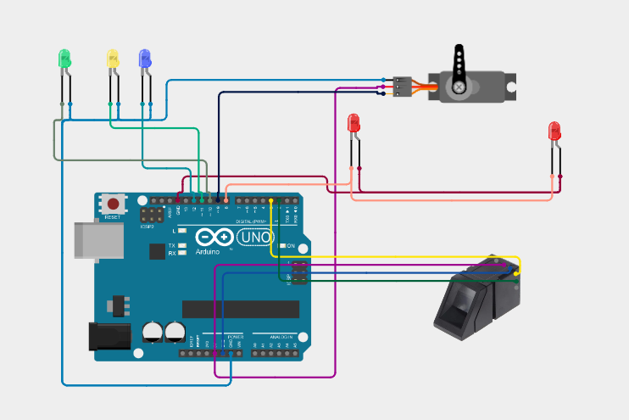

العملي منزل بعدين ادز الصور مالته

العملي تنفيذ
اضافه شخص
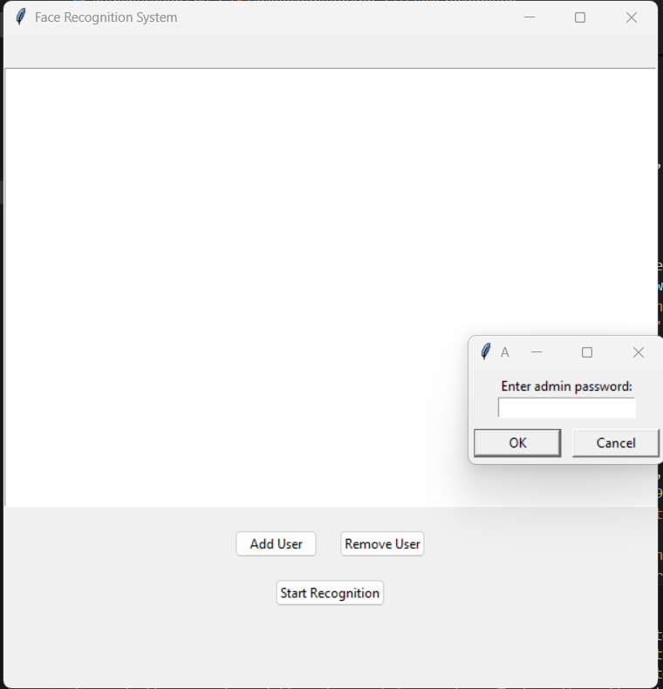 يطلب رمز

اسم الشحص
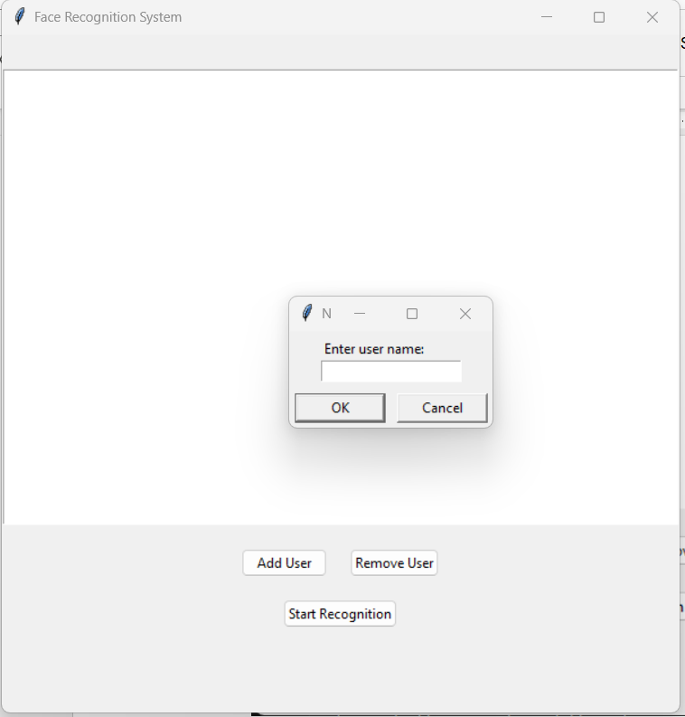

تبدء عمليه اخذ صور للوجه
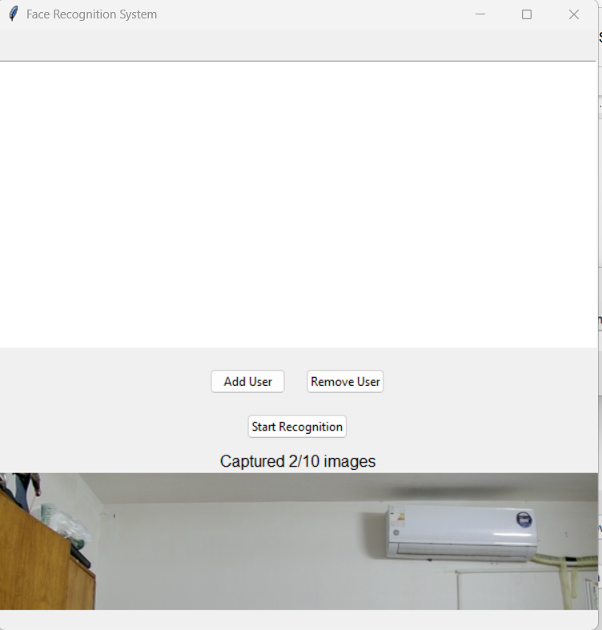

بدء التعرف
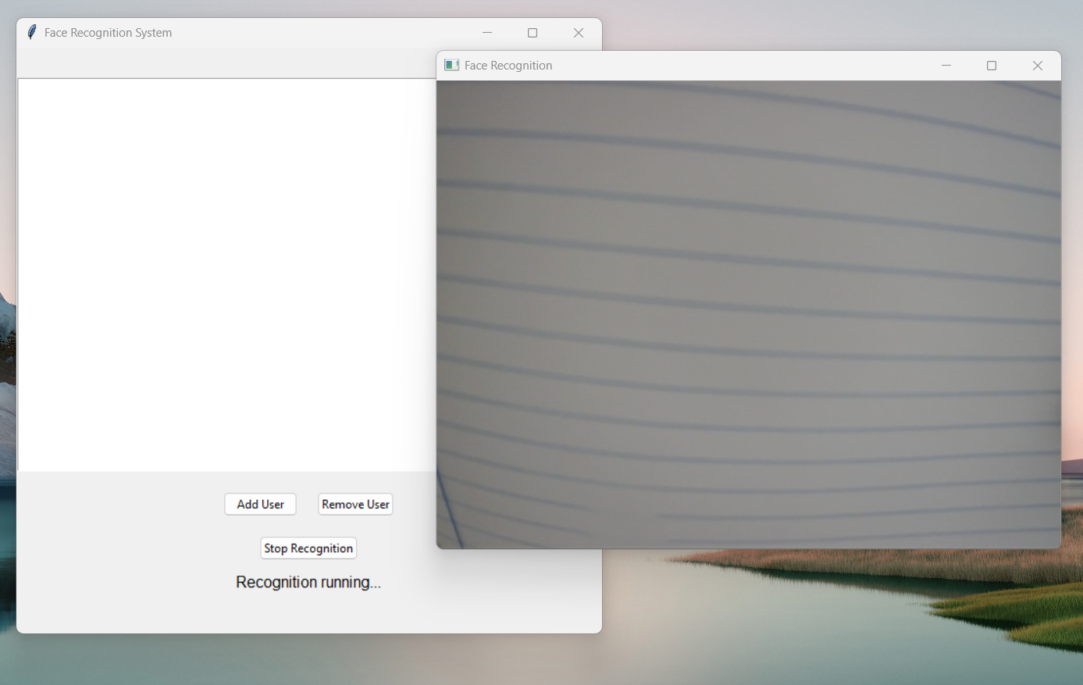

بصمه الاصبع
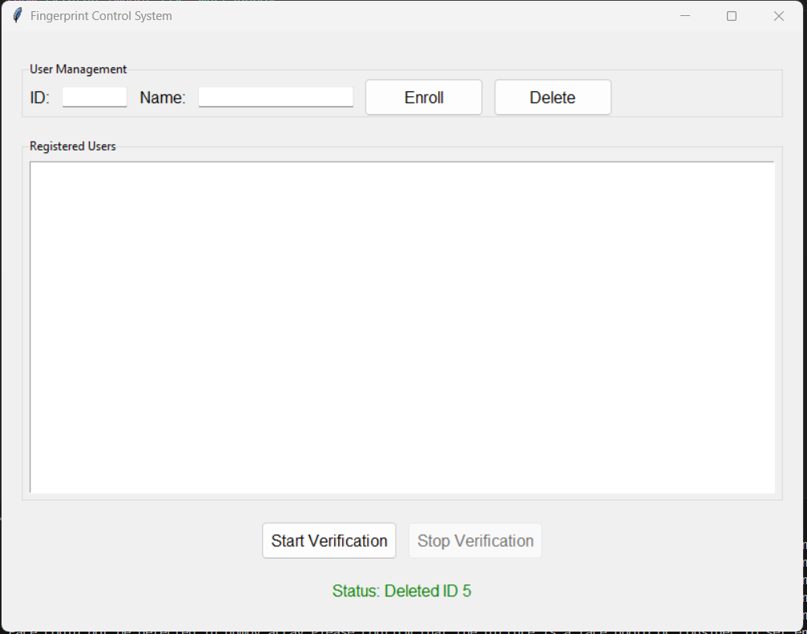
اضافه وتحرير وبدء الفحص

التحكم بالاشارات
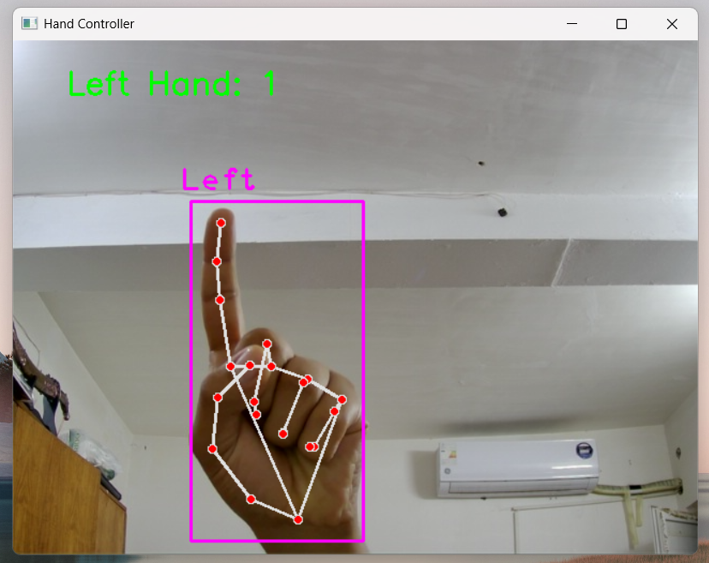
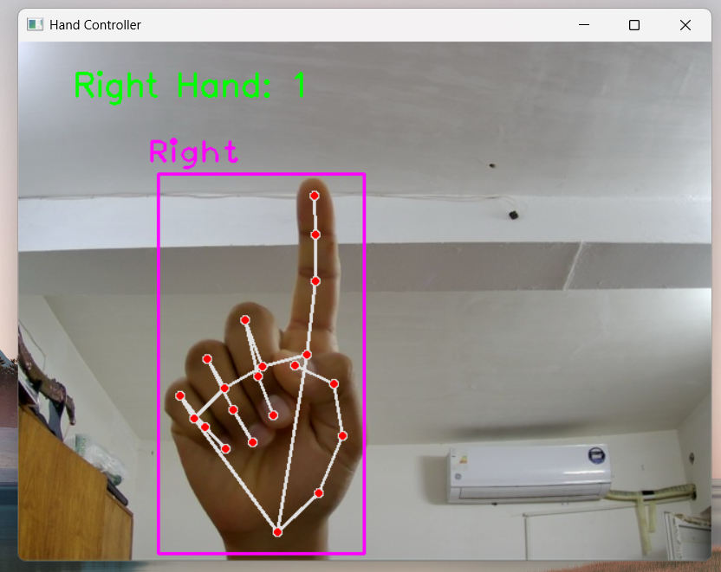
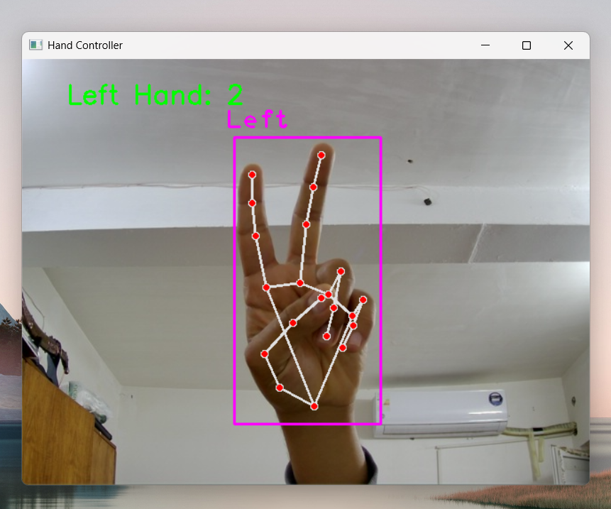
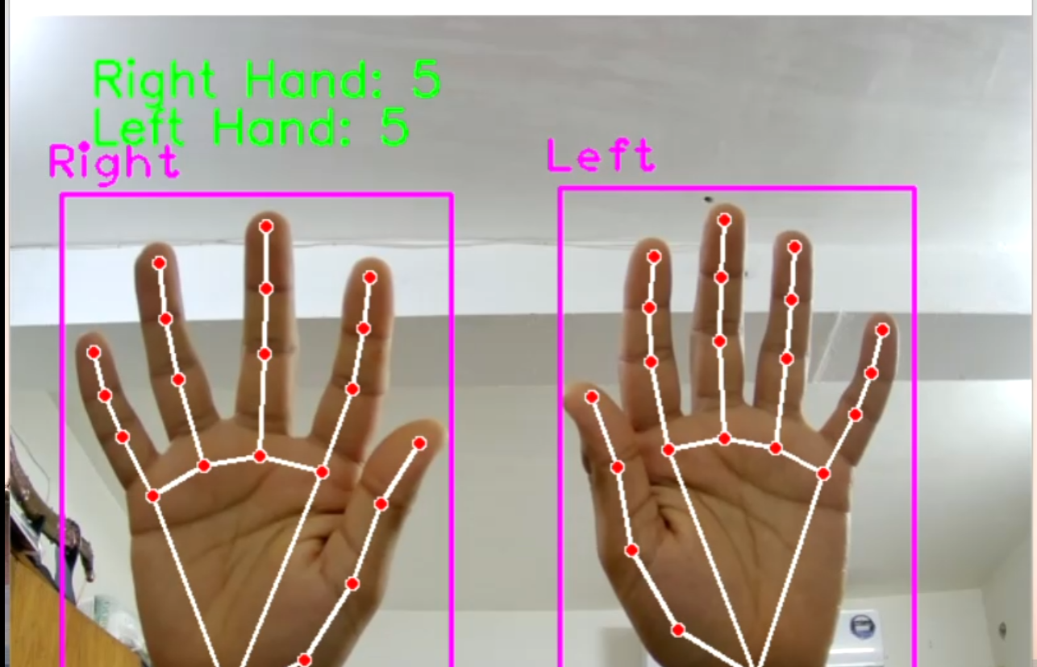

الأوامر المبرمجه حاليا

