# Names ID

Alaa Khaled El habibi ID:231002125

Jana Mahmoud Abdalla ID:231001245

Mariam Wassem ID: 231001582

# Overview

This database is designed to manage information related to biomedical research, including authors, research fields, journals, publishers, and research articles. The goal is to enable efficient tracking of contributions, collaborations, and publications in various biomedical domains.

# 1. Schema

All database objects are put under the schema:  
biomedical_schema

# 2. Tables and Relationships

## 2.1. Biomedical_Research_Field

Stores distinct biomedical research disciplines.

- Field_ID (Primary Key)  
- Field_Name (e.g., Immunology, Genetics)

## 2.2. Author

Contains detailed profiles of researchers.

- Author_ID (Primary Key)  
- Name, Qualification, Affiliation  
- Job_Title, Email (unique), h_index

## 2.3. Author_Field

Many-to-many relationship between Authors and Research Fields.

- Composite Key: Author_ID, Field_ID  
- Foreign Keys:  
 - Author_ID → Author  
 - Field_ID → Biomedical_Research_Field

## 2.4. Publisher

Stores journal publishers.

- Publisher_ID (Primary Key)  
- Publisher_Name, Publication_Types, Payment_Methods

## 2.5. Journal

Holds journal data.

- ISSN (Primary Key)  
- Journal_Name, Biomedical_Research_Field, Impact_Factor  
- Quarter, Publisher_ID (Foreign Key), Country, Start_Date  
- Volume_Publication_Rate (ENUM), Open_Access_Status

## 2.6. Research

Represents published biomedical research articles.

- Research_ID (Primary Key)  
- Title, Abstract, Publication_Date, Research_Field  
- Journal_ID (Foreign Key → Journal.ISSN)  
- Citations, Year

## 2.7. Research_Author

Many-to-many relationship between Authors and Research.

- Composite Key: Research_ID, Author_ID  
- Foreign Keys:  
 - Research_ID → Research  
 - Author_ID → Author

# 3. Queries with Screenshots

## Q1: Authors interested in Immunology

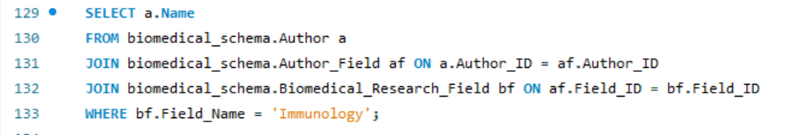

This query uses inner joins to connect the Author, Author_Field, and Biomedical_Research_Field tables. The many-to-many relationship between authors and research fields is resolved through the Author_Field junction table. By filtering for Field_Name = 'Immunology', the query lists only those authors who are associated with this discipline.

## Q2: Author with the most citations in 2023

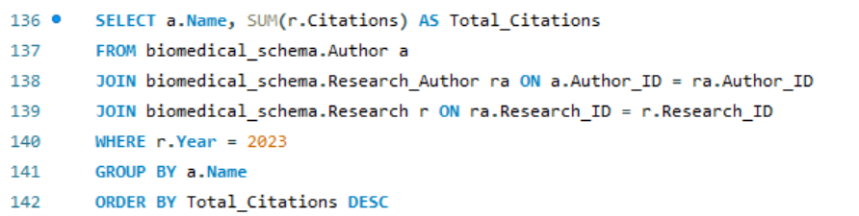

This query identifies the total number of citations for each author’s research in the year 2023. It involves a join between Author, Research_Author, and Research, with aggregation (SUM) used to calculate total citations per author. The LIMIT 1 clause returns the top-ranking author.

## Q3: Open access journals by Springer

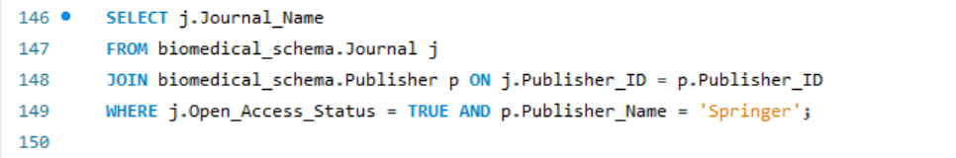

This query retrieves the names and ISSNs of journals published by Springer that offer open access. It performs a join between the Journal and Publisher tables and applies filters on both the publisher name and the Open_Access_Status.

**4.Developing a GUI Using Python (Tkinter/PyQt)**

Once the database was built and populated, we connected it to a Python-based **Graphical User Interface (GUI)**. This GUI allows:

* Viewing and inserting records
* Running custom queries from the front-end
* Navigating between tables using dropdowns or buttons
* Connecting securely to the MySQL server using a connector (e.g., mysql.connector)

Please edit these config according to the credentials of the Server connection on the executing machine (Replace the user and the password with your own server user and password)

**5. ER Diagram**

The following ER diagram illustrates the entities, their attributes, and the relationships between them, including cardinality and participation constraints.

**6. Triggers**

USE biomedical_schema;

DELIMITER //

CREATE TRIGGER trg_author_email_lower

BEFORE INSERT ON Author

FOR EACH ROW

BEGIN

SET NEW.Email = LOWER(NEW.Email);

END//

DELIMITER ;

**Purpose:** This trigger ensures that all author emails are stored in lowercase for consistency.