Human-AI Interaction

Project’s Goal:-
Design and evaluate a human–AI interaction system that integrates concepts from all course topics. The focus is on creating usable, ethical, and trustable interfaces rather than building AI models. Students must show how humans and AI collaborate, how design supports user needs, and how ethical and emotional issues are addressed. Your prototype can vary from an AI application/model to hardware system. (Note** the complexity of your project’s complexity can qualify the team for bonus marks)
- Groups should be from the same section

- Problem Definition & Context (10%)
- Clear description of the human–AI interaction scenario.
- Identification of target users and needs.
- Connection to real-world relevance.
- Prototype Design Quality (20%)
- Application of Shneiderman’s 8 Golden Rules.
- Clarity, simplicity, accessibility, inclusivity.
- Consistency across interface components.
- Human–AI Interaction Features (25%)
- Multiple interaction modes (chat, voice, recommendations, dashboards).
- Transparency and explainability of AI outputs.
- Handling of errors, ambiguity, and user control.
- Ethics & Trust (10%)
- Address privacy, bias, fairness, accountability.
- Clear safeguards or design choices to mitigate risks.

- Emotional Interaction (10%)
- Inclusion of emotion-aware or adaptive responses.
- Consideration of cultural and privacy issues.
- Future Vision (5%)
- Forecast of how the system may evolve.
- Positive and negative scenarios discussed.
- Evaluation & Testing (10%)
- Usability testing with peers or simulated users.
- Data collection (surveys, task success, error rates).
- Analysis of results.
- Deliverables & Presentation (10%)
- Prototype or mock-up demonstrating the system.
- Report structured with all required sections.
- Clear oral/visual presentation.

Deliverables:
- Prototype or Mock-up: Interactive prototype.
- Report (10–15 pages):
  - Problem definition and target users.
  - Historical context and connection to HAI evolution.
  - System design with Shneiderman’s 8 Golden Rules.
  - Human–AI interaction features (chat, voice, recommendations, dashboards).
  - Ethical and trust considerations (privacy, bias, fairness, accountability).
  - Emotional interaction design (adaptive or emotion-aware responses).
  - Future vision of your system (positive and negative scenarios).
  - Evaluation plan, method, and results (usability testing, surveys).
  - Conclusion and reflection.
- Presentation (10–12 minutes):
  - Demonstration of prototype.
  - Clear summary of design choices, evaluation results, and ethical considerations.
Delay penalty(20%): note that any failure to meet any deadlines can result in a penalty, any excesses must be reported beforehand to be accepted, otherwise none will be accepted.
Unique Project Approval
- Teams must propose unique project ideas (approved by the instructor).
- Identical projects across teams will be rejected.

Timeline
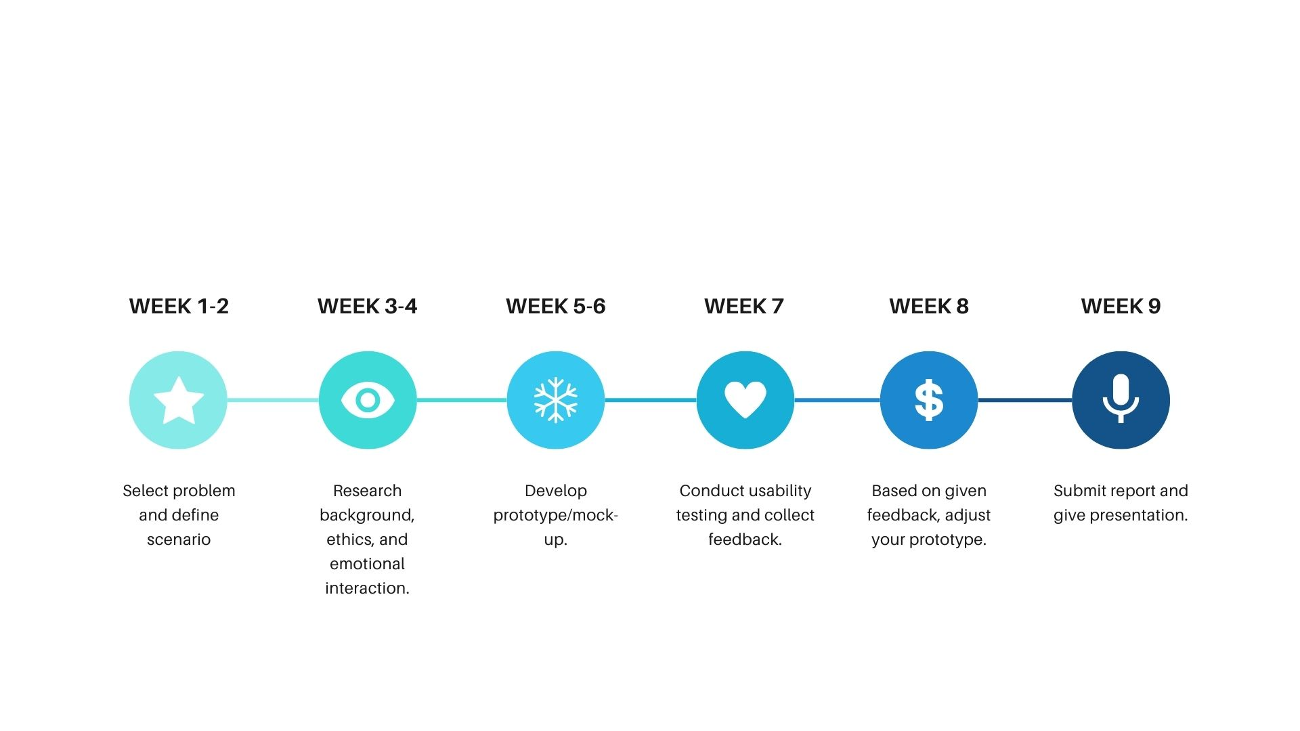

When submitting your project print the following page and submit it before your presentation:-

Criterion | Description | Weight | Grade
1. Problem Definition & Context | Clear description of scenario, target users, and real-world need | 10%
3. Prototype Design Quality | Application of Shneiderman’s 8 Golden Rules, clarity, accessibility, inclusivity | 20%
4. Human–AI Interaction Features | Multiple interaction modes (chat, voice, recommendations), transparency, user control | 25%
5. Ethics & Trust | Consideration of privacy, bias, fairness, accountability, safeguards | 10%
6. Emotional Interaction | Emotion-aware or adaptive responses, cultural sensitivity, privacy awareness | 10%
7. Future Vision | Forecast of system evolution, positive and negative scenarios | 5%
8. Evaluation & Testing | Usability testing, survey/task data, analysis of results | 10%
9. Deliverables & Presentation | Prototype/mock-up, structured report, clear oral/visual presentation | 10%
Team Idea:_____________________________________________________________ Section:___
Team Members:
1.______________________________________
2.______________________________________
3.______________________________________
4.______________________________________
5.______________________________________

