**Read Command**

**Example1**

**Example2**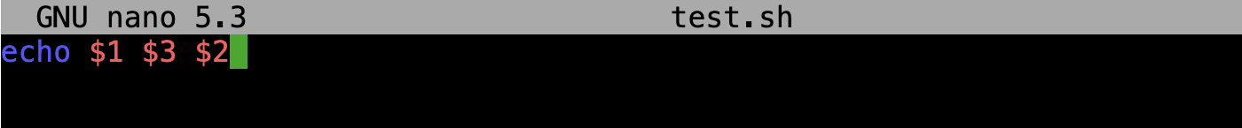

**Example3 (length)**

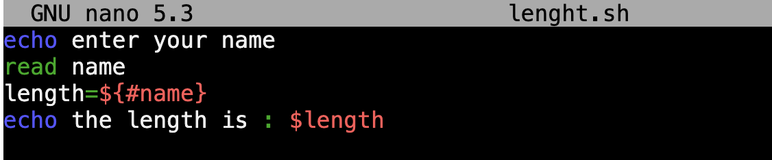

**Example4 (While do)**

**Example45 (For do)**

