**How to set-up an ProMaIDes-development framework with VC (v12.4.2019)**

**1. Download Visual Studio Community**

* https://visualstudio.microsoft.com/de/vs/community/
* Install also the English language package;
* Following packages, I installed:

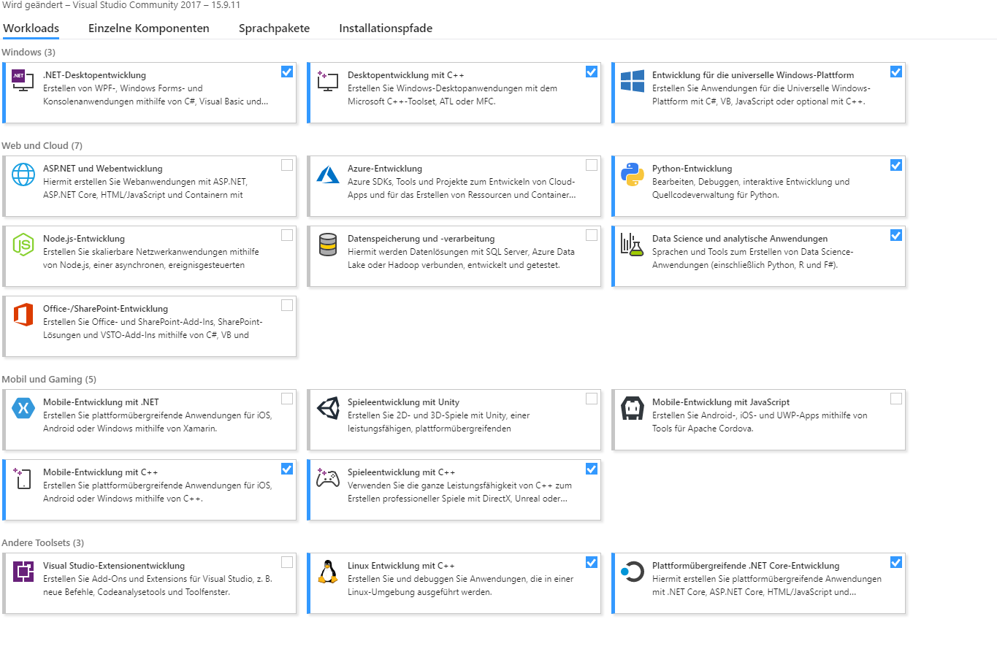

* It is important to install the UWP-tools for C++ (package universelle Windows-Plattform)

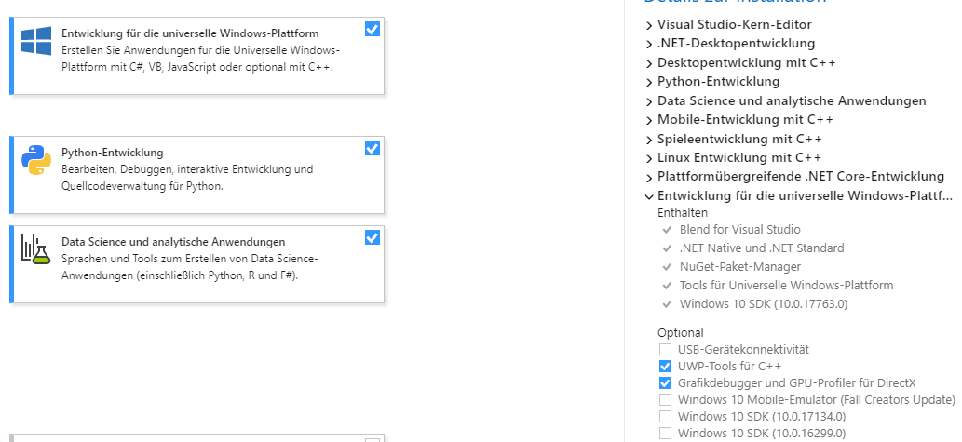

**2. Download QT-version for MSVC (open source version; 5.12.1 msvc2017_64)**

* https://www.qt.io/download

**3. Download QWT (currently 6.1.0)**

* https://sourceforge.net/projects/qwt/files/qwt/6.1.0/
* It must be compiled by VS; I can also deliver the binaries

**4. Download QT-add in for VC and install it**

* https://marketplace.visualstudio.com/items?itemName=TheQtCompany.QtVisualStudioTools-19123

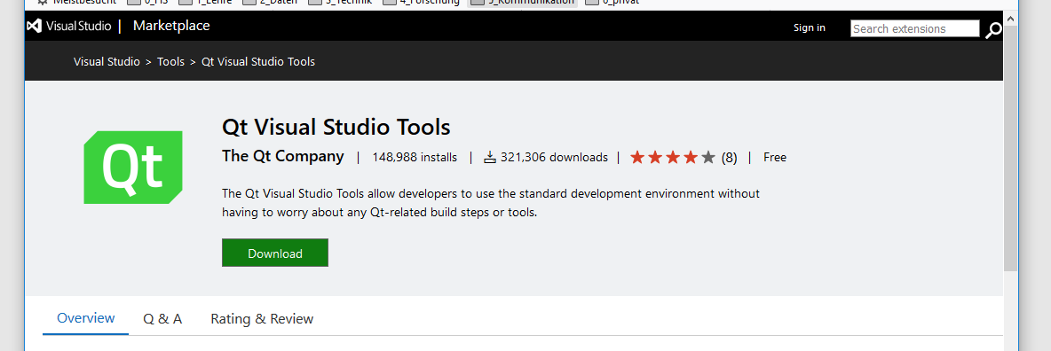

* Set the available QT-versions in MSVC in the *QT VS Tools*

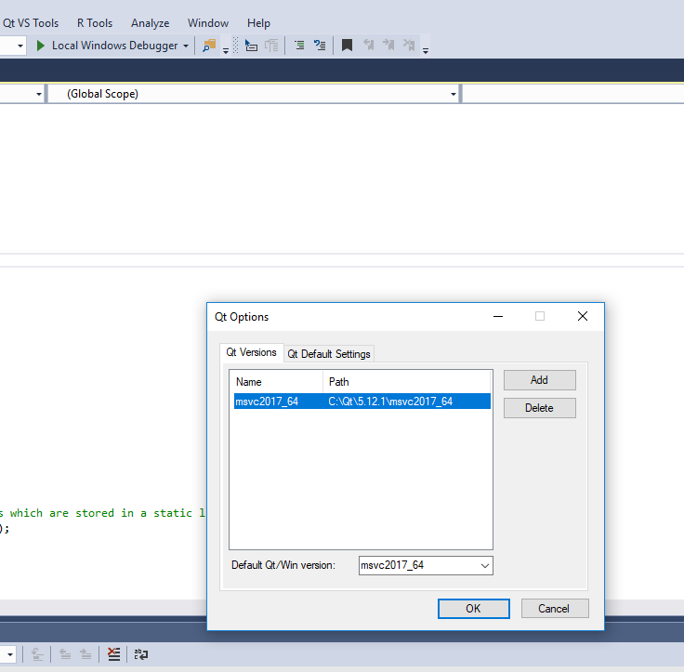

**5. Load step by step the pro-files of each module into VS**

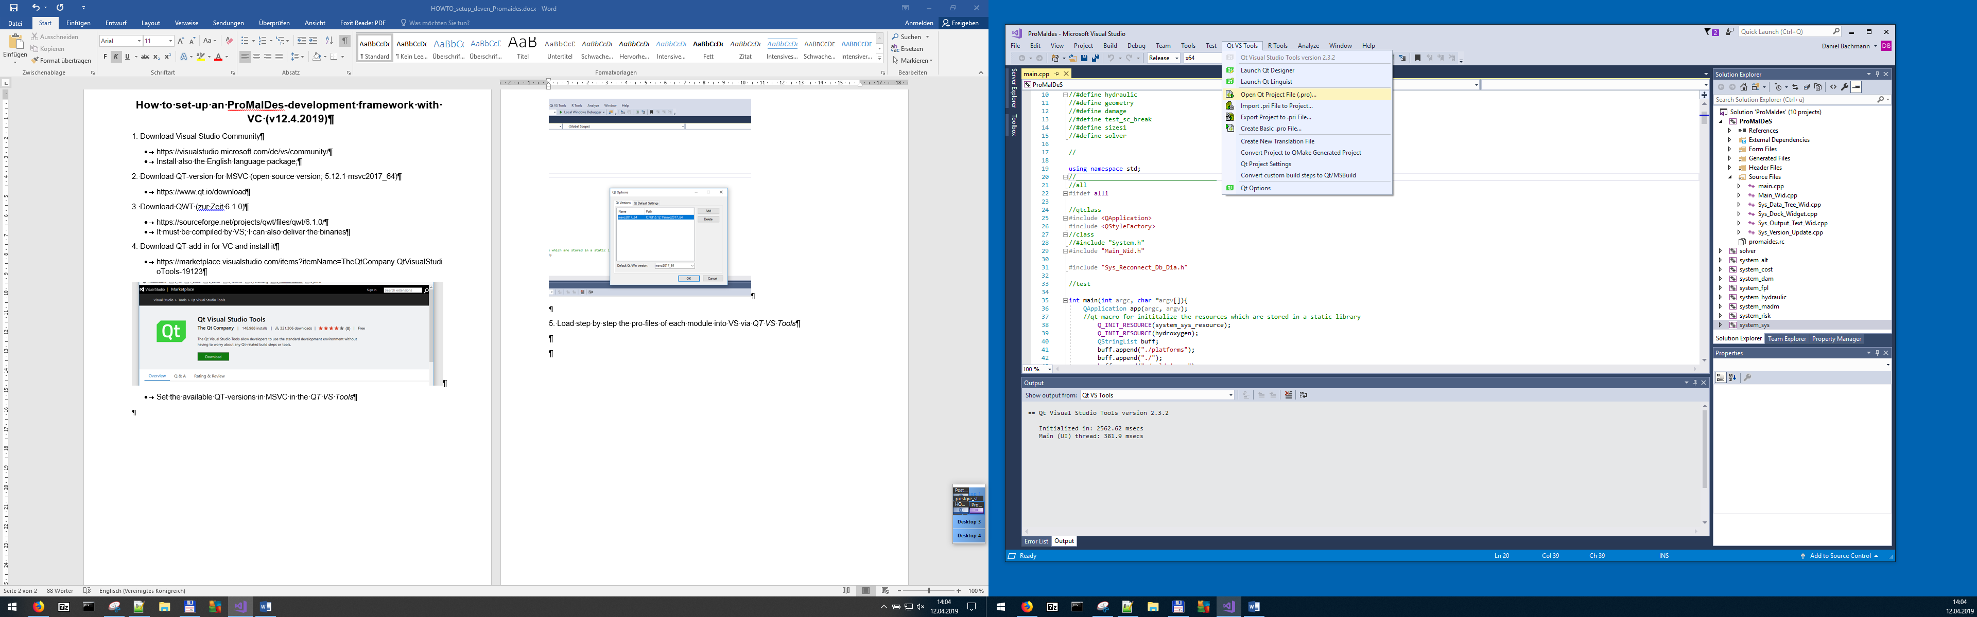

* Start by system_sys (all project will produce static libs, just the ProMaIDes.pro file will generate an executable)
* Use via *QT VS Tools/Open QT project file…*
* Set the project dependency; the required build order is shown below

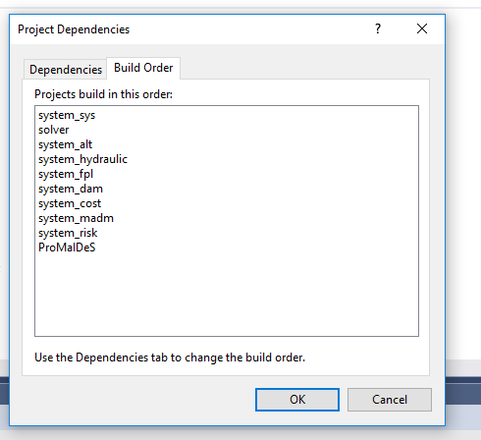

* Try to compile each project step-by-step
* Set the ProMaIDes-project as “Start-up project” (e.g “solution property pages”)

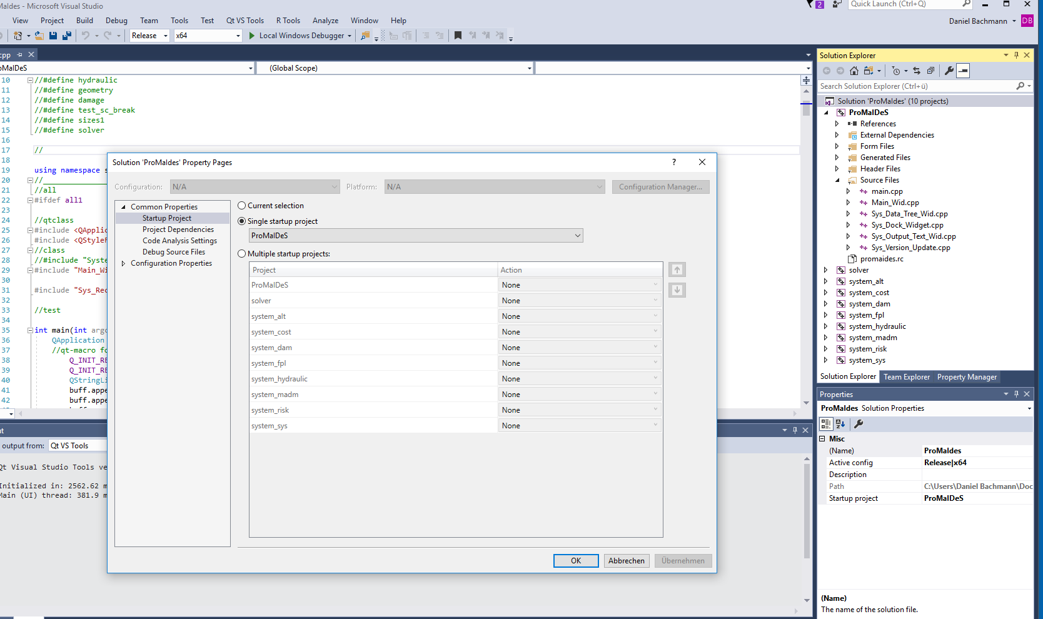

* Here you can specify further build option

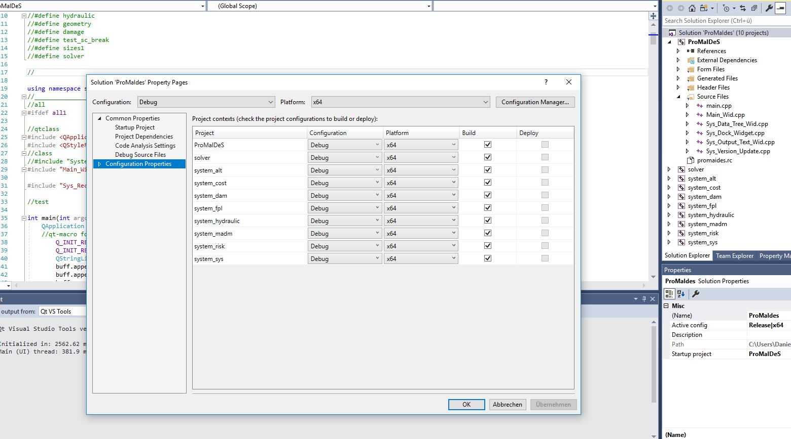

* Beware that after an import of the ProMaIdes-project file you have to delete in the Linker-properties the qwt.lib

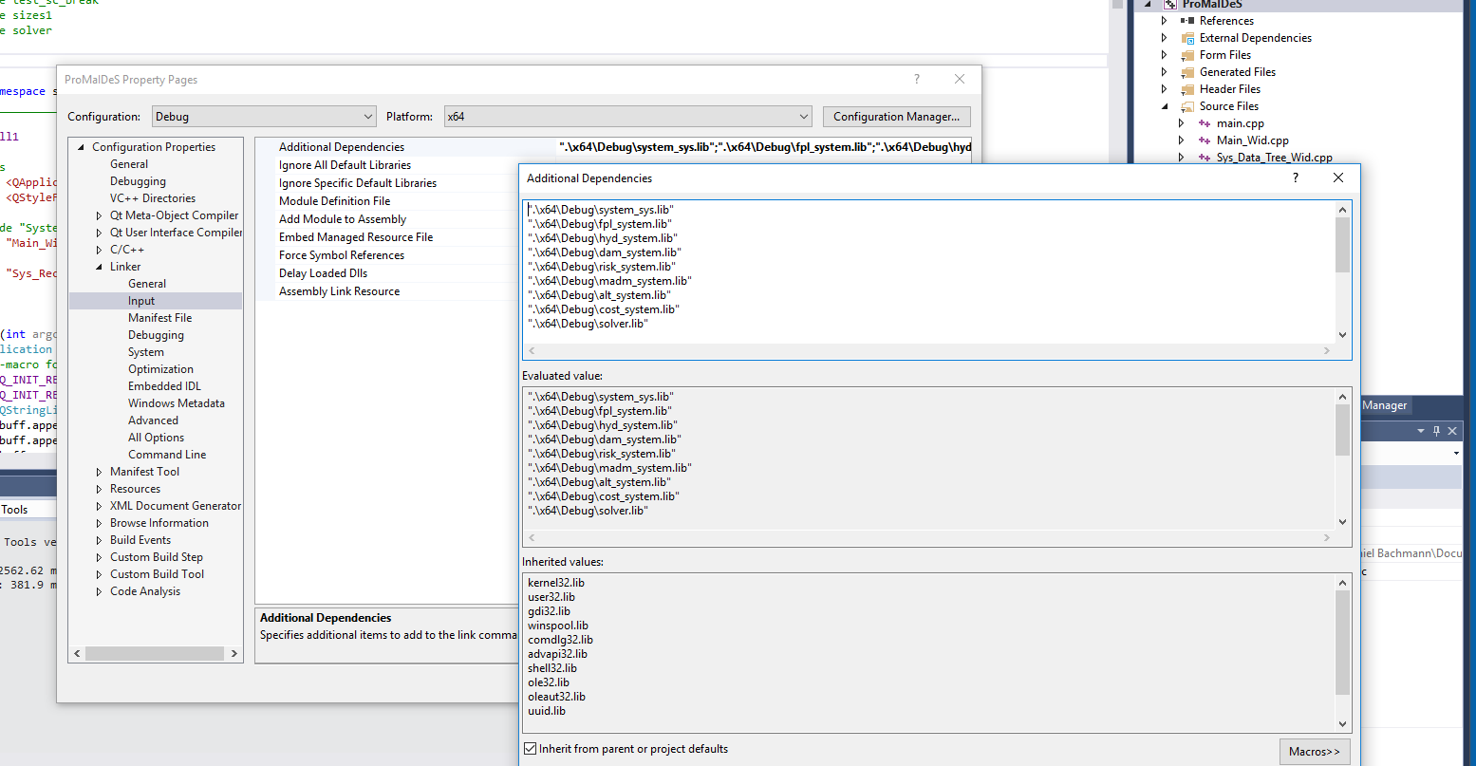

* Project dependency is as follow:
  + ProMaideS: to all
  + Solver: to none
  + System_alt: system_dam, system_fpl, system_hydraulic
  + System_cost: system_alt
  + system_dam: system_hydraulic, system_sys
  + system_fpl: system_sys
  + system_hydraulic: solver, system_sys
  + system_madm: system_cost, system_risk
  + system_risk: system_dam,system_fpl,system_hydaulic, system_sys
  + system_sys: to none

**6. Deploying:**for **deploying** the tool following files should by in folder (I’m not sure if all are required!, Should check it on a clean PC):

* + imageformats\ *(this one comes from the Qt/plugin folder)*
  + platforms\ *(this one comes from the Qt/plugin folder)*
  + ProMaIDeS.tlog\
  + sqldrivers\ *(this one comes from the Qt/plugin folder)*
  + alt_system.lib
  + cost_system.lib
  + dam_system.lib
  + fpl_system.lib
  + hyd_system.lib
  + icudt52.dll
  + icuin52.dll
  + icuuc52.dll
  + libbz2-1.dll
  + libeay32.dll
  + libfreetype-6.dll
  + libgcc_s_dw2-1.dll
  + libgcc_s_seh-1.dll
  + libglib-2.0-0.dll
  + libgomp-1.dll
  + libharfbuzz-0.dll
  + libiconv-2.dll
  + libintl-8.dll
  + libjpeg-8.dll
  + libmysql.dll
  + libpcre16-0.dll
  + libpng16-16.dll
  + libpq.dll
  + libstdc++-6.dll
  + libwinpthread-1.dll
  + madm_system.lib
  + main.obj
  + Main_Headers_Precompiled.h.obj
  + Main_Wid.obj
  + moc_Main_Wid.obj
  + moc_Sys_Data_Tree_Wid.obj
  + moc_Sys_Dock_Widget.obj
  + moc_Sys_Output_Text_Wid.obj
  + ProMaIDeS.log
  + promaides.res
  + ProMaIDes_vc.exe
  + ProMaIDes_vc.pch
  + ProMaIDes_vc.Build.CppClean.log
  + Qt5Core.dll
  + Qt5Gui.dll
  + Qt5OpenGL.dll
  + Qt5PrintSupport.dll
  + Qt5Sql.dll
  + Qt5Svg.dll
  + Qt5Widgets.dll
  + Qt5Xml.dll
  + qt_work.log
  + qwt.dll (*this one comes from the compiled qwt-directory*)
  + risk_system.lib
  + solver.lib
  + ssleay32.dll
  + Sys_Data_Tree_Wid.obj
  + Sys_Dock_Widget.obj
  + Sys_Output_Text_Wid.obj
  + Sys_Version_Update.obj
  + system_sys.lib
  + zlib1.dll

the QT-libs should be also copied from Qt folder

**7. Debugging**  
the same procedure you have to do for your debug folder; especially the sqldrivers, images and platform-folders are important!; be aware that you have to change the working directory of your Debug version in the Project-properties (Debugging) of the ProMaIDes-project to the folder, where the folders and libs are stored!

**Good luck!**