MET CS 555 Term Project
10 points

1. Assignment Description
Select a small data set from the available public data sets (you can find a list of public data sets here http://www.teymourian.de/public-data-sets-for-data-analytic-projects/ ).

Describe a research scenario and specify a research question based on data analytic methods that we learned in our class, for example methods like, one and two sample means, t-test, correlation tests, simple and multiple linear regression, ANOVA and ANCOVA, one and two-Sample Tests for Proportions and logistic regression.

Clean up your data and reduce it to no more than 500 observations if your data set is large.

2. Research Scenario Description (no more than 200 words)
Describe your research scenario in no more than 200 words. This is a general description of the use case. Similar to our class examples, we first describe the overall scenario and then we specify a specific research question based on it.

For my research project I am going to be looking at the New York Yellow Taxi data set that provides a large set of data giving all the trips for a particular month with their pickup times, location, and many more columns. To be more specific I will be looking at what datasets affect the amount of time it takes for a rider to reach their destination. From an initial look at this dataset these conclusions could vary from trip distance, area of pickup location or the area of the drop-off location. I will be performing various statistical methods to create a conclusion on what data points affect the time taken for the rider to reach their destination. This research can help taxi companies be better prepared so that they know exactly what will take them longer so that the customer is also able to plan ahead.

3. Describe the data set (no more than 200 words)
Describe briefly the data set. Describe each columns of the data set if you use the column in your analysis. Clean up your data before usage, for example you can remove the outliers. Remove unused columns. If possible provide a Link to the main data set source.

In this data set we have a lot of columns but the ones that I will be focused on is the tpep_pickup_datetime and tpep_dropoff_datetime as this will be needed to get the exact time taken for a customer to finish their ride. There are other columns in the dataset that are also important after the first glance such as tip distance, pick up location, drop off location, total fare amount. There are a number of columns that we will not use such as toll amount, airport charges, payment type, and this could be added to as we perform some statistical methods to eliminate unnecessary columns not required for this research question.

3. Research Question (no more than 100 words)
Describe briefly in one or two sentences the main research question. This is similar to the last sentence of our class examples.

Time taken for trips is something that taxi companies want to be able to predict, and for this they would need a model that can best predict the time taken. For this research project, I will be focusing on creating an accurate model and describe its statistically significance from the information found after performing tests on the variables such as trip distance, total amount, fare amount, tip amount, extra, airport fee, congestion surcharge, and so on…

4. Your solution R code
Copy your R code here. Start from read the data from a data file. Keep the following data read line.
This is similar to one of our R code examples.
---
title: "FinalProjectReport"
output: html_document
date: "2022-12-07"
---

```{r include=FALSE}
library("dplyr")
library("corrplot")
require("scatterplot3d")
library("ggstatsplot")
library("tidyverse")
library("rstatix")
library("ggpubr")
library("olsrr")
```

# Loading Dataset
```{r loading}
df <- read.csv("taxitripdata.csv")
```

# Exploring Dataset

```{r exploring}
summary(df)

head(df)
```

Creating new column to describe exact time taken for a trip since pickup and dropoff are in datetime format
Keep in mind the column being added, timeTaken, has units of minutes

```{r}
df$timeTaken <- paste(difftime(df$tpep_dropoff_datetime,df$tpep_pickup_datetime, units="mins"))
df$timeTaken <- as.numeric(df$timeTaken)
head(df)
```

We will be dropping some columns as they are all IDs and will not help in the model since they are categorical variables
```{r}
new_df <- df %>% select(-c(store_and_fwd_flag, tpep_pickup_datetime, tpep_dropoff_datetime, PULocationID, DOLocationID, VendorID, RatecodeID, payment_type))
```

# Outlier Handling

```{r}
boxplot(new_df)
```

We have now plotted our dataset, so we will remove our outliers first and then choose our sample size
With the boxplot we can see which variables have outliers and now we will remove them all
```{r outliers}
new_df <- new_df[-which(new_df$timeTaken %in% boxplot.stats(new_df$timeTaken)$out), ]
new_df <- new_df[-which(new_df$fare_amount %in% boxplot.stats(new_df$fare_amount)$out), ]
new_df <- new_df[-which(new_df$trip_distance %in% boxplot.stats(new_df$trip_distance)$out), ]
new_df <- new_df[-which(new_df$total_amount %in% boxplot.stats(new_df$total_amount)$out), ]
new_df <- new_df[-which(new_df$tolls_amount %in% boxplot.stats(new_df$tolls_amount)$out), ]
new_df <- new_df[-which(new_df$passenger_count %in% boxplot.stats(new_df$passenger_count)$out), ]
new_df <- new_df[-which(new_df$mta_tax %in% boxplot.stats(new_df$mta_tax)$out), ]
new_df <- new_df[-which(new_df$tip_amount %in% boxplot.stats(new_df$tip_amount)$out), ]
new_df <- new_df[-which(new_df$airport_fee %in% boxplot.stats(new_df$airport_fee)$out), ]
new_df <- new_df[-which(new_df$congestion_surcharge %in% boxplot.stats(new_df$congestion_surcharge)$out), ]

boxplot(new_df)
```

We can see from this that the majority of outliers have been removed, now we can go ahead with our investigation

## Choosing first 500 rows
```{r}
complete_df <- head(new_df, 500)

summary(complete_df)

attach(complete_df)
```

# Scatter Plot
```{r}
pairs(complete_df, upper.panel=NULL)
```
This output shows:
Some linear relationship between trip distance and time taken
No Linear relationship between passenger count and time taken, airport fee and time taken, congestion surhcarge and time taken, improvement surcharge and time taken, tolls amount and time taken, mta tax and time taken, extra and time taken
Some Linear relationship between tip amount and time taken, but with some noise
Strong Linear relationship between total amount and time taken, fare amount and time taken

We can also get a closer look at the ones we think is linear from the initial plot

#### trip distance and time taken
```{r}
plot(complete_df$trip_distance, complete_df$timeTaken)
```

We can confirm that is relationship is linear

#### total amount and time taken
```{r}
plot(complete_df$total_amount, complete_df$timeTaken)
```

We can confirm that this is also linear

#### fare amount and time taken
```{r}
plot(complete_df$fare_amount, complete_df$timeTaken)
```

We can see that there is a strong linear relationship

#### tip amount and time taken
```{r}
plot(complete_df$tip_amount, complete_df$timeTaken)
```
We can see that there is a very slight linear relationship while there is a lot of noise

# Testing

## Simple Linear Regression

### Trip Distance to Time Taken Linear Regression
#### Model
Now we will create the linear model and then print out a summary to check the R-squared and p-value to check the goodness of this model
```{r}
lmdistance <- lm(timeTaken~trip_distance, data=complete_df)
summary(lmdistance)
```

We can see that:
p-value is < 0.05, therefore, it shows that the variable is significant
slope and intercept p-value is < 0.05, therefore, it is clear both coefficients is significant
this model with distance as predictor explains about 61.3% variability of the target
residual standard error is 4.135

### Total Amount to Time Taken Linear Regression
#### Model
```{r}
lmamount <- lm(timeTaken~total_amount, data=complete_df)
summary(lmamount)
```

We can see that:
p-value is < 0.05, therefore, it shows that the variable is significant
slope and intercept p-value is < 0.05, therefore, it is clear both coefficients is significant
this model with total amount as predictor explains about 80% variability of the target
residual standard error is 2.934

### Fare Amount to Time Taken Simple Linear Regression
#### Model
```{r}
lmfare <- lm(timeTaken~fare_amount, data=complete_df)
summary(lmfare)
```

We can see that:
p-value is < 0.05, therefore, it shows that the variable is significant
slope and intercept p-value is < 0.05, therefore, it is clear both coefficients is significant
this model with fare amount as predictor explains about 86% variability of the target
residual standard error is 2.469

### Tip Amount to Time Taken Simple Linear Regression
#### Model
```{r}
lmtip <- lm(timeTaken~tip_amount, data=complete_df)
summary(lmtip)
```

We can see that:
p-value is < 0.05, therefore, it shows that the variable is significant
slope and intercept p-value is < 0.05, therefore, it is clear both coefficients is significant
this model with fare amount as predictor explains about 12% variability of the target, meaning it does not do a good job in predicting the time taken value
residual standard error is 6.238

From the Simple Linear Regressions that we ran above, we can say the fare amount gave us the best variability so we will plot the scatterplot along with the regression line
```{r}
plot(fare_amount, timeTaken)

abline(lmfare, col="blue")
```
As you can see the line does not fully explain the variability within time taken, so maybe we could try multiple linear regression and see if more predictors help improve the line

### Correlation

```{r}
res <- cor.test(timeTaken, tip_amount)
res
```
correlation is 0.349, since the correlation is not high we can say that this won't create a lot of noise

```{r}
res <- cor.test(timeTaken, trip_distance)
res
```
correlation of 0.783 means this variable could cause a lot of noise

```{r}
res <- cor.test(timeTaken, fare_amount)
res
```
We get a correlation of 0.929 so we can say it can cause a lot of noise as well

```{r}
res <- cor.test(timeTaken, total_amount)
res
```
The correlation for this is 0.898 so it will have a lot of noise when added to the model

After running the correlation tests, we can see what correlation we get, while some are high this could cause noise in our MLR model or it could help make it more accurate

### Check for Multi-Colinearity
```{r}
res <- cor.test(fare_amount, tip_amount)
res
```
We get a correlation of 0.363 therefore it should not have a lot of noise when added together

```{r}
res <- cor.test(fare_amount, total_amount)
res
```
We get a correlation of 0.962 therefore this could create a lot of noise when added together in the model

```{r}
res <- cor.test(fare_amount, trip_distance)
res
```
We get a correlation of 0.928 therefore this could create a lot of noise when added together in the model

```{r}
res <- cor.test(total_amount, tip_amount)
res
```
We get a correlation of 0.604 therefore this could create noise as well within our model

```{r}
res <- cor.test(total_amount, trip_distance)
res
```
We get a correlation of 0.890 therefore this could create a lot of noise as well within our model

```{r}
res <- cor.test(trip_distance, tip_amount)
res
```
We get a correlation of 0.326 therefore there is less chances of this creating noise in our model

We can see that some of the correlation values are high which could mean when added to a multiple linear regression model it could add a lot of noise, however, it could also not add noise but rather help the significance of the model instead

## Multiple Linear Regression
Now that we have created our linear regression models, cleaned our data, and identified which variables are significant and have linear relationship with the time taken
We will create the multiple regression model by adding different variables and seeing how the p-value is affected so that we create a model with the least p-value and a good r-squared value as well

### Fare Amount + Total Amount
#### Model
```{r}
lm_fare_total = lm(timeTaken~fare_amount+ total_amount, data=complete_df)
summary(lm_fare_total)
```
p-value < 0.05, therefore, the model is significant
p-value of coefficients for the intercept and the fare amount is < 0.05, however, total amount coefficient is > 0.05
The model for fare amount and total amount explains a 86% variability of time taken, however, this is lower than the variability shown in the simple linear regression by just the fare amount
residual standard error is 2.469
therefore we will not add total amount to the model since it reduces the variability

### Fare Amount + Trip Distance
#### Model
```{r}
lm_fare_trip = lm(timeTaken~fare_amount+trip_distance, data=complete_df)
summary(lm_fare_trip)
```
p-value < 0.05, therefore, the model is significant
p-value for all the coefficients is < 0.05, meaning that the slope and intercept coefficients are statistically significant
This model with fare amount and trip distance explains about 90.6% variability of time taken
residual standard error is 2.037
this is model is showing us good results, maybe we could try adding another variable to the model and see how it responds

#### Anova
Now we must test whether the improvement in variability in Adjusted R squared is significant or not
We can test this by using ANOVA, having a null hypothesis as improvement in adjusted r squared is not statistically significant, and the alternative hypothesis is the improvement in adjusted r squared is statistically significant
```{r}
anova(lmfare, lm_fare_trip)
```
the p-value from the anova shows us that we can reject the null hypothesis and accept the alternative hypothesis
so the improvement for the adjusted r squared is statistically significant

### Fare Amount + Trip Distance + Tip Amount
#### Model
```{r}
lm_fare_trip_tip = lm(timeTaken~fare_amount+trip_distance+tip_amount, data=complete_df)
summary(lm_fare_trip_tip)
```
p-value < 0.05, therefore, the model is statistically significant
p-value for some of the coefficients is < 0.05, meaning that the slope and intercept coefficients are statistically significant, p-value for tip amount is not below 0.05
This model with fare amount, trip distance and tip amount explains about 90.6% variability of time taken which is slightly higher than the model with trip distance and fare amount
This variability is higher than the previous model, therefore, making the model slightly more accurate
residual standard error is 2.039
Due to the p-value for tip amount coefficient we will not consider this model and since the r squared is the same we will not make the model more complex for no reason

### Fare Amount + Trip Distance + Total Amount
#### Model
```{r}
lm_fare_trip_total = lm(timeTaken~fare_amount+trip_distance+total_amount, data=complete_df)
summary(lm_fare_trip_total)
```
p-value < 0.05, therefore, the model is statistically significant
p-value for some the coefficients (slope and intercept) is < 0.05, therefore, making them significant, while the coefficients for total amount is > 0.05
This model with fare amount, total amount, tip amount, trip distance explains about 90.6% variability of time taken
residual standard error is 2.038 which is lower than the previous model as well
Due to the p-value of the coefficients we get the same r squared, therefore, we will not go forward with this model but take the model with the lower amount of variables since we do not want to make it more complex

### Residual Plot
#### Checking Linearity Assumption
```{r}
plot(lm_fare_trip, 1)
```
The red line is pretty much horizontal indicating that the linearity assumption holds well
Residual fluctuates between the -7 to 7 bound, which shows the fitted model is good prediction to a certain extent
Since we have a few points outside the bounds, 544, 583, 578, these could be outliers since they are very far from the 0 line
Large residuals tell us that there could indicate that either the variance is not constant (heterosceadasticity) or the true relationship between the variables is non linear
While there is a slight variance we could try transforming the data and see if the model is improved

#### Transforming using log(n)
Here we try transforming to try and get a better variance
```{r}
new_df <- complete_df
new_df$timeTaken <- log(new_df$timeTaken)
new_df <- new_df[is.finite(rowSums(new_df)),]

lm_fare_trip_transf <- lm(timeTaken~fare_amount+trip_distance, data=new_df)
summary(lm_fare_trip_transf)
```
As you can see the transformation has not helped the model at all, in fact it has made our model worse with an 67.7% variability now while before we had a 90.6% variability
Therefore, we will choose not to transform it as our previous model before transforming seems to be more significant

#### Checking Distribution of Residuals
```{r}
hist(resid(lm_fare_trip))
```
As you can see from the histogram the residuals are normally distributed which is a good thing
We can also see on the left tail that there are outliers, but on the most part it is normally distributed

#### Checking F-stat with f-dist value
```{r}
summary(lm_fare_trip)
qf(0.95, 2, 497)
```
F-stat is > 3.014 with 2411 so we can proceed to reject the null hypothesis and say that it is statistically significant

# Conclusion
In the statistical analysis I have used Correlation Tests, Anova, Simple Linear Regression, and Multiple Linear Regression.
After using simple linear regression to model all the variables individually with the time taken as the predictor variable to see which models are significant and can be expanded on by using the MLR model. I then tested the correlations for these variables with time taken to see which or if any variables has high correlation and could create noise in MLR model when combined. I then tested the correlations between the independent variables to see if there exists any multicolinearity as this could add noise to our model. Correlation between some independent variables was extremely high, however, adding these variables together in the model helped its overall accuracy as we saw with the r squared value and other diagnostic methods I applied when checking the goodness of the model. I also run some other diagnostics to check the linear relationship of the variables such plotting a scatterplot of the variable with the most significance and added a linear regression line to it to see how well it fits the data, so that I can visually observe. After the diagnostics of the simple linear regression, we then move onto the multiple linear regression portion of this and we start with the variable with most significant model and add other variables to it to see which combination provides us with the most accurate model. The MLR model that shows the most significance, with a good p-value, high r squared value, high f-stat, and normally distributed residuals, that I found was when time taken is predicted by fare amount, total amount, trip distance, and tip amount. To check the fit of the MLR model we ran diagnostics such as checking F-stat, checking the distribution of the residuals, checking the residual vs fitted plot to see if the model is actually linear or not. The residual vs fitted plot also showed that the constant variance factor was being violated, however, when I tried to transform using the log(n) method it affected the model negatively, therefore, we did not transform and went ahead using the original model. To conclude we can say that the fare amount, trip distance, total amount, and tip amount as multiple linear regression helps best explain the changes and variability in the time taken for each taxi trip.

5. Execute your R code, Copy and Paste results here in this Box.
Run your code and copy the output of your code to here.

FinalProjectReport

2022-12-07

Loading Dataset
df <- read.csv("taxitripdata.csv")

Exploring Dataset
summary(df)
## VendorID tpep_pickup_datetime tpep_dropoff_datetime passenger_count
## Min. :1.000 Length:10000 Length:10000 Min. :0.00
## 1st Qu.:1.000 Class :character Class :character 1st Qu.:1.00
## Median :2.000 Mode :character Mode :character Median :1.00
## Mean :1.711 Mean :1.61
## 3rd Qu.:2.000 3rd Qu.:2.00
## Max. :2.000 Max. :6.00
## trip_distance RatecodeID store_and_fwd_flag PULocationID
## Min. : 0.000 Min. : 1.000 Length:10000 Min. : 4
## 1st Qu.: 1.220 1st Qu.: 1.000 Class :character 1st Qu.:107
## Median : 2.130 Median : 1.000 Mode :character Median :148
## Mean : 3.207 Mean : 1.121 Mean :155
## 3rd Qu.: 3.900 3rd Qu.: 1.000 3rd Qu.:232
## Max. :42.250 Max. :99.000 Max. :265
## DOLocationID payment_type fare_amount extra
## Min. : 4 Min. :1.000 Min. :-80.00 Min. :-0.500
## 1st Qu.: 88 1st Qu.:1.000 1st Qu.: 7.00 1st Qu.: 0.500
## Median :151 Median :1.000 Median : 10.00 Median : 0.500
## Mean :155 Mean :1.247 Mean : 13.04 Mean : 1.167
## 3rd Qu.:233 3rd Qu.:1.000 3rd Qu.: 15.50 3rd Qu.: 3.000
## Max. :265 Max. :4.000 Max. :250.00 Max. : 4.250
## mta_tax tip_amount tolls_amount improvement_surcharge
## Min. :-0.5000 Min. : 0.000 Min. :-12.0000 Min. :-0.3000
## 1st Qu.: 0.5000 1st Qu.: 0.000 1st Qu.: 0.0000 1st Qu.: 0.3000
## Median : 0.5000 Median : 2.150 Median : 0.0000 Median : 0.3000
## Mean : 0.4889 Mean : 2.503 Mean : 0.1761 Mean : 0.2967
## 3rd Qu.: 0.5000 3rd Qu.: 3.360 3rd Qu.: 0.0000 3rd Qu.: 0.3000
## Max. : 0.5000 Max. :100.000 Max. : 40.0000 Max. : 0.3000
## total_amount congestion_surcharge airport_fee
## Min. :-92.30 Min. :-2.500 Min. :-1.250
## 1st Qu.: 12.30 1st Qu.: 2.500 1st Qu.: 0.000
## Median : 15.96 Median : 2.500 Median : 0.000
## Mean : 19.35 Mean : 2.315 Mean : 0.045
## 3rd Qu.: 22.30 3rd Qu.: 2.500 3rd Qu.: 0.000
## Max. :282.80 Max. : 2.500 Max. : 1.250
head(df)
## VendorID tpep_pickup_datetime tpep_dropoff_datetime passenger_count
## 1 1 2022-01-01 00:35:40 2022-01-01 00:53:29 2
## 2 1 2022-01-01 00:33:43 2022-01-01 00:42:07 1
## 3 2 2022-01-01 00:53:21 2022-01-01 01:02:19 1
## 4 2 2022-01-01 00:25:21 2022-01-01 00:35:23 1
## 5 2 2022-01-01 00:36:48 2022-01-01 01:14:20 1
## 6 1 2022-01-01 00:40:15 2022-01-01 01:09:48 1
## trip_distance RatecodeID store_and_fwd_flag PULocationID DOLocationID
## 1 3.80 1 N 142 236
## 2 2.10 1 N 236 42
## 3 0.97 1 N 166 166
## 4 1.09 1 N 114 68
## 5 4.30 1 N 68 163
## 6 10.30 1 N 138 161
## payment_type fare_amount extra mta_tax tip_amount tolls_amount
## 1 1 14.5 3.0 0.5 3.65 0.00
## 2 1 8.0 0.5 0.5 4.00 0.00
## 3 1 7.5 0.5 0.5 1.76 0.00
## 4 2 8.0 0.5 0.5 0.00 0.00
## 5 1 23.5 0.5 0.5 3.00 0.00
## 6 1 33.0 3.0 0.5 13.00 6.55
## improvement_surcharge total_amount congestion_surcharge airport_fee
## 1 0.3 21.95 2.5 0
## 2 0.3 13.30 0.0 0
## 3 0.3 10.56 0.0 0
## 4 0.3 11.80 2.5 0
## 5 0.3 30.30 2.5 0
## 6 0.3 56.35 2.5 0
Creating new column to describe exact time taken for a trip since pickup and dropoff are in datetime format
Keep in mind the column being added, timeTaken, has units of minutes
df$timeTaken <- paste(difftime(df$tpep_dropoff_datetime,df$tpep_pickup_datetime, units="mins"))
df$timeTaken <- as.numeric(df$timeTaken)
head(df)
## VendorID tpep_pickup_datetime tpep_dropoff_datetime passenger_count
## 1 1 2022-01-01 00:35:40 2022-01-01 00:53:29 2
## 2 1 2022-01-01 00:33:43 2022-01-01 00:42:07 1
## 3 2 2022-01-01 00:53:21 2022-01-01 01:02:19 1
## 4 2 2022-01-01 00:25:21 2022-01-01 00:35:23 1
## 5 2 2022-01-01 00:36:48 2022-01-01 01:14:20 1
## 6 1 2022-01-01 00:40:15 2022-01-01 01:09:48 1
## trip_distance RatecodeID store_and_fwd_flag PULocationID DOLocationID
## 1 3.80 1 N 142 236
## 2 2.10 1 N 236 42
## 3 0.97 1 N 166 166
## 4 1.09 1 N 114 68
## 5 4.30 1 N 68 163
## 6 10.30 1 N 138 161
## payment_type fare_amount extra mta_tax tip_amount tolls_amount
## 1 1 14.5 3.0 0.5 3.65 0.00
## 2 1 8.0 0.5 0.5 4.00 0.00
## 3 1 7.5 0.5 0.5 1.76 0.00
## 4 2 8.0 0.5 0.5 0.00 0.00
## 5 1 23.5 0.5 0.5 3.00 0.00
## 6 1 33.0 3.0 0.5 13.00 6.55
## improvement_surcharge total_amount congestion_surcharge airport_fee timeTaken
## 1 0.3 21.95 2.5 0 17.816667
## 2 0.3 13.30 0.0 0 8.400000
## 3 0.3 10.56 0.0 0 8.966667
## 4 0.3 11.80 2.5 0 10.033333
## 5 0.3 30.30 2.5 0 37.533333
## 6 0.3 56.35 2.5 0 29.550000
We will be dropping some columns as they are all IDs and will not help in the model since they are categorical variables
new_df <- df %>% select(-c(store_and_fwd_flag, tpep_pickup_datetime, tpep_dropoff_datetime, PULocationID, DOLocationID, VendorID, RatecodeID, payment_type))

Outlier Handling
boxplot(new_df)
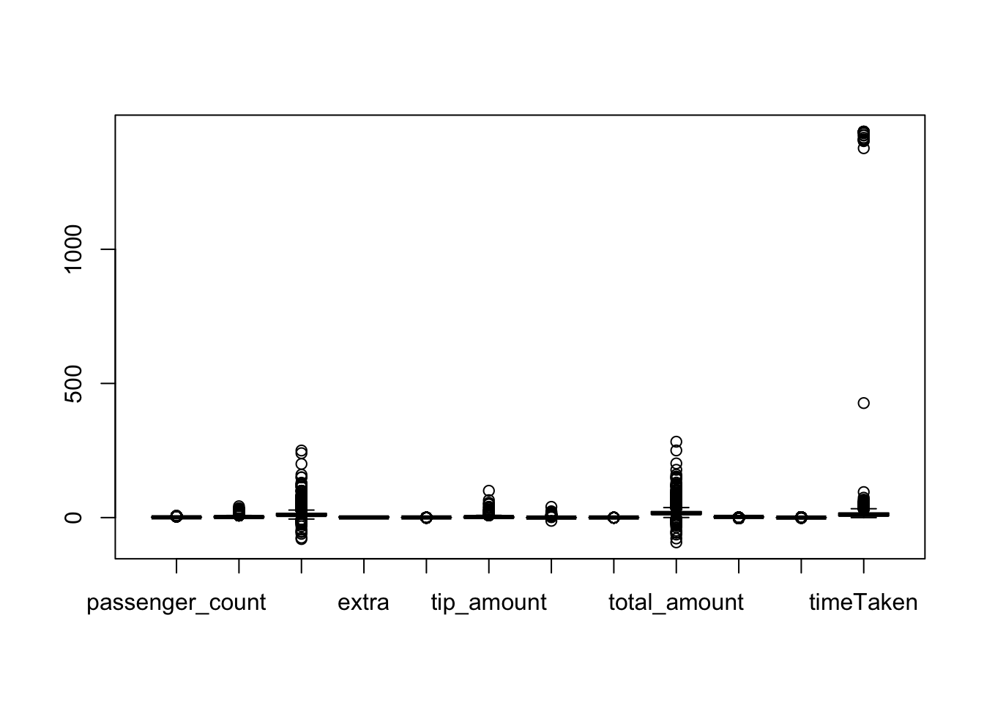
We have now plotted our dataset, so we will remove our outliers first and then choose our sample size
With the boxplot we can see which variables have outliers and now we will remove them all
new_df <- new_df[-which(new_df$timeTaken %in% boxplot.stats(new_df$timeTaken)$out), ]
new_df <- new_df[-which(new_df$fare_amount %in% boxplot.stats(new_df$fare_amount)$out), ]
new_df <- new_df[-which(new_df$trip_distance %in% boxplot.stats(new_df$trip_distance)$out), ]
new_df <- new_df[-which(new_df$total_amount %in% boxplot.stats(new_df$total_amount)$out), ]
new_df <- new_df[-which(new_df$tolls_amount %in% boxplot.stats(new_df$tolls_amount)$out), ]
new_df <- new_df[-which(new_df$passenger_count %in% boxplot.stats(new_df$passenger_count)$out), ]
new_df <- new_df[-which(new_df$mta_tax %in% boxplot.stats(new_df$mta_tax)$out), ]
new_df <- new_df[-which(new_df$tip_amount %in% boxplot.stats(new_df$tip_amount)$out), ]
new_df <- new_df[-which(new_df$airport_fee %in% boxplot.stats(new_df$airport_fee)$out), ]
new_df <- new_df[-which(new_df$congestion_surcharge %in% boxplot.stats(new_df$congestion_surcharge)$out), ]

boxplot(new_df)
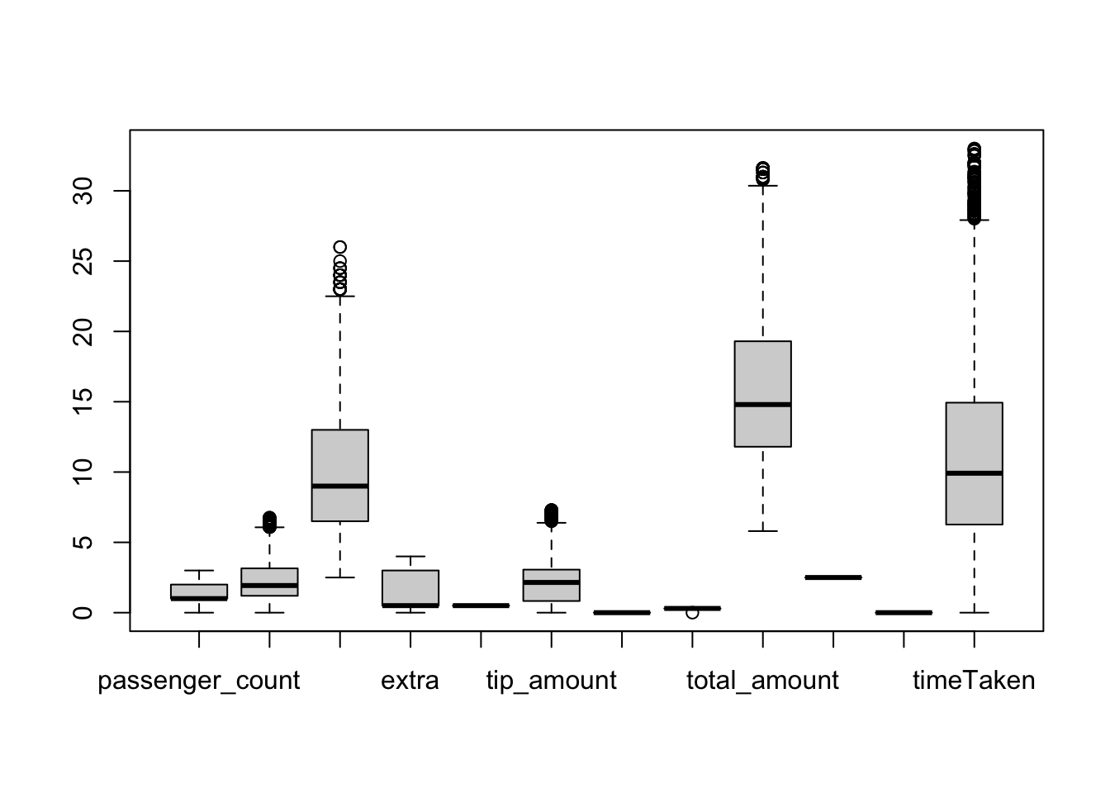
We can see from this that the majority of outliers have been removed, now we can go ahead with our investigation

Choosing first 500 rows
complete_df <- head(new_df, 500)

summary(complete_df)
## passenger_count trip_distance fare_amount extra mta_tax
## Min. :0.0 Min. :0.000 Min. : 2.50 Min. :0.000 Min. :0.5
## 1st Qu.:1.0 1st Qu.:1.137 1st Qu.: 6.50 1st Qu.:0.500 1st Qu.:0.5
## Median :1.0 Median :1.915 Median : 9.50 Median :0.500 Median :0.5
## Mean :1.4 Mean :2.268 Mean :10.23 Mean :1.341 Mean :0.5
## 3rd Qu.:2.0 3rd Qu.:3.107 3rd Qu.:14.00 3rd Qu.:3.000 3rd Qu.:0.5
## Max. :3.0 Max. :6.400 Max. :24.50 Max. :3.000 Max. :0.5
## tip_amount tolls_amount improvement_surcharge total_amount
## Min. :0.000 Min. :0 Min. :0.3 Min. : 6.30
## 1st Qu.:0.000 1st Qu.:0 1st Qu.:0.3 1st Qu.:11.76
## Median :2.000 Median :0 Median :0.3 Median :15.05
## Mean :1.926 Mean :0 Mean :0.3 Mean :15.95
## 3rd Qu.:2.960 3rd Qu.:0 3rd Qu.:0.3 3rd Qu.:19.86
## Max. :6.990 Max. :0 Max. :0.3 Max. :31.55
## congestion_surcharge airport_fee timeTaken
## Min. :2.5 Min. :0 Min. : 0.100
## 1st Qu.:2.5 1st Qu.:0 1st Qu.: 6.046
## Median :2.5 Median :0 Median :10.108
## Mean :2.5 Mean :0 Mean :11.257
## 3rd Qu.:2.5 3rd Qu.:0 3rd Qu.:15.150
## Max. :2.5 Max. :0 Max. :33.000
attach(complete_df)

Scatter Plot
pairs(complete_df, upper.panel=NULL)
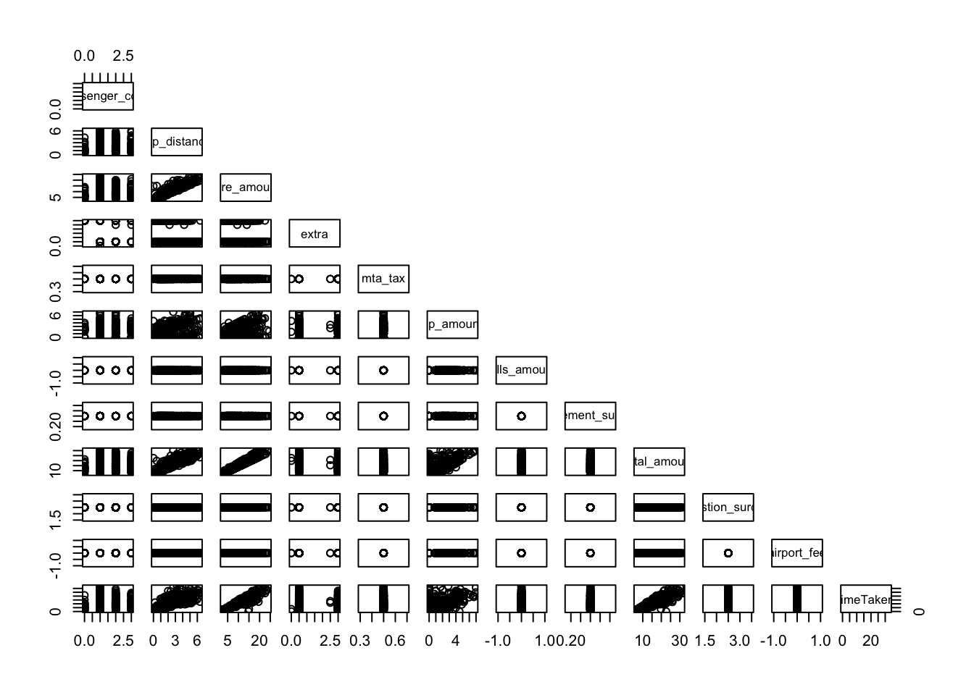 This output shows:
Some linear relationship between trip distance and time taken
No Linear relationship between passenger count and time taken, airport fee and time taken, congestion surhcarge and time taken, improvement surcharge and time taken, tolls amount and time taken, mta tax and time taken, extra and time taken
Some Linear relationship between tip amount and time taken, but with some noise
Strong Linear relationship between total amount and time taken, fare amount and time taken
We can also get a closer look at the ones we think is linear from the initial plot

trip distance and time taken
plot(complete_df$trip_distance, complete_df$timeTaken)
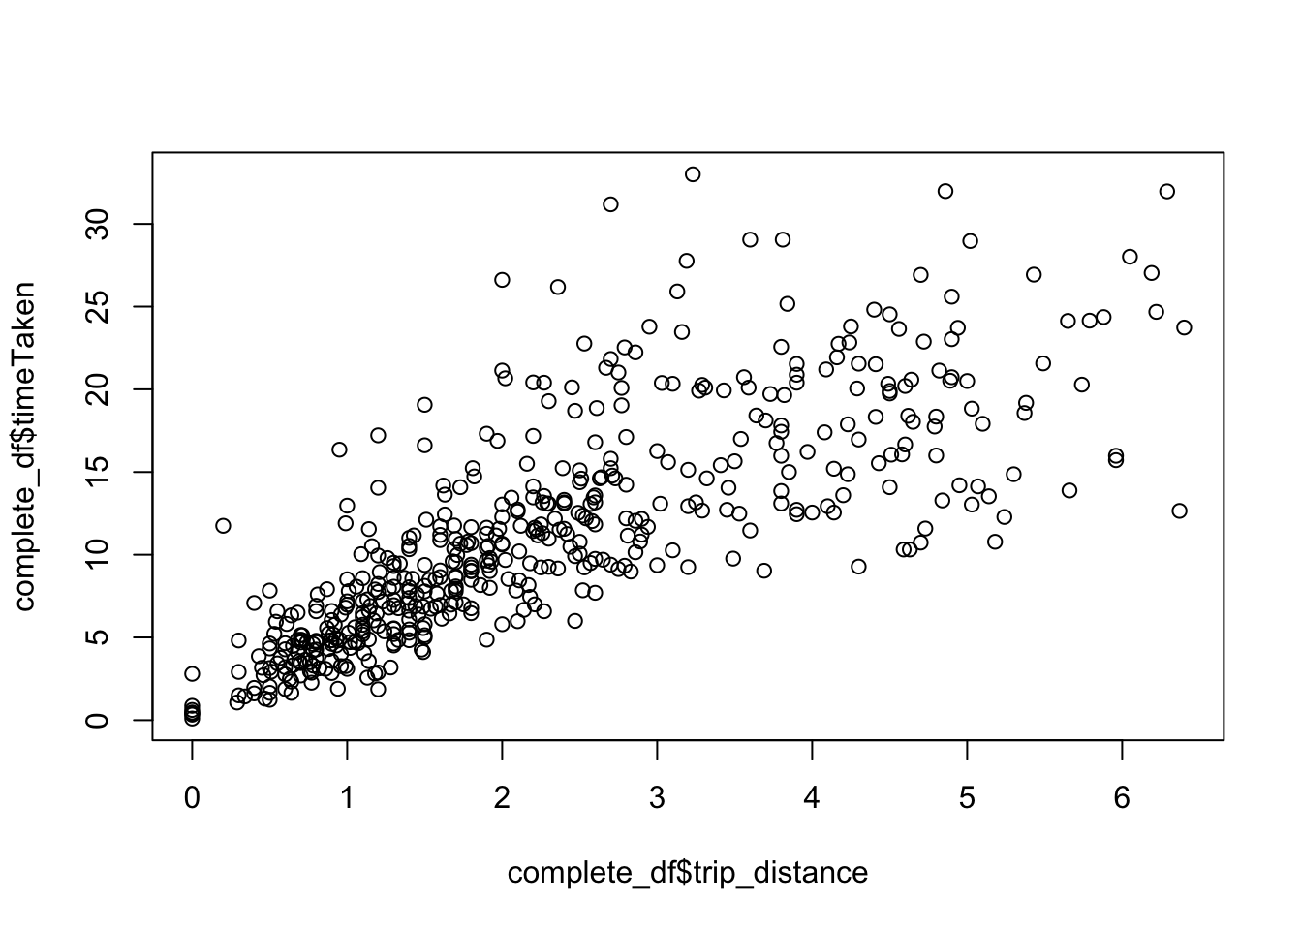
We can confirm that is relationship is linear

total amount and time taken
plot(complete_df$total_amount, complete_df$timeTaken)
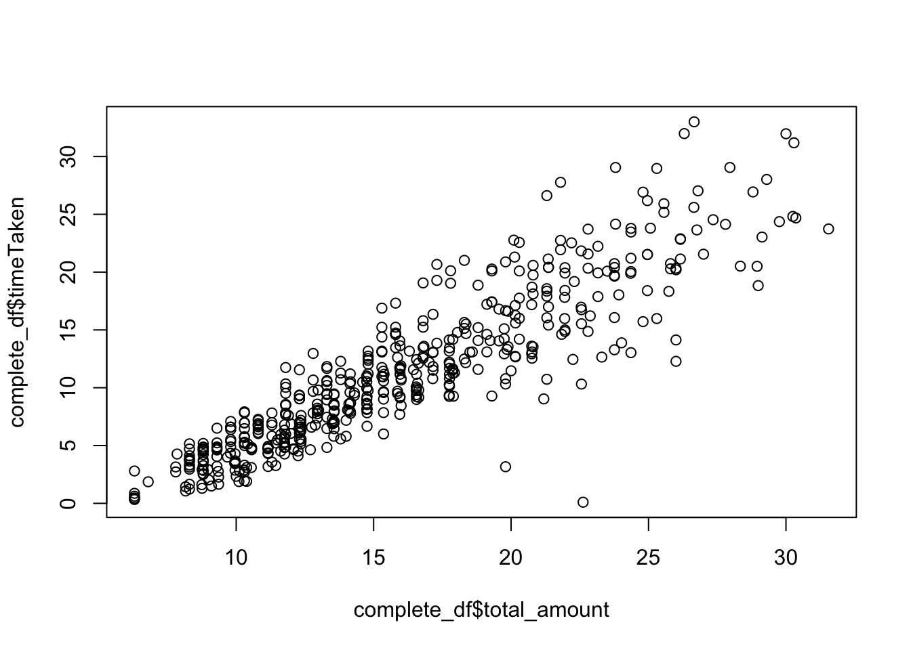
We can confirm that this is also linear

fare amount and time taken
plot(complete_df$fare_amount, complete_df$timeTaken)
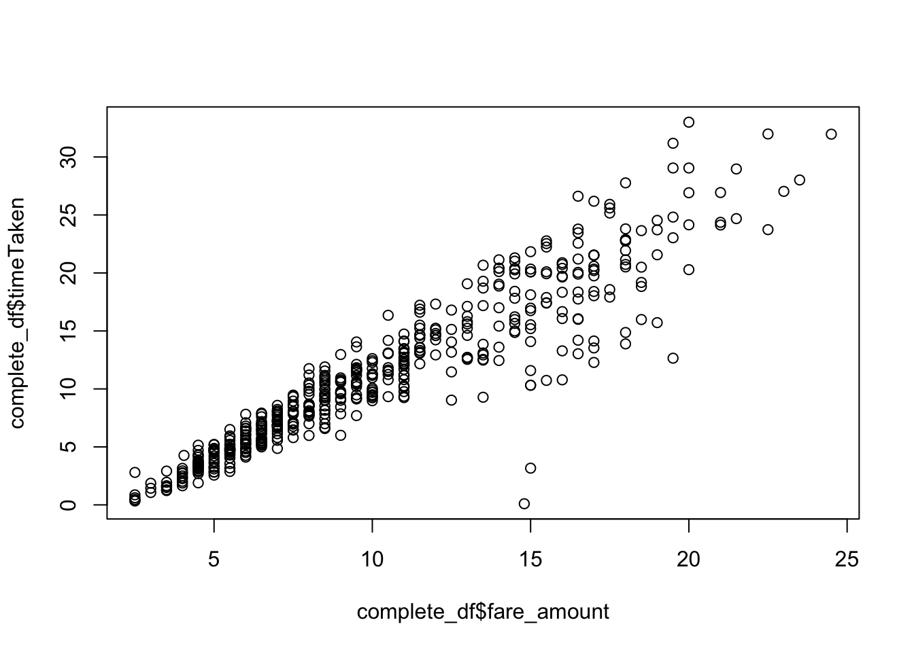
We can see that there is a strong linear relationship

tip amount and time taken
plot(complete_df$tip_amount, complete_df$timeTaken)
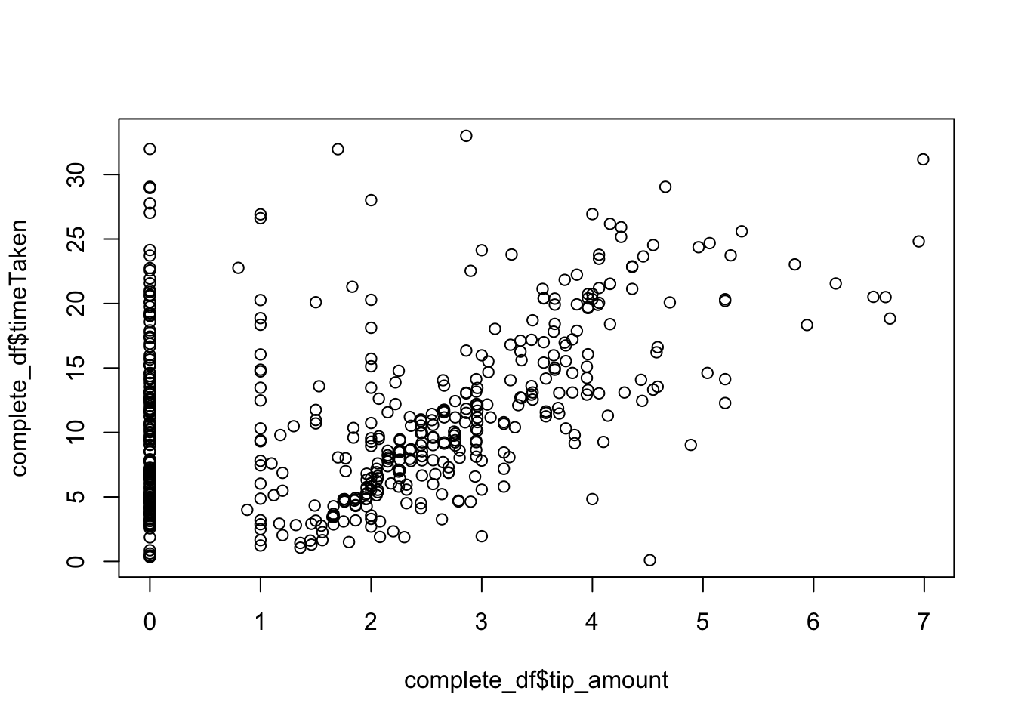 We can see that there is a very slight linear relationship while there is a lot of noise

Testing

Simple Linear Regression

Trip Distance to Time Taken Linear Regression

Model
Now we will create the linear model and then print out a summary to check the R-squared and p-value to check the goodness of this model
lmdistance <- lm(timeTaken~trip_distance, data=complete_df)
summary(lmdistance)
##
## Call:
## lm(formula = timeTaken ~ trip_distance, data = complete_df)
##
## Residuals:
## Min 1Q Median 3Q Max
## -13.3254 -2.4386 -0.5935 1.7038 18.3781
##
## Coefficients:
## Estimate Std. Error t value Pr(>|t|)
## (Intercept) 3.1159 0.3432 9.079 <2e-16 ***
## trip_distance 3.5886 0.1274 28.157 <2e-16 ***
## ---
## Signif. codes: 0 '***' 0.001 '**' 0.01 '*' 0.05 '.' 0.1 ' ' 1
##
## Residual standard error: 4.135 on 498 degrees of freedom
## Multiple R-squared: 0.6142, Adjusted R-squared: 0.6134
## F-statistic: 792.8 on 1 and 498 DF, p-value: < 2.2e-16
We can see that:
p-value is < 0.05, therefore, it shows that the variable is significant
slope and intercept p-value is < 0.05, therefore, it is clear both coefficients is significant
this model with distance as predictor explains about 61.3% variability of the target
residual standard error is 4.135

Total Amount to Time Taken Linear Regression

Model
lmamount <- lm(timeTaken~total_amount, data=complete_df)
summary(lmamount)
##
## Call:
## lm(formula = timeTaken ~ total_amount, data = complete_df)
##
## Residuals:
## Min 1Q Median 3Q Max
## -18.3891 -1.7151 -0.0756 1.3945 10.1671
##
## Coefficients:
## Estimate Std. Error t value Pr(>|t|)
## (Intercept) -6.05121 0.40274 -15.03 <2e-16 ***
## total_amount 1.08490 0.02387 45.45 <2e-16 ***
## ---
## Signif. codes: 0 '***' 0.001 '**' 0.01 '*' 0.05 '.' 0.1 ' ' 1
##
## Residual standard error: 2.934 on 498 degrees of freedom
## Multiple R-squared: 0.8058, Adjusted R-squared: 0.8054
## F-statistic: 2066 on 1 and 498 DF, p-value: < 2.2e-16
We can see that:
p-value is < 0.05, therefore, it shows that the variable is significant
slope and intercept p-value is < 0.05, therefore, it is clear both coefficients is significant
this model with total amount as predictor explains about 80% variability of the target
residual standard error is 2.934

Fare Amount to Time Taken Simple Linear Regression

Model
lmfare <- lm(timeTaken~fare_amount, data=complete_df)
summary(lmfare)
##
## Call:
## lm(formula = timeTaken ~ fare_amount, data = complete_df)
##
## Residuals:
## Min 1Q Median 3Q Max
## -17.1488 -0.8847 0.0628 1.1911 8.9304
##
## Coefficients:
## Estimate Std. Error t value Pr(>|t|)
## (Intercept) -2.16428 0.26432 -8.188 2.25e-15 ***
## fare_amount 1.31169 0.02347 55.883 < 2e-16 ***
## ---
## Signif. codes: 0 '***' 0.001 '**' 0.01 '*' 0.05 '.' 0.1 ' ' 1
##
## Residual standard error: 2.469 on 498 degrees of freedom
## Multiple R-squared: 0.8625, Adjusted R-squared: 0.8622
## F-statistic: 3123 on 1 and 498 DF, p-value: < 2.2e-16
We can see that:
p-value is < 0.05, therefore, it shows that the variable is significant
slope and intercept p-value is < 0.05, therefore, it is clear both coefficients is significant
this model with fare amount as predictor explains about 86% variability of the target
residual standard error is 2.469

Tip Amount to Time Taken Simple Linear Regression

Model
lmtip <- lm(timeTaken~tip_amount, data=complete_df)
summary(lmtip)
##
## Call:
## lm(formula = timeTaken ~ tip_amount, data = complete_df)
##
## Residuals:
## Min 1Q Median 3Q Max
## -14.887 -4.487 -1.482 3.776 23.496
##
## Coefficients:
## Estimate Std. Error t value Pr(>|t|)
## (Intercept) 8.4876 0.4343 19.541 < 2e-16 ***
## tip_amount 1.4379 0.1729 8.317 8.66e-16 ***
## ---
## Signif. codes: 0 '***' 0.001 '**' 0.01 '*' 0.05 '.' 0.1 ' ' 1
##
## Residual standard error: 6.238 on 498 degrees of freedom
## Multiple R-squared: 0.122, Adjusted R-squared: 0.1202
## F-statistic: 69.18 on 1 and 498 DF, p-value: 8.659e-16
We can see that:
p-value is < 0.05, therefore, it shows that the variable is significant
slope and intercept p-value is < 0.05, therefore, it is clear both coefficients is significant
this model with fare amount as predictor explains about 12% variability of the target, meaning it does not do a good job in predicting the time taken value
residual standard error is 6.238
From the Simple Linear Regressions that we ran above, we can say the fare amount gave us the best variability so we will plot the scatterplot along with the regression line
plot(fare_amount, timeTaken)

abline(lmfare, col="blue")
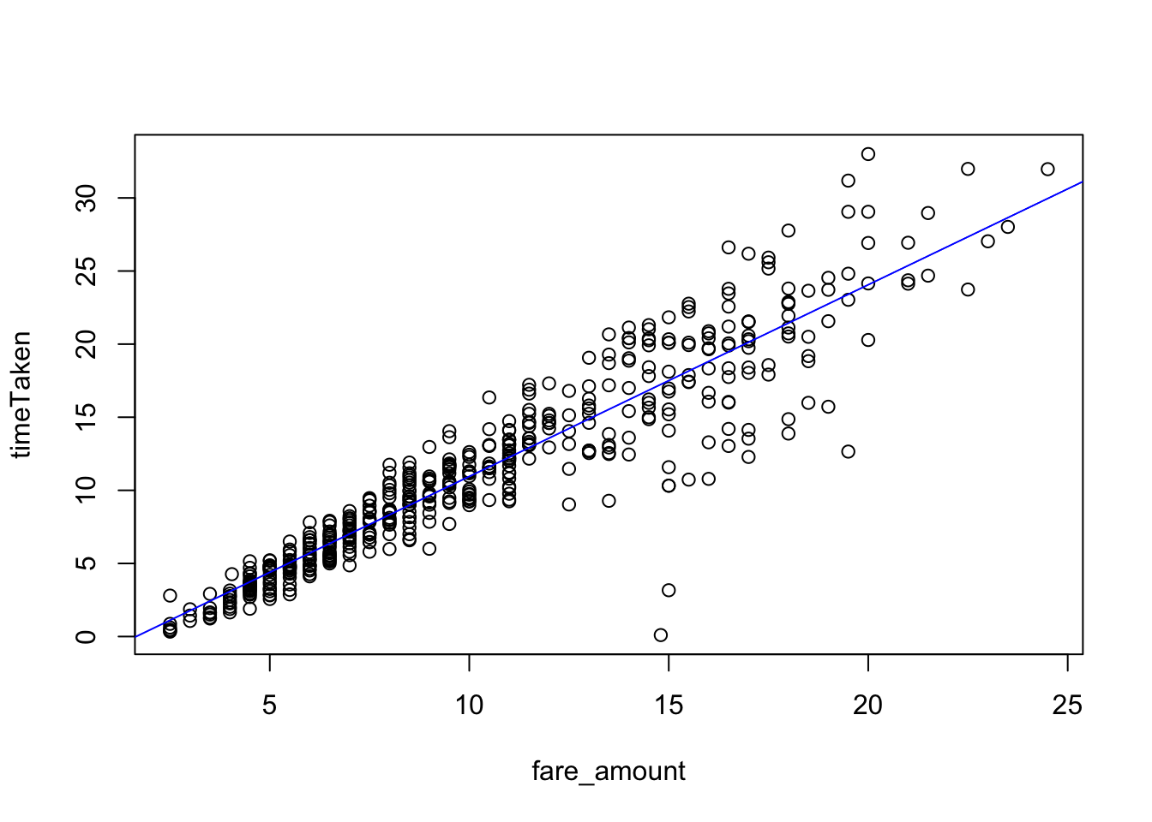 As you can see the line does not fully explain the variability within time taken, so maybe we could try multiple linear regression and see if more predictors help improve the line

Correlation
res <- cor.test(timeTaken, tip_amount)
res
##
## Pearson's product-moment correlation
##
## data: timeTaken and tip_amount
## t = 8.3175, df = 498, p-value = 8.659e-16
## alternative hypothesis: true correlation is not equal to 0
## 95 percent confidence interval:
## 0.2698182 0.4239523
## sample estimates:
## cor
## 0.3492454
correlation is 0.349, since the correlation is not high we can say that this won’t create a lot of noise
res <- cor.test(timeTaken, trip_distance)
res
##
## Pearson's product-moment correlation
##
## data: timeTaken and trip_distance
## t = 28.157, df = 498, p-value < 2.2e-16
## alternative hypothesis: true correlation is not equal to 0
## 95 percent confidence interval:
## 0.7473805 0.8153639
## sample estimates:
## cor
## 0.7837082
correlation of 0.783 means this variable could cause a lot of noise
res <- cor.test(timeTaken, fare_amount)
res
##
## Pearson's product-moment correlation
##
## data: timeTaken and fare_amount
## t = 55.883, df = 498, p-value < 2.2e-16
## alternative hypothesis: true correlation is not equal to 0
## 95 percent confidence interval:
## 0.9155617 0.9398434
## sample estimates:
## cor
## 0.9286913
We get a correlation of 0.929 so we can say it can cause a lot of noise as well
res <- cor.test(timeTaken, total_amount)
res
##
## Pearson's product-moment correlation
##
## data: timeTaken and total_amount
## t = 45.455, df = 498, p-value < 2.2e-16
## alternative hypothesis: true correlation is not equal to 0
## 95 percent confidence interval:
## 0.8791683 0.9134426
## sample estimates:
## cor
## 0.8976544
The correlation for this is 0.898 so it will have a lot of noise when added to the model
After running the correlation tests, we can see what correlation we get, while some are high this could cause noise in our MLR model or it could help make it more accurate

Check for Multi-Colinearity
res <- cor.test(fare_amount, tip_amount)
res
##
## Pearson's product-moment correlation
##
## data: fare_amount and tip_amount
## t = 8.7097, df = 498, p-value < 2.2e-16
## alternative hypothesis: true correlation is not equal to 0
## 95 percent confidence interval:
## 0.2849755 0.4373278
## sample estimates:
## cor
## 0.3635804
We get a correlation of 0.363 therefore it should not have a lot of noise when added together
res <- cor.test(fare_amount, total_amount)
res
##
## Pearson's product-moment correlation
##
## data: fare_amount and total_amount
## t = 78.562, df = 498, p-value < 2.2e-16
## alternative hypothesis: true correlation is not equal to 0
## 95 percent confidence interval:
## 0.9547941 0.9679824
## sample estimates:
## cor
## 0.9619445
We get a correlation of 0.962 therefore this could create a lot of noise when added together in the model
res <- cor.test(fare_amount, trip_distance)
res
##
## Pearson's product-moment correlation
##
## data: fare_amount and trip_distance
## t = 55.617, df = 498, p-value < 2.2e-16
## alternative hypothesis: true correlation is not equal to 0
## 95 percent confidence interval:
## 0.9148398 0.9393224
## sample estimates:
## cor
## 0.9280773
We get a correlation of 0.928 therefore this could create a lot of noise when added together in the model
res <- cor.test(total_amount, tip_amount)
res
##
## Pearson's product-moment correlation
##
## data: total_amount and tip_amount
## t = 16.92, df = 498, p-value < 2.2e-16
## alternative hypothesis: true correlation is not equal to 0
## 95 percent confidence interval:
## 0.5453818 0.6570570
## sample estimates:
## cor
## 0.6041777
We get a correlation of 0.604 therefore this could create noise as well within our model
res <- cor.test(total_amount, trip_distance)
res
##
## Pearson's product-moment correlation
##
## data: total_amount and trip_distance
## t = 43.567, df = 498, p-value < 2.2e-16
## alternative hypothesis: true correlation is not equal to 0
## 95 percent confidence interval:
## 0.8702635 0.9069386
## sample estimates:
## cor
## 0.8900323
We get a correlation of 0.890 therefore this could create a lot of noise as well within our model
res <- cor.test(trip_distance, tip_amount)
res
##
## Pearson's product-moment correlation
##
## data: trip_distance and tip_amount
## t = 7.6869, df = 498, p-value = 8.094e-14
## alternative hypothesis: true correlation is not equal to 0
## 95 percent confidence interval:
## 0.2449859 0.4018929
## sample estimates:
## cor
## 0.32568
We get a correlation of 0.326 therefore there is less chances of this creating noise in our model
We can see that some of the correlation values are high which could mean when added to a multiple linear regression model it could add a lot of noise, however, it could also not add noise but rather help the significance of the model instead

Multiple Linear Regression
Now that we have created our linear regression models, cleaned our data, and identified which variables are significant and have linear relationship with the time taken
We will create the multiple regression model by adding different variables and seeing how the p-value is affected so that we create a model with the least p-value and a good r-squared value as well

Fare Amount + Total Amount

Model
lm_fare_total = lm(timeTaken~fare_amount+ total_amount, data=complete_df)
summary(lm_fare_total)
##
## Call:
## lm(formula = timeTaken ~ fare_amount + total_amount, data = complete_df)
##
## Residuals:
## Min 1Q Median 3Q Max
## -17.2555 -0.9040 0.0361 1.1794 8.9496
##
## Coefficients:
## Estimate Std. Error t value Pr(>|t|)
## (Intercept) -2.47447 0.42066 -5.882 7.44e-09 ***
## fare_amount 1.23335 0.08591 14.356 < 2e-16 ***
## total_amount 0.06969 0.07351 0.948 0.344
## ---
## Signif. codes: 0 '***' 0.001 '**' 0.01 '*' 0.05 '.' 0.1 ' ' 1
##
## Residual standard error: 2.469 on 497 degrees of freedom
## Multiple R-squared: 0.8627, Adjusted R-squared: 0.8622
## F-statistic: 1562 on 2 and 497 DF, p-value: < 2.2e-16
p-value < 0.05, therefore, the model is significant
p-value of coefficients for the intercept and the fare amount is < 0.05, however, total amount coefficient is > 0.05
The model for fare amount and total amount explains a 86% variability of time taken, however, this is lower than the variability shown in the simple linear regression by just the fare amount
residual standard error is 2.469
therefore we will not add total amount to the model since it reduces the variability

Fare Amount + Trip Distance

Model
lm_fare_trip = lm(timeTaken~fare_amount+trip_distance, data=complete_df)
summary(lm_fare_trip)
##
## Call:
## lm(formula = timeTaken ~ fare_amount + trip_distance, data = complete_df)
##
## Residuals:
## Min 1Q Median 3Q Max
## -26.3820 -0.4726 0.0738 0.7746 6.2319
##
## Coefficients:
## Estimate Std. Error t value Pr(>|t|)
## (Intercept) -3.86969 0.24489 -15.80 <2e-16 ***
## fare_amount 2.05079 0.05201 39.43 <2e-16 ***
## trip_distance -2.58184 0.16861 -15.31 <2e-16 ***
## ---
## Signif. codes: 0 '***' 0.001 '**' 0.01 '*' 0.05 '.' 0.1 ' ' 1
##
## Residual standard error: 2.037 on 497 degrees of freedom
## Multiple R-squared: 0.9066, Adjusted R-squared: 0.9062
## F-statistic: 2411 on 2 and 497 DF, p-value: < 2.2e-16
p-value < 0.05, therefore, the model is significant
p-value for all the coefficients is < 0.05, meaning that the slope and intercept coefficients are statistically significant
This model with fare amount and trip distance explains about 90.6% variability of time taken
residual standard error is 2.037
this is model is showing us good results, maybe we could try adding another variable to the model and see how it responds

Anova
Now we must test whether the improvement in variability in Adjusted R squared is significant or not
We can test this by using ANOVA, having a null hypothesis as improvement in adjusted r squared is not statistically significant, and the alternative hypothesis is the improvement in adjusted r squared is statistically significant
anova(lmfare, lm_fare_trip)
## Analysis of Variance Table
##
## Model 1: timeTaken ~ fare_amount
## Model 2: timeTaken ~ fare_amount + trip_distance
## Res.Df RSS Df Sum of Sq F Pr(>F)
## 1 498 3035.6
## 2 497 2062.5 1 973.06 234.47 < 2.2e-16 ***
## ---
## Signif. codes: 0 '***' 0.001 '**' 0.01 '*' 0.05 '.' 0.1 ' ' 1
the p-value from the anova shows us that we can reject the null hypothesis and accept the alternative hypothesis
so the improvement for the adjusted r squared is statistically significant

Fare Amount + Trip Distance + Tip Amount

Model
lm_fare_trip_tip = lm(timeTaken~fare_amount+trip_distance+tip_amount, data=complete_df)
summary(lm_fare_trip_tip)
##
## Call:
## lm(formula = timeTaken ~ fare_amount + trip_distance + tip_amount,
## data = complete_df)
##
## Residuals:
## Min 1Q Median 3Q Max
## -26.4218 -0.4769 0.0659 0.7752 6.1713
##
## Coefficients:
## Estimate Std. Error t value Pr(>|t|)
## (Intercept) -3.88355 0.24768 -15.680 <2e-16 ***
## fare_amount 2.04721 0.05286 38.729 <2e-16 ***
## trip_distance -2.57961 0.16885 -15.278 <2e-16 ***
## tip_amount 0.02359 0.06069 0.389 0.698
## ---
## Signif. codes: 0 '***' 0.001 '**' 0.01 '*' 0.05 '.' 0.1 ' ' 1
##
## Residual standard error: 2.039 on 496 degrees of freedom
## Multiple R-squared: 0.9066, Adjusted R-squared: 0.906
## F-statistic: 1604 on 3 and 496 DF, p-value: < 2.2e-16
p-value < 0.05, therefore, the model is statistically significant
p-value for some of the coefficients is < 0.05, meaning that the slope and intercept coefficients are statistically significant, p-value for tip amount is not below 0.05
This model with fare amount, trip distance and tip amount explains about 90.6% variability of time taken which is slightly higher than the model with trip distance and fare amount
This variability is higher than the previous model, therefore, making the model slightly more accurate
residual standard error is 2.039
Due to the p-value for tip amount coefficient we will not consider this model and since the r squared is the same we will not make the model more complex for no reason

Fare Amount + Trip Distance + Total Amount

Model
lm_fare_trip_total = lm(timeTaken~fare_amount+trip_distance+total_amount, data=complete_df)
summary(lm_fare_trip_total)
##
## Call:
## lm(formula = timeTaken ~ fare_amount + trip_distance + total_amount,
## data = complete_df)
##
## Residuals:
## Min 1Q Median 3Q Max
## -26.4387 -0.4849 0.0778 0.7934 6.1168
##
## Coefficients:
## Estimate Std. Error t value Pr(>|t|)
## (Intercept) -4.06705 0.36252 -11.219 <2e-16 ***
## fare_amount 1.99943 0.08684 23.023 <2e-16 ***
## trip_distance -2.57850 0.16875 -15.280 <2e-16 ***
## total_amount 0.04483 0.06070 0.739 0.46
## ---
## Signif. codes: 0 '***' 0.001 '**' 0.01 '*' 0.05 '.' 0.1 ' ' 1
##
## Residual standard error: 2.038 on 496 degrees of freedom
## Multiple R-squared: 0.9067, Adjusted R-squared: 0.9061
## F-statistic: 1606 on 3 and 496 DF, p-value: < 2.2e-16
p-value < 0.05, therefore, the model is statistically significant
p-value for some the coefficients (slope and intercept) is < 0.05, therefore, making them significant, while the coefficients for total amount is > 0.05
This model with fare amount, total amount, tip amount, trip distance explains about 90.6% variability of time taken
residual standard error is 2.038 which is lower than the previous model as well
Due to the p-value of the coefficients we get the same r squared, therefore, we will not go forward with this model but take the model with the lower amount of variables since we do not want to make it more complex

Residual Plot

Checking Linearity Assumption
plot(lm_fare_trip, 1)
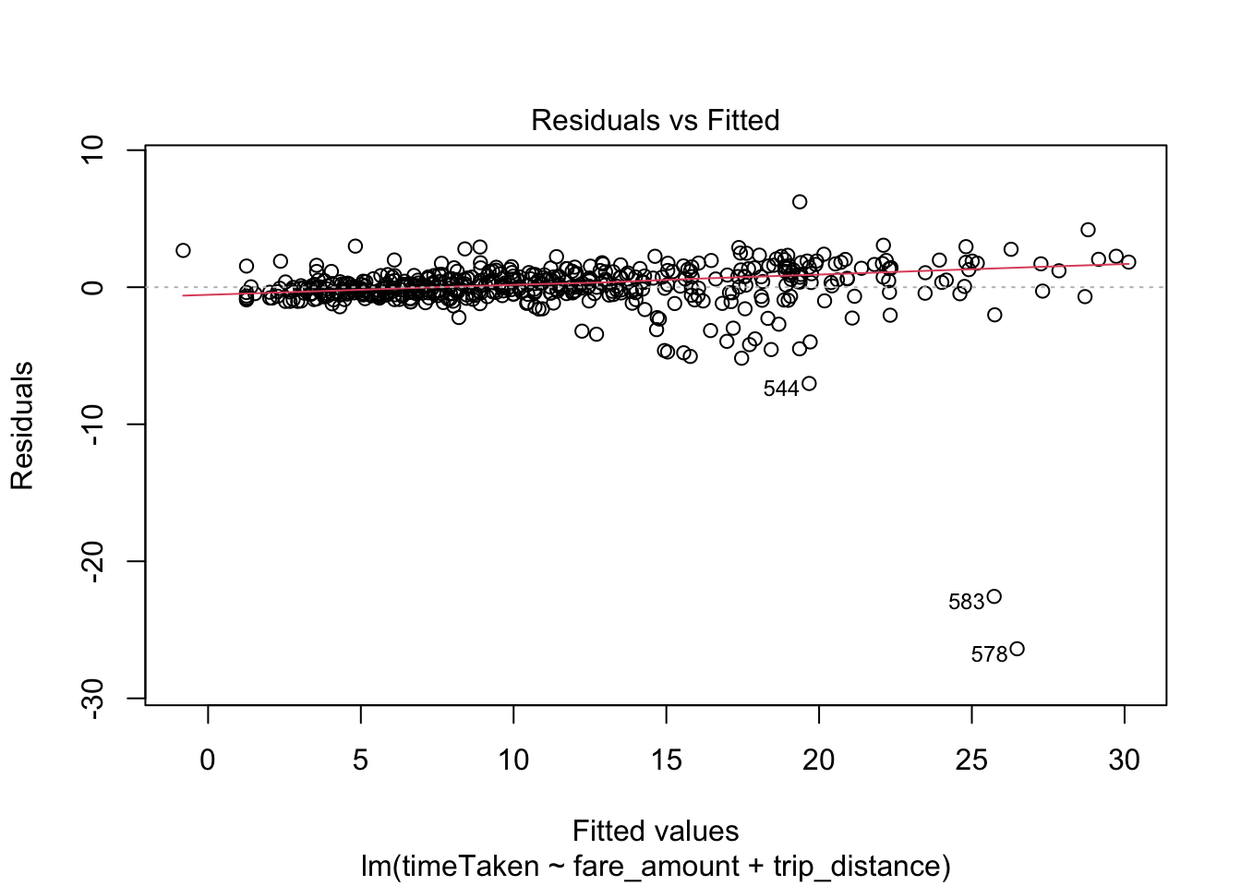 The red line is pretty much horizontal indicating that the linearity assumption holds well
Residual fluctuates between the -7 to 7 bound, which shows the fitted model is good prediction to a certain extent
Since we have a few points outside the bounds, 544, 583, 578, these could be outliers since they are very far from the 0 line
Large residuals tell us that there could indicate that either the variance is not constant (heterosceadasticity) or the true relationship between the variables is non linear
While there is a slight variance we could try transforming the data and see if the model is improved

Transforming using log(n)
Here we try transforming to try and get a better variance
new_df <- complete_df
new_df$timeTaken <- log(new_df$timeTaken)
new_df <- new_df[is.finite(rowSums(new_df)),]

lm_fare_trip_transf <- lm(timeTaken~fare_amount+trip_distance, data=new_df)
summary(lm_fare_trip_transf)
##
## Call:
## lm(formula = timeTaken ~ fare_amount + trip_distance, data = new_df)
##
## Residuals:
## Min 1Q Median 3Q Max
## -5.4014 -0.0916 0.0837 0.2235 0.4971
##
## Coefficients:
## Estimate Std. Error t value Pr(>|t|)
## (Intercept) 0.82361 0.05069 16.248 <2e-16 ***
## fare_amount 0.15373 0.01077 14.280 <2e-16 ***
## trip_distance -0.08416 0.03490 -2.411 0.0163 *
## ---
## Signif. codes: 0 '***' 0.001 '**' 0.01 '*' 0.05 '.' 0.1 ' ' 1
##
## Residual standard error: 0.4217 on 497 degrees of freedom
## Multiple R-squared: 0.679, Adjusted R-squared: 0.6778
## F-statistic: 525.8 on 2 and 497 DF, p-value: < 2.2e-16
As you can see the transformation has not helped the model at all, in fact it has made our model worse with an 67.7% variability now while before we had a 90.6% variability
Therefore, we will choose not to transform it as our previous model before transforming seems to be more significant

Checking Distribution of Residuals
hist(resid(lm_fare_trip))
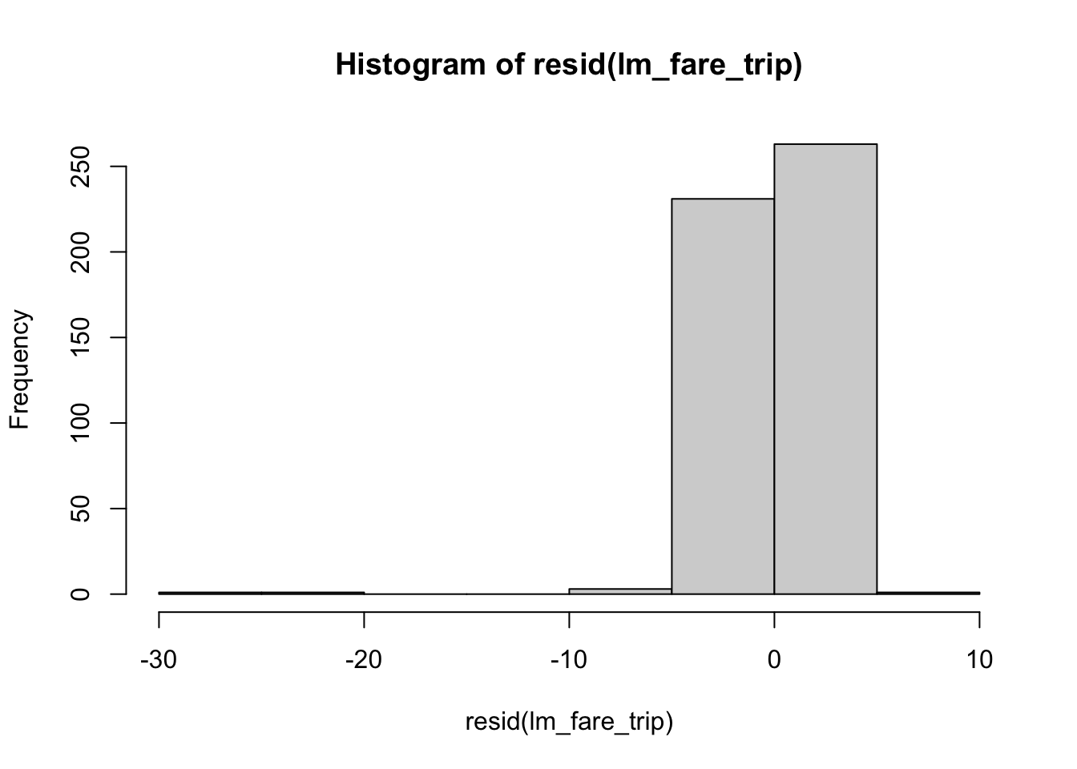 As you can see from the histogram the residuals are normally distributed which is a good thing
We can also see on the left tail that there are outliers, but on the most part it is normally distributed

Checking F-stat with f-dist value
summary(lm_fare_trip)
##
## Call:
## lm(formula = timeTaken ~ fare_amount + trip_distance, data = complete_df)
##
## Residuals:
## Min 1Q Median 3Q Max
## -26.3820 -0.4726 0.0738 0.7746 6.2319
##
## Coefficients:
## Estimate Std. Error t value Pr(>|t|)
## (Intercept) -3.86969 0.24489 -15.80 <2e-16 ***
## fare_amount 2.05079 0.05201 39.43 <2e-16 ***
## trip_distance -2.58184 0.16861 -15.31 <2e-16 ***
## ---
## Signif. codes: 0 '***' 0.001 '**' 0.01 '*' 0.05 '.' 0.1 ' ' 1
##
## Residual standard error: 2.037 on 497 degrees of freedom
## Multiple R-squared: 0.9066, Adjusted R-squared: 0.9062
## F-statistic: 2411 on 2 and 497 DF, p-value: < 2.2e-16
qf(0.95, 2, 497)
## [1] 3.013862
F-stat is > 3.014 with 2411 so we can proceed to reject the null hypothesis and say that it is statistically significant

Conclusion
In the statistical analysis I have used Correlation Tests, Anova, Simple Linear Regression, and Multiple Linear Regression. After using simple linear regression to model all the variables individually with the time taken as the predictor variable to see which models are significant and can be expanded on by using the MLR model. I then tested the correlations for these variables with time taken to see which or if any variables has high correlation and could create noise in MLR model when combined. I then tested the correlations between the independent variables to see if there exists any multicolinearity as this could add noise to our model. Correlation between some independent variables was extremely high, however, adding these variables together in the model helped its overall accuracy as we saw with the r squared value and other diagnostic methods I applied when checking the goodness of the model. I also run some other diagnostics to check the linear relationship of the variables such plotting a scatterplot of the variable with the most significance and added a linear regression line to it to see how well it fits the data, so that I can visually observe. After the diagnostics of the simple linear regression, we then move onto the multiple linear regression portion of this and we start with the variable with most significant model and add other variables to it to see which combination provides us with the most accurate model. The MLR model that shows the most significance, with a good p-value, high r squared value, high f-stat, and normally distributed residuals, that I found was when time taken is predicted by fare amount, total amount, trip distance, and tip amount. To check the fit of the MLR model we ran diagnostics such as checking F-stat, checking the distribution of the residuals, checking the residual vs fitted plot to see if the model is actually linear or not. The residual vs fitted plot also showed that the constant variance factor was being violated, however, when I tried to transform using the log(n) method it affected the model negatively, therefore, we did not transform and went ahead using the original model. To conclude we can say that the fare amount, trip distance, total amount, and tip amount as multiple linear regression helps best explain the changes and variability in the time taken for each taxi trip.

6. State Your Conclusion (no more than 100 words)
State the conclusion so that a none-statistician can understand.

To conclude, I have performed multiple tests to ascertain which kind of model would best fit our data. Best fit is described as a model that would be able to predict the time taken value the best. After performing these tests, I made a linear model that used multiple data columns instead of using just one. Furthermore, the columns that are part of this model are the fare amount, total amount, trip distance, and the tip amount. By comparing multiple different statistics from the tests helped determine the model to be the most significant.

Solution Submission

- Fill up this word file and upload it.
- Upload your data set. This is the data set after cleaning (a small CSV file)
- Upload your R file as a file with name “mini-project-solution.R”

Grading will be done based on
- Originality of selected data set and data analysis approach
- Data Preparation set and cleanup
- General Correctness of data analysis
- Quality of your R code and output results
- Correct final conclusion

