**EE417**

**POST-LAB #9 REPORT**

**3D Structure Recovery**

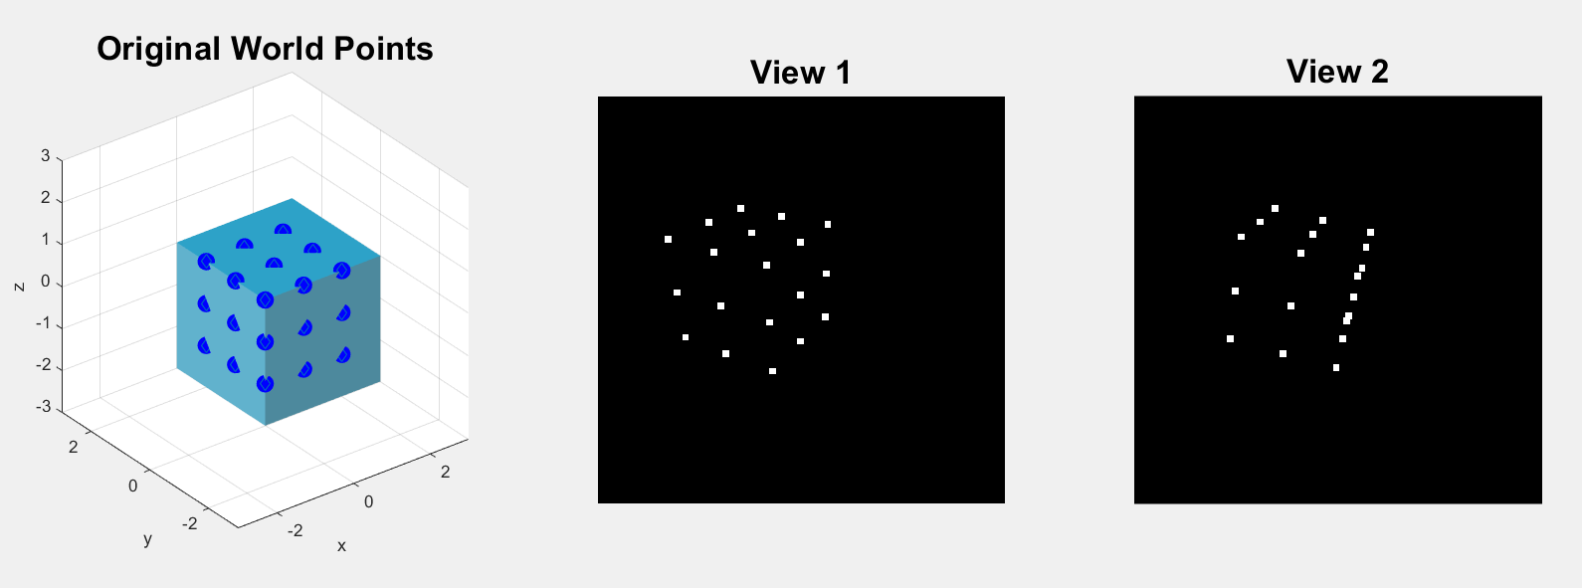In this lab we recovered 3D structure from two view by obtaining 4 possible rotation and translation solutions and then we selected one pair of them appropriately. The steps that we have followed were explained in detail in the lab document. As a consequence of the procedure of 3D structure recovery, we did not get the accurate scale factor of the object. Obtaining an accurate scale factor has been requested as a post-lab work.

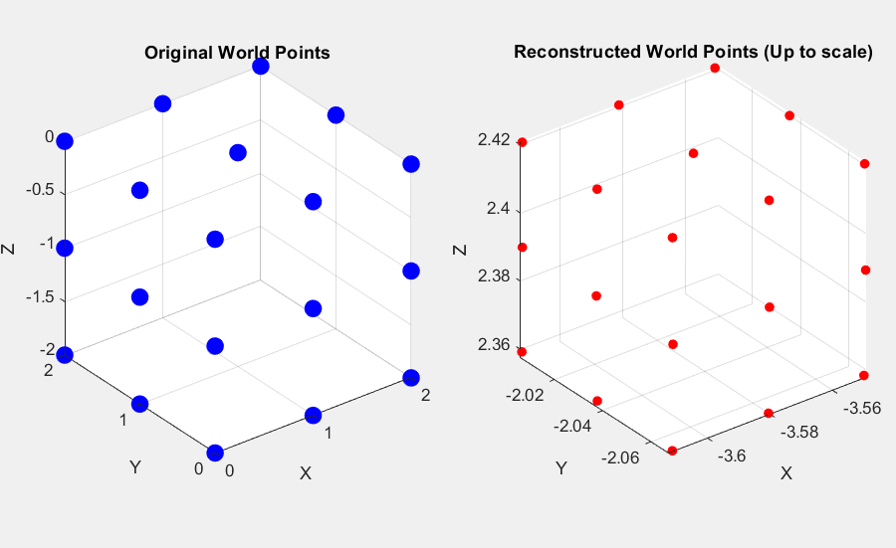

As can be seen above, the scale factor is not correct.

After reviewing of the literature, we have found Accurate Scale Factor Estimation in 3D Reconstruction (2013) paper. It suggests the following method:

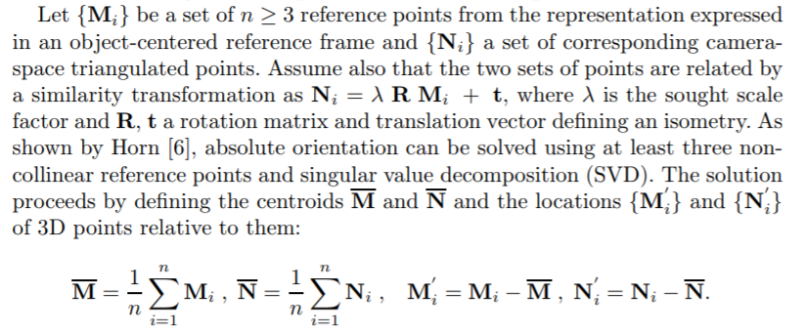

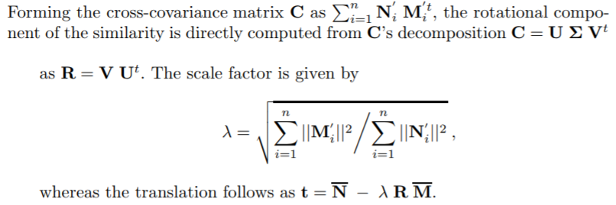

I implemented the method above as follows (the remaining code is the same with the lab that I have sent to sucourse):

Mavg = [mean(x1(1,:)); mean(x1(2,:)); mean(x1(3,:))]; % Finding the centroid of M

Navg = [mean(x2(1,:)); mean(x2(2,:)); mean(x2(3,:))]; % Finding the centroid of N

Mnum = 0;

Ndem = 0;

for i=1:1:N

Mnum = Mnum + (norm(x1(:,i)-Mavg))^2;

Ndem = Ndem + (norm(x2(:,i)-Navg))^2;

end

scalefactor = sqrt((Mnum/Ndem));

A = scalefactor*A;

disp(scalefactor);

**DISCUSSION**

My implementation gives the scalefactor as 1.0611 which is not correct. The correct scale was 100/3 that is far from my result. I think this wrong result is because of selecting of incorrect reference and corresponding points from two views (x1 and x2). I tried to select different points (5:19 and 1:10) but the result is not changed significantly. Nevertheless, I still belive that this method can be improved according to selecting the correct points.

* Full code is available on the sucourse.

**REFERENCE**

Lourakis, Manolis & Zabulis, Xenophon. (2013). Accurate Scale Factor Estimation in 3D Reconstruction. 8047. 498-506. 10.1007/978-3-642-40261-6_60.