Network Structure and experiment

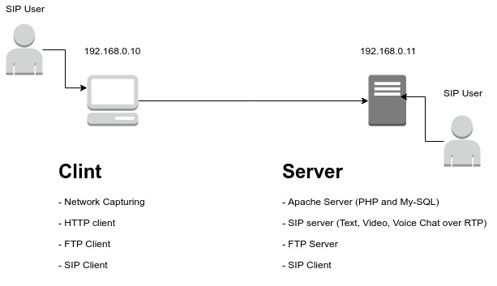
We have 3 different web side with with template filled from data base about 50 profile.
- First and second web page have similarity of 50% data and content.
- First and third web pages are totally different.
We have ftp server with 3 folder each contains 50 files.
- First and second folders have files with similarity of 50% of content.
- First and third folders have files totally different.
We have 2 SIP users doing 3 different conversations 50 times, each with random parameters, like different names location and appointments... etc.
- First and second conversations with similarity of 50% of content.
- First and third conversations are totally different.

Single experiment consist of captures traffic of (HTTP request to one of the web pages. Request to FTP File, One text conversation, RTP steam of video)

Be doing this we have (50 * 3) captured traffic of HTTP, SIP, FTP and RTP protocols.

Comparing the traffic similarity for each 3 traffic give one simple in out experiment, this means that we have 50 samples.

Algorithm:

conversation_parameters = [];
For I = 1 to 50:
conversation_parameters[i] = random_init()
End_for;
For J = 1 to 3:
IF (folderJ exist) remove folderI;
Create folderJ;
For I = 1 to 50:
- fileI;
- Start capture of Ethernet;
- do HTTP request to web page J with parameter I;
- do FTP request to folderJ file I;
- do conversation J with conversation_parameters[I];
- do RTP steram ov Video I of Folder J;
- Stop capture of Ethernet and Save Traffic[fileI] in folderJ ;
End_for;
End_for;

Implementation

Commands List

sudo apt install tshark

Start Capture:

enp0s25

sudo tshark -i wlan0 -w capture-output.pcap

Reading pcap:

tshark -r capture-output.pcap

Extract a protocol from traffic:

tshark -r trafic1.pcap --export-objects http,test

