**Naïve Preference Solver Tutorial**

**Starting the Program**

When the program starts, you will see the following displayed in the Command Prompts:

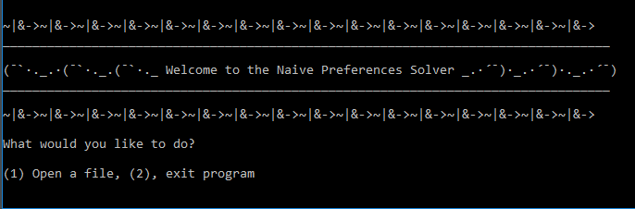

Figure 1

Since we just opened the program, we probably do not want to exit just yet, so type “1” and press “Enter”. You will be prompted to open a text file. The text file will contain the rules that are to be considered by the solver. I shall refer to the set of rules contained in the file as “R”.

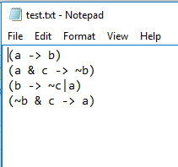But how do we get a text file? See the README file for details on the format of rule files. For this tutorial, we will use “text.txt”, which is included with the program. The file contains **four** rules. Type in “test” and press “Enter”. The program will read and evaluate the rules.

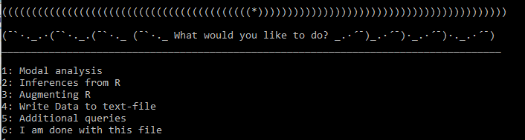After loading and processing the file, the program will print the rules and constraints (text.txt does not include constraints) and a table of the possible worlds at which the rules are evaluated (See *Figure 3 below*).

Figure 2

Figure 3

You will have a choice of six options. Let us make use of the options making use of our “text.txt” session. Enter “1” and “Enter”. The program will print out several “Modal analysis” options. 4 (or 5) and 6 are probably the most useful of these queries.

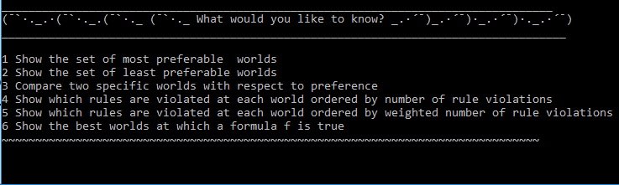

r0 a -> b

r1 a&c -> ~b

r2 b -> ~c|a

r3 ~b&c -> a

r4 b -> Not(c)

r5 c -> a

r6 c -> Not(b)

r7 Not(a) -> Not(c)