Compte Rendu TP3 Atelier Java

Lab 9:
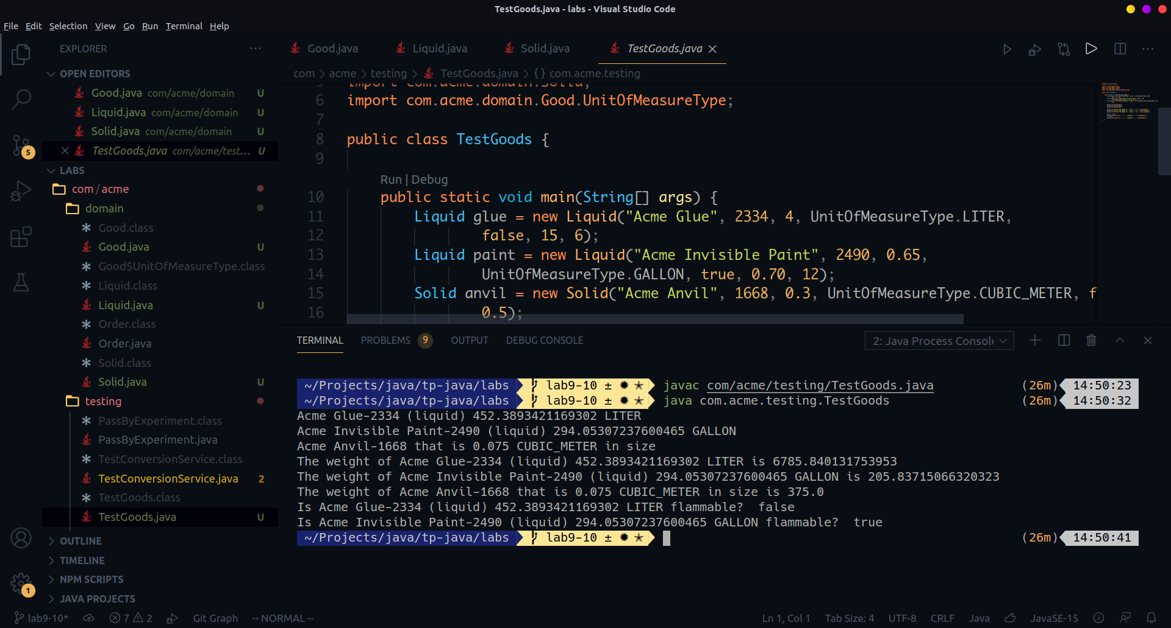
X is defined to be of type Good but a variable of type Liquid got assigned to it. This is possible because Liquid extends Good. X can reference any variable of a type that is a subclass of Good.
