Compte Rendu TP2 Atelier java

organized by Ala Ben Hamouda

lab 5:
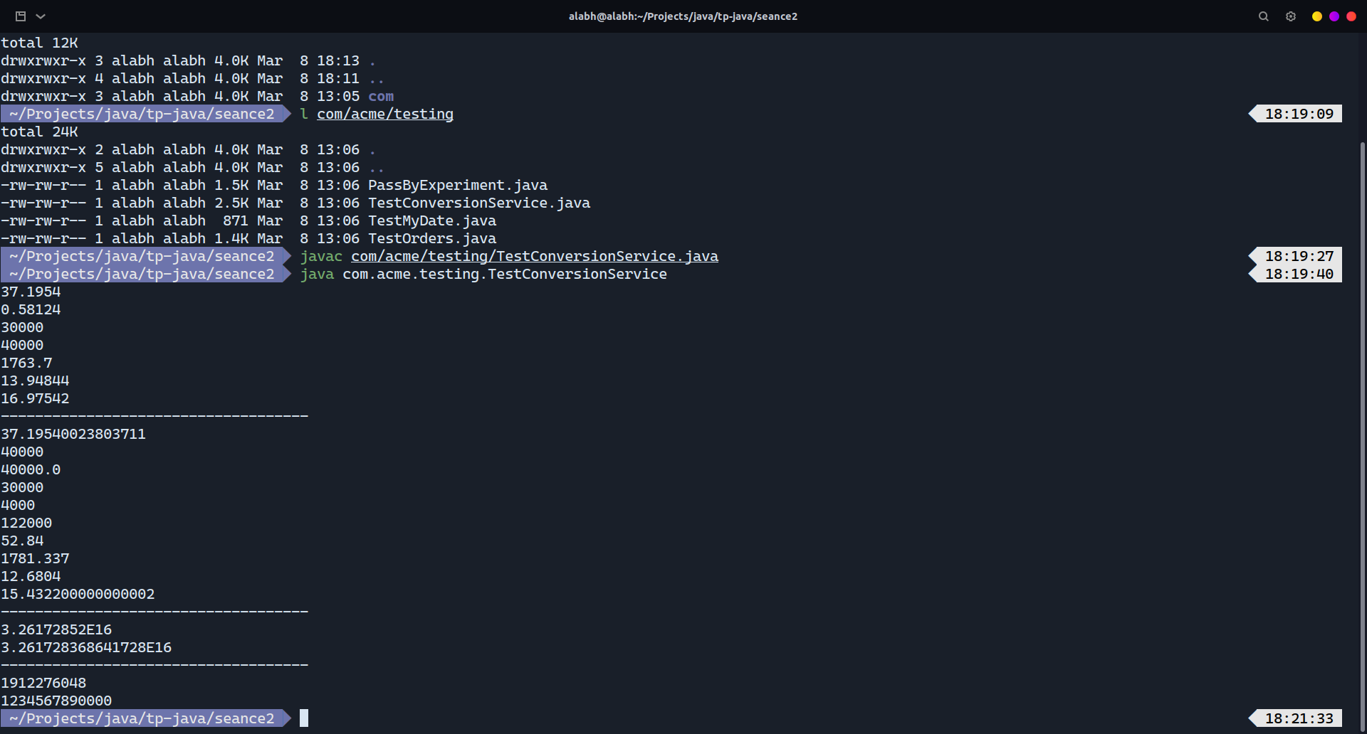
3.1.2:
The compiler complains because the types of arguments passed to functions don’t match the types of arguments: the compiler doesn’t convert double to a float for example because a double may be bigger than a float type can handle.

3.3:
the compiler can cast implicitly sometimes when the conversion is safe: from an int to a long or a float to a double.

3.4.3:
Working with floats rather than double reduces the precision of the calculations because float is a 32bits type and double is a 64bits type.
Same with Long and ints.

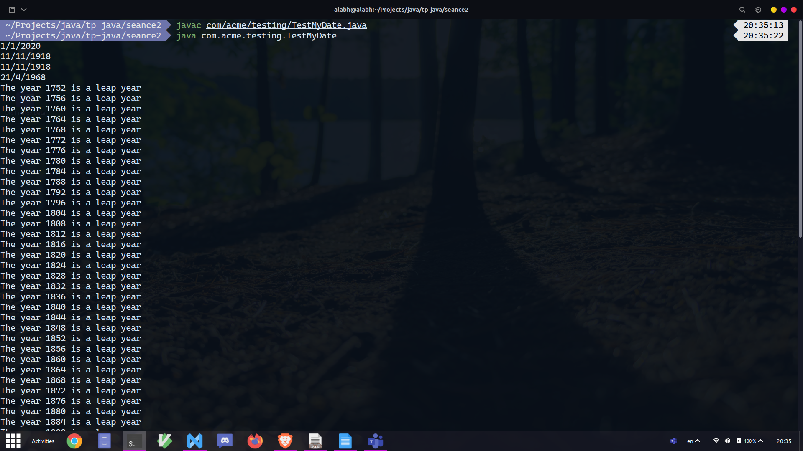
Lab 6:
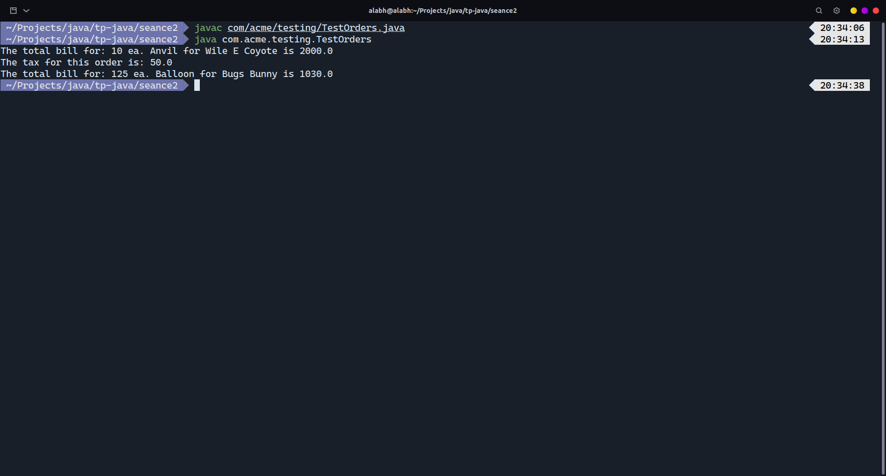
lab 7:
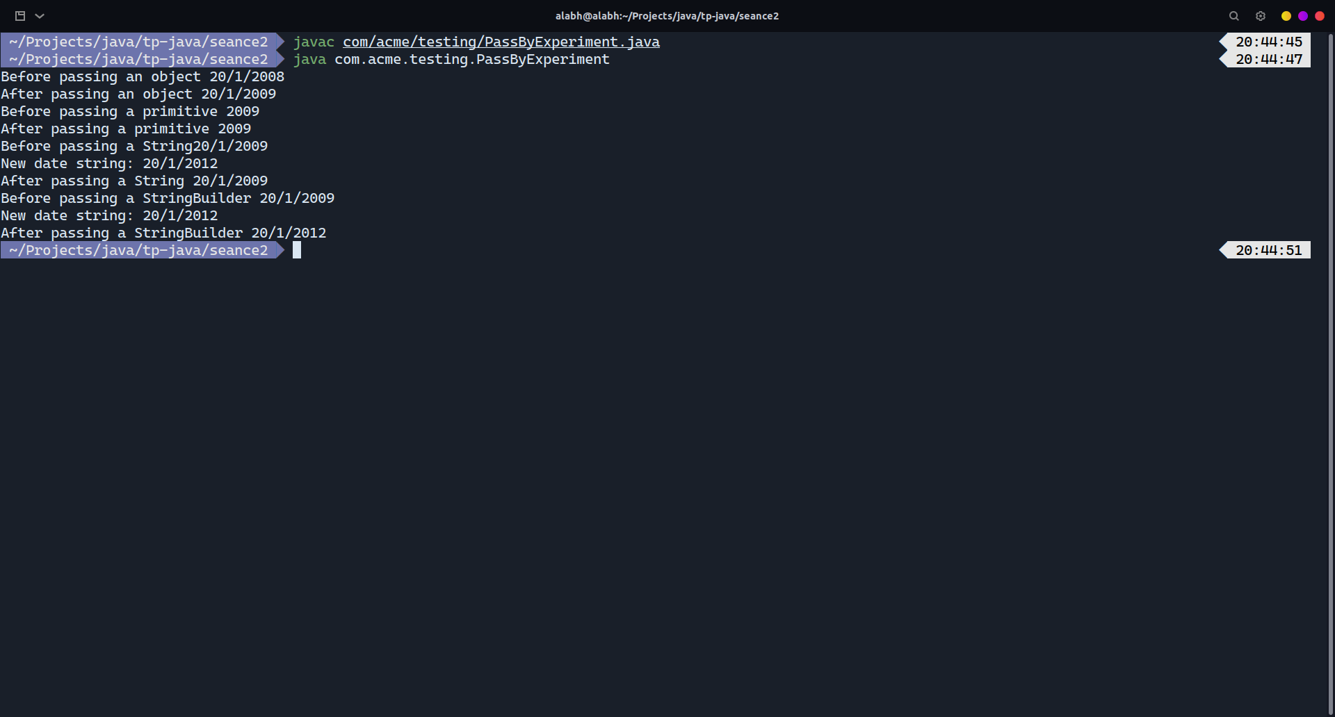
Primitives are passed by value to functions in java that’s why any modifications in the function don’t alter the original variable.
Objects are passed by reference therefore modifying the arguments from functions will modify the original object’s state. It’s not the case for strings because strings are immutable objects.
That’s why we have to work with StringBuilder when we want to modify and work with strings.

Lab 8:
