Compte Rendu TP3 Atelier Java
Organized by: Ala Ben Hamouda GL2

Lab 9:
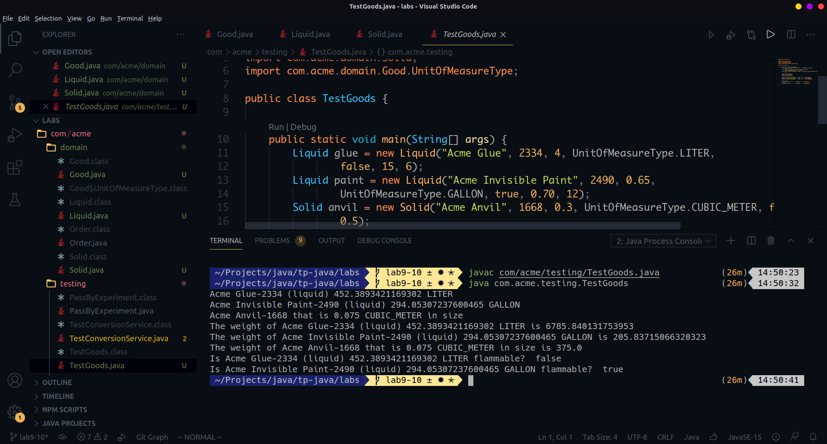
X is defined to be of type Good but a variable of type Liquid got assigned to it. This is possible because Liquid extends Good. X can reference any variable of a type that is a subclass of Good.
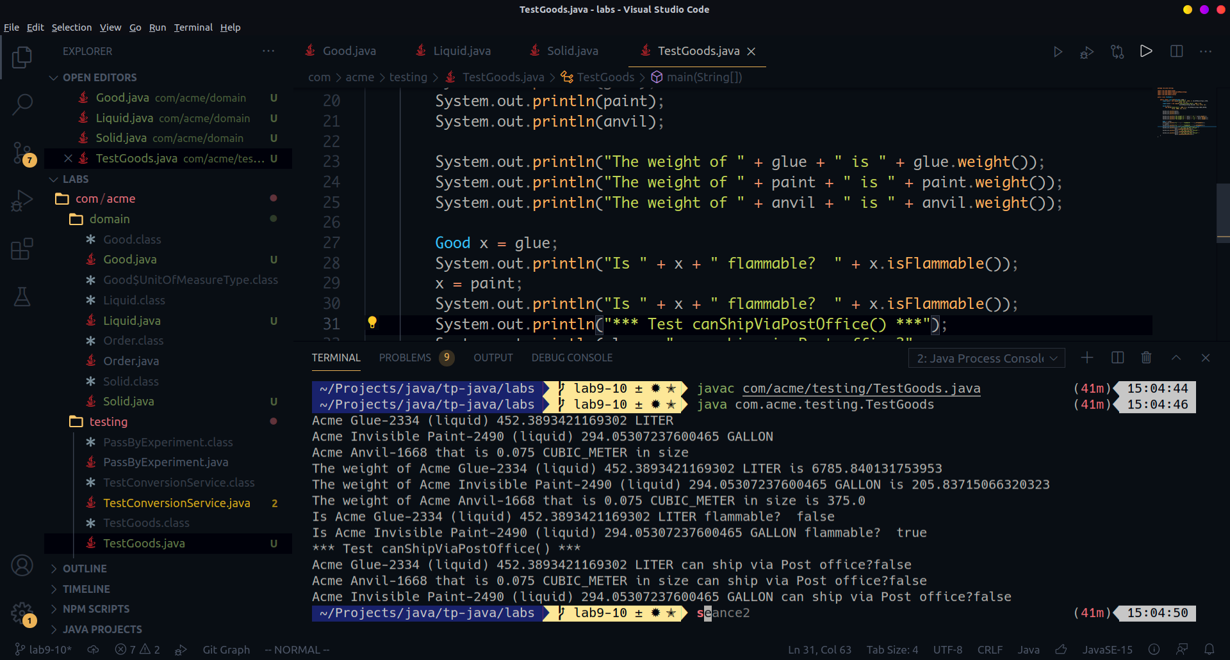

Lab 10:
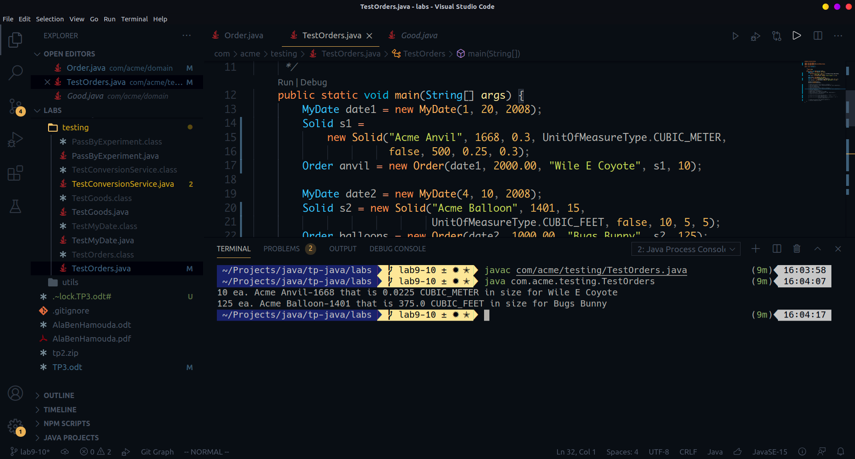
The output changes a little because now the toString method of Order class uses the toString method of Good class. So the toString method called on the product is dynamically bound the right toString method depending on the actual type of the product.

Step 2:Implement Equals on MyDate
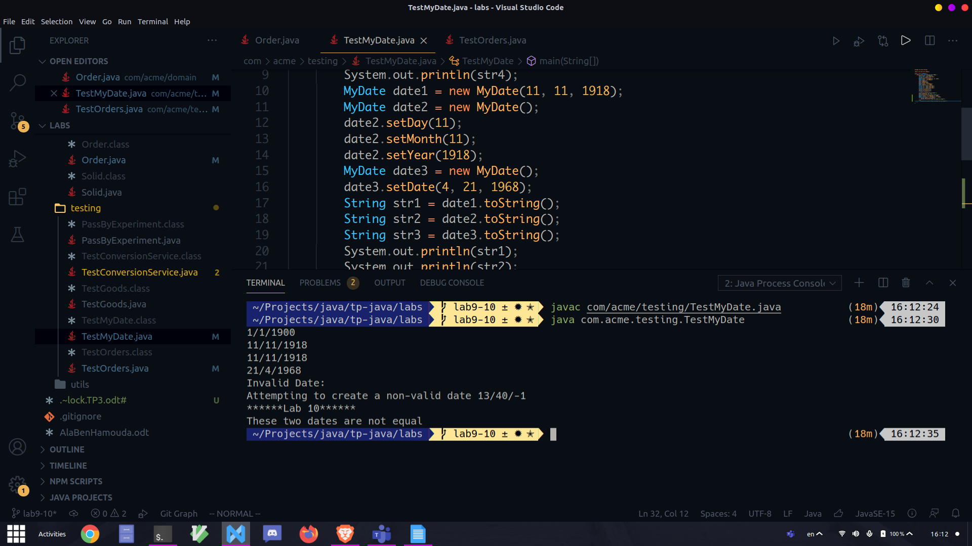

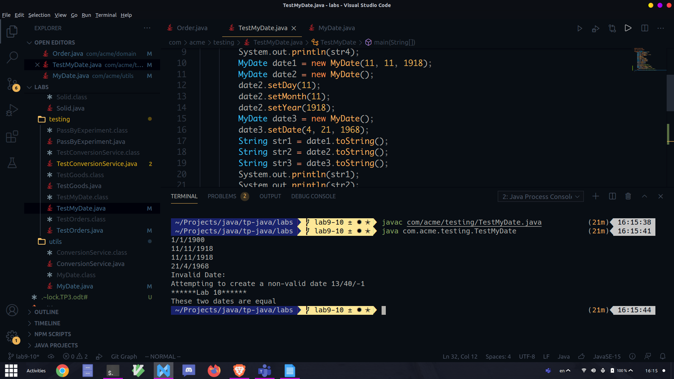
The default equals method inherited from the Object super class checks if the two variables have identical references.

Bonus:
The getProduct method defined in the Order class return a Good object. And the Good class doesn’t define any getLength method. Besides, the compiler doesn’t have a clue about the actual type of the Good object.
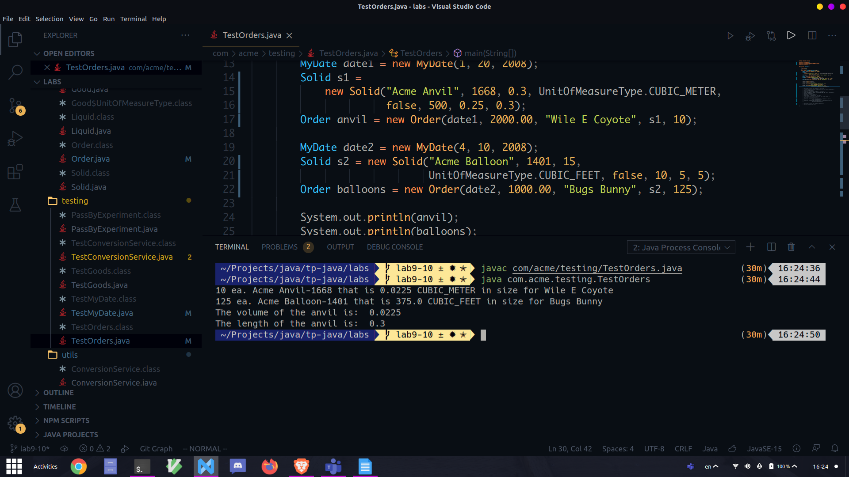
If the was really a Liquid rather than a Solid the program would throw an Exception the the runtime be cause he cannot cast a Liquid object to a Solid.

